## 错误1

Nginx error.log

2017/10/26 10:26:28 [alert] 3509#0: 1024 worker_connections are not enough

2017/10/26 10:26:28 [alert] 3509#0: 1024 worker_connections are not enough

2017/10/26 10:26:28 [alert] 3509#0: 1024 worker_connections are not enough

2017/10/26 10:26:28 [alert] 3509#0: 1024 worker_connections are not enough

2017/10/26 10:26:28 [alert] 3509#0: 1024 worker_connections are not enough

2017/10/26 10:26:28 [alert] 3509#0: 1024 worker_connections are not enough

2017/10/26 10:26:28 [alert] 3509#0: 1024 worker_connections are not enough

2017/10/26 10:26:28 [alert] 3509#0: 1024 worker_connections are not enough

2017/10/26 10:26:28 [alert] 3509#0: 1024 worker_connections are not enough

2017/10/26 10:26:28 [alert] 3509#0: 1024 worker_connections are not enough

2017/10/26 10:26:28 [alert] 3509#0: 1024 worker_connections are not enough

2017/10/26 10:26:28 [alert] 3509#0: 1024 worker_connections are not enough

2017/10/26 10:26:28 [alert] 3509#0: 1024 worker_connections are not enough

2017/10/26 10:26:28 [alert] 3509#0: 1024 worker_connections are not enough

2017/10/26 10:26:28 [alert] 3509#0: 1024 worker_connections are not enough

2017/10/26 10:26:28 [alert] 3509#0: 1024 worker_connections are not enough

2017/10/26 10:26:28 [alert] 3509#0: 1024 worker_connections are not enough

解决方法

events {

worker_connections 10240;

}

后来又出现

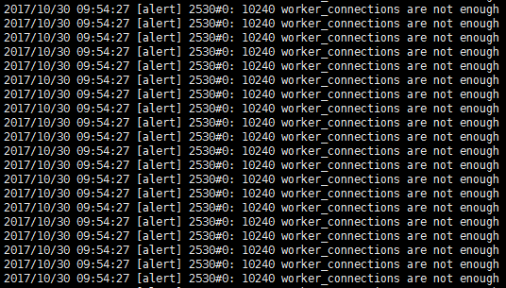

## 错误2

压测 /product/1234.json 接口

Redis server 大量 time_wait 链接

查看命令：

Netstat -na | grep 6379 | grep TIME_WAIT | wc -l

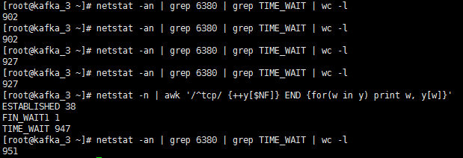

2000个并发 time wait 数量947

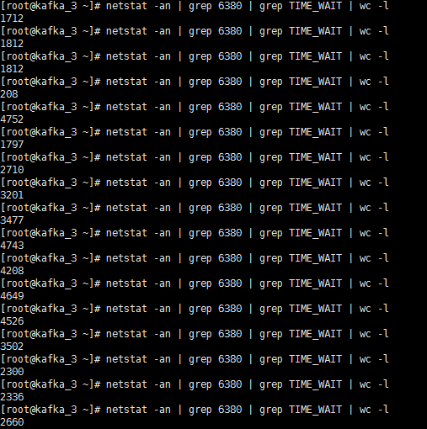

并发5000 time wait数量最大 4743

测试发现 time wait数量越高 系统响应越慢

**解决方法**

vim /etc/sysctl.conf

net.ipv4.tcp_syncookies = 1

net.ipv4.tcp_tw_reuse = 1

net.ipv4.tcp_tw_recycle = 1

/sbin/sysctl -p //使之生效

同时伴随着 worker_connection 不够用

## 错误3

这个方法

function set_local_cache(key, value, exptime)

if not exptime then

exptime = 0

end

local bigjson_cache = ngx.shared.bigjson_cache

--ngx.log(ngx.ERR, key, exptime)

local succ, err, forcible = bigjson_cache:set(key, value, exptime)

if succ == false then

ngx.log(ngx.ERR, err, ", ", forcible)

end

return succ

End

报错

set_local_cache(): no memory

**修改 nginx.conf**

lua_shared_dict bigjson_cache 100m;

把缓存改大些即可解决