CONTRACT
Contract No.: ContractNo
Date: Date

The Buyer: BuyerName
Address: BuyerAddress

The Seller: SellerName
Address: SellerAddress

This Contract is made by and between the Buyers and the Sellers; whereby the Buyers agree to buy and the Se
llers agree to sell the under mentioned commodity according to the terms and conditions stipulated below:

Item | PartNo | Edesc | Qty | Unit | Unit Price | Amount Price | Currency | Origin

3.COUNTRY OF ORIGIN: Origin ETC.
4. PORT OF DESTINATION: SHANGHAI, CHINA
5. INSURANCE: To be covered by the SELLER after Shipment.
6. THE TERMS OF PAYMENT: By T/T within 10 days after arrival of goods.
7. PACKING: To be packed in strong wooden case (s) or in carton (s), suitable for long distance air freight transportation and to change of climate well protected against molsture and shock. The Sellers shall be liable for and damage of the commodity and expenses incurred on account of improper packing and for and rust attributable to inadequate or importer protective measures taken by the Sellers in regard to the packing.
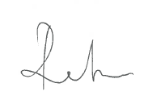
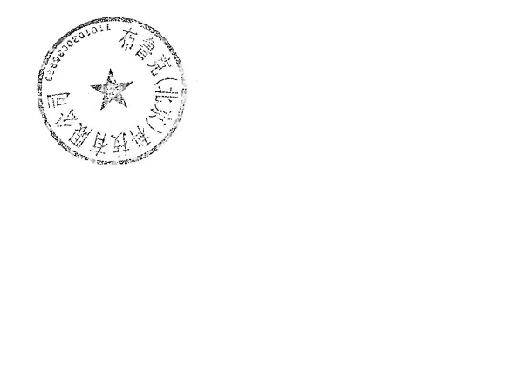
FOR AND ON BEHALF OF FOR AND ON BEHALF OF

THE SELLER: THE BUYER:

