CONTRACT
Contract No.: ContractNo
Date: Date
The Buyer: BuyerName
Address: BuyerAddress
The Seller: SellerName
Address : SellerAddress
- This Contract is made by and between the Buyers and the Sellers; whereby the Buyers agree to buy and the Sellers agree to sell the under mentioned commodity according to the terms and conditions stipulated below:
Item | PartNo | 中文品名 | Description | Model | Qty | Net Weight | Gross Weight | Unit Price | Amount | Currency | Origin | HsCode
2. TIME OF SHIPMENT: WITHIN THREE WEEKS AFTER RECEIVED THE ORDER
3. COUNTRY OF ORIGIN: Origin
4. PORT OF DESTINATION: SHANGHAI, CHINA
5. INSURANCE: To be covered by the SELLER after Shipment.
6. THE TERMS OF PAYMENT: By T/T within 10 days after arrival of goods.
7. PACKING: To be packed in strong wooden case (s) or in carton (s), suitable for long distance air freight transportation and to change of climate well protected against molsture and shock. The Sellers shall be liable for and damage of the commodity and expenses incurred on account of improper packing and for and rust attributable to inadequate or importer protective measures taken by the Sellers in regard to the packing.
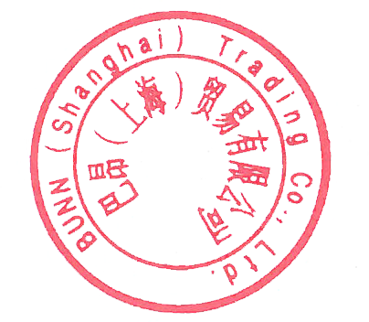
FOR AND ON BEHALF OF FOR AND ON BEHALF OF
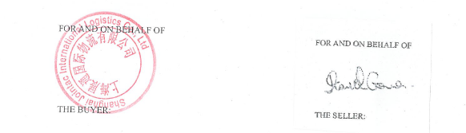
THE BUYER THE SELLER

