Dear Editors,

We are very pleased to hear of our article’s acceptance and are looking forward to publication in *Genetics*. We thank the editors and reviewers for their thoughtful comments. We now submit a revised manuscript that addresses all issues raised in the final round of reviews. In particular, we have made the following changes:

1. **Variable definitions**

We appreciate the reviewer’s suggestion in revising mathematical formulas, e.g. describing deviation and variance explicitly. We further revised the formulas that follows the mathematical norms. Specifically:

1. σ was used exclusively for deviations, whereas $σ^{2}$ was used for variances.
2. δ was replaced by σ for consistent notation of deviation
3. Gaussian models were consistently described as *N(mean, variance)*, in which the second parameter is the variance
4. **Determination of P-values**

There were errors in the formula describing the P-values. The integral part accidentally showed up twice. We are thankful to the reviewer for catching this up. The revised formulas are the following:

$P^{t}$ = 2 $\int_{-∞}^{0}{P(β|data)}dβ$* , for mean($P(β|data)$) > 0

$P^{t}$ = 2 $(1- \int_{-∞}^{0}{P\left(β | data\right)}dβ)$* , for mean($P(β|data)$) < 0

We did not change the way in calculating p-values from the first to the second draft of our manuscripts.

To show in more details operating characteristics of the p-values we calculated, we took the reviewer’s suggestion in running simulation to demonstrate the p-value we computed are in general consistent with the frequentist p-values.

To do so, we built a fixed effect ordered categorical model and applied it to the top 100 variants of the ADSP study. Model parameters were estimated by both MLE and MCMC. The frequentist p-values of variant effects were calculated from the MLE estimations of expected values and standard errors, as described in the manuscript. Tail p-values were calculated from the MCMC samples by using the formulas above. We did not run this simulation on mixed models because MLE was not stable in estimating mixed models and the corresponding frequentist p-values were hard to calculate. Simulation results showed (1) the two methods report consistent expected means of variants effects (top); (2) standard error estimation of variant effect mean by MLE and standard derivation estimation of variant effect parameter by MCMC are also consistent (middle); (3) the tail p-values that we proposed are in general consistent with the standard frequentist p-values (bottom). These plots have been added to the Supplemental Figures.

**Figure 1**

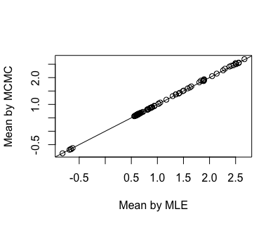

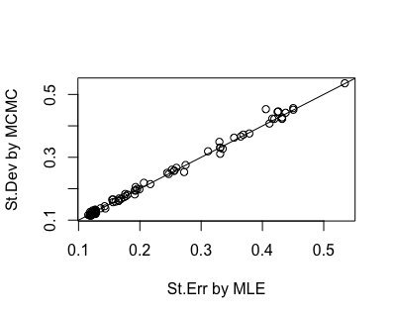

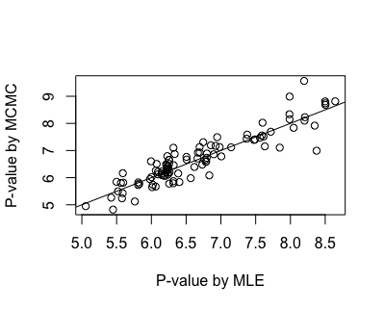

1. **Supplemental Figures**

We have added new information to the Supplemental Material in response to reviewers’ and editor’s comments. Specifically, we have added Supplemental Table 3 and Supplemental Figures 1, 2, 5, and 6. Additionally, we have moved information relevant to Supplemental Figure 8 from the main text to an extended caption in order to avoid confusion about the LRT/LOD calculation (this quantity is only used for Supplemental Figure 8).

1. **Changes to the Main Text**

We have made a number of minor changes to the main text to cite the new Supplemental Material and clarify our study. This includes new text:

* Changes in mathematical formulas on Lines 119-193, 234-235 to clarify as described in Item 1 above.
* Changes in Lines 218-223 to clarify P-value calculations as described in Item 2 above.
* Changes Lines 376-381 to clarify the use of IGAP priors.