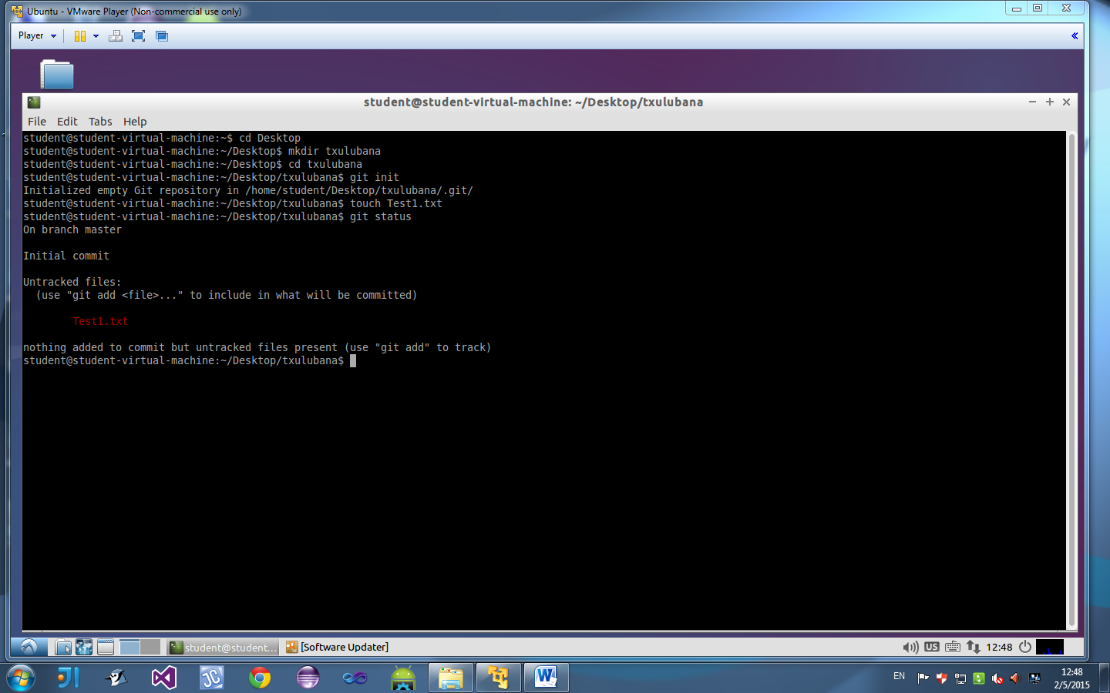

* Git init creates a new subdirectory named .git that contains necessary repository files
* Touch creates a new file, which in this case its “Test1.txt”, which is stored in .git
* Git status, in this case, displays the state that the “Test1.txt” file is in. Test1.txt shown in red font color because its untracked

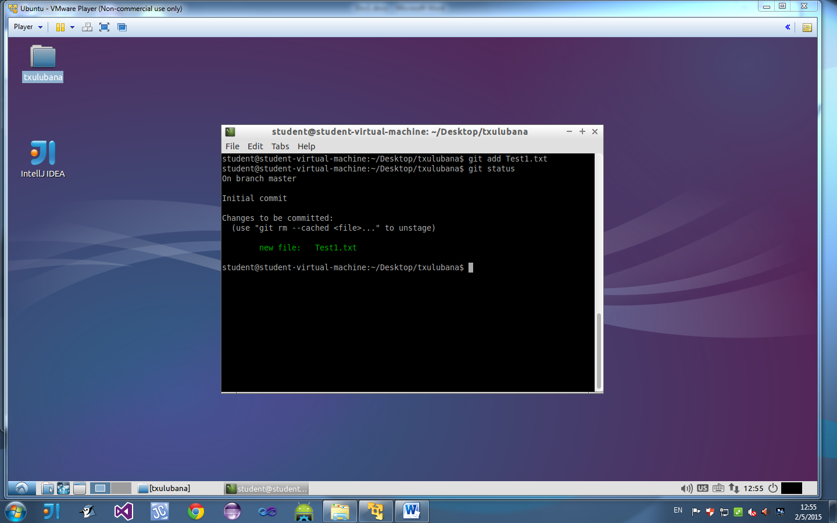

* Recently created file is tracked, using the git command “git add”
* Git status: Test1.txt is shown in green because now the file is being tracked

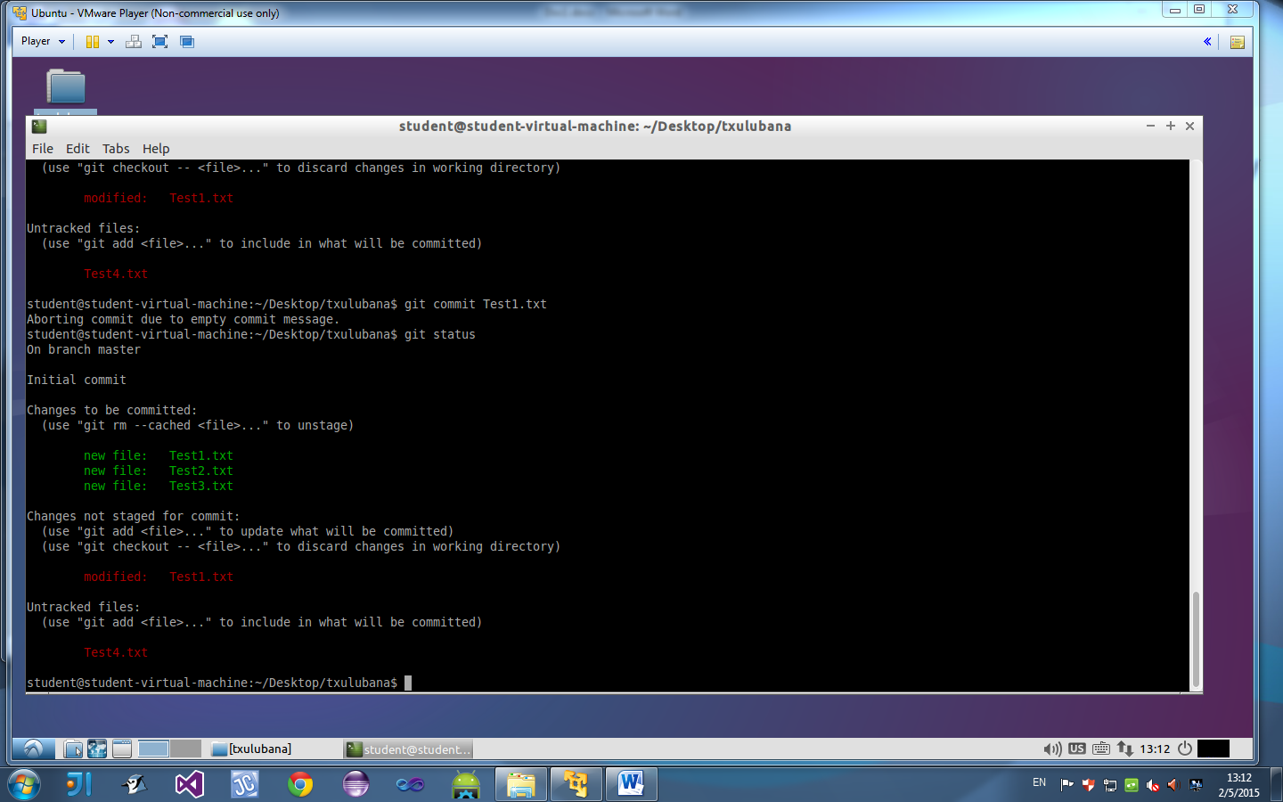

* Commit is aborted due to the fact that no message was saved and the status is still the same as before.

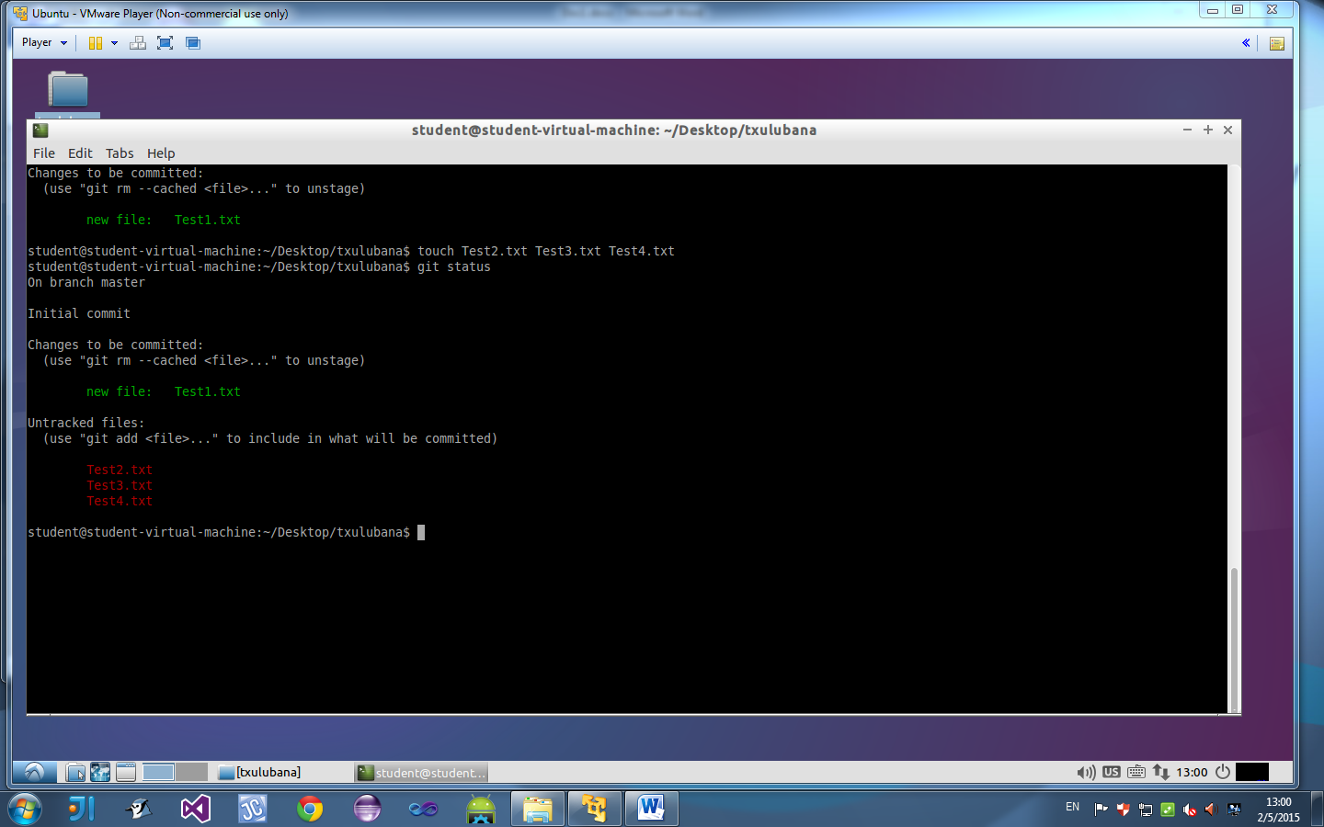

* Status shows three untracked files, which were recently created, and one tracked file. The three new files cant be committed, to commit them you need to track them first.

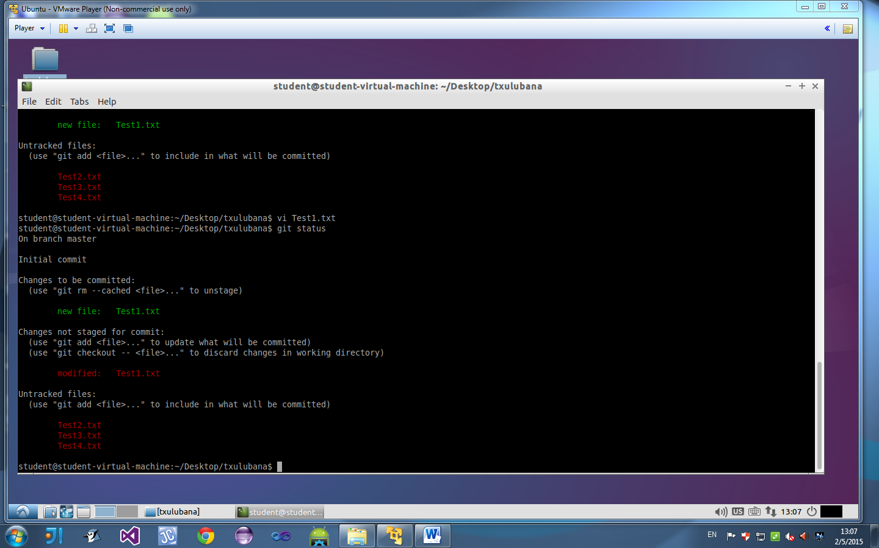

* Test1.txt is modified in vi. Status shows three untracked files, one tracked file and states which file has been modified. You are even given the command line you can use to undo the changes made in the modified file.

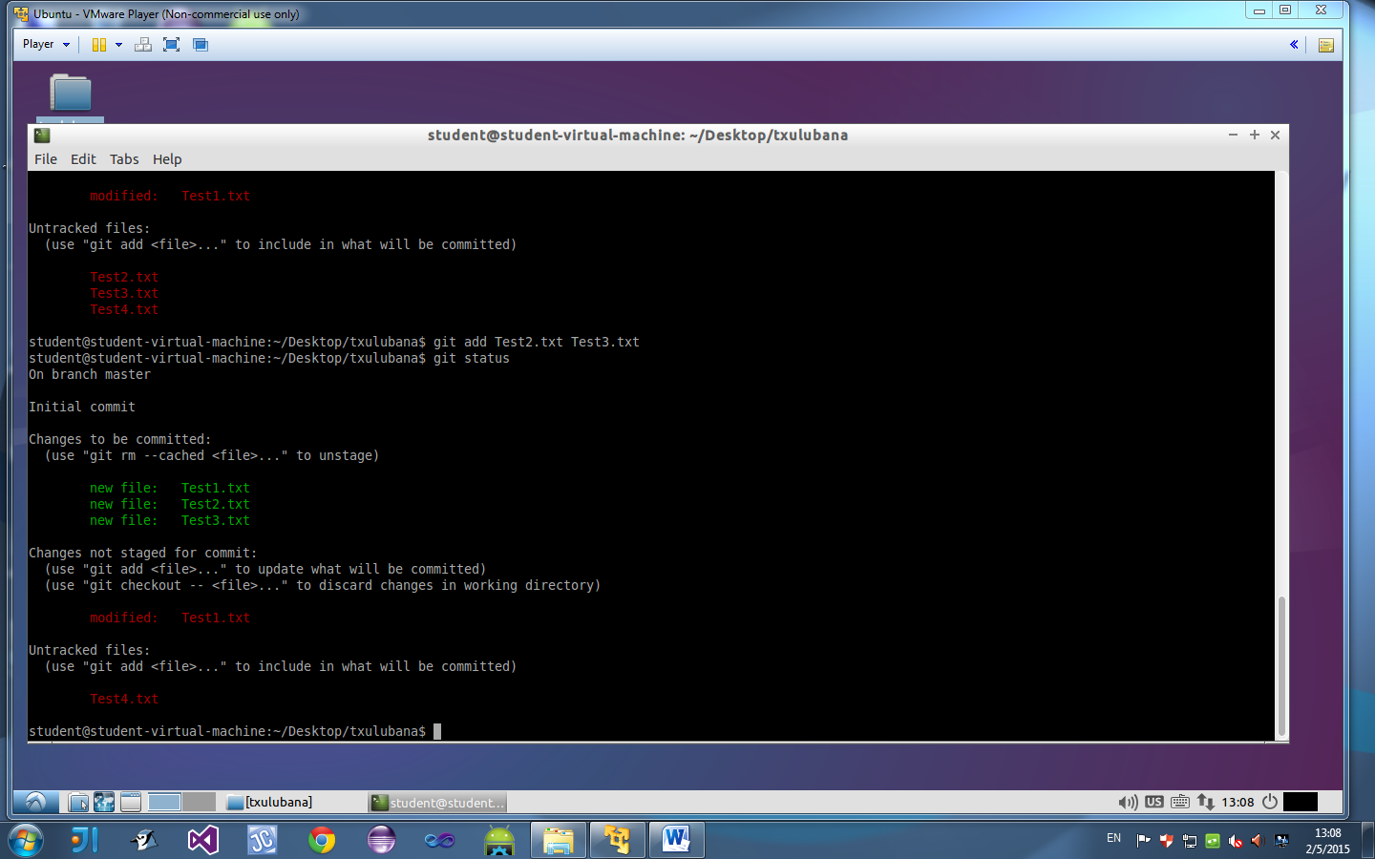

* Two of the three new files are tracked (shown in green font color), now we have three tracked files, one modified (shown in red font color) and one untracked file(shown in red font color).



* Status hasn’t changed, commit is aborted due to the fact that no message was written to it

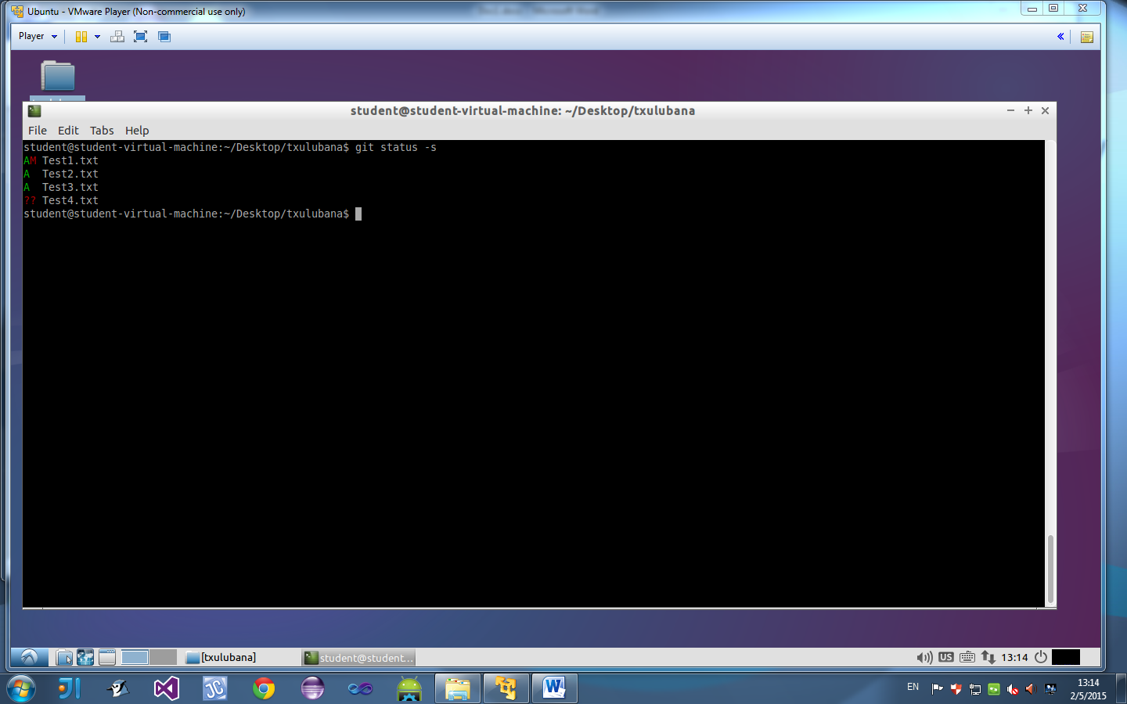

* Shows all the files created, first being the one that has been committed,followed by the other two that can be committed. The last one is the untracked file.
* A stands for added in index
* M stands for updated in index
* ?? means it is not tracked

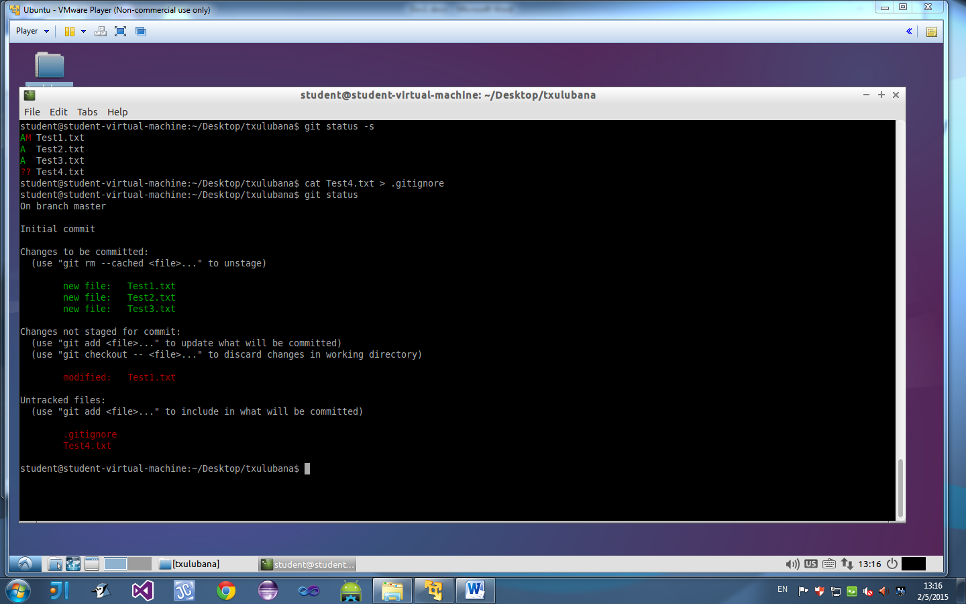

* An untracked .gitignore file is added. This is caused by the cat .gitignore command

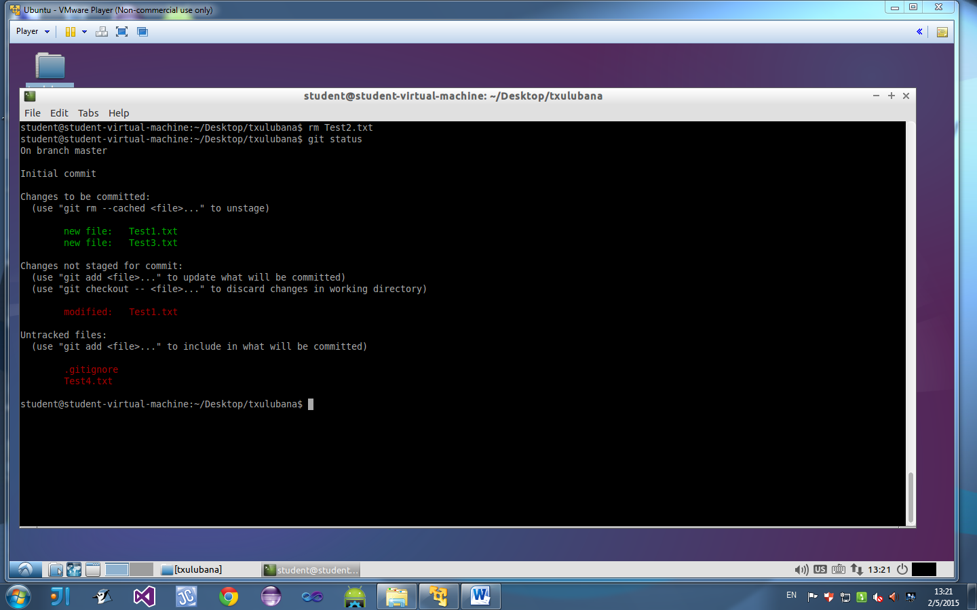

* Test2.txt is removed using the command “rm Test2.txt”, only two files are tracked now and is not displayed in the status

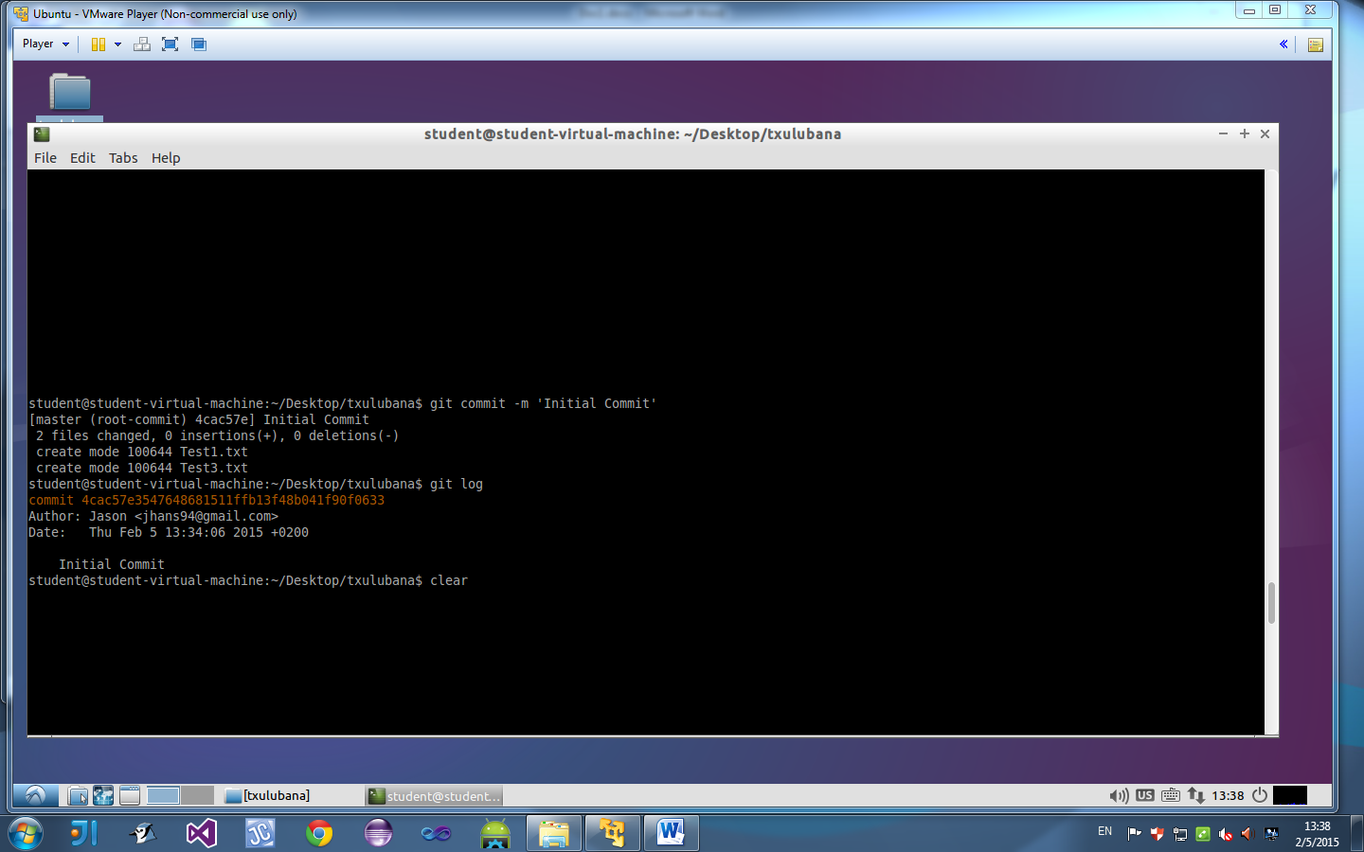

* Git log looks back at what you’ve done throughout your program and when the git log was done and by whom