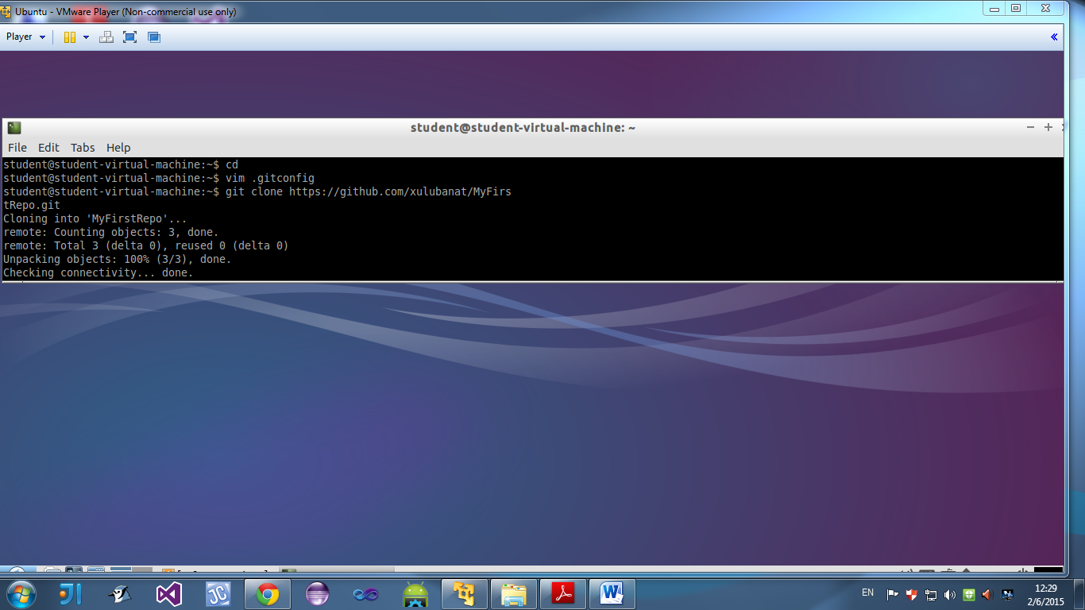

* Created repository and cloned it

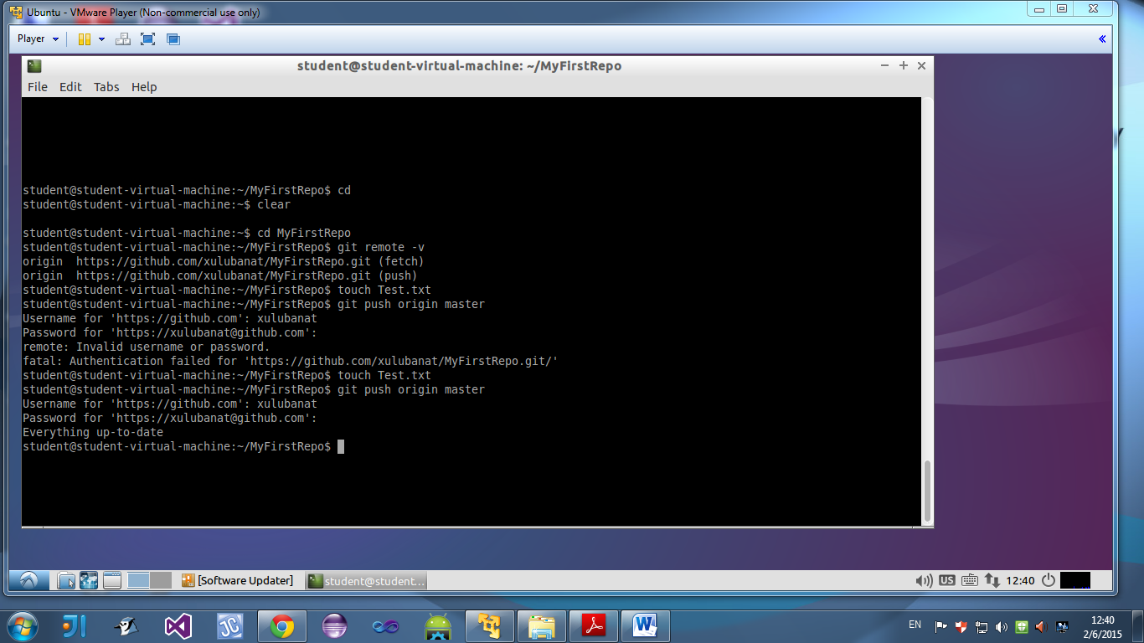

* Showing full remotes on local machine
* Created a file called “Test.txt”
* Pushed the file to GitHub and typed in my user details

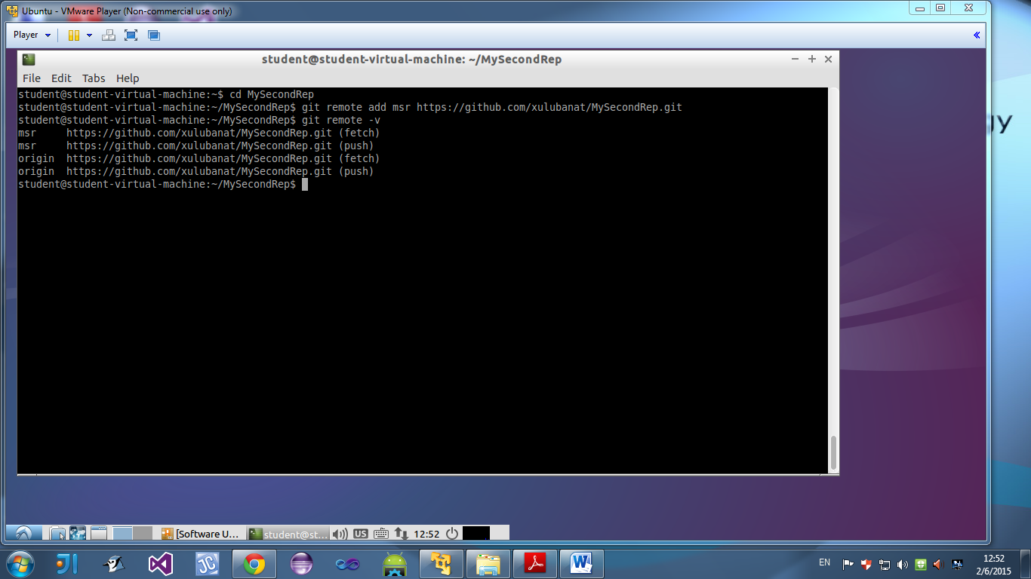

* Created git repo and added a remote
* Typed in command to output full remotes

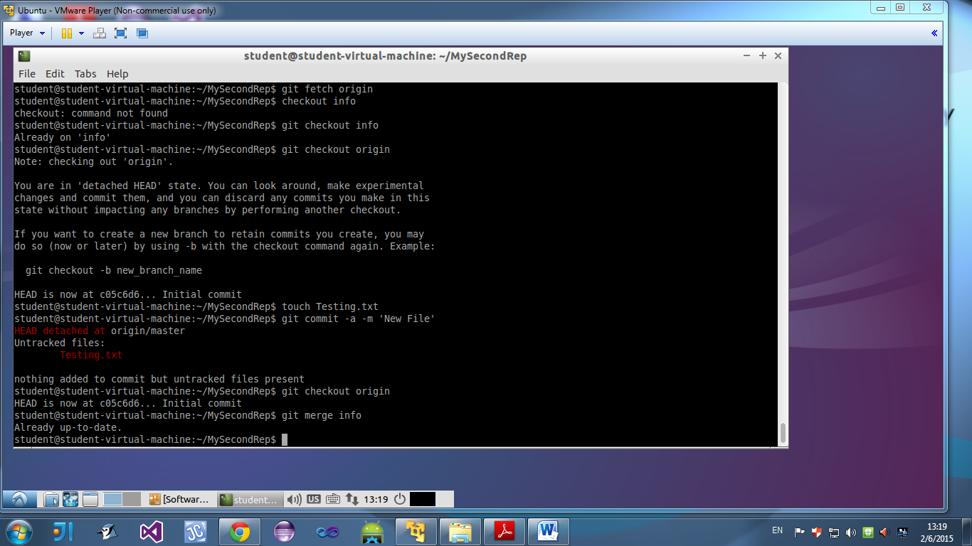

* Merged remote repository contents to origin

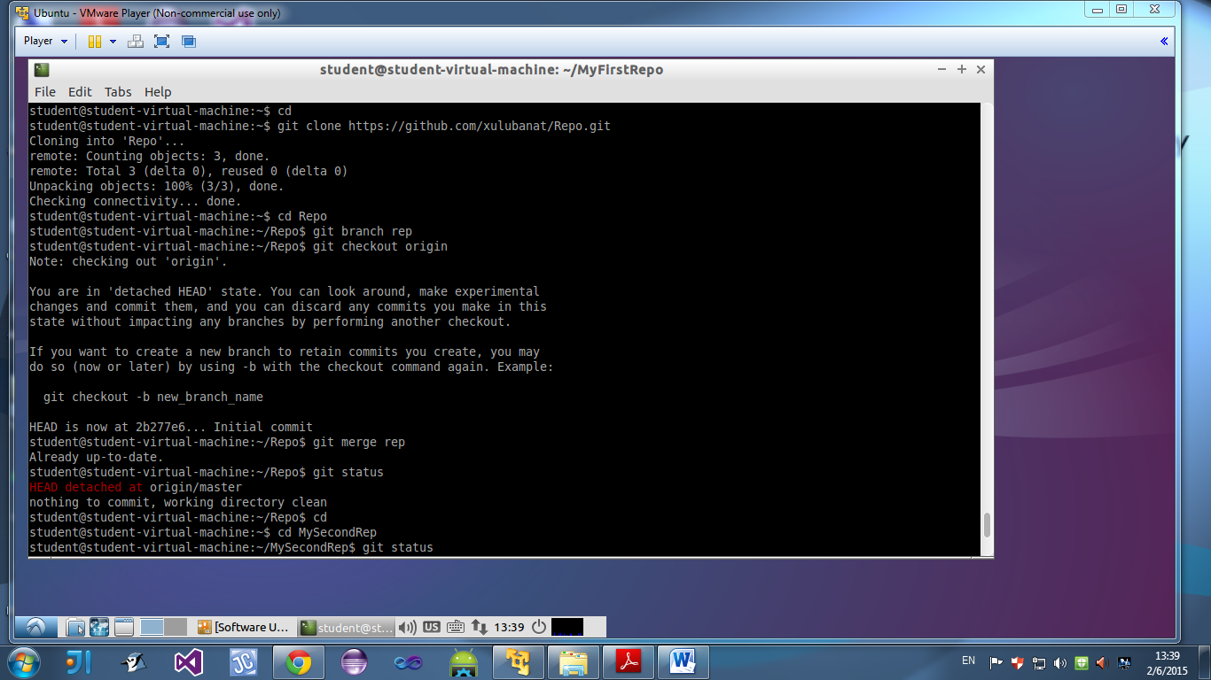

* Initialized new git repository and added another repo repository

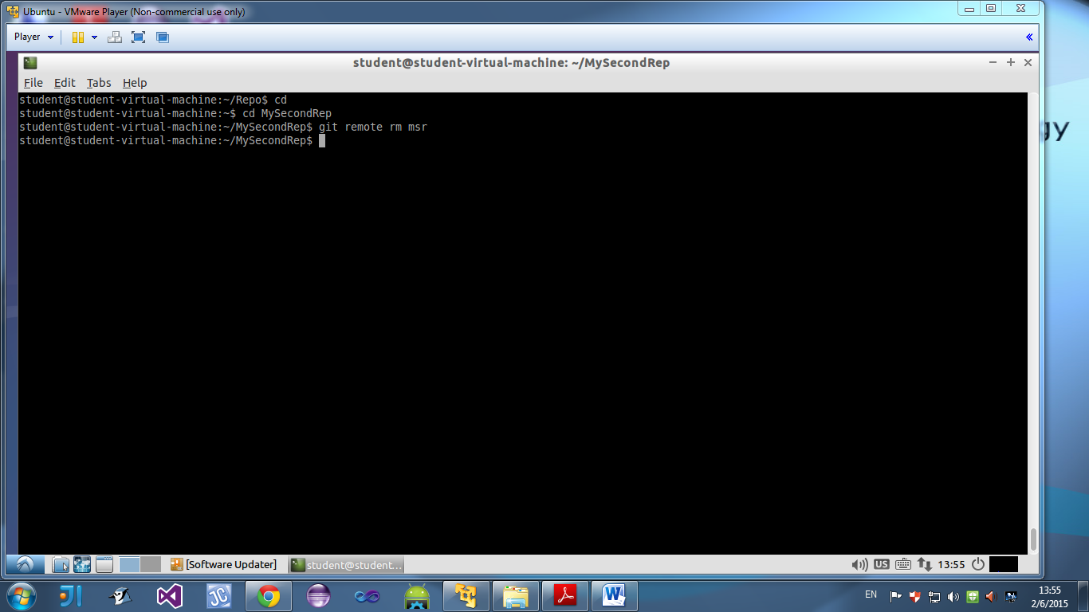

* Removed remote created in repository

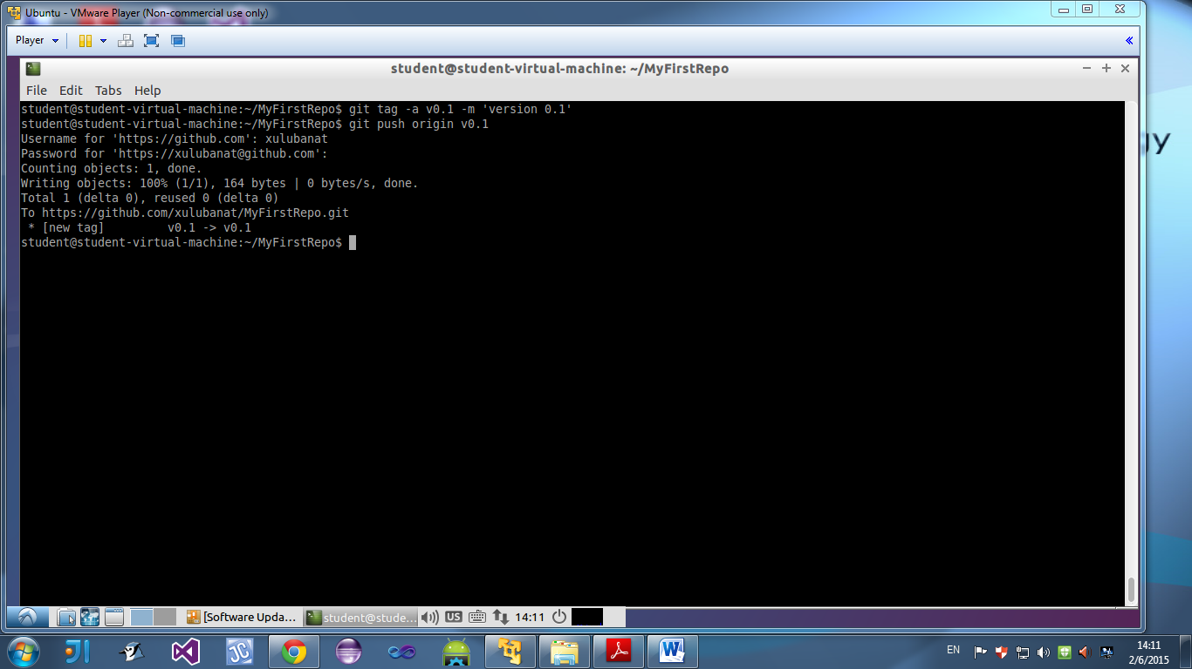

* Tagged repo with version number and committed them to gitHub