

|  |
| --- |
| Business Template  **Subject areas** |
| **Logo / Image** |

Contents

1 Business Description 3

1.1 Business background 3

1.2 Problems. Current Situation 3

1.3 The benefits of implementing a database. Project Vision 3

2 Model description 3

2.1 Definitions & Acronyms 3

2.2 Logical Scheme 3

2.3 Objects 3

# 

# Business Description

## Business background

## Problems. Current Situation

## the Benefits of implementing a database. Project Vision

# Model description

## Definitions & Acronyms

## Logical Scheme

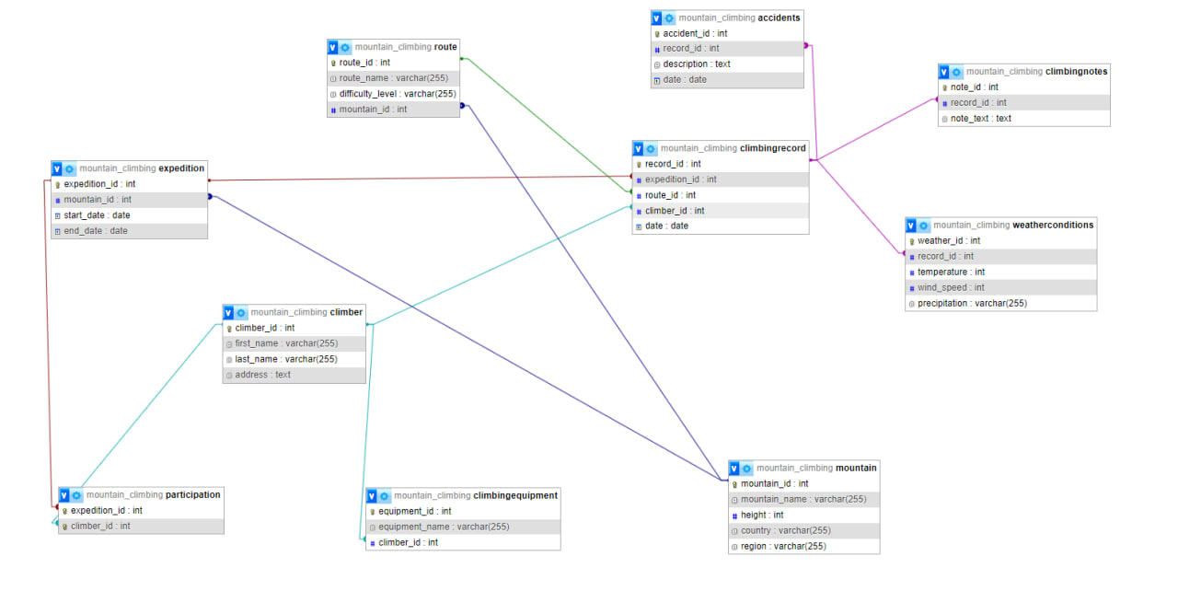

## Objects

Table Description

This table is named Mountains and contains information about mountains. It has the following columns:

mountain_id (INT, PRIMARY KEY): Unique identifier of the mountain.

name (VARCHAR(255)): Name of the mountain.

height (INT): Height of the mountain in meters.

country (VARCHAR(255)): Country where the mountain is located.

region (VARCHAR(255)): Region or area where the mountain is situated.

This table allows storing information about different mountains, their heights, locations, and belonging to specific countries or regions. The mountain_id column serves as the primary key for uniquely identifying each record in the table.

|  |  |  |  |
| --- | --- | --- | --- |
| Table Name | Field name | Field Description | Data Type |
| [mountain_climbing](http://localhost/phpmyadmin/index.php?route=/database/structure&db=mountain_climbing) | **Climber_id** | PK | Int |
| **First_name** | <description> | Var(255) |
|  | **Last_name** |  | Var(255) |
|  | **Address** |  | Var(255) |
|  | **record_ts** |  | DATETIME |

Comments on table relationships

Example with data

|  |  |  |  |  |
| --- | --- | --- | --- | --- |
| Climber_id | First_name | Last_name | Address | Record_id |
| 1 | John | Doe | 123 Main St | 2024-04-06 04:42:38 |