ALFA UNIVERSITY COLLEGE (AUC)
COMPLETE COMPANY PROFILE & FACT SHEET
Motto: "A Leader For All" | Subang Jaya, Selangor, Malaysia | MQA Ref: 211
1. General Overview & Corporate Fact Sheet
ALFA University College (shortened to AUC) is a private higher education institution located in Subang Jaya, Selangor, Malaysia. It started in the late 1990s as a small art and design academy and grew over the years into a full university college. Today, it runs more than 68 full-time programmes from Foundation and Diploma levels all the way up to Bachelor's, Master's, and PhD degrees, alongside technical skill certificates.
Field / Category | Official Details
Full Legal Name | ALFA University College (AUC)
Previous Names | Alif Creative Academy (started in 1998); ALFA International College / ALFA College (until 2021 upgrade)
Date of Establishment | Started in 1998 as Alif Creative Academy; owned by Nusantara Education Group since 2017
University College Upgrade | 2021 (Received University College status from the Ministry of Higher Education Malaysia / KPT)
MQA Registration Reference | IPTS Registration Reference No. 211
Quality Certifications | ISO International Quality Certification (since 2015) & Full MQA Accreditation
Main Campus Address | Lot 13, Persiaran Kewajipan, USJ 1, 47600 Subang Jaya, Selangor, Malaysia
Previous Campus Sites | Paramount Gardens, Petaling Jaya (from 1998); Subang Square SS15, Subang Jaya (until 2025 move to USJ 1)
Official Contact Details | Tel: +603-5631 9208 | Fax: +603-5631 9221 | Email: enquiry@alfa.edu.my
Official Website | https://alfa.edu.my/
Total Student Population | Approx. 3,276 students (67.8% Undergraduate, 32.2% Postgraduate)
International Students | Approx. 1,675 students from more than 40 countries
Staff & Faculty Headcount | Approx. 390 total academic/associated personnel (~80–100 core full-time campus staff)
Graduate Employment Rate | 95% reported employment rate within 6 months of graduation
2. Company History and Three Main Growth Phases
ALFA University College did not start out as a big university. Its history is divided into three clear phases that show how it changed from a specialized design school into a multidisciplinary university college:
- Phase 1: The Alif Creative Academy Era (Started in 1998): The college started in 1998 in Paramount Gardens, Petaling Jaya, under the name Alif Creative Academy. At the start, its main goal was simple: to give Malaysian students who loved art, graphic design, interior design, and architecture a practical place to study without paying massive tuition fees.
- Phase 2: The ALFA College & Nusantara Education Group Era (Up to 2021): The institution subsequently rebranded as ALFA College (also known as ALFA International College), operated out of Subang Square (SS15, Subang Jaya), and has been owned by Nusantara Education Group since 2017. During this period, management added new courses outside the art field, especially Early Childhood Education, Business Administration, and Accounting. In 2015, the college received its ISO international quality certification.
- Phase 3: The ALFA University College Era (2021 – Present): In 2021, Malaysia's Ministry of Higher Education (KPT) officially upgraded the institution to ALFA University College (AUC). Right after that, in 2022, AUC opened its Centre for Postgraduate Studies to run Master's and PhD programmes. In 2025, AUC moved its main operations from SS15 to a larger campus at Lot 13, Persiaran Kewajipan, USJ 1, Subang Jaya, Selangor, guided by its motto "A Leader For All".
3. Vision, Mission, Philosophy, and Core Values
ALFA builds its identity around accessible education and practical job skills. Below are the exact statements used by the institution:
- Educational Philosophy & Motto: "A Leader For All" and "Inspire. Innovate. Impact."
- Official Vision: "ALFA is a leading leader as a knowledge provider." In simple terms, the college wants to be a top choice for practical, career-focused education in Malaysia and the region.
- Official Mission: "ALFA provides a conducive educational affiliation with local and foreign universities in shaping Amazing Learning for Advancement."
- Shared Core Values (RAISE): The staff and students are guided by five values: Respect, Adaptability, Integrity, Service, and Empathy.
- Social & UN SDG Commitments: ALFA actively supports the United Nations Sustainable Development Goals, especially SDG 4 (Quality Education) and SDG 5 (Gender Equality). It also runs a Lifelong Learning Access Policy and financial aid initiatives for students coming from low-income families.
4. Leadership and Governance
ALFA University College is run by a Board of Governors and an executive management team made up of experienced Malaysian academics and administrators:
Position / Role | Name | Background & Key Responsibilities
Chairman | Prof. Dr. Shaharuddin Bin Mohd Satha | Long-serving Chairman who led the transition from ALFA College to ALFA University College and oversees strategic partnerships.
Managing Director / Chairman | Dr. Fairuz Bin Kamarulzaman | Oversees corporate governance, business operations, financial sustainability, and institutional growth.
Vice-Chancellor | Prof. Dr. Nurliza Haslin Binti Muslim | Holds a B.Sc. in Math & Economics (1987), Master's from UPM (1997), and Doctorate in Education from the University of Houston (2000). Over 35 years in education; joined ALFA in 2002 and previously served as Dean, Director of Quality, Director of APEL, and Deputy VC.
Board of Governors | Prof. Dr. Mohd Zambri Bin Jaafar  Prof. Datuk Dr. Yahya Bin Ibrahim  Prof. Dr. Mohamad Hanapi Mohamad | Senior academic advisors who monitor academic quality, MQA compliance, and long-term university policies.
Senior Academic Figures | Prof. Dr. Adenan Ayob  Prof. Azhar Bin Ahmad | Senior professors contributing to research, education, social sciences, and postgraduate supervision.
5. Organisational Structure: Schools and Centres
Academically, ALFA University College divides its courses across 7 specialized Schools and 4 Support Centres:
The 7 Academic Schools
- 1. School of Visual Communication: The oldest and most famous part of ALFA. Covers Graphic Design, Creative Multimedia, Animation, and Fine Arts.
- 2. School of Built Environment: Focuses on Architecture, Interior Architecture, Architectural Draughting, AutoCAD, and 3D Studio Max modeling.
- 3. School of Business, Management, Technology & Accounting: One of the largest faculties by student count. Runs Foundation in Business, BBA, Accounting, Finance, E-Business, HR Management, Retail, and MBA courses.
- 4. School of Education, Language & General Studies: Specializes in Early Childhood Education (a signature programme at ALFA), Teaching English as a Second Language (TESL), and general education studies.
- 5. School of Hospitality & Tourism Management: Runs hands-on courses in Culinary Arts, Hotel Management, Tourism Management, Event Management, and Bakery/Pastry skills.
- 6. School of Engineering (and Computing/IT): Handles Information Technology, Computer Science (Cyber Security and Networks), Artificial Intelligence (AI), and Engineering research.
- 7. School of Healthcare: A newer school offering Diploma in Pharmacy and Diploma in Healthcare Management.
The 4 Specialized Centres
- 1. Centre for Postgraduate Studies (School of Postgraduate): Established in 2022 to manage all Master's and PhD students, thesis supervision, and research defences.
- 2. Research Management Centre (RMC): Coordinates academic publications, conferences, and research grants.
- 3. APEL Center (Accreditation of Prior Experiential Learning): Allows working adults to use their real-life work experience to qualify for admission into Diploma, Degree, or Master's programmes even if they lack standard paper qualifications.
- 4. PILC Language Center: Runs intensive English language courses to help international students meet IELTS requirements before starting their main degree.
6. Complete Portfolio of Academic Programmes
ALFA University College offers over 68 full-time and Open Distance Learning (ODL) programmes. All academic courses are accredited by the Malaysian Qualifications Agency (MQA), while technical courses follow the Malaysian Skills Certificate (SKM/DKM) framework.
Study Level | Credits & Duration | Full List of Programmes Offered
Foundation Programmes | 50 Credits  (1 Year) | • Foundation in Business (MQA/FA15158)  • Foundation in Arts and Design (MQA/FA15205)  • Foundation in Information and Technology
Certificates & TVET Skills (SKM / DKM) | 60 Credits  (1 – 1.5 Years) | • Certificate in Art and Design (MQA/FA1071)  • Certificate in Early Childhood Education (MQA/FA1554)  • Certificate in Architecture Draughting (MQA/FA3366)  • SKM & DKM Skills: Culinary Arts, Pastry & Bakery, Bread Making, Information Management Systems
Diploma Programmes | 90 – 95 Credits  (2 – 3 Years) | • Business & Admin: Diploma in Business Administration (MQA/FA8031), Diploma in Accountancy (MQA/FA8465), Diploma in E-Business, Diploma in Retail Management, Diploma in Law Enforcement Management (MQA/FA15207)  • Creative & Built Environment: Diploma in Graphic Design (A5775), Diploma in Multimedia Design (A5933), Diploma in Architecture (A7672), Diploma in Interior Architecture (A7673)  • Computing: Diploma in Information Technology (MQA/FA13793)  • Hospitality & Tourism: Diploma in Culinary Arts (MQA/FA14848), Diploma in Hotel Management, Diploma in Tourism Management (MQA/FA12167), Diploma in Event Management (MQA/FA13342)  • Education & Healthcare: Diploma in Early Childhood Education (A9699), Diploma in TESL (MQA/FA15787), Diploma in Pharmacy, Diploma in Healthcare Management
Bachelor's Degrees (Honours) | 120 – 123 Credits  (3 Years) | • Business: Bachelor of Arts (Hons) in Business Administration (Full-Time & ODL) (MQA/FA14724), Bachelor of Accounting and Finance, Bachelor of E-Business (Hons), Bachelor of Human Resource Management (Hons), Bachelor of Law Enforcement  • Design & Architecture: Bachelor of Arts (Hons) in Graphic Design (MQA/FA14849), Bachelor of Arts (Hons) in Creative Multimedia (MQA/FA14850), Bachelor of Science (Hons) in Architecture  • Tech & IT: Bachelor of Information Technology (Hons) (MQA/FA14725), Bachelor of Computer Science (Cyber Security and Networks), Bachelor in Artificial Intelligence (AI)  • Education & Hospitality: Bachelor of Early Childhood Education (Hons), Bachelor of Science (Hons) in Hospitality Management (MQA/FA14957)
Master's Degrees | 40 – 43 Credits  (1 – 2 Years) | • Business & Management: Master of Business Administration (MBA) (MQA/FA14726), MBA in International Business, MBA in Oil and Gas Management, Master of Project Management, Master in Supply Chain Management, MSc in Management (By Research)  • Tech & Engineering: Master in Information Technology (MIT) (MQA/FA16152), MPhil in Engineering (By Research)  • Education & Arts: Master of Education in TESL (By Research), Master of Early Childhood Education (By Research), Master of Arts and Design (By Research), Master of Music (By Research)
Doctoral Degrees (PhD) | Research Thesis  (3+ Years) | • Doctor of Philosophy (PhD) in Management (MQA/FA15094)  • PhD in Business Administration  • PhD in Information Technology  • PhD in Education  • PhD in Social Sciences  • PhD in Performing Arts
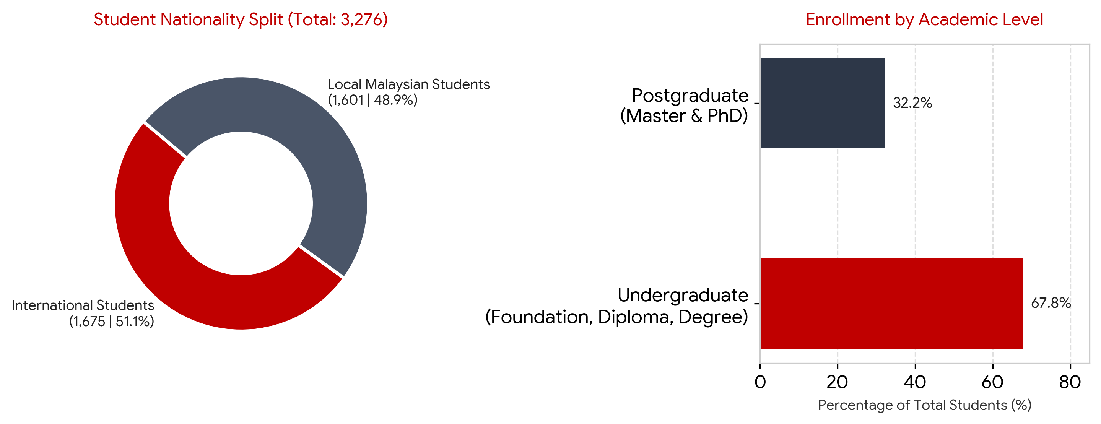
Figure 1: ALFA University College Student Demographics and Study Level Split.
7. Rankings, Accreditations, and Global Partnerships
- Times Higher Education (THE) Ranking: In the 2024 Times Higher Education Impact Rankings, ALFA University College was recognized among the Top 5 Private Universities in Malaysia and Top 13 Overall Universities in Malaysia for SDG 4 (Quality Education). Note: AUC does not hold an overall global position in the main QS World University Rankings, as it is a specialized boutique university college.
- Professional Body Recognition: Courses at ALFA are recognized by the Malaysian Qualifications Agency (MQA), the Board of Architects Malaysia (LAM), Cambridge Assessment, PILC, and the Emirates International Accreditation Centre.
- International Ministry Recognition: AUC is officially listed on the certification list of the Chinese Service Center for Scholarly Exchange (CSCSE) under the Ministry of Education of China, making it popular with Chinese postgraduate students.
- Central Asia & Global Ties: ALFA has built strong international links with Uzbekistan and other Central Asian countries (hosting official Embassy of Uzbekistan delegations on campus and offering up to 50%–100% partial/merit scholarships for eligible Central Asian students), Indonesia (MoU with Universitas Muslim Indonesia), and African/Middle Eastern institutions (such as the University of Dhalanj).
8. Campus Location, Transport Access, and Student Facilities
In 2025, ALFA relocated from its older building in Subang Square (SS15) to a bigger standalone campus at Lot 13, Persiaran Kewajipan, USJ 1, 47600 Subang Jaya, Selangor. This area is known as Malaysia's main higher education hub (near Sunway University, Taylor's, INTI, and Monash) and is about 15–20 minutes away from Kuala Lumpur.
- Road & Public Transport Access: Students can reach the campus easily via major highways (LDP, NPE, Federal Highway, and KESAS). By public transport, the closest train station is the USJ 7 LRT Station (on the Kelana Jaya Line) and the BRT Sunway Line, with feeder buses stopping right along Persiaran Kewajipan.
- 4 Apple iMac Computer Labs: Equipped with Apple iMacs and specialist software like AutoCAD, 3D Studio Max, Adobe Creative Cloud, and programming tools for design, architecture, and IT students.
- Specialized Studios & The ALFA Kitchen: Includes art and architecture drafting studios, plus a commercial-grade culinary training facility called the ALFA Kitchen for Culinary Arts, Bakery, and Hospitality students.
- Library & Open Educational Resources (OER): A physical campus library combined with digital study notes, recorded lectures, and research databases.
- Student Life & Support Spaces: Includes a Theatre Room for large seminars and guest talks, a Student Lounge for relaxing between classes, counselling and mental health support services, and an International Student Office that helps foreign students with EMGS visa processing and finding safe off-campus apartments or hostels nearby.
9. Admissions, Intakes, Fees, and Scholarships
- Intake Months: ALFA runs multiple intakes throughout the year, with the main intakes in January, May, and September. The September (Fall) intake is the largest and most popular among international students.
- English Entry Requirements (International): Diploma programmes require IELTS 5.0 (or equivalent); Bachelor's degrees require IELTS 5.5; Master's and PhD programmes require IELTS 6.0. Students without IELTS can take English placement classes at ALFA's PILC Language Center.
- Tuition Fees: ALFA positions itself as an affordable private university. Average annual tuition fees range between USD $2,500 and USD $3,800 (roughly RM 11,000 to RM 16,500 per year depending on the course), which is much lower than larger private universities in Subang Jaya.
- Financial Assistance: Malaysian students can apply for PTPTN study loans, Bank Rakyat education financing, or EPF withdrawals. International students have access to partial tuition fee waivers and special regional scholarship programmes.
10. Current Management Situation & Internal Challenges (FIB 2074 Focus)
Even though ALFA University College has strong academic accreditation, a new USJ 1 campus, and over 3,200 students, its internal management and marketing systems have not caught up with its fast growth. For our FIB 2074 Management Plan, two major operational problems stand out:
- Problem 1: High Cost of External Recruitment Agents & Weak Social Media: Because more than half of ALFA's students (1,675 out of 3,276) are international, the university relies heavily on 10 to 15 main university recruitment agents. Each of these main agents hires 5 to 10 sub-agents from smaller consulting agencies. When a student pays an average annual tuition fee of $2,500 USD, the consulting sub-agent takes 10% ($250) and the main university agent takes around 5% ($125). That means ALFA loses 15% ($375 per student) every year just on agent commissions. Meanwhile, ALFA's own social media accounts (such as Instagram and Facebook @AlfaUniversity.Official, which has around 16,000 followers on Facebook but very low engagement and outdated posts) are poorly managed, even though the college already pays staff for marketing. Because their digital marketing is weak, almost no students apply directly online.
- Problem 2: Paper-Based Bureaucracy & Lack of a Unified Digital Platform (CRM/ERM/HRM): Inside the campus, day-to-day administration for the 80–100 core staff and 3,276 students still relies heavily on slow, traditional paper forms and disconnected spreadsheets. There is no single unified platform connecting Human Resource Management (HRM), Enterprise Resource Management (ERM), and Customer Relationship Management (CRM). Because of this bureaucracy, processing student applications, visa paperwork, and academic records takes too much time. It also blocks the marketing team: even if a student sees an Instagram ad and wants to apply directly, there is no automated CRM portal to collect their documents, answer questions quickly, and track their enrollment.
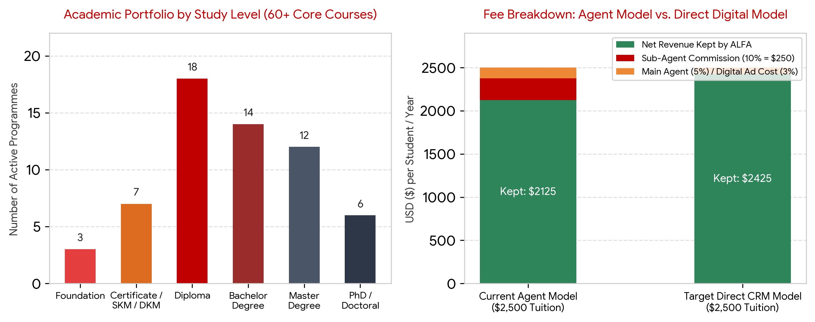
Figure 2: ALFA Programme Distribution (Left) and Tuition Fee Commission Loss vs. Target Direct CRM Model (Right).

