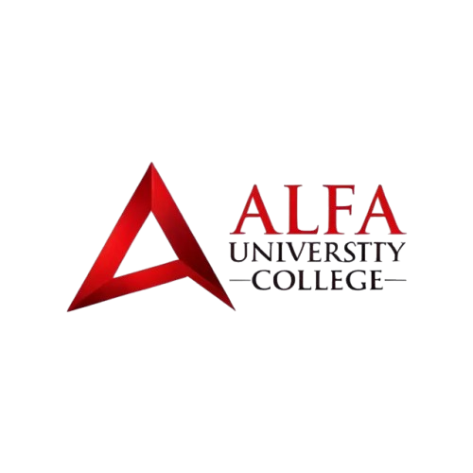
ALFA UNIVERSITY COLLEGE
Foundation in Business
FIB 2074 – INTRODUCTION TO MANAGEMENT
FINAL GROUP PROJECT (50 MARKS)
“DESIGN A MANAGEMENT PLAN FOR ALFA UNIVERSITY COLLEGE”
Group number / name: Group [Insert Group No.] – ALFA Management Team
Course name: Introduction to Management
Course code: FIB 2074
Lecturer: Dr. Paul
Submission Date: November 2026
Academic Year: 2026 / 2027
GROUP MEMBERS
No. | Full name | Student ID
1 | Member 1 (Part 1: Business Concept, Problems & Theories) | [Student ID]
2 | Member 2 (Part 2: Management Design 1 – Planning) | [Student ID]
3 | Member 3 (Part 3: Management Design 2 – Organising) | [Student ID]
4 | Member 4 (Part 4: Management Design 3 – Leading) | [Student ID]
5 | Member 5 (Part 5: Management Design 4 – Controlling) | [Student ID]
6 | Member 6 (Part 6: Leadership, Communication & Motivation) | [Student ID]
7 | Member 7 (Part 7: Integrated POLC, Recommendations & Conclusion) | [Student ID]
Groups have 5 to 7 members. Leave unused rows empty.
Submitted in partial fulfilment of course requirements

Table of Contents
Section | Project Title & Management Focus | Marks | Page No.
Section 1 | Business Concept and Management Situation (ALFA University College) | 4 Marks | Page 4
Section 2 | Application of Management Theories (Classical, Behavioural & Contingency) | 4 Marks | Page 7
Section 3 | Management Design 1: Planning the Business (Goals, SMART Objectives & Action Plan) | 6 Marks | Page 9
Section 4 | Management Design 2: Organising the Business (Structure, Authority & Span of Control) | 7 Marks | Page 13
Section 5 | Management Design 3: Leading the Business (Guidance, Power, Influence & Case) | 6 Marks | Page 16
Section 6 | Management Design 4: Controlling Business Performance (4 Steps & 5 Control Areas) | 7 Marks | Page 19
Section 7 | People Management: Leadership, Communication and Motivation | 7 Marks | Page 22
Section 8 | Integrated Management Solution and Recommendations (Connecting POLC) | 4 Marks | Page 24
Section 9 | Conclusion (Quality of Application & Presentation) | 5 Marks | Page 26
Section 10 | Academic References (APA 7th Edition) | Required | Page 27
Appendix A | Unified Financial Model: Agent Commissions vs. Direct Digital Plan | Supporting Data | Page 28

1. Business Concept and Management Situation
1.1 Overview of ALFA University College (AUC)
In this project, our group acts as the management team for ALFA University College (AUC), a private higher education institution in USJ 1, Subang Jaya, Selangor, Malaysia (ALFA University College, 2026a). The college started in 1998 as Alif Creative Academy, has been owned by Nusantara Education Group since 2017, and received university college status in 2021 (ALFA University College, 2026a; Times Higher Education, 2024). Guided by its motto "A Leader For All" and led by Chairman Dr. Shaharuddin Bin Mohd Satha and Vice-Chancellor Professor Dr. Nurliza Binti Musllim, AUC coordinates its budget, 120 full-time staff (assumption), classrooms, and student recruitment across 68 accredited programmes (Table 1).
Business Element | Operational Details for ALFA University College
Business Name & Motto | ALFA University College (AUC) – Private Higher Education Institution; Motto: "A Leader For All" (Verified: alfa.edu.my & THE).
Founding & Ownership | Started in 1998 as Alif Creative Academy; owned by Nusantara Education Group since 2017; received university college status in 2021 (Verified: alfa.edu.my & THE).
Operating Location | Lot 13, Persiaran Kewajipan, USJ 1, 47600 Subang Jaya, Selangor, Malaysia (Verified: alfa.edu.my).
Products & Services | 68 MQA-accredited full-time and Open Distance Learning (ODL) programmes across 7 Schools (Visual Communication; Business, Management, Technology & Accounting; Education, Language & General Studies; Hospitality & Tourism; Engineering; Healthcare; Built Environment) and 4 Centres (Postgraduate, Research, APEL, PILC Language Center), covering SKM, Foundation, Diploma, Bachelor's, Master's, and PhD levels (ALFA University College, 2026b).
Target Customers | 1) Malaysian high school graduates (SPM/STPM/IGCSE leavers); 2) International students from 40+ countries paying an average first-year tuition fee of $2,500 USD/year across 400 new students/year ($1,000,000 USD gross tuition; assumption); 3) Working adults via APEL and ODL (ALFA University College, 2026c).
Number of Employees | 120 full-time staff (assumption): 5 Top-Level executives/assistants, 65 Academic Affairs staff, 20 Digital Marketing & Recruitment staff, 12 IT & System staff, and 18 Registry, Finance & HR staff.
1.2 Two Major Management Challenges Facing Our Team
Based on our daily observations as ALFA students and our management audit, the university college faces two connected challenges that drain tuition revenue and slow down campus administration:
Challenge 1: 100% Agent Dependency ($150,000 Annual Commission Drain) and Inactive Social Media. Today, 100% of ALFA's 400 annual new students come through external recruitment agents, while 0% (0 students) apply directly online. There is no other channel today. ALFA works with 12 university (master) agents (10–15 range), and each master agent hires 8 consultancy sub-agents (5–10 range, or 96 sub-agents in total). On a $2,500 USD first-year fee, the sub-agent receives 10% ($250 USD) and the master agent receives 5% ($125 USD, our assumption), costing 15% ($375 USD) per student and leaving ALFA $2,125 USD (85.0%). Across 400 students, sub-agent fees cost $100,000 USD/year (400 × $250) and master-agent fees cost $50,000 USD/year (400 × $125, our assumption), totalling $150,000 USD a year (15% of the $1,000,000 USD gross first-year tuition), or $160,000 USD/year ($400.00/student) including $10,000 USD of existing low-impact marketing spend (our assumption).
Why does ALFA lose $150,000 a year in agent commissions while already paying salaries for a 20-person marketing team? Because ALFA's social media accounts are poorly run and generate zero direct enrolments. Although ALFA holds an official Instagram page (@alfauniversity.official with ~2,100 followers), a separate Design School Instagram page (@alfauniversitymy with ~1,100 followers), a Facebook page (@AlfaUniversity.Official with ~16,000 followers), plus TikTok and YouTube channels, posts are irregular, static, and lack helpful details on tuition fees, hostels, or direct application steps (ALFA University College, 2026d, 2026e). Prospective students receive slow replies and rely on external consulting sub-agents instead.
Challenge 2: Paper-Based Bureaucracy During Studies and an Underdeveloped "MyClass" Portal. The second challenge is paper-based bureaucracy across student and staff operations. On ALFA's website, the "MyClass" student portal is used only at semester end to download a static PDF of final exam grades; course registration, subject add/drop, live coursework marks, daily attendance, calendars, and online fee clearance are not built. Every semester, students spend 5 to 7 working days walking between offices collecting 3 to 4 physical signatures and ink stamps (Lecturer, Coordinator, Finance counter, Registry) to register for subjects, submit add/drop forms, get paper exam slips stamped with bank receipts, or request official letters. Lost exam slips bar students from exams, lecturers use paper attendance sheets, and clerks carry paper folders between offices. Without a unified cloud Customer Relationship Management (CRM), Enterprise Resource Management (ERP/ERM), and Human Resource Management (HRM) platform, social media leads cannot upload documents or enrol online without an agent.
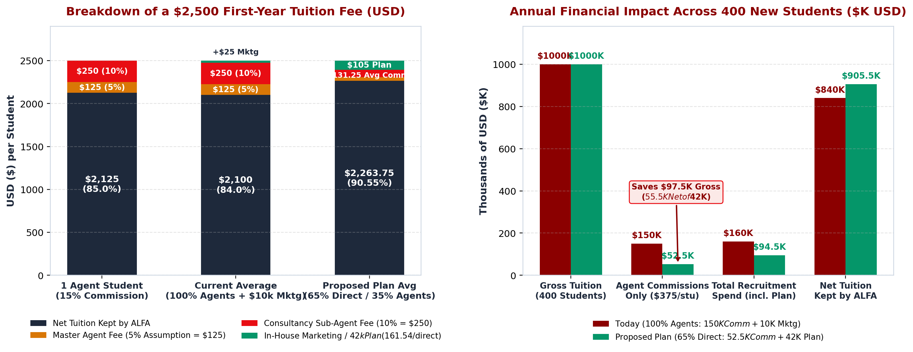
Figure 1: Breakdown of $2,500 First-Year Tuition Fee (Left) and Annual Financial Comparison Across 400 New Students ($150,000 Commissions / $160,000 Total Today vs. $94,500 Proposed Plan) (Right).
2. Application of Management Theories
Our management team applies Classical, Behavioural, and Contingency Theory from Lecture 2 (Dr. Paul, 2026; Fayol, 1949; Robbins & Coulter, 2021) to solve ALFA's agent dependency and paper bureaucracy together.
2.1 Applying Classical Theory (Work Structure, Standardisation, and Efficiency)
• Standardising In-Study Academic & Administrative Workflows: To eliminate the 5-to-7-day paper stamp chase, we upgrade the static MyClass page into "ALFA OneHub" (combining CRM, ERP, and HRM) and enforce a strict 4-step, 24-Hour Digital Student Service Standard Operating Procedure (SOP): (1) 1-click online submission of course registration, add/drop, or letter requests on ALFA OneHub; (2) automated real-time Finance fee and prerequisite check; (3) digital Programme Coordinator approval within 12 hours; and (4) automated digital timetable, letter, and QR exam-pass update within 24 hours.
• Clear Division of Work in Marketing: Applying the fast-food division of work model from Lecture 2 (Dr. Paul, 2026), we divide our 20-person Digital Marketing and Recruitment department into three specialised units under one Marketing Director: (a) 6 Short-Form Video Creators (producing 5 weekly Reels, TikToks, and YouTube Shorts), (b) 6 Direct CRM Admissions Counselors (answering student messages within 2 hours and guiding online onboarding), and (c) 4 Master Agent Auditors (monitoring the 12 master agents and enforcing our First Digital Timestamp Rule so direct leads never pay agent commissions).
2.2 Applying Behavioural Theory (Staff Involvement and $50 Direct Bonus)
• Involving and Supporting Staff ("Restaurant B" Approach): Following the supportive "Restaurant B" approach from Lecture 2 rather than criticizing mistakes like "Restaurant A" (Dr. Paul, 2026), our managers consult lecturers and senior registry clerks before launching ALFA OneHub in Month 6 so the digital screens remove their biggest daily headaches—such as replacing paper attendance sheets with a 30-second classroom QR scan.
• Fair Extrinsic Rewards for the In-House Marketing Team: Previously, external agents received $375 per student while ALFA's own marketing staff received only a fixed salary. Applying Behavioural Theory, we introduce a $50 USD per-student Direct Enrolment Team Bonus for our marketing and CRM staff across all 260 target direct online enrolments (260 × $50 = $13,000 USD/year budgeted inside our $42,000 plan), boosting morale and teamwork.
2.3 Applying Contingency Theory (Situational Training and Channel Mix)
• Situation A vs. Situation B in Staff Digital Training: Matching the "New vs. Experienced Employee" rule in Lecture 2 (Dr. Paul, 2026), our 120 staff have different levels of digital readiness. For young video creators and IT specialists (Experienced with digital tools), managers grant creative autonomy to test new video hooks. For senior registry clerks who have used paper stamps for over 10 years (New to cloud ERP software), managers provide step-by-step laminated guides, a safe sandbox practice mode, and patient 1-on-1 buddy coaching.
• Adapting Recruitment Channels by Market Segment: Instead of keeping 100% agent reliance or recklessly firing all agents overnight, we match recruitment channels to market conditions. In digital-first student markets where applicants use Instagram, TikTok, and WhatsApp daily (Malaysia, Indonesia, Central Asia), we shift to 65% direct online recruitment (260 students at $0 commission). In complex visa markets requiring local document notarisation (35% or 140 students), we retain audited master-agent referrals at the 15% ($375) commission rate while saving $97,500 per year across the 260 direct students.
3. Management Design 1: Planning the Business
Following the Robbins and Coulter Three-Step Framework (Step 1: Define Goals; Step 2: Establish Strategy; Step 3: Develop Plans) and the Six Steps to Plan Effectively from Lecture 3 (Dr. Paul, 2026; Robbins & Coulter, 2021), our team designed a 12-month transformation plan for ALFA University College.
3.1 Overall Organisational Goal and Specific SMART Objectives
Overall Organisational Goal (Broad 12-Month Destination)
To transform ALFA University College over the next 12 months from a 100% agent-dependent, paper-bound college into a modern digital campus that attracts 65% of new students directly through active social media marketing and replaces in-study paper bureaucracy with the unified ALFA OneHub cloud platform.
To achieve this broad destination across ALFA's three annual intake cycles (Academic Year 2026/2027), Table 2 sets four specific objectives, including three SMART Objectives (full mathematical derivations appear in Appendix A):
Objective Category | Target & SMART Breakdown
Objective 1 (SMART – Direct Enrolment & Commission Cut) | Specific & Measurable: Shift recruitment from 0% direct / 100% agents (400 stu) to 65% direct online (260 stu) and 35% agents (140 stu), cutting agent commissions from $150,000/yr to $52,500/yr—saving $97,500/yr gross and $55,500/yr net of the $42,000 budget ($65,500/yr saved vs. $160,000 baseline).  Attainable, Relevant & Time-Bound: Funded by $42,000 ($161.54/direct student; $236.25/student blended); reach 40% direct by M6 and 65% direct by M12.
Objective 2 (SMART – Social Media Funnel & Lead Speed) | Specific & Measurable: Post 5 Reels/TikToks weekly via 6 creators and 8 student ambassadors; grow @alfauniversity.official from 2,100 to 20,000 followers; generate >= 150 inquiries/month with <= 2-hour CRM reply speed.  Attainable, Relevant & Time-Bound: Backed by $12,000/yr Meta/TikTok ads and $4,000 studio; hit 9,500 followers by M6 and 20,000 by M12.
Objective 3 (SMART – Upgrade MyClass to ALFA OneHub) | Specific & Measurable: Upgrade MyClass into cloud ALFA OneHub (CRM, ERP, HRM), cutting student service wait times (course reg, exam slips, letters) from 5–7 days on paper to < 24 hours and cutting paper use by 90%.  Attainable, Relevant & Time-Bound: Built by 12 IT staff on a $9,500 SaaS upgrade; launch in M6 and reach 100% paperless workflows by M8.
Objective 4 (Operational – 120-Staff Certification) | Train all 120 employees across the 4 divisions between Months 5 and 8 so >= 95% pass the ALFA OneHub practical test by Month 8.
3.2 Strategy, Types of Plans, and Backup Contingency Plans
Under Step 2 of the Robbins and Coulter framework, our team implements a "Direct Digital Funnel & MyClass-to-OneHub Upgrade Strategy". Every direct social media inquiry is automatically logged and timestamped inside ALFA OneHub CRM ("First Digital Timestamp Rule") so external agents cannot claim the $375 (15%) commission on students who contacted ALFA online first. As taught in Lecture 3 (Dr. Paul, 2026), we align four types of plans:
• Strategic Plan (Long-Term, Directional, 1–3 Years): Set by Top Management to shift ALFA from 100% agent reliance and paper files to 65% direct digital intake and 100% paperless campus workflows within 12 months.
• Tactical Plans (Medium-Term, Departmental, 3–6 Months): Created by Middle Managers, including the Marketing Director's student ambassador campaign, the IT Manager's 4-month upgrade of MyClass into ALFA OneHub (Months 3–6), and the Operations Manager's staff training rollout (Months 5–8).
• Operational Plans (Short-Term, Specific, Daily/Weekly): Enforced by First-Line Leads, such as filming 5 Reels/TikToks per week, answering student messages within 2 hours, and processing in-study course add/drop and letter requests within 24 hours.
• Contingency Plans (Backup Plans for Unexpected Problems): To keep our plan flexible ("a rigid plan breaks; a flexible plan bends") (Dr. Paul, 2026), we establish two backup rules: First, if direct online enrolment is below 30% at Month 6, we reallocate $3,000 from low-performing ad sets within our $12,000 ad budget to offer a $100 Early-Bird Direct Online Registration Rebate for the next 30 direct applicants (keeping total spend at $42,000 while still saving $275/student vs. the $375 agent fee). Second, if senior clerks face a backlog during the Month 6 ERP launch, IT deploys 6 computing student interns as floor helpers for 30 days.
3.3 Practical Six-Step Action Plan ($42,000 Budget) and 12-Month Timeline
Applying the Six Steps to Plan Effectively from Lecture 3 (Set Goals → Check Situation → Identify Actions → Choose Best Plan → Put Into Action → Check Progress) (Dr. Paul, 2026), Table 3 outlines our 6-phase action plan across the $42,000 USD transformation budget:
Phase | WHAT Will Be Done | WHO | WHEN | RESOURCES ($42,000)
Phase 1: Social Studio Setup | Align @alfauniversity.official & @alfauniversitymy; activate TikTok/YT; buy studio gear; hire 8 student ambassadors. | Marketing Director & Social Media Lead | M1–M2 | $4,000 USD (Studio gear & stipends)
Phase 2: Agent Contract Audit | Audit 12 master agents & 96 sub-agents; add First Digital Timestamp Rule so direct CRM leads pay $0 commission. | Vice-Chancellor, Finance Sup. & Audit Lead | M2–M4 | $1,500 USD (Contract & portal setup)
Phase 3: ALFA OneHub Cloud Build | Upgrade MyClass into ALFA OneHub: CRM (5-min apply), ERP (15-min course reg, QR attendance & exam slips), HRM (120 staff). | Chief IT Manager + 2 Leads & 9 IT Staff | M3–M6 (Live M6) | $9,500 USD (Cloud SaaS & migration)
Phase 4: Direct Ads & $50 Bonuses | Run Meta/TikTok video ads to OneHub CRM ($12K) and pay $50/student bonus across 260 direct students ($13K). | Social Media Lead & Direct CRM Lead | M4–M12 | $25,000 USD ($12K ads + $13K bonus)
Phase 5: Staff ERP Rollout | Train all 120 staff; retire paper add/drop forms, exam slips & leave sheets by M8; award top paperless teams. | Operations & HR Mgr + 3 Supervisors | M5–M8 | $2,000 USD (Workshops & $400 awards)
Phase 6: Monthly Control Audits | Audit unit costs ($161.54 direct / $236.25 blended), <24-hr ERP speed & channel mix; trigger backup plan if needed. | Vice-Chancellor & 4 Division Heads | M6–M12 | $0 extra (Total Budget = $42,000 USD)
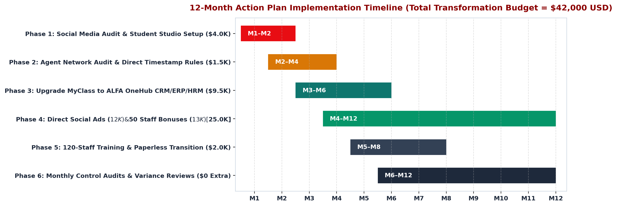
Figure 2: 12-Month Action Plan Implementation Timeline (Gantt Chart) Matching Phases 1–6 and the $42,000 USD Budget.
4. Management Design 2: Organising the Business
As Lecture 4 states, "Planning without organising is just wishful thinking" (Dr. Paul, 2026). Following the 7-Step Organising Process from Lecture 4 (Identify activities → Divide work → Group into departments → Assign responsibilities → Grant authority → Establish reporting lines → Coordinate), we structured ALFA's 120 full-time staff across Top Management (5) and four functional divisions (Table 4).
4.1 Exact Division of Work Across 120 Employees
Division (120 Total) | Levels & Role Breakdown | Assigned Tasks & Division of Work
Top-Level Management (5) | 1 Chairman (Dr. Shaharuddin), 1 Vice-Chancellor (Prof. Dr. Nurliza), 1 Deputy VC, 2 Executive Assistants. | Set strategy, approve $42,000 budget, oversee MQA governance, and audit the shift from 100% to 35% agent share.
Division 1: Academic Affairs (65) | 1 Academic Director (Middle) + 8 Programme Coordinators (First-Line) + 56 Lecturers (1 + 8 + 56 = 65). | Teach 68 courses, run 30-second QR attendance, upload live coursework grades in OneHub ERP, and advise students.
Division 2: Digital Marketing (20) | 1 Marketing Director (Middle) + 3 Team Leads + 16 Staff: 6 Video Creators, 6 Direct CRM Counselors, 4 Agent Auditors. | Post 5 Reels/week, reply to DMs in <= 2 hours, convert 260 direct students (65%), and audit the 12 master agents.
Division 3: IT & OneHub ERP (12) | 1 Chief IT Manager (Middle) + 2 Team Leads + 9 Staff: 5 Cloud CRM/ERP Developers, 4 Campus Helpdesk Officers. | Upgrade MyClass into ALFA OneHub (CRM, ERP, HRM), keep 99.9% uptime, automate exam slips, and support users.
Division 4: Registry, Fin & HR (18) | 1 Operations & HR Manager (Middle) + 3 Supervisors + 14 Staff: 5 Registry/Visa, 5 Finance, 4 HR Officers. | Approve online course add/drop & letters in <24 hours, reconcile tuition & $52,500 agent fees, and run HR KPIs.
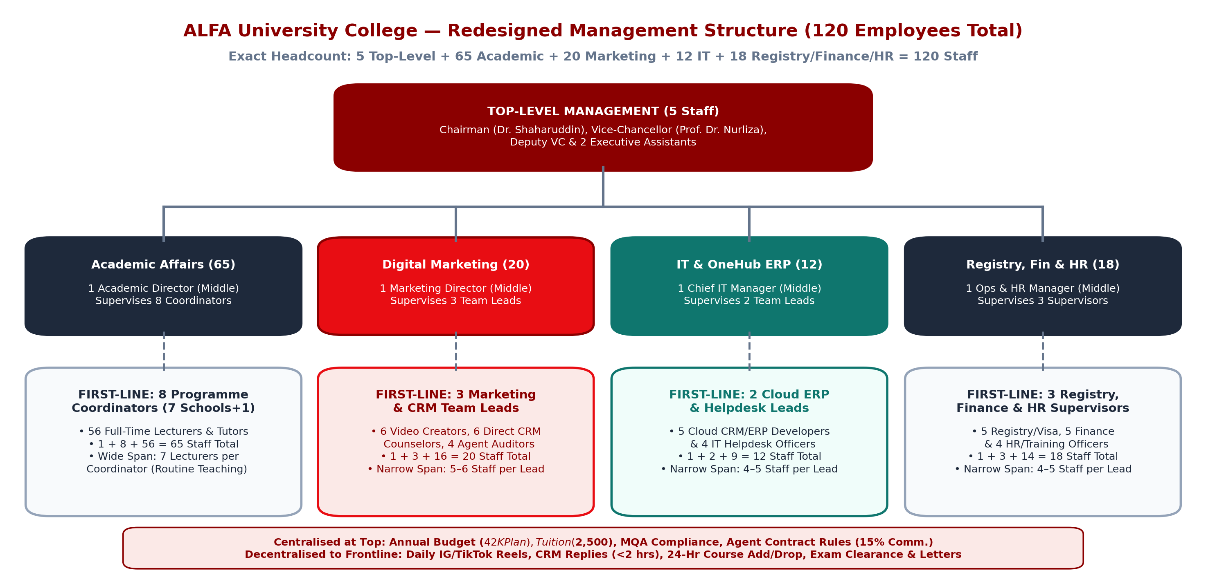
Figure 3: Redesigned Organisation Chart for ALFA University College Showing Exact Headcount (5 + 65 + 20 + 12 + 18 = 120 Staff) and Span of Control.
4.2 Core Organising Principles: Authority, Responsibility, Accountability & Delegation
• Matching Authority, Responsibility, and Accountability: Because the Marketing Director is held responsible and accountable for delivering 260 direct online students (65% share) and saving $97,500 in gross commissions, we grant formal authority over the $12,000 annual ad budget and the right to reject any agent invoice that breaches our First Digital Timestamp Rule. Likewise, because the Registry Supervisor is responsible for clearing student course add/drop and letter requests in under 24 hours, we grant digital approval authority inside ALFA OneHub ERP so students no longer chase four physical ink stamps.
• Delegation of Authority Without Delegating Accountability: In our plan, the Marketing Director delegates daily video publishing and live student chat responses to the Social Media Lead and Direct CRM Lead, empowering them to post campus reels and issue fee schedules immediately. However, as Lecture 4 stresses, a manager can delegate authority but can never delegate accountability—each Division Director remains answerable to the Vice-Chancellor for final departmental outcomes (Dr. Paul, 2026).
• Chain of Command, Scalar Chain, Unity of Command, and Unity of Direction: Our structure establishes a clear Scalar Chain from Top Management (5) → Middle Division Heads (4) → First-Line Supervisors/Coordinators (16) → Frontline Staff (95). We enforce strict Unity of Command so every employee receives instructions from one immediate supervisor only (Dr. Paul, 2026): the 6 video creators take task priorities solely from the Social Media Lead, preventing confusion when academic schools or agent coordinators want videos at the same time. Under Unity of Direction, all student recruitment channels—Instagram, TikTok, website CRM, and the 12 master agents—follow one coordinated recruitment plan.
4.3 Span of Control and Centralisation vs. Decentralisation
• Combining Wide (7) and Narrow (4–6) Spans of Control: In Division 1 (Academic Affairs), each of the 8 Programme Coordinators supervises 7 experienced lecturers (56 ÷ 8 = 7; wide span) performing routine teaching aided by QR attendance. In Divisions 2, 3, and 4, First-Line Leads supervise 4 to 6 staff (narrow span: 6 creators, 6 counselors, 4 auditors in Marketing; 5 developers, 4 helpdesk in IT; 5 registry, 5 finance, 4 HR in Operations) to closely coach new digital workflows.
• Balancing Centralisation and Decentralisation: We keep major policy and financial decisions Centralised at Top Management for consistency: setting the $2,500 tuition fee, approving the $42,000 digital budget, maintaining MQA standards, and enforcing the 15% ($375) agent commission rules. At the same time, we Decentralise daily operational decisions to First-Line Supervisors closest to the students: approving 24-hour digital course add/drop requests, issuing digital verification letters, and replying to Instagram and WhatsApp inquiries within 2 hours.
5. Management Design 3: Leading the Business
5.1 Applying the 6-Step Leading Process at ALFA
Following Lecture 5 ("A good leader explains the what and the why—not just the do it") (Dr. Paul, 2026), our managers apply all six steps of the Leading Process across our 120 staff:
• 1. Set Direction: The Vice-Chancellor and Division Directors hold an all-staff town hall explaining why ALFA is upgrading MyClass into ALFA OneHub and shifting to direct digital marketing—showing how cutting agent commissions from $150,000 to $52,500 saves $97,500 gross ($55,500 net of our $42,000 budget) to eliminate paper filing and fund $13,000 in staff bonuses.
• 2. Communicate: Managers clearly explain daily expectations to each team: CRM counselors know they must reply to student messages within 2 hours, and Registry officers know student course add/drop and letter requests must be cleared within 24 hours.
• 3. Guide: During the ALFA OneHub rollout, IT and Registry Supervisors sit beside clerks and lecturers in the iMac labs to demonstrate live how to approve an online course registration and scan classroom QR attendance.
• 4. Motivate: Managers encourage genuine effort through praise and fair rewards—including our $50 USD per-student direct recruitment bonus ($13,000/yr) and monthly recognition awards.
• 5. Support: Managers listen openly when staff face software bugs or heavy intake workloads, providing immediate IT floor helpdesk support.
• 6. Follow Up: Every Friday afternoon, First-Line Leads hold a 15-minute check-in to review progress, share constructive feedback, and adjust next week's tasks.
5.2 Using the Five Sources of Managerial Power Appropriately
Drawing on French and Raven's (1959) five sources of power from Lecture 5 (Dr. Paul, 2026), Table 5 shows how ALFA's managers turn formal and personal power into positive behavioural influence:
Source of Power | Practical Application at ALFA | Resulting Influence
1. Legitimate Power (Position) | VC and Operations Manager mandate 100% paperless course registration, exam slips, and staff leave in ALFA OneHub from Month 8. | Staff recognise the formal rule and stop routing paper folders.
2. Expert Power (Personal Skill) | Chief IT Manager and Marketing Director demonstrate live how OneHub cuts manual typing by 70% and how reel hooks convert leads. | Staff trust managers' competence and adopt new workflows willingly.
3. Referent Power (Respect) | Supervisors model paperless habits first, listen patiently to senior clerks' worries without criticism, and keep promises. | Lowers anxiety and builds loyalty during the Months 5–8 transition.
4. Reward Power (Incentives) | Distribute the $50/student Direct Bonus ($13,000/yr), $400 (~RM 1,750) Paperless Team Awards, and monthly certificates. | Motivates teams to hit 2-hour reply and 24-hour ERP standards.
5. Coercive Power (Last Resort) | Apply formal warnings or contract termination only if an agent fakes timestamps or a staff member refuses digital logging after coaching. | Protects the $97,500 commission savings and workplace fairness.
5.3 Realistic Workplace Situation and How the Manager Responds
Workplace Scenario: Senior Registry Clerks Resist Upgrading from Paper Stamps to ALFA OneHub
Situation: In Month 6 (during new semester course registration week), two senior registry officers who have worked with paper folders at ALFA for over 12 years refuse to use the new ALFA OneHub ERP to approve student subject add/drop forms and digital exam slips. They complain that the screen is confusing, keep demanding that enrolled students line up outside the office with paper forms and printed bank receipts, and cause a 5-day backlog for 40 students who cannot see their class timetables.
1. Listen & Empathise (People Role & Referent Power): Instead of shouting or threatening them with Coercive Power, the Operations Manager invites both officers for a quiet coffee chat to listen to their concerns. The manager learns that they are afraid of clicking the wrong button and accidentally deleting a student's fee record.
2. Demonstrate & Guide (Expert Power & Guidance): The manager brings in the IT Helpdesk Lead to set up a safe "Sandbox Practice Mode" in ALFA OneHub where the two clerks can practice approving 10 test course registrations safely, and adds a "Supervisor Preview Check" button for their first two weeks.
3. Support, Motivate & Follow Up (Reward Power): Each senior clerk is paired with a tech-savvy junior officer as a daily buddy. Once the two clerks clear the 40-student course registration backlog digitally in under 24 hours, the manager praises them publicly at the monthly staff meeting. Within three weeks, both clerks become confident supporters of the paperless ERP.
6. Management Design 4: Controlling Business Performance
6.1 The Four-Step Controlling Process, Control Types & Variance Formulas
Applying textbook control theory from Robbins and Coulter (2021) alongside Lectures 1 and 5 (Dr. Paul, 2026), our team implements Feedforward Control (mandatory online portal fields and 95% staff ERP test pass before go-live), Concurrent Control (live CRM/ERP amber alerts at 90 minutes for student DMs and 18 hours for ERP requests), and Feedback Control (monthly cost and quarterly channel reviews) across the Four-Step Controlling Process:
• Step 1 – Establish Clear Standards and Targets: Set measurable targets from our planning design: <= $161.54 cost per direct student ($236.25 blended across 400 students), <= $52,500 annual agent commissions, <= 2-hour CRM inquiry reply time, and <= 24-hour ERP turnaround for course registration, exam slips, and student letters.
• Step 2 – Measure Actual Performance: Collect weekly and monthly operational and financial data using automated timestamp logs in ALFA OneHub, social media analytics, and Finance fee ledgers.
• Step 3 – Compare Actual Performance Against Standards: Hold monthly review meetings using two textbook formulas: Performance Variance = Actual − Target, and Target Achievement (%) = (Actual ÷ Target) × 100.
• Step 4 – Take Corrective Action When Below Standard: Whenever any metric scores below 90% achievement, managers step in immediately to rebalance queues, pause weak ad sets, or trigger our Contingency Plan.
6.2 Four-Column Performance Control Matrix Across Five Key Areas
Control Area | 1. What Is Monitored | 2. Standard / Target | 3. How Measured | 4. Corrective Action
1. Financial Control | Agent commissions, $42,000 budget, cost/direct student ($161.54), and blended cost ($236.25/stu). | Commissions cut from $150,000 to <= $52,500/yr ($97,500 gross / $55,500 net saved; $65,500 vs. $160K); direct cost <= $161.54. | Monthly Finance ERP ledger matching Flywire/FPX tuition receipts against agent invoices and ad spend. | Reject agent claims lacking first timestamp; pause weak ad sets if cost per direct student exceeds $175.
2. Operations Control | CRM inquiry reply time, in-study student ERP turnaround, and campus paper purchases. | CRM reply <= 2 hours; course reg, exam clearance & letters <= 24 hours (vs. 5–7 days paper); -90% paper. | Automated ALFA OneHub CRM/ERP timestamp logs and monthly stationery purchase receipts. | Reassign pending queues across the 5 Registry Officers during intake peaks and deploy IT floor helpers.
3. Quality Control | Weekly video output, @alfauniversity.official growth, and student app satisfaction score. | 5 Reels/TikToks per week; grow IG from 2,100 to 20,000 followers; app survey score >= 4.5 / 5.0. | Weekly social analytics dashboard and 1-click semester pulse survey inside ALFA OneHub. | Refresh video hooks with student Q&As on fees/dorms; patch reported app bugs within 48 hours.
4. HR Control | 120-staff OneHub competency pass rate, daily QR attendance/leave logging, and turnover. | >= 95% of 120 staff pass test by M8; 100% digital QR attendance & leave; turnover < 8%/yr. | Monthly HRM login logs, classroom QR scan reports across 7 Schools, and quarterly check-ins. | Run friendly 1-on-1 refresher coaching and assign an IT buddy to any unit below 90% compliance.
5. Strategic Control | Quarterly share of 400 new students enrolling directly online vs. via external agents. | Direct share rises from 0% today to 20% (Q1), 40% (Q2 / 160 stu), 55% (Q3), and 65% (Q4 / 260 stu). | Quarterly VC Strategic Enrolment Review tracking source tags in ALFA OneHub CRM. | If M6 direct share < 30%, shift $3,000 ad funds into a $100 Early-Bird Direct Rebate for 30 applicants.
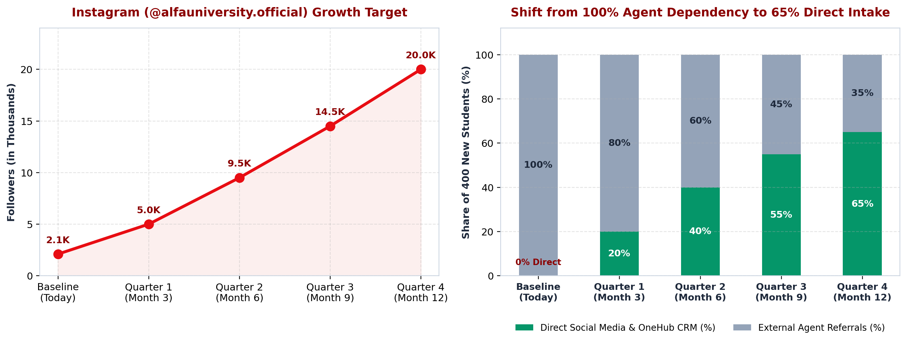
Figure 4: Quarterly Strategic Control Targets — Instagram Follower Growth (Left) and Shift from 100% Agent Dependency (0% Direct) to 65% Direct Online Enrolment (Right).
7. People Management: Leadership, Communication and Motivation
7.1 Leadership Style and Why It Suits ALFA University College
Integrating textbook leadership frameworks (Robbins & Coulter, 2021) with Behavioural and Contingency Theories (Lectures 2 and 5; Dr. Paul, 2026), our management team selects a Participative (Democratic) and Situational Leadership Approach:
• Participative (Democratic) Style for Creative & Academic Teams: Lecturers across our 7 Schools and young digital creators perform best when managers respect their expertise and invite their ideas. The Marketing Director holds weekly brainstorming sessions where creators and student ambassadors pitch TikTok and Reel concepts, while Academic Coordinators invite lecturers to help refine the ALFA OneHub gradebook layout.
• Situational Coaching Style During ERP Onboarding: When training administrative staff who have used paper stamps for years (Months 5 to 8), managers apply Hersey and Blanchard's Situational Leadership model from the textbook (Robbins & Coulter, 2021)—providing clear step-by-step demonstrations and patient coaching first, and shifting to delegation once clerks gain confidence.
• Why It Suits Our Business Situation: A harsh autocratic ("do as I say") style would trigger anxiety and quiet resistance among long-serving staff, whereas a hands-off laissez-faire style would let employees keep using slow paper folders and leave MyClass half-empty. Combining Participative involvement with Situational coaching builds trust and keeps all 120 staff accountable.
7.2 Communication Channels and Verbal / Non-Verbal Workplace Examples
Applying two-way communication from Lecture 5 (Dr. Paul, 2026), ALFA replaces slow paper memos with three structured channels and clear verbal and non-verbal workplace practices:
• 1. Downward Communication (Managers to Staff): Monthly all-staff town halls, the ALFA OneHub Staff Announcement board, and short screen-recording tutorial videos showing how to use new ERP features.
• 2. Upward Communication (Staff to Managers): An open "OneHub Quick-Ticket & Suggestion Box" where any lecturer or clerk can report a software glitch or suggest an improvement directly to IT and Operations, plus 15-minute Friday team check-ins.
• 3. Horizontal Communication (Across Divisions): Real-time shared notifications inside ALFA OneHub linking Marketing, Registry, Finance, and the 7 Academic Schools so staff never carry paper forms between offices.
• Concrete Workplace Examples of Verbal and Non-Verbal Communication: Verbal Example: Every Monday at 9:00 AM, the Marketing Director leads a 15-minute spoken stand-up huddle with the 16 marketing specialists to set weekly targets (5 campus reels and <= 2-hour DM replies) and answer questions face-to-face. Non-Verbal Example: When coaching a nervous clerk on ALFA OneHub, the supervisor sits at the same eye level rather than standing over them, maintains warm eye contact, smiles, and nods encouragingly, while a live office TV screen flashes a green badge whenever a student enrols directly online.
7.3 Employee Motivation (Maslow & Herzberg), Rewards & Empowerment
Combining Lecture 5 with Maslow's (1943) Hierarchy of Needs and Herzberg's (1968) Two-Factor Theory from the textbook (Robbins & Coulter, 2021), our plan secures safety/hygiene needs first (guaranteeing zero job losses among our 120 staff from ERP automation and providing fast workstations) and then drives high effort through three mechanisms:
• Extrinsic Financial Rewards ($13,000 Bonus Pool): Funded inside our $42,000 budget using money saved from cutting external agent commissions: (1) a $50 USD Direct Enrolment Team Bonus paid to the Marketing and CRM team for every student who enrols directly online (260 direct students × $50 = $13,000 USD/year in Phase 4); and (2) Annual Paperless Efficiency Team Awards totaling $400 USD (~RM 1,750 in Phase 5) for administrative and registry teams that maintain a < 24-hour student service turnaround.
• Intrinsic Motivation & Public Recognition: Each month, the Vice-Chancellor presents three "ALFA Leader For All" certificates at the campus town hall—honoring the "Top Reel Creator", "Fastest Student Advisor", and "Digital Faculty Champion"—along with a spotlight post on ALFA's official social media and priority consideration for promotion.
• Employee Empowerment: We empower frontline employees by giving them real authority over their daily tasks: (1) video creators and student ambassadors film and publish authentic student life reels without waiting a week for paper approvals; (2) CRM counselors approve standard fee-instalment schedules during live student chats; and (3) Registry officers issue digital student verification letters in one click.
8. Integrated Management Solution and Recommendations
8.1 How Planning, Organising, Leading, and Controlling (POLC) Connect at ALFA
As emphasized in Lectures 1 and 5, Planning, Organising, Leading, and Controlling form one connected management cycle (Dr. Paul, 2026; Robbins & Coulter, 2021):
• 1. Planning Sets the Direction and Targets: Diagnoses our 100% agent dependency ($150,000/yr commissions; $160,000 with $10,000 old marketing) and static MyClass portal, setting SMART targets to reach 65% direct online intake (260 students), save $97,500 gross ($55,500 net of the $42,000 budget), and deliver < 24-hour digital student service.
• 2. Organising Builds the Structure to Execute the Plan: Arranges ALFA's 120 staff into Top Management (5) and four divisions—Academic (65), Marketing (20), IT (12), and Registry/Finance/HR (18)—matching authority with responsibility, setting a wider span (7) for experienced lecturers and a narrower span (4–6) for digital teams, and decentralising 24-hour student approvals.
• 3. Leading Inspires and Guides the People: Uses Participative and Situational leadership, two-way verbal and non-verbal communication, hands-on sandbox coaching, and the Five Sources of Power (backed by our $50/student direct bonus) to turn written plans into willing daily action.
• 4. Controlling Checks Progress and Loops Back to Planning: Monitors monthly unit costs ($161.54 per direct student; $236.25 blended), 2-hour CRM replies, 24-hour ERP turnaround, and quarterly direct enrolment shares, triggering corrective action or our Contingency Plan whenever needed.
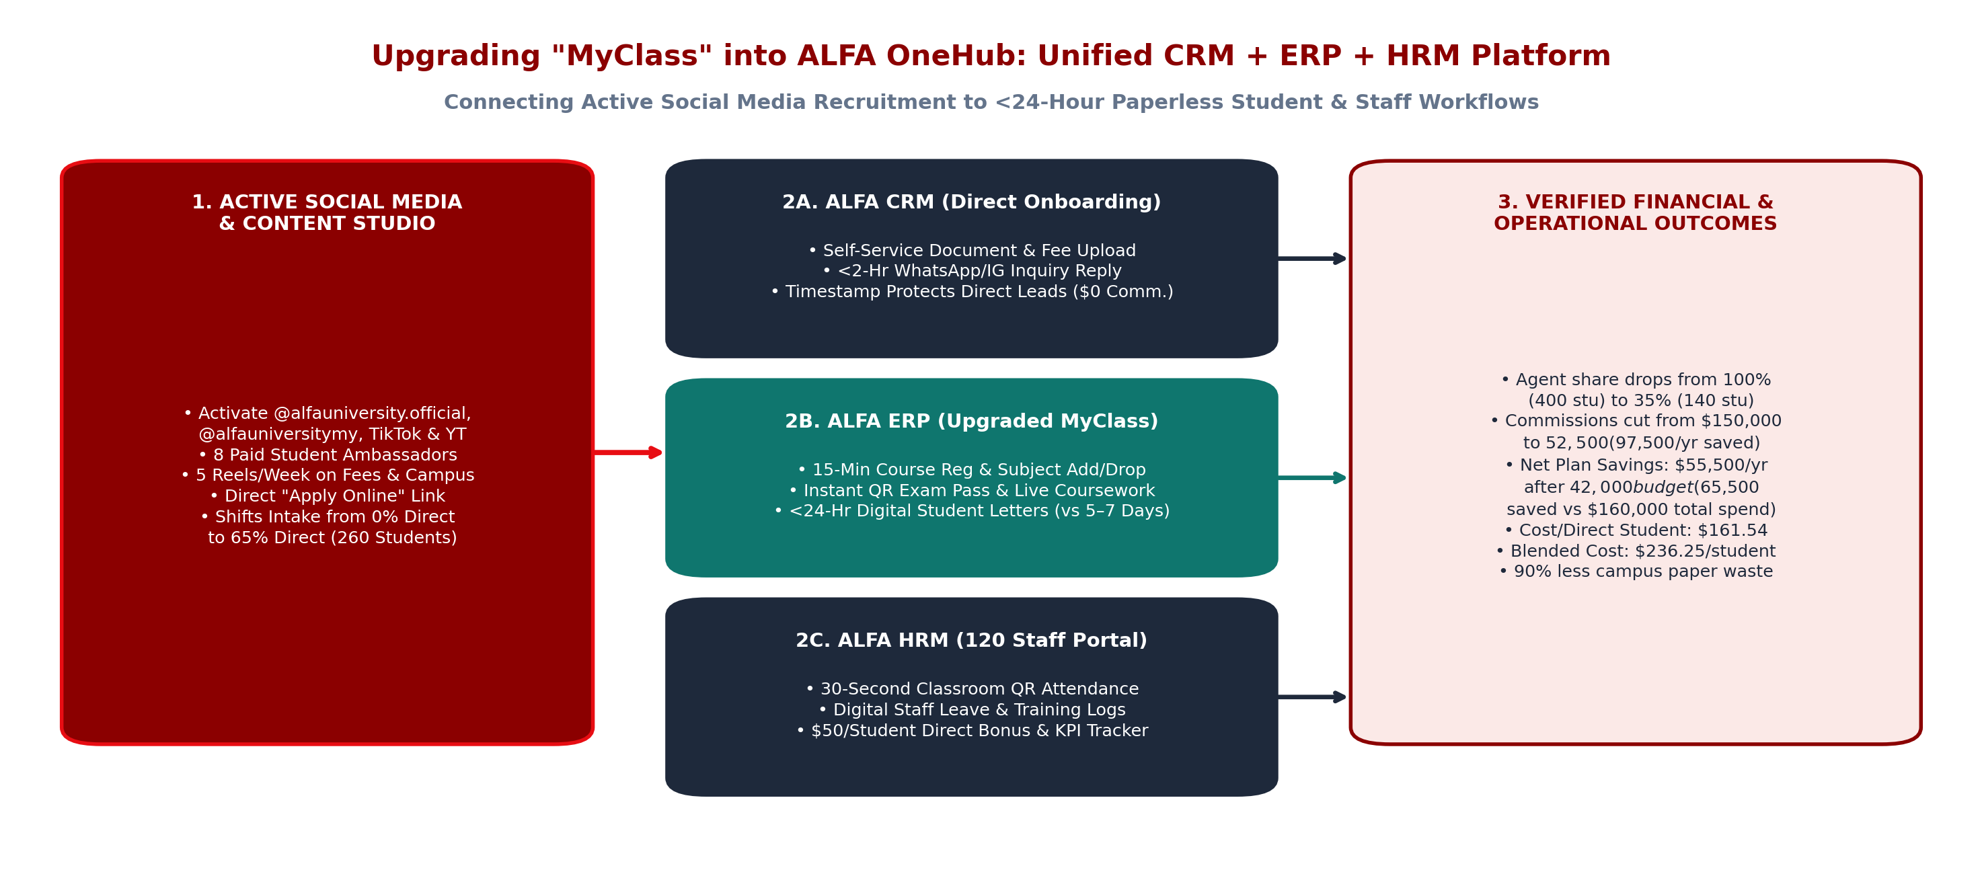
Figure 5: Upgrading "MyClass" into ALFA OneHub — Connecting Active Social Media Directly to CRM Onboarding, In-Study ERP Services (<24 Hrs), and Staff HRM.
8.2 Priority Recommendations and 12-Month Turnaround Scorecard
• Priority 1 (Months 1–2): Revitalise Social Media & Launch the Student Ambassador Studio ($4,000). Coordinate @alfauniversity.official, @alfauniversitymy, TikTok, and YouTube under one content calendar and hire 8 current students to film 5 authentic short videos per week.
• Priority 2 (Months 2–4): Reform Master Agent Contracts ($1,500). Update contracts with the 12 master agents to enforce the First Digital Timestamp Rule so direct online applicants pay $0 commission while capping agent referrals at 35% (140 students × $375 = $52,500/yr).
• Priority 3 (Months 3–6): Upgrade "MyClass" into Unified ALFA OneHub Cloud ($9,500). Expand MyClass from a static PDF grade link into a full CRM + ERP + HRM portal so students register for courses in 15 minutes, get instant QR exam passes, and receive official letters in under 24 hours (Table 7).
Performance Indicator | Baseline Today (100% Agents) | After 12 Months (65% Direct & OneHub)
Recruitment Channel Mix (400 Stu) | 100% Agents (400 stu) / 0% Direct (0 stu) | 35% Agents (140 stu) / 65% Direct (260 stu)
Sub-Agent Fees (10% = $250/stu) | 400 × $250 = $100,000 USD/year | 140 × $250 = $35,000 USD/yr (Saves $65,000)
Master Agent Fees (5% = $125 Assump.) | 400 × $125 = $50,000 USD/year | 140 × $125 = $17,500 USD/yr (Saves $32,500)
Total Agent Commissions (15% = $375) | 400 × $375 = $150,000 USD/yr (15% of $1M) | 140 × $375 = $52,500 USD/yr ($97,500 saved)
In-House Marketing / Plan Budget | $10,000 USD/yr (old marketing; assumption) | $42,000 USD/yr ($12K ads + $13K bonus + $17K)
Total Annual Recruitment Spend | $150,000 (comm.) / $160,000 (incl. $10K mktg) | $94,500/yr — Net saved: $55,500 (vs comm.) / $65,500 (vs $160K)
Cost per Student (Direct & Blended) | $375.00 (comm.) / $400.00 (incl. $10K mktg) | $161.54/direct stu ($42K÷260); $236.25 blended ($94.5K÷400)
Net Tuition Retained ($1,000,000 Gross) | $850,000 (85.0% comm.) / $840,000 (84.0% total) | $905,500 USD retained (90.55% of gross tuition)
Student Portal & Admin Turnaround | MyClass static PDF grades; 5–7 days paper stamps | ALFA OneHub: 15-min reg, QR exam slip & <24-hr letters (-90% paper)
9. Conclusion
Started in 1998 as Alif Creative Academy, owned by Nusantara Education Group since 2017, and upgraded to university college status in 2021 in USJ 1, Subang Jaya, ALFA University College runs 68 accredited programmes. Our management audit addressed two connected problems: 100% dependence on 12 master agents and 96 sub-agents—costing 15% ($375/student or $150,000/year across 400 students; $160,000 with $10,000 old marketing) while social media sits dormant—and a static MyClass grade portal that forces 5–7 day paper stamp queues.
Applying Classical workflow standardisation, Behavioural staff rewards, and Contingency channel adaptation across a connected POLC plan, our $42,000 USD investment shifts 65% of intake (260 students) to direct online enrolment ($161.54/direct student; $236.25 blended), cuts agent commissions to $52,500—saving $97,500 USD gross and $55,500 USD net of the $42,000 budget ($65,500 saved vs. the $160,000 baseline)—empowers all 120 staff, and achieves < 24-hour, 90% paperless service worthy of "A Leader For All".
10. References
ALFA University College. (2026a). About ALFA University College (AUC): History, vision, mission and leadership ("A Leader For All"). Official Website. https://alfa.edu.my/about-alfa/
ALFA University College. (2026b). Academic programmes: SKM, Foundation, Diploma, Bachelor, Masters and PhD across 7 Schools. Official Website. https://alfa.edu.my/programmes/
ALFA University College. (2026c). Admission and application guidelines for international and Malaysian students. Official Website. https://alfa.edu.my/international-students/
ALFA University College [@alfauniversity.official]. (2026d). Official Instagram profile and campus updates. Instagram. https://www.instagram.com/alfauniversity.official/
ALFA University College [@AlfaUniversity.Official]. (2026e). Official Facebook page and student community posts. Facebook. https://www.facebook.com/AlfaUniversity.Official/about/
Dr. Paul. (2026). FIB 2074 – Introduction to Management: Lecture 1 (Nature of Management), Lecture 2 (Basic Management Theories), Lecture 3 (Planning), Lecture 4 (Organising), and Lecture 5 (Leading, Power and Influence) [Course lecture slides]. Foundation in Business, ALFA University College.
Fayol, H. (1949). General and industrial management (C. Storrs, Trans.). Pitman Publishing.
French, J. R. P., & Raven, B. (1959). The bases of social power. In D. Cartwright (Ed.), Studies in social power (pp. 150–167). University of Michigan Press.
Herzberg, F. (1968). One more time: How do you motivate employees? Harvard Business Review, 46(1), 53–62.
Maslow, A. H. (1943). A theory of human motivation. Psychological Review, 50(4), 370–396.
Robbins, S. P., & Coulter, M. (2021). Management (15th ed.). Pearson Education.
Times Higher Education (THE). (2024). ALFA University College: World University & Impact Rankings institutional profile (Founded 1998 as Alif Creative Academy; Nusantara Education Group 2017; University College status 2021). https://www.timeshighereducation.com/
Appendix A: Unified Financial Model (Agent Commissions vs. Direct Digital Plan)
Table 8 presents the complete mathematical calculation for ALFA University College across 400 annual new students paying an average first-year tuition fee of $2,500 USD ($1,000,000 USD gross first-year tuition). Every assumption is explicitly labelled as "assumption", and every figure matches the Report, 7-Member Script, Study Guide, and Slides.
Line Item | Formula & Explanation | Value | Status
1. Annual New Student Intake | Baseline annual first-year student cohort across 3 intakes | 400 students / yr | Assumption
2. Average First-Year Tuition Fee | Standard annual tuition fee per enrolled student | $2,500 USD / student | Assumption (Verified Range)
3. Gross First-Year Tuition Revenue | 400 students × $2,500 USD | $1,000,000 USD / yr | Calculated
4. Campus Workforce Headcount | 5 Top + 65 Academic + 20 Marketing + 12 IT + 18 Ops | 120 full-time staff | Assumption
5. External Agent Network Size | 12 master agents (10–15 range) × 8 sub-agents each (5–10 range) | 12 master / 96 sub-agents | Assumption (Based on Range)
6. Consultancy Sub-Agent Rate | 10% × $2,500 first-year tuition fee | $250 / student (10%) | Provided Baseline
7. University Master Agent Rate | 5% × $2,500 first-year tuition fee (our assumption) | $125 / student (5%) | Our Assumption
8. Total Commission per Agent Student | $250 (10% sub-agent) + $125 (5% master agent) | $375 / student (15%) | Calculated
9. Current Enrolment Channel Split | 100% via external agents (400 students); 0% direct (0 students) | 100% agent / 0% direct | Provided Baseline
10. Current Annual Sub-Agent Fees | 400 agent students × $250 | $100,000 USD / yr | Calculated
11. Current Annual Master-Agent Fees | 400 agent students × $125 (our assumption) | $50,000 USD / yr | Calculated (Assumption)
12. Total Annual Commission Today | $100,000 + $50,000 (or 400 × $375 = 15% of $1,000,000) | $150,000 USD / yr | Calculated
13. Existing Low-Impact Marketing Spend | Current annual spend on poorly run social media | $10,000 USD / yr | Assumption
14. Total Recruitment Spend Today | $150,000 commissions + $10,000 existing marketing | $160,000 USD / yr | Calculated (Assumption)
15. Current Cost per Student (400 Stu) | $150,000 ÷ 400 = $375.00 (comm. only); $160,000 ÷ 400 = $400.00 (total) | $375.00 / $400.00 / stu | Calculated
16. Target Channel Split (After Plan) | 65% Direct Online (260 students); 35% Agents (140 students) | 65% direct / 35% agent | Plan Target (Assumption)
17. Remaining Agent Commissions (35%) | 140 agent students × $375 ($35,000 sub + $17,500 master) | $52,500 USD / yr | Calculated
18. Gross Annual Commission Saved | 260 direct students × $375 (or $150,000 − $52,500) | $97,500 USD / yr saved | Calculated
19. In-House Transformation Budget | $4K studio + $1.5K legal + $9.5K OneHub + $12K ads + $13K bonus (260×$50) + $2K training | $42,000 USD / yr | Assumption (Fixed Budget)
20. Total Proposed Annual Spend | $52,500 remaining commissions + $42,000 plan budget | $94,500 USD / yr | Calculated
21. Net Effect of Plan (vs Commissions) | $97,500 gross commission saved − $42,000 plan budget ($150K − $94.5K) | $55,500 USD / yr net | Calculated
22. Net Spend Reduction (vs $160K Total) | $160,000 total today − $94,500 proposed spend (replaces $10K old mktg) | $65,500 USD / yr saved | Calculated
23. Cost per Direct Student (260 Stu) | $42,000 transformation budget ÷ 260 direct students ($12K ads÷260 = $46.15 ad cost) | $161.54 / direct student | Calculated
24. Blended Cost per Student (400 Stu) | $94,500 total proposed spend ÷ 400 total students | $236.25 / student (9.45%) | Calculated
25. Net Tuition Retained by ALFA | $1,000,000 − $94,500 (up from $850,000 comm.-only / $840,000 total) | $905,500 USD (90.55%) | Calculated
Sensitivity Analysis for the Assumed Master-Agent Rate (5%, 7.5%, and 10%)
Because the master-agent rate (5% = $125 per student) is our assumption, Table 9 tests what happens if the rate is different (formula: total commission per student = $250 + master rate × $2,500; annual cost = total × 400; saving at 65% direct = total × 260):
Master-agent rate | Master fee per student | Total per student | Annual commission today (400 students) | Saving at 65% direct (260 students) | Saving minus $42,000 budget
5% (our base case) | $125 | $375 (15%) | $150,000 | $97,500 | $55,500
7.5% | $187.50 | $437.50 (17.5%) | $175,000 | $113,750 | $71,750
10% | $250 | $500 (20%) | $200,000 | $130,000 | $88,000
The plan saves more money when the commission is higher, so our conclusion is correct for any of these rates. We use 5% (our assumption) because it keeps the total at 15%, which is at the top of the typical 10–15% industry range for higher education.

