Schemas

The questions in this challenge are based on the *Mining* database schema shown in the diagram below. You can click the diagram to see a larger version of the diagram.

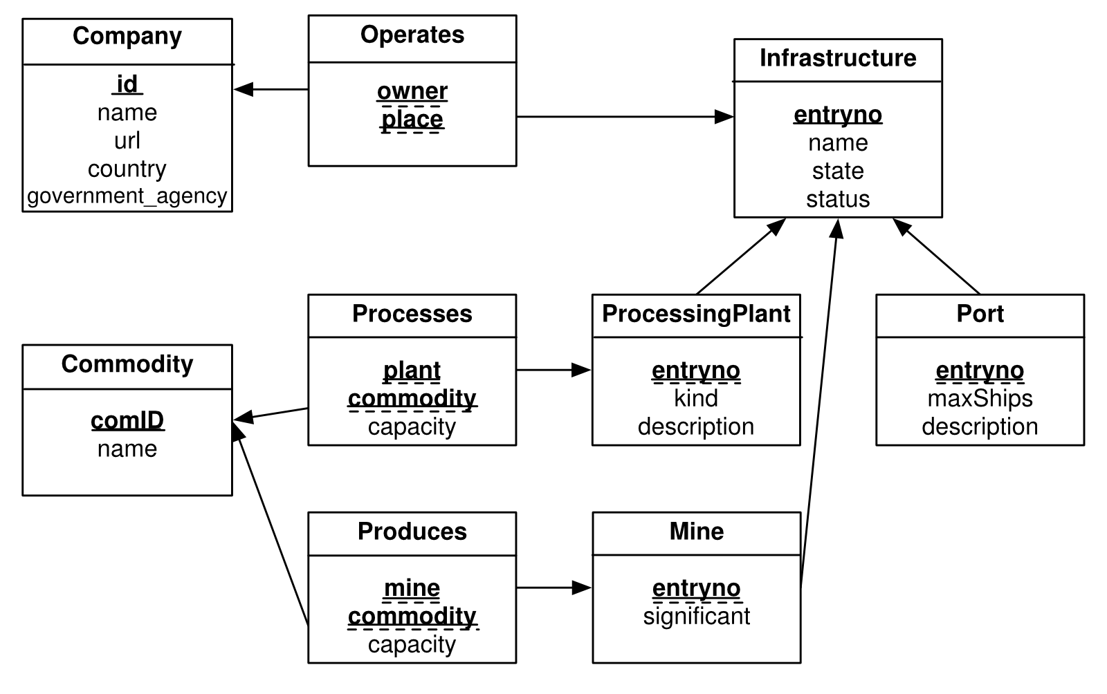

In the above diagram, primary key attributes are shown in bold and underlined; foreign key attributes are dashed-underlined and with an arrow pointing to the referenced table.

Company(id INTEGER, name VARCHAR(60), url VARCHAR(200),

country CHAR(3) -- country code

government_agency CHAR(1) -- 'Y' or 'N'

);

Infrastructure(entryNo INTEGER, name VARCHAR(50), state VARCHAR(3), status VARCHAR(20));

Port(entryNo INTEGER, maxShips INTEGER, description VARCHAR(200));

ProcessingPlant(entryNo INTEGER, kind VARCHAR(50), description VARCHAR(200));

Mine(entryno INTEGER,

significant CHAR(1) -- 'Y' or 'N'

);

Commodity(comId VARCHAR(5), name VARCHAR(50));

Operates(owner INTEGER, place INTEGER);

Produces(mine INTEGER, commodity VARCHAR(5), capacity INTEGER);

Processes(plant INTEGER, commodity VARCHAR(5), capacity INTEGER);



