AGENTIC WORKFLOWS
Chat and Workout Generation
Production architecture and implementation design
Status | Proposed design
Prepared | July 27, 2026
Scope | FastAPI, LangGraph/LangChain, Chroma, Tavily, Cohere, Supabase

Recommendation: Use LangGraph for explicit workflow control and streaming, LangChain for model/tool/structured-output adapters, and small provider services for Chroma, Tavily, Cohere, and Supabase. Keep one stateless LangChain Search Agent and reuse it from both workflows.

Decision summary
- No separate free-form routing agent is required at the top level.
- The Chat workflow contains one controller agent; all retrieval is delegated to the Search Agent.
- Workout generation is mostly deterministic: load context, rewrite, search, generate structured output, validate.
- User JWTs remain request-scoped runtime dependencies and are never checkpointed.
- Generated workouts are drafts until the user accepts them; acceptance and persistence are separate operations.

1. Scope and design position
This design covers two production workflows: an evidence-grounded conversational assistant and a workout-generation workflow. Both reuse one specialized Search Agent and authenticated user-data services. The design fits the current FastAPI application while creating clear seams for provider replacement, testing, observability, and gradual migration.
Architecture position: Do not wrap every line of the application in LangChain. Use LangGraph at orchestration boundaries, LangChain at model/tool boundaries, and ordinary Python for data access, normalization, validation, and business rules.

Goals
- Read bounded message history and maintain conversational continuity.
- Delegate every retrieval decision to one reusable Search Agent.
- Read and modify Supabase-backed exercise data without weakening RLS.
- Stream user-visible output while preserving typed final state and source attribution.
- Generate workout plans from user context, prior training, evidence, and a strict output schema.
- Keep provider-specific code replaceable and independently testable.

Non-goals for the first production version
- A swarm of peer agents or a general-purpose supervisor that can invent new workflows.
- Allowing a model to issue arbitrary SQL, PostgREST filters, table names, or columns.
- Saving a generated plan before the user explicitly accepts it.
- Using graph checkpoints as the only product database for chat history.
- Exposing raw provider responses directly to the final-answer model or API client.

Why this composition
Layer | Recommended responsibility | Reason
FastAPI | Authentication, request validation, cancellation, stream response | Keeps transport and security outside model logic.
LangGraph | State, explicit nodes/edges, recovery, streaming, subgraph composition | Best fit for deterministic steps mixed with agentic decisions.
LangChain | Model initialization, tools, structured output, provider adapters | Reduces provider glue without owning domain behavior.
Python services | Supabase, Chroma, Tavily, Cohere, normalization, validation | Small interfaces are simpler to test and replace.
Supabase | Product data and RLS-enforced authorization | Remains the source of truth for user-owned records.

2. Proposed application structure
Use app/ai as the root for agentic application code, but do not introduce a top-level agents/ directory for one specialized agent. Organize this code by stable responsibility: workflows/ contains request-level orchestration, search/ contains the reusable tool-calling search capability, services/ contains framework-agnostic provider and domain integrations, and contracts/ contains shared types. If several independent agents emerge later, an agents/ category can be introduced when it represents real structure rather than anticipated structure.
server/app/
|-- ai/
| |-- contracts/
| | |-- context.py
| | |-- evidence.py
| | `-- workout.py
| |-- workflows/
| | |-- chat/
| | | |-- graph.py
| | | |-- state.py
| | | |-- prompts.py
| | | `-- nodes/
| | `-- workout_generation/
| | |-- graph.py
| | |-- state.py
| | |-- prompts.py
| | `-- nodes/
| |-- search/
| | |-- agent.py
| | |-- tools.py
| | |-- prompts.py
| | `-- schemas.py
| |-- services/
| | |-- retrieval/
| | | |-- chroma.py
| | | |-- indexing.py
| | | `-- rerank.py
| | |-- web/
| | | `-- tavily.py
| | `-- user_data/
| | |-- conversations.py
| | |-- exercises.py
| | `-- training_history.py
| |-- models.py
| `-- observability.py
|-- auth/
|-- db/
| `-- supabase.py
`-- api/

Placement decisions
Current concern | Proposed location | Notes
Chroma handler / vector store | ai/services/retrieval/chroma.py | Online retrieval adapter only; no agent decorators.
Document ingestion and sparse indexing | ai/services/retrieval/indexing.py | Offline/admin path; collection schema and sparse field are created here.
Tavily client | ai/services/web/tavily.py | One process-level client; invocation parameters may vary per search plan.
Cohere reranker | ai/services/retrieval/rerank.py | Internal service; keep scores and provenance in typed results.
Search capability | ai/search/agent.py + tools.py | agent.py exposes search_sources; tools.py contains thin LangChain tool adapters over ordinary provider services.
Supabase REST transport | db/supabase.py | Generic authenticated transport, unaware of prompts or agents.
Exercise/history operations | ai/services/user_data/ | Allow-listed domain methods; no arbitrary table or filter input.

Migration note: Move behavior in small steps. First establish contracts and framework-agnostic services, then add thin LangChain adapters in ai/search/tools.py and compose workflows. Do not decorate service methods as tools; direct application code should remain able to call the same services without an agent.

3. Chat workflow
The Chat workflow is the request-level orchestrator. It loads bounded history, invokes one Chat Controller agent, exposes a single Search Agent delegation tool plus narrow exercise-data tools, streams the answer, and persists the completed turn. There is no separate LLM router in front of the controller.
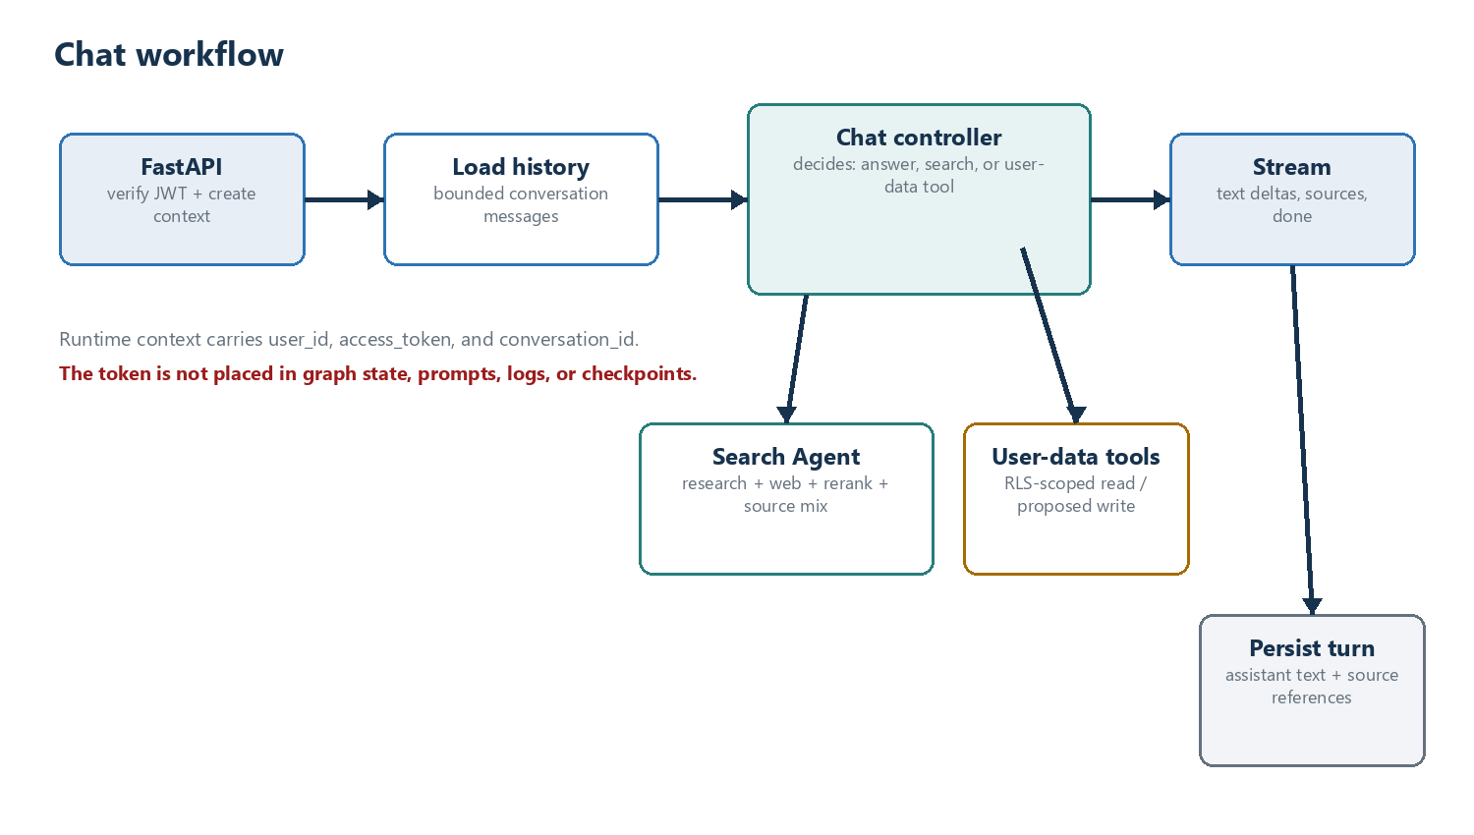
Figure 1. Chat request, delegated retrieval, RLS-scoped data access, streaming, and persistence.

Responsibilities
- Verify the Supabase access token at the FastAPI boundary and construct immutable WorkflowContext.
- Persist the user message, then load a bounded window of prior messages from the product database.
- Invoke the Chat Controller with history and tools. The controller may answer directly, delegate search, or call a user-data tool.
- Stream only safe public events: status, text delta, sources, done, or error.
- Persist the final assistant message and source references after successful completion.

Controller tools
Tool | Behavior | Guardrail
search_sources | Delegates to the Search Agent and returns SourceBundle. | No direct Chroma, Tavily, or reranker tools are exposed to Chat.
get_recent_workouts | Reads user-owned workout and exercise records. | User identity comes from runtime context; table names are fixed.
get_exercise_details | Fetches one user-visible exercise/workout object. | RLS plus object-level validation.
propose_changes | Creates a typed proposed mutation. | No write occurs until explicit confirmation.
apply_changes | Applies an approved mutation idempotently. | Confirmation token, allow-listed fields, transaction, audit log.

Message history and persistence
Use Supabase chat_threads and chat_messages as the product source of truth. Load the latest bounded window and, when needed, a stored conversation summary. A LangGraph checkpointer may be added for recovery and debugging, but it should not create a second competing history model. Use conversation_id as thread_id when checkpointing.
- Store user messages before model execution so an interrupted request is recoverable.
- Store assistant text, model metadata, source references, and completion status after generation.
- Summarize older turns asynchronously when the token budget is exceeded.
- Do not place access tokens, provider keys, or full provider payloads in state or checkpoints.

RLS and JWT propagation
Decision: Yes, authenticated database work needs the caller's JWT at the deepest database call. Pass it through WorkflowContext or a request-scoped Supabase client, not through model-visible tool arguments and not through checkpointed graph state.

The publishable key plus Authorization: Bearer <user JWT> causes Supabase Data API requests to run under the authenticated role and therefore evaluate RLS. A service-role or secret key bypasses RLS and must not be used for normal chat or workout operations. Reserve administrative credentials for isolated background jobs such as ingestion.

Streaming contract
Keep the current newline-delimited JSON transport if it works well for the client. Drive it from graph streaming and normalize internal events into a stable API contract. Token streaming should come from the final answer node; tool progress may emit coarse status events.
{"type": "status", "stage": "searching"}
{"type": "text", "delta": "Progressive overload means..."}
{"type": "sources", "sources": [...]}
{"type": "done", "message_id": "..."}

Chat workflow skeleton
@dataclass(frozen=True)
class WorkflowContext:
user_id: str
access_token: str
conversation_id: str
class ChatState(MessagesState):
sources: list[SourceItem]
answer: str | None
def build_chat_workflow(*, chat_controller, conversation_service):
graph = StateGraph(ChatState, context_schema=WorkflowContext)
graph.add_node("load_history", conversation_service.load_history_node)
graph.add_node("assistant", chat_controller)
graph.add_node("persist_turn", conversation_service.persist_turn_node)
graph.add_edge(START, "load_history")
graph.add_edge("load_history", "assistant")
graph.add_edge("assistant", "persist_turn")
graph.add_edge("persist_turn", END)
return graph.compile(checkpointer=production_checkpointer)
async def stream_chat(request, user):
context = WorkflowContext(
user_id=user.id,
access_token=user.access_token,
conversation_id=request.conversation_id,
)
config = {"configurable": {"thread_id": request.conversation_id}}
async for mode, event in chat_graph.astream(
{"messages": [{"role": "user", "content": request.text}]},
context=context,
config=config,
stream_mode=["messages", "updates"],
):
yield to_public_event(mode, event)

4. Shared Search Agent
The search capability lives in ai/search rather than a generic agents/ folder. Its public entry point is search_sources(request), implemented by one reusable, stateless LangChain agent created with create_agent. Chat and Workout Generation call that entry point through a typed boundary. Inside the module, the agent chooses and chains research search, online search, and reranking tools; those tools are thin adapters over provider services and return a normalized SourceBundle.
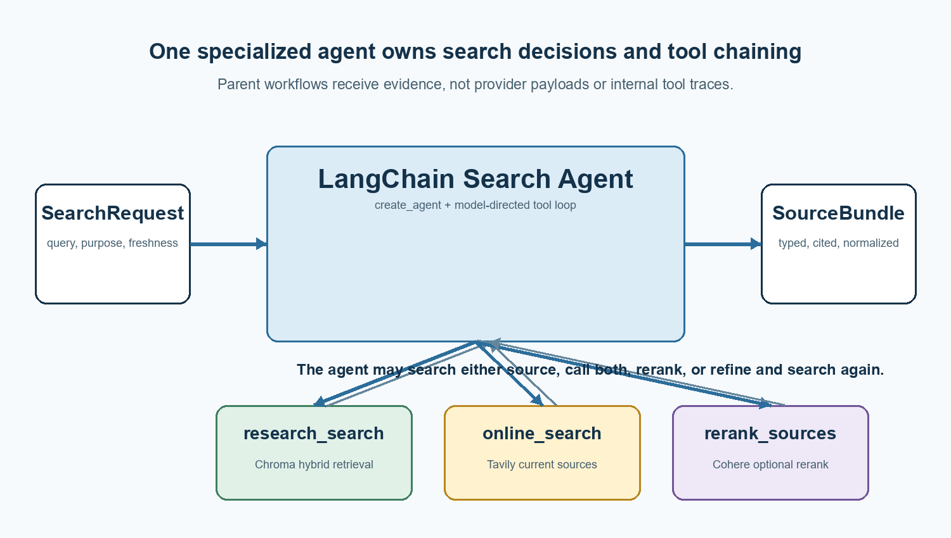
Figure 2. LangChain Search Agent dynamically selecting and chaining retrieval tools.

Why bundle search behind one agent
- The parent imports one search_sources entry point instead of provider clients, LangChain tools, or internal tool traces.
- ai/search owns the agent prompt, tool descriptions, tool-call limits, and typed SourceBundle response.
- ai/search/tools.py adapts plain service methods into JSON-serializable LangChain tools; it contains no provider connection logic.
- ai/services remains reusable from deterministic workflows, background jobs, tests, and administrative code without invoking an agent.
- The agent is stateless per invocation; the parent supplies the search request and retains conversation or workout state.

Typed contracts
class SearchRequest(BaseModel):
query: str
purpose: Literal["chat", "workout_generation"]
freshness: Literal["not_needed", "helpful", "required"] = "helpful"
top_k: int = 12
class SearchResult(BaseModel):
id: str
content: str
source_type: Literal["research", "web"]
title: str | None = None
url: str | None = None
score: float | None = None
metadata: dict[str, str | int | float | bool | None] = {}
class SourceBundle(BaseModel):
query: str
sources: list[SearchResult]
summary: str | None = None
search_modes: list[Literal["research", "web"]]
reranked: bool = False

Retrieval policy
Question shape | Research | Web | Rerank
Foundational training principle | Primary | Usually off | When candidate pool is broad
Current recommendation or news | Supporting | Required | Usually yes
Workout generation | Primary | Use for gaps/freshness | Yes for broad evidence pools
Simple direct fact | One focused query | Only if time-sensitive | Usually no

Chroma hybrid retrieval
Use Chroma's Search API with dense and sparse KNN rankings fused by reciprocal rank fusion. The collection must be created with a sparse vector index and documents must populate the sparse_embedding field during indexing. A query that references key="sparse_embedding" cannot add sparse capability to an existing dense-only collection.
Weight interpretation: RRF weights [2.0, 1.0] mean a two-to-one contribution ratio between semantic and sparse ranks. They do not mean that the final score is literally 67% semantic similarity and 33% keyword similarity.

Tavily online retrieval
Use the current langchain-tavily package, not the deprecated community Tavily tool. Keep one process-level TavilySearch instance and vary supported invocation-time search parameters from the search plan. Return result snippets and metadata; leave include_answer disabled so the final application model performs synthesis.
- fast: one credit, low latency, multiple relevant snippets per result.
- ultra-fast: one credit, minimum latency, one summary per result.
- basic: one credit, balanced general-purpose retrieval, one summary per result.
- advanced: two credits, highest relevance and higher latency, multiple snippets per result.

Reranking and research preference
Cohere returns an ordered list of source indexes with relevance scores. Preserve those scores. Rerank research and web pools separately, then apply an explicit blend policy. This avoids one source type suppressing the other merely because the candidate distributions differ.
Recommended blend: For workout generation, reserve a research floor only when relevant research clears a minimum score. A practical starting policy is 60-80% research and 20-40% web, followed by evaluation. Never promote an irrelevant paper solely to satisfy a quota.

Search Agent skeleton
@tool
async def search_research_docs(query: str, top_k: int = 15) -> list[SearchResult]:
return await research_service.search(query, top_k=top_k)
@tool
async def search_online(query: str, max_results: int = 10) -> list[SearchResult]:
return await web_service.search(query, max_results=max_results)
@tool
async def rerank_sources(
query: str,
results: list[SearchResult],
top_n: int = 10,
) -> list[SearchResult]:
return await rerank_service.rerank(query, results, top_n=top_n)
search_agent = create_agent(
model=search_model,
tools=[search_research_docs, search_online, rerank_sources],
system_prompt=SEARCH_AGENT_PROMPT,
response_format=SourceBundle,
)
async def search_sources(request: SearchRequest) -> SourceBundle:
result = await search_agent.ainvoke({
"messages": [
{"role": "user", "content": request.model_dump_json()}
]
})
return SourceBundle.model_validate(result["structured_response"])
Production note: Keep @tool decorators and model-facing descriptions in ai/search/tools.py, not in services. Passing a small list[SearchResult] into rerank_sources is the clearest first implementation. For large result sets, keep candidates in ToolRuntime state or a run-scoped store and pass result_set_id values instead.

5. Workout generation workflow
Workout generation should be an explicit workflow, not an unconstrained tool loop. It combines authoritative user data, a compact view of recent training, a low-latency query rewrite, the shared Search Agent, structured generation, and deterministic validation.
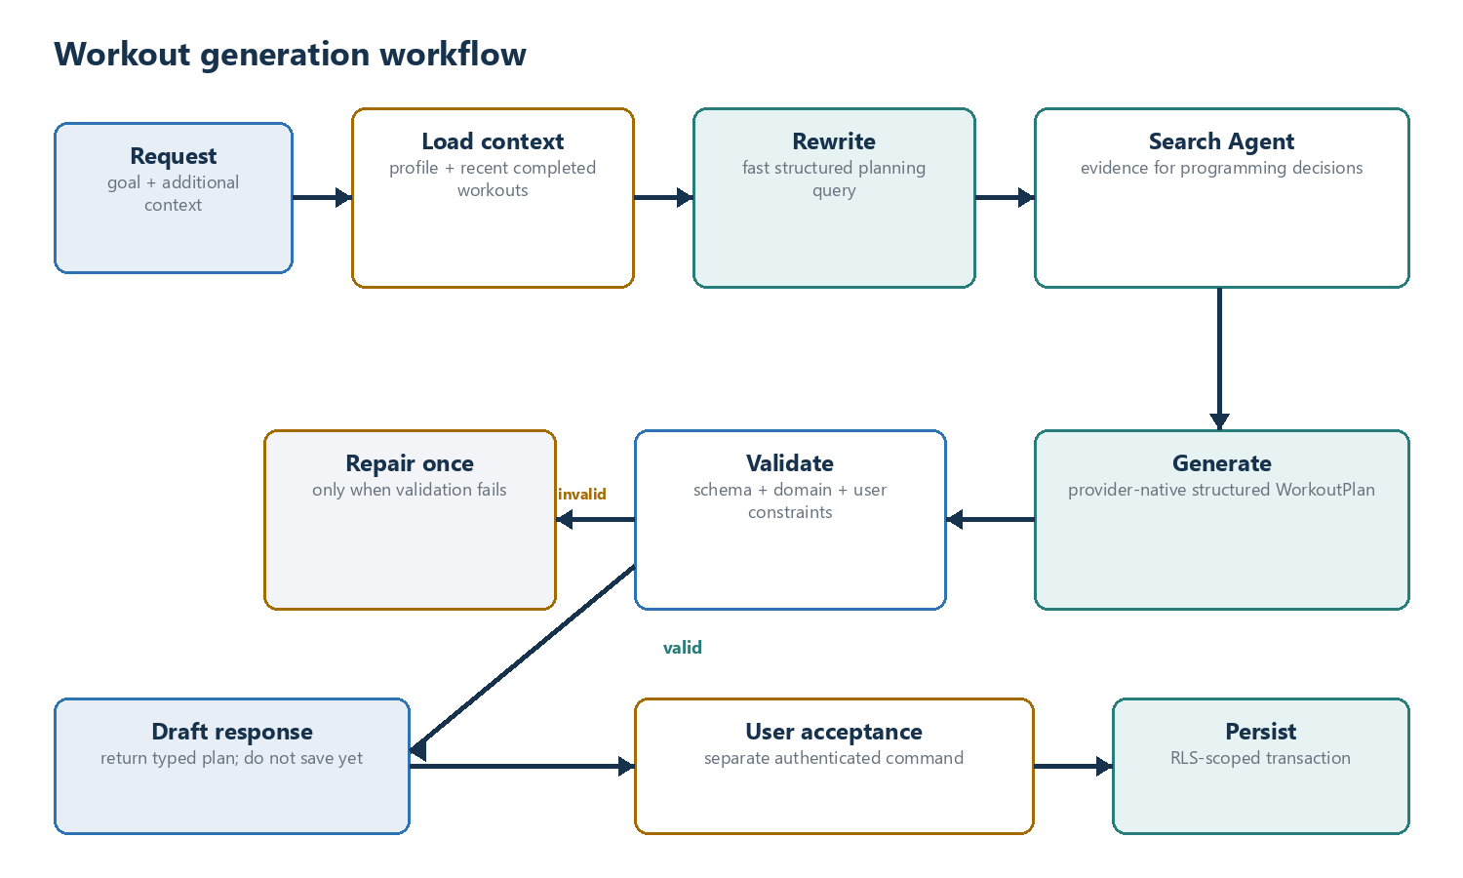
Figure 3. Workout generation from request through user acceptance and persistence.

Input context
Load profile and prior training in one context node, using concurrent service calls internally. Query only the data needed to make the next programming decision. A useful first window is the most recent four to eight weeks plus a compact summary of older trends.
Context group | Minimum useful fields | Purpose
Profile | goal, experience, training days, session duration, equipment | Hard constraints and personalization
Completed workouts | date, exercise, sets, reps, load, RPE/RIR, completion | Progression, fatigue, adherence
Scheduled workouts | future date and planned exercises | Avoid collisions and duplicate stress
Readiness / feedback | pain, soreness, sleep, notes when available | Modify volume, intensity, and exercise choice

The current exercise schema can support an initial version, but production-quality progression becomes much stronger when completed sets, load, effort, and completion status are captured. Missing data should be represented explicitly rather than inferred.

Low-latency planning rewrite
Use a small, low-latency model with structured output. It should transform the user request and compact profile/history summary into a retrieval-oriented WorkoutPlanningQuery. It must not invent injuries, equipment, dates, or training age. If rewriting times out, fall back to a deterministic query assembled from the original goal and known profile fields.
class WorkoutPlanningQuery(BaseModel):
retrieval_query: str
primary_goal: str
constraints: list[str]
priorities: list[str]
freshness: Literal["not_needed", "helpful", "required"]

Structured generation
After retrieval, use a direct model call with provider-native structured output when supported. The generator no longer needs tools, so it does not need to be a second agent. Validate the returned Pydantic object before returning it to the API.
- Use stable exercise identifiers when available; keep display names as presentation data.
- Represent intensity explicitly, such as load guidance, percentage, RPE, or RIR.
- Include rest, tempo, warm-up, and conditioning fields only when the product can render and store them.
- Carry schema_version so plans can evolve safely.
- Keep evidence references at workout or rationale level without exposing long raw chunks.

Validation and repair
Validation layer | Examples | Failure behavior
Schema | types, required fields, date format, enum values | One structured repair attempt
User constraints | days/week, duration, equipment, requested goal | Repair or return actionable error
Programming rules | volume bounds, duplicate stress, rest, progression | Repair with validation errors
Persistence | foreign keys, idempotency, transaction | Do not partially save

Safety boundary: The workflow returns a draft. Saving is a separate authenticated action after user acceptance. High-impact changes, injury-related requests, and unsupported constraints should produce clear caveats or require review rather than silent invention.

Workout workflow skeleton
class WorkoutState(TypedDict, total=False):
request: PlanRequest
user_context: UserTrainingContext
planning_query: WorkoutPlanningQuery
sources: SourceBundle
draft: WorkoutPlan
validation_errors: list[str]
repair_count: int
def build_workout_workflow(*, context_service, rewrite_node, search_node, generate_node):
graph = StateGraph(WorkoutState, context_schema=WorkflowContext)
graph.add_node("load_context", context_service.load_training_context)
graph.add_node("rewrite", rewrite_node)
graph.add_node("search", search_node)
graph.add_node("generate", generate_node)
graph.add_node("validate", validate_workout_plan)
graph.add_node("repair", repair_workout_plan)
graph.add_edge(START, "load_context")
graph.add_edge("load_context", "rewrite")
graph.add_edge("rewrite", "search")
graph.add_edge("search", "generate")
graph.add_edge("generate", "validate")
graph.add_conditional_edges(
"validate",
validation_route,
{"valid": END, "repair": "repair", "fail": END},
)
graph.add_edge("repair", "validate")
return graph.compile(checkpointer=production_checkpointer)
async def generate_workout(request, user) -> WorkoutPlan:
context = WorkflowContext(
user_id=user.id,
access_token=user.access_token,
conversation_id=f"plan:{request.request_id}",
)
state = await workout_graph.ainvoke(
{"request": request, "repair_count": 0},
context=context,
config={"configurable": {"thread_id": context.conversation_id}},
)
return WorkoutPlan.model_validate(state["draft"])

6. Production requirements

Client lifecycle and concurrency
Initialize Chroma, Tavily, Cohere, and model clients once per server process, preferably during FastAPI lifespan startup or in cached provider factories. Function calls reuse those objects. Each worker process still owns its own instances. Confirm thread safety for any synchronous SDK used from concurrent requests; wrap blocking calls with an executor or use async clients where available.

Timeouts, retries, and fallbacks
Dependency | Timeout / retry posture | Fallback
Supabase auth/data | Short timeout; retry only idempotent reads | Fail closed for auth; clear API error for data
Chroma | Bounded timeout; one retry for transient failure | Web-only evidence if policy permits
Tavily | Bounded timeout; one retry with jitter | Research-only evidence or answer without fresh claims
Cohere rerank | Short timeout; no unbounded retry | Use retrieval order and record rerank=false
Rewrite model | Very short timeout | Deterministic query from original request
Generation model | Request deadline and cancellation | Return a retryable error; never partial structured plan

Security controls
- Treat retrieved text, workout notes, and web pages as untrusted data; prompts must state that embedded instructions are not executable.
- Keep access tokens in runtime context only and redact Authorization headers, API keys, and raw prompts from logs.
- Expose domain tools, not generic database tools. Validate every identifier and field with Pydantic.
- Use idempotency keys for writes and transactions for multi-table workout persistence.
- Require explicit confirmation for deletes, replacements, bulk edits, or changes that affect scheduled workouts.
- Enforce maximum query length, result counts, document size, tool calls, and total workflow deadline.

Observability
Trace each graph run with request_id, user_id hash, conversation_id, node durations, model/provider names, token usage, retrieval counts, source mix, rerank status, validation failures, and final outcome. Do not record raw JWTs or unnecessary personal data. Use LangSmith or OpenTelemetry-compatible tracing according to the team's operational preference.

Testing and evaluation
Level | Coverage
Unit | Search policy, normalization, source blending, Pydantic schemas, workout validators, RLS query builders
Contract | Provider adapter fixtures for Chroma, Tavily, Cohere, and Supabase error shapes
Agent / graph | Search tool-choice and chaining coverage; no-search chat; research-only; web-only; combined search; optional rerank; query-refinement and tool-call limits
Security | Cross-user record attempts, prompt injection in retrieved text, mutation confirmation, secret redaction
Evaluation | Citation correctness, retrieval relevance, research share, plan constraint adherence, progression quality
Load | Concurrent streams, worker client reuse, cancellation, timeout behavior, provider throttling

Recommended delivery sequence
- Define WorkflowContext, SourceBundle, WorkoutPlanningQuery, and WorkoutPlan contracts.
- Split current search.py into framework-agnostic provider services, then build ai/search as the typed LangChain agent capability over those services.
- Create RLS-scoped conversation and training-history services over the existing Supabase transport.
- Build Chat workflow with history, controller, search delegation, streaming, and persistence.
- Build Workout workflow with context load, rewrite, search, structured generation, and validation.
- Add confirmation-based workout persistence and mutation audit records.
- Add production checkpointer, tracing, evaluations, and failure-injection tests.
- Remove the old rag pipeline only after both workflows pass parity and security checks.

7. Decision record
Decision | Choice | Consequence
Agentic root | app/ai; no agents/ directory | Uses workflows, search, contracts, and services as meaningful responsibility boundaries.
Top-level router | No standalone router agent | Fewer model calls; Chat Controller handles tool decisions.
Search ownership | One agent in ai/search | Avoids a one-item category while preserving agent-owned retrieval policy and tool chaining.
Search persistence | Stateless per invocation | No checkpoint conflicts or hidden search memory.
Chat history | Supabase product tables | Clear source of truth; checkpointing remains operational.
JWT handling | Immutable runtime context | RLS works without exposing secrets to the model or checkpoints.
Workout generator | Direct structured model call | Less agent overhead after evidence has been collected.
Workout writes | User acceptance then transaction | Prevents accidental side effects and partial plans.
Provider abstraction | Small service adapters | Swapping vendors does not require rewriting graph logic.

8. Documentation basis
The design was checked against the following primary documentation on July 27, 2026. Package APIs should still be pinned and validated in the application's lock file before implementation.
- LangGraph: Workflows and agents
https://docs.langchain.com/oss/python/langgraph/workflows-agents
- LangChain: Agents
https://docs.langchain.com/oss/python/langchain/agents
- LangChain: Custom workflow
https://docs.langchain.com/oss/python/langchain/multi-agent/custom-workflow
- LangGraph: Streaming
https://docs.langchain.com/oss/python/langgraph/streaming
- LangGraph: Persistence
https://docs.langchain.com/oss/python/langgraph/persistence
- LangGraph: Subgraphs
https://docs.langchain.com/oss/python/langgraph/use-subgraphs
- LangChain: Runtime context
https://docs.langchain.com/oss/python/langchain/runtime
- LangChain: Tools and ToolRuntime
https://docs.langchain.com/oss/python/langchain/tools
- LangChain: Structured output
https://docs.langchain.com/oss/python/langchain/structured-output
- Chroma: Hybrid Search with RRF
https://docs.trychroma.com/cloud/search-api/hybrid-search
- Tavily: LangChain integration
https://docs.tavily.com/documentation/integrations/langchain
- Tavily: Search API and search-depth behavior
https://docs.tavily.com/documentation/api-reference/endpoint/search
- Cohere: Rerank API v2
https://docs.cohere.com/v2/reference/rerank
- Supabase: JSON Web Tokens
https://supabase.com/docs/guides/auth/jwts
- Supabase: Securing your data and RLS
https://supabase.com/docs/guides/database/secure-data
- Supabase Python: Retrieve a user
https://supabase.com/docs/reference/python/auth-getuser

