Problem3:

I used several ways to improve the performance of the model in a few ways:

The first thing I did is to add more examples into the the original data set. The procedure is simply creating noises(randomly from 0 to 1) in k(randomly from 1 to 10) pixels for one picture. I did it 10 times for each piece of data and got a data set 10 times larger.

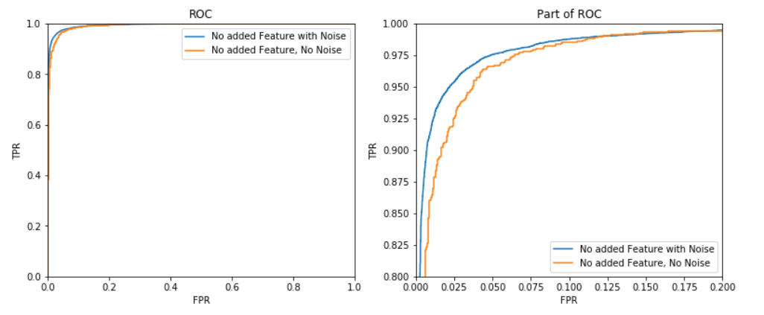

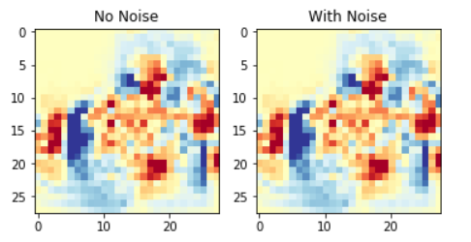

This improves the error rate of the test set from 5.3% to **4%**. And the AUROC is improved to **0.993**. The feature plot doesn’t change much, not surprisingly.

Then I trained with the new feature given(ave and x2). The improvement is not significant. The error rate drop to **0.39** and the AUROC is improved quite a bit to **0.996**.

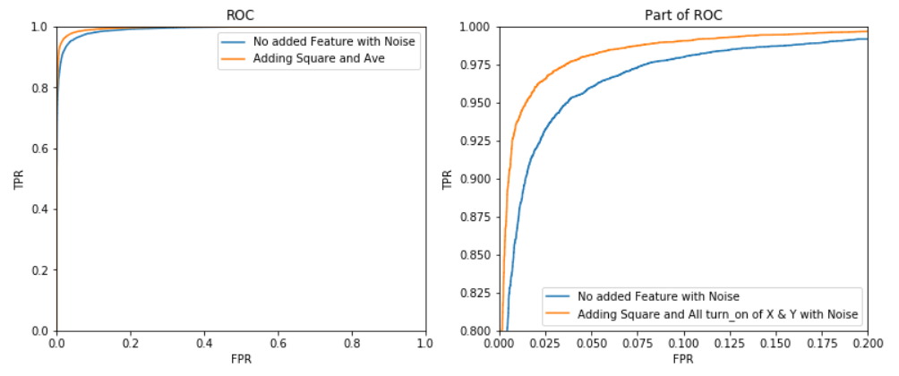

The model I used is to consider a bright point with its neighbors. How many bright points has one bright neighbor horizontally, how many has 2? The same applies vertically. This 4 features helps to reduce the error rate to **3.6%**, while interestingly the AUROC keeps almost the same at **0.994**.

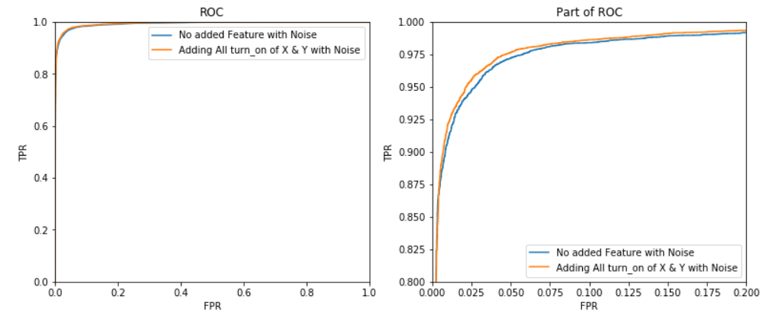

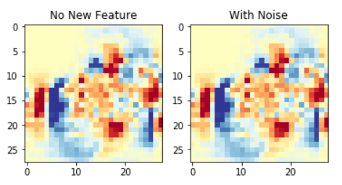

The feature map of weight doesn’t change so much, but the weight of added features are also comparably large.