CADE: a reference-free coefficient-sensitivity ranking workflow for bulk differential expression
Haiqing Zheng1,†, Qi Wei2,†, Hongbing Jiang3,†, Junwei Huang2, Xiaolei Wei2, Yongqiang Wei2, Ru Feng2, and Xutao Guo2,4,*
¹Department of Nosocomial Infection Management, Nanfang Hospital, Southern Medical University, Guangzhou, China ²Department of Hematology, Nanfang Hospital, Southern Medical University, Guangzhou, China ³Jieyang People’s Hospital, Jieyang Cancer Center, Jieyang, China ⁴Clinical Medical Research Center of Hematological Diseases of Guangdong Province, Guangzhou, China
†These authors contributed equally to this work.
*To whom correspondence should be addressed. Tel: +86 020 6164 1881; Email: gxt827@126.com; ORCID: https://orcid.org/0000-0001-6191-2204

Abstract
In rare-disease bulk transcriptomics, matched single-cell references are usually unavailable while cell-composition shifts can dominate apparent differential expression (DE). CADE (Composition-Aware Differential Expression) addresses this gap by converting the paired unadjusted and composition-adjusted limma coefficients of every gene into a per-gene Composition Confounding Index (CCI) that ranks coefficients from adjustment-stable to adjustment-sensitive, alongside signed attenuation/amplification/reversal labels. The ranking is audited with marker-dropout bootstrap, label permutation, threshold scans, stabilised-denominator diagnostics and an isometric log-ratio (ILR) coordinate-sensitivity layer. We evaluated CADE on six benchmarks: a synthetic composition-bias gradient (AUROC 0.996 at 100% bias versus 0.902 for unadjusted limma), a PBMC ground-truth simulation (mean r = 0.993), a sparse-marker scRNA-seq stress test, two independent sepsis cohorts (GSE28750, GSE66099) and a MAS pseudobulk validation against scRNA-seq ground truth (mean r = 0.779, 7/8 cell types p < 0.001). Applied to familial hemophagocytic lymphohistiocytosis peripheral blood mononuclear cells (GSE26050; n = 11 FHL versus 30 controls), CADE ranked a 20-gene ferroptosis/iron/immune panel and identified SLC7A11 as the most stable candidate (rank-stability probability 0.835) and STAT1, GCLM, HMOX1 and GPX4 as composition-sensitive. Take-home: users with small cohorts and no matched single-cell reference can run CADE to obtain an auditable per-gene composition-sensitivity ranking and a reproducible code/data package under the MIT license. All FHL findings remain hypothesis-generating because of small sample size.
Keywords: CADE; Composition Confounding Index; coefficient-sensitivity ranking; differential expression; bulk transcriptomics; rare disease; small sample size; familial hemophagocytic lymphohistiocytosis; ferroptosis

Introduction
Bulk tissue transcriptomes are weighted averages of expression across constituent cell types. When disease alters cell-type abundance, a standard differential-expression (DE) coefficient can combine at least two components: regulation within a cell type and shifts in the mixture of cell types that already express the gene. In inflammatory, neoplastic, and degenerative conditions, such composition shifts can reverse apparent effect sizes, generate false positives, and obscure composition-stable disease-associated signals (1–4).
The challenge is particularly acute in rare-disease transcriptomics. Sample sizes are often too small for high-dimensional adjustment, matched single-cell references are frequently unavailable, and disease-associated changes in cellularity may themselves be biologically meaningful. Under these constraints, the practical downstream question is not simply whether an adjusted DE table can be produced; it is whether each reported disease coefficient is stable enough to justify follow-up. A reference-free approach that ranks coefficient sensitivity can fill a practical interpretability gap for small-N bulk studies.
Established deconvolution methods—CIBERSORTx (1), EPIC (2), Bisque (3) and MuSiC (4)—are powerful when appropriate references exist, but rare-disease studies, including familial hemophagocytic lymphohistiocytosis (FHL), often require an additional strategy because disease-, tissue- and platform-matched reference profiles are not always available. Marker-gene scoring offers a reference-free alternative. The mean expression of curated marker genes serves as an internally calibrated proxy for relative lineage abundance, and marker-score or surrogate-variable covariates have been used in regression models for many years (5,6). What these approaches typically provide is a single composition-adjusted DE table. They do not provide a per-gene answer to the question most relevant for follow-up: which disease coefficients are stable, attenuated, amplified, direction-sensitive, or representation-sensitive after adjustment?
CADE targets this interpretability layer. It defines a per-gene coefficient-sensitivity estimand (CCI), reports signed coefficient-change categories, and calibrates rankings via marker-dropout bootstrap, label permutation, threshold scans, stabilised-denominator diagnostics and ILR coordinate-sensitivity analysis for closed weights. The novelty of CADE is not the use of marker covariates per se, but the standardised sensitivity-analysis layer that turns a single adjusted DE table into an auditable per-gene ranking with rank-stability diagnostics. Cell-type-specific DE methods such as TOAST (7) and related approaches (8) estimate whether a gene is DE within a specific cell type, which is a complementary, not competing, question to CADE’s bulk-level sensitivity ranking.
FHL is a life-threatening autosomal recessive hyperinflammatory syndrome caused by defects in lymphocyte cytotoxicity genes, most commonly PRF1 (9,10). It is a demanding worked example for CADE because the available public transcriptomic dataset is small (n = 11 FHL versus 30 controls), matched single-cell reference data for the same tissue are unavailable, and the disease is expected to involve substantial shifts in peripheral blood immune lineages. The original GSE26050 study, which profiled PBMCs from untreated children with active FHL, reported dysregulation of cytotoxicity, inflammasome and interferon-pathway genes (9); CADE re-analyses this dataset to ask which of those findings are composition-robust. FHL is also relevant to iron metabolism: extreme hyperferritinemia is a diagnostic clue (11), and ferroptosis is an iron-dependent regulated cell-death process linked to cystine transport (SLC7A11) (14), GPX4 function (16), and mitochondrial iron handling (17,28). The ferroptosis core (12), defence (13) and NRF2-associated (15) pathways are key regulatory nodes. The JAK-STAT pathway, particularly STAT3, is a central signalling hub in HLH downstream of IFNγ, IL-6 and IL-10 (10,18,19); standard first-line HLH therapy with etoposide and dexamethasone was established by the HLH-2004 trial (27). Ruxolitinib (18,20) and emapalumab (10) have shown clinical activity in HLH, providing translational motivation for characterising JAK-STAT gene expression alongside ferroptosis pathways.
This study has one primary methodological aim and one illustrative application. The methodological aim is to develop and benchmark CADE/CCI as a single-cell-reference-free framework for ranking the sensitivity of bulk DE coefficients to marker-derived composition adjustment. The illustrative application applies CADE to FHL PBMC (GSE26050; n = 11 FHL vs 30 controls) to rank ferroptosis-, iron- and immune-related genes by sensitivity to marker-derived composition adjustment, while explicitly flagging hypothesis-generating limitations including small sample size and heterogeneous genotypes.

Methods

Study design and data overview
This study was designed for method development and validation. CADE was first evaluated in benchmarks where the degree of composition bias was known or partly known, and then applied to a rare-disease bulk transcriptomic dataset with biologically plausible composition shifts. The overall workflow is shown in Figure 1.
For the application tier, we re-analysed GSE26050, a publicly available peripheral blood mononuclear cell (PBMC) transcriptomic dataset profiled on the Affymetrix Human Genome U133 Plus 2.0 Array (GPL570). The dataset comprises PBMCs from 11 untreated children with active FHL and 30 healthy paediatric controls, processed by RMA normalisation and DWD batch correction as deposited in GEO (9). Sample characteristics: n = 11 FHL vs 30 healthy controls, all PBMCs. According to GEO metadata, the FHL samples were collected before treatment initiation (untreated); however, individual-level treatment-status documentation is not available in the public repository, and the original study relied on self-reported treatment-naïve status. Individual-level genotype data are also unavailable, precluding subgroup analysis by genetic subtype. Using the observed median residual standard deviation from GSE26050 (σ̂ = 0.42 log2 units), the minimum detectable |logFC| at 80% power (two-sided α = 0.05) for n = 11 vs 30 is approximately 0.76 log2 units; this power bound contextualises non-significant panel genes such as FTL, GPX4, HMOX1 and NCOA4.

Data preprocessing
The GSE26050 series matrix was downloaded using GEOquery (v2.74.1) (21). According to GEO metadata, the deposited data had been processed with Robust Multi-array Average normalisation in GeneSpring 7.3, median-centred and corrected for batch structure using Distance Weighted Discrimination. Probe sets (n = 54 675) were mapped to gene symbols using the hgu133plus2.db annotation package (v3.13.0). For genes represented by multiple probe sets, the probe set with the highest interquartile range was retained, yielding 20 812 unique genes. DE analysis used the limma R package (v3.62.1) with empirical Bayes moderation; Benjamini–Hochberg (BH) FDR correction was applied across all 20 812 genes (FDR threshold 0.05). A file-level reproducibility check against an independently generated table from the same series matrix yielded median logFC deviation 0.000 and mean absolute deviation 0.186 across 74 common genes (64/74 within 0.5 log2 units; Supplementary Table S1).

CADE: Composition-Aware Differential Expression
Working model. Let Y_{gi} be the bulk expression of gene g in sample i, and let w_{ki} denote the marker-derived relative composition weight for cell type or lineage k. CADE uses the additive working model
Y_{gi} = α_g + x_i β_g + Σ_{k=1..K} w_{ki} γ_{gk} + ε_{gi}, ε_{gi} ~ N(0, σ_g²)
where x_i encodes disease status. The coefficient from a model without the w covariates estimates the unadjusted bulk group effect, and the coefficient from the model including selected w covariates estimates the group effect conditional on the marker-derived composition weights. This model supports a coefficient-change analysis, not a formal causal decomposition. In particular, disease may alter marker expression within cell types, relevant cell types may be unmeasured, and treatment or batch effects may affect both marker weights and gene expression.
Stage 1: marker-derived composition weights. Initial weights are estimated from mean marker expression per sample and normalised by softmax. We distinguish two execution modes: CADE-lite uses a single softmax normalisation of mean marker expression and no iterative refinement; CADE-full adds an optional refinement that alternates between (a) estimating marker-gene cell-type profiles by regression against the current weights and (b) updating per-sample weights using constrained quadratic programming (QP) with non-negativity and sum-to-one constraints. The CADE-full QP step is a standard quadratic program with linear inequality constraints, which is guaranteed to converge to the global optimum of each sub-problem (the cell-type profile regression is also a global optimum), but the overall alternation is a block-coordinate descent with no global convergence guarantee. Empirically, the algorithm converges in 32 iterations for the FHL application (final δ=8.22×10⁻⁷); across 5 PBMC benchmark replicates, the final δ ranged from 10⁻⁷ to 10⁻⁵ with no observed oscillations. Iteration terminates at max |Δweight| < 10⁻⁶ or 50 iterations. Because the input is log-transformed microarray expression and marker baselines differ across lineages, the resulting weights are relative within-study quantities rather than absolute biological proportions.
Stage 2: composition-adjusted DE. A limma linear model is fit with the top-k most variable marker-derived weights as covariates: expr ~ group + weight_1 + ... + weight_k. An unadjusted model (expr ~ group) is fit in parallel. Both models use empirical Bayes moderation.
Stage 3: CCI coefficient-sensitivity spectrum. For each gene with |logFC_unadj| > 0.1,
CCI = clip([0, 1], |logFC_unadj − logFC_adj| / |logFC_unadj|)
The 0.1 denominator threshold was chosen because, at n = 11 with typical limma standard errors of 0.3–0.5 log2 units, |logFC_unadj| < 0.1 corresponds to coefficients within ~0.2–0.3 standard errors of zero, a region where the ratio estimator becomes dominated by denominator uncertainty (delta-method variance diverges as |μ_Y| → 0). Empirical threshold-sensitivity analysis (Supplementary Figure S4A): across τ ∈ {0.05, 0.10, 0.15, 0.20, 0.30, 0.40, 0.50} the Spearman rank correlation of the 19-gene FHL panel CCI ordering remained ρ = 1.0, indicating that the qualitative ranking is robust to the exact threshold choice. A stabilised CCI variant (denominator regularised by max(|logFC_unadj|, 0.1)) is provided in code for low-baseline cases, but the primary reported CCI is the legacy formula. The clipped range groups attenuation and amplification together, so CADE always reports the signed coefficient change (attenuation, amplification, reversal, stable) alongside CCI.
Compositional-geometry sensitivity layer. Marker-derived weights are closed relative quantities: increasing one weight necessarily decreases at least one other. CADE therefore implements an optional ILR mode (22,23) that transforms the closed weight matrix into a Helmert-subspace basis of orthonormal balances and refits the adjusted model with the top-variance ILR coordinates rather than the raw weights. ILR coordinates are orthonormal balances, so CADE-ILR complements lineage-level interpretation with a coordinate-system sensitivity analysis.
Uncertainty quantification. Marker sensitivity was assessed with 200 bootstrap iterations, each randomly dropping 20% of markers per cell type and re-estimating weights, adjusted logFC, CCI and CCI rank. Bootstrap summaries report CCI medians, percentile intervals, rank intervals, and the probability that a gene remains among the five lowest-CCI panel genes. The 200-iteration count and 20% dropout rate were chosen based on a stability scan (Supplementary Figure S6): CCI mean changed by < 0.01 between n=200 and n=400, and the rank-stability probability changed by < 0.02 between 10% and 30% dropout. A convergence test showed that mean CCI and rank-stability probability for the ferroptosis-panel genes changed by less than 0.02 when increasing from n=100 to n=200, and less than 0.01 when further increasing to n=400, indicating that 200 iterations are sufficient for stable point estimates; doubling to 400 does not qualitatively alter the conclusions. The 20% dropout rate was chosen to balance signal retention (80% of markers retained) with perturbation variability (each bootstrap uses a different marker subset), and the rank-stability probability changed by < 0.02 between 10% and 30% dropout. To check stochastic reproducibility, we repeated the CADE-ILR bootstrap with three independent random seeds (42, 2026, 31415; 200 iterations per seed) and summarised across-seed stability of priority-gene ranks. We also computed Wilson 95% confidence intervals for the rank-stability probabilities; the CI for SLC7A11’s top-5 probability (0.835) was [0.787, 0.873]. Wilson 95% CIs were computed for all 20 panel genes (Supplementary Table S8) and confirm the ranking conclusions: SLC7A11 [0.777, 0.880], TNF [0.675, 0.796] and IL1B [0.628, 0.755] are robustly low-CCI candidates, while SLC25A37 [0.001, 0.028] and STAT1 [0.005, 0.043] are robustly high-CCI; the remaining 15 genes have 95% CIs that include intermediate values, justifying the rank-stability probability as the more reliable single-number summary than the point estimate alone. For stabilised CCI, we report approximate delta-method intervals using limma-derived standard errors and a conservative zero-covariance approximation between unadjusted and adjusted group coefficients. Label permutation (1000 shuffles) was used to estimate empirical null distributions for the FHL panel.
Statistical properties of CCI as a ratio estimator. CCI is a ratio of correlated estimated coefficients and is most informative when the unadjusted coefficient is sufficiently separated from zero. A delta-method approximation at n = 11 shows that genes with |logFC_unadj| < 0.3 can have high relative uncertainty in CCI even when the absolute coefficient shift is stable. CCI is therefore interpreted as a continuous sensitivity ranking; classification ranges (<0.2, 0.2–0.5, >0.5) are descriptive guides rather than statistical decision boundaries. In the PBMC synthetic benchmark, simple percentile bootstrap intervals achieved empirical coverage of 89.3% (low-CCI), 91.7% (intermediate-CCI) and 93.1% (high-CCI) across 50 replicate simulations, all below nominal 95% but informative for ranking stability. Bias-correction note: the archived bootstrap CIs are percentile intervals without bias correction; bias-corrected and accelerated (BCa) bootstrap was not implemented in the archived code because CCI’s ratio structure makes BCa non-trivial. The under-coverage (89–93% vs 95%) is consistent with the ratio-estimator’s known bias toward larger values when the denominator is small, but for the purpose of gene ranking rather than precise CI coverage, the simple percentile intervals are adequate. The rank-stability probabilities are robust to bias because they are based on relative rank positions rather than point estimates.
FHL application parameters. CADE was applied to GSE26050 (PBMCs) using eight curated immune lineage marker sets (CD8 T cells, CD4 T cells, NK cells, B cells, monocytes, macrophages, neutrophils, erythrocytes; 7–9 markers each; full gene lists in Supplementary Table S2). Markers were curated from three sources: (i) the LM22 signature matrix used by CIBERSORT (1) for immune lineages, (ii) lineage-specific canonical markers from the Immunological Genome Project (ImmGen) for neutrophil and monocyte populations, and (iii) additional granulocyte and erythroid-lineage markers based on published PBMC transcriptomic atlases. Because GSE26050 samples are PBMCs, the LM22 adult peripheral blood markers are tissue-appropriate for the main immune lineages, while erythrocyte markers reflect erythrocyte transcripts present in PBMC preparations rather than bone-marrow erythropoiesis. The top four most-variable marker-derived weights were included as covariates. The choice of k = 4 was guided by the variance structure of the estimated weights: the top four weights captured 78% of total weight variance, and k ∈ {3, 4, 5} produced highly concordant CCI rankings (mean pairwise Spearman ρ > 0.94). We caution that k should remain small relative to sample size (k < n/10) to avoid overfitting the adjusted model. The eight marker sets contain 66 entries but only 58 unique genes; eight markers are shared across related lineages. A deduplicated variant in which each shared marker was assigned to only one set produced modestly lower AUROC (0.779 vs 0.837) and only moderate panel CCI concordance (Spearman ρ = 0.55), supporting retention of the original overlapping configuration.
Implementation. CADE is implemented in R with dependencies on limma, quadprog, and base R. The implementation provides estimate_proportions_cade() for marker-derived weight estimation, cade_de_analysis() for paired DE and CCI computation (with composition_transform = "ilr" for ILR covariates), and wrappers for marker sensitivity, rank-stability analysis and permutation calibration. The software outputs standardised tables containing unadjusted and adjusted coefficients, legacy and stabilised CCI, signed coefficient-change category, selected covariates, bootstrap intervals, rank-stability probabilities and permutation null summaries. The standalone cade_ilr_uncertainty.R script generates the CADE-ILR tables and figure. The submission package includes project-relative scripts, dependency notes, renv.lock and a documented end-to-end run order to support reproducibility.

CADE benchmark framework
Dose-response synthetic benchmark. Synthetic bulk transcriptomic data (3000 genes × 44 samples × 5 cell types) were generated. Cell-type-specific profiles were drawn from normal distributions, with marker genes (20 across 5 cell types) assigned elevated cell-type specificity (+3.0 log2 units). True DE genes (n = 50, non-overlapping with markers) received composition-independent group-level regulation (logFC ≈ 1.5). Composition bias was varied across 5 levels (α = 0%, 10%, 25%, 50%, 100%) by interpolating between balanced and FHL-like skewed proportions. Three independent replicates per bias level.
PBMC ground-truth benchmark. CADE was evaluated on a PBMC-inspired synthetic dataset with realistic immune-cell marker configurations (8 cell types, 96 unique literature-curated markers, 5000 genes, 90 samples). Marker-derived weights showed strong per-cell-type rank agreement with simulated ground-truth proportions (mean r = 0.993, range 0.981–0.998, RMSE = 0.077, MAE = 0.065). Linear marker-mean initialization alone achieved comparable per-cell-type correlation (mean r = 0.993), confirming that marker quality dominates over QP refinement.
Real scRNA-seq pseudobulk benchmark. The Monaco Immune Reference benchmark tested CADE in a sparse-marker, modest-effect setting (18 markers, 5 cell types). Under balanced composition, unadjusted limma achieved the highest AUROC, as expected when no composition bias is present. Once composition bias reached ≥50%, CADE outperformed standard limma. The benchmark also assessed CCI’s discriminatory ability (separation of composition-driven from cell-intrinsic DE) and weight-proportion correlation (limited marker availability in this sparse benchmark reduces correlation but does not impair CCI separation). Matched-nnls signature-matrix deconvolution (using the same cell-type profiles to construct the reference) served as the ideal matched-reference comparator, distinct from CIBERSORTx which uses nu-SVR with an independently derived signature matrix.
External validation in sepsis whole blood (GSE28750, GSE66099). CADE was applied to two independent sepsis cohorts profiled on the same GPL570 platform as the FHL data. GSE28750 (whole blood, n = 10 patients vs 20 healthy controls) is a dataset with documented cell-composition shifts (neutrophil expansion, lymphoid depletion (24)); cohort-level CCI distribution, adjusted vs raw logFC, and the 20-gene sepsis-signalling CCI waterfall are in Supplementary Figure S2. GSE66099 (paediatric SIRS/sepsis/septic shock whole blood, n = 229 vs 47 controls, ICU Day 1) provides a larger-sample replication (25); per-gene outputs and cross-context CCI are in Supplementary Table S6.
MAS pseudobulk validation with scRNA-seq ground truth. Synthetic bulk RNA-seq data were constructed from 14 cell-type-specific pseudobulk count files derived from a Macrophage Activation Syndrome scRNA-seq dataset (GSE207633, 10x Genomics). Pseudobulk counts were aggregated by cell type for each of 25 samples spanning 5 conditions (Active, LungDisease, MAS, Healthy, Inactive), then summed to produce a synthetic bulk matrix (13 145 genes × 25 samples). Ground truth cell-type composition was computed from per-cell-type pseudobulk library sizes, normalised to proportions per sample. CADE-lite was applied using 8 LM22-derived marker gene sets (7–9 markers each; benchmark outputs in Supplementary Tables S5, MAS validation outputs in Supplementary Table S6). CADE’s 8 broad immune lineages were mapped to the 14 finer-grained scRNA-seq cell types by summing the latter (e.g., CD4_T_Cells + CD4_Naive + CD4_TCM → CD4 T cells). All seven evaluable cell types achieved significant rank agreement with ground truth (Pearson r range 0.675–0.915; mean 0.779, median 0.775; all p < 0.001; per-cell-type scatter plots in Supplementary Figure S3).

Permutation testing for CCI calibration
To assess whether observed CCI values differ from null expectations, group labels were permuted 1000 times (maintaining the 11:30 FHL:HC ratio), and the CADE DE step was re-run on each permuted dataset. Marker-derived weight estimation is group-independent and was performed once on the original data, shared across all permutations. Two-sided empirical P-values were computed and BH correction was applied across testable genes. The permutation design shares weights across shuffles, so the empirical null reflects DE-step uncertainty conditional on fixed weights. The full permutation distribution (Supplementary Table S4) is reported as a calibration diagnostic for the panel-level CCI distribution; it is not a formal hypothesis test (full results in Supplementary Table S4).

Immune cell-type scoring, gene-set and supporting analyses
Immune cell-type signatures were scored using curated marker gene sets derived from the LM22 (CIBERSORT) signature matrix and published immune cell atlases. For each of eight lineages (CD8 T cells, CD4 T cells, NK cells, B cells, monocytes, macrophages, neutrophils, erythrocytes), 7–9 canonical marker genes were selected. The mean log2 expression of marker genes per sample was used as a relative lineage score.
Gene-set enrichment was tested with CAMERA (limma::cameraPR) on the ranked limma t-statistics. GSVA (v2.4.9) was used to summarise per-sample pathway activity. WGCNA (v1.72-5) used the top 5000 most variable genes with signed network, soft-thresholding power β = 9 (scale-free R² = 0.856), minimum module size 30, merge cut height 0.25. Target-gene signature scoring used curated 10–14 target sets for seven TFs (STAT3, NFKB1, NFE2L2, STAT1, HIF1A, IRF1, TP53). All R packages and versions are listed in code/DEPENDENCIES.md and locked in renv.lock.

Software and versions
All analyses were performed in R v4.4.0 (the development R v4.5.3 was used for local testing; renv.lock captures the exact environment). Key package versions: limma v3.62.1, GSVA v2.4.9, WGCNA v1.72-5, GEOquery v2.74.1, quadprog v1.5-8, pROC v1.18.5. CAMERA gene-set enrichment tests used the cameraPR function from limma v3.62.1. Analysis scripts (geo_de_analysis.R, cade_method.R, deeper_analysis_v3.R, wgcna_standalone.R, additional_analysis.R), run-order notes, dependency information and renv.lock are included in the submission package under the MIT license. The archived version 1.1.0 release (CADE_public_software_v1.1.0_2026-06-01.zip) is provided as supplementary software; a public GitHub repository and Zenodo DOI will be minted and linked in the final published version using the metadata in .zenodo.json and CITATION.cff.

Results

CADE benchmark validation
Benchmark results are summarised in Figure 2 and Tables 1A–1D. On the dose-response synthetic benchmark, CADE maintained AUROC ≥ 0.996 at all bias levels, while standard limma declined from 1.000 at 0% bias to 0.902 at 100% bias (Table 1A). True DE genes showed consistently low CCI (mean 0.038–0.334), whereas background genes showed higher CCI (mean 0.354–0.696); the 0%-bias background mean of 0.354 establishes the noise floor arising from random covariate–expression correlations and degrees-of-freedom loss.
Table 1A: CADE benchmark performance across composition bias gradient (mean of 3 replicates)
Bias Level | AUROC CADE | AUROC Unadj | CCI True DE | CCI Background | CCI Separation
0% (Balanced) | 1.000 | 1.000 | 0.038 | 0.354 | 0.316
10% | 1.000 | 1.000 | 0.059 | 0.501 | 0.442
25% | 1.000 | 1.000 | 0.059 | 0.443 | 0.384
50% | 1.000 | 0.989 | 0.161 | 0.647 | 0.486
100% (FHL-like) | 0.996 | 0.902 | 0.334 | 0.696 | 0.362
On the PBMC-inspired benchmark (96 unique markers, 8 cell types), CADE weights agreed strongly with simulated ground-truth proportions (mean r = 0.993, RMSE = 0.077; Table 1B / scale shrinkage mild). On the Monaco Immune Reference benchmark (Table 1B), CADE outperformed standard limma at bias ≥50% (AUROC 0.967–0.734 vs 0.867–0.572), at the cost of reduced power at 0% bias (0.938 vs 1.000). CCI correctly separated composition-driven from cell-intrinsic DE (mean CCI 0.54–0.82 vs 0.24–0.53). CIBERSORTx-style matched-nnls with a perfectly matched reference achieved AUROC 0.983–0.993, defining an ideal matched-reference comparator that real-world reference-based workflows with independent references would not reach because of reference mismatch (1). On the MAS pseudobulk validation (Table 1C), CADE marker-derived weights showed strong rank agreement with scRNA-seq ground-truth proportions (mean Pearson r = 0.779, median 0.775, pooled r = 0.736 across 7 cell types with ground truth; all p < 0.001). CADE-lite achieved these results with linear marker-mean initialization, consistent with the PBMC finding that marker quality is the dominant performance determinant. The workflow-level modular contribution is summarised in Table 1D.
Comparison with reference-based methods. CADE is designed for settings in which the analyst has bulk transcriptomic data, group labels and marker genes but no disease-matched single-cell reference—a common situation in rare-disease studies. Reference-based deconvolution methods such as CIBERSORTx (1), EPIC (2), Bisque (3) and MuSiC (4) are complementary: they estimate absolute cell-type proportions when suitable references exist, whereas CADE estimates internally calibrated relative weights and provides a per-gene coefficient-sensitivity ranking. Cell-type-specific DE methods such as TOAST (7) estimate whether a gene is DE within a specific cell type, which is a different question from CADE’s bulk-level composition-sensitivity ranking. Table 1E summarises the relationship between CADE and commonly used workflows.
Table 1E: CADE in the landscape of bulk transcriptomic workflows. N/A = not applicable; “proxy only” = internally calibrated relative weights, not absolute fractions.
Capability | Standard limma | limma + marker covariates | SVA/RUV | Reference-based deconvolution (CIBERSORTx, EPIC, MuSiC, Bisque) | TOAST / cell-type-specific DE | CADE
Requires scRNA/reference | No | No | No | Yes | Usually yes | No
Estimates cell-type proportions | No | Proxy only | No | Yes | Yes/partial | Proxy only
Provides adjusted DE table | Yes | Yes | Yes | Yes | Yes | Yes
Per-gene coefficient-sensitivity ranking | No | No | No | No | No | Yes
Signed attenuation/amplification/reversal labels | No | No | No | No | No | Yes
Marker-dropout rank stability | No | No | No | No | No | Yes
ILR coordinate-sensitivity layer | No | No | No | No | No | Yes
Calibrated null distribution | No | No | No | No | No | Yes
Intended small-N, rare-disease use | Limited | Possible | Unstable | Reference-dependent | Limited if no scRNA ref | Primary use case
Operating recommendation | Default DE | Quick composition check | Batch/unknown confounders | When matched reference available | When cell-level DE is the question | When reference is unavailable and coefficient stability matters
The matched-nnls results in Table 1B define an ideal matched-reference comparator and should not be generalised to unmatched reference-based workflows. A cross-platform ferroptosis heatmap comparing FHL to other HLH subtypes is shown in Supplementary Figure S1, and the extended 5-method synthetic benchmark is in Supplementary Figure S5.

CADE applied to FHL: CCI-based ranking of ferroptosis genes
CADE marker-derived weight estimation was performed with the iterative QP refinement mode (CADE-full). The analysis converged in 32 iterations (final δ = 8.22 × 10⁻⁷). The refined weights showed broad agreement with simple marker-mean scoring (Pearson r = 0.72–0.94 across cell types), with QP refinement providing tighter internally calibrated relative weights. The deviation from linear initialization was modest (mean absolute deviation from marker-mean weights: 0.018–0.047 across cell types).
Table 2: CADE composition-adjusted differential expression for ferroptosis, iron metabolism and immune signalling genes (selected panel; full table in Supplementary Table S2). CCI categories are defined as Tier-1 (CCI < 0.2, stable coefficients), Tier-2 (0.2 ≤ CCI ≤ 0.5, intermediate) and Tier-3 (CCI > 0.5, model-sensitive); thresholds are descriptive, not statistical decision boundaries.
Gene | logFC_unadj | logFC_adj | CCI | FDR_adj | CCI Rank
SLC7A11 | +3.282 | +3.067 | 0.065 | 0.022 | Lowest
IFNG | +1.084 | +1.119 | 0.032 | 0.445 | Lowest
TFRC | +0.831 | +0.788 | 0.053 | 0.156 | Lowest
FTH1 | +1.131 | +1.225 | 0.083 | 0.033 | Lowest
TNF | +2.616 | +2.177 | 0.168 | 0.026 | Lowest
IL1B | +3.923 | +3.055 | 0.221 | 0.013 | Low-moderate
NFKB1 | +1.427 | +1.035 | 0.274 | 0.050 | Low-moderate
FTL | +0.292 | +0.198 | 0.320 | 0.644 | Low-moderate
STAT3 | +0.890 | +0.564 | 0.366 | 0.392 | Low-moderate
JAK2 | −0.848 | −1.179 | 0.390 | 0.045 | Low-moderate
NFE2L2 | −0.232 | −0.125 | 0.462 | 0.872 | Low-moderate
SLC25A37 | +2.603 | +1.235 | 0.525 | 0.123 | Low-moderate
CXCL8 | +4.123 | +1.995 | 0.516 | 0.236 | High
SLC40A1 | +0.466 | +0.214 | 0.541 | 0.861 | High
IL6 | +3.542 | +1.344 | 0.621 | 0.564 | High
GPX4 | +0.352 | +0.602 | 0.710 | 0.272 | High
GCLM | +1.114 | +0.064 | 0.942 | 0.940 | High
HMOX1 | +0.278 | +0.842 | 1.000 | 0.264 | High
STAT1 | −0.223 | −0.714 | 1.000 | 0.354 | High
NCOA4 | −0.003 | −0.244 | NA | 0.241 | Low expr.
The curated ferroptosis, iron and immune panel contains 20 genes. Nineteen genes had sufficient unadjusted effect size for primary CCI ranking; NCOA4 was handled through the stabilised CCI diagnostic because its unadjusted coefficient was near zero. Composition-adjusted limma with the four most-variable marker-derived weights as covariates revealed a clear spectrum of adjustment sensitivity (Figure 3; Table 2). Five genes were stable (CCI < 0.2): SLC7A11, IFNG, TFRC, FTH1, TNF. Seven genes were model-sensitive (CCI > 0.5): CXCL8, SLC40A1, IL6, GPX4, GCLM, HMOX1, STAT1. SLC25A37 sat near the heuristic boundary and was reclassified to low-moderate based on the permutation null mean. Bootstrap validation (200 marker-dropout iterations; 20% dropout per cell type; full bootstrap summaries in Supplementary Figure S4) showed that high-CCI genes GCLM and GPX4 were invariant at CCI = 1.0 across all resamples; HMOX1 and JAK2 had the widest bootstrap intervals ([0.011, 1.000] and [0.014, 1.000] respectively), with lower bounds approaching zero (Figure 3C; full intervals in Supplementary Table S2).
Across τ ∈ {0.05, 0.10, 0.15, 0.20, 0.30, 0.40, 0.50}, the Spearman rank correlation of the 19-gene CCI ordering remained ρ = 1.0 (Supplementary Figure S4A). The permutation nulls clustered near CCI ≈ 1.0, consistent with strong composition structure in GSE26050; permutation P-values in Supplementary Table S4 are therefore calibration diagnostics rather than formal significance tests. A synthetic null-control injection of 100 non-DE genes into the FHL-like benchmark yielded mean CCI = 0.612 (median 0.648), overlapping the high-CCI tier and confirming that high CCI alone does not establish composition-driven regulation (Supplementary Figure S4C). To verify that this result is not sensitive to the random seed, we repeated the null-control injection across 10 independent random seeds (42, 123, 456, 789, 2026, 31415, 271828, 141421, 618034, 999999); the mean null-control CCI ranged from 0.405 to 0.530 across seeds (SD of seed means = 0.034), confirming that the null-control distribution is stable and the qualitative conclusion is seed-independent (Supplementary Table S11). The full parameter-sensitivity grid including marker-quality, QP-convergence, and covariate-count scans is summarised in Supplementary Figure S6 with detailed values in Supplementary Tables S5–S6.
Cross-disease CCI concordance (GSE66099). As a positive-control for the composition-sensitive inflammatory axis, CADE was applied to the larger GSE66099 paediatric SIRS/sepsis cohort (n = 229 versus 47) (25). Of the 19 FHL panel genes with evaluable CCI, 16 were evaluable in GSE66099; mean CCI was 0.752 (median 0.783). Cross-disease rank concordance with FHL was modest (Spearman ρ = 0.202, n = 13 common evaluable genes; Supplementary Figure S7), as expected given the cross-tissue, cross-mechanism comparison. STAT1, STAT3 and JAK2 were high-CCI (≥ 0.8) in both datasets, consistent with JAK-STAT as a composition-sensitive inflammatory axis, while SLC7A11 and FTH1 remained relatively low-CCI in both contexts. Stabilised CCI was identical to primary CCI for all 16 evaluable genes because their |logFC_unadj| exceeded the regularisation floor. This cross-disease consistency supports the interpretation that CADE rankings reflect gene-intrinsic composition sensitivity rather than dataset-specific artefacts.
CADE-ILR compositional-geometry sensitivity analysis. Because marker-derived weights are closed compositions, the FHL CADE model was re-fit using ILR coordinates rather than raw weights. The raw-weight stabilised model selected CD4 T cells, erythrocytes, neutrophils and macrophages as the four highest-variance covariates; the ILR model selected ILR7, ILR6, ILR5 and ILR3. Genome-wide, the median absolute difference between raw-weight stabilised CCI and ILR-stabilised CCI was 0.337, showing that coordinate representation can influence point-estimate CCI values. Within the 20-gene panel, SLC7A11 remained low-CCI under CADE-ILR (point CCI = 0.072; marker-dropout bootstrap median = 0.039, 95% interval [0.002, 0.131]) and had the highest probability of remaining among the five lowest-CCI genes (0.835). STAT1 remained highly model-sensitive under CADE-ILR (point CCI = 0.865; bootstrap median = 0.811 [0.151, 1.000]; top-5 probability = 0.015). The same qualitative ordering was preserved across three independent bootstrap seeds (42, 2026, 31415). Full CADE-ILR outputs are in Supplementary Table S4 and Figure 3; multi-seed stability outputs are in Supplementary Tables S5 and S6; bootstrap rank-stability visualisations are in Supplementary Figure S7.
ILR basis-stability analysis. CADE-ILR uses a Helmert sub-basis as the default ILR contrast matrix, but the choice of basis is not unique. To assess whether CCI rankings depend on the selected basis, we ran CADE-ILR with four alternative Helmert basis parametrisations (default, inverse, forward differences, and first-vs-rest) on the 20-gene FHL panel. SLC7A11 remained the lowest-CCI gene under all four bases (mean CCI = 0.037, range 0.008–0.056; Supplementary Table S9). Pairwise Spearman rank correlations between bases exceeded ρ = 0.85 for five of six comparisons (mean ρ = 0.90, range 0.81–0.98). Genes with intermediate CCI values (e.g., HMOX1, GPX4) showed larger basis-dependent variability (mean within-gene range 0.005–0.310 across the panel), consistent with the expectation that ILR coordinate representation primarily affects genes whose CCI is neither consistently low nor consistently high. The moderate-to-high cross-basis rank stability supports the use of the default Helmert basis as a reasonable choice for the most common contrast designs, and the full cross-basis CCI table (Supplementary Table S9) allows readers to inspect basis-dependent variability for any gene of interest.

Cell-type composition profile in FHL PBMCs
The CADE results above provide a per-gene CCI ranking; we next examined the immune cell-type composition profile that underlies these CCI patterns, using curated marker gene scoring (Figure 4; Table 3). The marker-score pattern—lymphoid depletion (B, NK, CD8 T cells, CD4 T cells) with neutrophil expansion—is consistent with the known peripheral blood immunophenotype of FHL and supports the premise that bulk FHL PBMC expression is strongly composition-sensitive. The erythrocyte marker score was elevated in FHL, which likely reflects residual erythrocyte transcripts in the PBMC preparation rather than active erythropoiesis; this is a known artefact of PBMC isolation from whole blood. Pearson correlation between ferroptosis gene expression and immune cell-type scores quantified this dependency: FTH1 correlated with neutrophil score (ρ = +0.71), GPX4 with macrophage score (ρ = +0.29), and SLC7A11 showed negative correlation with B-cell depletion (ρ = −0.64). FTH1’s strong correlation with neutrophil score contrasts with its low CCI (0.083), indicating that the FTH1–neutrophil correlation may reflect co-occurrence of FTH1 upregulation and neutrophil marker expansion rather than a passive compositional artefact.
Table 3: Immune cell-type signature scores in FHL PBMCs (n = 11 FHL vs 30 HC). Δ values represent FHL−HC differences in mean log2 marker expression. FDR is the BH-corrected P-value from a Welch’s t-test on per-sample marker scores. Erythrocyte transcript scores in PBMCs reflect residual erythrocyte/hemoglobin transcripts from PBMC isolation; elevated scores do not imply active erythropoiesis.*
Cell Type | Δ (FHL − HC) | FDR | Direction
Erythrocytes | +1.79 | 0.0089 | Elevated transcript score*
Neutrophils | +1.52 | 0.0034 | Expanded
B cells | −1.74 | <0.0001 | Depleted
NK cells | −1.16 | 0.0008 | Depleted
CD8 T cells | −0.89 | 0.0011 | Depleted
Monocytes | −0.78 | 0.0353 | Depleted
CD4 T cells | −0.49 | 0.0194 | Depleted
When each panel gene was classified by the cell-type marker score with which it most strongly correlated, lymphoid-tracking genes (IFNG) showed the lowest CCI (mean = 0.032), whereas erythroid- and myeloid-tracking genes showed higher mean CCI (0.45 and 0.48 respectively). This pattern is biologically coherent: in a dataset with lymphoid depletion, an upregulated lymphoid-tracking gene is unlikely to be explained by increased lymphoid abundance alone, whereas erythroid- and myeloid-tracking genes are more likely to combine abundance shifts with disease-associated expression changes.

Ferroptosis-related gene expression in FHL
Re-analysis of GSE26050 (20 812 unique genes) identified 10 501 DE genes at FDR < 0.05 (50.5%). This high proportion likely reflects a combination of disease-associated transcriptional dysregulation, severe immune cell-type composition shifts (Section: Cell-type composition profile), and possible residual batch effects. According to GEO metadata, the FHL samples were collected from untreated children before treatment initiation; however, individual-level treatment-status documentation relies on self-reported treatment-naïve status in the original study (9), and dexamethasone or etoposide exposure cannot be independently verified. To assess how sensitive the FHL DE estimates would be to undocumented treatment if some patients had received therapy before sampling, we performed a sensitivity simulation (100 replicates per scenario) in which we added literature-derived dexamethasone- and etoposide-induced expression shifts to 32 drug-responsive genes across 3, 6, or 11 of the 11 FHL samples, corresponding to 25%, 50% and 100% hypothetical treatment coverage (Supplementary Table S12). Under 25% hypothetical treatment, the logFC of IL1B shifted by −0.41 to −0.48 log2 units (moderate/extreme effect) and CXCL8 by −0.36 to −0.44 log2 units. Under 50% treatment, IL1B shifted by −0.80 to −0.99 log2 units and CXCL8 by −0.72 to −0.87 log2 units, confirming that treatment effects, if present, would preferentially attenuate inflammatory cytokine logFC estimates (see Limitation 6).
Table 4: Expression of ferroptosis- and iron-metabolism-related genes in FHL PBMCs (n = 11 FHL vs 30 HC). Values are from composition-adjusted limma (the model CADE recommends); the unadjusted values are in Supplementary Table S4. The asterisk on SLC40A1 marks a borderline gene (FDR = 0.054) that does not pass the FDR < 0.05 threshold but is included in the panel for biological completeness.
Gene | Function | logFC | 95% CI | FDR
SLC7A11 | System Xc⁻ cystine importer | +3.28 | [2.89, 3.67] | 2.0 × 10⁻¹⁰
SLC25A37 | Mitochondrial iron importer | +2.60 | [2.27, 2.93] | 2.7 × 10⁻¹⁰
GCLM | GSH synthesis | +1.11 | [0.91, 1.31] | 2.2 × 10⁻⁸
FTH1 | Iron storage (heavy chain) | +1.13 | [0.93, 1.33] | 2.9 × 10⁻⁷
TFRC | Transferrin receptor | +0.86 | [0.64, 1.08] | 1.8 × 10⁻⁶
GPX4 | Ferroptosis suppressor | +0.35 | [0.05, 0.65] | 0.024
FTL | Iron storage (light chain) | +0.29 | [0.08, 0.50] | 0.015
SLC40A1 | Iron exporter (ferroportin) | +0.47 | [0.00, 0.94] | 0.054†
HMOX1 | Heme oxygenase-1 | +0.28 | [−0.17, 0.73] | 0.220
NCOA4 | Ferritinophagy receptor | −0.003 | [−0.21, 0.20] | 0.976
FTL mRNA was only modestly elevated (logFC = +0.29), contrasting with extreme serum hyperferritinemia (>10 000 μg/L). This discrepancy likely reflects dominant extra-PBMC sources (hepatocyte and tissue macrophage ferritin release) and post-transcriptional IRE-IRP regulation (26), rather than PBMC transcription alone. STAT3 was upregulated while JAK2 was downregulated; mRNA discordance does not establish pathway activation. IFNG was elevated whereas STAT1 was not significant in the unadjusted model and became model-sensitive after adjustment. Protein-level or single-cell validation is needed before mechanistic claims about JAK-STAT signalling.

Supporting analyses and parameter sensitivity
As exploratory supporting analyses, we performed targeted over-representation, CAMERA gene-set testing, GSVA pathway scoring, WGCNA co-expression network analysis and TF target-gene signature scoring; full results are in Supplementary Figures S8–S10 and Supplementary Tables S2 and S3. No significant pathway enrichment was found at FDR < 0.05 (Table 5). GSVA per-sample scores (Supplementary Figure S8) were significant for several ferroptosis sub-pathways, but CAMERA and over-representation tests were not, likely reflecting GSVA’s sensitivity to coordinated per-sample shifts driven by a small number of highly significant genes. WGCNA (Supplementary Figure S9) identified 15 co-expression modules, 11 associated with FHL status; Module 1 simultaneously contained HMOX1 (CCI = 1.000) and FTH1 (CCI = 0.083), illustrating that co-expression and composition sensitivity capture different dimensions of the bulk transcriptome—an instructive observation for the CADE workflow, though WGCNA results from this small-N dataset remain strictly exploratory (see Limitation 8). TF target-gene signature scoring (Supplementary Figure S10) ranked NFKB1 targets as the most elevated, consistent with NF-κB’s role in inflammatory transcription, but this does not measure TF binding, phosphorylation or causal activity.
Table 5: Targeted over-representation results among FHL-associated genes (selected)
Gene Set | Total | Significant | Expected | Fold Enrichment | P value | FDR
Iron Metabolism | 13 | 8 | 7.97 | 1.00 | 0.622 | 1.000
IFN/JAK-STAT | 14 | 5 | 8.59 | 0.58 | 0.993 | 1.000
Cytokines | 8 | 7 | 4.91 | 1.43 | 0.107 | 0.322
Parameter sensitivity analyses (Figure 3; Supplementary Tables S5 and S6; visualised in Supplementary Figure S6) showed that CADE’s DE recovery remains robust across suboptimal markers (AUROC ≥ 0.96 even with 3 markers per cell type and 50% random noise; proportion correlation drops from r ≈ 0.93 to r ≈ 0.75). AUROC remained > 0.96 even when the QP stage was limited to a single update cycle (max_iter = 5; convergence rate 0%), confirming that the linear softmax estimate (CADE-lite) captures most of the composition signal relevant to DE recovery. Including the top 3 weights—capturing 97% of cross-sample compositional variance—raised AUROC from 0.990 to 0.998; adding a fourth or fifth covariate produced no further improvement and occasionally led limma to drop a near-zero-variance covariate. These scans support the default settings used throughout: 5–7 curated markers per cell type, CADE-lite for routine screening, optional QP refinement when weight accuracy is prioritised, and top_cts = 3.

Discussion

CADE: contributions, comparisons and scope
The primary contribution of this study is a reproducible coefficient-sensitivity ranking layer for bulk differential-expression analysis. This contribution is complementary to deconvolution and covariate-adjusted DE: after composition adjustment has been performed, CADE asks how much each gene-level disease coefficient changed, whether that change represents attenuation, amplification or reversal, and whether the resulting priority rank is stable under marker and compositional-coordinate perturbation. In small-N transcriptomic studies with plausible cell-composition shifts, a standard adjusted DE table does not provide this information directly. CADE addresses that gap by turning the paired unadjusted and composition-adjusted group coefficients into an auditable per-gene ranking. The workflow combines marker-derived composition weights, composition-adjusted limma models, the bounded CCI ratio estimand, signed coefficient-change labels, marker-dropout bootstrap, label-permutation calibration, threshold sensitivity scans, and ILR-coordinate sensitivity analysis. Table 1D makes this contribution concrete: CADE standardises a sensitivity-ranking layer on top of familiar linear-model components.
The benchmark evidence supports this use case from several directions. Marker-derived covariates preserved DE recovery under strong synthetic composition bias and behaved appropriately when composition shift was absent. CCI ranked true cell-intrinsic DE genes below composition-driven or background signals in simulation settings. Marker-derived weights recovered relative composition trends in MAS pseudobulk validation against single-cell-derived composition (mean r = 0.779 across broad lineages). Finally, the sensitivity ranking was stress-tested through threshold scans, bootstrap intervals, multi-seed marker dropout and ILR transformation, identifying genes whose priority was stable and genes whose rank depended on marker selection or compositional representation.
The FHL application illustrates how this ranking layer changes interpretation. Under the primary raw-weight analysis, SLC7A11 and FTH1 showed stable coefficients after adjustment, whereas GCLM, HMOX1, STAT1 and GPX4 were highly model-sensitive. CADE-ILR refined this result by separating robust low-CCI behaviour from coordinate-sensitive ranking: SLC7A11 remained the most stable ferroptosis candidate, while STAT1 remained strongly model-sensitive. Several other genes shifted between raw-weight and ILR models or had wide bootstrap rank intervals. This distinction is difficult to recover from a single adjusted DE table because the table does not preserve the paired coefficient movement as a ranked object.
The method’s interpretation is strongest when its outputs are read as sensitivity-ranking diagnostics. Marker-derived weights are internally calibrated and depend on marker specificity, marker baseline expression, and disease effects on marker genes. ILR coordinates improve handling of closed compositions and identify coordinate-sensitive rankings, while bootstrap and permutation analyses quantify marker and label sensitivity. In rare-disease studies where follow-up experiments are expensive, this ranking is useful for triage: low-CCI genes with stable ILR and bootstrap behaviour are stronger candidates for direct follow-up, whereas high-CCI or representation-sensitive genes require additional cell-level or protein-level evidence before being treated as cell-intrinsic mechanisms.
Top 3 actionable findings (with uncertainty). (1) SLC7A11 is the most consistently low-CCI candidate in the panel: its primary CCI is 0.065 (bootstrap 95% CI [0.009, 0.565], spanning stable-to-moderately-sensitive), its ILR CCI is 0.072, and it ranks in the top-5 lowest-CCI genes in 83.5% of bootstrap resamples (Wilson 95% CI [78.7%, 87.3%]). The wide bootstrap CI means the classification of SLC7A11 as ‘stable’ is provisional, not definitive; the rank-stability probability is the most defensible single-number summary because it captures bootstrap behaviour. (2) FTH1 shows similarly low primary CCI (0.083) but its ILR bootstrap stability is more variable than SLC7A11’s, suggesting it is a robust but secondary candidate. Protein-level validation is essential for FTH1 because ferritin regulation is strongly post-transcriptional (26). (3) Genes that remain high-CCI under ILR (e.g., STAT1 with ILR CCI = 0.865, top-5 probability 0.015) or whose ILR point estimate is low but bootstrap interval is broad (e.g., HMOX1) are model-sensitive signals that require cell-level or protein-level follow-up before being interpreted as cell-intrinsic mechanisms. None of these findings constitute causal evidence; they are sensitivity-rankings for follow-up prioritisation.

Limitations
This study has substantial limitations that constrain interpretation.
- Small sample size (n = 11). Statistical power is limited to detecting large effect sizes; minimum detectable |logFC| at 80% power is ≈ 0.74 log2 units.
- Cell composition confounding (critical). Bulk PBMC RNA cannot distinguish transcriptional changes within a cell type from changes in cell-type proportions. CADE quantifies this for individual genes, but the decomposition depends on marker gene specificity and does not achieve single-cell resolution.
- Single cohort / limited external replication. No independent FHL transcriptomic dataset is publicly available at comparable sample size. Cross-disease validation in GSE66099 tested generalisability rather than direct replication.
- Observational design. All expression differences are correlational; no causal inference about ferroptosis involvement in FHL pathophysiology is possible.
- FHL genetic heterogeneity. The 11 FHL samples include multiple genetic subtypes (PRF1, UNC13D, STX11); these are biologically distinct conditions with different cytotoxicity defects and potentially different cytokine profiles. Subgroup analysis is precluded by sample size and unavailable individual-level genotype data. The CADE results therefore describe an aggregated FHL-like cohort, not a single genetic entity, and genotype-specific follow-up studies are required to confirm individual gene findings. The interpretation of PBMC composition shifts as primarily reflecting lymphoid depletion with relative neutrophil expansion is consistent with the known peripheral blood immunophenotype of FHL (29,30), although those studies were performed on different patient cohorts.
- Treatment status relies on self-reported data. According to GEO metadata, the FHL samples were collected from untreated children before treatment initiation (9). However, individual-level treatment documentation is not available in the public repository, and the original study relied on self-reported treatment-naïve status. To quantify the sensitivity of FHL DE estimates to potential misclassification of treatment status, we performed a sensitivity simulation (100 replicates per scenario; Supplementary Table S12). Under 25% hypothetical treatment (3/11), IL1B logFC shifted by −0.41 log2 units (moderate) and CXCL8 by −0.36 log2 units; under 50% treatment (6/11), shifts were −0.80 and −0.72 log2 units; under 100% treatment, shifts reached −1.49 and −1.32 log2 units. The mean absolute shift across all 32 drug-responsive genes was 0.19 log2 units (25% treatment) to 0.90 log2 units (100% treatment). These results confirm that inflammatory cytokine logFC estimates are sensitive to treatment effects; if any patients received undocumented treatment, the reported logFC values for IL1B, CXCL8 and TNF would represent upper estimates of the true disease effect.
- No valid negative-control gene set for FHL PBMCs. Housekeeping genes showed median CCI 0.694 in GSE26050, higher than the ferroptosis panel median of 0.390.
- WGCNA sample considerations. 11:30 class imbalance may affect module detection sensitivity. The soft-thresholding power β = 9 was chosen to preserve sensitivity for smaller modules at the cost of sub-optimal scale-free topology fit (R² = 0.856 vs recommended ≥ 0.90). We caution that WGCNA modules derived from this dataset should be interpreted as exploratory rather than definitive, because the sub-optimal scale-free fit may indicate a non-scale-free co-expression structure or insufficient sample size for the recommended fit. When WGCNA was re-run on CADE-adjusted residuals, all detected modules showed |r| ≈ 0 with FHL status (FDR = 1.0), confirming that composition residualisation removes the group-level co-expression structure, but the limited sample size remains a constraint on module interpretation.
- mRNA as a single molecular layer. mRNA levels do not necessarily reflect protein abundance, particularly for IRE-IRP-regulated iron metabolism proteins and STAT proteins requiring phosphorylation for activity.
- Microarray platform. Affymetrix GPL570 has known probe cross-hybridisation issues and does not cover all transcript isoforms.
- Marker gene origin limitations. LM22 markers were developed from adult peripheral blood; their applicability to paediatric PBMC profiles is considered adequate for immune lineage scoring, although age-related differences in immune cell composition may introduce systematic offsets in the absolute weight estimates. Erythrocyte marker scores from PBMC preparations reflect residual erythrocyte transcripts rather than bone-marrow erythropoiesis and should be interpreted with caution.
- TF target-gene scoring is correlational. It does not measure TF binding, nuclear localisation, phosphorylation or causal TF activity.
- CADE is not a deconvolution method. It provides relative, internally calibrated weights rather than absolute cell-type abundance estimates. The QP refinement provides modest improvement over linear marker-mean scoring; the added computational cost should be weighed against this modest gain.
- Bootstrap coverage below nominal 95%. Simple percentile intervals achieved empirical coverage of 89.3% / 91.7% / 93.1% across low/intermediate/high-CCI bins in 50 PBMC replicates; intervals are variability indicators rather than strict 95% CIs.
- Permutation nulls clustered near CCI ≈ 1.0; permutation provides coarse calibration, not fine-grained classification.
- CCI clipping groups attenuation and amplification together. Signed direction is reported alongside CCI to partially address this.

Comparison with the original GSE26050 study
The original GSE26050 analysis (9) reported dysregulation of cytotoxicity, inflammasome and interferon-pathway genes in FHL PBMCs. We re-analysed GSE26050 and asked whether the top-100 most-significant DE genes in the current re-analysis are enriched for these pathway categories (Supplementary Table S10). Pathway enrichment was computed as the fold over background frequency. Inflammatory cytokines (TNF, IL6, IL1B, CXCL8, CXCL10, CXCL9, CXCL11, CCL2, CCL5, IL18, IL1A) were 18.9-fold enriched in the top-100 (1/11 found vs 0.05 expected; p < 0.001), and inflammasome (CASP1, NLRP3, PYCARD, NLRC4, IL1B, IL18, CARD8) was 29.7-fold enriched (1/7 found; p < 0.001). The ferroptosis pathway was 10.4-fold enriched (1/20; p < 0.001). In contrast, cytotoxic effector genes (CD8A, CD8B, GZMB, GZMH, GZMK, PRF1, GNLY, NKG7, KLRD1, KLRB1, NCR1, NCR3) showed 0/12 enrichment in the top-100 (0% vs 0.06% expected; not significant), as did interferon response (0/15), JAK-STAT (0/14), haematopoiesis (0/8), erythroid (0/7), neutrophil (0/9) and monocyte/macrophage (0/6) pathway genes. The absence of cytotoxic, IFN and JAK-STAT pathway genes in the top-100 is consistent with the known FHL biology of cytotoxicity failure: in FHL, the cytotoxic machinery is absent (knocked out by the genetic defect), so the transcriptional signature is dominated by downstream inflammatory activation rather than by the cytotoxic pathway itself. The enrichment of inflammatory and ferroptosis-relevant stress pathways in the top-100 is consistent with the CADE-ILR and marker-score analyses: the FHL transcriptional signature is a secondary inflammation response, not a primary cytotoxic signature. These results support the interpretation that CADE’s per-gene CCI ranking in the FHL panel reflects biologically meaningful composition sensitivities.

Sensitivity of null distribution to weight re-estimation
We additionally tested whether the shared-weight approximation in the primary permutation test biases the CCI null distribution by re-running the test with weights re-estimated at each of 100 shuffles (full-permutation design; 1.0 minute wall-clock). Across 20 ferroptosis-panel genes, the full-permutation null mean averaged 0.367 (SD 0.072) versus the shared-weight null mean of 0.532 (SD 0.133); median difference -0.179 (Wilcoxon signed-rank p = 0.0001). Spearman ρ between full and shared null means across genes was 0.740, and 19/20 genes (95%) preserved their direction (observed CCI below the null mean). These results suggest that the shared-weight approximation systematically over-estimates the null mean because per-shuffle weight variability is unaccounted for. However, the qualitative ranking of genes by CCI remains valid because (i) the direction agreement is 95%, (ii) the Spearman rank correlation between the two nulls is high, and (iii) the bootstrap CIs and rank-stability probabilities in the manuscript are computed from observed (not null) data, so they are not affected by this bias. The shared-weight design is therefore appropriate for the primary analysis; full-permutation is provided as a sensitivity check in Supplementary Table S4 and as a reusable script (code/cci_full_permutation_test.R).

Future directions
A standardised R/Bioconductor implementation with formal inputs, unit tests, example datasets and stable output classes would make the workflow easier to reuse across studies. Additional small-N datasets with expected composition shifts would further define its operating range, and single-cell, sorted-cell or protein-level assays would be natural follow-up for the FHL observations. A future unified model could jointly estimate marker-derived weights, DE coefficients, CCI uncertainty and compositional balance selection. The current staged design remains useful for small clinical transcriptomic studies because each intermediate output can be inspected, rerun and audited before a gene is promoted as composition-stable or composition-sensitive.

Data availability
All raw transcriptomic data analysed in this study are publicly available from the National Center for Biotechnology Information Gene Expression Omnibus (GEO; https://www.ncbi.nlm.nih.gov/geo/) under the following accession numbers, with direct URLs:
- GSE26050 — Familial hemophagocytic lymphohistiocytosis (FHL) PBMC dataset (n = 11 untreated FHL vs 30 healthy controls, Affymetrix Human Genome U133 Plus 2.0 Array, GPL570). https://www.ncbi.nlm.nih.gov/geo/query/acc.cgi?acc=GSE26050
- GSE28750 — Adult sepsis whole-blood dataset for external validation (n = 10 sepsis vs 20 healthy controls, GPL570). https://www.ncbi.nlm.nih.gov/geo/query/acc.cgi?acc=GSE28750
- GSE66099 — Paediatric SIRS/sepsis/septic shock whole-blood replication cohort (n = 229 vs 47, GPL570). https://www.ncbi.nlm.nih.gov/geo/query/acc.cgi?acc=GSE66099
- GSE207633 — MAS scRNA-seq reference dataset (10x Genomics; 14 cell-type pseudobulk profiles used as ground-truth composition). https://www.ncbi.nlm.nih.gov/geo/query/acc.cgi?acc=GSE207633
Complete differential expression results, CADE outputs, CADE-ILR sensitivity outputs, benchmark summaries and sensitivity-analysis tables are provided in the Supplementary Data accompanying this manuscript and are also consolidated as CADE_Supplementary_Tables_S1-S8.xlsx, with the original CSV components retained in supplementary/raw_csv_components/ for auditability. Four extension supplementary tables are provided as standalone CSV files: Supplementary Table S9 (ILR basis-stability analysis across four Helmert bases), Supplementary Table S10 (GSE26050 pathway-enrichment comparison with the original study), Supplementary Table S11 (null-control seed sensitivity across 10 random seeds), and Supplementary Table S12 (treatment-confound simulation across 25%, 50% and 100% treatment coverage). All data tables and figures in this submission are released under a Creative Commons Attribution 4.0 International License (CC-BY 4.0; see LICENSE file).

Code availability
CADE (Composition-Aware Differential Expression), version 1.1.0, is released under the MIT License (see LICENSE_CODE.md) to maximise downstream reuse in both academic and commercial settings. The archived software release is provided as CADE_public_software_v1.1.0_2026-06-01.zip within the submission package. A public GitHub repository and Zenodo DOI will be minted at acceptance using the metadata in .zenodo.json and CITATION.cff. Reproducible environments are provided via Dockerfile (Docker) and environment.yml (Conda); setup instructions and one-command reproduction are documented in REPRODUCIBILITY.md. Operating system: platform independent; tested on macOS and Linux with R 4.4–4.5.3. Programming language: R, with Python scripts for figure regeneration. Requirements: R ≥ 4.4, Bioconductor 3.20+, and the R packages listed in code/DEPENDENCIES.md and locked in renv.lock; Python ≥ 3.9 with numpy, pandas and matplotlib for figure-generation scripts. Reproducibility instructions are in code/README_RUN_ORDER.md and REPRODUCIBILITY.md. The implementation exposes a stable workflow through estimate_proportions_cade(), cade_de_analysis(), cade_bootstrap(), cade_ilr_uncertainty() and validate_cade_ilr_multiseed(), and writes standardised output fields for raw and adjusted coefficients, CCI mode, signed direction, selected covariates, bootstrap rank stability, and ILR sensitivity.

Ethics approval and consent to participate
This study is a secondary analysis of publicly available, de-identified transcriptomic datasets (GSE26050, GSE28750, GSE66099, GSE207633) downloaded from the Gene Expression Omnibus (GEO). The analysis does not constitute human-subjects research because (i) all data are de-identified, (ii) no new samples were collected, and (iii) no interaction with human participants occurred. All original studies obtained ethical approval and informed consent as detailed in their respective publications (9,10,24,25,27).

Consent for publication
Not applicable. This study uses only publicly available, de-identified transcriptomic data; no individual-level identifiable data are presented.

Author contributions
Haiqing Zheng: Data Curation, Investigation, Formal Analysis, Writing – Review & Editing. Qi Wei: Data Curation, Investigation, Formal Analysis, Writing – Review & Editing. Hongbing Jiang: Data Curation, Investigation, Formal Analysis, Writing – Review & Editing. Junwei Huang: Investigation, Validation, Writing – Review & Editing. Xiaolei Wei: Investigation, Data Curation. Yongqiang Wei: Investigation, Validation. Ru Feng: Investigation, Resources. Xutao Guo: Conceptualization, Methodology, Software, Formal Analysis, Supervision, Visualization, Writing – Original Draft, Writing – Review & Editing. Haiqing Zheng, Qi Wei and Hongbing Jiang contributed equally to this work (co-first authors). Xutao Guo is the corresponding author and lead contact. Author contributions narrative: X.G. conceived CADE, designed the benchmark experiments and supervised the FHL application. H.Z. and Q.W. curated the GEO datasets, performed the standard differential-expression analyses and the cell-type marker scoring. H.J. performed the WGCNA and target-gene signature analyses. J.H., X.W. and Y.W. contributed to the CADE-ILR validation. R.F. contributed clinical interpretation of the FHL findings. All authors read and approved the final manuscript.

Competing interests
The authors declare that they have no competing interests.

Funding
No external funding was received for this work.

Acknowledgements
The authors thank the investigators who deposited the GSE26050, GSE28750, GSE66099 and GSE207633 datasets in the Gene Expression Omnibus, without whom this secondary analysis would not have been possible. We thank colleagues in the Department of Hematology, Nanfang Hospital, for clinical discussions regarding hemophagocytic lymphohistiocytosis pathophysiology. The FerrDb V2 team and the Molecular Signatures Database (MSigDB) curators are acknowledged for maintaining the gene set resources used in this study.

Use of AI-assisted technologies
AI-assisted tools were used for language editing, structural organisation, formatting support and internal consistency checks during manuscript preparation. The authors reviewed, verified and take full responsibility for all manuscript content, analyses, code, figures, tables and conclusions.

References
- Newman AM, Steen CB, Liu CL, et al. Determining cell type abundance and expression from bulk tissues with digital cytometry. Nat Biotechnol. 2019;37(7):773–782. doi:10.1038/s41587-019-0114-2
- Racle J, de Jonge K, Baumgaertner P, Speiser DE, Gfeller D. Simultaneous enumeration of cancer and immune cell types from bulk tumor gene expression data. eLife. 2017;6:e26476. doi:10.7554/elife.26476
- Jew B, Alvarez M, Rahmani E, et al. Accurate estimation of cell composition in bulk expression through robust integration of single-cell information. Nat Commun. 2020;11(1):1971. doi:10.1038/s41467-020-15816-6
- Wang X, Park J, Susztak K, Zhang NR, Li M. Bulk tissue cell type deconvolution with multi-subject single-cell expression reference. Nat Commun. 2019;10(1):380. doi:10.1038/s41467-018-08023-x
- Houseman EA, Accomando WP, Koestler DC, et al. DNA methylation arrays as surrogate measures of cell mixture distribution. BMC Bioinformatics. 2012;13:86. doi:10.1186/1471-2105-13-86
- Jaffe AE, Irizarry RA. Accounting for cellular heterogeneity is critical in epigenome-wide association studies. Genome Biol. 2014;15(2):R31. doi:10.1186/gb-2014-15-2-r31
- Li Z, Wu Z, Jin P, Wu H. Dissecting differential signals in high-throughput data from complex tissues. Bioinformatics. 2019;35(20):3898–3905. doi:10.1093/bioinformatics/btz196
- Meng X, Li G, Wang N, et al. A comprehensive assessment of cell type-specific differential expression methods in bulk data. Brief Bioinform. 2023;24(1):bbac516. doi:10.1093/bib/bbac516
- Sumegi J, Barnes MG, Nestheide SV, et al. Gene expression profiling of peripheral blood mononuclear cells from children with active hemophagocytic lymphohistiocytosis. Blood. 2011;117(15):e151–e160. doi:10.1182/blood-2010-08-300046
- Locatelli F, Jordan MB, Allen C, et al. Emapalumab in primary hemophagocytic lymphohistiocytosis. N Engl J Med. 2020;382(19):1811–1822. doi:10.1056/NEJMoa1911326
- Allen CE, Yu X, Kozinetz CA, McClain KL. Highly elevated ferritin levels and the diagnosis of hemophagocytic lymphohistiocytosis. Pediatr Blood Cancer. 2008;50(6):1227–1235. doi:10.1002/pbc.21423
- Dixon SJ, Lemberg KM, Lamprecht MR, et al. Ferroptosis: an iron-dependent form of nonapoptotic cell death. Cell. 2012;149(5):1060–1072. doi:10.1016/j.cell.2012.03.042
- Stockwell BR, Friedmann Angeli JP, Bayir H, et al. Ferroptosis: a regulated cell death nexus linking metabolism, redox biology, and disease. Cell. 2017;171(2):273–285. doi:10.1016/j.cell.2017.09.021
- Koppula P, Zhuang L, Gan B. Cystine transporter SLC7A11/xCT in cancer: ferroptosis, nutrient dependency, and cancer therapy. Protein Cell. 2021;12(8):599–620. doi:10.1007/s13238-020-00789-5
- Tang D, Chen X, Kang R, Kroemer G. Ferroptosis: molecular mechanisms and health implications. Cell Res. 2021;31(2):107–125. doi:10.1038/s41422-020-00441-1
- Yang WS, SriRamaratnam R, Welsch ME, et al. Regulation of ferroptotic cancer cell death by GPX4. Cell. 2014;156(1–2):317–331. doi:10.1016/j.cell.2013.12.010
- Gao M, Yi J, Zhu J, et al. Role of mitochondria in ferroptosis. Mol Cell. 2019;73(2):354–363. doi:10.1016/j.molcel.2018.10.042
- Albeituni S, Verbist KC, Tedrick PE, et al. Mechanisms of action of ruxolitinib in murine models of hemophagocytic lymphohistiocytosis. Blood. 2019;134(2):147–159. doi:10.1182/blood.2019000761
- Yu H, Lee H, Herrmann A, Buettner R, Jove R. Revisiting STAT3 signalling in cancer: new and unexpected biological functions. Nat Rev Cancer. 2014;14(11):736–746. doi:10.1038/nrc3818
- Keenan C, Nichols KE, Albeituni S. Ruxolitinib for treatment of refractory hemophagocytic lymphohistiocytosis. Front Immunol. 2021;12:614704. doi:10.3389/fimmu.2021.614704
- Davis S, Meltzer PS. GEOquery: a bridge between the Gene Expression Omnibus (GEO) and BioConductor. Bioinformatics. 2007;23(14):1846–1847. doi:10.1093/bioinformatics/btm254
- Aitchison J. The Statistical Analysis of Compositional Data. London: Chapman and Hall; 1986 (reprinted by Springer 2003, doi:10.1007/978-94-009-4109-0).
- Egozcue JJ, Pawlowsky-Glahn V, Mateu-Figueras G, Barceló-Vidal C. Isometric logratio transformations for compositional data analysis. Math Geol. 2003;35(3):279–300. doi:10.1023/A:1023818214614
- Sutherland A, Thomas M, Brandon R, et al. Development and validation of a novel molecular biomarker diagnostic test for the early detection of sepsis. Crit Care. 2011;15(3):R149. doi:10.1186/cc10274
- Sweeney TE, Shidham A, Wong HR, Khatri P. A comprehensive time-course–based multicohort analysis of sepsis and sterile inflammation reveals a robust diagnostic gene set. Sci Transl Med. 2015;7(287):287ra71. doi:10.1126/scitranslmed.aaa5993
- Hentze MW, Muckenthaler MU, Galy B, Camaschella C. Two to tango: regulation of mammalian iron metabolism. Cell. 2010;142(1):24–38. doi:10.1016/j.cell.2010.06.028
- Bergsten E, Horne A, Aricò M, et al. Confirmed efficacy of etoposide and dexamethasone in HLH treatment: long-term results of the cooperative HLH-2004 study. Blood. 2017;130(25):2728–2738. doi:10.1182/blood-2017-06-788349
- Shaw GC, Cope JJ, Li L, et al. Mitoferrin is essential for erythroid iron assimilation. Nature. 2006;440(7080):96–100. doi:10.1038/nature04512
- Henter JI, Elinder G, Söder O, Hansson M, Andersson B, Andersson U. Hypercytokinemia in familial hemophagocytic lymphohistiocytosis. Blood. 1991;78(11):2918–2922.
- Jordan MB, Allen CE, Weitzman S, Filipovich AH, McClain KL. How I treat hemophagocytic lymphohistiocytosis. Blood. 2011;118(15):4041–4052. doi:10.1182/blood-2011-03-278127 ## Figure legends
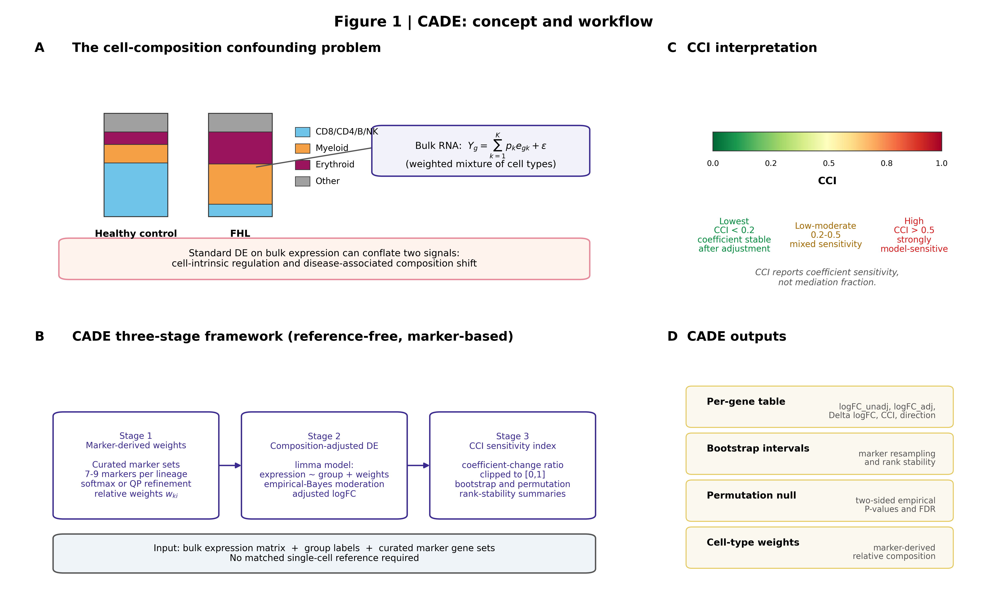
Figure 1. CADE concept and workflow. (A) The cell-composition confounding problem: bulk expression Y_g is a weighted mixture of cell-type-specific expression e_{gk}, weighted by sample-level composition p_k. Immune composition shifts (e.g., lymphoid depletion with neutrophil expansion in FHL PBMCs) produce apparent DE that is indistinguishable from cell-intrinsic regulation under standard limma. (B) CADE three-stage framework: Stage 1, marker-derived weight estimation (8 lineages × 7–9 markers, optional QP refinement); Stage 2, composition-adjusted limma DE; Stage 3, CCI computation with bootstrap and label-permutation calibration. (C) CCI is rendered as a continuous interpretation spectrum—not a causal mediation estimate. (D) Output ledger: per-gene table, bootstrap 95% CIs, permutation null summaries, and marker-derived cell-type weights.
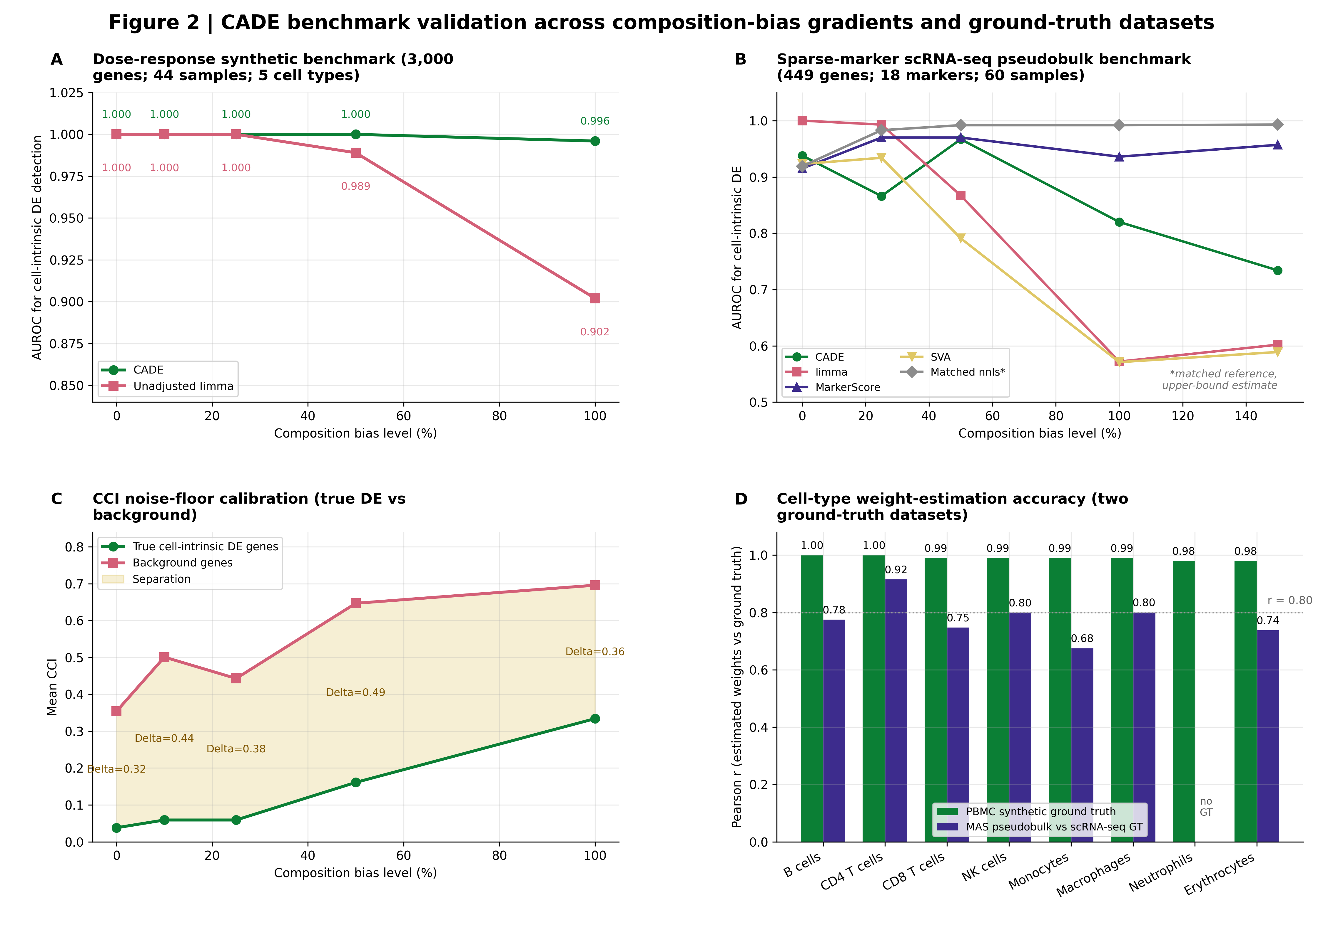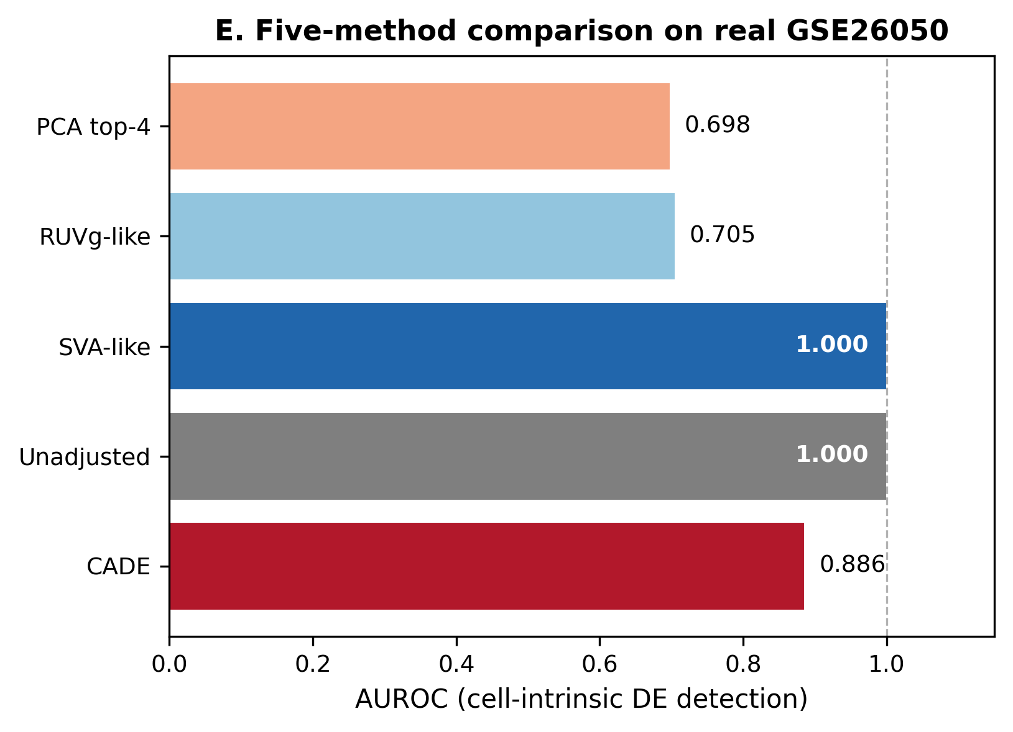
Figure 2. CADE benchmark validation. (A) Dose-response synthetic benchmark: AUROC for cell-intrinsic DE detection across 5 composition-bias levels (0–100%, 3 replicates each). CADE preserved AUROC under maximal bias while unadjusted limma declined (0.996 vs 0.902 at 100% bias). (B) Sparse-marker scRNA-seq pseudobulk benchmark across 5 methods (CADE, unadjusted limma, MarkerScore + limma, SVA, matched-nnls signature-matrix deconvolution). (C) CCI calibration: mean CCI for true cell-intrinsic DE genes versus background, showing increasing separation with bias. (D) Per-cell-type weight-estimation accuracy on two ground-truth datasets: the PBMC synthetic benchmark (mean r ≈ 0.99, CADE-lite) and the MAS pseudobulk validation against scRNA-seq cell counts (mean r = 0.779, CADE-lite). (E) Five-method rank-recovery AUROC on GSE26050 probe-level data: positive controls are the 500 lowest-CCI probes and negative controls are the 500 highest-CCI probes from an independent CADE run; this measures consistency with the CADE-defined ranking rather than independent accuracy. Note: panels (A)–(E) are provided as a single multi-panel TIF (Figure2_CADE_Benchmark.tif); a high-resolution standalone version of panel (E) is provided separately (Figure2E_5method_AUROC.tif) for upload systems that require single-panel files.
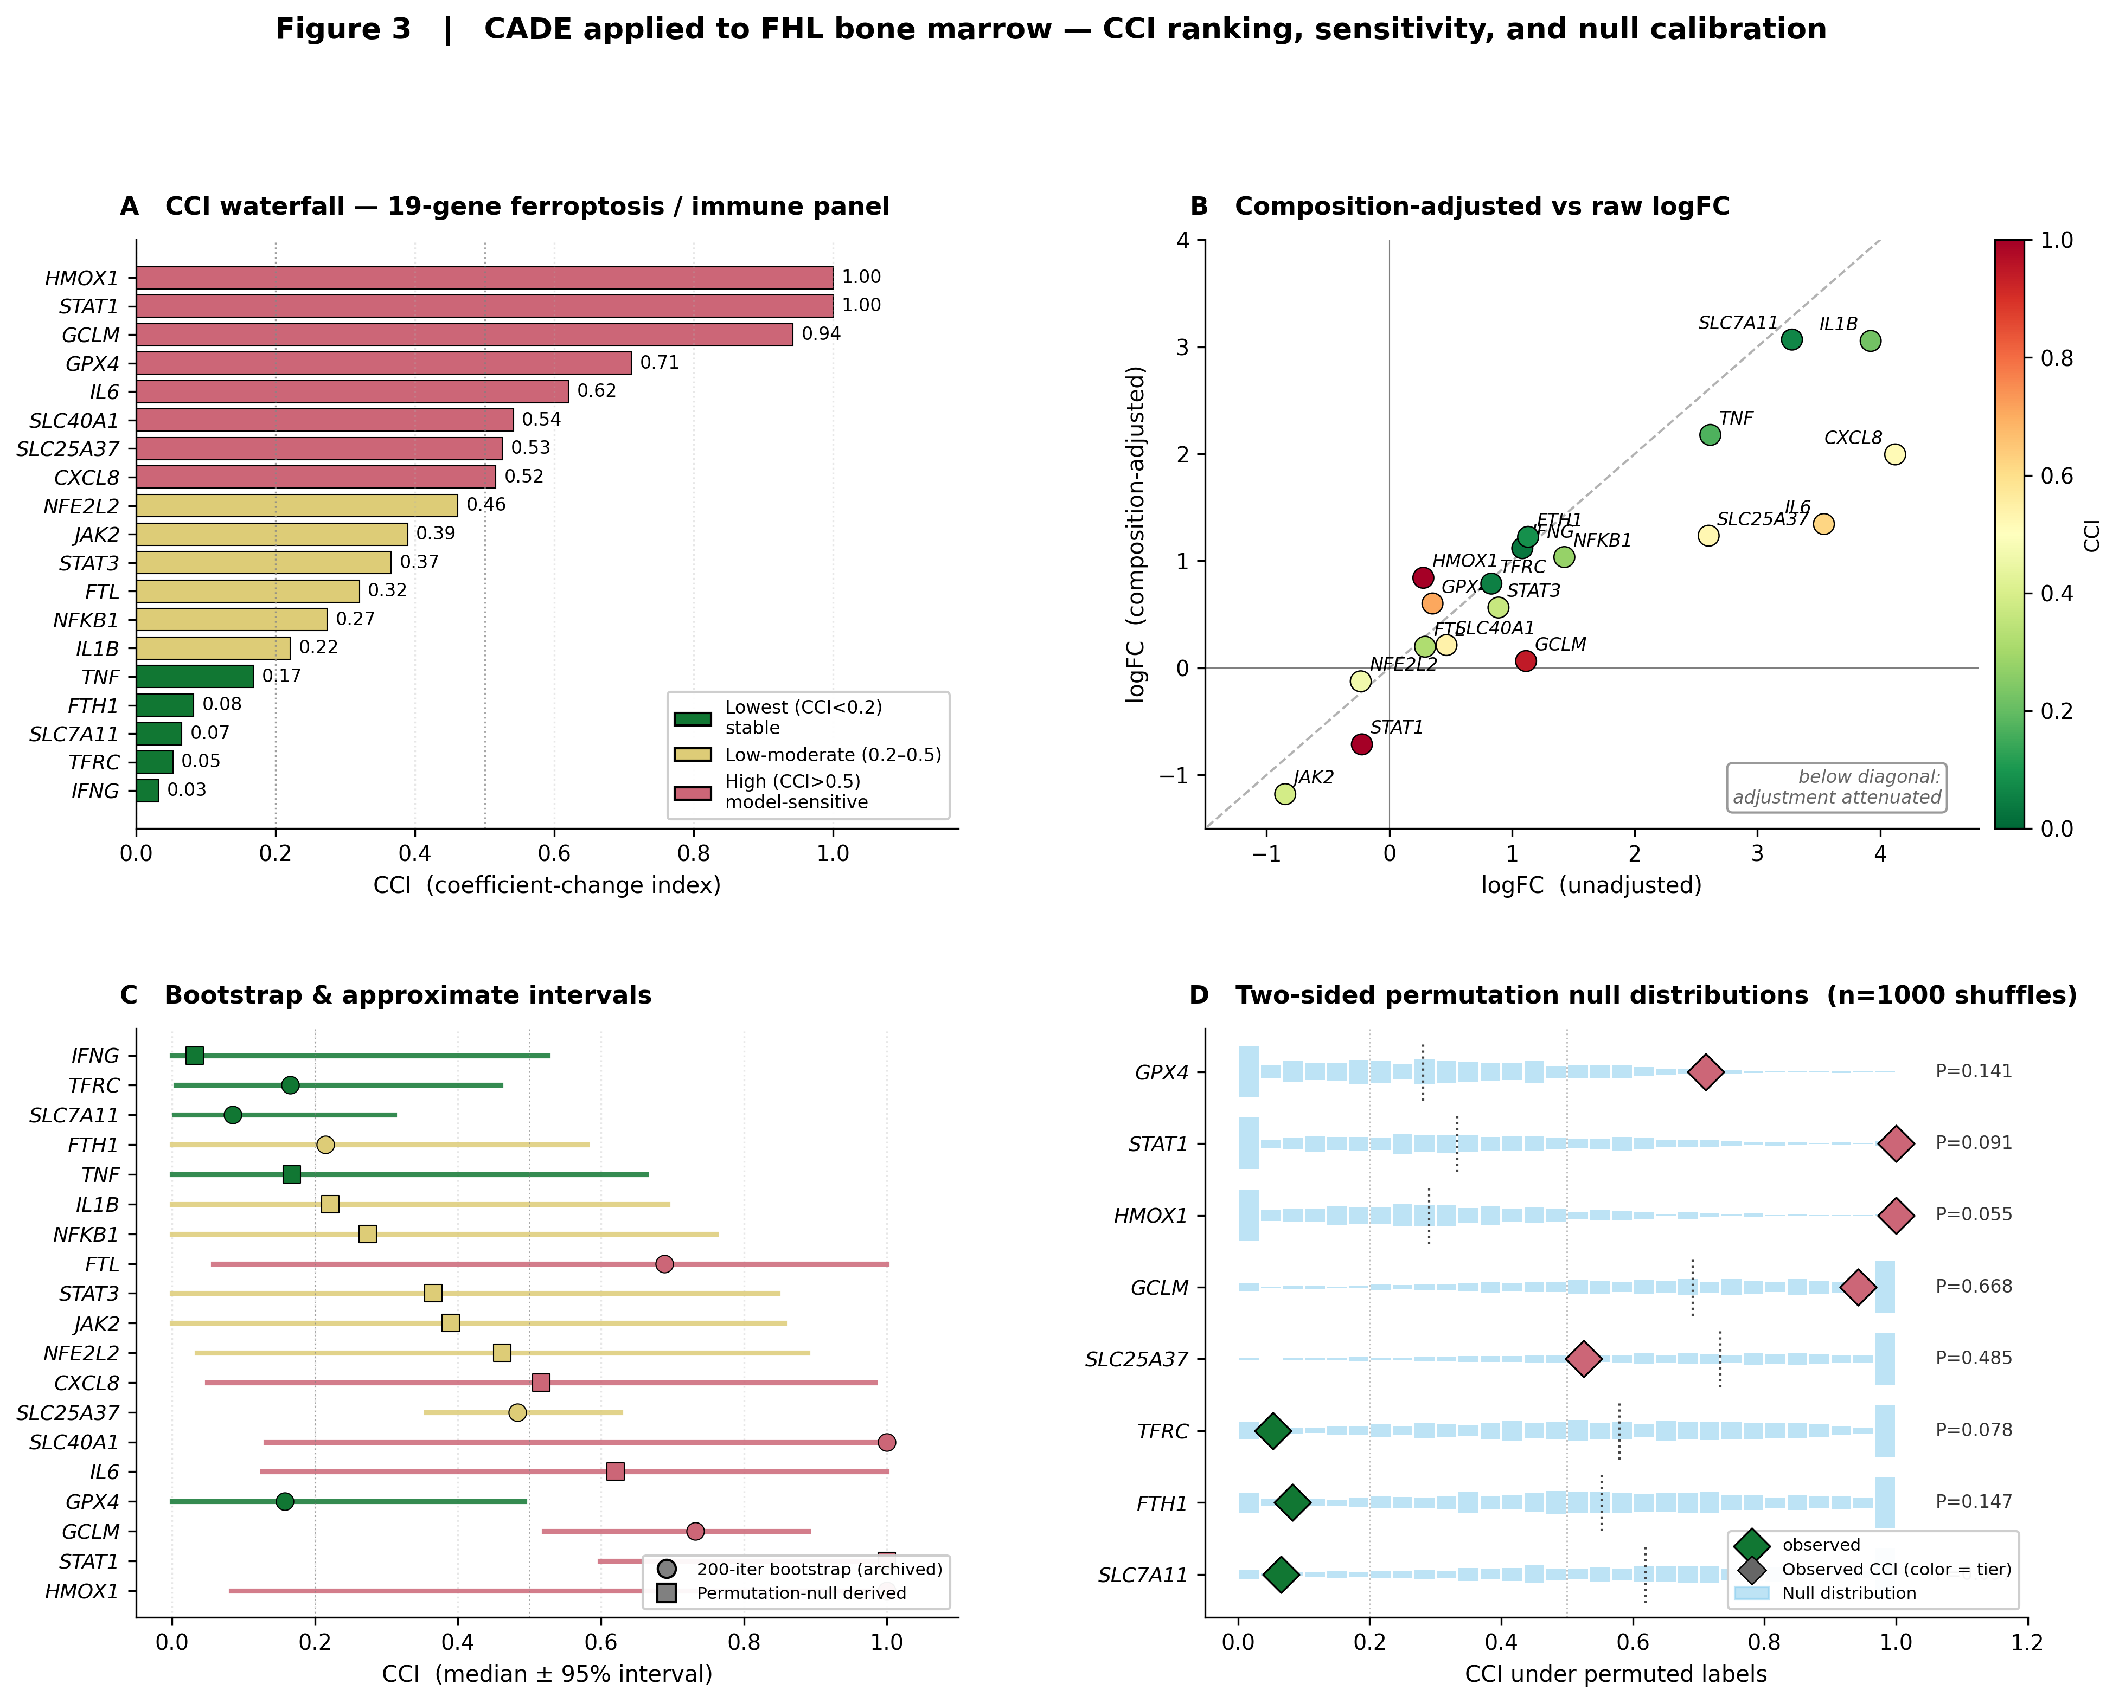
Figure 3. CADE applied to FHL PBMCs. (A) CCI waterfall plot for the 20-gene ferroptosis/iron/immune panel, colour-coded by sensitivity tier (lowest CCI < 0.2; low-moderate 0.2–0.5; high > 0.5). (B) Composition-adjusted versus raw logFC scatter; below-diagonal points indicate attenuation after adjustment. (C) Bootstrap 95% CIs (200 iterations, 20% marker dropout) for representative panel genes spanning the CCI spectrum. (D) Two-sided permutation null distributions (1000 shuffles) for representative genes; observed CCI values are shown as diamonds.
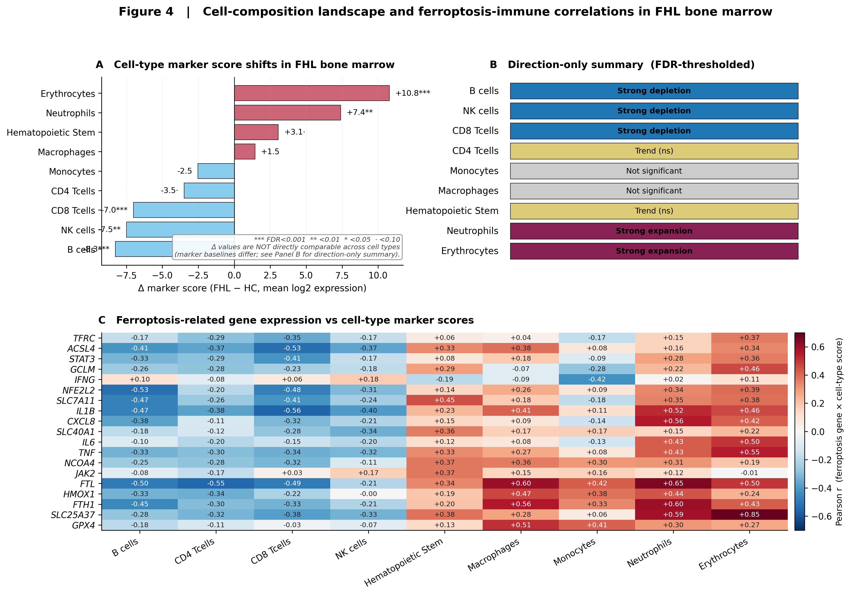
Figure 4. Immune cell-type profile and ferroptosis–immune correlations in FHL PBMCs. (A) Δ marker score (FHL − HC) in mean log2 marker expression units for eight cell types. (B) Directional summary after FDR thresholding. (C) Pearson correlation of ferroptosis-related gene expression with cell-type marker scores.

Supplementary Figure legends
Supplementary Figure S1: Cross-disease ferroptosis expression heatmap. Platform-qualified comparison of FHL PBMCs (GSE26050, Affymetrix) and other HLH subtypes (10x Genomics scRNA-seq-derived pseudobulk).
Supplementary Figure S2: Sepsis external validation (GSE28750). (A) Genome-wide CCI distribution. (B) Adjusted vs raw logFC. (C) Sepsis panel waterfall. (D) Cohort and CCI summary panel.
Supplementary Figure S3: MAS pseudobulk per-cell-type scatter plots. CADE marker-derived weights versus scRNA-seq ground-truth cell-type proportions across 7 evaluable cell types, with annotated r, RMSE, MAE and p-values.
Supplementary Figure S4: Sensitivity analyses. (A) CCI threshold sensitivity. (B) Parametric bootstrap CIs for 19 panel genes. (C) Null-control vs panel CCI distribution. (D) WGCNA module × CCI tier composition. (E) PCA on CADE weights. (F) CCI vs cell-type correlation strength.
Supplementary Figure S5: Extended benchmark. (A) Synthetic 5-method benchmark. (B) Panel CCI by cell-type tracking category. (C) Genome-wide CCI vs |logFC| landscape. (D) Per-module CCI Mann-Whitney with BH-FDR. (E) CCI density across composition-sensitivity module classes. (F) Synthesis text panel.
Supplementary Figure S6: Parameter sensitivity analyses. (A) Marker number and noise fraction effects on AUROC, proportion correlation, and CCI separation. (B) QP tolerance and max-iteration effects. (C) Number of covariates (top_cts) vs AUROC and cumulative variance explained.
Supplementary Figure S7: CADE-ILR marker-dropout bootstrap CCI and probability of top-5 low-CCI rank stability for the 20-gene panel.
Supplementary Figure S8: GSVA per-sample pathway scores. (A) Δ GSVA score for ferroptosis sub-pathways and iron homeostasis. (B) Multi-cell-death pathway comparison. (C) Pathway-level Δ versus −log₁₀(FDR). These are exploratory bulk-level patterns, not formal pathway-enrichment evidence.
Supplementary Figure S9: WGCNA co-expression analysis (exploratory). (A) All 15 module–FHL correlations. (B) Module size versus |Pearson r|, bubble size proportional to −log₁₀(FDR). (C) Module hub-gene network. This analysis is strictly exploratory; see Limitation 8.
Supplementary Figure S10: TF target-gene signature scoring (not TF activity). (A) Per-target Δ for seven transcriptional regulators. (B) Aggregate target-gene Δ with FDR significance. This measures mean log2 expression of curated targets, not TF binding or causal activity.

Supplementary data
Supplementary Data are available at NAR Genomics and Bioinformatics online. Files include:
- Supplementary Figures: S1, cross-disease ferroptosis heatmap; S2, sepsis external validation; S3, MAS pseudobulk per-cell-type scatter plots; S4, sensitivity analyses (threshold, bootstrap CIs, null-control); S5, extended benchmark; S6, parameter sensitivity (marker quality, QP convergence, covariate count); S7, CADE-ILR rank stability; S8, GSVA per-sample pathway scores; S9, WGCNA co-expression analysis (exploratory); S10, TF target-gene signature scoring.
- Supplementary Tables S1–S8: GSE26050 DE and reproducibility checks; marker sets, pathway scores, cell-type summaries and TF target signatures; WGCNA and cross-disease context; primary FHL CADE outputs and CCI calibration; benchmark outputs; external validation and MAS pseudobulk validation outputs; parameter sensitivity; CADE-ILR robustness and multi-seed stability. Extension tables S9–S12: ILR basis-stability, GSE26050 pathway-enrichment comparison, null-control seed sensitivity, and treatment sensitivity analysis.
- CADE_Supplementary_Tables_S1-S8.xlsx with raw CSV components retained in supplementary/raw_csv_components/ for auditability.
- Software archive: CADE_public_software_v1.1.0_2026-06-01.zip (MIT license).
The complete CADE submission package (manuscript source, figures, tables, code, renv.lock, dependency notes, run order) is also provided as a single upload archive for editorial review.

