Xu Wang
Prof. Simon Shim
Data 260
31 August 2026

DATA 260 — Homework 1

Section 0 — Personal Configuration and Domain
All values below are derived from the last four digits of my SJSU Student ID and stay fixed for the rest of the semester.
SID4 | 9275
PORT_BASE | 8275 (8000 + 9275 mod 900)
PREFIX | s9275
SEED | 9275
VERIFY_SEED | 269275 (260000 + 9275)
DOMAIN_ID | 3 (9275 mod 8) — Grocery supply and recall notices

Environment
Hardware | MacBook Pro (Apple silicon), 8 GB RAM, macOS
Local model | qwen3:8b via Ollama (Q4_K_M, context length 40,960)
Python | 3.12 in the conda environment `data260`
Container runtime | Docker Desktop, image built for linux/amd64
Cloud | AWS ECS Fargate, region us-east-1, account 457145067527

Tagged commit hash (tag hw1): Repository: https://github.com/xuwang-goldenwater/data260-9275
Domain entity
My assigned domain is grocery supply and recall notices. The entity modeled throughout this homework is a RecallNotice: a public announcement that a food product already on the market is being pulled back because of a safety or labeling problem. The full field definition is in DOMAIN_SCHEMA.md at the repository root.

Part 1 — Section I: HTML
File: code/web_application/index.html

I.1 — Create an HTML page titled HW1-{Your Name}
The <title> element sets the text shown on the browser tab.
<head>
<meta charset="UTF-8" />
<meta name="viewport" content="width=device-width, initial-scale=1.0" />

<!-- Requirement I.1: page title -->
<title>HW1-Xu Wang</title>
...
</head>

I.2 — Heading tag naming the assigned domain entity
HTML heading tags run from <h1> to <h6>. <h1> renders at the largest font size, so it is the tag required here.
<!-- Requirement I.2: largest heading tag naming the domain entity -->
<h1>Recall Notice</h1>

Outputs of I.1 and I.2

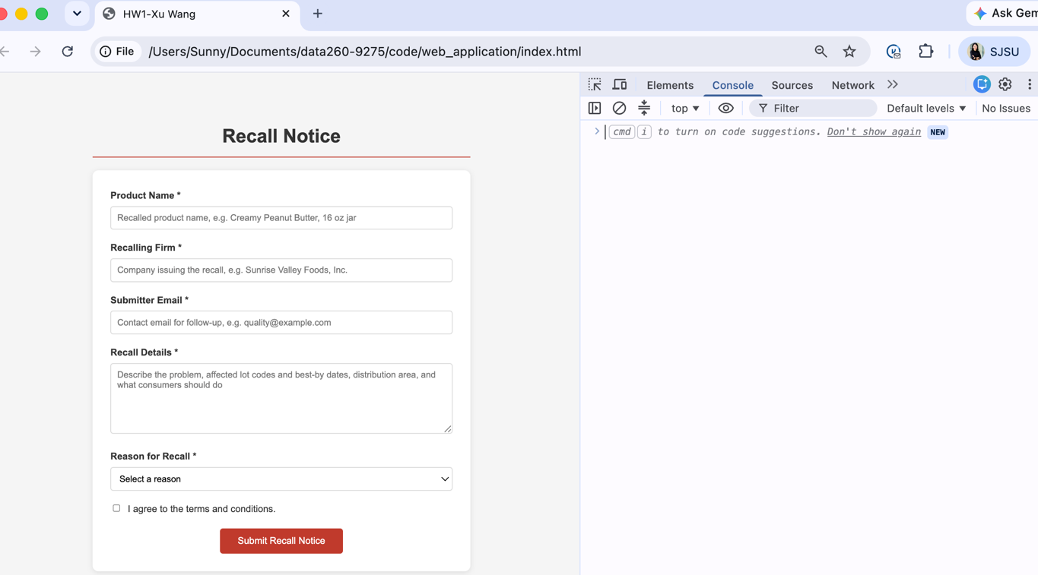

I.3 — DOMAIN_SCHEMA.md defining the entity fields and category values
DOMAIN_SCHEMA.md was written before any code. It fixes the seven field names so that the HTML id attributes, the JavaScript keys, and the JSON sent to the agent in Part 2 all match.

Fields
productName | string, required — name of the recalled product. Used as the agent title.
recallingFirm | string, required — company issuing the recall.
submitterEmail | email, required — contact for follow-up.
description | string, required — what is wrong, affected lots, consumer action. Used as the agent content.
category | enum, required — reason for the recall.
agreedToTerms | boolean, required — must be true.
submissionDate | ISO 8601 string, derived — added in JavaScript at submission time.

Category values
Undeclared Allergen | Bacterial Contamination | Foreign Material | Mislabeling
These are the three most common real causes of FDA food recalls plus labeling error. In Q1 2026, undeclared allergens accounted for 40.7% of FDA food recalls, foreign material 17.1%, and bacterial contamination 15.7%. Severity class (Class I / II / III) is assigned by the regulator after review rather than by the submitter, so it is not part of this form.

For more details, please go to the DOMAIN_SCHEMA.md file.

I.4 — Form for the domain entity
Each of the seven requirements a–g maps to one control.

I.4.a — Required text input for the primary field, with placeholder and autofocus
<label for="productName">Product Name *</label>
<input
type="text"
id="productName"
placeholder="Recalled product name, e.g. Creamy Peanut Butter, 16 oz jar"
required
autofocus
/>
required blocks an empty submit; autofocus puts the cursor in this field as soon as the page loads.

I.4.b — Required text input for the secondary field, with placeholder
<label for="recallingFirm">Recalling Firm *</label>
<input
type="text"
id="recallingFirm"
placeholder="Company issuing the recall, e.g. Sunrise Valley Foods, Inc."
required
/>

I.4.c — Required email input for the submitter's email
<label for="submitterEmail">Submitter Email *</label>
<input
type="email"
id="submitterEmail"
placeholder="Contact email for follow-up, e.g. quality@example.com"
required
/>
type="email" makes the browser check the address format before the form is submitted.

I.4.d — Required text area for the content / description field
<label for="description">Recall Details *</label>
<textarea
id="description"
placeholder="Describe the problem, affected lot codes and best-by dates, distribution area, and what consumers should do"
required
></textarea>

I.4.e — Dropdown for category selection with four domain-appropriate options
<label for="category">Reason for Recall *</label>
<select id="category" required>
<option value="" disabled selected>Select a reason</option>
<option value="Undeclared Allergen">Undeclared Allergen</option>
<option value="Bacterial Contamination">Bacterial Contamination</option>
<option value="Foreign Material">Foreign Material</option>
<option value="Mislabeling">Mislabeling</option>
</select>
The first option is a placeholder: disabled so it cannot be chosen, selected so it shows by default, and value="" so required rejects it.

I.4.f — Checkbox and label reading “I agree to the terms and conditions.”
<div class="terms">
<input type="checkbox" id="agreedToTerms" />
<label for="agreedToTerms">I agree to the terms and conditions.</label>
</div>
The checkbox deliberately has no required attribute. Requirement II.1.b asks for this check to be done in JavaScript with an alert; a required attribute would let the browser block the submit first and the JavaScript branch would never run.

I.4.g — Submit button with domain-appropriate text
<button type="submit">Submit Recall Notice</button>

Output — complete form & required-field validation
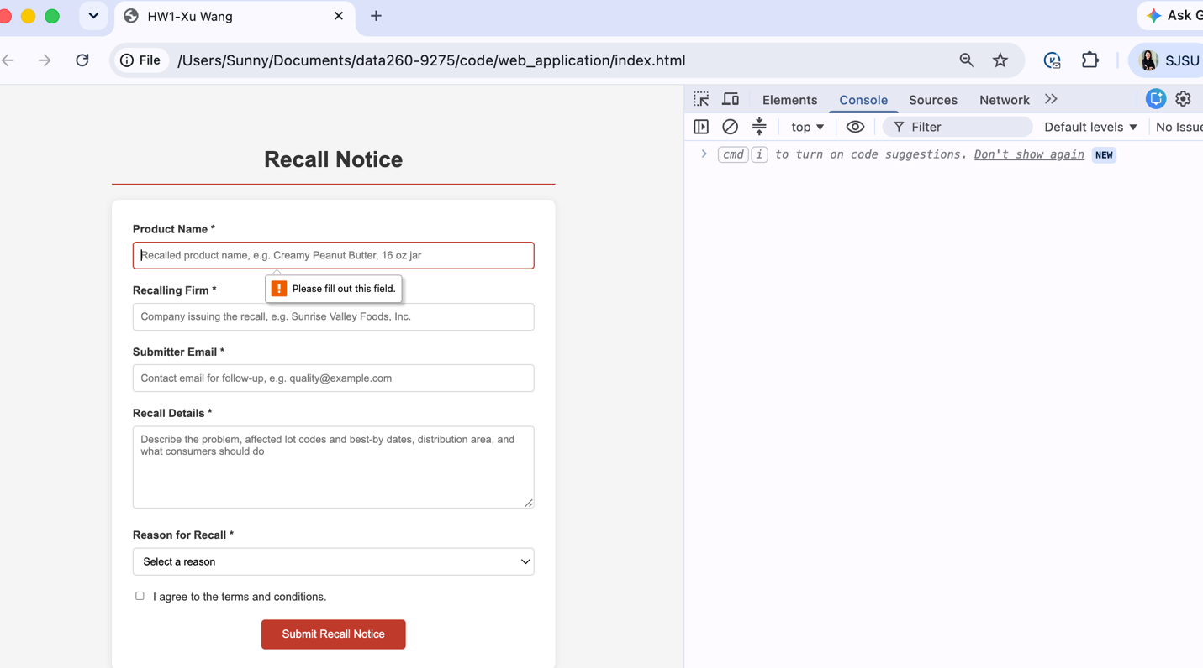

Output — category dropdown
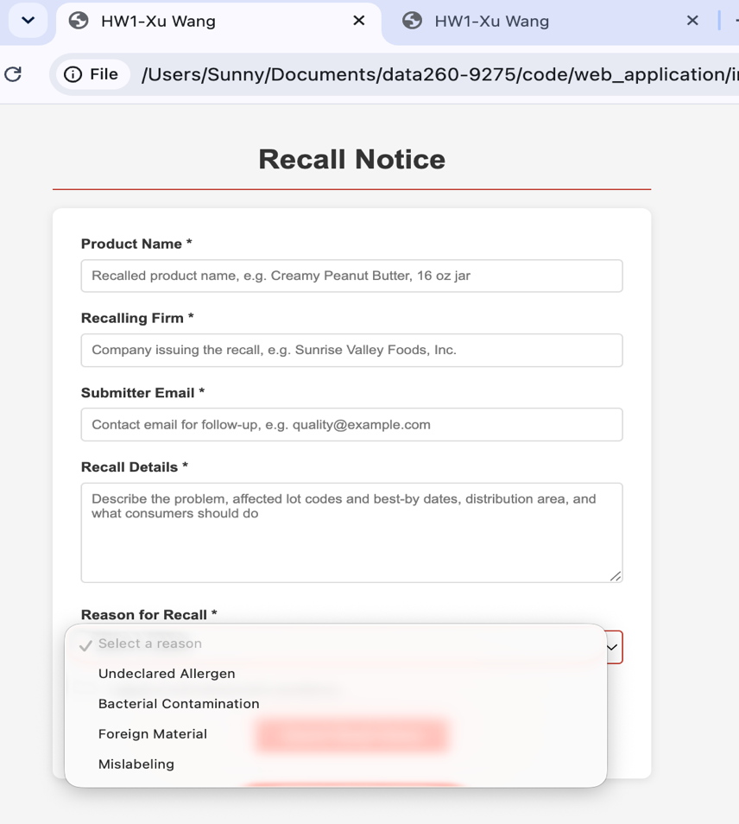
I.5 — Script tag linking the Part II JavaScript at the end of the file
<!-- Requirement I.5: link the Part II JavaScript at the end of the file -->
<script src="app.js"></script>

</body>
</html>
The browser parses the document from top to bottom. The script looks up the form by its id, so it has to run after the form element exists. Placing the tag just before </body> guarantees that; a tag in <head> would run too early and find nothing.

Part 1 — Section II: JavaScript
File: code/web_application/app.js
All console output below is produced by the submit handler registered on the form. The handler calls event.preventDefault() so the page does not reload and the console output stays visible.

II.1 — Arrow function validating the form
II.1.a the description must be longer than 25 characters; II.1.b the terms checkbox must be checked. Each failure shows an alert and stops the submission.
const validateRecallNotice = (description, agreedToTerms) => {
if (description.trim().length <= 25) {
alert(
"Recall Details must be longer than 25 characters. " +
"Please describe the affected lots and what consumers should do."
);
return false;
}

if (!agreedToTerms) {
alert("Please agree to the terms and conditions before submitting this recall notice.");
return false;
}

return true;
};
An arrow function is written as (parameters) => { body }. It is a shorter way of writing function(parameters) { body }.

Output — II.1.a short description
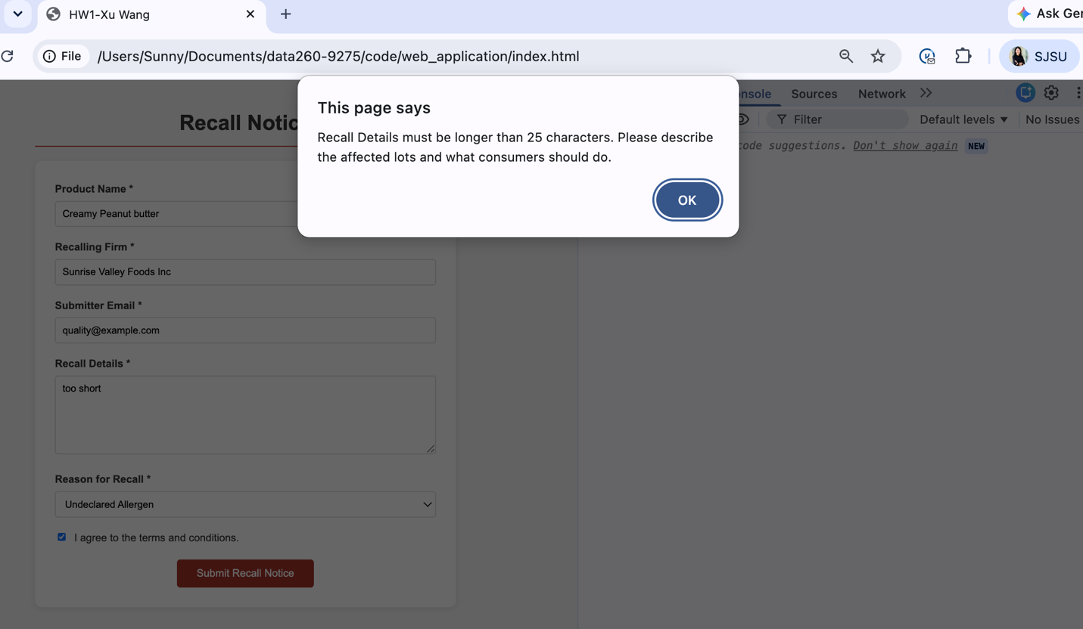
Output — II.1.b terms not accepted
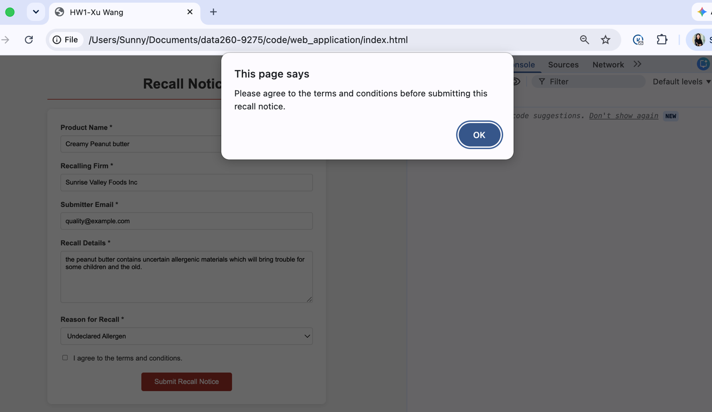

II.2 — Convert the form data into a JSON string and log it
const formData = {
productName: document.getElementById("productName").value,
recallingFirm: document.getElementById("recallingFirm").value,
submitterEmail: document.getElementById("submitterEmail").value,
description: document.getElementById("description").value,
category: document.getElementById("category").value,
agreedToTerms: document.getElementById("agreedToTerms").checked,
};

const jsonString = JSON.stringify(formData, null, 2);
console.log("II.2 Form data as a JSON string:");
console.log(jsonString);
JSON.stringify turns a JavaScript object into text. The third argument, 2, indents the output by two spaces so it is readable in the console.

II.3 — Object destructuring for the primary field and email
const parsedData = JSON.parse(jsonString);

const { productName, submitterEmail } = parsedData;
console.log("II.3 Destructured from the parsed object:");
console.log(" productName :", productName);
console.log(" submitterEmail:", submitterEmail);
Destructuring pulls named properties out of an object into standalone variables in one statement, instead of writing parsedData.productName and parsedData.submitterEmail separately. The names inside the braces must match the property names.

II.4 — Spread operator adding submissionDate
const parsedDataWithDate = {
...parsedData,
submissionDate: new Date().toISOString(),
};
console.log("II.4 Parsed object with submissionDate added:");
console.log(parsedDataWithDate);
The spread operator ... copies every property of parsedData into a new object, and submissionDate is then added to that copy. The original parsedData is left unchanged.

Output of II.2, II.3, and II.4
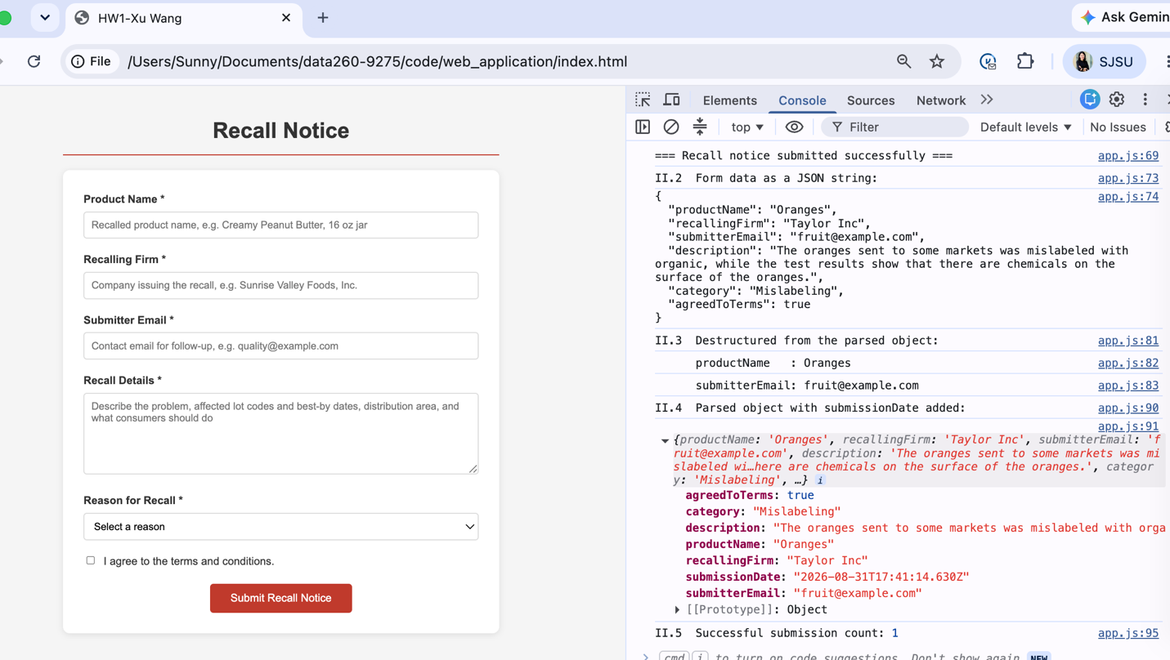

II.5 — Closure tracking the number of successful submissions
const createSubmissionCounter = () => {
let count = 0;
return () => {
count = count + 1;
return count;
};
};

const countSubmission = createSubmissionCounter();

// inside the submit handler, after validation passes:
const submissionCount = countSubmission();
console.log("II.5 Successful submission count:", submissionCount);
count is declared inside createSubmissionCounter, so no code outside can read or modify it directly. The inner function returned by createSubmissionCounter keeps access to count even after the outer function has finished. That combination of an inner function plus the variables it captured is a closure. Each call to countSubmission() increments the same private count.

Output
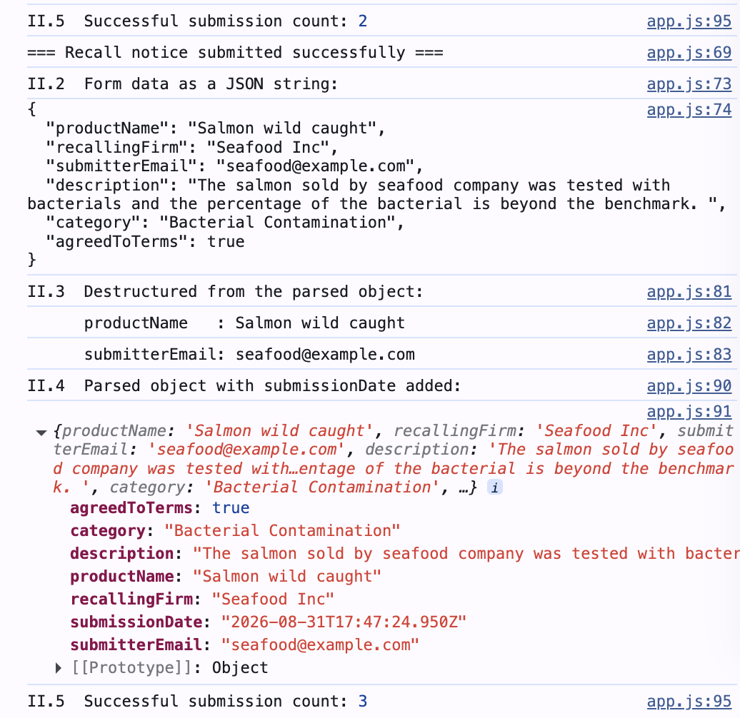

Deployment

Docker — local build and run
The Dockerfile lives at code/Dockerfile. The build context is code/web_application/, so only index.html and app.js are copied into the image; the Python files under code/ are excluded.
Commands
cd ~/Documents/data260-9275

docker build -f code/Dockerfile -t recall-notice-app code/web_application

docker run -d -p 8275:80 --name recall-notice recall-notice-app
Nginx listens on port 80 inside the container. The -p 8275:80 flag maps host port 8275 to container port 80, so the application is reached at http://localhost:8275 — PORT_BASE from Section 0.

Dockerfile
FROM nginx:alpine

RUN rm -rf /usr/share/nginx/html/*

COPY . /usr/share/nginx/html/

EXPOSE 80

CMD ["nginx", "-g", "daemon off;"]

Output
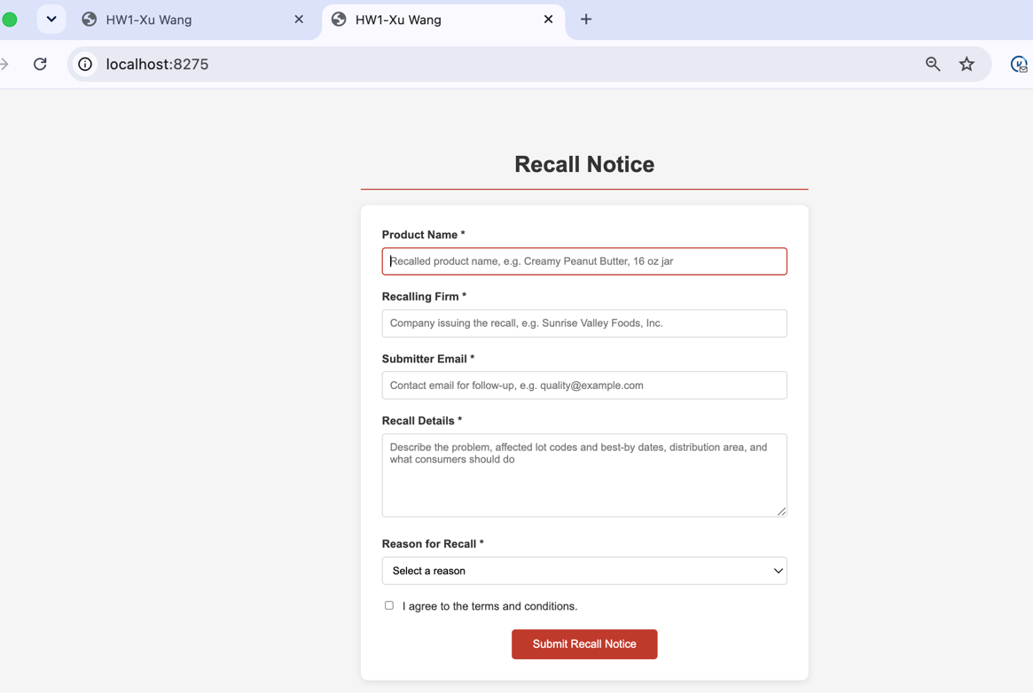

AWS ECS — one task running the same image
The image pushed to ECR was built with --platform linux/amd64. The Mac is Apple silicon, so a default build produces an arm64 image and the Fargate task fails with exec format error.
Commands
aws ecr create-repository --repository-name recall-notice-app --region us-east-1

aws ecr get-login-password --region us-east-1 | docker login --username AWS \
--password-stdin 457145067527.dkr.ecr.us-east-1.amazonaws.com

docker build --platform linux/amd64 -f code/Dockerfile \
-t recall-notice-app:amd64 code/web_application

docker tag recall-notice-app:amd64 \
457145067527.dkr.ecr.us-east-1.amazonaws.com/recall-notice-app:latest

docker push 457145067527.dkr.ecr.us-east-1.amazonaws.com/recall-notice-app:latest

Cluster | data260-hw1-cluster
Service | recall-notice-service
Task definition | recall-notice-task (Fargate, Linux/X86_64, 0.25 vCPU, 0.5 GB)
Desired tasks | 1
Container port | 80 (nginx); security group allows inbound HTTP from 0.0.0.0/0
Public IP | 54.205.107.97
Region | us-east-1

One problem worth recording: the first attempt to create the cluster failed with “Unable to assume the service linked role.” The AWS account was new and the console was left in the Ohio region while the image had been pushed to N. Virginia. Switching the console to us-east-1 and confirming AWSServiceRoleForECS existed resolved it.

The service and cluster were deleted immediately after the screenshot was taken, so no Fargate charges continued to accrue.
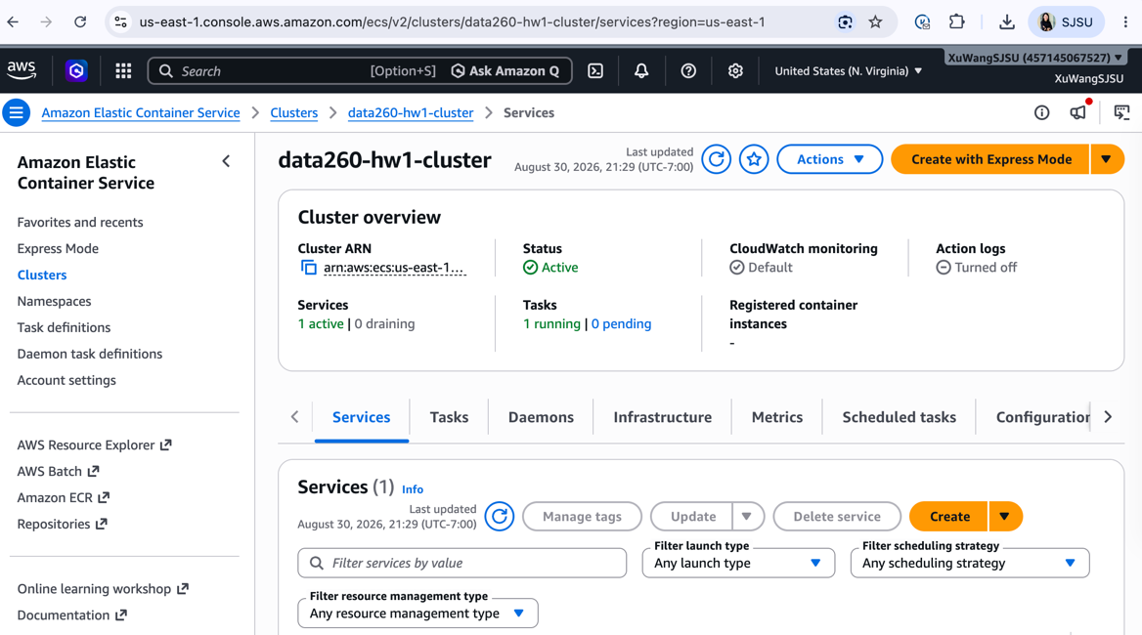

Output
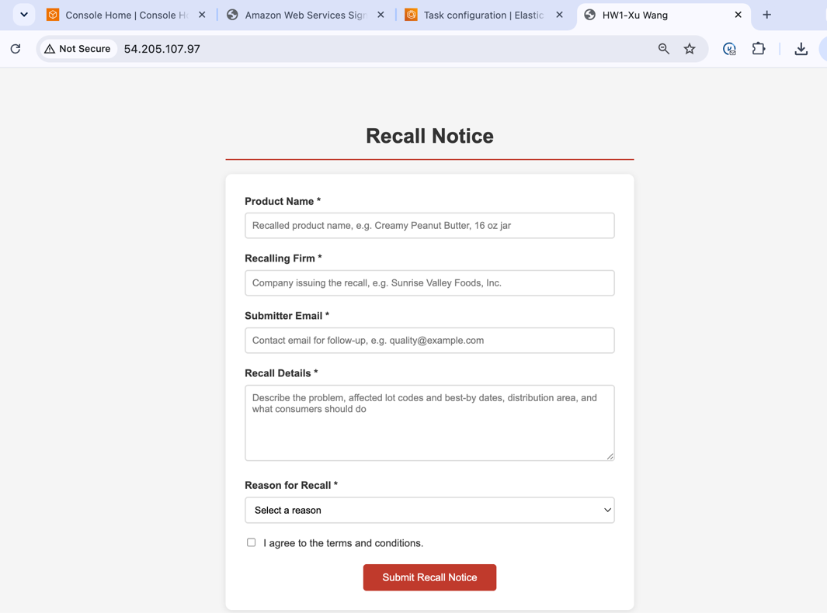

Part 2 — Agentic AI
Files: code/agents_demo.py (pipeline), src/model_client.py (model adapter)

Command used
cd ~/Documents/data260-9275/code
python agents_demo.py

How the pipeline works, in my own words
The input is a title and a content block. Three stages run in sequence.
input (title + content)
|
Planner model call 1: propose 3 tags and a summary
|
Reviewer model call 2: check the Planner's work against the same source text
|
Finalizer plain Python, no model call: enforce the output contract
|
Publish JSON
Planner
The Planner receives the title and content and nothing else. It is told to produce exactly three short tags and a summary of at most 25 words, and that every tag must use words that appear in or are directly stated by the source text. It returns JSON.
Reviewer
The Reviewer receives the same title and content plus the Planner's proposal. It checks four things: that there are exactly three tags with no near-duplicates, that each tag is grounded in the source rather than in outside knowledge, that each tag is specific rather than a generic category word, and that the summary is within the word limit and supported by the content. It returns corrected tags and a summary, a boolean saying whether it changed anything, and a one-sentence note explaining why.
Finalizer
The Finalizer is deterministic Python and makes no model call. It lowercases and deduplicates the tags, pads from the Planner's list if the Reviewer returned fewer than three, and truncates the summary to 25 words. I did it this way because a language model does not guarantee it will obey a count or a length limit, and the assignment requires exactly three tags and at most 25 words. Putting the hard contract in code means the output is always valid regardless of what the model returns. The model supplies judgement; the code supplies the guarantee.

Strict JSON output
Both agents are given a JSON schema that Ollama enforces server-side through its format parameter, rather than being asked in prose to return JSON.
PLANNER_SCHEMA = {
"type": "object",
"properties": {
"tags": {
"type": "array",
"items": {"type": "string"},
"minItems": 3,
"maxItems": 3,
},
"summary": {"type": "string"},
"rationale": {"type": "string"},
},
"required": ["tags", "summary"],
}
Two defensive layers back this up, because a local model still returns unexpected text sometimes. strip_model_artifacts removes qwen3's <think>...</think> reasoning block and any markdown code fence; extract_json_object then scans for the first balanced pair of braces if a plain json.loads fails.
THINK_BLOCK = re.compile(r"<think>.*?</think>", re.DOTALL | re.IGNORECASE)
CODE_FENCE = re.compile(r"```(?:json)?\s*(.*?)```", re.DOTALL)

def strip_model_artifacts(text: str) -> str:
text = THINK_BLOCK.sub(" ", str(text))
fenced = CODE_FENCE.search(text)
if fenced:
text = fenced.group(1)
return text.strip()

Requirement 4: the domain is not hardcoded
Neither agents_demo.py nor model_client.py contains the words food, grocery, recall, allergen, or any other domain term. The prompts refer only to TITLE and CONTENT. The same script runs unchanged on any of the eight assigned domains.
To make that claim checkable rather than merely asserted, the Finalizer prints a grounding report: for each final tag, whether every word in it also occurs in the input text. Comparison uses a crude language-general stemmer so that word forms match.
SUFFIXES = ("ing", "ies", "es", "ed", "s")

def stem(word: str) -> str:
for suffix in SUFFIXES:
if word.endswith(suffix) and len(word) - len(suffix) >= 3:
base = word[: -len(suffix)]
if suffix == "ies":
base += "y"
return base
return word

def grounding_report(tags, title, content):
source_words = {stem(w) for w in WORD.findall(f"{title} {content}".lower())}
report = {}
for tag in tags:
tag_words = [stem(w) for w in WORD.findall(tag)]
report[tag] = bool(tag_words) and all(w in source_words for w in tag_words)
return report
The stemmer was added after the first run exposed a defect in the original exact-match version. That episode is written up in AI_USE.md.
Console output
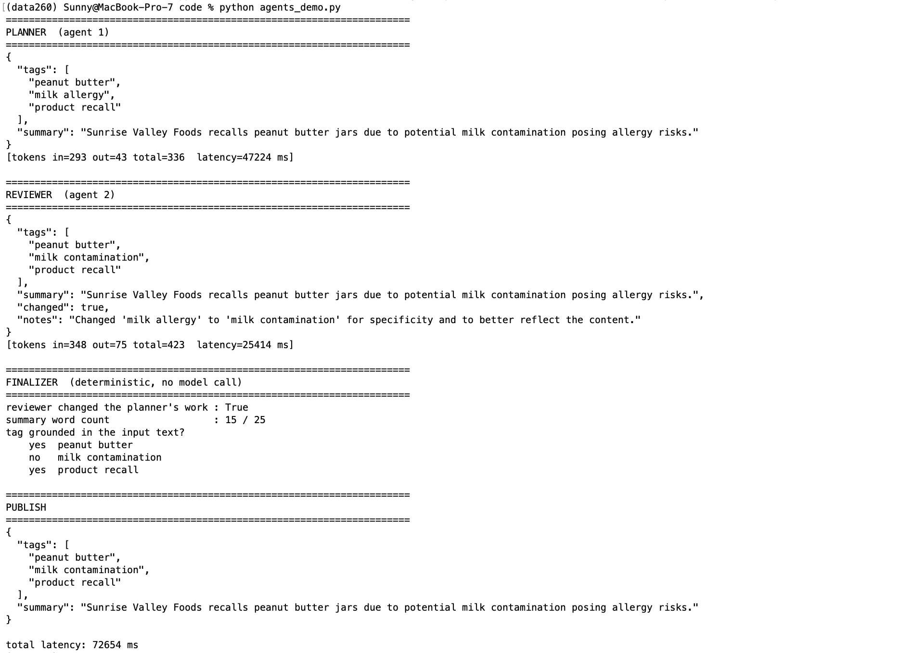

Publish JSON produced by the run recorded above
{
"tags": [
"peanut butter",
"milk contamination",
"product recall"
],
"summary": "Sunrise Valley Foods recalls peanut butter jars due to potential milk contamination posing allergy risks."
}

Short answers
Q1. The three final tags obtained
peanut butter, milk contamination, product recall

Q2. The final summary (25 words or fewer)
“Sunrise Valley Foods recalls peanut butter jars due to potential milk contamination posing allergy risks.” (15 words)

Q3. Did the Reviewer agent change anything?
Yes. The Planner proposed peanut butter, milk allergy, product recall. The Reviewer replaced milk allergy with milk contamination and recorded the reason in its notes field: “Changed 'milk allergy' to 'milk contamination' for specificity and to better reflect the content.” Across the 40 runs of Part 3 the Reviewer changed the Planner's output in 37 of them, so this is its normal behaviour rather than a one-off.

Part 3 — Measuring Non-Determinism
Files: code/nondeterminism_runner.py, reports/hw01/METRICS.md, reports/hw01/raw/

Setup
Frozen input | reports/hw01/cases/nondeterminism_input.json (89-word recall notice)
Pipeline | code/agents_demo.py, Planner → Reviewer → Finalizer
Model | qwen3:8b via Ollama, context length 40,960
Hardware | MacBook Pro, 8 GB RAM
Runs | 20 at temperature 0.7, 20 at temperature 0.0
Run window | 2026-08-30, 21:51–22:01 PDT
Raw data | reports/hw01/raw/nondeterminism_runs.jsonl and .csv
Console log | reports/hw01/RUN_LOG.txt

Command used
python -u nondeterminism_runner.py 2>&1 | tee ../reports/hw01/RUN_LOG.txt
Tag sets are compared without regard to order, so a reordering of the same three tags counts as one set rather than two. Each run is appended to the JSONL file as soon as it finishes, so an interruption loses at most one run and a re-run resumes rather than starting over.

Required results
Metric | Temp 0.7 | Temp 0.0
Distinct tag sets | 2 | 1
Tags in all 20 runs | 2 | 3
Tags in exactly 1 run | 0 | 0
Latency p50 / p95 / p99 (ms) | 12,122 / 15,876 / 18,586 | 12,378 / 30,359 / 36,294

Additional measures from the same 40 runs
Metric | Temp 0.7 | Temp 0.0
Distinct summaries | 9 | 1
Runs where the Reviewer changed the output | 17 / 20 | 20 / 20
Distinct tags seen overall | 4 | 3

Tag frequency
Tag | Temp 0.7 (of 20) | Temp 0.0 (of 20)
peanut butter | 20 | 20
product recall | 20 | 20
milk contamination | 18 | 20
milk allergy | 2 | 0

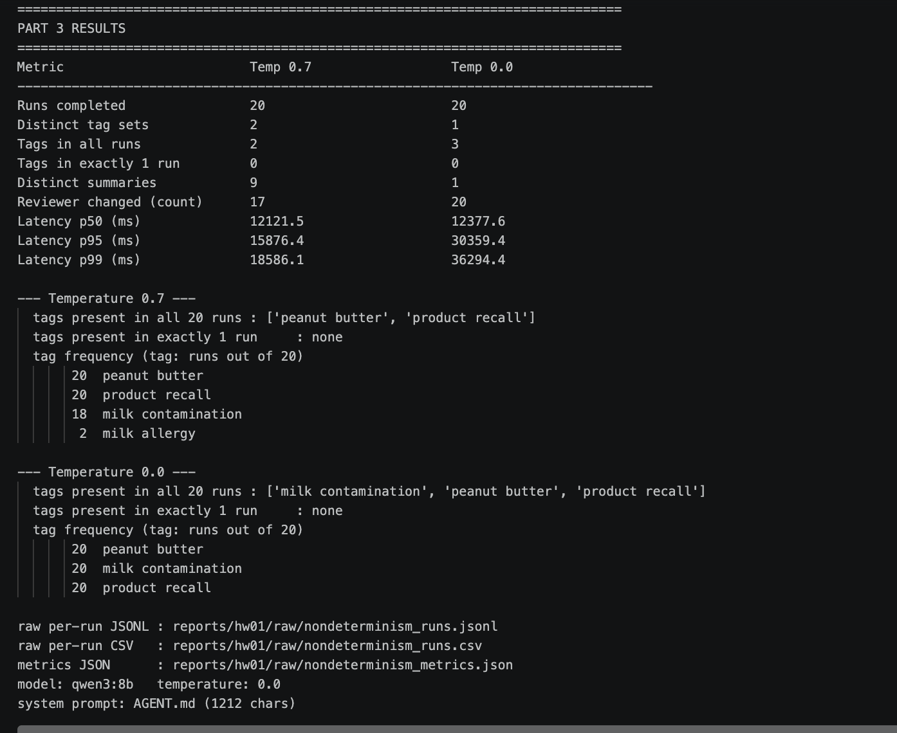

Observations
1. Temperature 0.0 produced no variation at all in these runs.
One tag set and one summary across 20 runs. This does not prove the pipeline is deterministic in general. Floating-point accumulation order on the GPU and server-side batching can still introduce differences, and 20 runs on a single input is a small sample. It shows only that no variation surfaced under these conditions.
2. Tags were far more stable than summaries.
At temperature 0.7 there were 2 distinct tag sets but 9 distinct summaries, from the same runs at the same temperature. The tag field is short, capped at three items, and drawn from words in the source; the summary is free prose with many equally valid phrasings. What made the output reproducible was constraining its shape, not lowering the temperature.
3. The single tag that varied is the safety-relevant one.
Two of the three tags were identical in all 40 runs. The one that moved was the hazard tag: milk contamination in 18 runs, milk allergy in 2. Both describe the same underlying hazard, but they are different strings, and any downstream system that routes on the tag would treat them as different categories.
4. Temperature did not change per-run cost; machine state did.
The p50 latencies are within 2% of each other, 12.1 s against 12.4 s, which is what should be expected: sampling temperature changes which token is chosen, not how many tokens are produced or how fast each one is produced. The much heavier tail at temperature 0.0 (p95 of 30.4 s against 15.9 s) is not a temperature effect. In RUN_LOG.txt the slow runs form a contiguous block, runs 10 through 15, at 20 to 36 seconds, while every run before and after is 10 to 13 seconds. A contiguous block is the signature of machine state, in this case memory pressure on an 8 GB machine, not of sampling behaviour. Reading this as “temperature 0.0 is slower” would be a misreading of my own data.
5. The Reviewer agent does real work.
It altered the Planner's output in 37 of 40 runs, almost always replacing milk allergy with milk contamination. The three runs where it made no change are the runs where the Planner had already produced the tag the Reviewer preferred.

Required analysis
What two users sending identical input might see
At temperature 0.7, two users submitting this same recall notice would receive the same three tags about 90% of the time (18 of 20 runs) and different tags about 10% of the time: one sees milk contamination, the other sees milk allergy. The summaries differ far more often, with 9 distinct wordings in 20 runs, so two users are more likely than not to read differently-phrased summaries of the same facts. At temperature 0.0 both users saw identical output in every run.
One case where run-to-run variation is acceptable
Summary wording shown to a human reader. All 9 distinct summaries carried the same facts: the product, the undeclared milk, the allergy risk, and the recall. A person reading any one of them learns the same thing and takes the same action. The same holds for using tags as search facets or to surface related notices; a user who sees milk allergy instead of milk contamination still finds relevant material. Nobody is harmed by the difference.
One case where it is not acceptable
Routing allergen alerts by tag. If the tag decides which subscribers are notified, for example everyone who has registered a milk allergy, then the 10% of runs producing milk allergy instead of milk contamination reach a different audience. Under the FDA classification a Class I recall is one with a reasonable probability of serious adverse health consequences or death, and undeclared milk in a peanut butter product is exactly that case. A one-in-ten chance of routing a life-safety alert to the wrong list is a defect, not tolerable variance.
The fix is not simply setting temperature to 0. It is taking the safety-critical field out of free generation entirely. The submission form in Part 1 makes the user choose category from four fixed values rather than letting a model produce that string. Free-text tags stay useful for search and discovery, where the variation measured above does no harm.

Part 4 — Model Client and Token Accounting
Files: src/model_client.py (adapter), code/hw1_client.py (CLI), AGENT.md (system prompt)

The adapter
src/model_client.py exposes one method, complete(messages, tools=None). Every model call in the repository goes through it, including both agents in Part 2. Swapping the backend means editing this one file.
It calls the Ollama Python client directly rather than a framework wrapper, because the Ollama response carries prompt_eval_count and eval_count, which are the per-turn input and output token counts this part must report. A wrapper would hide them.
def complete(self, messages, tools=None, temperature=None,
response_format=None, think=False):
temp = self.temperature if temperature is None else temperature
kwargs = {"model": self.model, "messages": messages,
"options": {"temperature": temp}}
if tools:
kwargs["tools"] = tools
if response_format is not None:
kwargs["format"] = response_format

started = time.perf_counter()
response = self._client.chat(think=think, **kwargs)
latency_ms = (time.perf_counter() - started) * 1000.0

payload = dict(response)
input_tokens = int(payload.get("prompt_eval_count") or 0)
output_tokens = int(payload.get("eval_count") or 0)

self.turn_count += 1
self.cumulative_input_tokens += input_tokens
self.cumulative_output_tokens += output_tokens
...
think defaults to False. ollama show qwen3:8b lists thinking among the model's capabilities, so without this the reply would be prefixed by a <think> block.

AGENT.md and verifying the model follows it
AGENT.md is read from disk at startup and used verbatim as the system prompt. Changing the assistant's behaviour needs no code change. It demands bullet-only replies:
## Output format - strict

Reply with bullet points only.

- Every line of your reply MUST begin with `- `.
- No preamble, no greeting, no closing sentence, no summary paragraph.
- No headings, no numbered lists, no code fences, no tables.
- One finding per bullet. At most 6 bullets per reply.
- Each bullet is one sentence, at most 25 words.
- If the code has no defects, reply with the single bullet `- No defects found.`
Asking for a format is not the same as getting it, so hw1_client.py measures compliance after every turn instead of assuming it.
def check_bullet_only(reply):
lines = [ln.strip() for ln in reply.strip().splitlines() if ln.strip()]
violations = []
non_bullet = [ln for ln in lines if not ln.startswith(("- ", "* "))]
if non_bullet:
violations.append(f"{len(non_bullet)} line(s) do not start with a bullet")
if len(lines) > 6:
violations.append(f"{len(lines)} bullets, limit is 6")
if "```" in reply:
violations.append("contains a code fence")
...
Result: the model complied on turns 1 to 4 and violated the contract on turn 5.
[turn 4] input tokens = 774 output tokens = 35 total tokens = 809 (5480 ms)
[AGENT.md bullet-only check] PASS (1 bullets)

[turn 5] input tokens = 834 output tokens = 244 total tokens = 1078 (24959 ms)
[AGENT.md bullet-only check] FAIL -> 13 bullets, limit is 6
Turn 5 asked the model to list every distinct defect it had reported across the conversation. That request conflicted with the six-bullet cap, and the model chose to satisfy the request. It also ignored the instruction not to repeat itself, reproducing all thirteen earlier bullets verbatim rather than deduplicating them. A system prompt is a strong prior on behaviour, not an enforced constraint. This is why the check exists in code.

Five-turn conversation
Command used
python -u hw1_client.py --script 2>&1 | tee -a ../reports/hw01/RUN_LOG.txt
The five turns are deliberately ordered. Turns 1 to 3 are independent code reviews. Turn 4 asks which of the three functions shown so far is most fragile, and turn 5 asks for every distinct defect reported across the whole conversation. Neither of the last two can be answered from the question alone; both require the earlier turns to be present in the request. That is the experimental evidence for the first conceptual question below.

Per-turn token accounting
Turn | Input tokens | Output tokens | Total | Latency (ms) | AGENT.md check
1 | 344 | 25 | 369 | 17,715 | PASS
2 | 463 | 101 | 564 | 12,289 | PASS
3 | 622 | 118 | 740 | 16,385 | PASS
4 | 774 | 35 | 809 | 5,480 | PASS
5 | 834 | 244 | 1,078 | 24,959 | FAIL
Total | 3,037 | 523 | 3,560 | — | 4 of 5

/stats after turn 3
turn count : 3
cumulative input tokens : 1429
cumulative output tokens : 244
cumulative total tokens : 1673
conversation messages : 7
serialized history length (chars) : 3359
serialized history length (bytes) : 3361
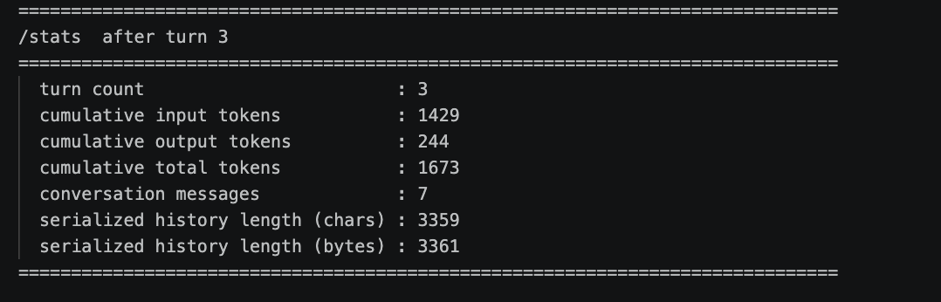

/stats after turn 5
turn count : 5
cumulative input tokens : 3037
cumulative output tokens : 523
cumulative total tokens : 3560
conversation messages : 11
serialized history length (chars) : 5030
serialized history length (bytes) : 5032
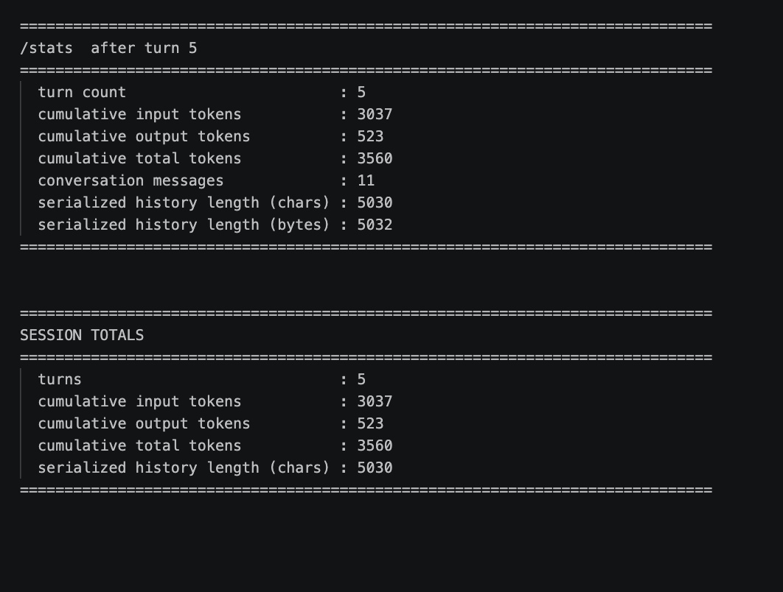

/stats does not alter the history. It calls history_length(), which serializes self.history to measure it and writes nothing back. In interactive mode the command is intercepted before any message is appended, so the counters and the conversation both stay clean.

Two incorrect reviews the model produced
Both were caught by reading the reply against the code rather than accepting it.
Turn 1. The model reported:
- The `count` variable is not declared with `const` or `let`, leading to a
potential global variable.
The submitted code declares it on the second line: let count = 0;. The defect does not exist.

Turn 3. The model reported:
- The function incorrectly returns `True` as a boolean but uses division to
achieve it, which is unnecessary and confusing.
clamp_summary contains no division of any kind. The claim is fabricated.

Both replies were fluent, correctly formatted, and passed the bullet-only check, which is the point: format compliance says nothing about factual correctness. These are recorded in AI_USE.md.

Conceptual questions
Why is prior conversation context resent with every turn?
Because the model holds no state between calls. Each request is independent and the server keeps nothing from the previous one, so anything the model needs must be inside the request.
Turn 4 shows this directly. The question was 108 characters, roughly 25 tokens, but the turn billed 774 input tokens. The other ~750 were the earlier conversation being replayed. That replay is what let the model answer “of the three functions I have shown you so far” correctly; with only the question it would have had no idea which three functions were meant.
This is the same statelessness REST requires of a web service: the server does not remember the client, so the client carries the context.
How is a system prompt different from a user message?
Position and persistence: the system prompt is message index 0 and is resent unchanged every turn, while user messages accumulate behind it. Purpose: it sets standing rules for how to answer rather than asking a question; AGENT.md never requests anything, it constrains the shape of every reply. Cost: its 1,212 characters were billed in all five turns, so a system prompt is a fixed tax on every request rather than a one-time setup cost.
It is not an enforcement mechanism. Turn 5 produced 13 bullets against a cap of 6, because the user's request conflicted with the cap and the model chose the request.
Why do input tokens grow over a conversation?
Every turn sends the system prompt, every previous user message, every previous assistant reply, and the new message. Nothing is removed, so the request lengthens each time: 344, 463, 622, 774, 834. Each increase tracks what was added since the previous turn; input rose 159 tokens from turn 2 to turn 3, and turn 2's reply was 101 tokens plus the new question.
The cumulative effect is lopsided: 3,037 input tokens against 523 output tokens, so 85% of everything processed was input and most of that was history being re-read. Because turn n carries everything before it, total tokens over a conversation grow roughly with the square of the turn count rather than linearly.
What eventually limits that growth?
The context window: the maximum number of tokens the model will accept in one request. Once history plus the new message exceeds it, the request either fails or the oldest messages are silently dropped and the model forgets the start of the conversation without saying so.
For this setup ollama show qwen3:8b reports a context length of 40,960 tokens. Input reached 834 by turn 5 and grew by roughly 120 to 150 tokens per turn, that growth being the previous reply plus the new question, so the window fills somewhere around turn 300. The effective ceiling can be lower: the running server's num_ctx may be set below what the model supports, and the smaller number applies.
Before that hard ceiling, latency bites first, and this session shows it tracks output rather than input. Turn 4 read 774 input tokens and finished in 5.5 s because it wrote only 35 tokens; turn 5 read a similar 834 and took 25.0 s because it wrote 244. Input is processed in one parallel prefill pass while output is generated one token at a time. Input is therefore cheap per token but grows without bound, which is what later techniques address: trimming or summarising old turns, retrieving only the relevant history instead of all of it, and caching the unchanged prefix so the same prefill is not paid for twice.

