DATA-260 Homework 8 — Kafka Request/Response, Agent Pipeline, Failure Behavior
Xu Wang_018319275 · SJSU · DATA 260
GitHub repository: https://github.com/xuwang-goldenwater/data260-9275
Section 0 — Personal Configuration
Value | Definition | My value
SID4 | Last four digits of SJSU ID | 9275
PORT_BASE | 8000 + (SID4 mod 900) | 8275
PREFIX | "s" + SID4 | s9275
SEED | SID4 | 9275
VERIFY_SEED | 260000 + SID4 | 269275
DOMAIN_ID | SID4 mod 8 | 3 — Grocery supply and recall notices (entity: RecallNotice)

Item | Value
Hardware | MacBook Pro, Apple M1, 8 GB RAM, macOS; Docker Desktop
Kafka | apache/kafka:3.8.0, 1 broker, KRaft mode (docker-compose.yml)
Local model | qwen2.5:3b via Ollama, temperature 0, seed 9275 (Part 2 agents)
Kafka client | confluent-kafka (Python)
Code commit verified | cdf9602 — make verify-hw08: 30 passed / 0 failed
Tag | hw8

Part 1 — RecallNotice Request/Response over Kafka
The domain logic runs only in the worker. The client (homework_demo.py) and the FastAPI wrapper never touch the data; they send a request message and wait for the response with the same correlation_id. Operations: CREATE_RECALL_NOTICE and GET_RECALL_NOTICE; the id field is recall_notice_id. Entities are kept in a plain Python dict inside the worker.
Topics and message schemas
Topic | Written by | Read by
s9275_recall_notice_requests | homework_demo.py / FastAPI | worker (group s9275_recall_worker)
s9275_recall_notice_responses | worker (topic named in reply_to) | homework_demo.py / FastAPI

Request schema (CREATE and GET)
{"correlation_id": "94cf8dce-...", "reply_to": "s9275_recall_notice_responses",
"operation": "CREATE_RECALL_NOTICE",
"data": {"productName": "...", "recallingFirm": "...", "submitterEmail": "...",
"description": "...", "category": "Undeclared Allergen", "agreedToTerms": true}}
{"correlation_id": "...", "reply_to": "s9275_recall_notice_responses",
"operation": "GET_RECALL_NOTICE", "data": {"recall_notice_id": "08b73dc8-..."}}

Response schema (success and error)
{"correlation_id": "94cf8dce-...", "success": true,
"recall_notice_id": "08b73dc8-...", "message": "Recall notice created"}
{"correlation_id": "6bbe28f4-...", "success": true, "recall_notice": {"recall_notice_id": "08b73dc8-...", ...}}
{"correlation_id": "err-notfound-1", "success": false, "error": "Recall notice not found"}

correlation_id flow
The client creates the correlation_id once, before sending (one per request: CREATE and GET each get their own). The FastAPI wrapper forwards a caller's X-Correlation-ID header unchanged and only creates one when it is missing. The worker copies it into every response, error responses included. The client and the API match a response to its request only by this value.
Code — worker (validate, process, reply to reply_to, commit after the reply)
code/kafka_app/recall_service.py — handle_request() (validation in validate_notice())
if operation == "CREATE_RECALL_NOTICE":
problem = validate_notice(data)
if problem:
return error(problem)
notice_id = str(uuid.uuid4())
...
if operation == "GET_RECALL_NOTICE":
notice_id = data.get("recall_notice_id")
if not isinstance(notice_id, str) or not notice_id.strip():
return error("Missing field: recall_notice_id")
record = store.get(notice_id.strip())
if record is None:
return error("Recall notice not found")
return {"correlation_id": cid, "success": True, "recall_notice": record}
return error("Unknown operation")

code/kafka_app/worker.py — main loop
response = handle_request(request, STORE)
log("PROCESSED", f"cid={response['correlation_id']} op={request.get('operation')} "
f"success={response['success']} store_size={len(STORE)}")
reply_to = request.get("reply_to") or RESPONSE_TOPIC
producer.produce(reply_to, key=str(response["correlation_id"]),
value=json.dumps(response))
producer.flush(10)
log("SENT", f"topic={reply_to} {json.dumps(response)}")
consumer.commit(message=msg, asynchronous=False)

Code — FastAPI wrapper (waits for the matching correlation_id)
code/kafka_app/api.py
async def call_worker(operation: str, data: Dict[str, Any], cid: Optional[str]) -> Dict[str, Any]:
"""Send one request to Kafka and wait for its response."""
cid = cid or str(uuid.uuid4())
request = {"correlation_id": cid, "reply_to": RESPONSE_TOPIC,
"operation": operation, "data": data}
fut = LOOP.create_future()
PENDING[cid] = fut
try:
log("SENT", f"topic={REQUEST_TOPIC} {json.dumps(request)}")
producer.produce(REQUEST_TOPIC, key=cid, value=json.dumps(request))
await run_in_threadpool(producer.flush, 5)
response = await asyncio.wait_for(fut, TIMEOUT_S)
except asyncio.TimeoutError:
log("TIMEOUT", f"cid={cid} no response after {TIMEOUT_S}s")
raise HTTPException(504, detail={"correlation_id": cid,
"error": "No response from worker"})
finally:
PENDING.pop(cid, None)
log("RETURNED", f"cid={cid} success={response.get('success')} -> HTTP caller")
return response

V-1 Docker containers
docker compose runs kafka, a one-shot kafka-init job that creates all seven topics, the worker and the API.
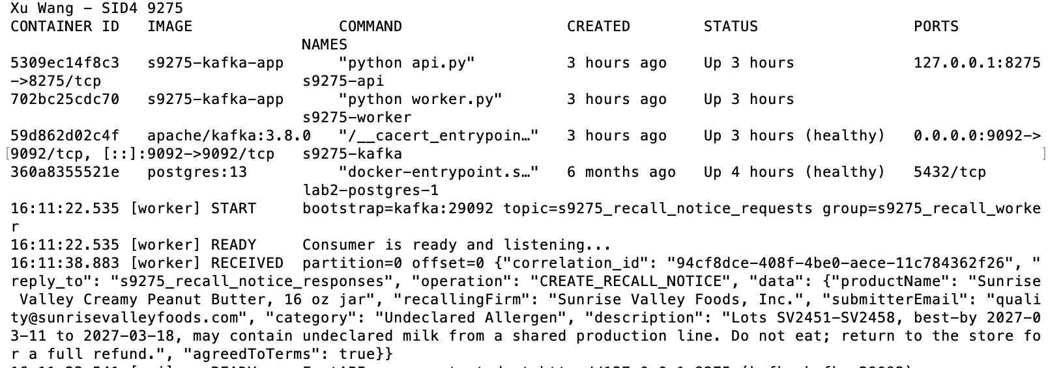
V-2 / V-3 / V-4 CREATE -> GET, message flow, full sequence (homework_demo.py)
homework_demo.py logs its own SENT and RECEIVED lines and pulls the worker's lines for the same correlation_id from docker logs, so the complete sequence prints in order: client SENT -> worker RECEIVED -> worker PROCESSED -> worker SENT -> client RECEIVED -> correlation_id check.

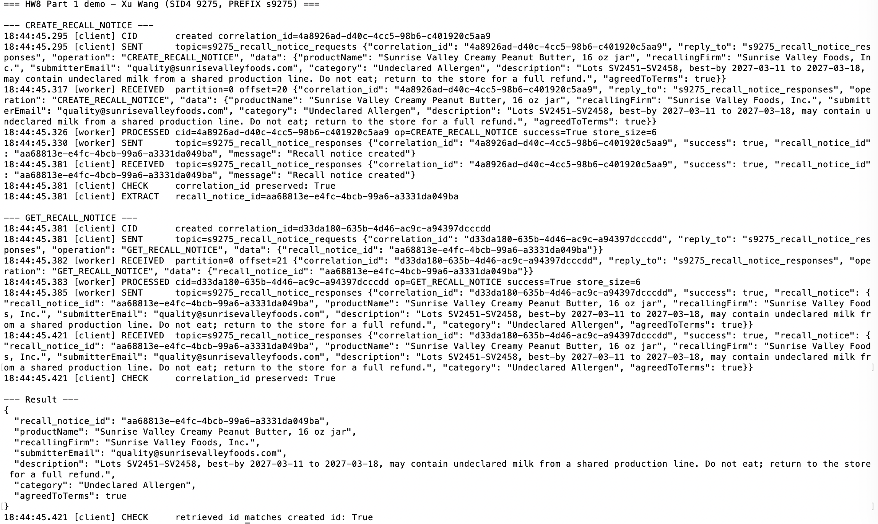
Validation and error responses (through FastAPI)
Request | Response | correlation_id
CREATE without productName | Missing field: productName | err-missing-1
CREATE with category "Spoiled" | Invalid field: category must be one of [...] | err-category-1
GET does-not-exist | Recall notice not found | err-notfound-1
DELETE_RECALL_NOTICE | Unknown operation | err-op-1
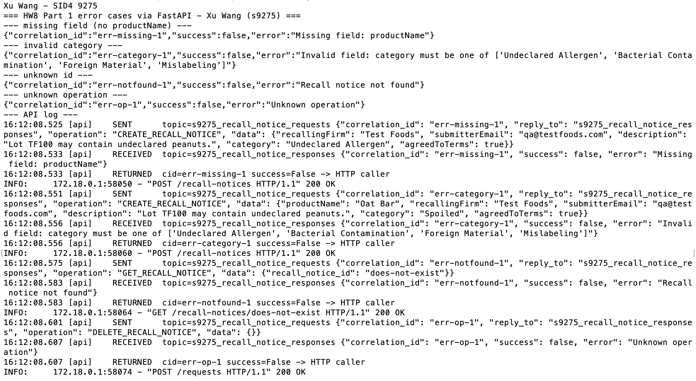

Part 2 — Three-Agent Kafka Pipeline
Planner, Writer and Reviewer run as separate processes in their own terminals. No agent imports or calls another; each reads one topic, adds its field to the message, and writes the next topic. The message grows as it moves (question -> plan -> draft -> status/answer) and keeps the original correlation_id.
Sender | Reads topic | Sends to
You (send_question.py) | - | s9275_inbox (a question)
Planner (planner.py) | s9275_inbox | s9275_tasks (a 3-step plan)
Writer (writer.py) | s9275_tasks (2 partitions) | s9275_drafts (a draft answer)
Reviewer (reviewer.py) | s9275_drafts | s9275_final (status + answer)

Topic creation
docker-compose.yml — kafka-init service
for t in recall_notice_requests recall_notice_responses inbox drafts final dead_letter; do
$$T --create --if-not-exists --topic s9275_$$t --partitions 1 --replication-factor 1 --bootstrap-server $$B
done
$$T --create --if-not-exists --topic s9275_tasks --partitions 2 --replication-factor 1 --bootstrap-server $$B
$$T --describe --bootstrap-server $$B | grep -E "^Topic"

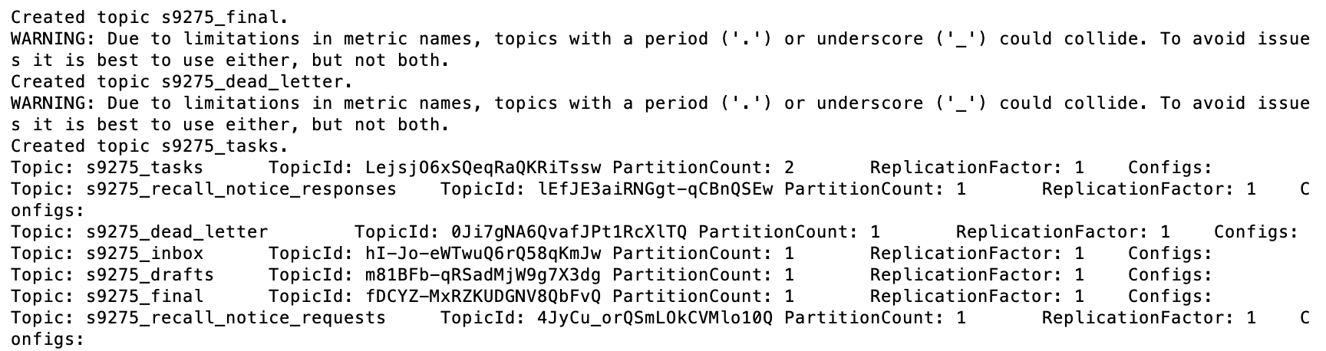

Agent code
planner.py — plan, forward, commit
steps = parse_steps(llm(SYSTEM, message["question"], max_tokens=200))
log(AGENT, "PLANNED", f"cid={cid} steps={steps}", cid=cid)
out = {**message, "plan": steps, "trace": add_trace(message, AGENT)}
send(producer, TASKS, out)
log(AGENT, "SENT", f"cid={cid} -> {TASKS}", cid=cid)
consumer.commit(message=msg, asynchronous=False)

writer.py — the Writer's work
def write_draft(message: dict) -> str:
"""The real work. A message without 'question' raises KeyError (the poison case)."""
if SLOW_SECONDS:
log(AGENT, "WORKING", f"cid={message.get('correlation_id')} "
f"pid={os.getpid()} sleeping {SLOW_SECONDS:.0f}s - kill window")
time.sleep(SLOW_SECONDS)
steps = "\n".join(f"{i}. {s}" for i, s in enumerate(message.get("plan", []), 1))
prompt = f"Question: {message['question']}\n\nPlan:\n{steps}"
return llm(SYSTEM, prompt, max_tokens=300)

reviewer.py — deterministic rules, then the model's JSON verdict
def rule_check(draft: str, plan: list[str]) -> str | None:
"""Return a rejection reason, or None if the draft passes the hard rules."""
if not draft.strip():
return "draft is empty"
if len(draft.split()) > MAX_WORDS:
return f"draft is longer than {MAX_WORDS} words"
similarity = SequenceMatcher(None, _norm(draft), _norm(" ".join(plan))).ratio()
if similarity >= COPY_THRESHOLD:
return f"draft repeats the plan instead of answering (similarity {similarity:.2f})"
return None
def review(message: dict) -> tuple[str, str]:
"""Return (status, reason)."""
draft = message.get("draft", "")
problem = rule_check(draft, message.get("plan", []))
if problem:
return "rejected", f"rule check: {problem}"
steps = "\n".join(f"{i}. {s}" for i, s in enumerate(message.get("plan", []), 1))
raw = llm(SYSTEM, f"Question: {message['question']}\n\nPlan:\n{steps}\n\nDraft:\n{draft}",
max_tokens=120, json_mode=True)
try:
verdict = json.loads(raw)
approved = verdict.get("approved") is True
reason = str(verdict.get("reason", "")).strip() or "no reason given"
except (ValueError, AttributeError):
return "approved", "rule checks passed; model verdict unparseable"
return ("approved" if approved else "rejected"), reason

One message journey, inbox -> final
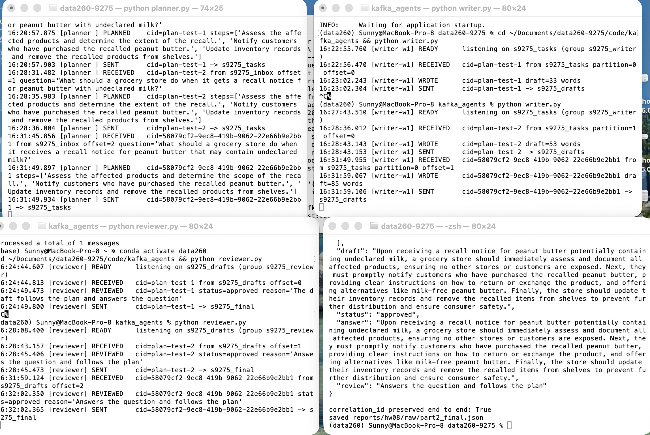
Journey — raw/part2_journey.log (all agents, ordered by time)
16:31:45.854 [client ] SENT cid=58079cf2-9ec8-419b-9062-22e66b9e2bb1 -> s9275_inbox question='What should a grocery store do when...
16:31:45.856 [planner ] RECEIVED cid=58079cf2-9ec8-419b-9062-22e66b9e2bb1 from s9275_inbox offset=2 question='What should a grocery st...
16:31:49.897 [planner ] PLANNED cid=58079cf2-9ec8-419b-9062-22e66b9e2bb1 steps=['Assess the affected products and determine the scope...
16:31:49.934 [planner ] SENT cid=58079cf2-9ec8-419b-9062-22e66b9e2bb1 -> s9275_tasks
16:31:49.955 [writer-w1] RECEIVED cid=58079cf2-9ec8-419b-9062-22e66b9e2bb1 from s9275_tasks partition=0 offset=1
16:31:59.067 [writer-w1] WROTE cid=58079cf2-9ec8-419b-9062-22e66b9e2bb1 draft=85 words
16:31:59.106 [writer-w1] SENT cid=58079cf2-9ec8-419b-9062-22e66b9e2bb1 -> s9275_drafts
16:31:59.124 [reviewer ] RECEIVED cid=58079cf2-9ec8-419b-9062-22e66b9e2bb1 from s9275_drafts offset=2
16:32:02.350 [reviewer ] REVIEWED cid=58079cf2-9ec8-419b-9062-22e66b9e2bb1 status=approved reason='Answers the question and follows the...
16:32:02.365 [reviewer ] SENT cid=58079cf2-9ec8-419b-9062-22e66b9e2bb1 -> s9275_final
16:32:02.379 [client ] FINAL cid=58079cf2-9ec8-419b-9062-22e66b9e2bb1 from s9275_final status=approved

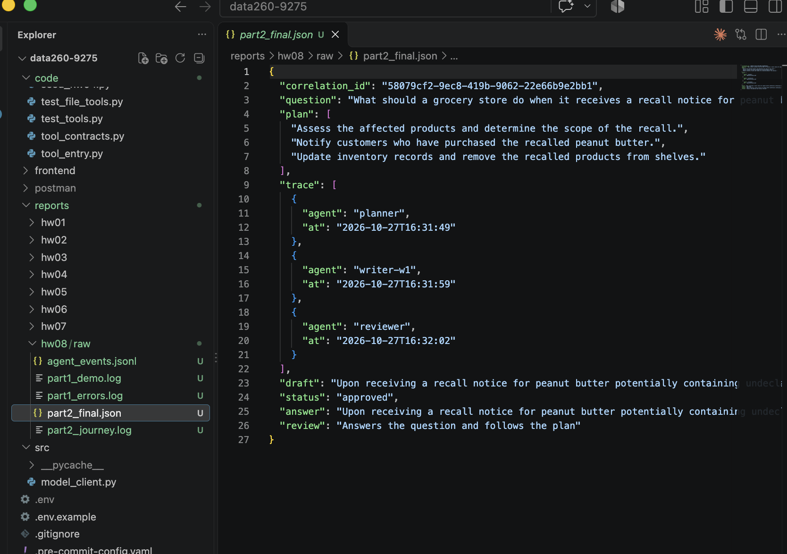
How Kafka helped the agents coordinate
Kafka is the only thing the agents share. The Planner finishes and moves on without knowing whether a Writer is running; the plan waits in s9275_tasks until one is. That decoupling showed up in testing: the first test plan sat in s9275_tasks while no Writer existed and was processed the moment I started writer.py. Each agent's consumer group remembers how far it has read, so a restarted agent continues where it stopped, and the two partitions of s9275_tasks let a second Writer share the load without any change to the Planner. The correlation_id carried in the message is what lets the client pick its own answer out of s9275_final.
Found in testing: While testing, the first Writer prompt made qwen2.5:3b copy the plan as its answer and the model Reviewer approved it. The Reviewer now rejects any draft ≥ 0.8 similar to the plan before asking the model (see AI use).
Part 3 — Failure Behavior
All fixes live in writer.py and reliability.py. Each fix has its own switch (FIX_IDEMPOTENCY, FIX_MANUAL_COMMIT, FIX_DLQ, all on by default); every "before" run turns off exactly one, so each row of the table changes one thing. Results are checked by counting drafts with the correlation_id in s9275_drafts (part3_tools.py check), not by reading log wording.
writer.py — order of operations with the fixes on
# Duplicate delivery fix: an id that already produced a draft is skipped.
if FIX_IDEMPOTENCY and store.seen(cid):
log(AGENT, "DUPLICATE", f"cid={cid} already processed - skipped, no new draft",
cid=cid)
commit(msg)
continue
work = (lambda m: order_test_work(m, msg)) if message.get("order_test") else write_draft
if FIX_DLQ:
ok, result, attempts = run_with_retries(
work, message,
on_retry=lambda n, exc: log(AGENT, "RETRY", f"cid={cid} attempt {n}/"
f"{MAX_ATTEMPTS} failed: {type(exc).__name__}: {exc}",
cid=cid))
if not ok:
to_dead_letter(producer, raw, msg, AGENT, result, attempts)
log(AGENT, "DEAD_LTR", f"cid={cid} -> s9275_dead_letter after {attempts} "
f"attempts ({result})", cid=cid)
commit(msg)
continue
draft = result
else:
draft = work(message) # before fix: an exception ends the process
if message.get("order_test"):
log(AGENT, "ORDERED", f"cid={cid} {draft}", cid=cid,
recall_notice_id=message["recall_notice_id"], seq=message["seq"])
else:
log(AGENT, "WROTE", f"cid={cid} draft={len(draft.split())} words", cid=cid)
out = {**message, "draft": draft, "trace": add_trace(message, AGENT)}
send(producer, DRAFTS, out)
log(AGENT, "SENT", f"cid={cid} -> {DRAFTS}", cid=cid)
store.mark(cid) # after the output is in Kafka
commit(msg) # last: only now is this message done

I. Duplicate delivery
reliability.py — ProcessedStore: finished correlation_ids, kept in var/writer_processed.txt (survives restarts)
def seen(self, cid: str) -> bool:
return cid in self.ids
def mark(self, cid: str) -> None:
"""Call only after the output has been sent."""
self.ids.add(cid)
with self.path.open("a") as fh:
fh.write(cid + "\n")

Before (FIX_IDEMPOTENCY=0): the same task, same correlation_id, sent twice was processed twice — 2 model calls and 2 drafts. After: the second copy is recognised and skipped; 1 draft.
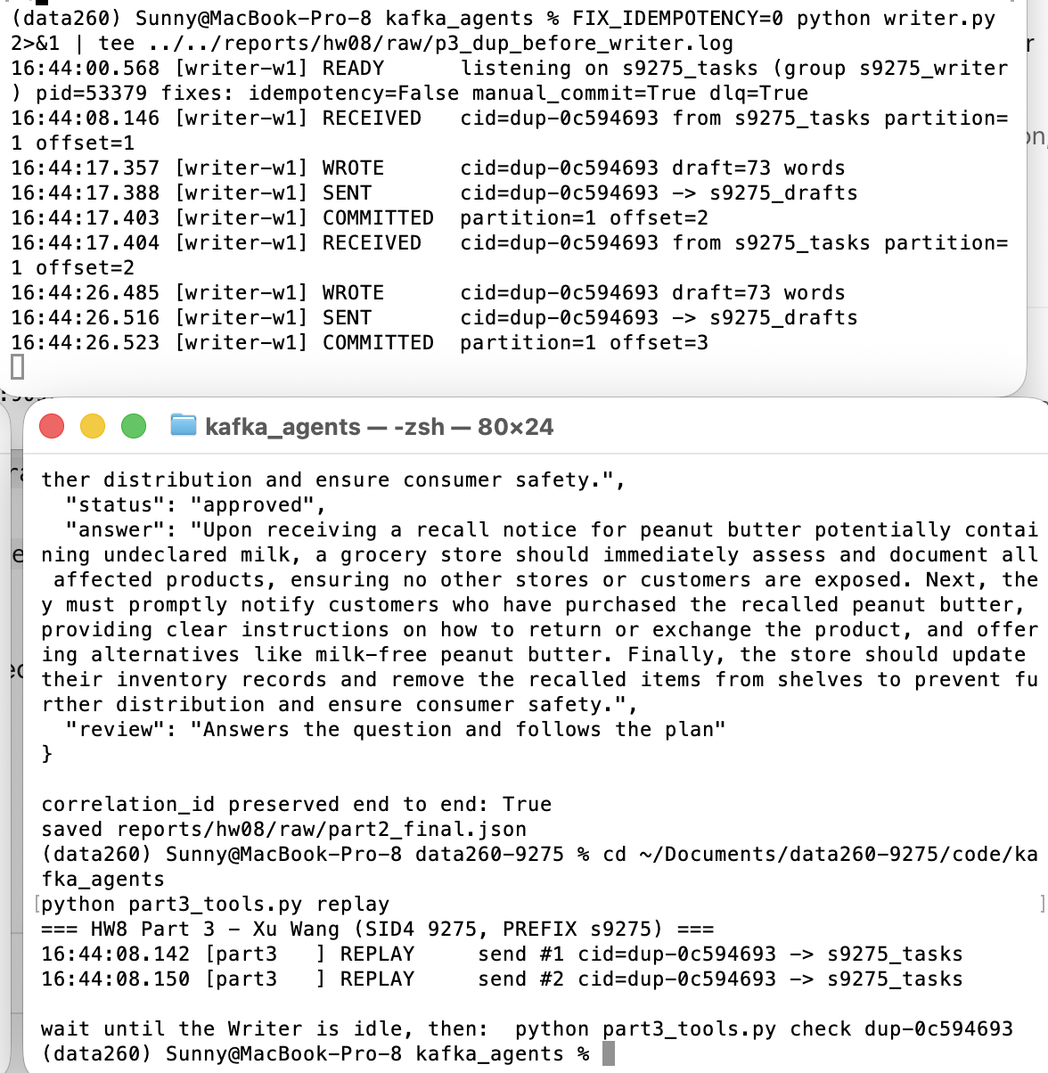

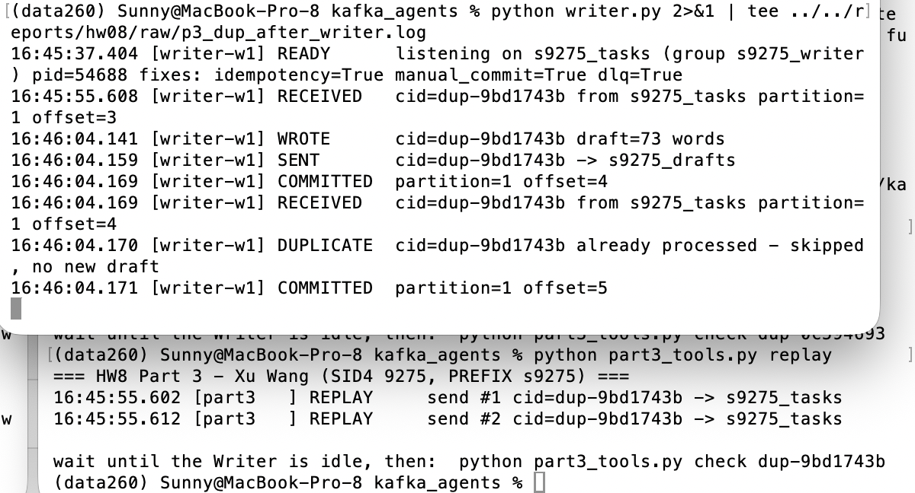
II. Consumer death
common.py — make_consumer(): manual commit; auto-commit only for the before run
config = {
"bootstrap.servers": BOOTSTRAP,
"group.id": group_id,
"auto.offset.reset": offset_reset,
"enable.auto.commit": auto_commit,
# A killed consumer is noticed after 10 s instead of the default 45 s,
# so its partitions move to the restarted consumer quickly.
"session.timeout.ms": 10000,
}
if auto_commit:
config["auto.commit.interval.ms"] = 1000

The Writer was started with SLOW_SECONDS=20, killed with kill -9 while working on the task, and restarted. Before (auto-commit every second): the offset was committed before the work finished (LAG 0), the restarted Writer received nothing and the task was lost — 0 drafts. After: the offset was still uncommitted (LAG 1); the restarted Writer re-read the same offset 5, finished it and only then committed offset 6 — 1 draft.
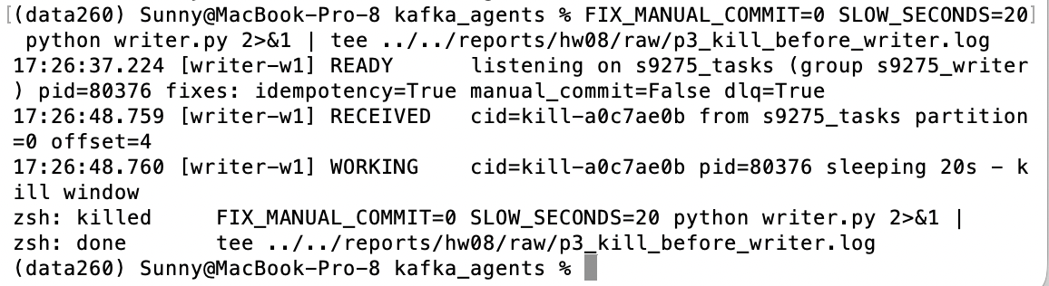
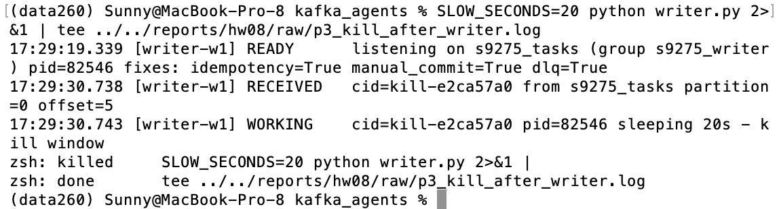
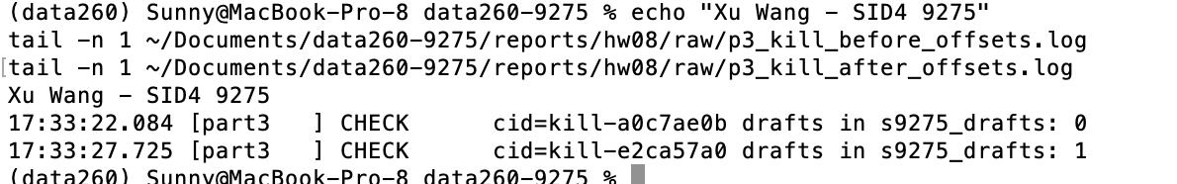

III. Poison message
reliability.py — bounded retries (the dead-letter send is in the writer.py block above)
def run_with_retries(fn: Callable[[Dict[str, Any]], Any], message: Dict[str, Any],
on_retry: Callable[[int, Exception], None]) -> Tuple[bool, Any, int]:
"""Return (ok, result_or_error_text, attempts_used)."""
last_error: Exception | None = None
for attempt in range(1, MAX_ATTEMPTS + 1):
try:
return True, fn(message), attempt
except Exception as exc: # noqa: BLE001 - any failure counts as a failed attempt
last_error = exc
on_retry(attempt, exc)
if attempt < MAX_ATTEMPTS:
time.sleep(BACKOFF_S * attempt)
return False, f"{type(last_error).__name__}: {last_error}", MAX_ATTEMPTS

A task without a question field was sent, with a normal task behind it in the same partition. Before (FIX_DLQ=0): KeyError killed the Writer; the restart re-read offset 7 and died again; partition 1 stayed at LAG 2 and the normal task was blocked. After: 3 attempts, then the original message and the error went to s9275_dead_letter, offset 8 was committed and the normal task was processed (1 draft).
s9275_dead_letter record (original message omitted here)
{
"correlation_id": "poison-73ba33df",
"failed_agent": "writer-w1",
"source_topic": "s9275_tasks",
"source_partition": 1,
"source_offset": 7,
"attempts": 3,
"error": "KeyError: 'question'"
}
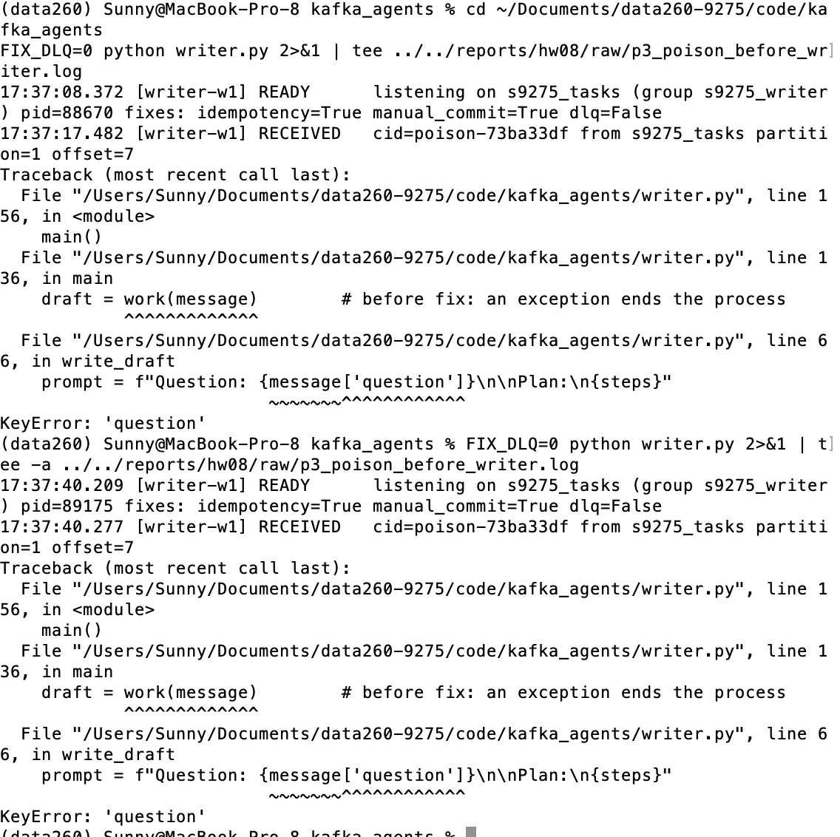
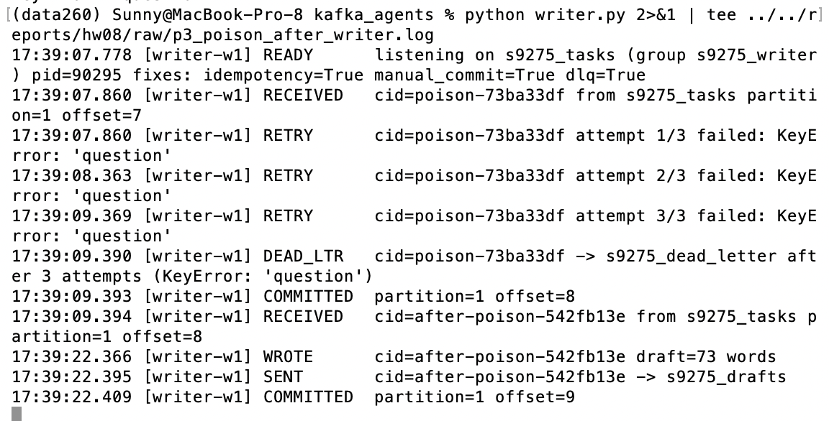

IV. Ordering — two partitions, two Writers
part3_tools.py — the only difference between the two runs: the message key
if run == "keyed":
# Fix: key by the related entity -> one partition per recall -> order kept.
producer.produce(TASKS, key=m["recall_notice_id"], value=json.dumps(message))
else:
# Before: no key; spread round-robin over the 2 partitions.
producer.produce(TASKS, value=json.dumps(message), partition=i % 2)

Using VERIFY_SEED 269275, 20 related tasks were generated: 4 recalls × 5 steps (notice received, lots verified, shelves cleared, customers notified, recall closed), interleaved but always sent in step order. Two Writers (w1, w2) in group s9275_writer each owned one partition of s9275_tasks. In these runs the Writer replaces the model call with 0.1–0.6 s of fixed work per (recall, step), so the key is the only variable. The no-key run spreads tasks round-robin over the two partitions (librdkafka's sticky partitioner would otherwise put a fast burst of keyless messages in one partition and hide the problem).
Run | Recall | Partitions | Writers | Step order processed | Violations
no key | RN-c6810e | 0,1 | w1,w2 | [1, 2, 4, 3, 5] | 1
no key | RN-c973f5 | 0,1 | w1,w2 | [1, 3, 2, 5, 4] | 2
no key | RN-c97b16 | 0,1 | w1,w2 | [1, 2, 3, 4, 5] | 0
no key | RN-efb54f | 0,1 | w1,w2 | [1, 2, 3, 4, 5] | 0
key = recall_notice_id | RN-c6810e | 0 | w2 | [1, 2, 3, 4, 5] | 0
key = recall_notice_id | RN-c973f5 | 1 | w1 | [1, 2, 3, 4, 5] | 0
key = recall_notice_id | RN-c97b16 | 1 | w1 | [1, 2, 3, 4, 5] | 0
key = recall_notice_id | RN-efb54f | 0 | w2 | [1, 2, 3, 4, 5] | 0

Total violations: 3 without a key, 0 with the key. A violation is a step processed after a higher-numbered step of the same recall.
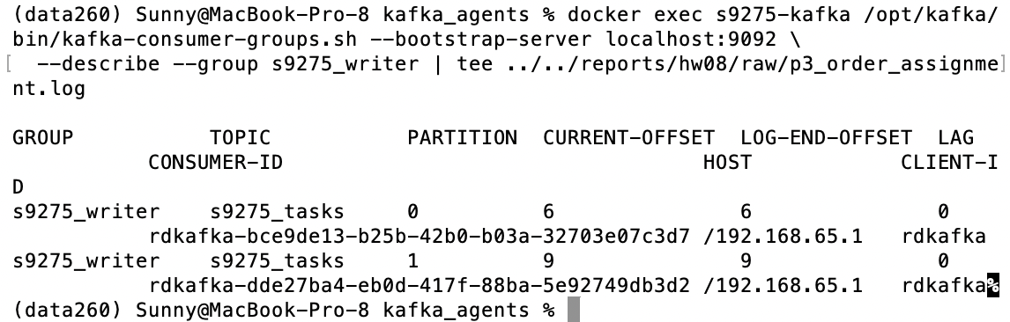
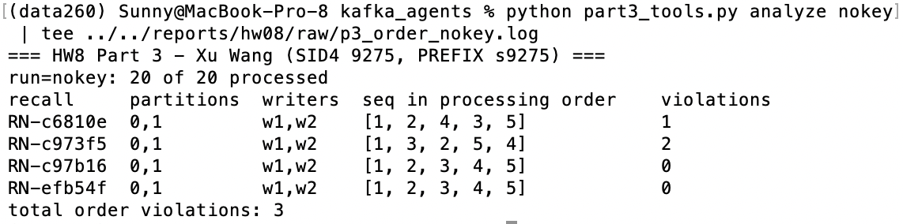
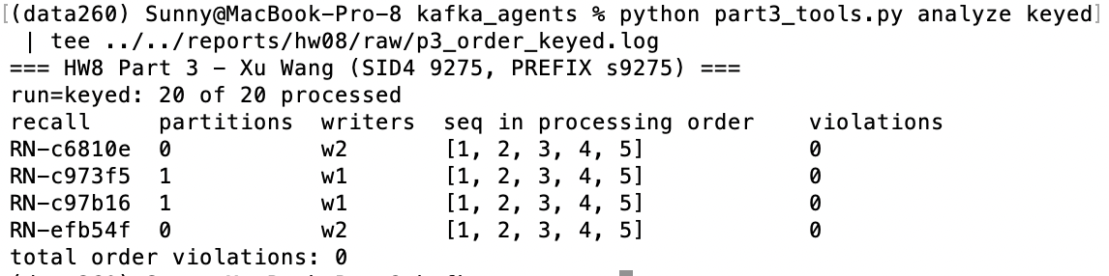
Failure table
Failure scenario | Before fix | After fix
Duplicate delivery | Same task + correlation_id sent twice -> processed twice, 2 drafts (dup-0c594693) | Second copy -> DUPLICATE skipped, 1 draft (dup-9bd1743b)
Consumer killed mid-work | Auto-commit: offset committed before work finished (LAG 0); restart gets nothing; 0 drafts — lost (kill-a0c7ae0b) | Commit after send: LAG 1 after crash; restart re-reads offset 5, commits 6; 1 draft (kill-e2ca57a0)
Poison message | KeyError kills Writer; restart dies on the same offset 7; LAG 2 — next task blocked | 3 attempts -> s9275_dead_letter -> commit; next task processed, 1 draft
Two partitions / two consumers | No key: every recall split over partitions 0,1 and w1,w2; 3 order violations | Key = recall_notice_id: one partition and one Writer per recall; steps 1-5 in order; 0 violations

Screenshots for every row are above; full logs in reports/hw08/RUN_LOG.txt and raw/.
V. Comparison with the HW2 in-process graph
In HW2 the LangGraph supervisor called each node as a function in one Python process; a step started only when the previous call returned.
Benefits gained by moving to Kafka:
- Decoupled failure. When a Writer died, the Planner and Reviewer kept running and the unfinished task stayed in s9275_tasks; the restarted Writer finished it (Part 3 II). In HW2 an exception in one node ended the whole run.
- Independent scaling. A second Writer joined group s9275_writer and took one of the two partitions with no change to the Planner or Reviewer (Part 3 IV). In HW2 every step ran at the speed of one process.
New responsibilities I now handle myself:
- Duplicates and offsets. Kafka delivers at least once, so the same task can arrive twice; I had to add an idempotency store and decide exactly when to commit the offset (after the output is sent). A function call runs once and has no offset.
- Ordering and bad input. Order is only guaranteed inside one partition, so related messages need a key; and a message that always fails must be retried a bounded number of times and moved to a dead-letter topic, or it blocks its partition. In HW2 steps were ordered by the call stack and an error simply raised.
Verification
make verify-hw08 runs verify_hw08.py on commit cdf9602 and writes reports/hw08/verification.json: 30 passed, 0 failed. Live checks: containers running, 7 topics, s9275_tasks has 2 partitions, CREATE -> GET round trip through Kafka and through FastAPI, three error cases, correlation_id echoed every time. Unit and evidence checks: Reviewer copy rule, idempotency store, 3 retry attempts, and the before/after result of all four failure rows. The script uses a temporary directory and does not change application code.
AI Use
1. What I used an AI assistant for, and what I did myself.
I used Claude (Anthropic) as a coding assistant.
I summarized the assignment into concrete tasks, proposed the design (one compose stack for Kafka + worker + FastAPI, a growing JSON message for the three agents, one switch per Part 3 fix so each "before" run changes only one thing).
It wrote the framework of code one file at a time: the RecallNotice worker and FastAPI wrapper, homework_demo.py, the Planner, Writer and Reviewer, the reliability helpers, the Part 3 test tool.
I filled up the core parts of each file.
I ran every command on my Mac (Docker, the four agent terminals, every before/after failure run), chose to run the consumer-death test by hand, step by step, instead of an automated script, took every screenshot, and checked each result against the expected output before committing.
2. One AI-produced output that was wrong.
The first Writer prompt asked the model to answer "covering each step of the plan in order". qwen2.5:3b answered by copying the three plan lines word for word, and the Reviewer (also the model) approved it, so the first end-to-end run delivered "status": "approved" with an answer that answered nothing.
3. How I detected it.
I read the final JSON from s9275_final for the first test message (plan-test-1): the draft and answer fields were identical to the plan list, and the review reason was "The draft follows the plan and answers the question". The pipeline "worked"; only reading the content showed the failure.
4. What I changed and why it works now.
Two changes. The Writer prompt now asks for one paragraph of 3–5 full sentences, uses the plan only as an outline and forbids copying the plan lines or a numbered list. The Reviewer got a deterministic rule that runs before the model: if the draft's normalized text is ≥ 0.8 similar to the plan (difflib), it is rejected. The copied draft scores 1.00 and is rejected; the next runs produced 53- and 85-word answers that pass the rule and were approved. verify_hw08.py checks both cases, so the rule cannot silently disappear.
A second issue I verified independently: after the compose file changed, Docker recreated the Kafka container and every topic was gone, which made homework_demo.py fail with "no partition assignment". Listing the topics confirmed it; the fix is the kafka-init service, which recreates all seven topics before the worker and API start.

