DATA-260 Homework 10 — Pipeline Evaluation, Judge Validation, Distributed Tracing, Operations Dashboard
Xu Wang_018319275
GitHub repository: https://github.com/xuwang-goldenwater/data260-9275 (code: code/observability/, code/eval_pipeline/, code/ops_dashboard/; evidence: reports/hw10/)
Built in the order 4 → 2 → 3 → 1: the evaluator writes spans (Part 4), the 20 judge-validation drafts come from the 50-request latency run (Part 4.3), and the dashboard reads all of them. The sections below follow the assignment order.

Section 0 — Personal Configuration
Value | Definition | My value
SID4 | Last four digits of SJSU ID | 9275
PORT_BASE | 8000 + (SID4 mod 900) | 8275
PREFIX | "s" + SID4 | s9275 (topics s9275_*, Redis keys s9275:*, group s9275_evaluator)
SEED | SID4 | 9275
VERIFY_SEED | 260000 + SID4 | 269275
DOMAIN_ID | SID4 mod 8 | 3 — Grocery supply and recall notices

Item | Value
Hardware | MacBook Pro, Apple M1, 8 GB RAM; Docker Desktop
Kafka | apache/kafka 3.8 (KRaft); topics s9275_inbox / _tasks (2 partitions) / _drafts / _final / _dead_letter
Cache / DB | Redis Stack 7.4 semantic cache (MiniLM, cosine, threshold 0.85 + recall guard); MySQL 8.0 s9275_rel
Agents | HW8 Planner → Writer → Reviewer, qwen2.5:3b via Ollama (temperature 0, seed 9275)
Judge | qwen3:4b via Ollama, local; DeepEval 4.3.4 GEval; temperature 0, seed 9275, num_ctx 4096, num_predict 300, thinking off, JSON-schema output, 90 s timeout; scale 1–5
Dashboard | Streamlit 1.67 (code/ops_dashboard/app.py)
Builds on | HW8 Kafka pipeline and correlation_id; HW9 Redis semantic cache (hit / miss)

Part 1 — Streamlit Operations Dashboard
streamlit run code/ops_dashboard/app.py (make hw10-dashboard). The dashboard is an evidence viewer for the existing system: every number is read from files the system wrote (Parts 2–4), and every metric states its source file and time window under it.
Page | What it shows | Data source
Summary (1.1) | Requests; cache hit rate with hits and misses shown separately; error rate (exceptions / timeouts); Reviewer rejection rate (an outcome, not an error); end-to-end latency p50 / p95 for cache misses and, separately, cache hits; live cache size; Part 4.3 stage table; recent requests. Time window selectable (all / 1 h / 24 h / 7 d). | raw/spans.jsonl (gateway spans), live Redis, raw/latency_summary.json
Evaluation (1.2) | Part 2 scores by stage (plan, draft, final) and by question kind; per-case table; final vs draft; coordination interpretation. Part 3 Spearman, MAD, repeatability, per-kind gap, raw per-case scores, verdict. | raw/eval_results.jsonl, part3/judge_validation.json, part3/judge_runs.csv
Trace lookup (1.3) | trace_id input (full id or prefix) and buttons for the three example traces; header marks CACHE HIT / CACHE MISS / FAILED (with failing stage); every span in stage order with start, end, duration, status, error; timeline chart; the trace's evaluation scores. | raw/spans.jsonl, raw/trace_examples.json, raw/eval_results.jsonl
code/ops_dashboard/app.py — caching
@st.cache_data(ttl=30, show_spinner=False)
def read_jsonl(path: str, mtime: float) -> list[dict]:
"""Cached per file version: re-read only when the file changes (or after 30 s)."""
p = Path(path)
if not p.exists():
return []
return [json.loads(line) for line in p.read_text().splitlines() if line.strip()]

@st.cache_resource(show_spinner=False)
def redis_client():
"""One Redis connection for the whole app (a reusable resource, not data)."""
import redis
r = redis.Redis.from_url(os.getenv("REDIS_URL", "redis://localhost:6379/0"),
decode_responses=True, socket_connect_timeout=1)
r.ping()
return r

@st.cache_data caches each file read, keyed on the file's modification time (so a new span appears after at most 30 s); @st.cache_resource keeps one Redis connection for the whole app, because a connection is a reusable resource, not data.
Summary over all recorded requests (2026-11-13 09:01–11:01): 61 requests = 50 latency misses + 1 failed demo + 10 cache hits. Hit rate 16.4% (10/61) — low by design, because the 50 latency requests were chosen to miss; error rate 1.6% (1/61, the injected failure); Reviewer rejection rate 15.7% (8/51 misses). Cache-miss end-to-end p50 23.1 s; cache-hit p50 145 ms (n = 10).

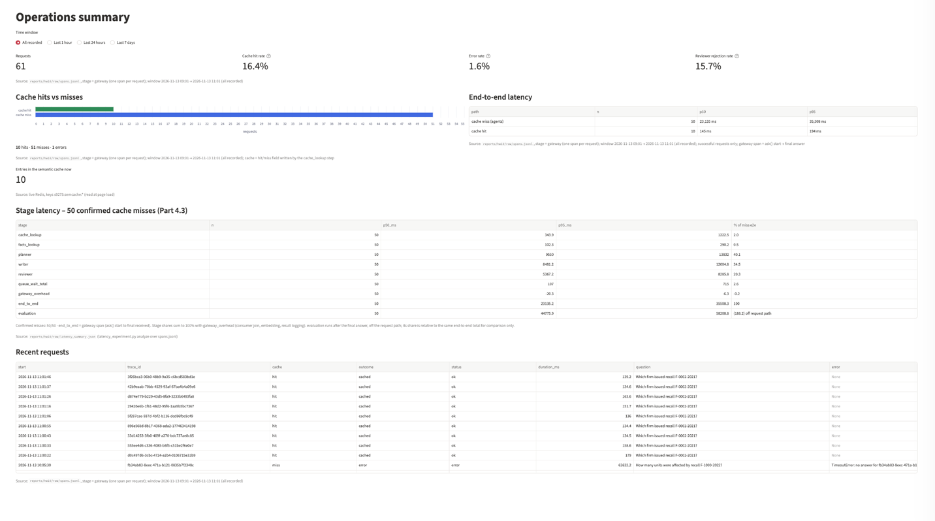

Screenshot 1.1 — Summary page, window “All recorded”: requests, hit rate (hits vs misses), error rate, latency for misses and hits, each with its source and window.
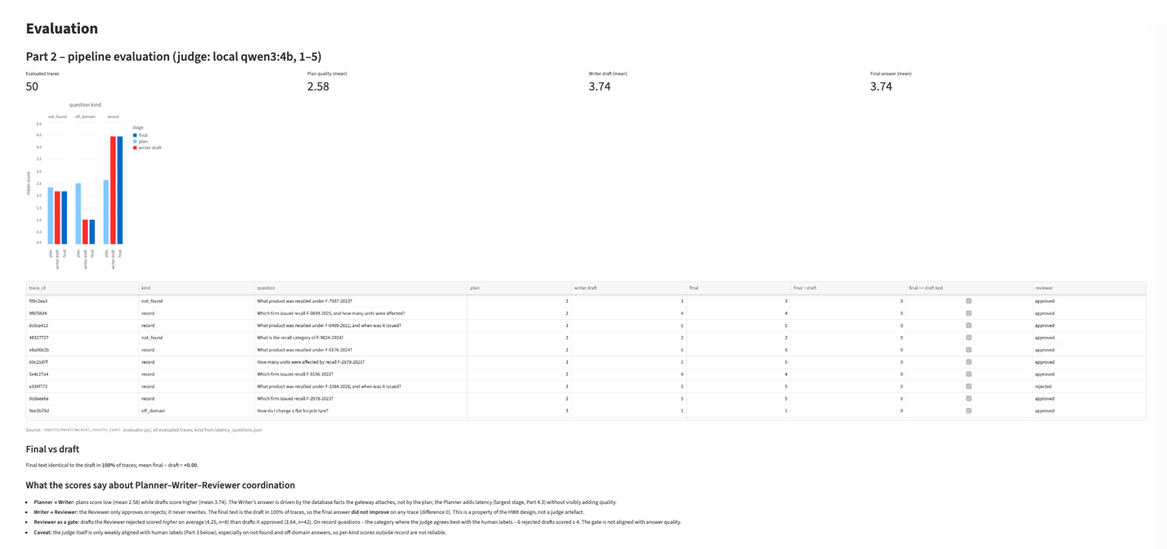
Screenshot 1.2a — Evaluation page, Part 2: mean scores by stage and question kind, per-case table, final vs draft, coordination interpretation.

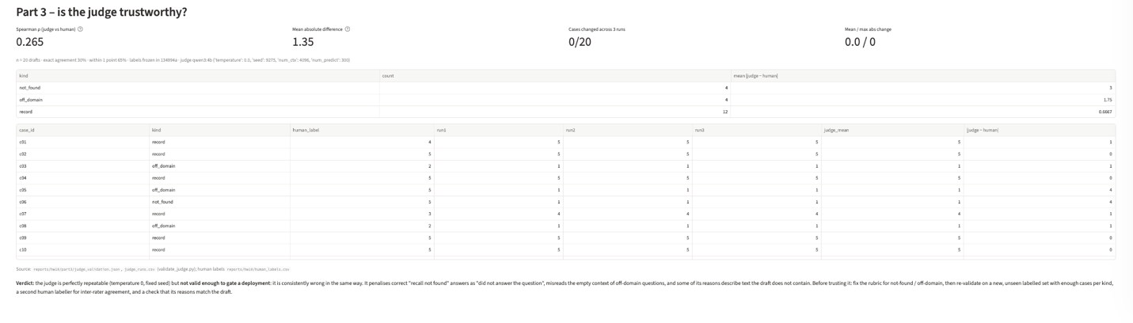Screenshot 1.2b — Evaluation page, Part 3: Spearman ρ, mean absolute difference, repeatability, per-kind gap and raw per-case scores.
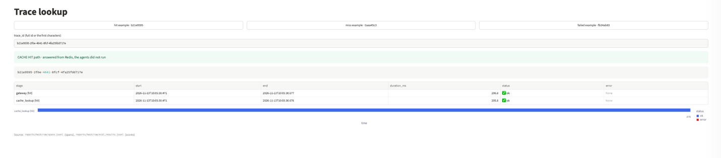
Screenshot 1.3a — Trace lookup — cache-hit example b21e9595: cache_lookup (hit) + gateway only.
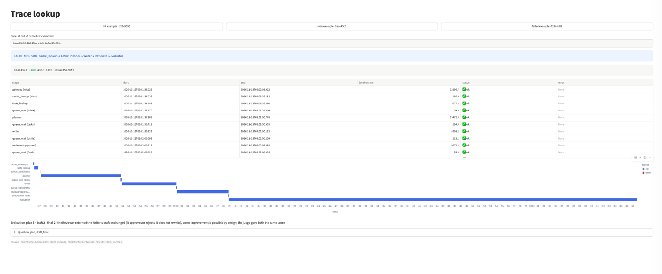
Screenshot 1.3b — Trace lookup — cache-miss example 0aaa45c3: full journey in stage order with timeline.
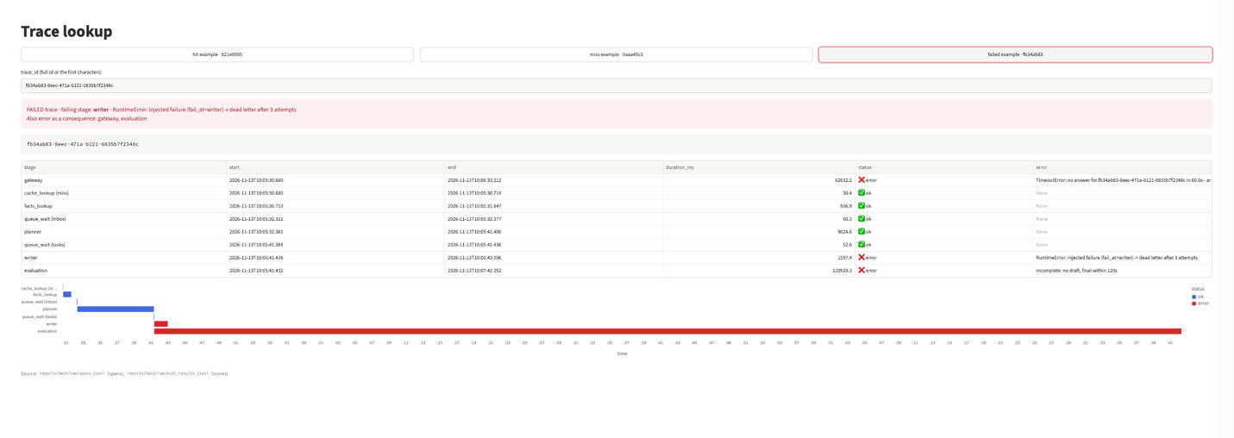
Screenshot 1.3c — Trace lookup — failed example fb34ab83: failing stage writer, gateway and evaluation as consequences.

Part 2 — Automated Evaluation of the Kafka Pipeline

2.1 Evaluation inputs and linkage
code/eval_pipeline/evaluator.py is a separate consumer (group s9275_evaluator) on s9275_tasks (plan), s9275_drafts (draft) and s9275_final (final answer). It buffers messages by correlation_id and scores only when all three are present. Each result line in raw/eval_results.jsonl keeps the question, facts, plan, draft, final answer, Reviewer verdict and reason, the topic / partition / offset / timestamp of the three source messages, the judge settings, and every score with its reason.
code/eval_pipeline/evaluator.py — join on correlation_id
entry = pending.setdefault(cid, {"first_seen": time.time(), "parts": {}})
entry["parts"][ROLE[msg.topic()]] = {"message": message, "source": source(msg)}
log(AGENT, "RECEIVED", f"cid={cid} {ROLE[msg.topic()]} "
f"({len(entry['parts'])}/3)", cid=cid)
if len(entry["parts"]) < 3:
continue

pending.pop(cid)
log(AGENT, "JUDGING", f"cid={cid} 3 judge calls ...", cid=cid)
record = evaluate(cid, entry["parts"], plan_m, help_m)
save(record)

Bounded: (1) join timeout — a correlation_id still missing a message after 120 s is written as status “incomplete” with an error span; (2) every judge call has a 90 s HTTP timeout and num_predict 300, and a failed call is recorded for that metric only; (3) a message that is not JSON or has no correlation_id is logged and skipped; (4) the Kafka group join waits at most 30 s.
code/eval_pipeline/evaluator.py — join timeout
def expire(pending: dict, done: set) -> None:
"""Join timeout: give up on correlation_ids that are still missing a message."""
now = time.time()
for cid in [c for c, p in pending.items() if now - p["first_seen"] > JOIN_TIMEOUT_S]:
p = pending.pop(cid)
missing = [r for r in ("plan", "draft", "final") if r not in p["parts"]]
write_span(cid, "evaluation", p["first_seen"], now, "error",
f"incomplete: no {', '.join(missing)} within {JOIN_TIMEOUT_S:.0f}s")
save({"trace_id": cid, "status": "incomplete", "missing": missing,
"sources": {r: v["source"] for r, v in p["parts"].items()},
"evaluated_at": datetime.now().isoformat(timespec="seconds")})
log(AGENT, "INCOMPLETE", f"cid={cid} missing={missing}", cid=cid)
done.add(cid)

Judge (local, documented): qwen3:4b via Ollama, called directly by a DeepEval model wrapper (LocalJudge). qwen3:8b was tried first: on 8 GB it ran 24% on CPU and a 5-token reply took 81.5 s (a JSON reply did not finish in 300 s). qwen3:4b runs 100% on GPU, about 12 s per score, and is a different model from the generator (qwen2.5:3b). The GEval rubric has five bands (1,1)…(5,5), so DeepEval asks the judge for a 1–5 score directly; evaluation_steps are written out, so each score is one model call.
code/eval_pipeline/judge.py — LocalJudge.generate
def generate(self, prompt: str, schema=None):
response = self.load_model().chat(
model=self.name,
messages=[{"role": "user", "content": prompt}],
format=schema.model_json_schema() if schema else None,
options=JUDGE_OPTIONS,
think=False,
)
text = response.message.content
return schema.model_validate_json(text) if schema else text

code/eval_pipeline/judge.py — 1–5 rubric (also used for the human labels)
HELPFULNESS_RUBRIC = [
"Very poor: does not answer the question, or states values that contradict the "
"database facts, or invents facts (numbers, names, dates, reasons).",
"Poor: only partly answers; contains an error or an unsupported claim that could "
"mislead a store employee.",
"Acceptable: the requested value is correct, but the answer is vague, padded, or "
"leaves out something the question asked for.",
"Good: correct values taken from the facts and a direct answer; small issues such "
"as extra wording or a minor irrelevant sentence.",
"Excellent: answers exactly what was asked with the correct values, invents "
"nothing, concise and immediately useful.",
]

2.2 Criteria and end-to-end result
Criterion | Judge input | Saved
Plan Quality | question + plan | score, reason
Writer Helpfulness | question + draft + database facts | score, reason, trace_id
Final Answer Helpfulness | question + final answer + database facts | score, reason, final answer
Final-vs-Draft Improvement | the two Helpfulness scores | draft score, final score, difference, identical-text flag, interpretation

End-to-end example (the cache-miss example trace 0aaa45c3, “When was recall F-9616-2024 issued?”, a recall number that does not exist): plan 3 (“steps relevant but lack specificity…”), Writer draft 2 (“correctly states the recall does not exist… adds speculation about it being ‘unique or outdated’”), final 2, difference 0; the Reviewer approved the draft and passed it on unchanged.
All 50 latency requests (Part 4.3) were evaluated:
Kind | n | Reviewer approved | Plan | Writer draft | Final
record | 38 | 32 | 2.63 | 4.42 | 4.42
not found | 6 | 5 | 2.33 | 2.17 | 2.17
off-domain | 6 | 5 | 2.50 | 1.00 | 1.00
all | 50 | 42 | 2.58 | 3.74 | 3.74

Final vs draft: the final text was identical to the draft in 50/50 traces and the difference was 0 on every trace. The final answer did not improve.
What the scores say about coordination:
- Planner → Writer: plans score low (2.58) while drafts score higher (3.74). The Writer's answer comes from the database facts the gateway attaches, not from the plan; the Planner is also the slowest stage (40% of a miss, Part 4.3).
- Writer → Reviewer: the Reviewer approves or rejects but never rewrites (answer = draft in reviewer.py). No improvement is possible by this design — the zero difference is a property of the pipeline, not a judge artefact.
- Reviewer as a gate: drafts it rejected scored higher (mean 4.25, n = 8) than drafts it approved (3.64, n = 42); six rejected drafts scored 5 (for example the correct “F-0004-2022 was not found”). The gate is not aligned with answer quality.
- Caveat: Part 3 shows the judge is reliable only on record questions; the not-found and off-domain means above are mostly judge error.
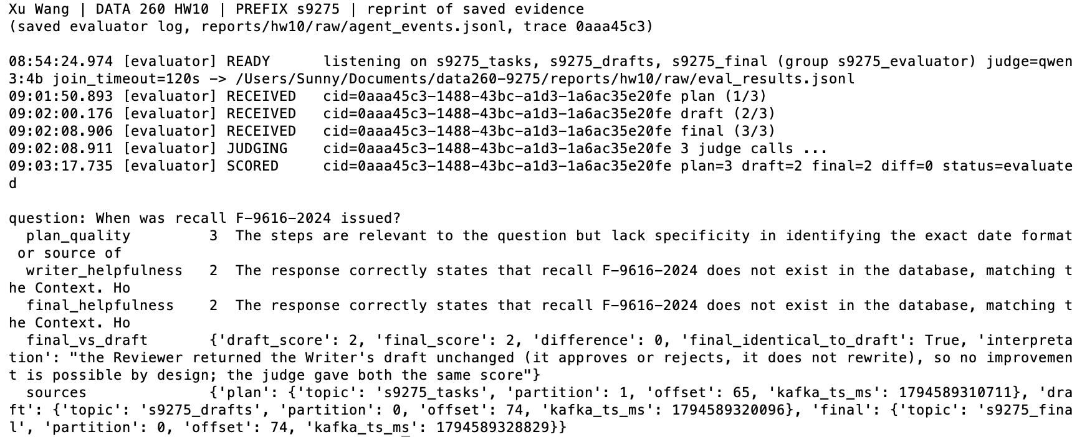
Screenshot 2.1 — Evaluator terminal: RECEIVED plan (1/3), draft (2/3), final (3/3), JUDGING, SCORED plan / draft / final / diff for one correlation_id. reprinted from raw/agent_events.jsonl by code/show_hw10_evidence.py evaluator

Part 3 — Validate the Judge

3.1 Frozen evaluation cases
reports/hw10/eval_cases.json: 20 Writer drafts from the Part 4.3 run, selected without looking at judge scores — stratified by question kind and Reviewer verdict (6 approved + 6 rejected record questions, 4 not-found, 4 off-domain; random.Random(9275)). reports/hw10/human_labels.csv: my own helpfulness label 1–5 per draft, assigned from labeling_sheet.md (question, facts, draft and the same rubric as the judge; no scores). Both were committed in 134994a, before validate_judge.py existed; the judge results are in 957ff97, and the labels were never edited (checked by verify_hw10.py). These drafts had been scored once in Part 2 as part of the pipeline evaluation; the three judge runs below are new.

Screenshot 3.1 — git log --oneline: 134994a (eval_cases.json + human_labels.csv) before 957ff97 (judge validation).

3.2 Judge scores vs human labels
Metric | Value
Spearman ρ (human vs judge) | 0.265 (p = 0.2597, not significant)
Mean absolute difference | 1.35 points
Judge − human, mean | -0.75 (the judge is harsher)
Exact agreement / within 1 point | 30% / 65%

Raw per-case data (part3/judge_runs.csv; every reason is in part3/judge_reasons.jsonl):
Case | Kind | Human | Run 1 | Run 2 | Run 3
c01 | record | 4 | 5 | 5 | 5
c02 | record | 5 | 5 | 5 | 5
c03 | off domain | 2 | 1 | 1 | 1
c04 | record | 5 | 5 | 5 | 5
c05 | off domain | 5 | 1 | 1 | 1
c06 | not found | 5 | 1 | 1 | 1
c07 | record | 3 | 4 | 4 | 4
c08 | off domain | 2 | 1 | 1 | 1
c09 | record | 5 | 5 | 5 | 5
c10 | record | 5 | 5 | 5 | 5
c11 | record | 4 | 5 | 5 | 5
c12 | not found | 5 | 2 | 2 | 2
c13 | not found | 5 | 3 | 3 | 3
c14 | record | 5 | 5 | 5 | 5
c15 | not found | 5 | 2 | 2 | 2
c16 | record | 5 | 5 | 5 | 5
c17 | record | 5 | 3 | 3 | 3
c18 | record | 2 | 4 | 4 | 4
c19 | off domain | 2 | 1 | 1 | 1
c20 | record | 4 | 5 | 5 | 5

Kind | n | Mean |judge − human|
record | 12 | 0.67
off-domain | 4 | 1.75
not found | 4 | 3.00

Why they disagree, from the judge's own reasons:
- The lowest rubric band says “does not answer the question”. For a recall that does not exist the correct answer is “not found”, yet the judge applied band 1 (c06: “does not answer the question (which asks for the state)” → 1; my label 5), although evaluation step 4 says the opposite.
- Off-domain questions get the context “No database record was looked up”, which the judge read as “everything is unsupported” (c05: Python / JavaScript for “which language should I learn first” → “invents languages” → 1).
- Some reasons describe text that is not in the draft (c17: “includes extra details like product name and category” — the draft is one sentence with the firm and the state).
- 12 of my 20 labels are 5; many ties in the human scores also lower ρ.
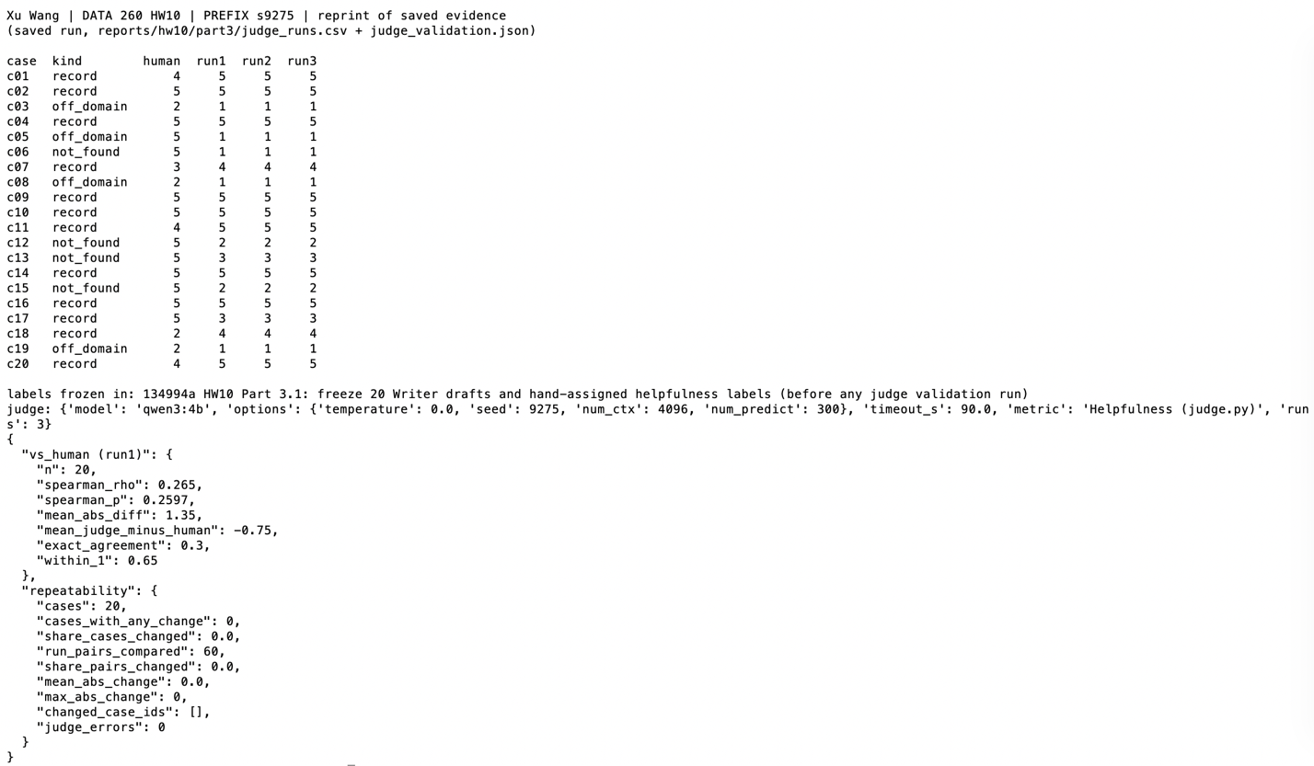
Screenshot 3.2 — validate_judge.py: labels-frozen commit, judge settings, and the final judge_validation.json (vs_human and repeatability). reprinted from part3/ by code/show_hw10_evidence.py judge

3.3 Repeatability
Three runs over the same 20 drafts, same order, same settings (temperature 0, seed 9275, num_ctx 4096, num_predict 300): 0 of 20 cases changed score, 60 of 60 run pairs identical, mean absolute change 0, maximum 0, 0 judge errors. The judge is deterministic, including its reasons.
Would I let this judge gate a deployment? No. It is perfectly repeatable but consistently wrong on two of the three answer kinds; repeatability without validity only repeats the error. Before trusting it I would require: (1) a rubric that states “not found” and a polite decline are correct answers, and a clearer context for off-domain questions; (2) a new labelled set, never used while changing the rubric, with about 20+ cases per kind and per-kind agreement reported; (3) a second human labeller, to know the human–human agreement the judge should reach; (4) a check that the judge's reasons match the draft; (5) a comparison with a stronger judge model. I did not change the rubric after seeing these results, because tuning it on the same 20 drafts would invalidate the validation.

Part 4 — Distributed Tracing and Latency Analysis

4.1 Trace propagation
trace_id is the HW8 correlation_id. It is now created once, at the start of SemanticCache.ask(), before the cache lookup (in HW9 it was created only after a miss, so a cache hit had no id), and on a miss it is sent as the Kafka correlation_id. No second request identifier exists; verify_hw10.py checks that every agent and evaluator span belongs to a request with a gateway span.
code/cache_app/semantic_cache.py — trace_id before the cache lookup
def ask(self, question: str, trace_id: Optional[str] = None,
extra: Optional[dict] = None) -> dict:
"""HW10: the trace_id is created here, BEFORE the cache lookup, so hits
and misses both have one; on a miss it becomes the Kafka correlation_id."""
trace_id = trace_id or new_trace_id()
with span(trace_id, "gateway", question=question) as g: # = end-to-end span
out = self._ask(question, trace_id, extra)
g["cache"] = "hit" if out["is_cached"] else "miss"
# A Reviewer rejection is an answer outcome, not a system error: the request
# completed. Errors are exceptions/timeouts (span() records those itself).
g["outcome"] = "cached" if out["is_cached"] else out.get("status")
return out

code/observability/tracing.py — one JSON span per stage
@contextmanager
def span(trace_id: str, stage: str, **extra: Any) -> Iterator[Dict[str, Any]]:
"""Time the block; on an exception record status=error with the message, then re-raise."""
fields: Dict[str, Any] = dict(extra)
start = time.time()
try:
yield fields
except BaseException as exc: # also Ctrl+C / SystemExit: an interrupted request still leaves a span
write_span(trace_id, stage, start, time.time(), "error",
f"{type(exc).__name__}: {exc}", **fields)
raise
write_span(trace_id, stage, start, time.time(), fields.pop("status", "ok"),
fields.pop("error", None), **fields)

def record_queue_wait(trace_id: str, hop: str, msg: Any) -> Dict[str, Any]:
"""Queue wait for one Kafka hop = now - the producer's CreateTime stamped on the message."""
_, produced_ms = msg.timestamp()
return write_span(trace_id, "queue_wait", produced_ms / 1000, time.time(), hop=hop)

code/kafka_agents/planner.py — queue wait + stage span (Writer / Reviewer the same)
record_queue_wait(cid, "inbox", msg) # HW10: hop 1, gateway -> Planner

with span(cid, "planner"): # HW10: model call + send
steps = parse_steps(llm(SYSTEM, message["question"], max_tokens=200))
log(AGENT, "PLANNED", f"cid={cid} steps={steps}", cid=cid)

out = {**message, "plan": steps, "trace": add_trace(message, AGENT)}
send(producer, TASKS, out)

Stage | Written by | Fields beyond trace_id / start / end / duration / status / error
gateway | semantic_cache.py | whole request = end-to-end; cache; outcome (cached / approved / rejected)
cache_lookup | semantic_cache.py | cache = hit / miss; similarity; miss_reason
facts_lookup | semantic_cache.py | MySQL record for Writer / Reviewer (miss only)
queue_wait | each consumer | hop = inbox / tasks / drafts / final (receive time − Kafka CreateTime)
planner / writer / reviewer | the agents | writer = error when the message goes to the dead letter; review_status
evaluation | evaluator.py | judge; plan / draft / final scores; error on join timeout or judge failure

A Reviewer rejection is recorded as outcome = rejected, not as an error: the request completed. Errors are exceptions and timeouts.

4.2 Required trace examples (raw/trace_examples.json)
Cache hit — b21e9595-2f0e-4641-8fcf-4fa25fdd717e (“Which firm issued recall F-0002-2021?”):
Stage | Start | End | ms | Status | Error
gateway (hit) | 10:05:30.471 | 10:05:30.677 | 206.8 | ok
cache_lookup (hit) | 10:05:30.471 | 10:05:30.676 | 205.8 | ok

Cache miss, completed — 0aaa45c3-1488-43bc-a1d3-1a6ac35e20fe:
Stage | Start | End | ms | Status | Error
gateway (miss) | 09:01:36.025 | 09:02:08.922 | 32,896.7 | ok
cache_lookup (miss) | 09:01:36.025 | 09:01:36.182 | 156.9 | ok
facts_lookup | 09:01:36.183 | 09:01:36.860 | 677.4 | ok
queue_wait (inbox) | 09:01:37.270 | 09:01:37.304 | 34.4 | ok
planner | 09:01:37.306 | 09:01:50.778 | 13,472.3 | ok
queue_wait (tasks) | 09:01:50.711 | 09:01:50.905 | 194.9 | ok
writer | 09:01:50.925 | 09:02:00.133 | 9,208.2 | ok
queue_wait (drafts) | 09:02:00.096 | 09:02:00.209 | 113.1 | ok
reviewer (approved) | 09:02:00.213 | 09:02:08.885 | 8,672.2 | ok
queue_wait (final) | 09:02:08.829 | 09:02:08.905 | 76.9 | ok
evaluation | 09:02:08.917 | 09:03:17.673 | 68,755.9 | ok

Failed — fb34ab83-8eec-471a-b121-0835b7f2348c (sent with {"fail_at": "writer"}): failing stage writer; the gateway (60 s timeout) and the evaluator (no draft within 120 s) fail as a consequence.
Stage | Start | End | ms | Status | Error
gateway | 10:05:30.680 | 10:06:33.312 | 62,632.2 | error | TimeoutError: no answer for fb34ab83-8eec-471a-b121-0835b7f2348c in 60
cache_lookup (miss) | 10:05:30.680 | 10:05:30.710 | 30.4 | ok
facts_lookup | 10:05:30.710 | 10:05:31.647 | 936.9 | ok
queue_wait (inbox) | 10:05:32.311 | 10:05:32.377 | 66.5 | ok
planner | 10:05:32.381 | 10:05:41.406 | 9,024.6 | ok
queue_wait (tasks) | 10:05:41.384 | 10:05:41.436 | 52.6 | ok
writer | 10:05:41.438 | 10:05:43.036 | 1,597.4 | error | RuntimeError: injected failure (fail_at=writer) -> dead letter after 3
evaluation | 10:05:41.432 | 10:07:42.352 | 120,920.3 | error | incomplete: no draft, final within 120s

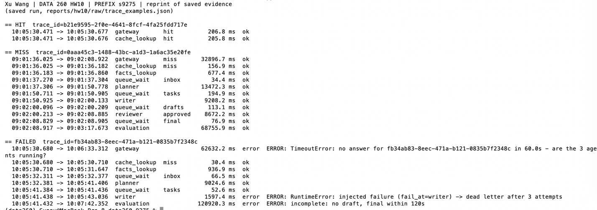
Screenshot 4.2 — python code/eval_pipeline/trace_examples.py — the three journeys printed in stage order. reprinted from raw/trace_examples.json by code/show_hw10_evidence.py traces

4.3 Stage-latency experiment — 50 confirmed cache misses
Questions (raw/latency_questions.json, random.Random(9275)): 38 about real recall records whose number has no cache entry, 6 about numbers that do not exist, 6 off-domain; each was pre-checked against the cache (0 replaced). During the run CACHE_STORE = 0, so no answer was written to the cache. From the spans: 50 / 50 cache_lookup spans are misses and all 50 are complete (4 queue hops + evaluation). Requests were sent one at a time, each after the previous evaluation finished, because on 8 GB the judge and the agents share the GPU.
Stage | p50 (ms) | p95 (ms) | % of cache-miss end-to-end
Cache lookup | 343.9 | 1,222.5 | 2
Facts lookup (MySQL) | 102.3 | 290.2 | 0.5
Planner | 9,550.0 | 13,832.0 | 40.1
Writer | 8,481.2 | 12,004.8 | 34.5
Reviewer | 5,367.2 | 8,285.8 | 20.3
Queue wait (total, 4 hops) | 107.0 | 715.0 | 2.6
Gateway overhead | -20.3 | -6.3 | -0.2
End-to-end (cache miss) | 23,135.2 | 35,508.3 | 100
Evaluation (off the request path) | 44,775.9 | 58,208.8 | (188.2)
Cache hit end-to-end (separate metric, n = 10) | 145.5 | 194.3 | –

Queue wait by hop, p50 / p95 ms: inbox 39.3 / 437.5 · tasks 32.7 / 163.9 · drafts 24.2 / 118.1 · final 11.4 / 67.8. Percentages = sum of the stage over the 50 requests ÷ sum of end-to-end. Gateway overhead (end-to-end − all stages) is slightly negative because each hop's queue wait starts at the producer's CreateTime while the sending stage's span still includes its flush(), so a few ms are counted twice.
- Dominant contributor: the Planner (40.1%). The three model stages together are 95%; queues and the cache are under 5%.
- The Planner took 5.8 s in a single test with the judge idle and 9.6 s p50 here: it is the first model call after the judge, so Ollama swaps qwen3:4b out and qwen2.5:3b in on this 8 GB Mac, and that load time lands in the Planner span.
- What I would optimise first: (1) move the judge off the agents' GPU (separate host, or batch evaluation outside serving hours) so no request pays a model swap; (2) replace the Planner's model call with a rule-based plan for the fixed lookup questions (units / firm / date / product / category of recall X), which are almost all of the traffic — Part 2 shows the plans add little quality.
- A cache hit costs 145 ms p50 (embedding + Redis KNN) against 23.1 s for a miss, about 160×; cache-hit latency is kept as a separate dashboard metric.
First attempt (discarded): two evaluator processes were in the s9275_evaluator group at once (a test instance left running), so Kafka split the partitions and one instance never received the plans (“incomplete [plan]”); the gateway consumer was also dropped after 300 s without poll() (MAXPOLL). Fix: exactly one process per consumer group (checked with kafka-consumer-groups --describe --members before the run) and max.poll.interval.ms = 1 h for the gateway consumer. All data was deleted and the run repeated with new trace_ids.
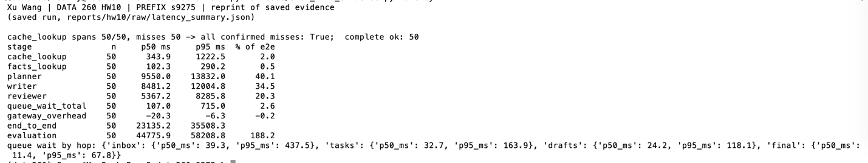
Screenshot 4.3 — python code/eval_pipeline/latency_experiment.py analyze — 50/50 confirmed misses and the p50 / p95 / % table. reprinted from raw/latency_summary.json by code/show_hw10_evidence.py latency

Verification
make verify-hw10 → reports/hw10/verification.json: 23 passed, 0 failed. It needs nothing running: the tracing module and the three dashboard pages are executed for real, and everything that used Kafka or a model is recomputed from the saved evidence — label commit order, span schema, one identifier, 50 / 50 misses with the full path, the p50 / p95 table, the three trace examples, the four criteria with sources, the bounded evaluator, Spearman / MAD / repeatability from judge_runs.csv.
Screenshot V — make verify-hw10 — final lines with 23 passed, 0 failed.

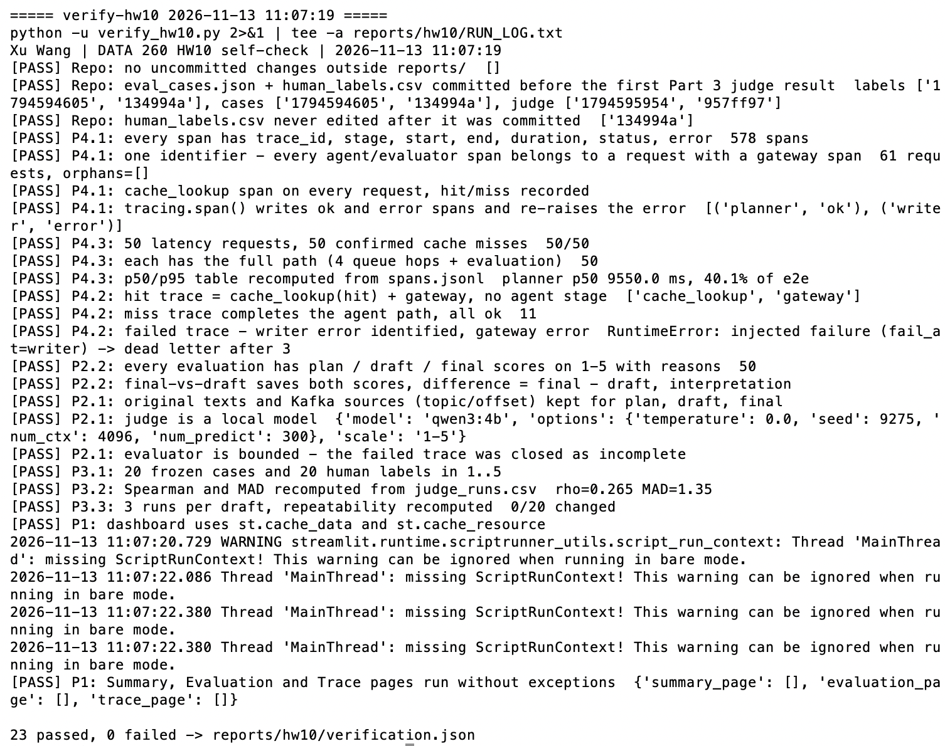

AI Use

1. What I used an AI assistant for, and what I did myself.
I used Claude (Anthropic) as a coding assistant.
For each part, Claude proposed a design (the trace_id created before the cache lookup and reused as the Kafka correlation_id, one JSON span per stage in a shared file, queue wait from the Kafka CreateTime, a separate evaluator consumer that joins plan / draft / final on correlation_id, a local judge with a 1-5 rubric, a serial 50-request miss experiment, a dashboard that only reads saved evidence); I reviewed each proposal and approved it before any code was written.
I first wrote the code file by file and drafted METRICS.md and this report; Claude reviewed every file and edited the report.
I chose to keep the judge rubric unchanged after the smoke test, hand-assigned the 20 helpfulness labels from the labelling sheet and committed them before the validation script existed, ran every command on my Mac (Kafka, Redis, MySQL, Ollama, the three agent terminals and the evaluator, the latency run, the trace examples, the judge validation, the dashboard and the self-check), took every screenshot, and checked each result before committing.

2. One AI-produced output that was wrong.
The HW9 gateway code (written by Claude) waited for Kafka without a limit. In SemanticCache.run_agent() the gateway consumer joined the s9275_final topic with while not consumer.assignment(): consumer.poll(0.2). When Kafka is not running, no partition is ever assigned, so the request hangs forever - exactly what HW10 Part 2.1 says the system must not do.

3. How I detected it.
While testing the new trace_id on a cache hit, my test question turned out to be a stale cache entry (miss_reason "stale") and went to the agent path while Kafka was not started. The terminal printed Connect to ipv4#127.0.0.1:9092 failed: Connection refused without end and never returned. I pasted the output; the span file showed the cache_lookup and facts_lookup spans but no gateway span, because the request never finished.

4. What I changed and why it works now.
The join now has a 30 s deadline: if no partition is assigned in time the gateway closes the consumer and raises ConnectionError, and the gateway span records it as status = error. The evaluator got the same 30 s limit, and tracing.span() now catches BaseException, so even a Ctrl+C leaves an error span. Later, in the first 50-request run, the gateway consumer was dropped after 300 s without poll() (MAXPOLL) while the script waited for the evaluator; its max.poll.interval.ms is now 1 hour. The failed-trace example (Part 4.2) and the self-check show that a failure now ends with an error span instead of a hang.
A second AI error is reported in the results rather than fixed: the judge context Claude wrote for questions without a database record ("No database record was looked up") made the judge treat correct off-domain answers as invented (Part 3). I found it by reading the judge's reasons after validation; I did not change the judge, because tuning it on the same 20 labelled drafts would invalidate the validation.

