DATA-260 — Homework 4
Xu Wang
Repository: github.com/xuwang-goldenwater/data260-9275

Section 0 — Personal configuration and domain
Value | This submission | How it is derived
SID4 | 9275 | last four digits of the SJSU Student ID
PORT_BASE | 8275 | 8000 + (9275 mod 900)
PREFIX | s9275 | "s" + SID4
SEED | 9275 | SID4
VERIFY_SEED | 269275 | 260000 + SID4
DOMAIN_ID | 3 — grocery supply and recall notices | 9275 mod 8

Item | Value
Hardware | MacBook Pro, Apple M1, 8 GB RAM, macOS
Local model | qwen3:8b via Ollama (temperature 0, thinking off); embeddings sentence-transformers/all-MiniLM-L6-v2 on CPU
Database | MySQL 8.0.43, database s9275_rel
Stack | Python 3.12 (conda env data260), FastAPI + SQLAlchemy 2 + PyMySQL; React 18 + Vite + react-router-dom 6
Tagged commit | __________ (fill in: git rev-parse --short hw4)
Tag | hw4

Homework 4 extends the same codebase. The HW3 FastAPI app in code/auth_app/ becomes the backend for the React client: users and sessions move from in-memory dictionaries into MySQL, and the recall-notice data moves from HW2's JSON file into MySQL. HW2's code/api_server.py is unchanged. The React client is in frontend/, the Part 3 and Part 4 scripts are in code/, and reports/hw04/ holds evidence only (RUN_LOG.txt, raw/, METRICS.md, AI_USE.md, verification.json).

Part 1 — React client
Run: make run-hw04 (API on http://localhost:8275) and make run-frontend (React on http://localhost:5173). Log in with demo@s9275.example.com / recall-demo-9275. The entity is a recall notice: primary field product_name, secondary field category.

1.1 Login (Login.jsx) and "Login required"
Login posts email + password to POST /api/auth/login. The backend answers with Set-Cookie; the component never reads the cookie. When no one is logged in, Home shows "Login required" and the navbar hides "Add Record".
frontend/src/pages/Login.jsx
export default function Login({ onLogin }) {
const [email, setEmail] = useState("");
const [password, setPassword] = useState("");
const [error, setError] = useState("");
const [busy, setBusy] = useState(false);

async function handleSubmit(e) {
e.preventDefault();
setError("");
setBusy(true);
try {
await onLogin(email.trim(), password);
} catch (err) {
setError(err.status === 401 ? "Invalid email or password." : err.message);
setBusy(false);
}
}

frontend/src/components/Navbar.jsx
// "Add Record" is only shown to a logged-in user.
export default function Navbar({ user, onLogout }) {
return (
<nav className="navbar">
<Link to="/" className="brand">Recall Notice Desk</Link>
<div className="nav-links">
<NavLink to="/" end>Notices</NavLink>
{user && <NavLink to="/create">Add Record</NavLink>}
</div>

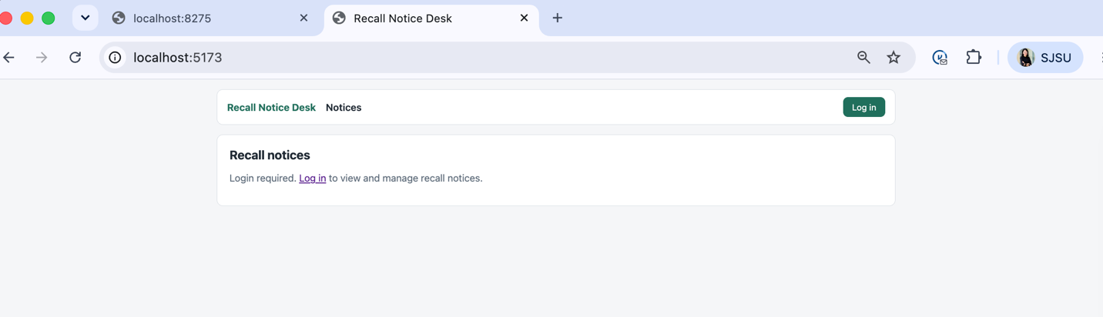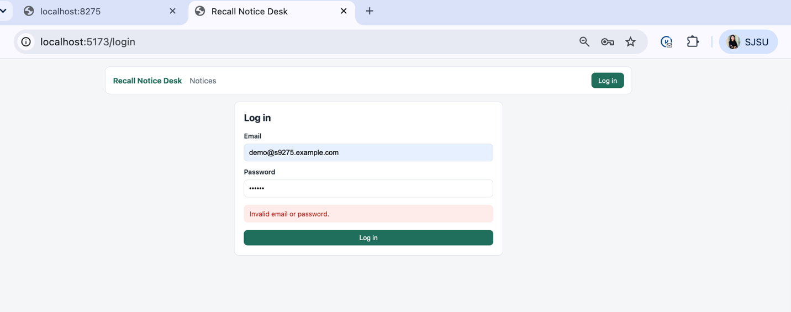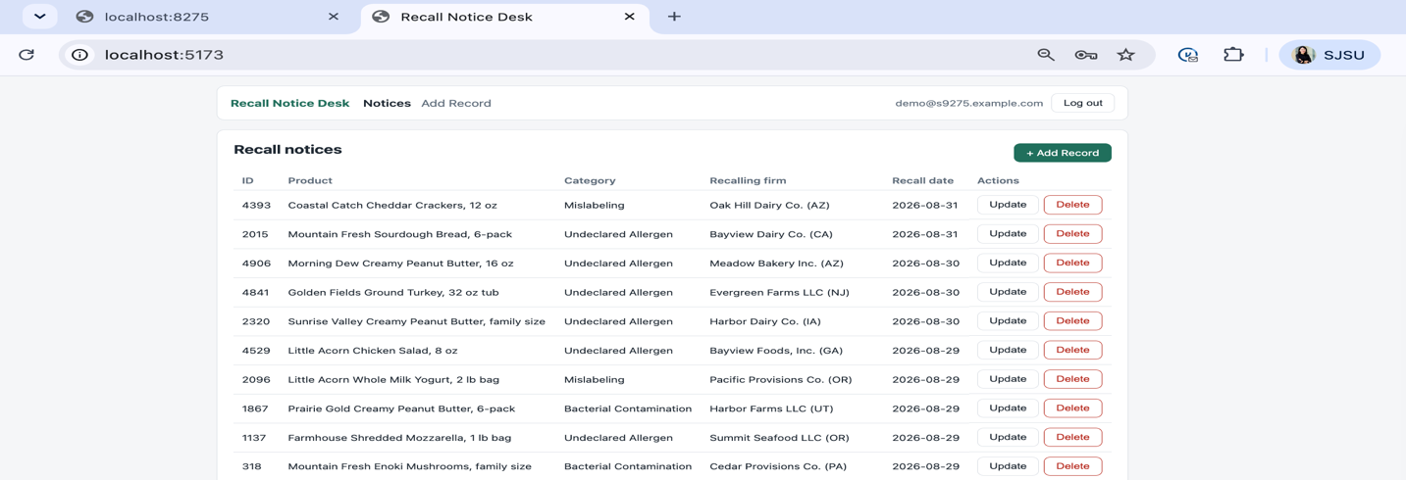

1.2 HTTP-only session cookie
code/auth_app/routers/auth.py — login sets an opaque token in an HTTP-only cookie
now = utcnow()
token = secrets.token_urlsafe(32) # 43 random URL-safe characters
db.add(SessionToken(id=token, user_id=user.id, created_at=now,
expires_at=new_expiry(now, now)))
db.commit()

response.set_cookie(
key=config.COOKIE_NAME,
value=token,
httponly=True, # JavaScript cannot read it
samesite="lax", # sent to localhost:8275 from localhost:5173 (same site)
secure=False, # plain http on localhost; set True behind HTTPS
max_age=config.ABSOLUTE_TIMEOUT_SECONDS,
path="/",
)
return user
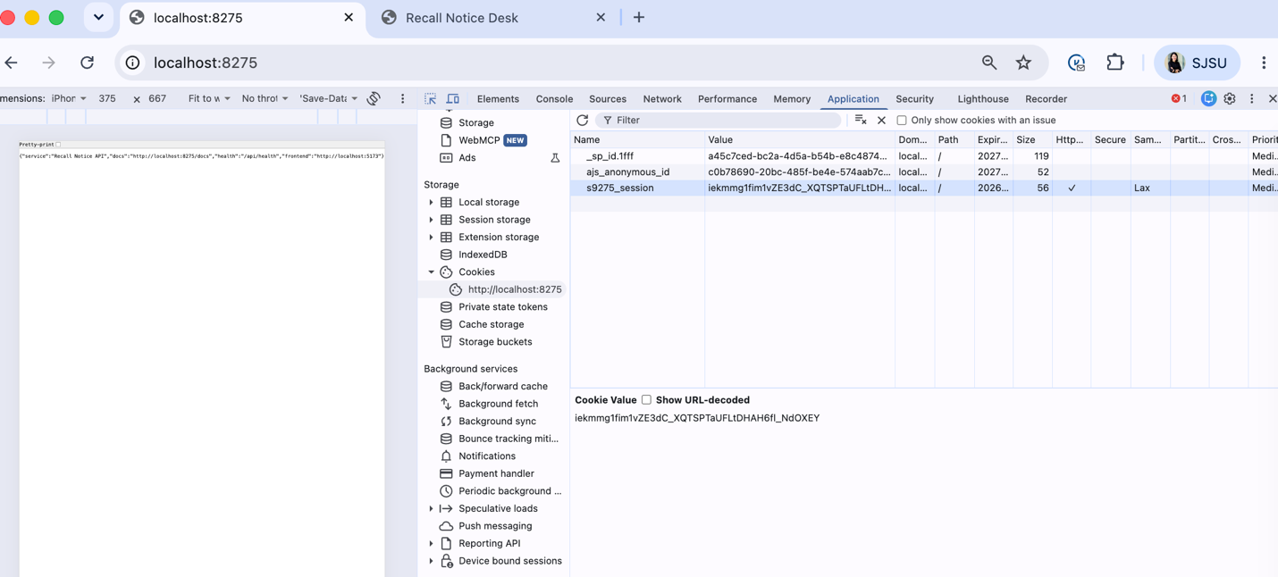

1.3 Home page (Home.jsx), route /
Home receives the records, loading state and page number from App as props and renders them as a table. The 5,000 seeded rows are shown 50 per page. Update and Delete pass the record id through router state.
frontend/src/pages/Home.jsx
export default function Home({ user, notices, loading, page, pageSize, onPageChange }) {
const navigate = useNavigate();

if (!user) {
return (
<div className="card">
<h2>Recall notices</h2>
<p className="notice">Login required. <Link to="/login">Log in</Link> to view and manage recall notices.</p>
</div>
);
}

return (
<div className="card">
<div className="card-header">
<h2>Recall notices</h2>
<Link className="btn primary" to="/create">+ Add Record</Link>
</div>

frontend/src/pages/Home.jsx — row actions
<td className="actions">
<button className="btn" onClick={() => navigate("/update", { state: { id: n.id } })}>
Update
</button>
<button className="btn danger" onClick={() => navigate("/delete", { state: { id: n.id } })}>
Delete
</button>
</td>
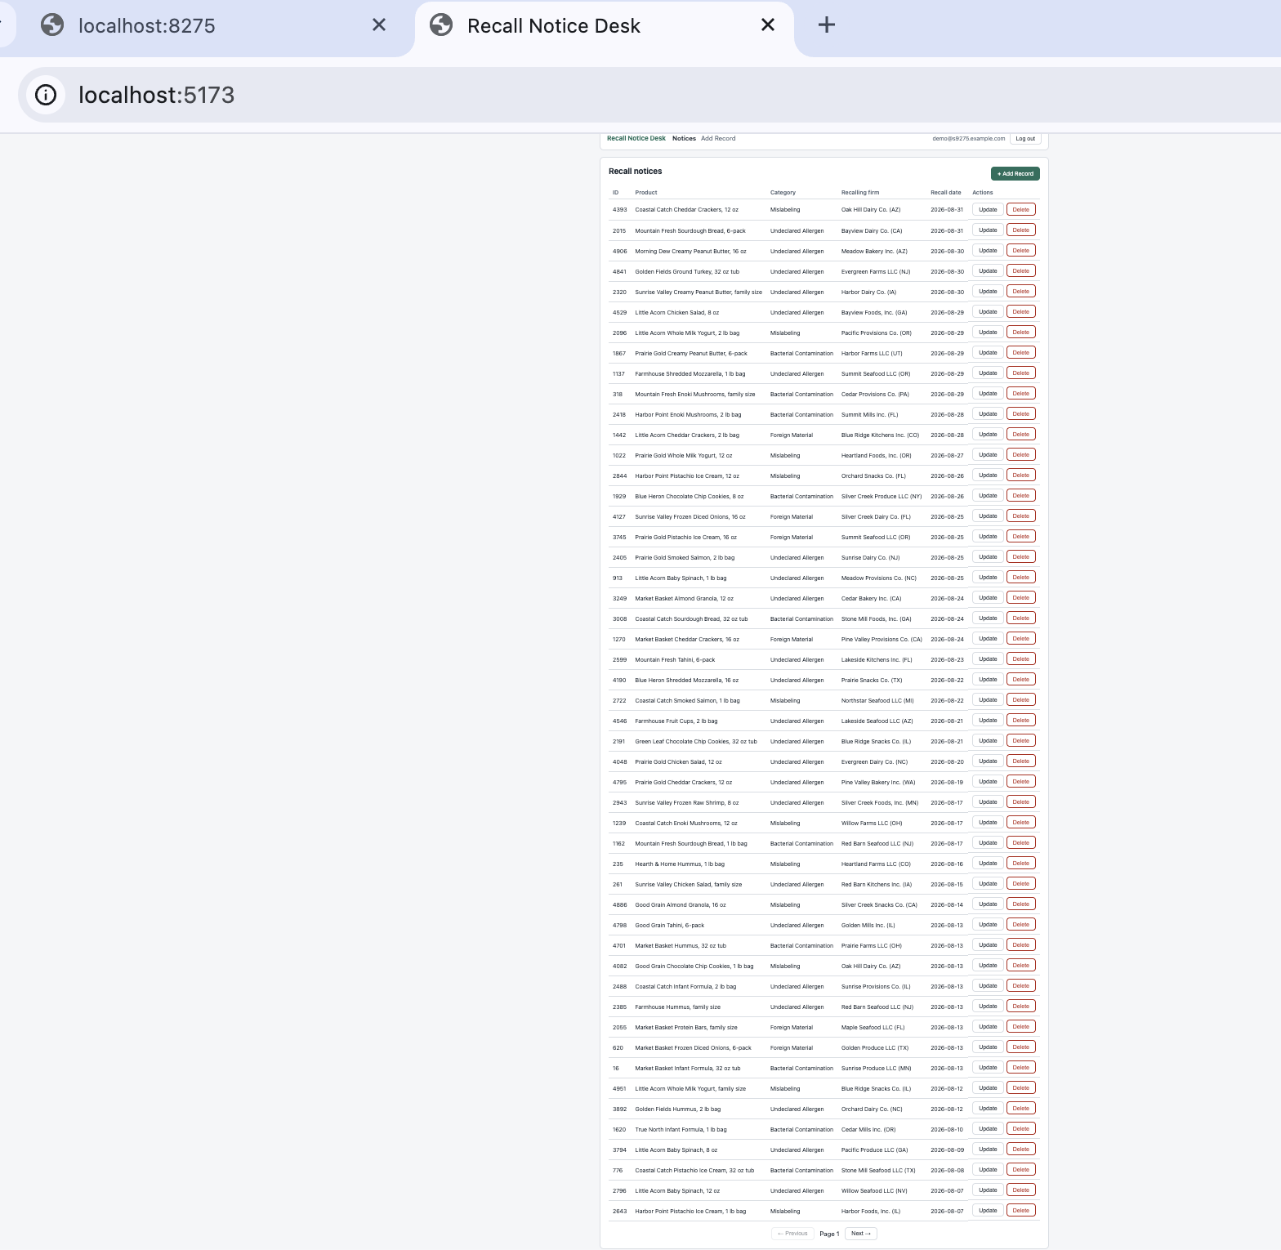

1.4 Add a new record (CreateRecord.jsx), route /create
frontend/src/pages/CreateRecord.jsx
export default function CreateRecord({ onAdd }) {
const [productName, setProductName] = useState(""); // primary field
const [category, setCategory] = useState(""); // secondary field
const [error, setError] = useState("");
const [busy, setBusy] = useState(false);

async function handleSubmit(e) {
e.preventDefault();
setError("");
setBusy(true);
try {
await onAdd({ product_name: productName.trim(), category });
} catch (err) {
setError(err.message);
setBusy(false);
}
}

frontend/src/pages/CreateRecord.jsx — inputs and submit button
<label htmlFor="productName">Product name</label>
<input id="productName" required autoFocus value={productName}
placeholder="e.g. Sunrise Valley Creamy Peanut Butter, 16 oz"
onChange={(e) => setProductName(e.target.value)} />

<label htmlFor="category">Recall category</label>
<select id="category" required value={category} onChange={(e) => setCategory(e.target.value)}>
<option value="" disabled>Choose a category</option>
{CATEGORIES.map((c) => <option key={c} value={c}>{c}</option>)}
</select>

{error && <div className="alert">{error}</div>}
<div className="form-actions">
<button className="btn primary" type="submit" disabled={busy}>
{busy ? "Filing…" : "File Recall Notice"}
</button>

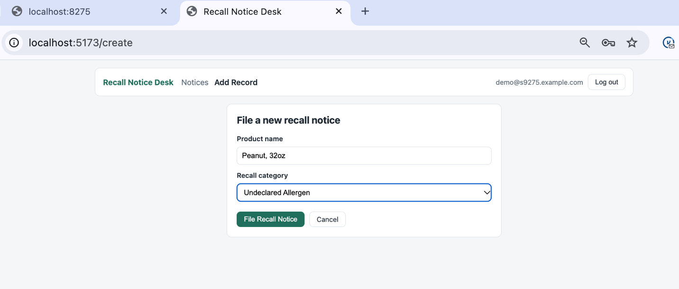
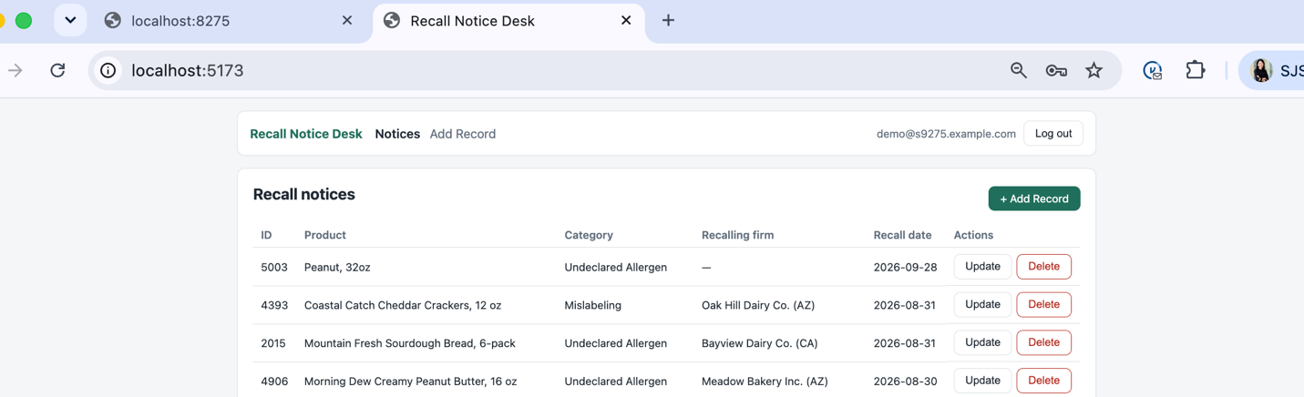

1.5 Update a record (UpdateRecord.jsx), route /update
frontend/src/pages/UpdateRecord.jsx
export default function UpdateRecord({ onUpdate }) {
const id = useLocation().state?.id;
const [productName, setProductName] = useState("");
const [category, setCategory] = useState("");
const [loading, setLoading] = useState(Boolean(id));
const [error, setError] = useState("");
const [busy, setBusy] = useState(false);

useEffect(() => {
if (!id) return;
getNotice(id)
.then((n) => {
setProductName(n.product_name);
setCategory(n.category);
})
.catch((err) => setError(err.message))
.finally(() => setLoading(false));
}, [id]);

frontend/src/pages/UpdateRecord.jsx — submit
async function handleSubmit(e) {
e.preventDefault();
setError("");
setBusy(true);
try {
await onUpdate(id, { product_name: productName.trim(), category });
} catch (err) {
setError(err.message);
setBusy(false);
}
}
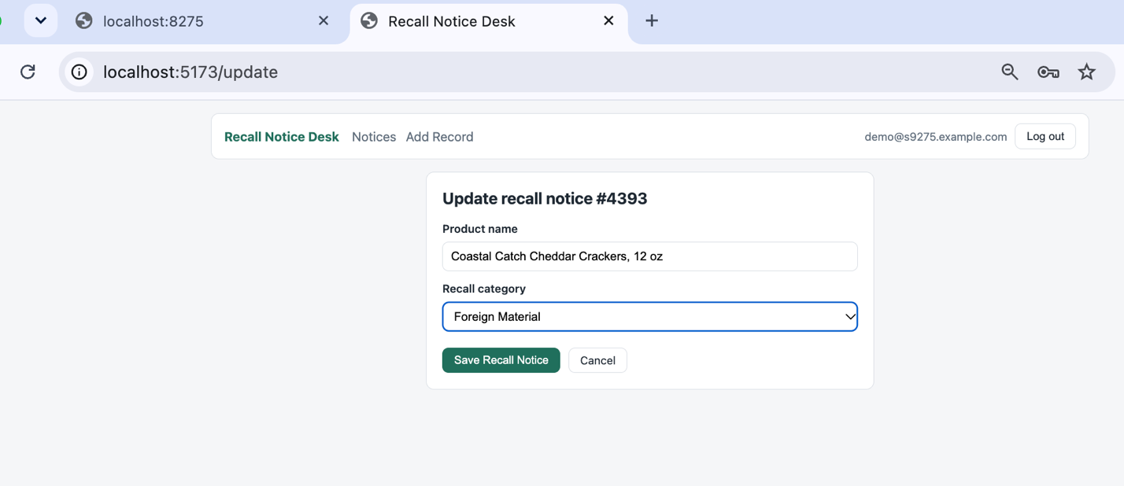
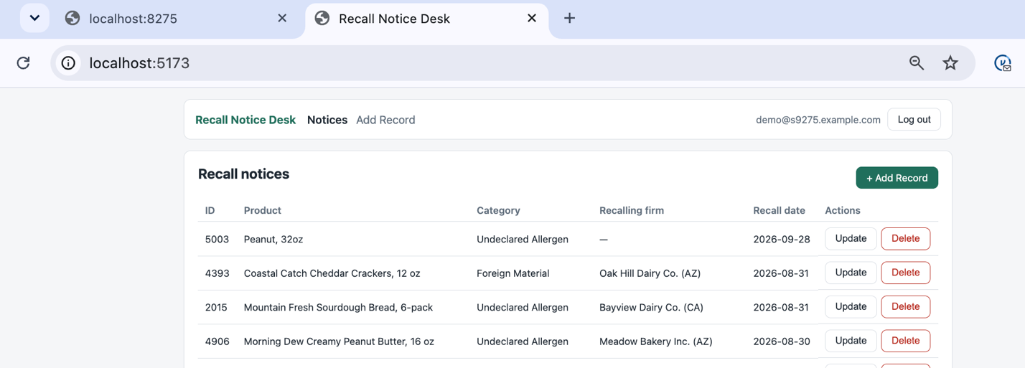

1.6 Delete a record (DeleteRecord.jsx), route /delete
frontend/src/pages/DeleteRecord.jsx
export default function DeleteRecord({ onDelete }) {
const id = useLocation().state?.id;
const [notice, setNotice] = useState(null);
const [error, setError] = useState("");
const [busy, setBusy] = useState(false);

useEffect(() => {
if (!id) return;
getNotice(id).then(setNotice).catch((err) => setError(err.message));
}, [id]);

frontend/src/pages/DeleteRecord.jsx — button
async function handleDelete() {
setError("");
setBusy(true);
try {
await onDelete(id);
} catch (err) {
setError(err.message);
setBusy(false);
}
}
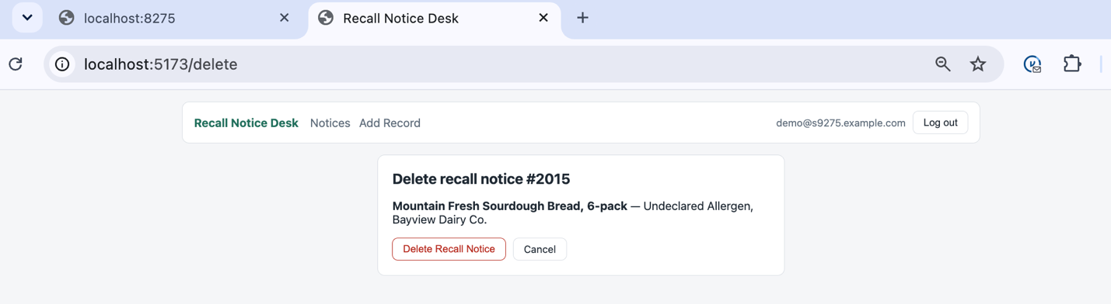
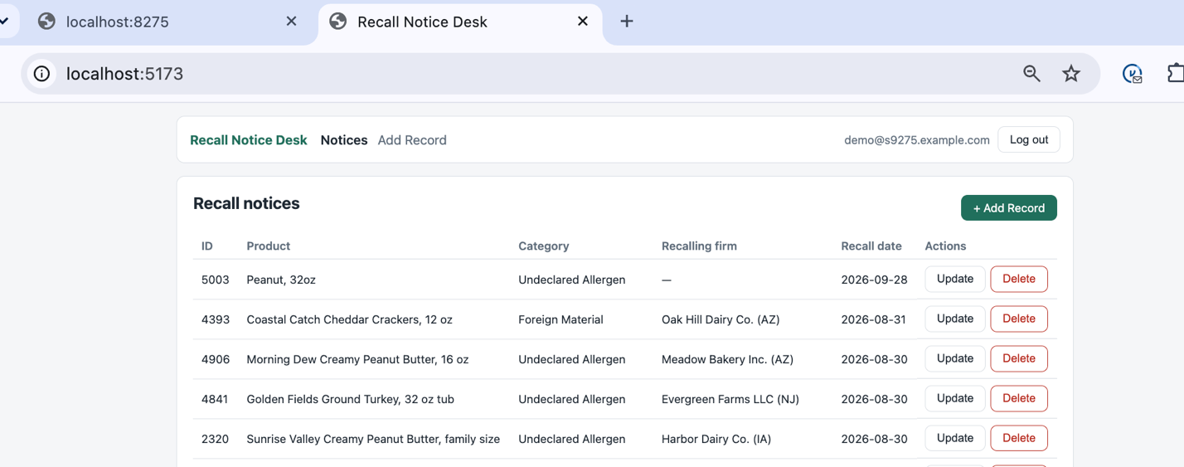

1.7 Props, hooks and React Router (App.jsx)
App owns the auth state and the list, loads them with useEffect, and passes onAdd / onUpdate / onDelete as props. Every handler calls the backend first, so the list always reflects MySQL.
frontend/src/App.jsx — handlers passed as props
async function onAdd(notice) {
await api.createNotice(notice); // MySQL assigns the AUTO_INCREMENT id
if (page === 1) await loadNotices(); // new notices are dated today -> top of page 1
else setPage(1);
navigate("/");
}

async function onUpdate(id, notice) {
const updated = await api.updateNotice(id, notice);
setNotices((prev) => prev.map((n) => (n.id === id ? updated : n)));
navigate("/");
}

async function onDelete(id) {
await api.deleteNotice(id);
await loadNotices(); // refill the page from the database
navigate("/");
}

frontend/src/App.jsx — routes
<Routes>
<Route
path="/"
element={
<Home
user={user}
notices={notices}
loading={loading}
page={page}
pageSize={PAGE_SIZE}
onPageChange={setPage}
/>
}
/>
<Route
path="/login"
element={user ? <Navigate to="/" replace /> : <Login onLogin={onLogin} />}
/>
<Route
path="/create"
element={<RequireAuth user={user}><CreateRecord onAdd={onAdd} /></RequireAuth>}
/>
<Route
path="/update"
element={<RequireAuth user={user}><UpdateRecord onUpdate={onUpdate} /></RequireAuth>}
/>
<Route
path="/delete"
element={<RequireAuth user={user}><DeleteRecord onDelete={onDelete} /></RequireAuth>}
/>
<Route path="*" element={<Navigate to="/" replace />} />
</Routes>

Part 2 — MySQL persistence and server-side sessions

2.1 Database connection (db_session_basede26)
code/auth_app/database.py
DATABASE_URL = URL.create(
"mysql+pymysql",
username=config.MYSQL_USER,
password=config.MYSQL_PASSWORD,
host=config.MYSQL_HOST,
port=config.MYSQL_PORT,
database=config.DB_NAME,
query={"charset": "utf8mb4"},
)

engine = create_engine(DATABASE_URL, pool_pre_ping=True)

# The assignment requires this exact name for the database connection variable.
# Every request gets its own Session from this factory (see get_db).
db_session_basede26 = sessionmaker(bind=engine, autoflush=False, expire_on_commit=False)

Base = declarative_base()

def get_db():
"""FastAPI dependency: one Session per request, always closed afterwards."""
db = db_session_basede26()
try:
yield db
finally:
db.close()

2.2 Schema: s9275_rel
code/sql/hw04_schema.sql is applied by make db-init. users.email is UNIQUE; sessions.id is the session token; recall_notices has an auto-increment id, the primary field product_name and the secondary field category, plus firm_id (Part 3 related table) and recall_date.
code/sql/hw04_schema.sql
CREATE TABLE users (
id INT AUTO_INCREMENT PRIMARY KEY,
name VARCHAR(100) NOT NULL,
email VARCHAR(255) NOT NULL,
password_hash CHAR(60) NOT NULL,
CONSTRAINT uq_users_email UNIQUE (email)
) ENGINE=InnoDB;
CREATE TABLE sessions (
id VARCHAR(64) PRIMARY KEY,
user_id INT NOT NULL,
created_at DATETIME NOT NULL,
expires_at DATETIME NOT NULL,
CONSTRAINT fk_sessions_user FOREIGN KEY (user_id) REFERENCES users (id) ON DELETE CASCADE
) ENGINE=InnoDB;
...
CREATE TABLE recall_notices (
id INT AUTO_INCREMENT PRIMARY KEY,
product_name VARCHAR(255) NOT NULL,
category VARCHAR(40) NOT NULL,
firm_id INT NULL,
recall_date DATE NOT NULL,
CONSTRAINT fk_notices_firm FOREIGN KEY (firm_id) REFERENCES firms (id) ON DELETE SET NULL,
CONSTRAINT ck_notices_category CHECK (category IN
('Undeclared Allergen', 'Bacterial Contamination', 'Foreign Material', 'Mislabeling'))
) ENGINE=InnoDB;

2.3 Session check on every protected route
The cookie holds only a random token (secrets.token_urlsafe(32), 43 characters). The server looks it up in the sessions table; logout deletes the row, so a copied cookie stops working. Sessions expire after 15 minutes idle and 1 hour absolute (the HW3 rules).
code/auth_app/deps.py
def require_session(request: Request, db: Session = Depends(get_db)) -> SessionToken:
"""401 unless the cookie names a live row in the sessions table.

Costs two SQL statements per request (SELECT the session, UPDATE its
expiry). Part 3 reports these separately from the list query itself.
"""
token = request.cookies.get(config.COOKIE_NAME)
if not token:
raise HTTPException(status_code=401, detail="Login required")

row = db.get(SessionToken, token)
now = utcnow()
if row is None:
raise HTTPException(status_code=401, detail="Login required")
if row.expires_at <= now:
db.delete(row)
db.commit()
raise HTTPException(status_code=401, detail="Session expired")

row.expires_at = new_expiry(row.created_at, now) # sliding idle timeout
db.commit()
return row

2.4 CRUD endpoints — Postman
All routes require a session (router-level dependency). The Postman collection is reports/hw04/postman_collection.json; run "Login" first so Postman stores the cookie.
code/auth_app/routers/notices.py — create / update / delete
@router.post("", response_model=NoticeOut, status_code=201)
def create_notice(payload: NoticeIn, db: Session = Depends(get_db)):
check_firm(db, payload.firm_id)
notice = RecallNotice(
product_name=payload.product_name.strip(),
category=payload.category,
recall_date=payload.recall_date or date.today(),
firm_id=payload.firm_id,
)
db.add(notice)
db.commit() # MySQL assigns the AUTO_INCREMENT id here
return load_notice(db, notice.id)

@router.put("/{notice_id}", response_model=NoticeOut)
def update_notice(notice_id: int, payload: NoticeIn, db: Session = Depends(get_db)):
notice = load_notice(db, notice_id)
check_firm(db, payload.firm_id)
notice.product_name = payload.product_name.strip()
notice.category = payload.category
if payload.recall_date is not None:
notice.recall_date = payload.recall_date
if "firm_id" in payload.model_fields_set: # only change the firm when it was sent
notice.firm_id = payload.firm_id
db.commit()
db.expire(notice) # reload so the response shows the new firm
return load_notice(db, notice_id)

@router.delete("/{notice_id}", status_code=204)
def delete_notice(notice_id: int, db: Session = Depends(get_db)):
notice = load_notice(db, notice_id)
db.delete(notice)
db.commit()
return Response(status_code=204)

Operation | Request | Expected
No session | GET /api/notices | 401 Login required
Login | POST /api/auth/login | 200 + Set-Cookie s9275_session (HttpOnly)
Add (POST) | POST /api/notices | 201, new id
View all (GET) | GET /api/notices?page=1&page_size=10 | 200, 10 items with firm
View by id (GET) | GET /api/notices/{id} | 200
Update (PUT) | PUT /api/notices/{id} | 200, new values
Delete (DELETE) | DELETE /api/notices/{id} | 204; then GET → 404
Logout | POST /api/auth/logout, then GET /api/notices | 200, then 401

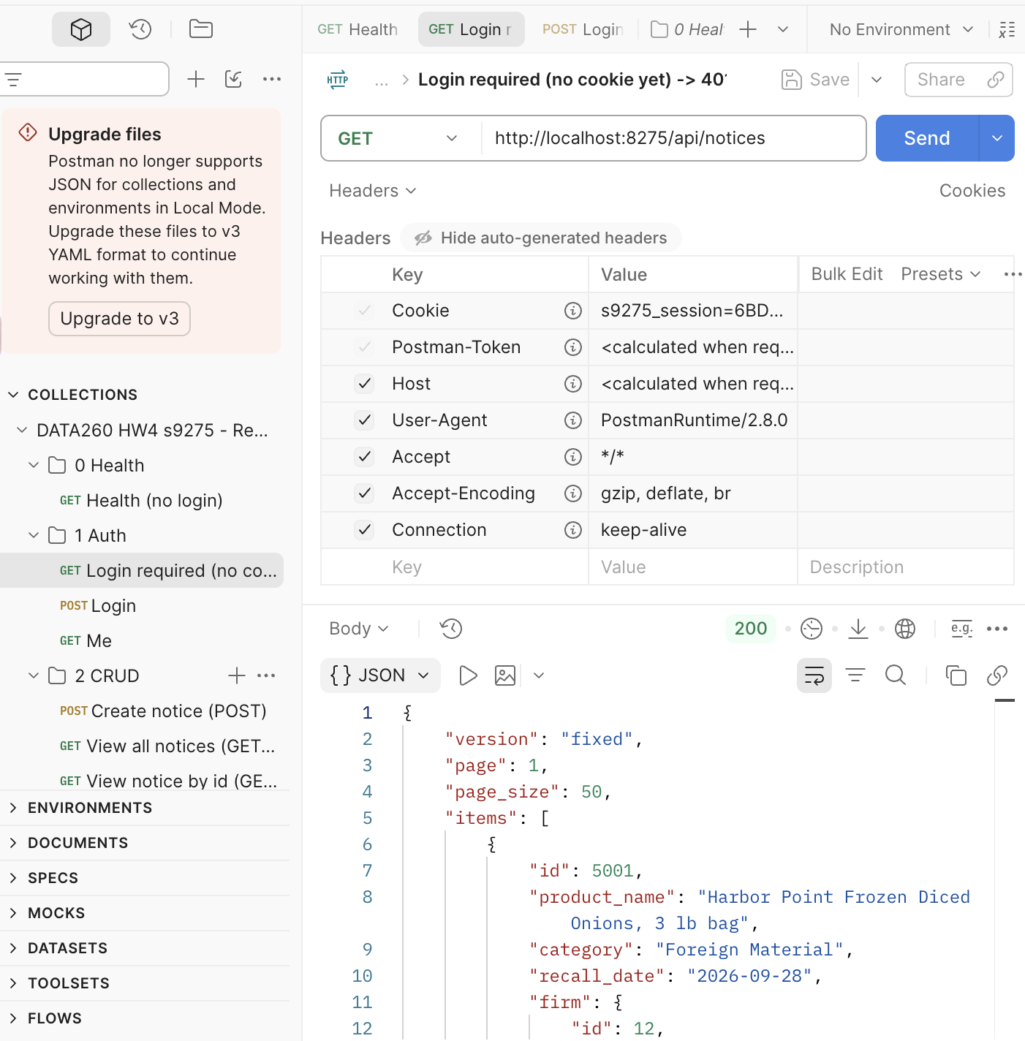

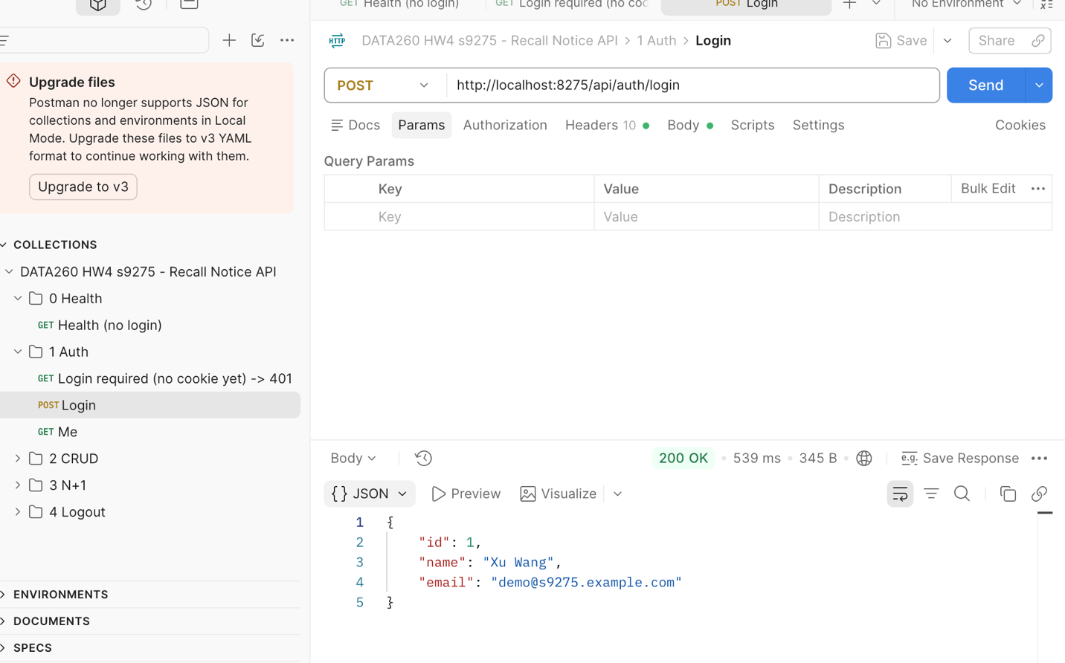

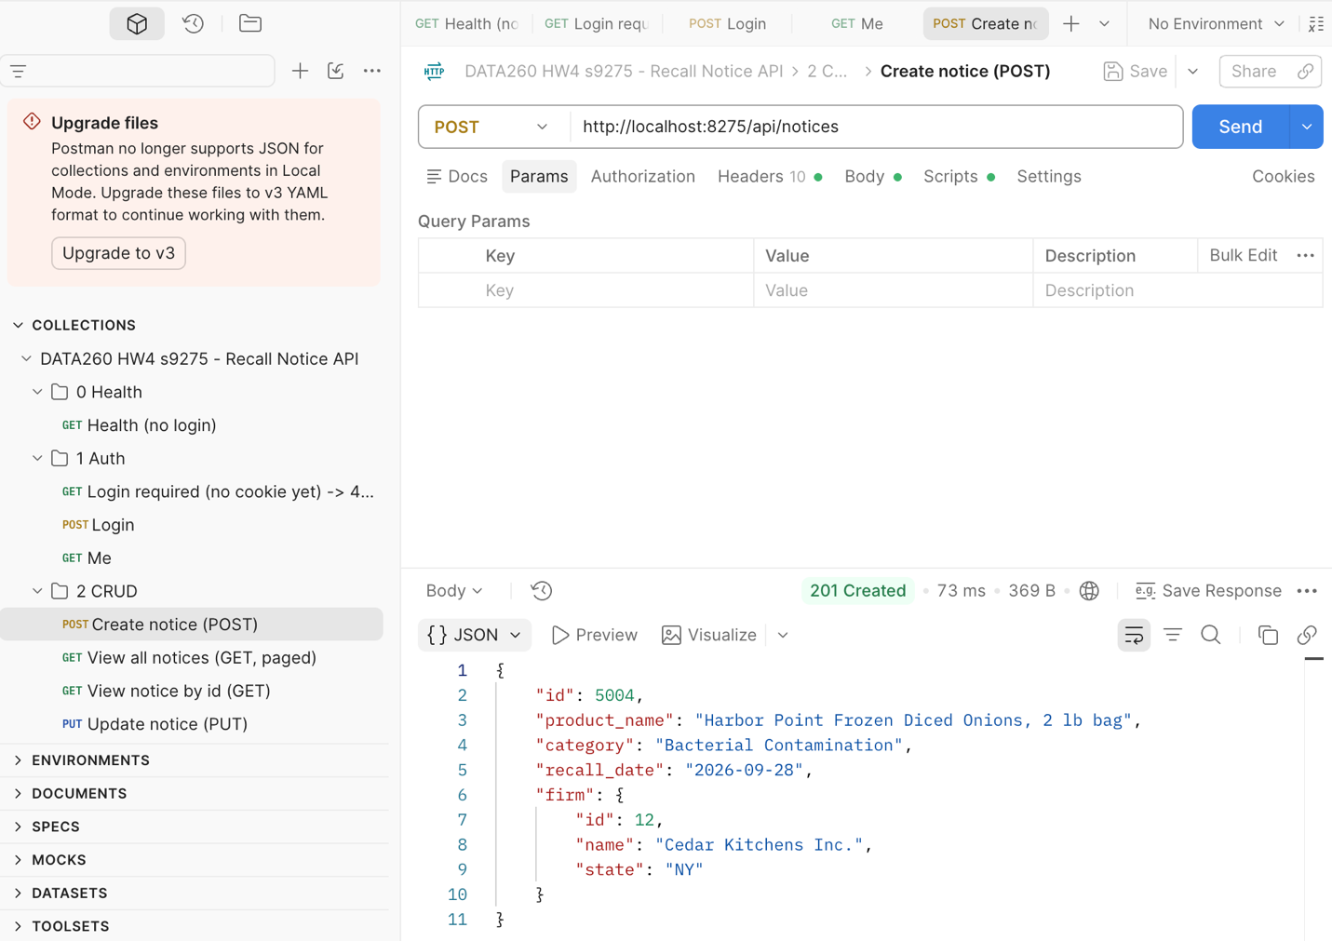

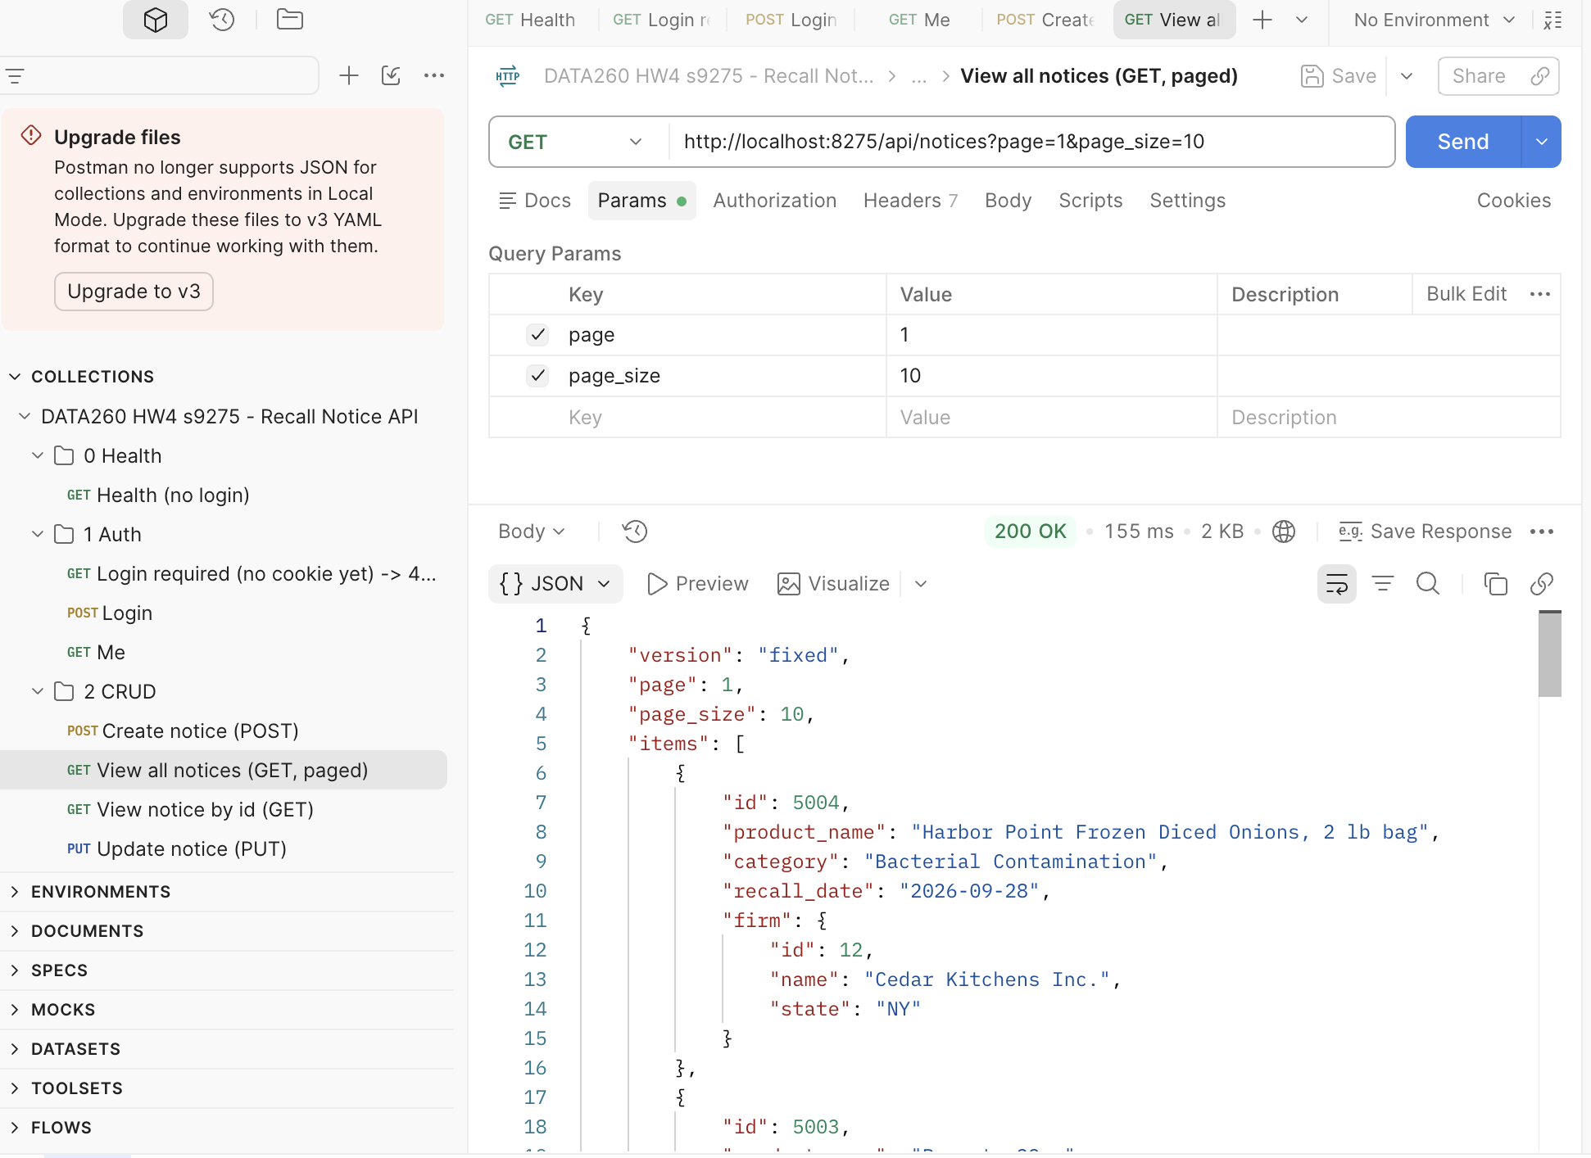

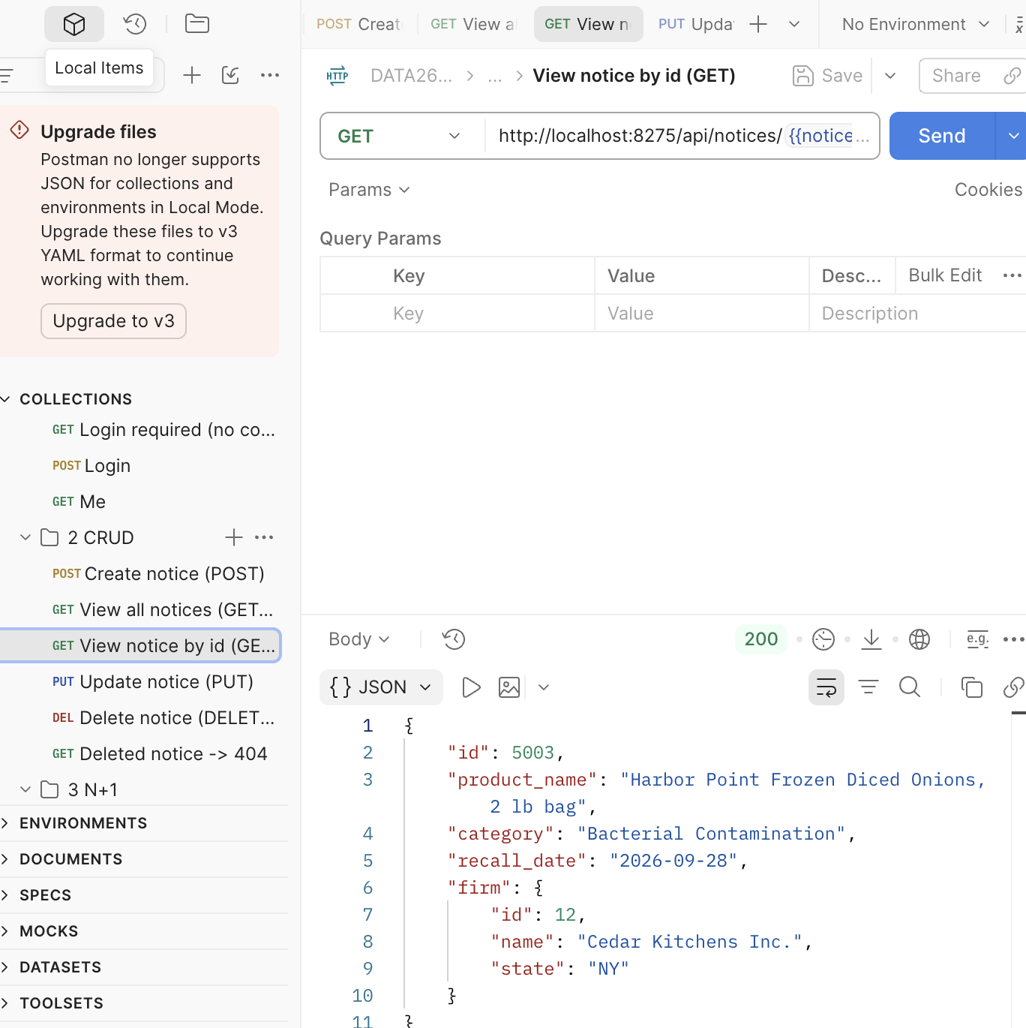

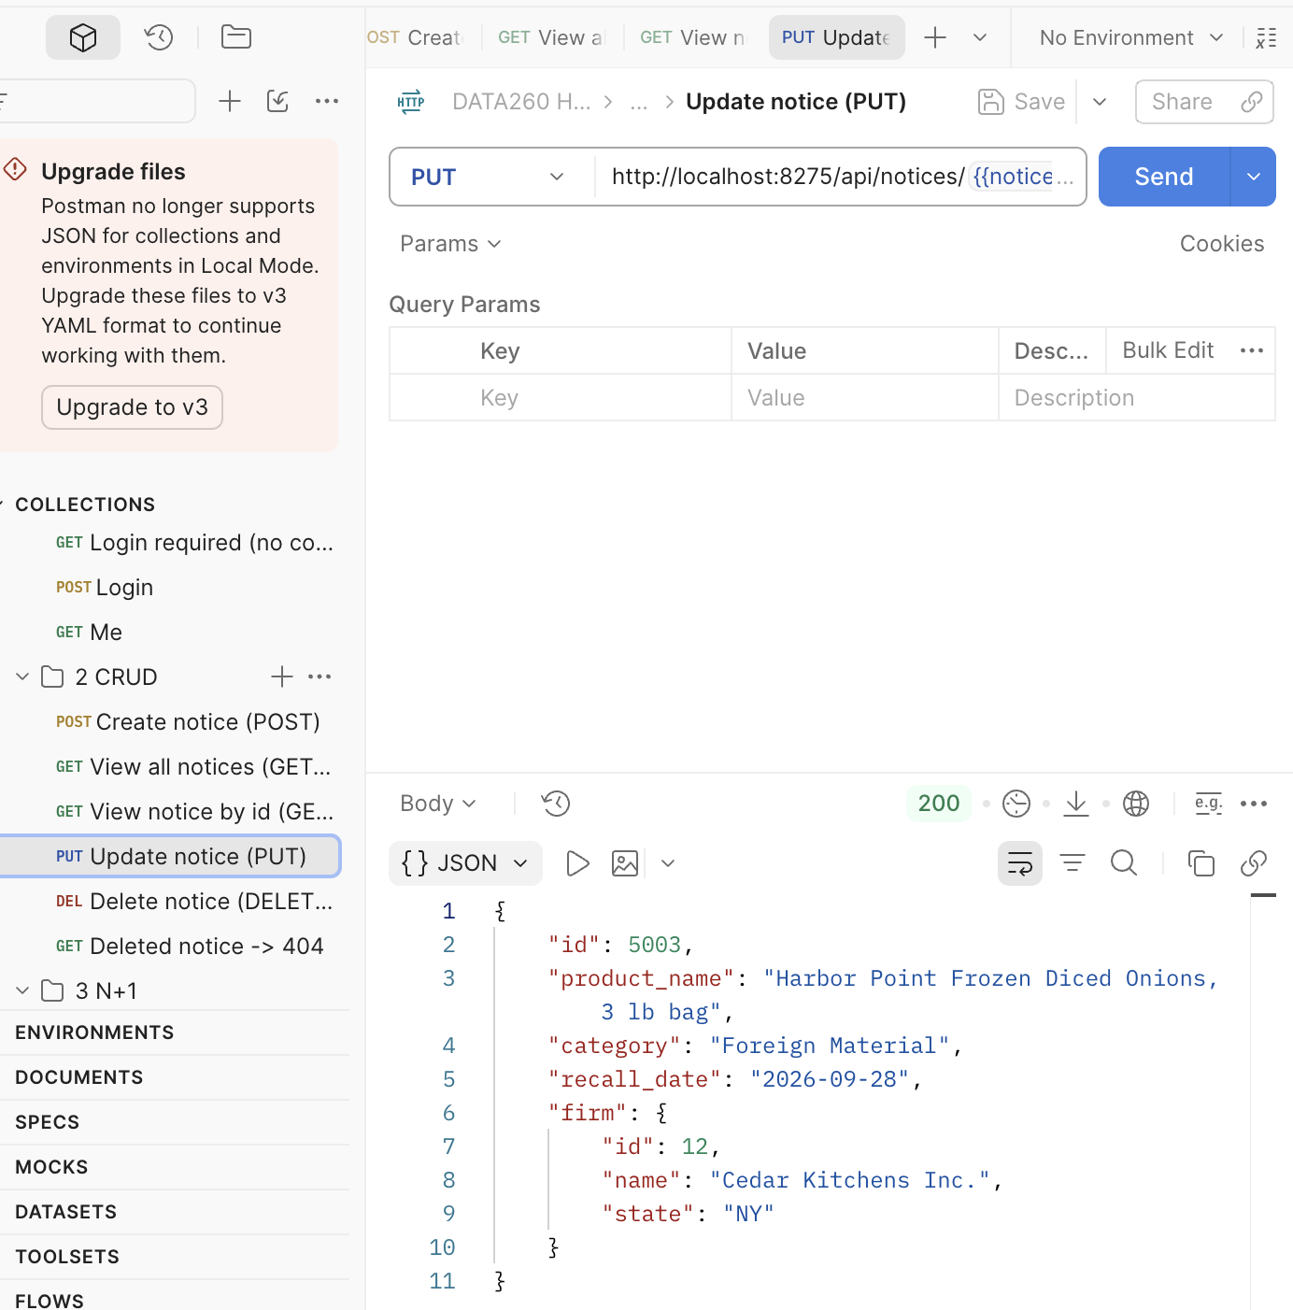

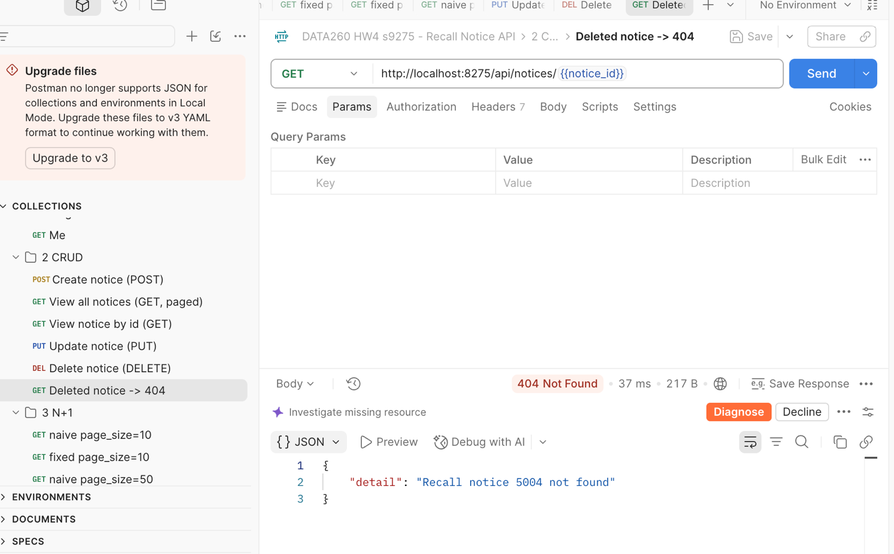

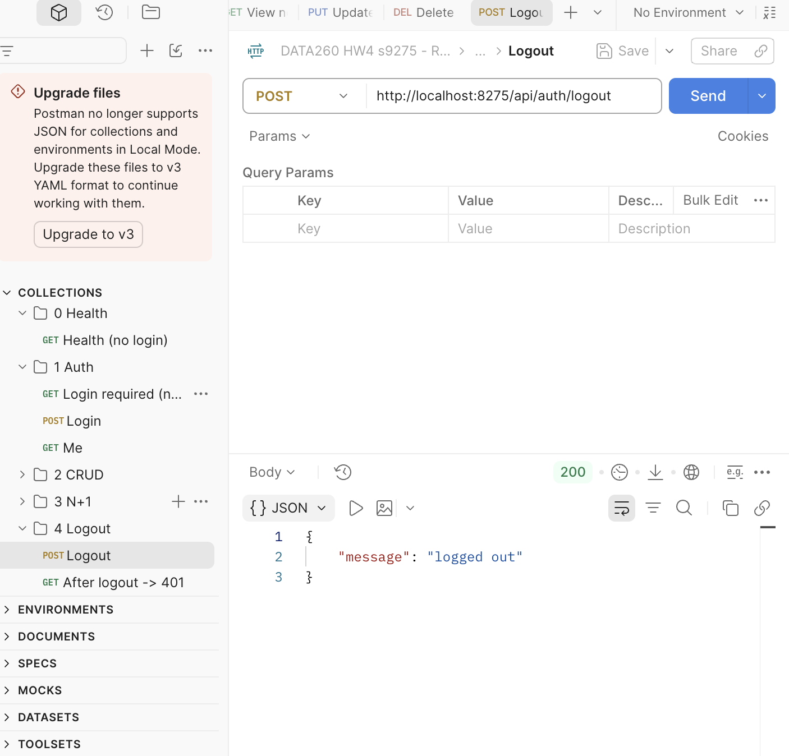

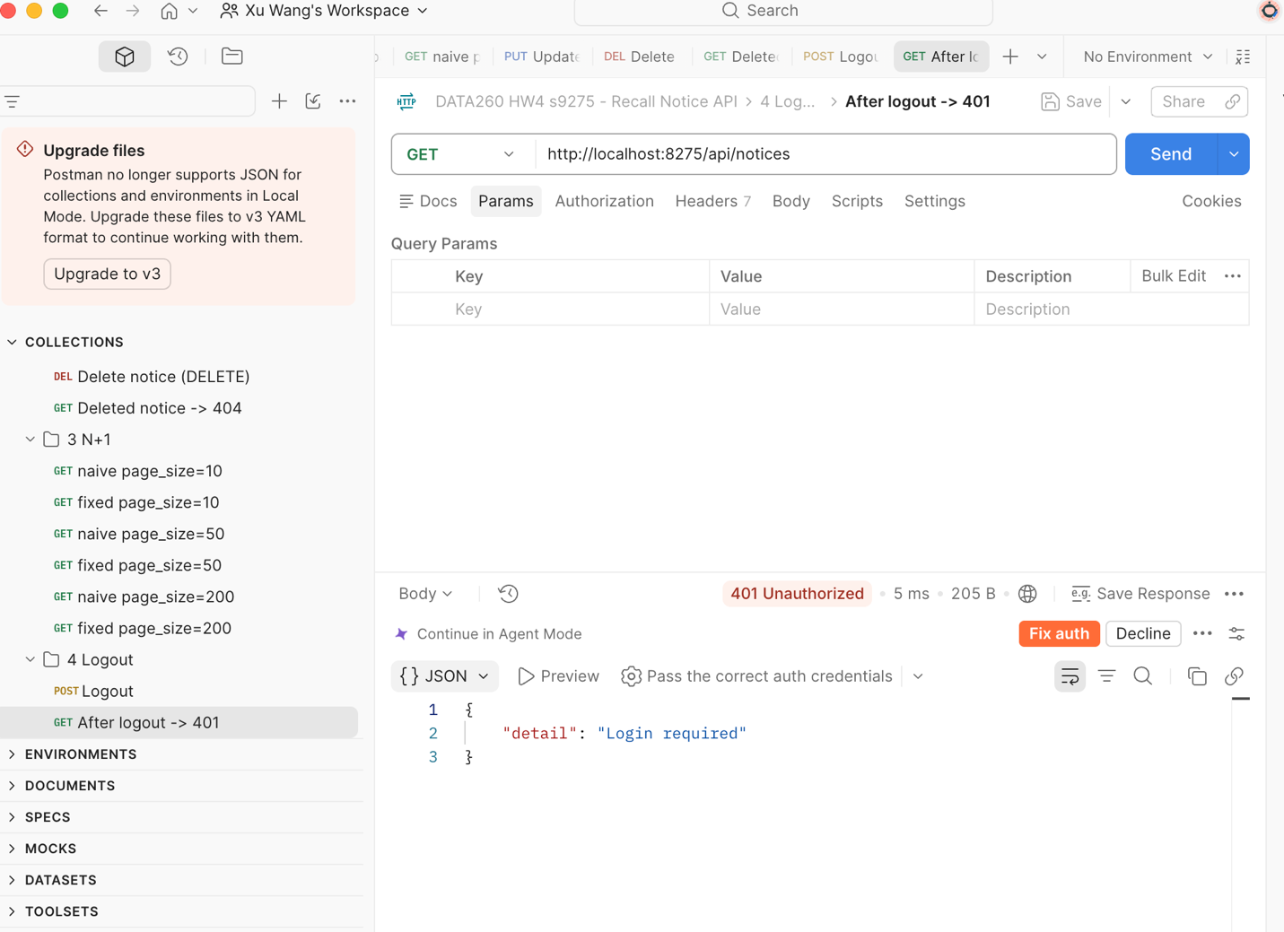

2.5 Database

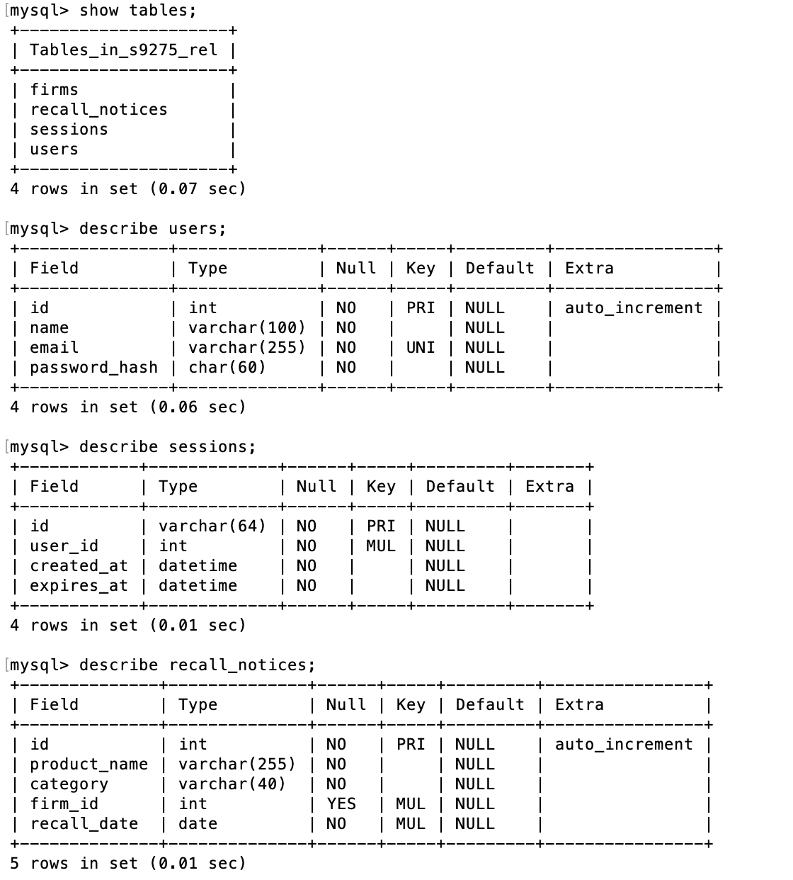

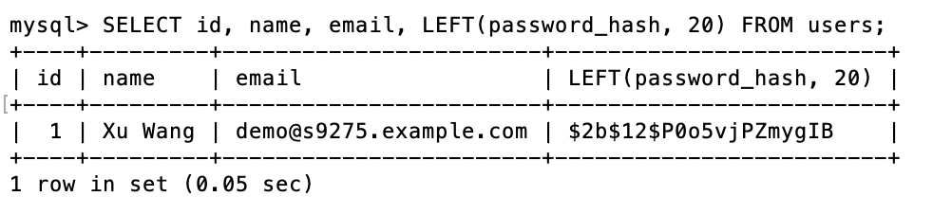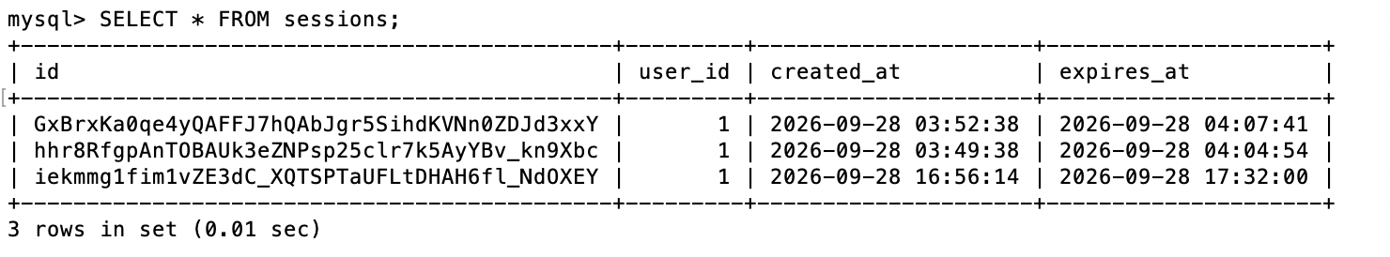

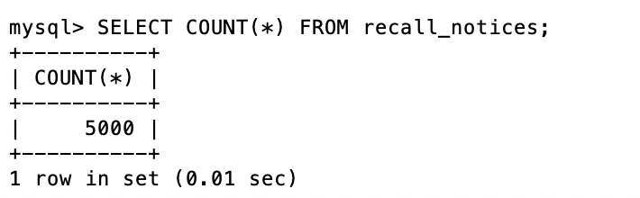

2.6 Project folder structure

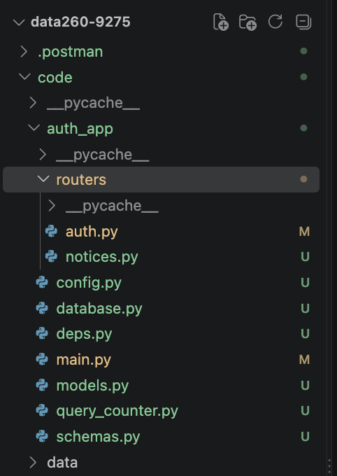

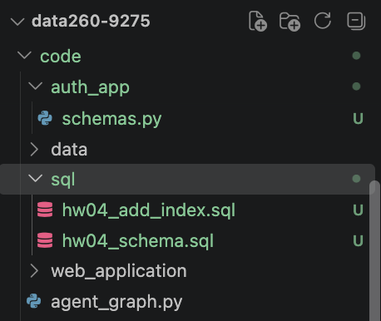

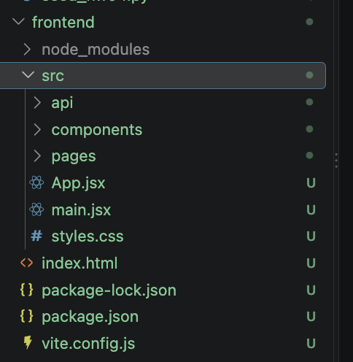

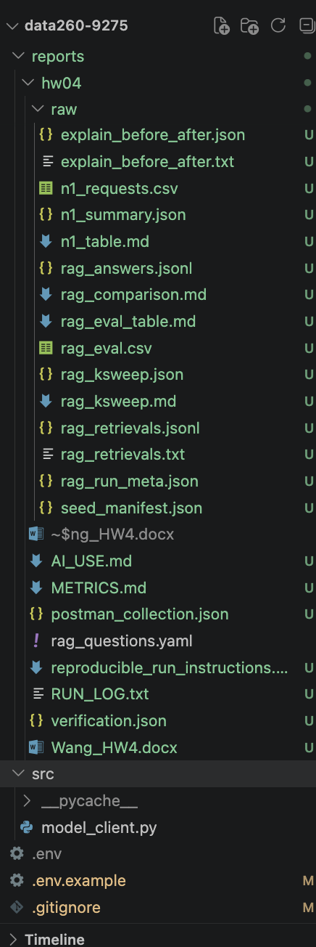

Part 3 — N+1 measurement and query tuning

3.1 Seed data (SEED 9275)
code/seed_hw04.py creates 200 firms and 5,000 recall notices with random.Random(9275); every notice gets a firm_id in 1..200, so all rows have related data. The SHA-256 of the generated rows (018ba267…) was identical on two machines, so the seed is reproducible. Schema: code/sql/hw04_schema.sql.
code/seed_hw04.py
def generate(rng: random.Random):
firm_names = [f"{w} {t}" for w in FIRM_WORDS for t in FIRM_TYPES] # 240 unique
rng.shuffle(firm_names)
firms = [(firm_names[i], rng.choice(STATES)) for i in range(N_FIRMS)]

categories = [c for c, _ in CATEGORY_WEIGHTS]
weights = [w for _, w in CATEGORY_WEIGHTS]
notices = []
for _ in range(N_NOTICES):
name = f"{rng.choice(BRANDS)} {rng.choice(PRODUCTS)}, {rng.choice(SIZES)}"
category = rng.choices(categories, weights)[0]
firm_id = rng.randint(1, N_FIRMS)
recall_date = DATE_START + timedelta(days=rng.randint(0, DATE_DAYS))
notices.append((name, category, firm_id, recall_date.isoformat()))
return firms, notices

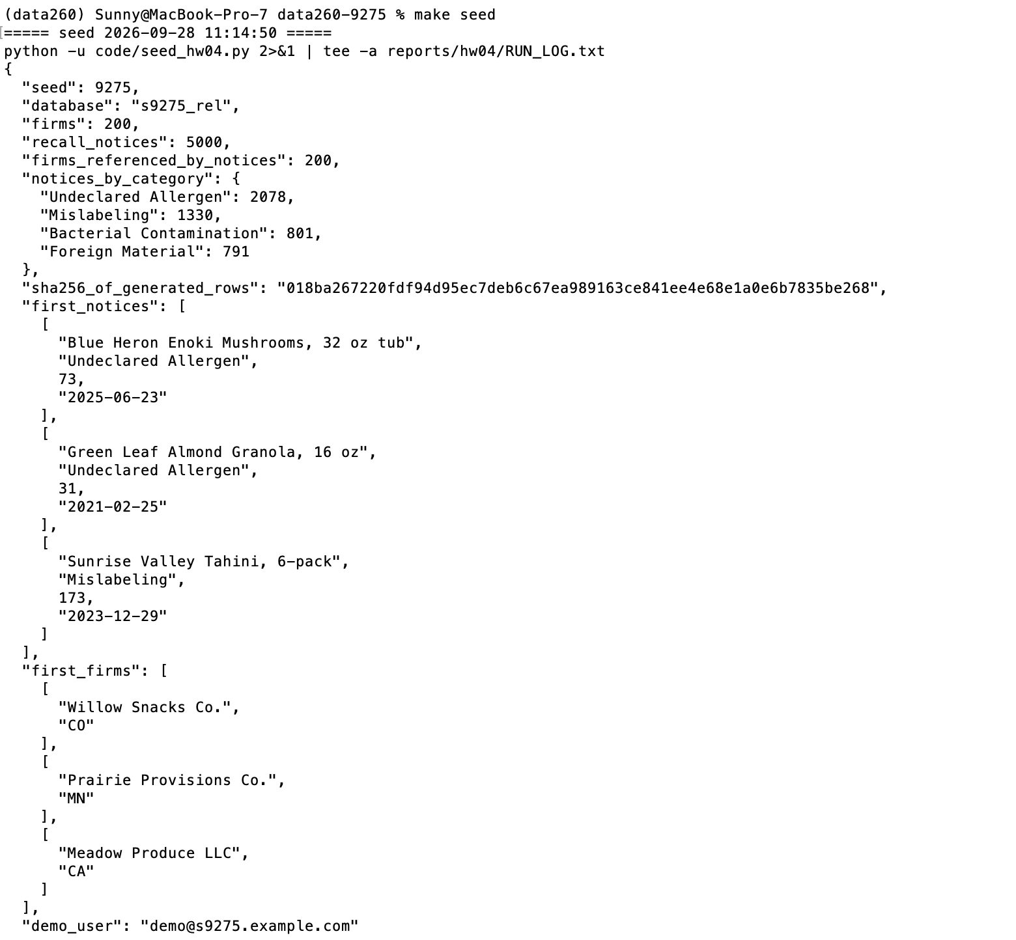

3.2 Naive (N+1) and fixed (JOIN) list endpoints
Both endpoints return the same page with each notice's firm. The naive version runs one query for the page and one per row; the fixed version uses joinedload, which produces a single LEFT OUTER JOIN. A SQLAlchemy before_cursor_execute listener counts statements per request and returns them in the X-SQL-Total and X-SQL-List headers.
code/auth_app/routers/notices.py — naive
def list_naive(response: Response, page: int = PageNo, page_size: int = PageSize,
db: Session = Depends(get_db)):
"""N+1 on purpose: one query for the page, then one query per row for its firm.

db.execute(select(...)) always goes to MySQL. db.get(Firm, id) would not:
it returns an already-loaded firm from the Session's identity map without
SQL, which would hide part of the N+1 cost and make the count depend on
how many firms repeat on the page.
"""
before = mark_list_start(response)
notices = db.execute(page_query(page, page_size)).scalars().all() # 1 query

items = []
for n in notices: # N queries
firm = None
if n.firm_id is not None:
firm = db.execute(select(Firm).where(Firm.id == n.firm_id)).scalar_one()
items.append(NoticeOut(id=n.id, product_name=n.product_name, category=n.category,
recall_date=n.recall_date,
firm=FirmOut.model_validate(firm) if firm else None))
mark_list_end(response, before)
return NoticePage(version="naive", page=page, page_size=page_size, items=items)

code/auth_app/routers/notices.py — fixed
def fixed_items(db: Session, page: int, page_size: int):
stmt = page_query(page, page_size).options(joinedload(RecallNotice.firm))
return db.execute(stmt).scalars().all() # 1 query: ... LEFT OUTER JOIN firms

@router.get("/fixed", response_model=NoticePage)
def list_fixed(response: Response, page: int = PageNo, page_size: int = PageSize,
db: Session = Depends(get_db)):
"""Same rows and same JSON as /naive, loaded with a single JOIN."""
before = mark_list_start(response)
items = fixed_items(db, page, page_size)
mark_list_end(response, before)
return NoticePage(version="fixed", page=page, page_size=page_size, items=items)

code/auth_app/query_counter.py
@event.listens_for(engine, "before_cursor_execute")
def _count(conn, cursor, statement, parameters, context, executemany):
counter = _current.get()
if counter is not None:
counter.add(statement)

3.3 Both versions at each page size — Postman

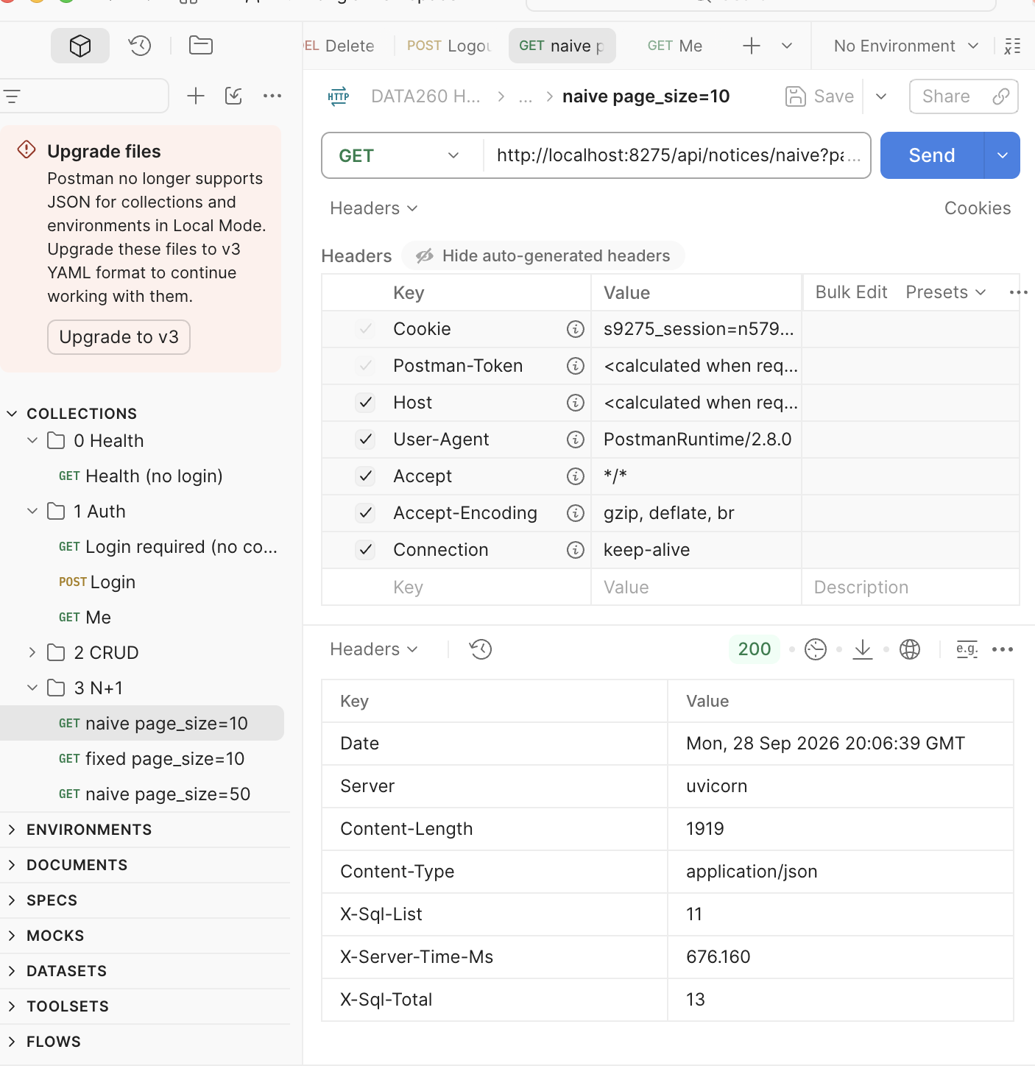

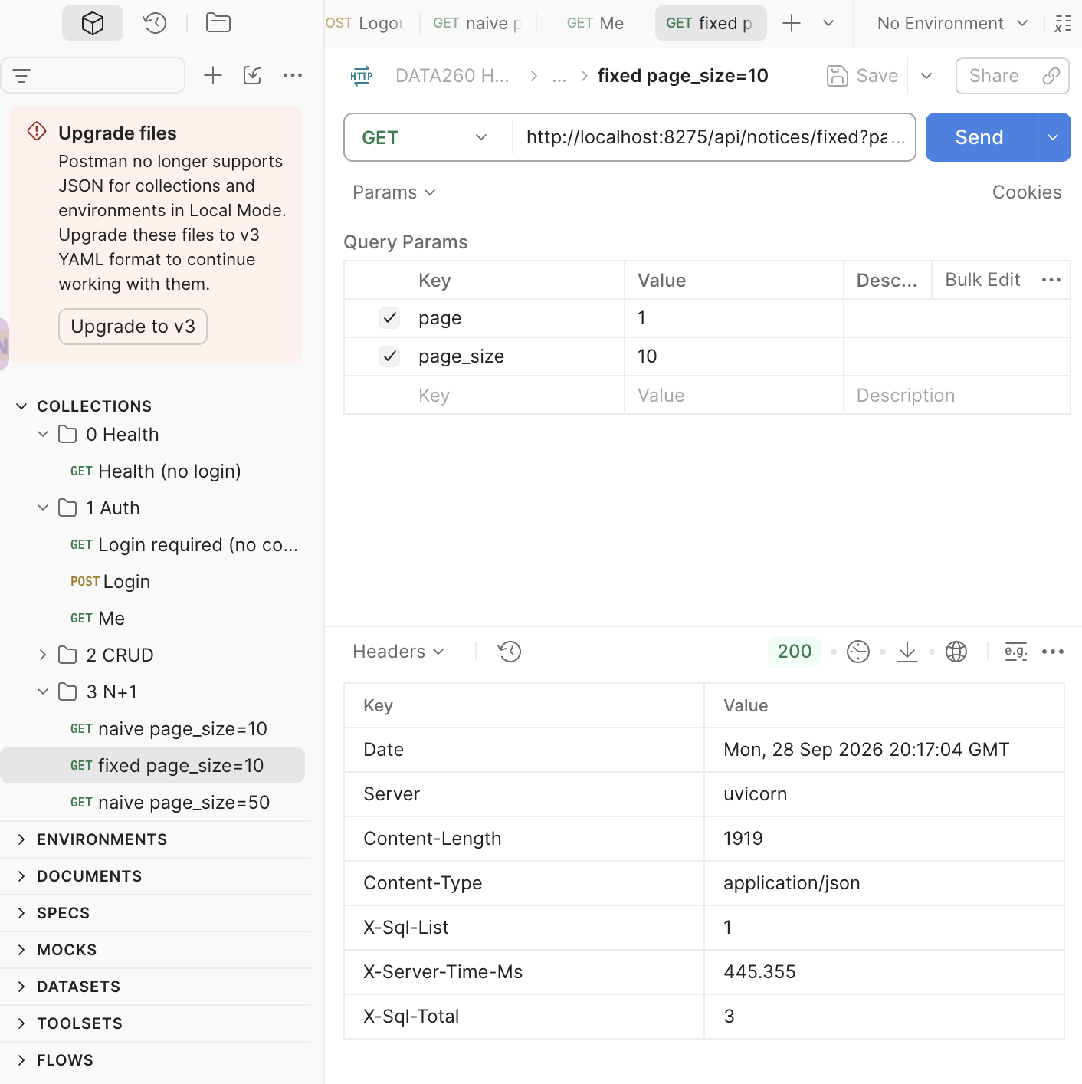

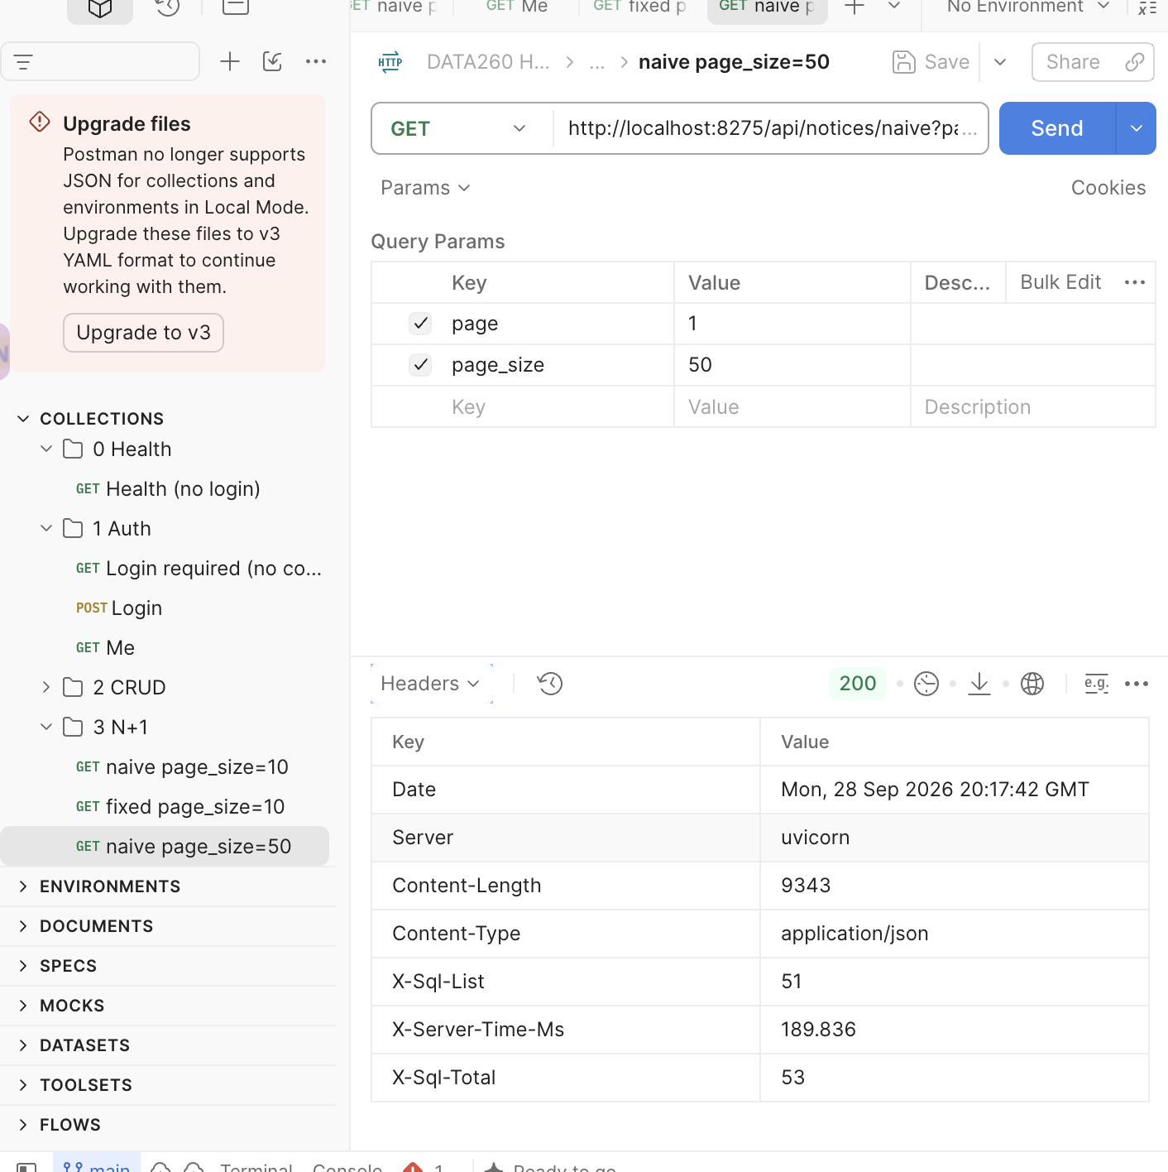

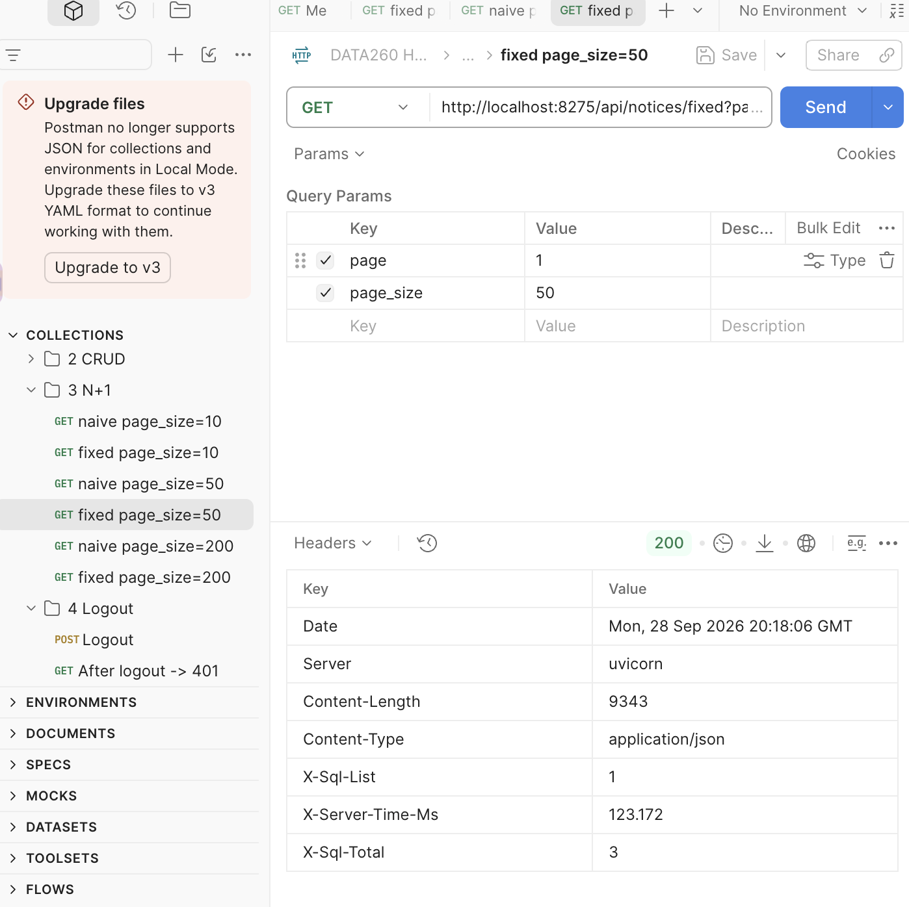

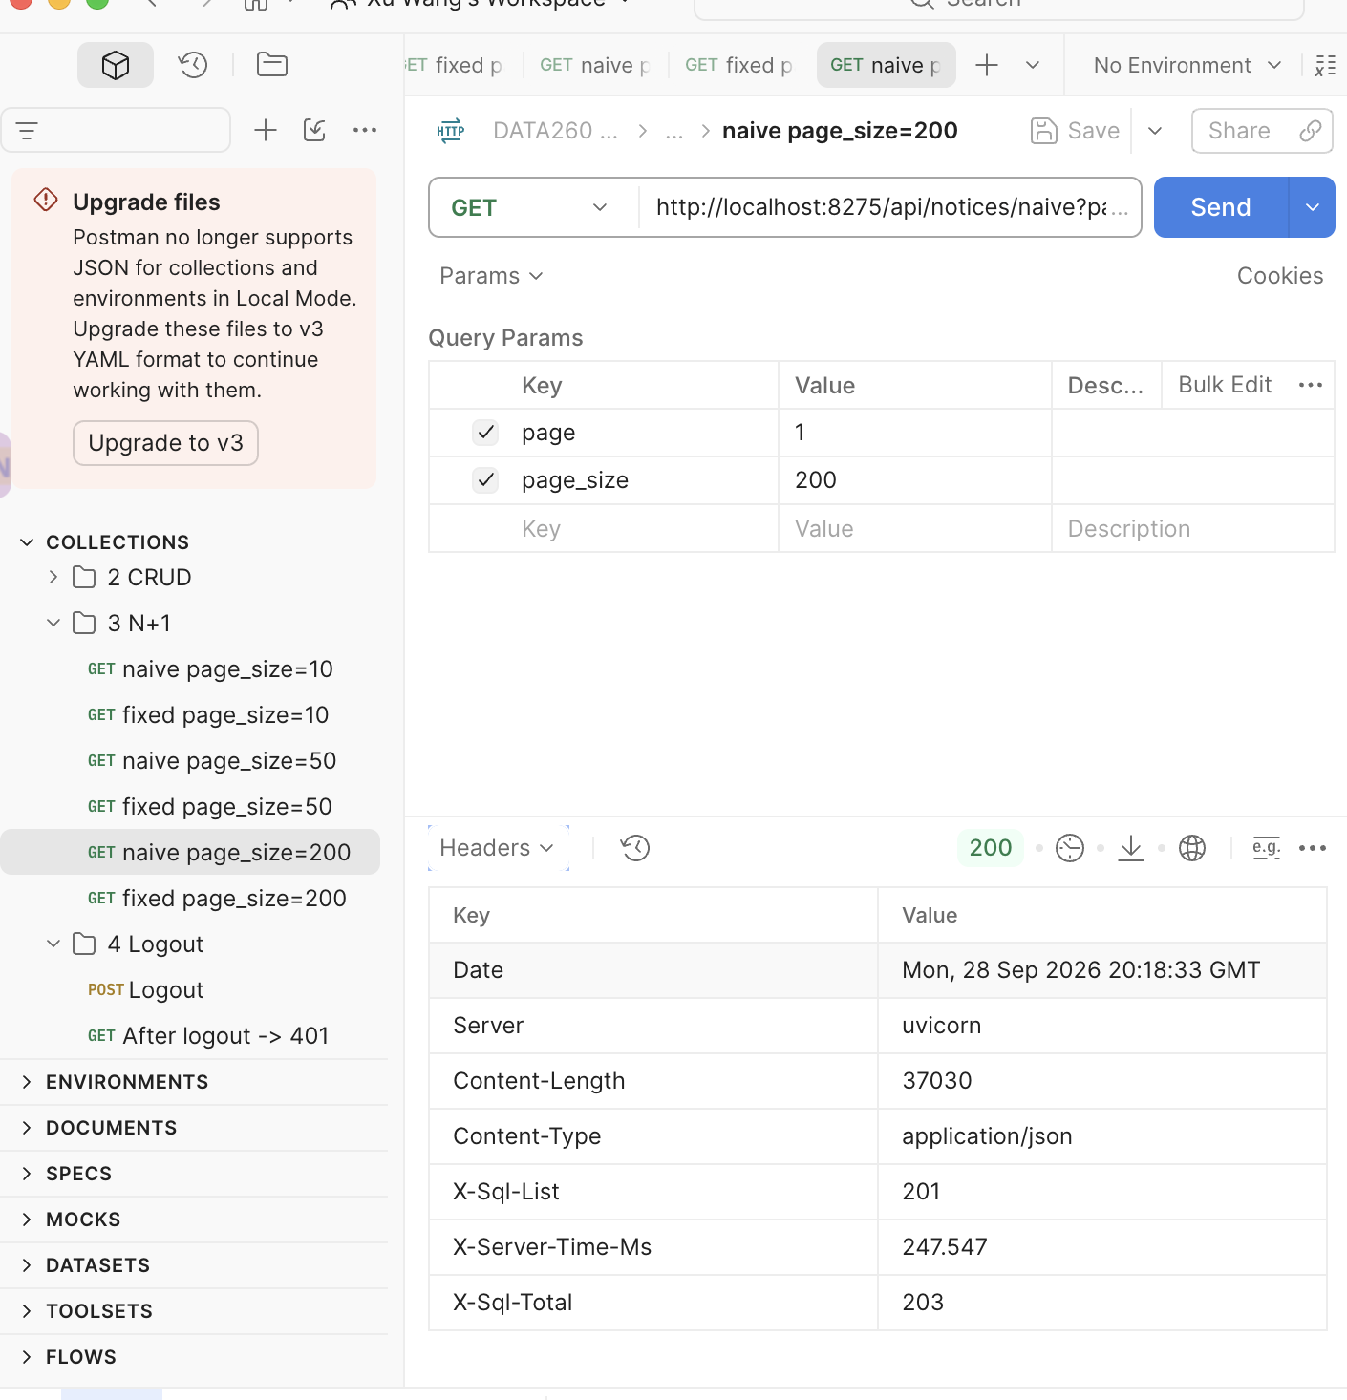

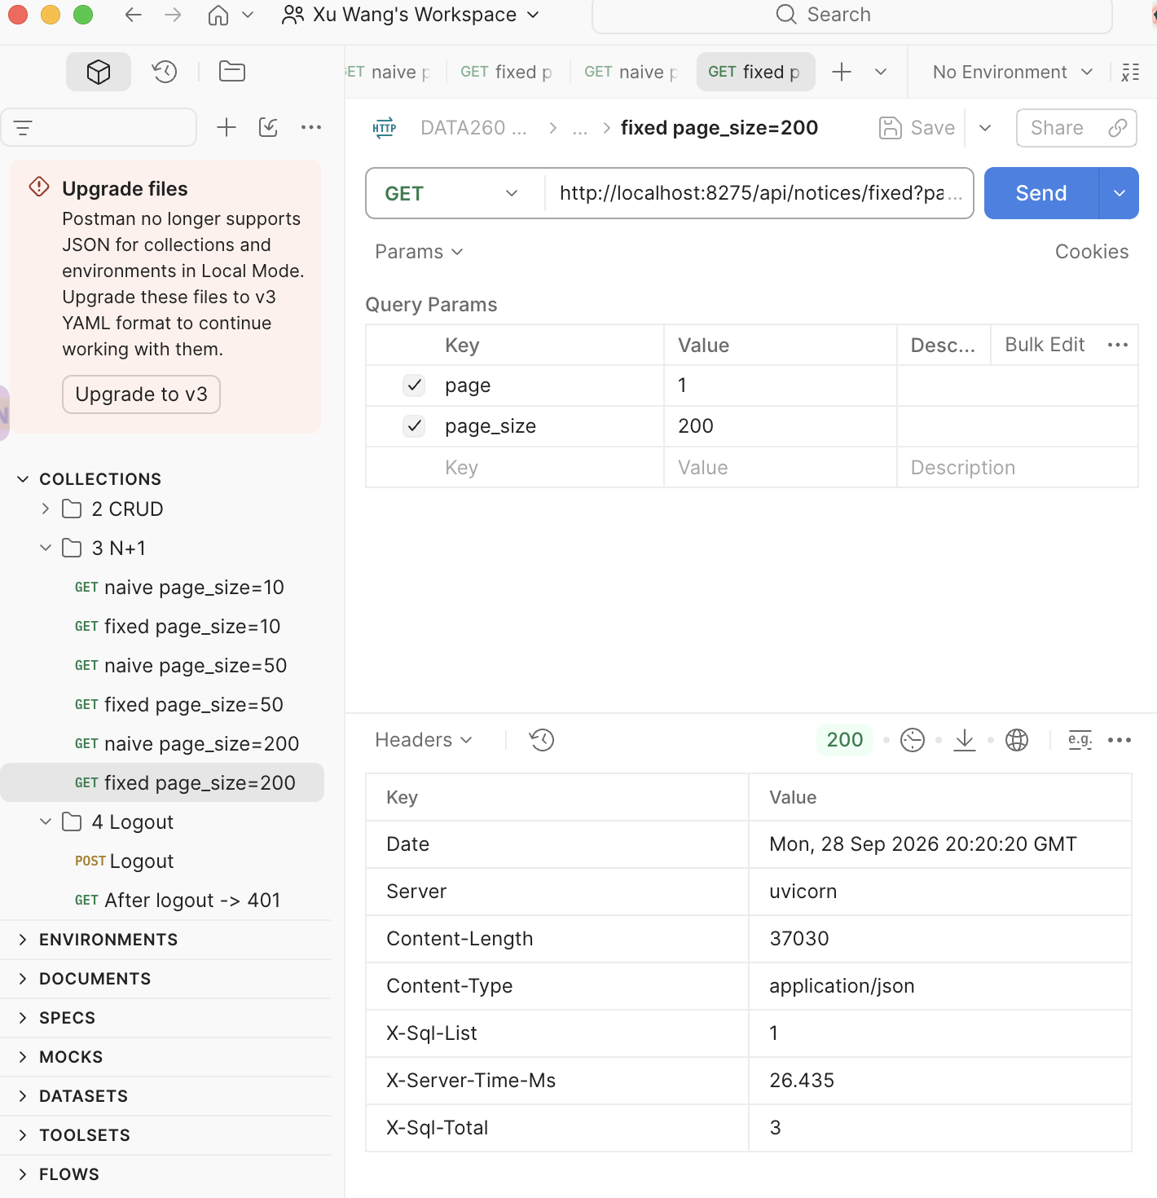

3.4 Measurements (180 requests)
code/n1_bench.py sends 5 warm-up requests per group, then 30 measured requests per page size and version over HTTP. Naive and fixed are paired on the same random page (seed 9275) and interleaved. Raw data: reports/hw04/raw/n1_requests.csv (180 rows), n1_summary.json. SQL statements are shown as total / list-only; the difference of 2 is the session check (SELECT + UPDATE).
Page size | Version | SQL stmts/req | p50 (ms) | p95 (ms) | p99 (ms)
10 | naive | 13 / 11 | 10.21 | 12.33 | 15.91
10 | fixed | 3 / 1 | 9.60 | 12.94 | 14.52
50 | naive | 53 / 51 | 19.33 | 20.98 | 22.33
50 | fixed | 3 / 1 | 10.53 | 12.52 | 23.29
200 | naive | 203 / 201 | 52.51 | 57.30 | 67.47
200 | fixed | 3 / 1 | 12.76 | 14.93 | 15.65

Speed-up (naive p50 / fixed p50): page 10 = 1.06x, page 50 = 1.84x, page 200 = 4.12x. All 180 naive/fixed pairs returned identical items. Measured on 2026-09-28 11:27 with the recall_date index present (it affects both versions equally).
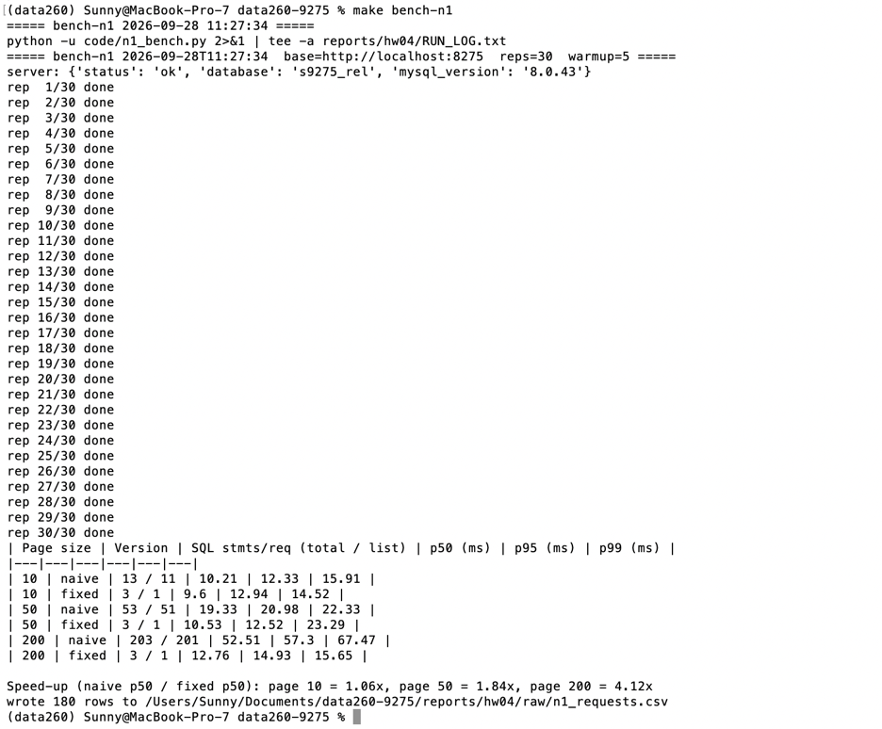
Why the speed-up grows with page size. The naive endpoint sends 1 + N queries, so its time grows linearly with N: from page 10 to page 200 its p50 rises from 10.2 to 52.5 ms, about 0.22 ms per extra row — the cost of one more round trip to MySQL plus building one ORM object. The fixed endpoint sends one JOIN whatever N is, so it stays almost flat (9.6 → 12.8 ms; the increase is serialising more rows). Both versions pay the same per-request overhead of roughly 9–10 ms (HTTP, the two session statements, FastAPI). At page 10 that overhead dominates and the 10 extra queries add little (1.06x); at page 200 the 200 extra round trips are most of the naive request's time (4.12x). The speed-up is roughly (overhead + N × per-query cost) / overhead, so it keeps growing with N, and it would be much larger with the database on another machine, where each round trip costs milliseconds instead of a fraction of one. With 30 samples p99 is close to the maximum and noisy (e.g. fixed at page 50: p95 12.5 ms but p99 23.3 ms), so p50 is the fair comparison.

3.5 One index and EXPLAIN before / after
code/sql/hw04_add_index.sql
CREATE INDEX ix_recall_notices_recall_date ON recall_notices (recall_date);

code/explain_index.py drops the index if present, runs EXPLAIN and EXPLAIN ANALYZE on the fixed endpoint's SQL (… ORDER BY recall_date DESC, id DESC LIMIT n) for page 1 at each page size, adds the index, and repeats. Output: reports/hw04/raw/explain_before_after.txt / .json.
Page size | Before: type / key / Extra | After: type / key / Extra | Median ms (20 runs)
10 | ALL / – / Using filesort | index / ix_recall_notices_recall_date / Backward index scan | 2.38 → 0.37
50 | ALL / – / Using filesort | ALL / – / Using filesort | 3.42 → 3.14
200 | ALL / – / Using filesort | ALL / – / Using filesort | 4.82 → 4.92
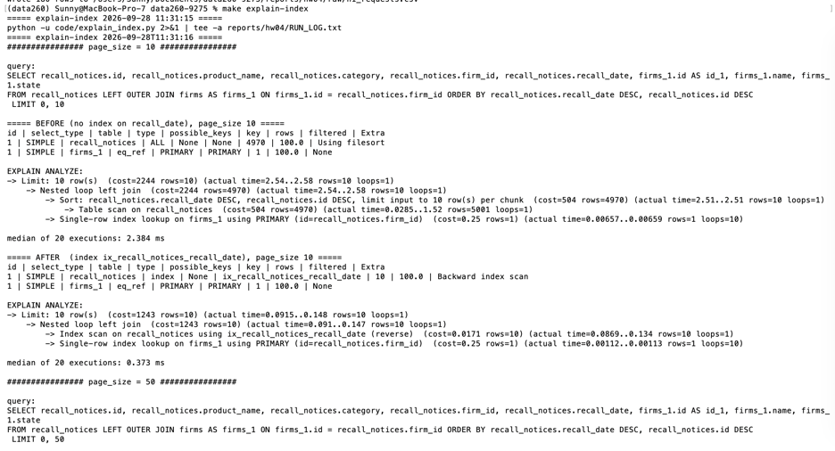
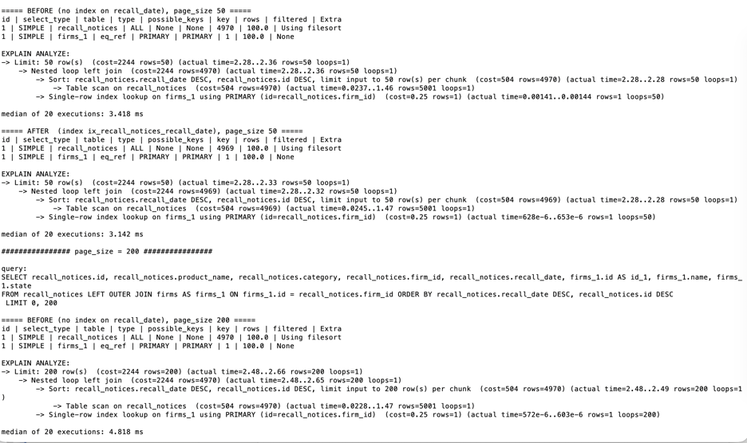
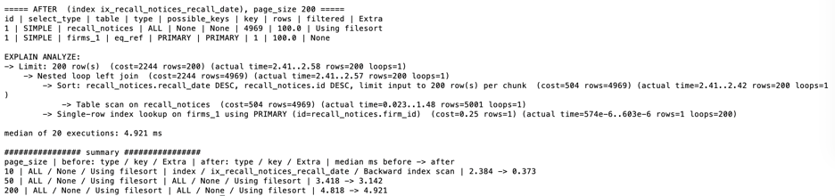
What changed. Without the index, MySQL has no ordered structure on recall_date, so for every page it reads the whole table (type=ALL, "Table scan … rows=5001") and sorts it (Using filesort) just to return the first N rows. With the index, the page-10 plan reads the index backwards and stops after 10 entries (type=index, Backward index scan; estimated rows 4,970 → 10, optimizer cost 2,244 → 1,243). An InnoDB secondary index also stores the primary key, so (recall_date, id) is already in the requested DESC, DESC order and no sort is needed: the median time fell from 2.38 ms to 0.37 ms (6.4x faster). For page sizes 50 and 200 the optimizer kept the full scan even though the index exists. The index holds only recall_date and id, so every row found through it needs a second lookup to fetch product_name and category. On a 5,000-row table that fits in memory, one sequential scan plus an in-memory sort is estimated to be cheaper than 50 or 200 random lookups (the cost stays 2,244 before and after). The plans are identical before and after, so the 3.42 → 3.14 ms and 4.82 → 4.92 ms differences are run-to-run noise, not an effect of the index. On a much larger table, or with a filter such as WHERE recall_date >= … that selects a small range, the index would be chosen for every page size.

Part 4 — Grounded RAG question answering

4.1 Corpus, chunks and index
Corpus: 90 documents reused from HW3 (89 FDA food-recall announcements + 21 CFR Part 7) in reports/hw03/corpus/. SentenceSplitter with chunk_size = 500 and chunk_overlap = 50 tokens gives 182 chunks; each keeps its text, source file and chunk_id. Chunks are embedded with all-MiniLM-L6-v2 on the CPU and stored in a FAISS IndexFlatIP over unit vectors, so the score is cosine similarity.
code/rag.py — chunking
def load_chunks():
"""Split every corpus file into chunks: {chunk_id, source, text, tokens}."""
from llama_index.core.node_parser import SentenceSplitter
from llama_index.core.utils import get_tokenizer

tokenizer = get_tokenizer()
splitter = SentenceSplitter(chunk_size=CHUNK_SIZE, chunk_overlap=CHUNK_OVERLAP)
chunks = []
for path in sorted(CORPUS_DIR.glob("*.txt")):
text = path.read_text(encoding="utf-8")
for i, piece in enumerate(splitter.split_text(text)):
chunks.append({
"chunk_id": f"{path.stem}#{i}",
"source": path.name,
"text": piece,
"tokens": len(tokenizer(piece)),
"sha": hashlib.sha256(piece.encode("utf-8")).hexdigest()[:16],
})
return chunks, tokenizer

code/rag.py — FAISS store
def __init__(self, chunks, embedder):
import faiss
faiss.omp_set_num_threads(1) # avoid clashing with torch's OpenMP on macOS
self.chunks = chunks
self.embedder = embedder
self.vectors = embedder.encode([c["text"] for c in chunks])
self.index = faiss.IndexFlatIP(self.vectors.shape[1])
self.index.add(self.vectors)
self._query_cache = {}

def query_vector(self, question):
"""Each question is embedded once, so configs B, C and every k see the same vector."""
if question not in self._query_cache:
self._query_cache[question] = self.embedder.encode([question])
return self._query_cache[question]

def search(self, question, k):
q = self.query_vector(question)
scores, ids = self.index.search(q, k)
# FAISS must agree with a plain numpy dot product over all chunks.
brute = np.argsort(-(self.vectors @ q[0]))[:k]
if list(ids[0]) != list(brute) and not np.allclose(
np.sort(self.vectors[ids[0]] @ q[0]), np.sort(self.vectors[brute] @ q[0]), atol=1e-5):
raise RuntimeError(f"FAISS and numpy disagree for {question!r}: {ids[0]} vs {brute}")
return [{**self.chunks[i], "row": int(i), "score": round(float(s), 4)}
for s, i in zip(scores[0], ids[0]) if i >= 0]

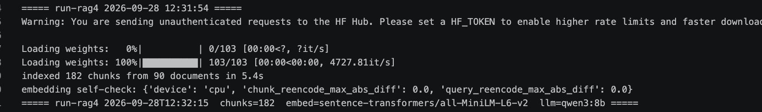

4.2 Retrieval printed before the LLM call
For every question and configuration, rag.py prints the retrieved chunks with rank, score, chunk_id and the C decision (kept / dropped and why) before the model is called. Full output: reports/hw04/raw/rag_retrievals.txt and .jsonl.
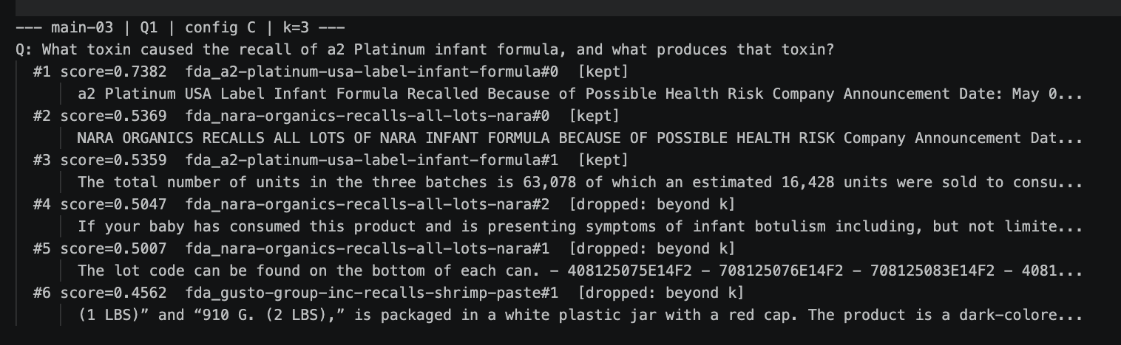
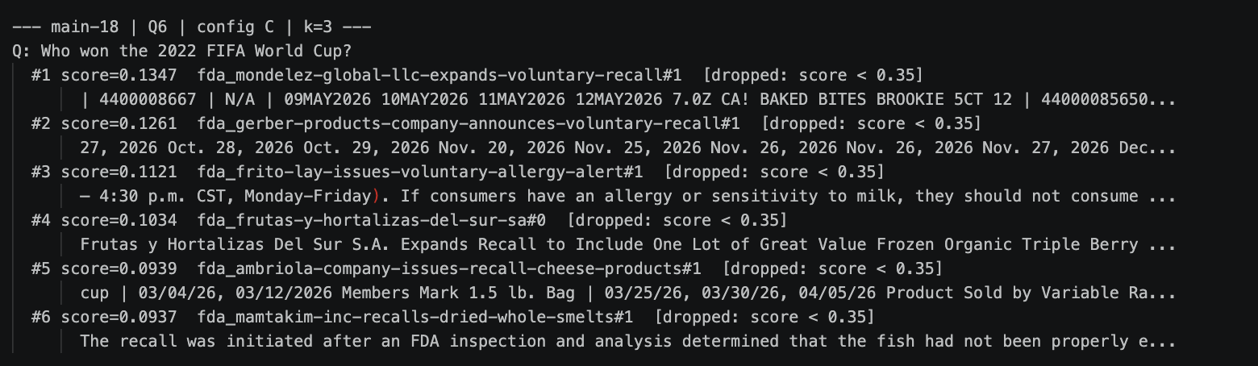

4.3 Three configurations
- A — No RAG: the question alone.
- B — Basic RAG: the raw top-3 chunks pasted before the question, no labels, no rules.
- C — Context-engineered RAG: 2k candidates → drop score < 0.35 → drop duplicates (same text, or cosine ≥ 0.92 to a kept chunk) → keep the best k → order by score → label [S1]… with source and chunk_id → 1,600-token budget → grounding rules. If nothing survives the threshold, C returns the refusal sentence without calling the model.
code/rag.py — config C context
def engineered_context(store, question, k, tokenizer):
"""Config C: filter, de-duplicate, keep k, trim to the token budget.

Returns (all candidates with a decision each, the kept chunks in order).
"""
candidates = store.search(question, k * CANDIDATE_MULTIPLIER)
kept, used_tokens = [], 0
for c in candidates:
if c["score"] < SCORE_THRESHOLD:
c["decision"] = f"dropped: score < {SCORE_THRESHOLD}"
elif any(c["sha"] == x["sha"] for x in kept):
c["decision"] = "dropped: exact duplicate text"
elif any(store.cosine(c["row"], x["row"]) >= DEDUP_COSINE for x in kept):
twin = max(kept, key=lambda x: store.cosine(c["row"], x["row"]))
c["decision"] = f"dropped: near-duplicate of {twin['chunk_id']}"
elif len(kept) >= k:
c["decision"] = "dropped: beyond k"
elif used_tokens + c["tokens"] > CONTEXT_TOKEN_BUDGET:
c["decision"] = f"dropped: token budget {CONTEXT_TOKEN_BUDGET}"
else:
c["decision"] = "kept"
kept.append(c)
used_tokens += c["tokens"]
return candidates, kept # candidates are already in score order

code/rag.py — grounding rules
SYSTEM_GROUNDED = f"""You answer questions about food recall notices using ONLY the numbered sources provided.
Rules:
1. Use only facts stated in the sources. Do not use outside knowledge.
2. After every sentence, cite the source number(s) it came from in square brackets, e.g. [S1] or [S1][S3].
3. If the sources do not contain enough evidence to answer, reply with exactly this sentence and nothing else:
{REFUSAL}
4. If the question could refer to several different recalls, say that briefly, then give only what the sources support, with citations.
5. Keep the answer under 120 words."""

4.4 Six questions — results (k = 3)
Questions: reports/hw04/rag_questions.yaml, committed before the retrieval run. Full answers: raw/rag_comparison.md and raw/rag_answers.jsonl.
Q (type) | A — No RAG | B — Basic RAG | C — Context RAG
Q1 one chunk | wrong ("saxitoxin") | correct, grounded | correct, grounded, cites [S1]
Q2 two chunks | wrong ("every 7 days") | correct, not grounded | correct, not grounded
Q3 across documents | incomplete | correct, not grounded | correct, grounded, [S1][S2]
Q4 ambiguous | generic advice | generic advice, not grounded | generic advice, not grounded
Q5 not in documents | hallucinated "$1.2 million" fine | refused | exact refusal (rules)
Q6 unrelated | answered ("Argentina") | answered wrongly ("France") | exact refusal (threshold, no LLM call)

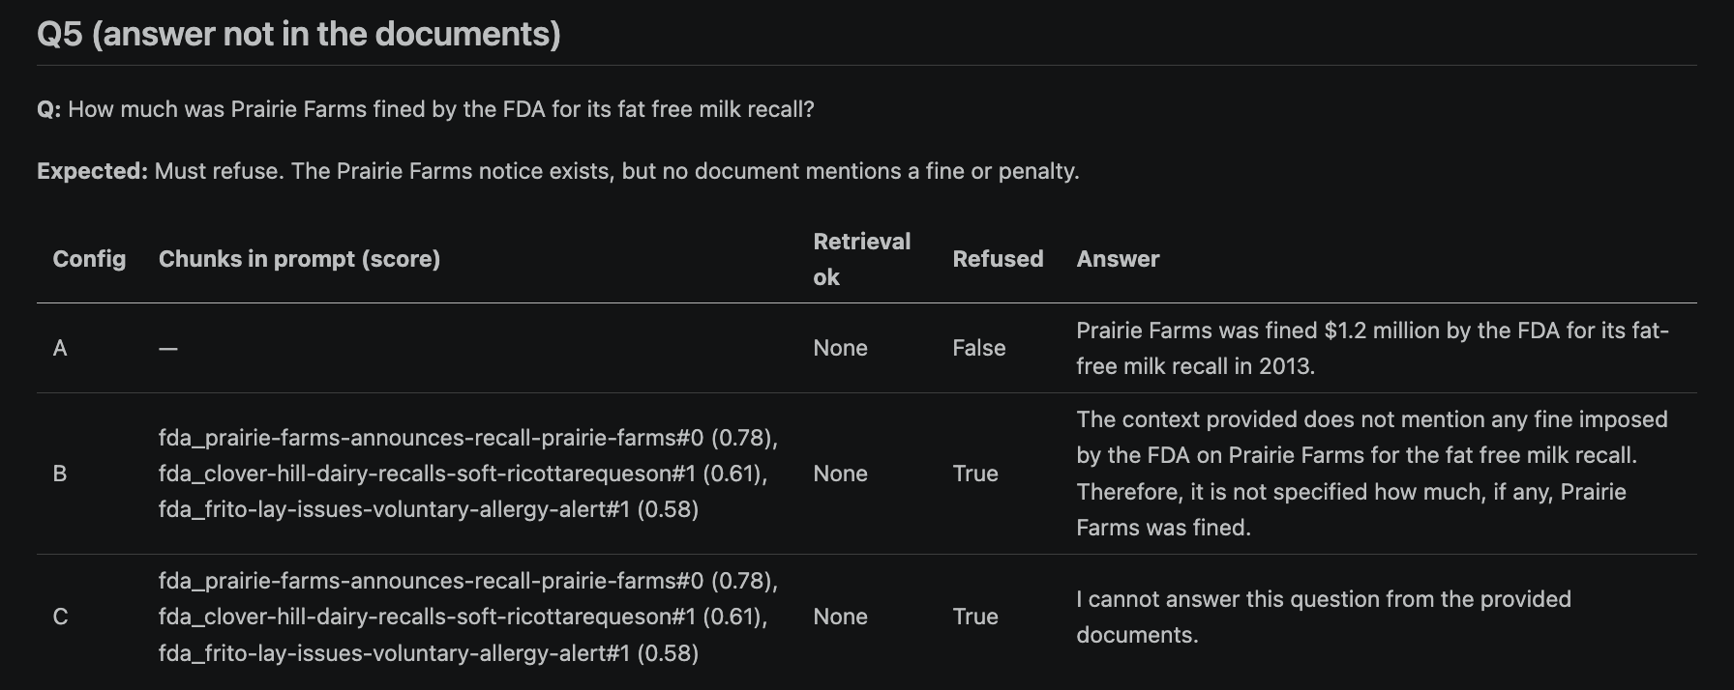

4.5 top_k sweep (k = 1, 3, 5)
Q | Config | k | Chunks in prompt | Context tokens | Evidence retrieved | Result
Q2 | B | 1 | 1 | 477 | no | answered from model knowledge
Q2 | B | 3 | 3 | 1,336 | no | definition chunk still missing
Q2 | B | 5 | 5 | 2,304 | yes | both chunks in prompt
Q2 | C | 1 | 1 | 477 | no | refused
Q2 | C | 3 | 3 | 1,336 | no | answered, status part cited
Q2 | C | 5 | 3 | 1,336 | no | budget dropped the definition chunk
Q3 | B | 1 | 1 | 495 | partial | partial answer
Q3 | B | 3 | 3 | 1,202 | yes | complete
Q3 | B | 5 | 5 | 2,157 | yes | complete, 2x context
Q3 | C | 1 | 1 | 495 | partial | partial answer
Q3 | C | 3 | 3 | 1,202 | yes | complete, cited
Q3 | C | 5 | 4 | 1,596 | yes | complete; budget dropped 6

More context helped Q2: the Class I definition (§ 7.3) ranks below three other Part 7 chunks and only reached B's prompt at k = 5. It did not help Q3, where k = 3 already held the Listeria paragraph and k = 5 only added more copies of it, nearly doubling the prompt. Irrelevant chunks appeared whenever k exceeded the number of chunks holding the answer (Q2 at k = 3: effectiveness checks § 7.42 and firm-initiated recalls § 7.46). Best k: 3 for Q3 and most questions; Q2 needed 5 in B, and in C the 1,600-token budget cut the needed chunk at k = 5. Raw: raw/rag_ksweep.md / .json.
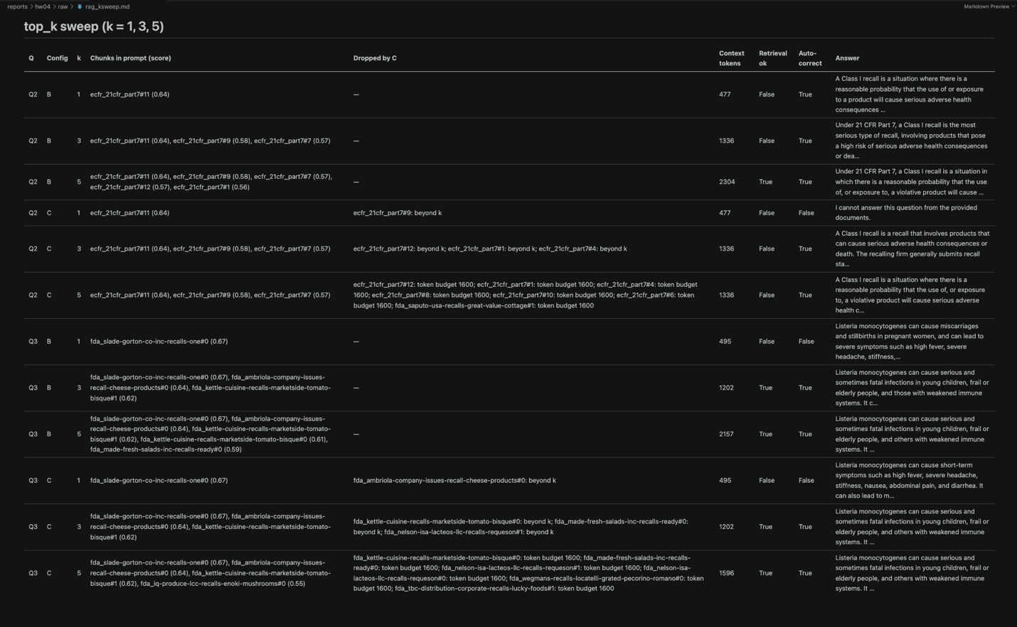

4.6 Evaluation
correct_answer and grounded were judged by hand for all 18 rows (raw/rag_eval.csv); retrieval, refusal and format were checked by the script. Accuracy counts a refusal as the correct answer for Q5/Q6. Faithfulness = grounded / answers that were not refusals (small denominators).
Config | Correct retrieval (Q1–Q4) | Accuracy | Faithfulness | Format compliance | Refused Q5/Q6 | Wrong refusals Q1–Q4
A — No RAG | n/a | 1/6 | n/a | n/a | 0/2 | 0/4
B — Basic RAG | 3/4 | 5/6 | 1/5 | n/a | 1/2 | 0/4
C — Context RAG | 3/4 | 6/6 | 2/4 | 6/6 | 2/2 | 0/4

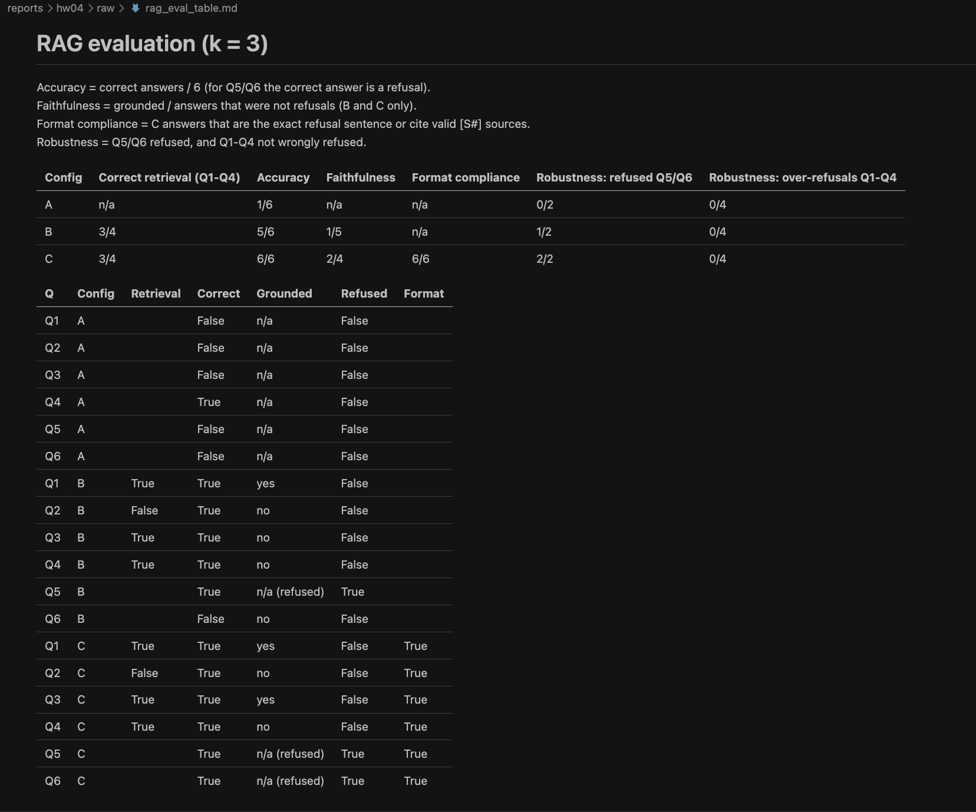

4.7 Analysis
Retrieval. Once the embeddings were computed on the CPU (see AI use), MiniLM placed a relevant chunk in the top three for Q1, Q3 and Q4, so correct retrieval was 3/4 for both B and C. Q2 was the hard case: it asks two things, and the status-report section (§ 7.53, score 0.64) outranked the Class I definition (§ 7.3), which only entered the prompt at k = 5. For Q5 retrieval did its job—the Prairie Farms notice scored 0.78—but the fact asked for, a fine, is not in it. For Q6 the best chunk scored only 0.13.
Context changes. The score threshold was the most effective single change: it removed every chunk for Q6, so C refused without calling the model, while B passed three unrelated chunks and the model answered "France". Source labels plus grounding rules made C cite [S#] in every answer (format 6/6) and produced the exact refusal for Q5 even though a relevant-looking chunk was present, so the rules, not retrieval, handled Q5. A larger k helped Q2 but not Q3, where k = 5 only added more copies of the same Listeria paragraph and doubled the prompt. The token budget cut both ways: it kept C's prompts near 1,300–1,600 tokens but dropped the Q2 definition at k = 5. De-duplication never fired—the Listeria paragraphs are reworded across notices and whole chunks were never 0.92 similar—so sentence-level de-duplication would be needed. For Q4 no configuration said the question was ambiguous; all three merged the similar consumer instructions of several notices.
Hallucination. Without retrieval the model invented a $1.2 million fine for Q5, answered Q6 from world knowledge, and got Q1 ("saxitoxin") and Q2 ("every 7 days") wrong: accuracy 1/6. B refused Q5 but answered Q6 wrongly; C refused both.
How the pieces combine. Accuracy rose from 1/6 (A) to 5/6 (B) to 6/6 (C), but faithfulness stayed low (B 1/5, C 2/4). For Q2 both B and C were correct without support in their chunks: the model filled in the missing definition from its own knowledge. A correct answer and a grounded answer are therefore different measures. Retrieval quality sets the ceiling—evidence that is not in the window cannot be cited—context engineering decides what the model sees, and the prompt controls citations and refusals. The largest remaining gain would come from retrieval, for example smaller chunks or splitting multi-part questions like Q2, rather than from more prompt rules.
(403 words)

Verification
verify_hw04.py starts the API on PORT_BASE (or reuses a running one) and checks behaviour: React files and routes, schema and db_session_basede26, 401 without a session, HttpOnly cookie with an opaque token stored in sessions, a full CRUD round trip checked directly in MySQL, logout invalidating the token, naive = 1 + N vs fixed = 1 list queries with identical data at 10/50/200, 180 raw rows, the index and EXPLAIN files, and the RAG outputs (C refused Q5 and Q6). It writes reports/hw04/verification.json with homework, SID4, commit, tag, model, SEED / VERIFY_SEED and pass/fail per check. It creates one temporary record and one session and removes both; no application file is modified.

AI use (AI_USE.md)

1. What I used an AI assistant for, and what I did myself
AI assistant (Claude):
- Wrote the first version of the code after I approved the design: the MySQL-backed
API in code/auth_app/, the schema/seed scripts, the React client in frontend/,
n1_bench.py, explain_index.py, rag.py, verify_hw04.py, and the Postman
collection. It tested these in its own environment against MySQL 8.0 and with
a headless browser before handing them over.
Drafted the six RAG questions.
Me:
Read the assignment and the instructor's DATA236 demo and listed the gaps between
them (the demo logs in with a user_id and no password, protects only the list
endpoint, and stores naive datetimes in a time-zone column).
- Made the design decisions: extend the HW3 auth app instead of HW2's api_server.py
and keep HW2 untouched; put the React client in a root-level frontend/; model the
domain as recall notices + firms; pass the record id to /update and /delete
through router state so the routes match the assignment literally.
- Set up and ran everything on my Mac (MySQL 8.0.43, conda env, Ollama qwen3:8b), and
fixed the environment problems I ran into (empty MySQL password in .env, running
in the conda base env with Python 3.13 instead of data260).
- Tested the React app by hand, took the Postman / database / UI screenshots.
- Reviewed the RAG questions and committed them before the retrieval run.
- Read every RAG answer against the retrieved chunks and filled correct_answer and
grounded in raw/rag_eval.csv myself.

2. One AI-produced output that was wrong
The first version of rag.py let sentence-transformers choose its device. On my
M1 Mac it chose Apple's GPU backend (MPS) for the MiniLM embeddings, while Ollama was
using the same GPU for qwen3:8b. The run finished without crashing, but the retrieval
was wrong: config B retrieved almost nothing relevant (correct retrieval 1/4) and config
C refused all six questions, including Q1–Q4, because every candidate chunk scored
below the 0.35 threshold.

3. How I detected the problem
The same question got different retrieval results in different configurations. Config
C searches a pool of 2k candidates, so its list must contain B's top 3 with the same
scores — but for Q4 the top score was 0.65 in B and 0.11 in C, and for Q1 B's first
hit was a lettuce recall while C's was the a2 infant-formula notice. That can only
happen if the same question produces different embeddings on different calls.
RUN_LOG.txt then showed the cause: Metal errors
Insufficient Memory (kIOGPUCommandBufferCallbackErrorOutOfMemory) on the
Apple M1 device during the run. The GPU ran out of memory and the embedding
calls silently returned bad vectors.

4. What I changed and why it works now
- Embeddings run on the CPU (SentenceTransformer(..., device="cpu")), so they no
longer compete with Ollama for GPU memory. MiniLM is small, so the index still
builds in seconds.
- Each question is embedded once and cached, so B, C and every k in the sweep use the
identical query vector.
- Every FAISS search is cross-checked against a plain numpy dot product over all
chunks; a mismatch stops the run.
- Before any model call, self_check() re-encodes 8 chunks and all 6 questions and
stops the run if the vectors differ at all. The check result and the package versions
are saved in raw/rag_run_meta.json.
In the re-run the self-check reported a difference of 0.0 for both chunks and queries,
B and C show the same ranking and scores for every question (Q4: 0.6502 in both),
correct retrieval rose to 3/4 for B and C, and C answered Q1–Q4 and refused only Q5 and
Q6. The questions file was not changed between the two runs, so the commit that fixed
the questions before retrieval still holds.

