DATA-260 Sec 21&71 — Homework 2
Xu Wang
Repository: github.com/xuwang-goldenwater/data260-9275

Section 0 — Personal configuration and domain
Value | This submission | How it is derived
SID4 | 9275 | last four digits of the SJSU Student ID
PORT_BASE | 8275 | 8000 + (9275 mod 900)
PREFIX | s9275 | "s" + SID4
SEED | 9275 | SID4
VERIFY_SEED | 269275 | 260000 + SID4
DOMAIN_ID | 3 — grocery supply and recall notices | 9275 mod 8

Item | Value
Hardware | MacBook Pro, Apple silicon, 8 GB RAM, macOS
Local model | qwen3:8b via Ollama, temperature 0.0
Model adapter | src/model_client.py (unchanged from Homework 1)
Python | 3.12, conda environment "data260"
Tagged commit | 9096148
Tag | hw2

Homework 2 extends the Homework 1 codebase in place. Application code lives only in code/ and src/. reports/hw02/ holds evidence only. The Homework 1 self-check, verify_hw01.py, still passes without changes against the changed files.
Entity: RecallNotice, defined in DOMAIN_SCHEMA.md. Fields: productName (primary), recallingFirm (secondary), submitterEmail, description, category (four fixed values), agreedToTerms, submissionDate.

Part 1 — HTML & CSS

1.1 Usable at 375px
The Homework 1 page was one form in a fixed 640px column. Homework 2 adds a record list above it, a search bar, and two buttons on every record. All of that has to still work at 375px. That is the width of an iPhone SE.
Five rules do the work. Nothing else in styles.css sets a fixed width. verify_hw02.py checks for that.
- The stylesheet is mobile-first. The base rules are the narrow layout, and the one breakpoint widens it at 480px instead of narrowing it below.
- Every row that could overflow is a flex container with flex-wrap, so the search field and its two buttons stack instead of being squeezed.
- min-width: 0 on the search input. Without it a flex item will not shrink below the width of its content, and it pushes the row wider than the screen.
- overflow-wrap: anywhere on product names and firm names. A long product name is one unbreakable token otherwise.
- Buttons are min-height: 44px, which is Apple's minimum comfortable touch target. The base font is 16px so iOS Safari does not zoom in when a field is focused.
code/web_application/styles.css — the toolbar row
/* ---------- toolbar: search + new ------------------------------------- */
/* flex-wrap is what keeps this usable at 375px: the search field and the two
buttons drop onto their own lines instead of being squeezed. */

.toolbar {
display: flex;
flex-wrap: wrap;
gap: 8px;
margin-bottom: 16px;
}

.toolbar input[type="search"] {
flex: 1 1 100%;
min-width: 0; /* without this a flex item refuses to shrink */
}

.toolbar button { flex: 1 1 auto; }

@media (min-width: 480px) {
.toolbar input[type="search"] { flex: 1 1 60%; }
.toolbar button { flex: 0 0 auto; }
}
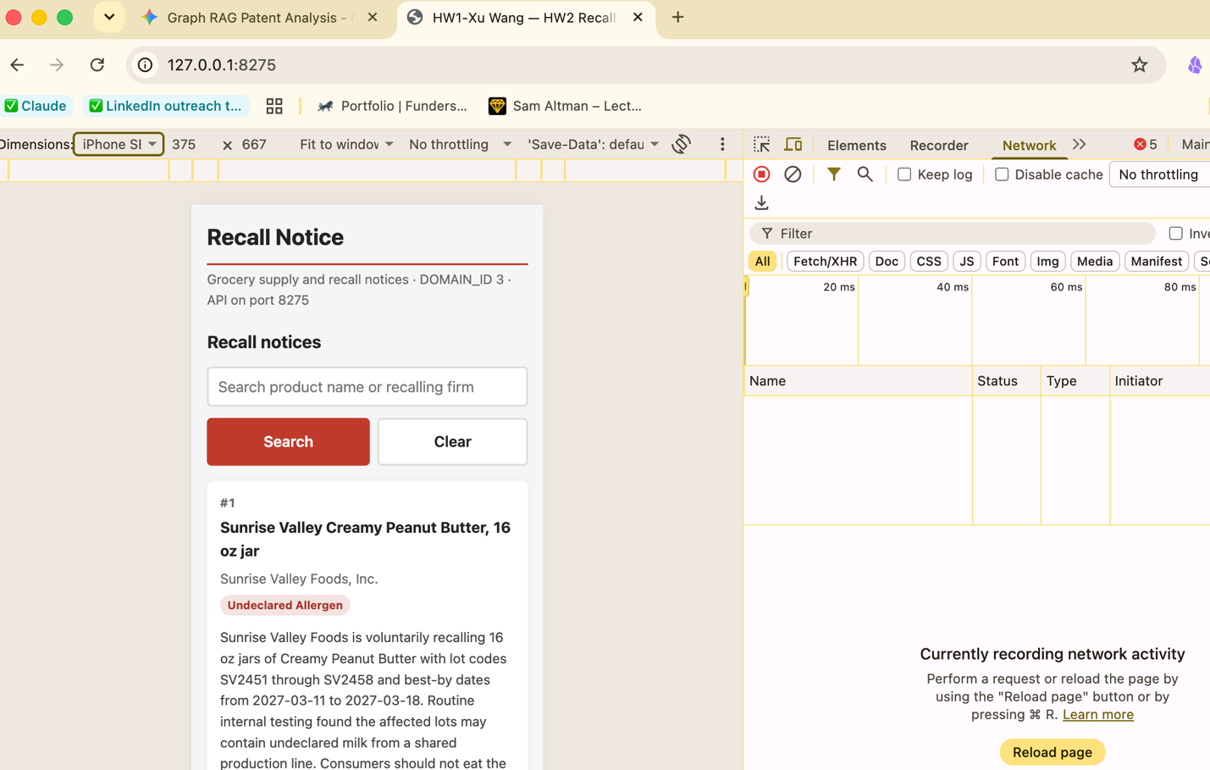

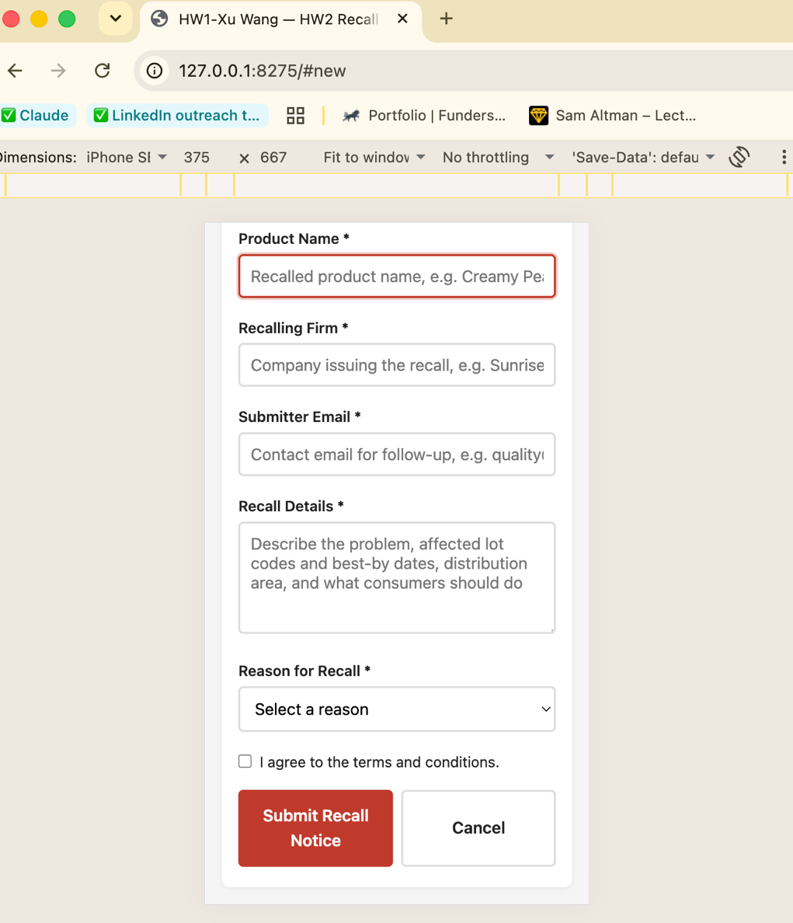

1.2 Visible loading, empty and error states
All three states are written into the same element, #listState. Each function clears the list first, then replaces the class and the content of that element. Because they all write to the same place, two states cannot show at once. There is no combination of flags that can produce that.
code/web_application/app.js
// ---------------------------------------------------------------------------

const showLoading = () => {
noticeList.innerHTML = "";
listState.className = "state";
listState.innerHTML = '<span class="spinner"></span>Loading recall notices&hellip;';
listState.hidden = false;
};

const showEmpty = (query) => {
noticeList.innerHTML = "";
listState.className = "state";
listState.textContent = query
? 'No recall notices match "' + query + '".'
: "No recall notices on file yet. Use the button below to file the first one.";
listState.hidden = false;
};

const showError = (message) => {
noticeList.innerHTML = "";
listState.className = "state state-error";
listState.innerHTML =
"<strong>Could not load recall notices.</strong>" +
"<span></span>" +
'<button type="button" id="retryBtn">Retry</button>';
listState.querySelector("span").textContent = message;
listState.hidden = false;
$("retryBtn").addEventListener("click", () => loadNotices(searchInput.value.trim()));
};

const hideState = () => { listState.hidden = true; };

code/web_application/styles.css
/* ---------- loading / empty / error states ----------------------------- */

.state {
background: var(--card);
border-radius: var(--radius);
padding: 24px 16px;
text-align: center;
color: var(--muted);
}

.state-error {
background: #fdecea;
color: #7f231c;
border: 1px solid #f5c6c2;
text-align: left;
}

.state-error strong { display: block; margin-bottom: 4px; color: var(--red-dark); }
.state-error button { margin-top: 10px; }

.spinner {
display: inline-block;
width: 22px;
height: 22px;
margin-right: 8px;
vertical-align: -5px;
border: 3px solid var(--line);
border-top-color: var(--red);
border-radius: 50%;
animation: spin 0.8s linear infinite;
}

@keyframes spin { to { transform: rotate(360deg); } }

@media (prefers-reduced-motion: reduce) {
.spinner { animation-duration: 2.4s; }
}

One thing changed from Homework 1. HW1 reported validation failures with alert(). Part 1 asks for visible error states, and an alert is not part of the page. It cannot be screenshotted in place and it disappears when you click it. The same two rules now mark the bad field inside the page. The rules themselves did not change, which is why verify_hw01.py still finds the 25-character check and the terms check.
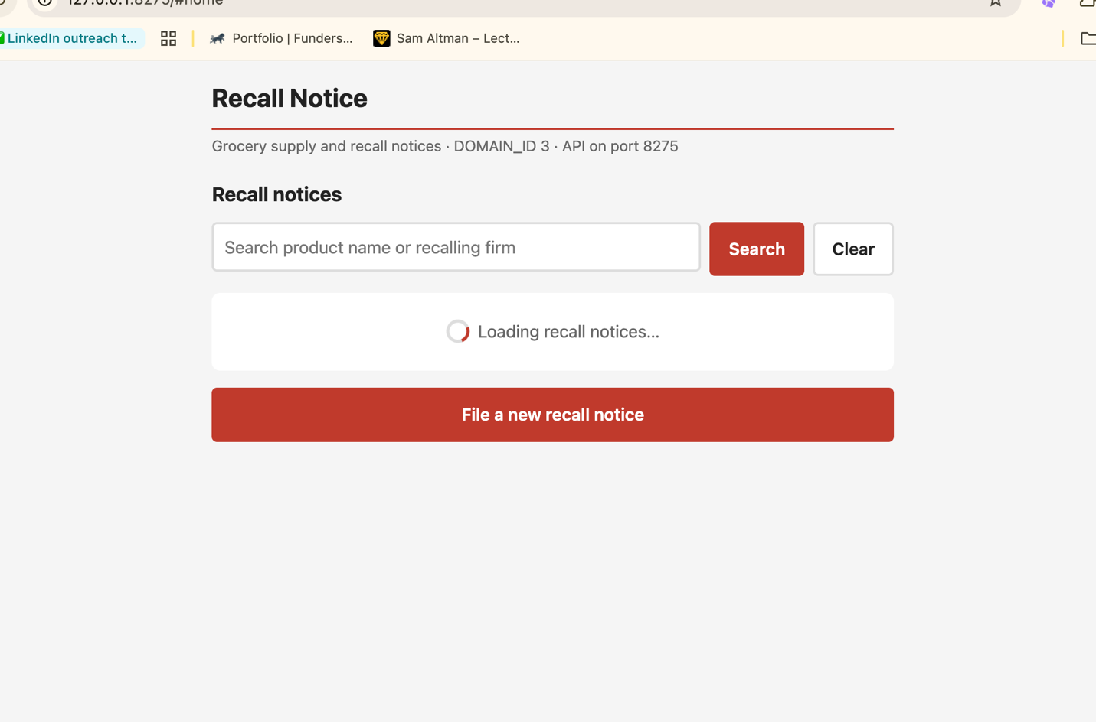
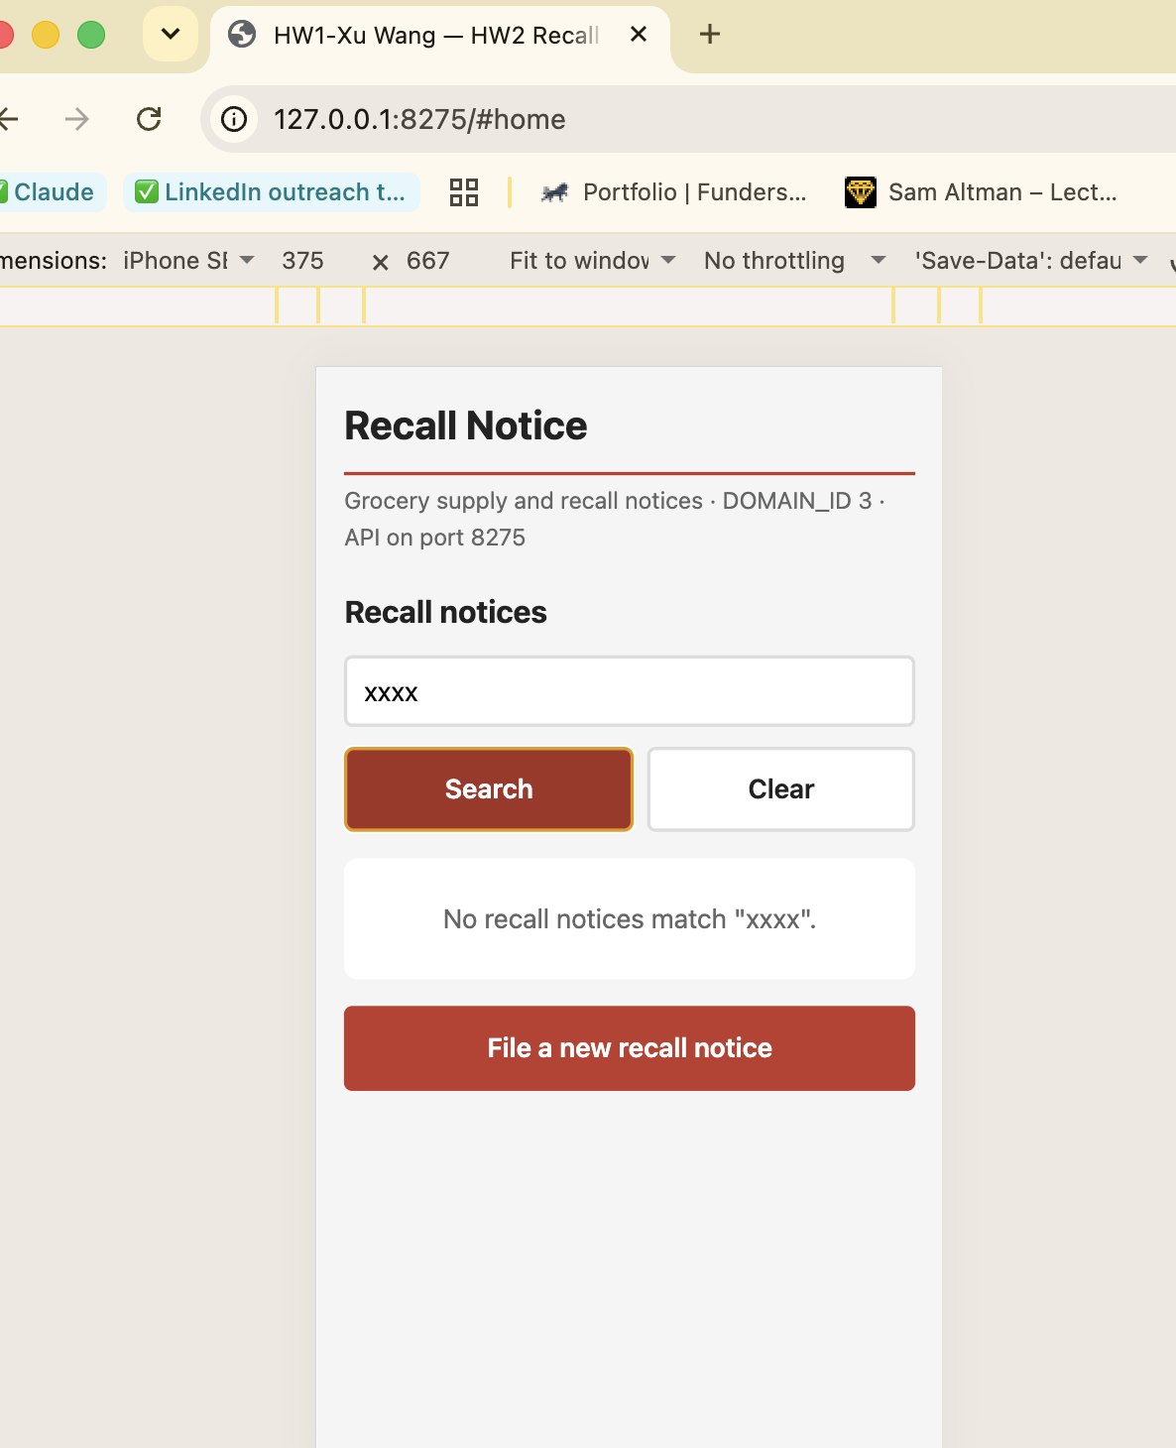
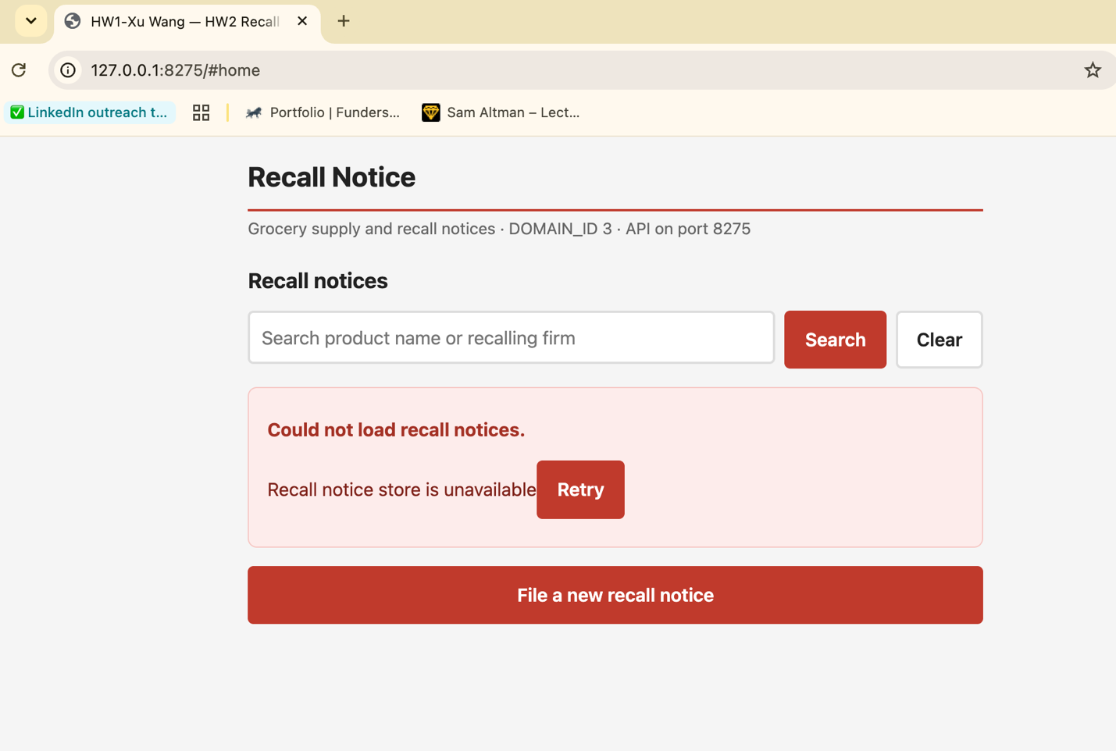

Part 2 — FastAPI
code/api_server.py serves both the JSON API and the Part 1 page on PORT_BASE 8275, so the whole application is one process on one port. Records are stored in code/data/recall_notices.json. That file is created on first start from a seed file that is committed, so a fresh clone always starts with the same three notices.
The request model repeats the same rules the browser checks. A check in the browser is a convenience, not a guarantee. Anyone can POST to this endpoint without using the page at all.
code/api_server.py — the request model
class NoticeIn(BaseModel):
"""What the client sends on POST and PUT."""

productName: str = Field(min_length=1)
recallingFirm: str = Field(min_length=1)
submitterEmail: str
description: str
category: Literal[CATEGORIES] # type: ignore[valid-type]
agreedToTerms: bool
submissionDate: Optional[str] = None

@field_validator("submitterEmail")
@classmethod
def _email(cls, value: str) -> str:
if not EMAIL_RE.match(value.strip()):
raise ValueError("submitterEmail is not a valid email address")
return value.strip()

@field_validator("description")
@classmethod
def _description(cls, value: str) -> str:
# The same rule the browser enforces in app.js, enforced again here.
# A client-side check is a convenience; it is not a guarantee, because
# anyone can POST to this endpoint without going through the page.
if len(value.strip()) <= 25:
raise ValueError("description must be longer than 25 characters")
return value

@field_validator("agreedToTerms")
@classmethod
def _terms(cls, value: bool) -> bool:
if not value:
raise ValueError("agreedToTerms must be true")
return value

2.1 Add a new record
The user fills in the primary field (product name) and the secondary field (recalling firm), plus the other required fields. On success the server assigns the next id and the browser goes back to the home view with the updated list.
code/api_server.py
@app.post("/api/notices", response_model=Notice, status_code=201)
async def create_notice(payload: NoticeIn) -> dict:
"""Part 2.1 - add a new record and return it with its assigned id."""
notices = load_notices()
record = payload.model_dump()
record["id"] = next_id(notices)
record["submissionDate"] = payload.submissionDate or datetime.now(timezone.utc).isoformat()
notices.append(record)
save_notices(notices)
print(f"[POST] created notice {record['id']}: {record['productName']}")
return record

code/web_application/app.js — POST, then back to the home view
const submitBtn = $("submitBtn");
const originalLabel = submitBtn.textContent;
submitBtn.disabled = true;
submitBtn.textContent = editingId === null ? "Submitting…" : "Saving…";

try {
if (editingId === null) {
// Part 2.1 - add a new record
const created = await request(API, {
method: "POST",
headers: { "Content-Type": "application/json" },
body: JSON.stringify(parsedDataWithDate),
});
showToast("Recall notice #" + created.id + " added.");
} else {
// Part 2.2 - update an existing record
await request(API + "/" + editingId, {
method: "PUT",
headers: { "Content-Type": "application/json" },
body: JSON.stringify(parsedDataWithDate),
});
showToast("Recall notice #" + editingId + " updated.");
}
// Parts 2.1 and 2.2 - back to the home view with the updated list.
goHome();
} catch (err) {
showToast("Save failed: " + err.message, true);
} finally {
submitBtn.disabled = false;
submitBtn.textContent = originalLabel;
}
});
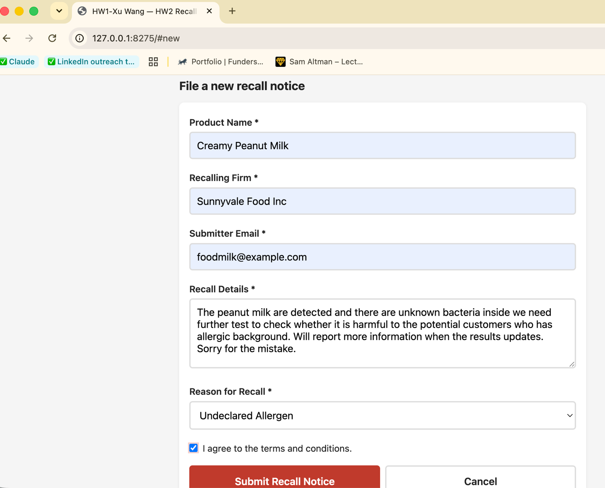
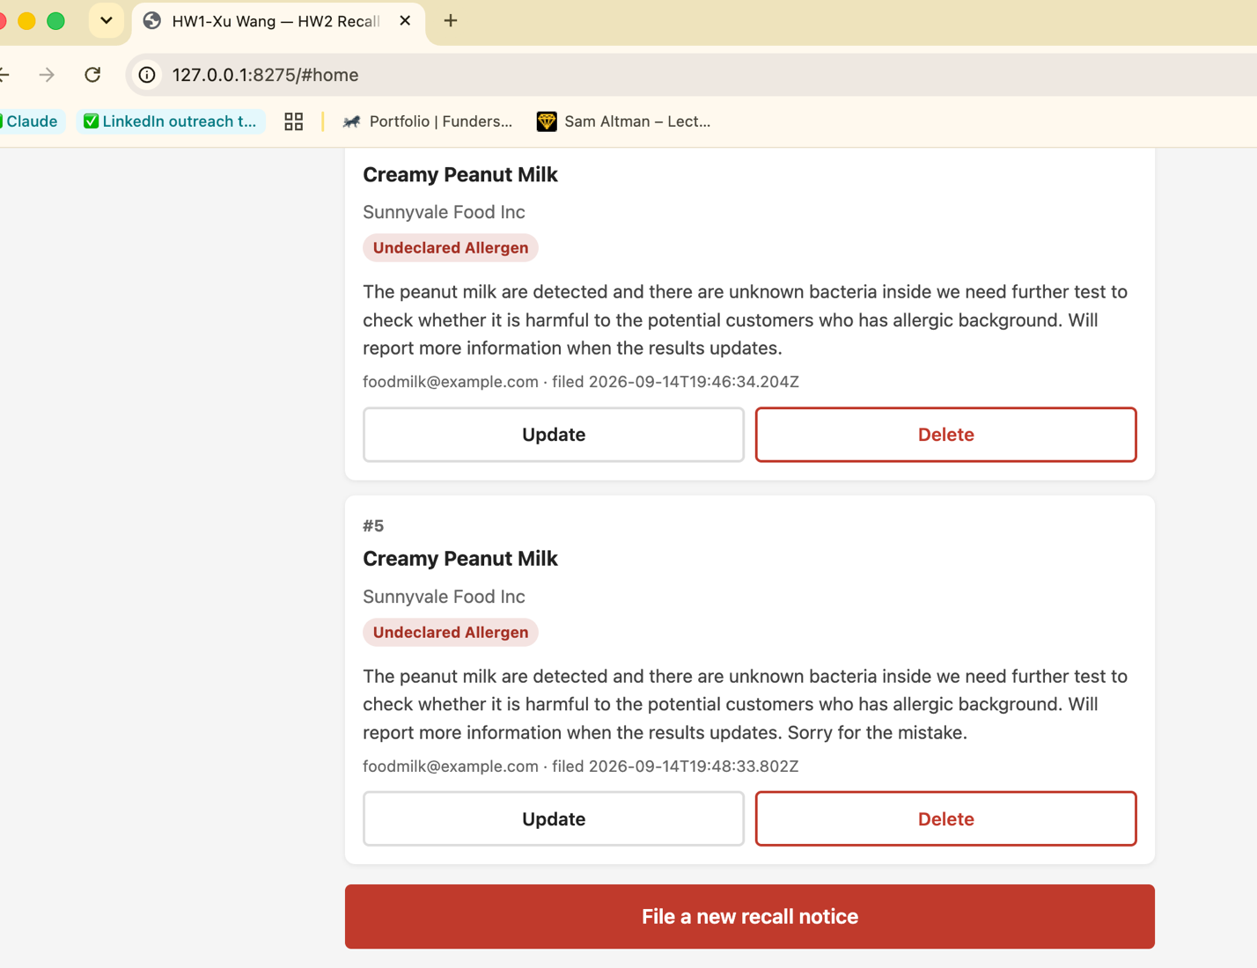

2.2 Update the record with ID 1
The same form is used for updating. It is filled in from GET /api/notices/1 when the URL hash is #edit/1. The id cannot be edited, because the id is what says which record is being changed. submissionDate is kept if the client does not send a new one.
code/api_server.py
@app.put("/api/notices/{notice_id}", response_model=Notice)
async def update_notice(notice_id: int, payload: NoticeIn) -> dict:
"""Part 2.2 - replace the primary, secondary and remaining fields of a record.

The id is not editable: it identifies the record being changed.
"""
notices = load_notices()
index = find_index(notices, notice_id)
record = payload.model_dump()
record["id"] = notice_id
record["submissionDate"] = payload.submissionDate or notices[index]["submissionDate"]
notices[index] = record
save_notices(notices)
print(f"[PUT] updated notice {notice_id}: {record['productName']}")
return record

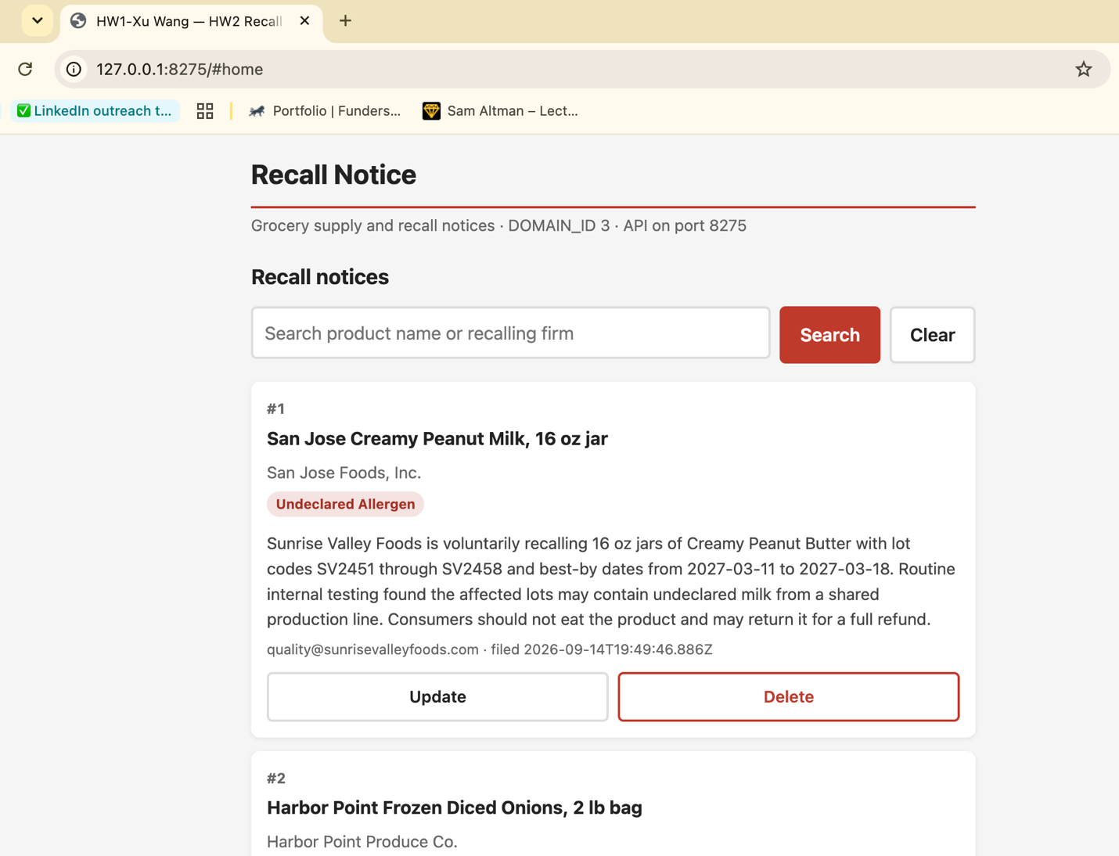

2.3 Delete the record with the highest ID
Deleting takes a second click instead of opening a confirm() dialog. That way the confirmation is part of the page and shows up in a screenshot. The server returns 204 with an empty body. The browser then reloads the list.
code/api_server.py
@app.delete("/api/notices/{notice_id}", status_code=204)
async def delete_notice(notice_id: int) -> Response:
"""Part 2.3 - remove a record."""
notices = load_notices()
index = find_index(notices, notice_id)
removed = notices.pop(index)
save_notices(notices)
print(f"[DELETE] removed notice {notice_id}: {removed['productName']}")
return Response(status_code=204)

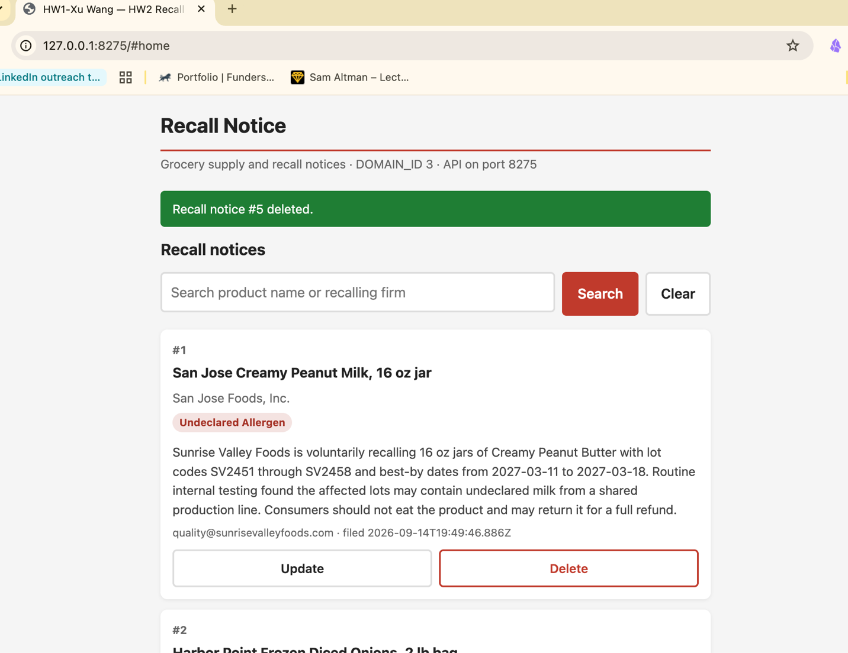

2.4 Search by the primary or secondary field
The search term is sent to the server. It is not filtered in the browser. Matching ignores case and covers productName (primary) and recallingFirm (secondary). A search with no matches returns 200 and an empty list, not an error. That is why the page shows the empty state and not the error state.
code/api_server.py
@app.get("/api/notices", response_model=List[Notice])
async def list_notices(
response: Response,
q: Optional[str] = Query(default=None, description="match product name or recalling firm"),
) -> List[dict]:
"""Part 2.4 - list, optionally filtered by a search term.

The term is matched case-insensitively against the primary field
(productName) and the secondary field (recallingFirm).
"""
delay_ms = int(os.getenv("DEMO_DELAY_MS", "0"))
if delay_ms:
await asyncio.sleep(delay_ms / 1000.0)

if os.getenv("DEMO_FAIL_LIST") == "1":
raise HTTPException(status_code=500, detail="Recall notice store is unavailable")

response.headers["Cache-Control"] = "no-store"
notices = load_notices()

if q:
needle = q.strip().lower()
notices = [
n
for n in notices
if needle in n["productName"].lower() or needle in n["recallingFirm"].lower()
]
return notices

code/web_application/app.js
// Part 2.4 - search. The query is sent to the server, which matches it against
// the primary field (productName) and the secondary field (recallingFirm).
const loadNotices = async (query) => {
showLoading();
try {
const url = query ? API + "?q=" + encodeURIComponent(query) : API;
const notices = await request(url);
if (notices.length === 0) {
showEmpty(query);
return;
}
hideState();
renderNotices(notices);
} catch (err) {
showError(err.message);
}
};

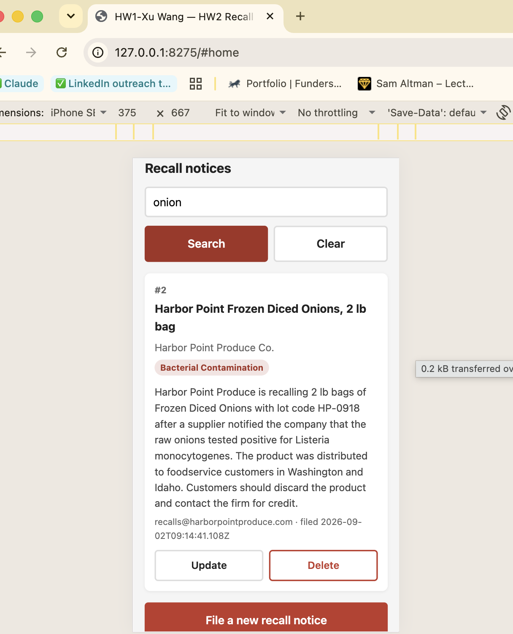

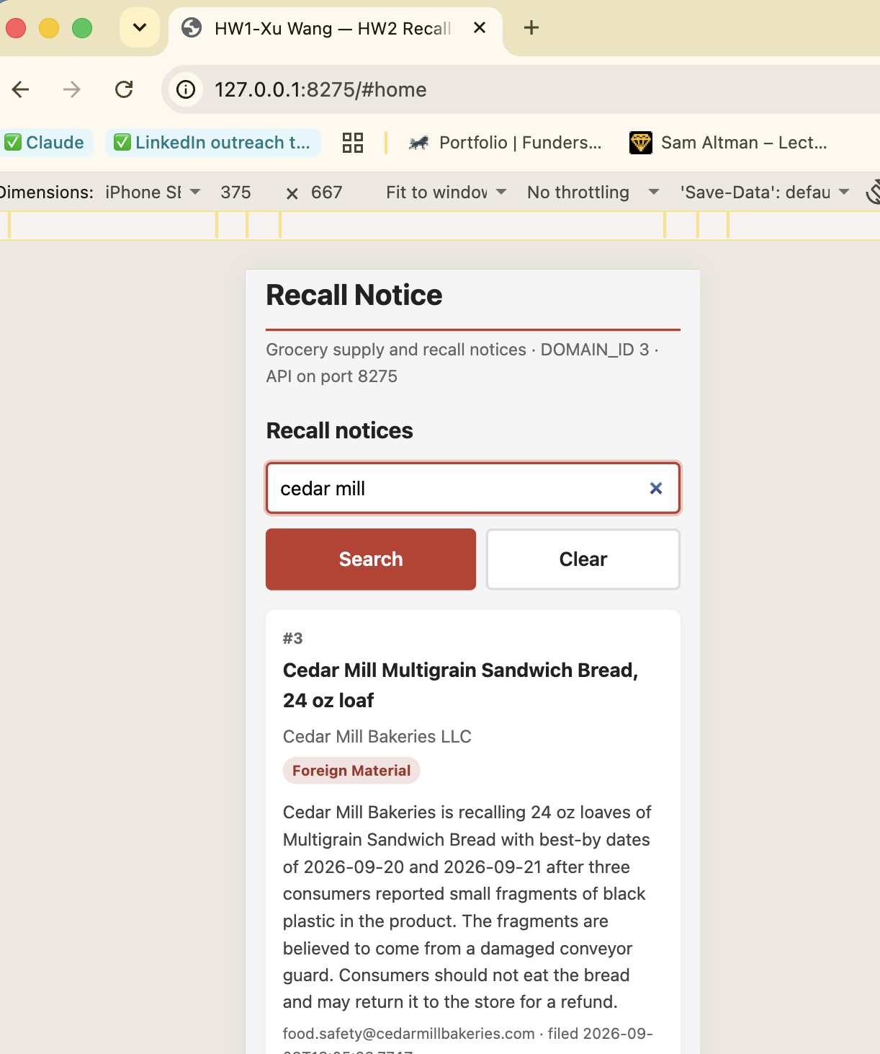

Part 3 — Stateful agent graph
Homework 1 ran Planner, then Reviewer, then Finalizer in a straight line. A line cannot go back. So if the Reviewer disagreed with the Planner it had no way to ask for a correction. It could only overwrite the answer itself. Homework 2 makes the same two agents into nodes of a LangGraph StateGraph, with a supervisor that decides after every step where control goes next.
The flow implemented in code/agent_graph.py
+---------------------+
| supervisor | <-- counts agent dispatches, enforces ceiling
| (router_logic) |
+----------+----------+
|
+------------+-------------+
| |
(no valid proposal) (proposal needs review)
v v
+----------+ +-----------+
| planner | | reviewer |
+----+-----+ +-----+-----+
| |
+------> supervisor <------+ (no issues) --> END
(issues) --> planner

Every model call still goes through src/model_client.py, the adapter from Homework 1. agent_graph.py does not import ollama and does not import langchain. verify_hw02.py checks this by reading the import statements rather than by searching the text, so the docstring is allowed to mention those names.

Step 2 — the shared state
AgentState is the memory every node reads from and writes to. The first block is the state the assignment suggests. The second block is what Part 4 needs in order to classify a run after it finishes.
code/agent_graph.py
class AgentState(TypedDict, total=False):
"""The memory every node reads from and writes to.

The first block is the assignment's suggested state. The second block is
what Part 4 needs in order to classify a run afterwards.
"""

# --- inputs, present before the graph starts ---
title: str
content: str
email: str
strict: bool
task: str
llm: Any # the ModelClient instance

# --- agent outputs ---
planner_proposal: Optional[Dict[str, Any]]
reviewer_feedback: Optional[Dict[str, Any]]
turn_count: int

# --- loop safety and bookkeeping (Part 4) ---
turn_ceiling: int
validation_error: Optional[str]
planner_attempts: int
reviewer_attempts: int
status: str # running | complete | abandoned
force_reviewer_issues: bool
history: List[Dict[str, Any]]

A node never changes this dictionary directly. It returns a dictionary with only the keys it wants to change, and LangGraph merges that into the state. That is why every node below ends with a return instead of an assignment.

Steps 3 and 4 — the agents and the supervisor
The supervisor does no work itself. Its only job is to count and to stop. The counter is in one place only. That is what makes the ceiling a guarantee instead of a convention, because there is exactly one line in the program where a run can be ended.
One turn is one dispatch to an agent. A run that is right the first time costs two turns: Planner once, Reviewer once. The supervisor visits that go straight to END are not counted, because no agent ran. This matters for Part 4.4. If the counter went up on every supervisor visit, a clean run would cost three turns, and a ceiling of 2 could never finish any run at all, not even a correct one.
The supervisor and the router call the same function, so the counter and the route cannot disagree about what happens next.
code/agent_graph.py
def next_worker(state: AgentState) -> Optional[str]:
"""Which agent still has work to do, or None if the run is over.

Order matters. Each branch answers one question, and the first one that
applies wins:
1. is the run already over, either finished or abandoned?
2. is there a proposal that passed validation?
3. has that proposal been reviewed yet?
4. did the review find something wrong?

Both the supervisor node and the routing function read this one predicate,
so the counter and the route can never disagree about what happens next.
"""
if state.get("status") in ("complete", "abandoned"):
return None

if state.get("validation_error") or state.get("planner_proposal") is None:
return "planner"

feedback = state.get("reviewer_feedback")
if feedback is None:
return "reviewer"

if feedback.get("has_issues"):
return "planner"

return None

code/agent_graph.py
def supervisor_node(state: AgentState) -> Dict[str, Any]:
"""Counts turns and stops the graph when the ceiling is reached.

This node does no work of its own. Keeping the counter here, rather than in
the agents, means there is exactly one place where a run can be declared
over, which is what makes the ceiling a guarantee instead of a convention.

One turn is one dispatch to an agent. A run that is right the first time
therefore costs two turns: Planner once, Reviewer once. The supervisor
visits that route straight to END are not counted, because no agent ran.
"""
ceiling = state.get("turn_ceiling", DEFAULT_CEILING)
pending = next_worker(state)

if pending is None:
print(f"---NODE: Supervisor (no work left, {state.get('turn_count', 0)} turns used) ---")
return {}

turn = state.get("turn_count", 0) + 1
print(f"---NODE: Supervisor (turn {turn}/{ceiling} -> {pending}) ---")

update: Dict[str, Any] = {"turn_count": turn}
if turn > ceiling:
print(f" turn ceiling {ceiling} reached; abandoning the run")
update["status"] = "abandoned"
return update

def router_logic(state: AgentState) -> str:
"""Reads the state and names the next node. Writes nothing."""
worker = next_worker(state)
return worker if worker is not None else END

Step 5 — assembling the graph
code/agent_graph.py
def build_graph():
graph = StateGraph(AgentState)

graph.add_node("supervisor", supervisor_node)
graph.add_node("planner", planner_node)
graph.add_node("reviewer", reviewer_node)

graph.set_entry_point("supervisor")

# The supervisor is the only node with a choice to make.
graph.add_conditional_edges(
"supervisor",
router_logic,
{"planner": "planner", "reviewer": "reviewer", END: END},
)

# Both workers hand control straight back, so the turn counter and the
# ceiling are applied after every single step.
graph.add_edge("planner", "supervisor")
graph.add_edge("reviewer", "supervisor")

return graph.compile()

Both workers have a plain edge back to the supervisor instead of a conditional edge of their own. Only the supervisor has a choice to make, so only the supervisor gets conditional edges. This means the turn counter and the ceiling are applied after every single step.

Step 6 — running and testing
Invoking with .stream() prints each node’s update as it happens rather than only the final state.
code/agent_graph.py

if stream:
# Part 3 Step 6 - .stream() shows the output of each step as it happens.
for chunk in app.stream(state, config=config):
for node_name, update in chunk.items():
# A node that changed nothing yields None here. The supervisor
# does that on its last visit, when no agent still owes work.
if not update:
continue
final.update(update)
keys = [k for k in update if k not in ("history", "llm")]
print(f" [stream] {node_name} updated: {', '.join(keys)}")
else:
final = dict(app.invoke(state, config=config))

Before any run against the local model, the control flow of the graph is checked offline. code/graph_offline_test.py replaces ModelClient with a fake that returns prepared answers. Thirteen behaviours are checked in about one second without Ollama: a clean run, a schema rejection followed by a retry, a Reviewer sending work back, a Reviewer that always objects, and the same ceiling on both the .stream() and the .invoke() path. This test found two real problems before the experiment was run. Both are described in AI_USE.md.

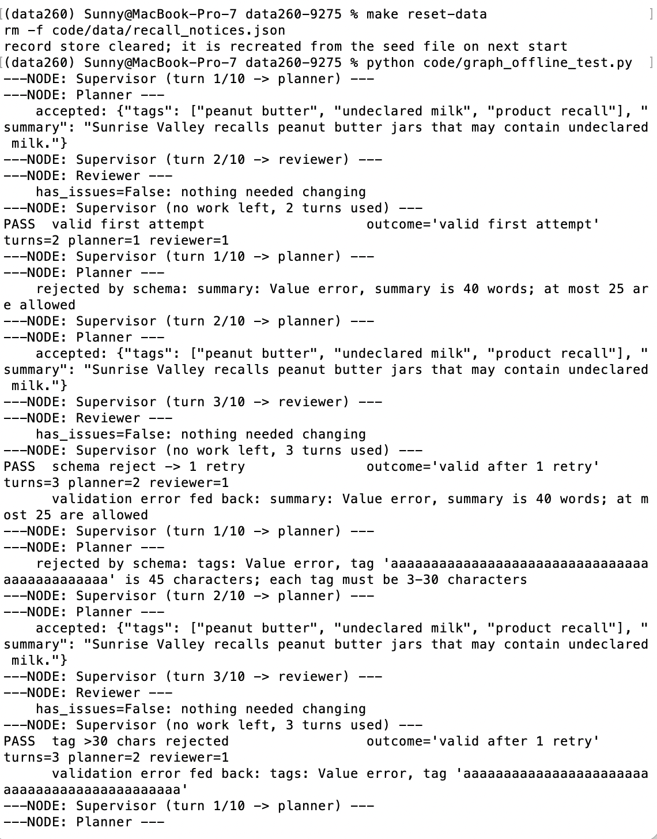

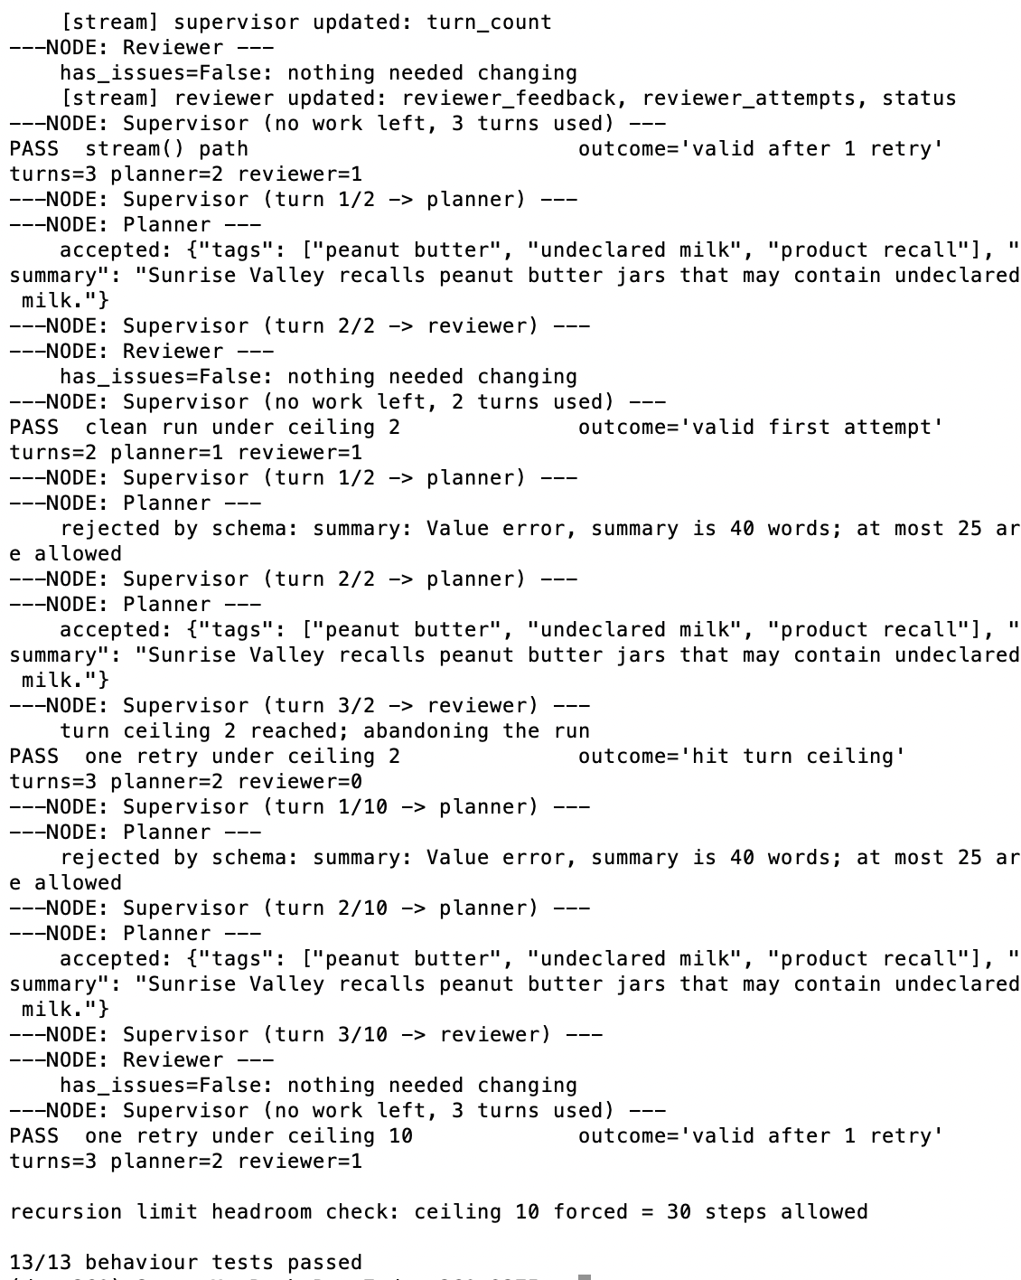

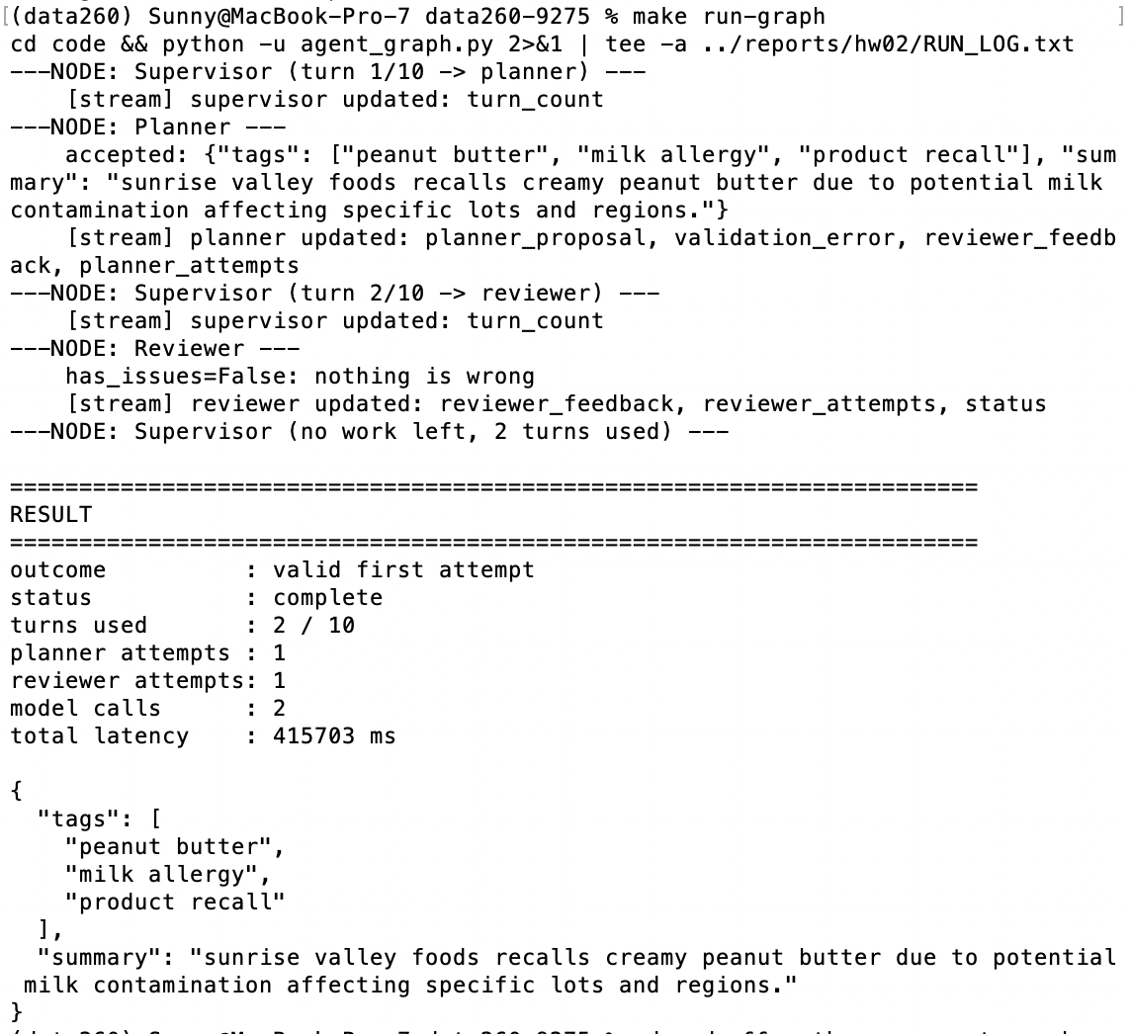

The correction loop
The assignment asks for the Reviewer to be changed so that it always returns an issue, so the graph can be watched sending the task back to the Planner. I did this with a command-line flag instead of editing reviewer_node. If I edit the code by hand I have to remember to undo it, and any run done before undoing it is wrong without any warning. A flag can be run again by anyone and it leaves the normal path alone.
code/agent_graph.py — reviewer_node
def reviewer_node(state: AgentState) -> Dict[str, Any]:
"""Check the validated proposal against the source text.

Part 3 Step 6 asks for the correction loop to be demonstrated by making the
Reviewer always complain. That is the --force-reviewer-issues flag rather
than an edit to this function, so the loop test is reproducible and the
normal path is never left modified by accident.
"""
print("---NODE: Reviewer ---")
attempts = state.get("reviewer_attempts", 0) + 1
history = list(state.get("history", []))

if state.get("force_reviewer_issues"):
feedback = {
"has_issues": True,
"issues": "forced rejection for the loop test (--force-reviewer-issues)",
"forced": True,
}
history.append(
{"node": "reviewer", "attempt": attempts, "turn": state.get("turn_count", 0),
"forced": True, "has_issues": True}
)
print(" forced issue; sending the task back to the Planner")
return {"reviewer_feedback": feedback, "reviewer_attempts": attempts, "history": history}

client: ModelClient = state["llm"]
proposal = state.get("planner_proposal") or {}

response = client.complete(
messages=[
{"role": "system", "content": REVIEWER_SYSTEM},
{
"role": "user",

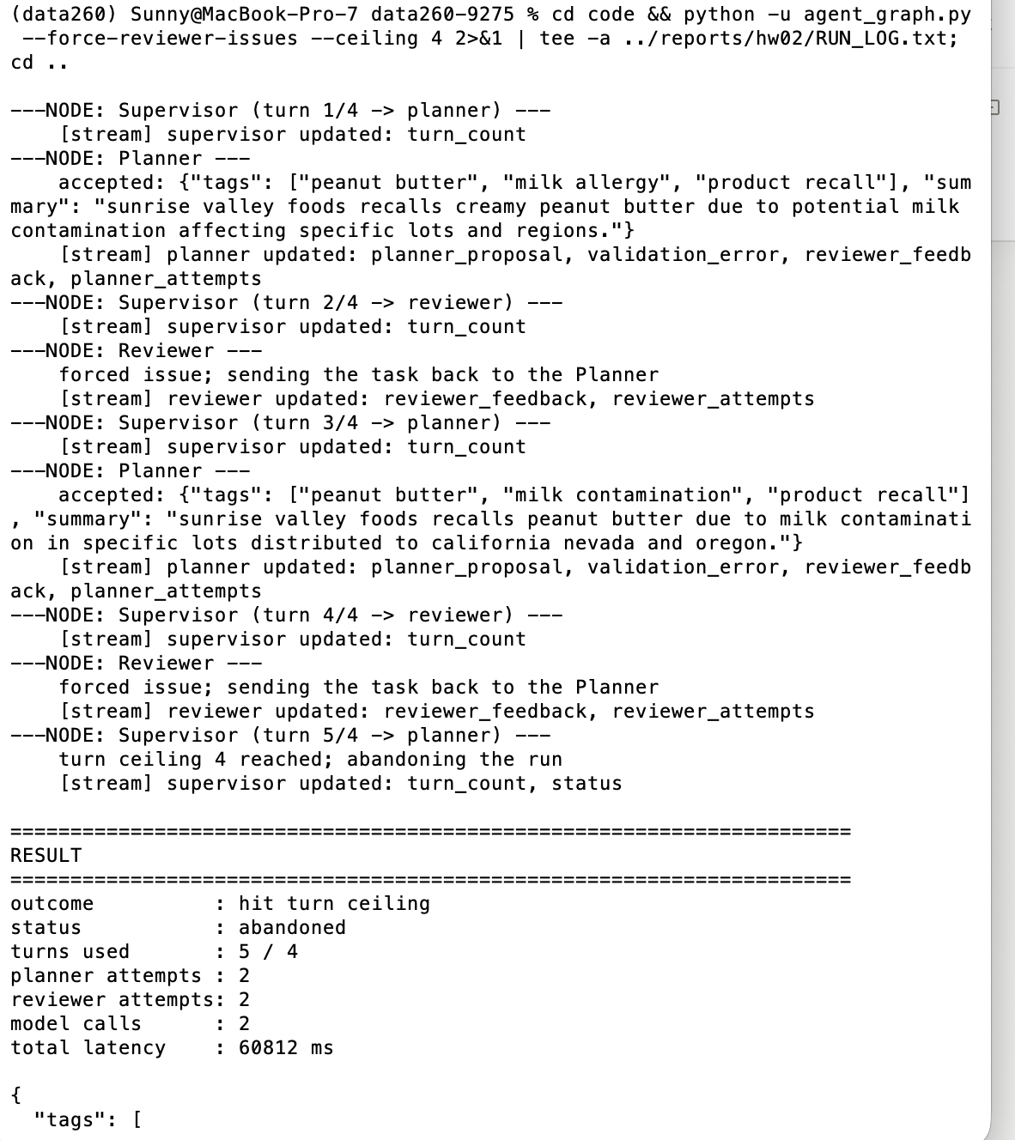

Part 4 — Output schema and loop safety

4.1 Validating the Planner’s output with Pydantic
The contract is exactly three string tags, each 3–30 characters, and a summary of at most 25 words.
code/agent_graph.py
class PlannerOutput(BaseModel):
"""What the Planner must produce for the run to continue.

The JSON *shape* is already enforced by Ollama's `format` parameter. What
that cannot express is the semantic part of the contract: how long a tag
may be and how many words a summary may contain. Those are the two rules
below, and they are the ones that actually fail in practice.
"""

tags: List[str] = Field(min_length=TAG_COUNT, max_length=TAG_COUNT)
summary: str

@field_validator("tags")
@classmethod
def _tag_lengths(cls, tags: List[str]) -> List[str]:
for tag in tags:
if not isinstance(tag, str):
raise ValueError(f"tag {tag!r} is not a string")
if not (TAG_MIN_CHARS <= len(tag) <= TAG_MAX_CHARS):
raise ValueError(
f"tag {tag!r} is {len(tag)} characters; each tag must be "
f"{TAG_MIN_CHARS}-{TAG_MAX_CHARS} characters"
)
return tags

@field_validator("summary")
@classmethod
def _summary_words(cls, summary: str) -> str:
words = len(summary.split())
if words > MAX_SUMMARY_WORDS:
raise ValueError(
f"summary is {words} words; at most {MAX_SUMMARY_WORDS} are allowed"
)
if words == 0:
raise ValueError("summary is empty")
return summary

This layer is not a duplicate of the JSON schema that is already sent to Ollama. The format parameter guarantees that the reply parses and has exactly three string tags. It cannot say “each tag is 3 to 30 characters” or “the summary is at most 25 words”. Every rejection recorded in this homework was a length violation that the JSON schema had already accepted.

4.2 Feeding the validation error back
A rejected proposal never reaches the Reviewer. The Planner is told what was wrong and tries again. The feedback is the only thing that changes between attempts.
code/agent_graph.py — the gate
try:
validated = PlannerOutput(**raw)
except ValidationError as err:
message = format_validation_error(err)
entry.update({"valid": False, "error": message, "raw": raw})
history.append(entry)
print(f" rejected by schema: {message}")
return {
"planner_proposal": None,
"validation_error": message,
"reviewer_feedback": None,
"planner_attempts": attempts,
"history": history,
}

proposal = validated.model_dump()

code/agent_graph.py — the feedback on the next attempt
attempts = state.get("planner_attempts", 0) + 1
history = list(state.get("history", []))

user_parts = [build_input_block(state)]

if state.get("validation_error"):
# Part 4.2 - feed the validation error back to the Planner.
user_parts.append(
"YOUR PREVIOUS ANSWER WAS REJECTED BY THE OUTPUT VALIDATOR:\n"
f"{state['validation_error']}\n"
"Fix exactly that problem and answer again."
)
elif state.get("reviewer_feedback", {}) and state["reviewer_feedback"].get("has_issues"):
user_parts.append(
"A REVIEWER REJECTED YOUR PREVIOUS ANSWER:\n"
f"previous: {json.dumps(state.get('planner_proposal'), ensure_ascii=False)}\n"
f"reviewer said: {state['reviewer_feedback'].get('issues', '')}\n"
"Address that and answer again."
)

code/agent_graph.py — how a finished run is classified
def classify(state: Dict[str, Any]) -> str:
"""Part 4.3 - the four outcome buckets."""
if state.get("status") != "complete":
return "hit turn ceiling"
retries = max(0, int(state.get("planner_attempts", 1)) - 1)
if retries == 0:
return "valid first attempt"
if retries == 1:
return "valid after 1 retry"
return "valid after 2+ retries"

4.3 Thirty runs on one frozen input
The input was written to reports/hw02/cases/schema_input.json before the experiment and was not edited afterwards. It is the same recall notice used in the Homework 1 non-determinism experiment, so the two homeworks measure different things on the same text. Model qwen3:8b, temperature 0.0, turn ceiling 10.
Outcome over 30 runs | Count | Mean latency (ms)
Valid first attempt | 30 | 17,594
Valid after 1 retry | 0 | —
Valid after 2+ retries | 0 | —
Hit turn ceiling | 0 | —

Latency p50 15,224 ms, p95 33,030 ms, min 9,027 ms, max 53,767 ms. Every run cost exactly 2 turns and 2 model calls.
The retry path never fired. This is a result, not a missing one. The margins show why. Summaries came in at 17 to 18 words against a limit of 25, and tags at 12 to 14 characters against a limit of 30. The gate was nowhere near binding on well-formed input.

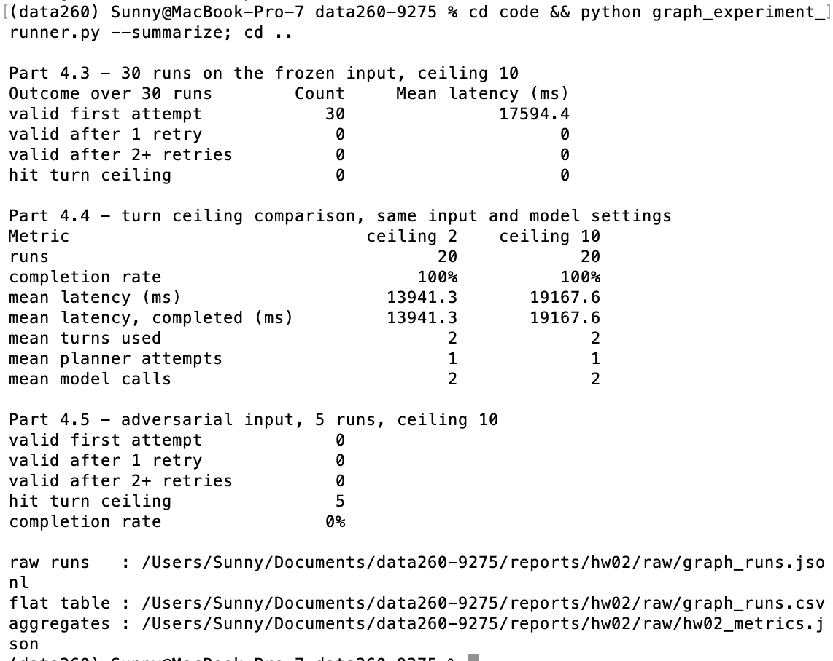

4.4 Turn ceiling 2 versus 10
Same frozen input, same model, same temperature, 20 runs each.
Metric | Ceiling 2 | Ceiling 10
Completion rate | 100% (20/20) | 100% (20/20)
Mean latency (ms) | 13,941 | 19,168
Median latency (ms) | 11,163 | 14,618
p95 latency (ms) | 19,343 | 35,838
Mean turns used | 2.0 | 2.0
Mean planner attempts | 1.0 | 1.0
Mean model calls | 2.0 | 2.0
Input / output tokens | 12,760 / 1,300 | 12,760 / 1,300

The latency difference is not caused by the ceiling. Both arms ran exactly two turns and two model calls per run, and used the same number of tokens down to the byte. A ceiling only does something when a run tries to go past it, and no run did. The 5.2 second gap in the means is machine noise on an 8 GB laptop. The same effect was recorded in Homework 1, where runs 10 to 15 of one batch slowed from 12 s to 20 to 36 s under memory pressure while the work being done did not change. Reading this gap as “ceiling 2 is faster” would be a misreading of this data.

Which one to deploy: ceiling 2
- On well-formed input the two are the same: same completion rate, same turns, same token cost.
- They differ only on input that fails, and there the difference is the cost of failing. Under ceiling 10 the adversarial case took 11 turns, 10 model calls and 95 seconds to reach the same outcome that ceiling 2 reaches in 3 turns and 2 model calls. I measured this directly on the same input. Ceiling 2 abandoned it in 38.1 s with a warm model. The first run of the session, which had to load the model, took 67.5 s.
- So the choice is not between succeeding and failing. It is between failing fast and failing slow. Five times the model calls on every bad input buys nothing that this data can show.
There is a limit to this recommendation. The first-attempt rate was 100% over 30 runs, so this experiment never saw a run that a retry would have saved. It shows that retries are not needed here. It does not show that they are never needed. Ceiling 2 allows exactly one Planner attempt and one review. If some later input turns out to need one correction, ceiling 2 would throw away work that ceiling 3 or 4 would keep. Before generalising, 4.3 should be repeated on more inputs.

4.5 The adversarial input
reports/hw02/cases/adversarial_input.json looks like a real recall notice. What makes it hard is deliberate. The important product terms are long hyphenated words. Hydrolyzed-Vegetable-Protein-Seasoning-Blend is 44 characters. The notice also carries three separate hazards, two firms, four lot ranges and six states, so any summary that stays true to the content runs past 25 words.
Outcome over 5 runs | Count | Mean cost
Valid first attempt | 0 | —
Valid after 1 retry | 0 | —
Valid after 2+ retries | 0 | —
Hit turn ceiling | 5 | 11 turns, 10 calls, 95,057 ms

Why it causes trouble
Not randomness. All five runs produced the same trace, which is what made the cause findable. Run 1, shortened:
Step | What happened
P1 | tags [hydrolyzedvegetableprotein, listeriamonocytogenes, stainlesssteelwire] — VALID
R1 | "stainlesssteelwire is not specific enough, should be stainlesssteelwirefragments"
P2 | complies — VALID
R2 | "hydrolyzedvegetableprotein is not specific enough"
P3 | lengthens to hydrolyzedvegetableproteinseasoning, 35 chars — REJECTED by the validator
P4 | backs off to 26 chars — VALID
R3 | "should be hydrolyzed-vegetable-protein-seasoning-blend" — that string is 44 chars
P5 | complies — REJECTED by the validator
P6 | backs off again — VALID
R4 | "product-recall is too generic" … and so on until turn 11

The Planner is not failing. It produced a valid proposal on four of its six attempts. The run never ends because the Reviewer keeps asking for a tag that the validator does not allow. REVIEWER_SYSTEM asks for tags that are specific rather than generic and says nothing about the 3 to 30 character limit. For a product whose specific name is 44 characters, those two requirements contradict each other. No output can satisfy both.
This is a livelock, not a deadlock. Work is happening on every step, but no step gets the run closer to finishing. The turn ceiling is the only thing that stops it. Without it, this input would loop forever on a notice that a person would call ordinary.

One fix
Give the Reviewer the same output contract that the validator enforces. REVIEWER_SYSTEM should state the 3 to 30 character tag limit and the 25 word summary limit, and should reject a proposal only for a problem that can be fixed inside those limits. Then the contradiction cannot be written down. A Reviewer that knows about the 30 character limit cannot ask for a 44 character tag.
That is one change to a prompt and it deals with the cause. Raising the ceiling would only make the loop longer. Lowering it would hide the loop without explaining it. A stronger version of the same fix is to check the Reviewer's suggestion against PlannerOutput before it is sent back, so a suggestion that could not pass never reaches the Planner. This is the same idea as the deterministic Finalizer in Homework 1: put the hard contract in code, not in a prompt.

Two findings worth recording

Refactoring the Reviewer changed the published output
Same input, same model, same temperature. Homework 1 published [peanut butter, milk contamination, product recall]. Homework 2 publishes [peanut butter, milk allergy, product recall] in all 70 frozen-input runs.
Nothing about the model changed. In Homework 1 the Reviewer returned corrected tags and rewrote milk allergy into milk contamination in 37 of 40 runs. In Homework 2 the Reviewer only judges. It returns has_issues and a sentence, and it reported no issue in 70 of 70 runs. So the wording the Planner produced is what gets published.
This matters because of which field it is. The Homework 1 analysis picked out this exact tag as the safety-relevant one. If the tag decides which subscribers get an allergen alert, milk allergy and milk contamination go to different lists. I changed the architecture for control-flow reasons and it moved a safety-critical value with no warning.

Temperature 0.0 is still not a determinism guarantee
Of 70 frozen-input runs, 69 produced the same summary. The one that differed was the first run of the session, on a cold model. Tag sets were identical in all 70. This matches the Homework 1 finding on a larger sample. What makes an output reproducible is constraining its shape. Short fields with limits are much more stable than free prose.

Self-check
make verify-hw02 starts the FastAPI server on PORT_BASE against a temporary record store, so the check never touches code/data/recall_notices.json or any application file. It then does create, update, delete and search over HTTP, runs the offline graph test, runs one live graph with a 240-second timeout, and re-checks the recorded Part 4 data against the output contract.
Every check is behavioural. None of them compares model output to a fixed string, because the model does not say the same thing twice. They ask questions that can be counted instead. Exactly three tags? Every tag 3 to 30 characters? Did the request succeed? Did the process exit? Results are written to reports/hw02/verification.json.
