HW1
Xu Wang
018319275
- (+1) Create Snowflake Account via Snowflake Academia as instructed
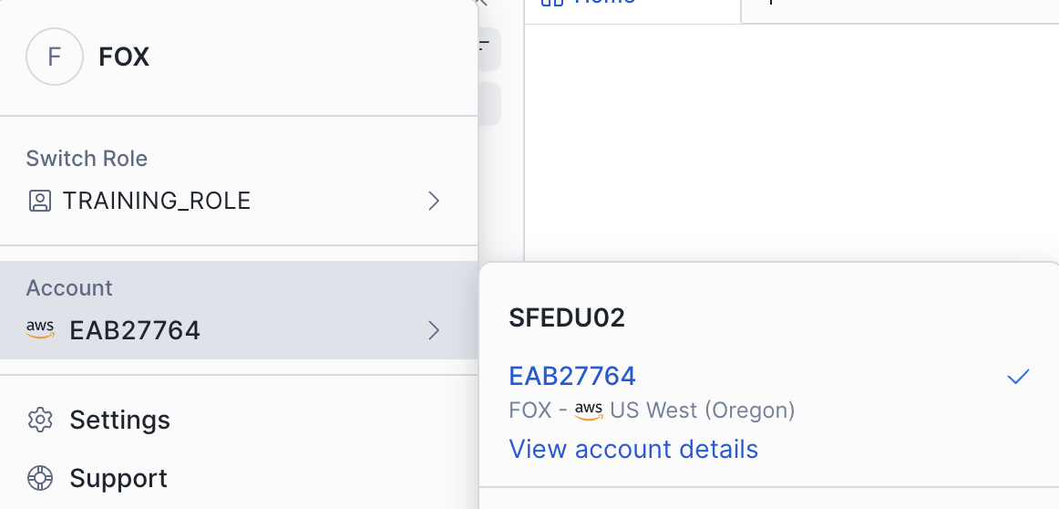

- (+1) Create Schema 'schema_car_sales' under your Database. Use the warehouse of size XSMALL.
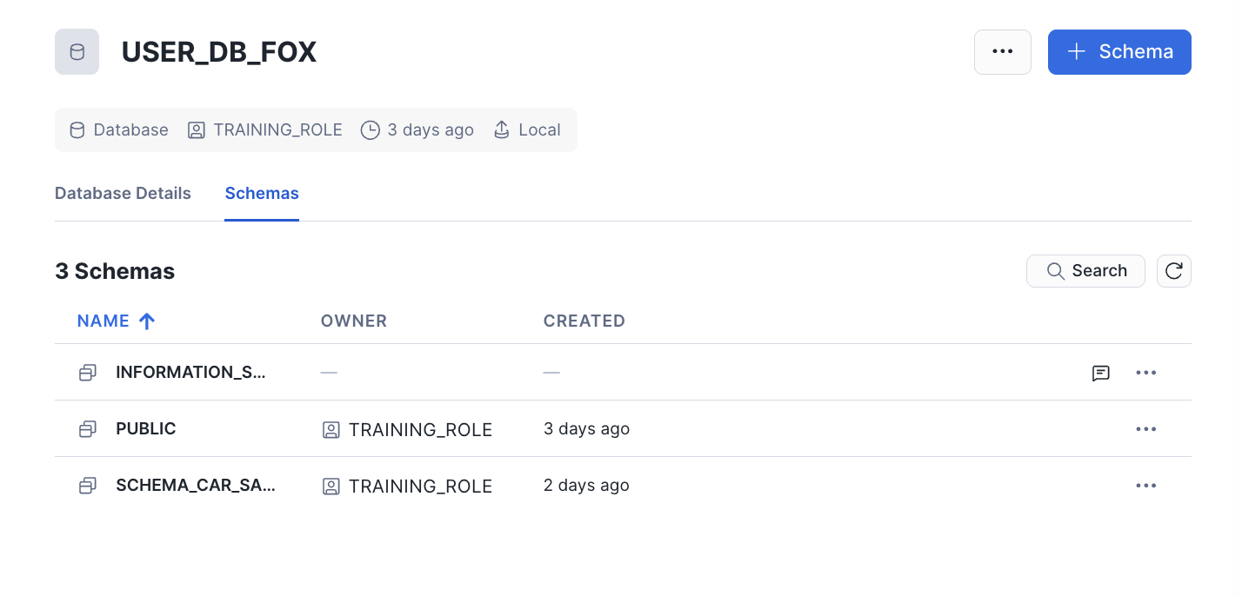

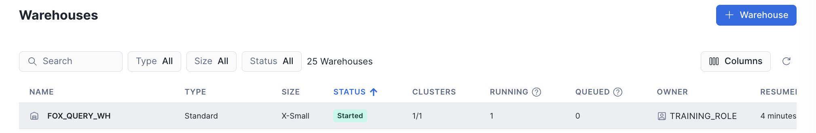
- (+1) Create Stage 'stage_car_sales' in Snowflake and load the csv.
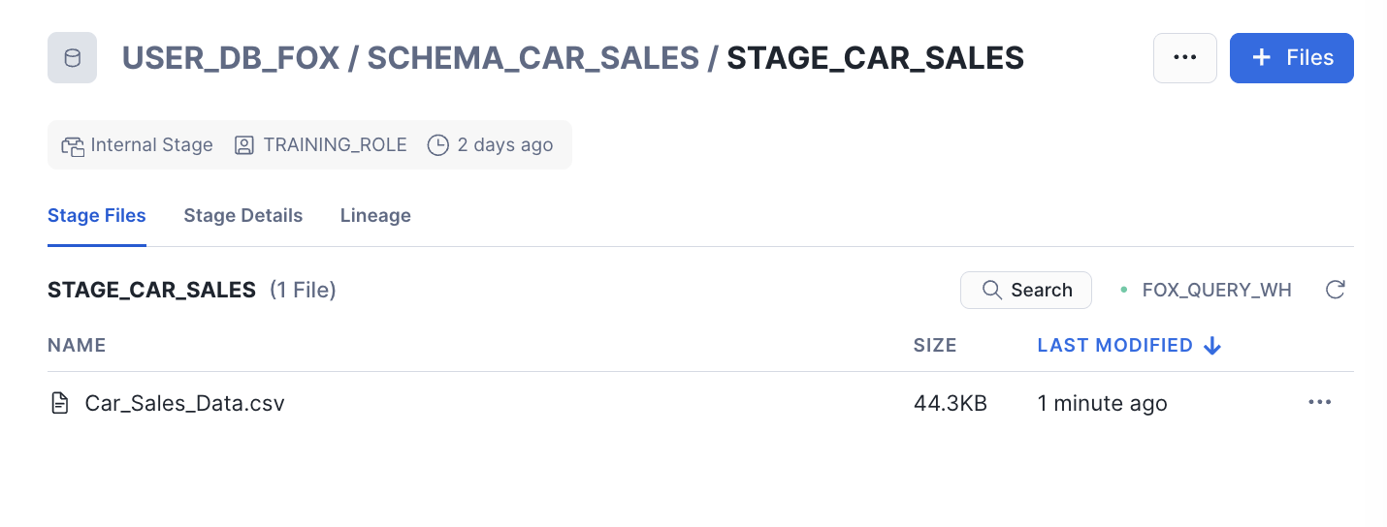
- (+2) Create file format and Load Data into the 'data_car_sales' table (COPY INTO OR UI LOAD).
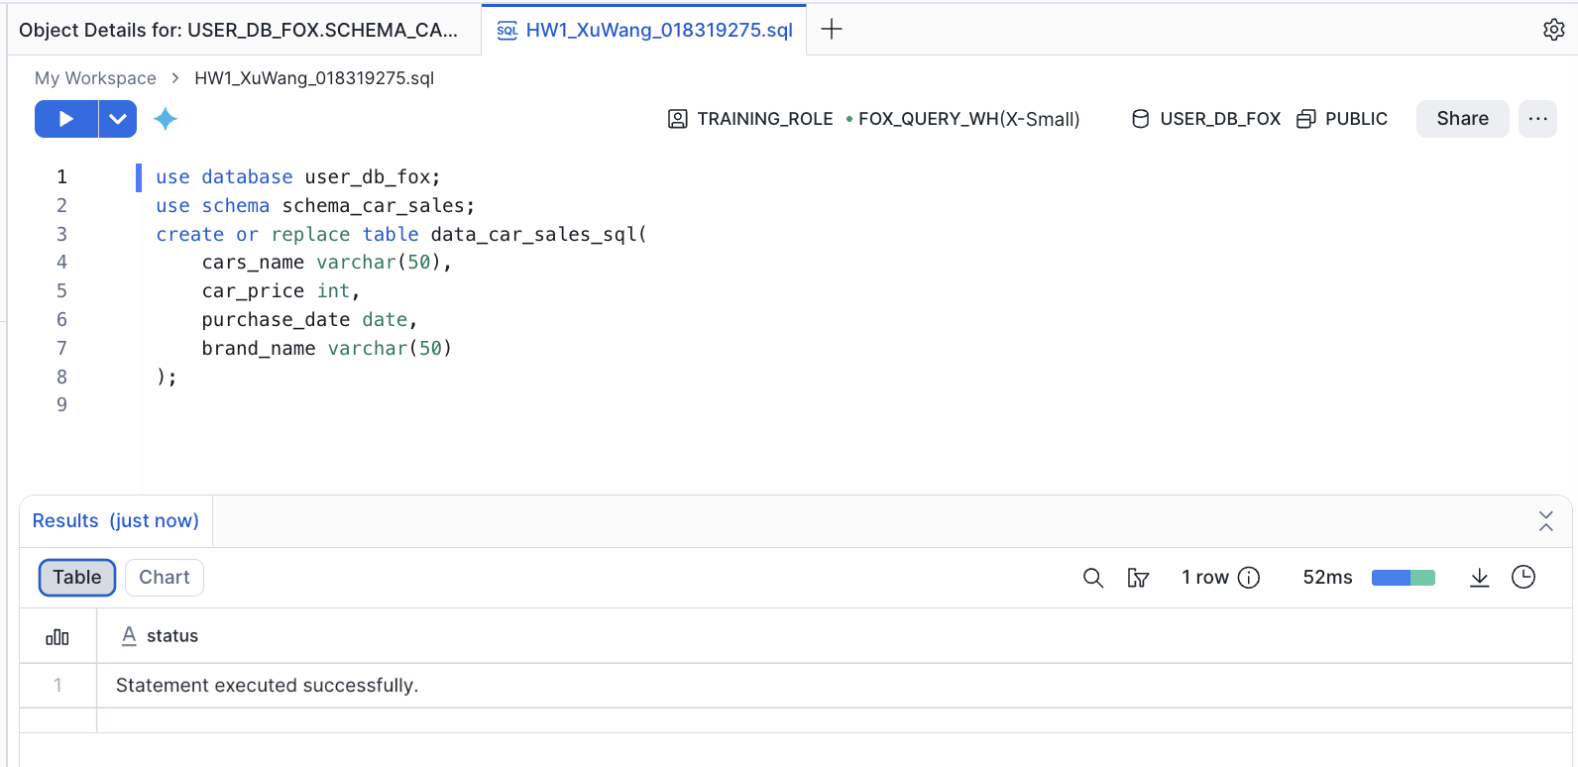
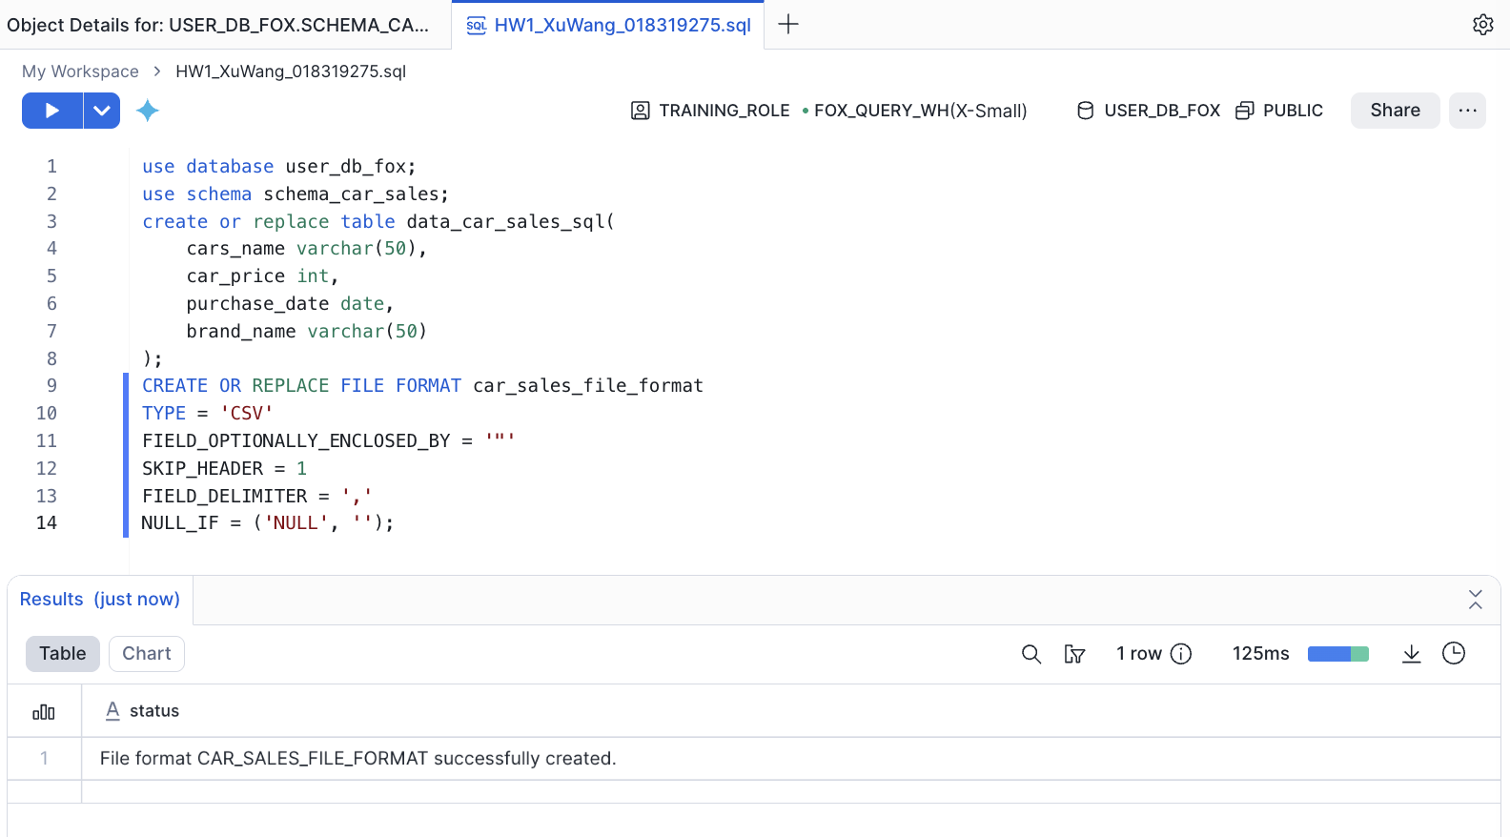
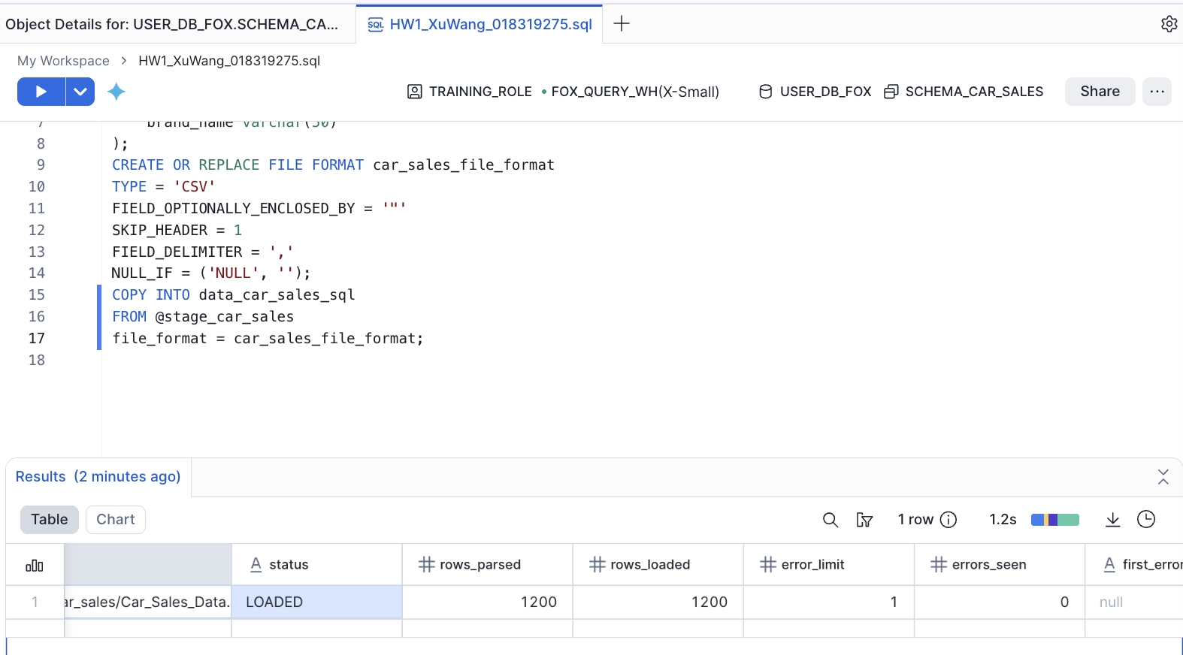

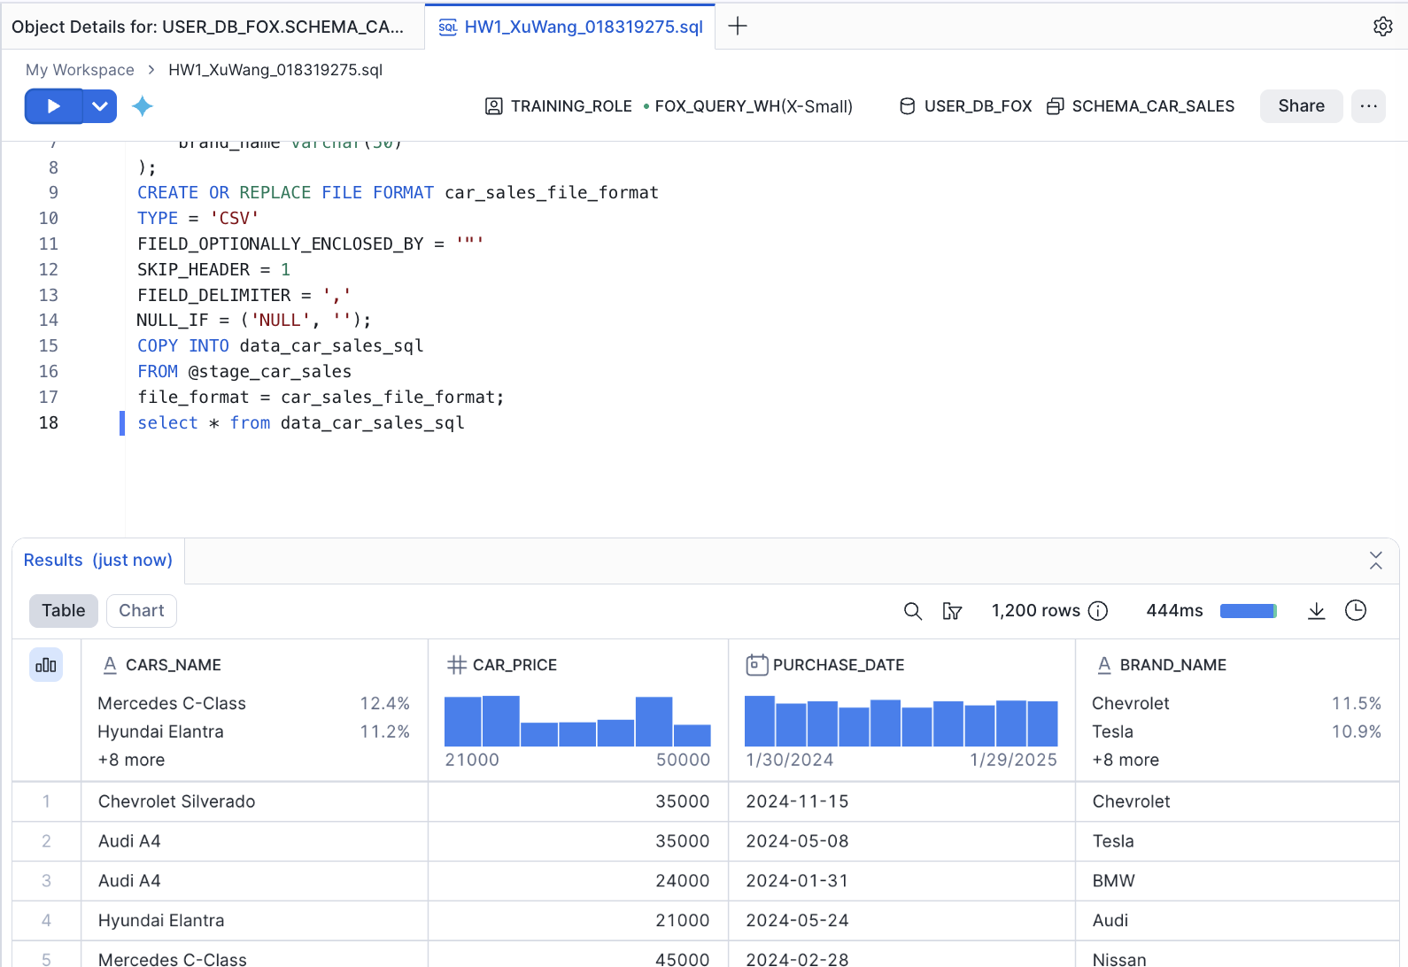
- (+6) Write an SQL queries for each that shows the following insights
  - The average number of cars sold per month in 2024 in ascending order of the month (ordered Jan -> Dec).
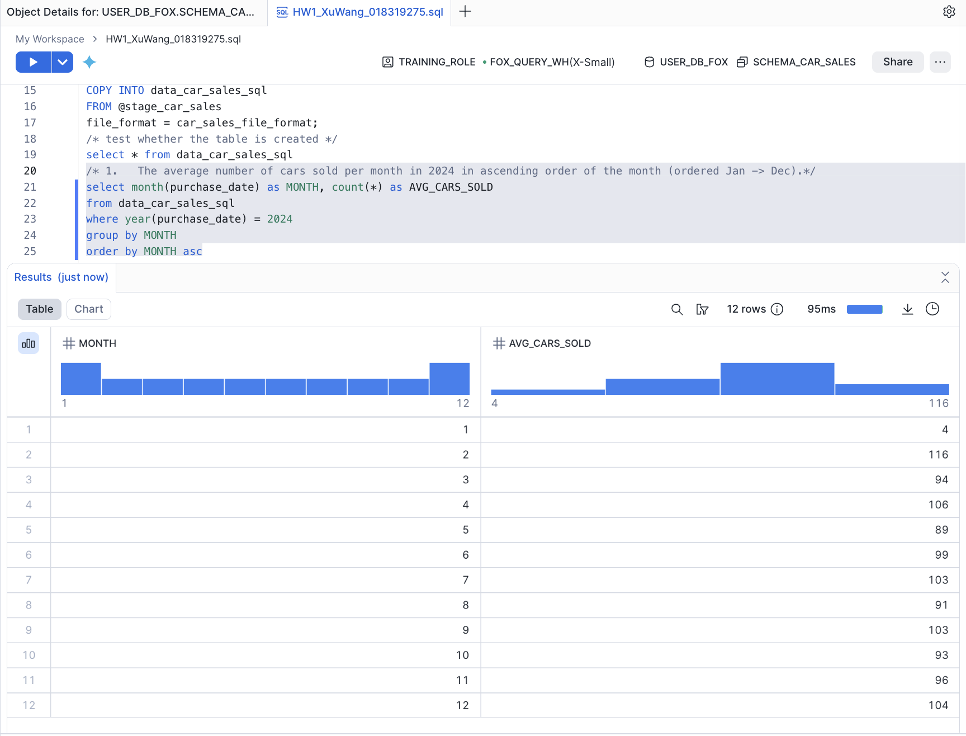

  - The top 5 best-selling cars along with the count in 2024.
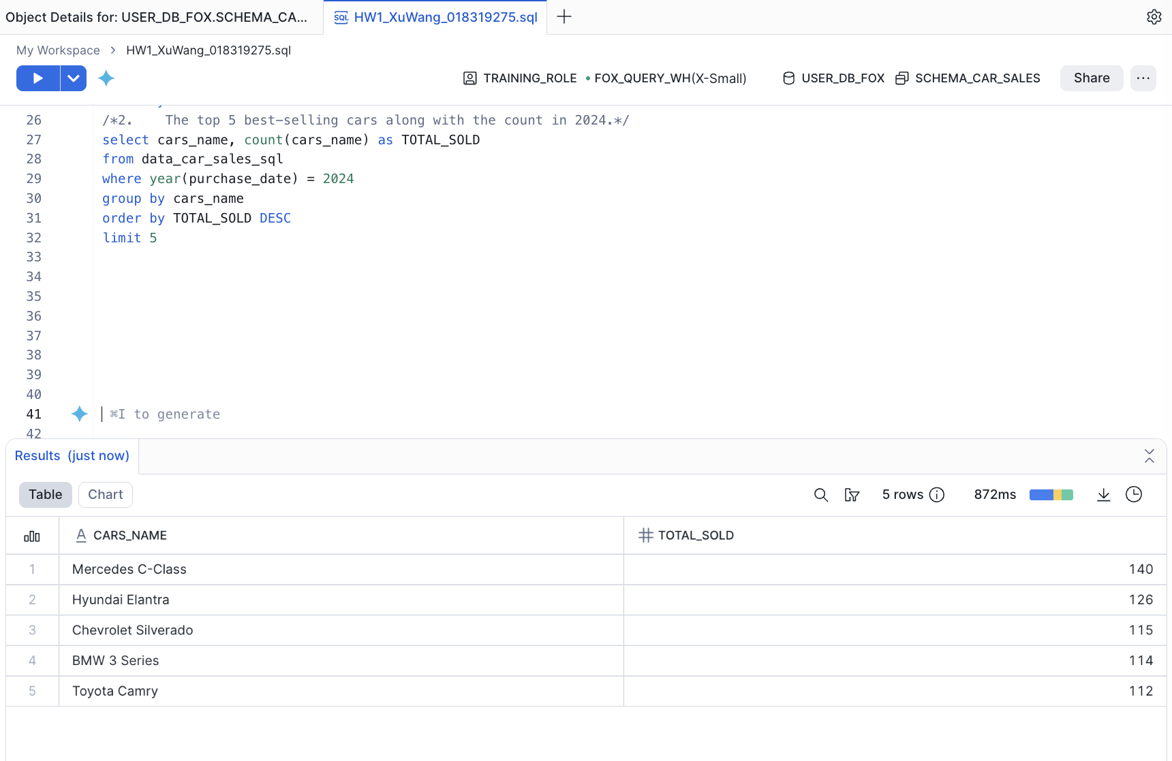
  - The top 3 least-selling cars along with the count in 2024.

