Homework4
Xu Wang
018319275

- (+2) Create a Table Weather_DATA under raw schema with SanJose.csv

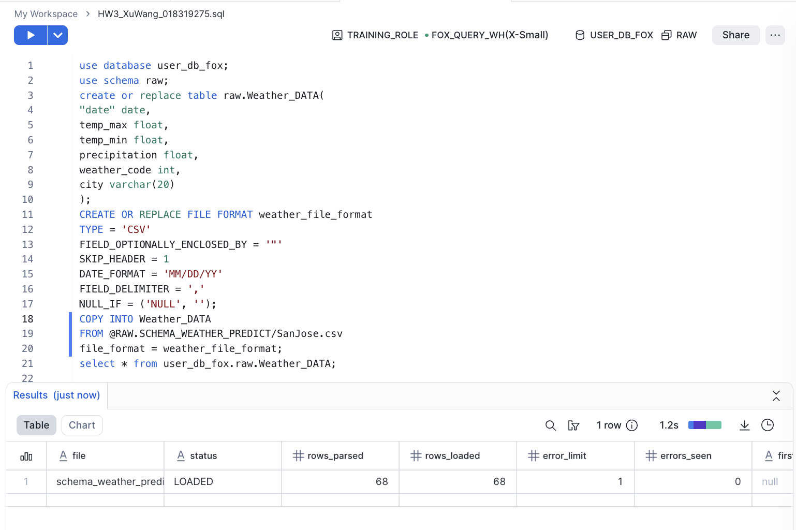
- (+3) Create a view to forecast city of 'SanJose'
- temp_max should be the forecasting target
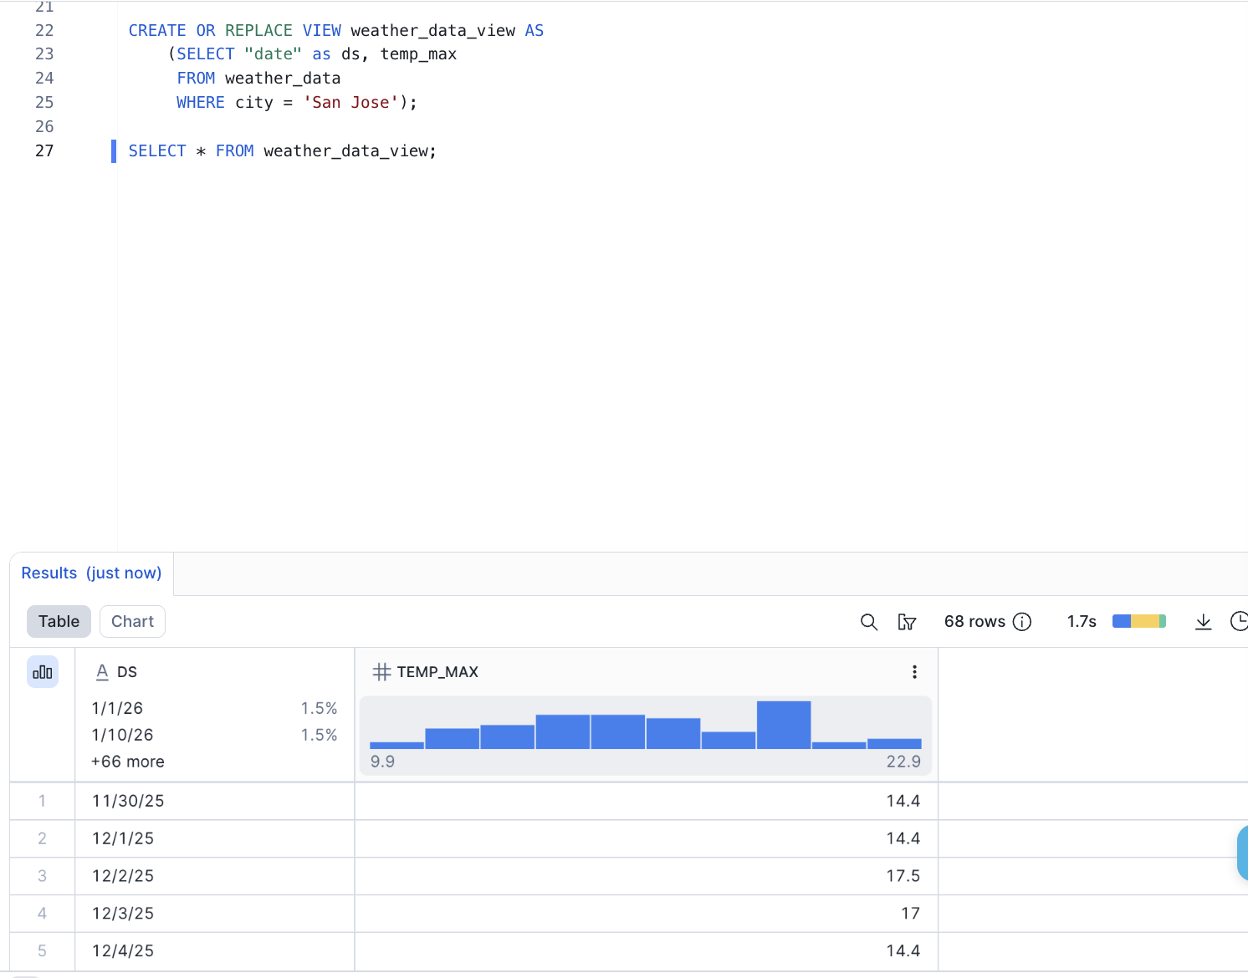

- (+3) Create a forecast model ‘weather_temperature’
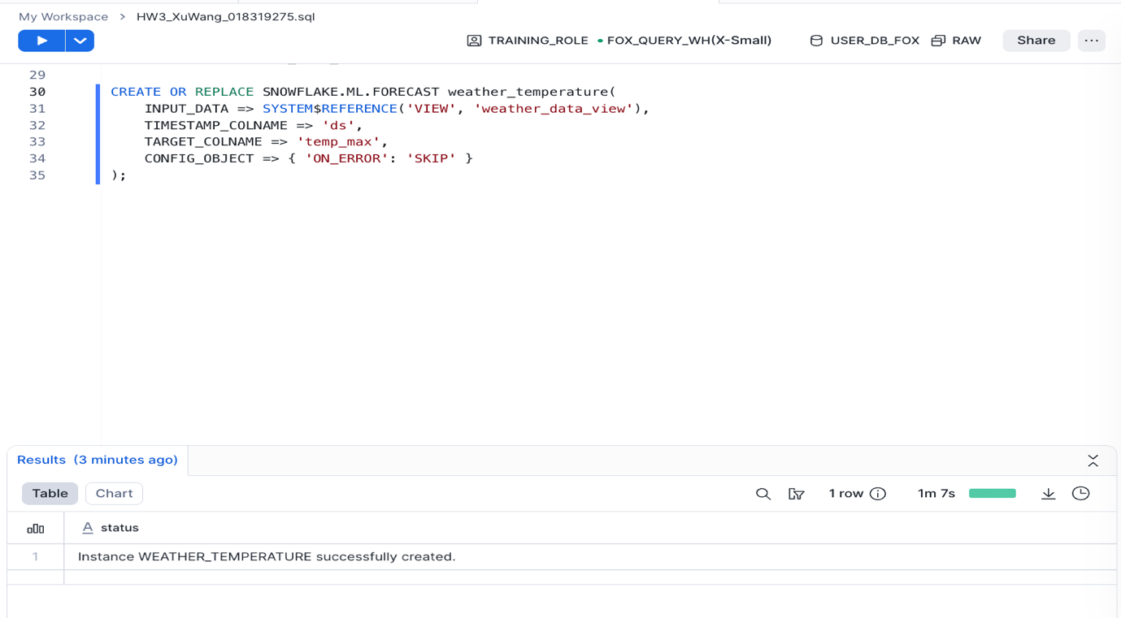
- (+1) Display the Results (historical + predicted together)
- Run the forecast for the next 7days, and display the results together with the historical data in a single query output by using UNION
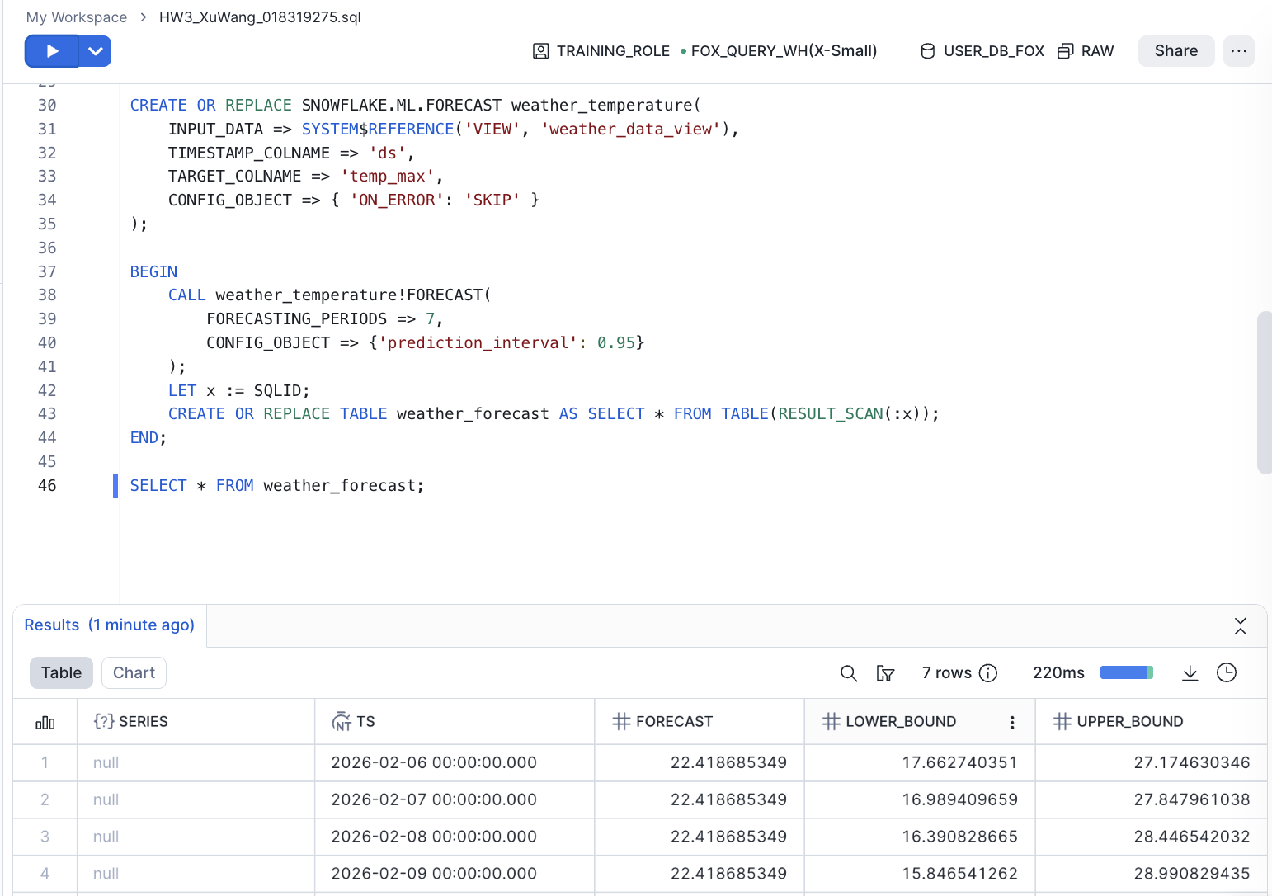
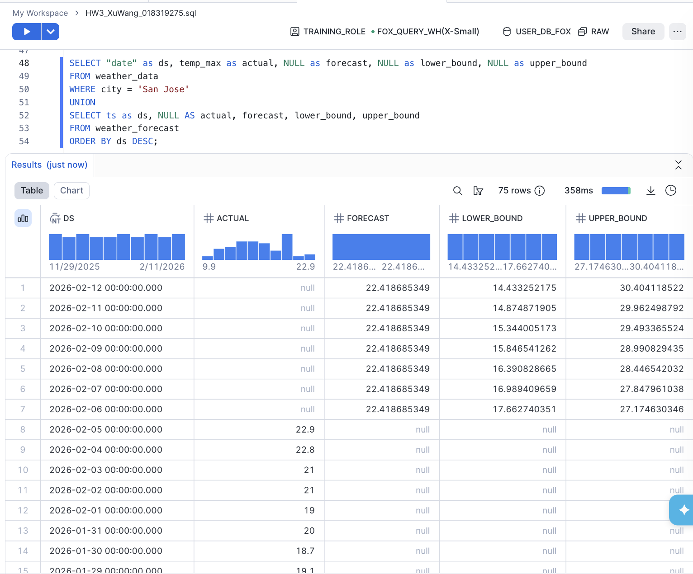
- (+3) Explain your understanding about the Forecasting Process.
The Forecasting process is explained as follows:
- Data preparation: the raw data was correctly interpreted by using a custom FILE_FORMAT to handle the specific date strings (MM/DD/YY);
- Schema Mapping: create a View to map the raw business data into a machine-learning-ready format (ds and target);
- Model Creating: Using SNOWFLAKE.ML.FORECAST to learn and train a model;
- Inference generating: telling the model to predict the next 7 days temperature with CI of 95%, and saving the results to a table weather_forecast；
- Unified reporting: display the results together with the historical data in a single query output by using UNION.

