Homework4
Xu Wang
018319275
Colab link
https://colab.research.google.com/drive/14dVyoBQSS9_yle5LIe8qVAm88ICZ3kj#scrollTo=WGoIMPQMcl_T

- (+1) Pick up a city and get its lat/long
Los Altos Lat：37.3852 Long：-122.1141
- (+1) Secure your Snowflake credentials (don't expose them in the code)
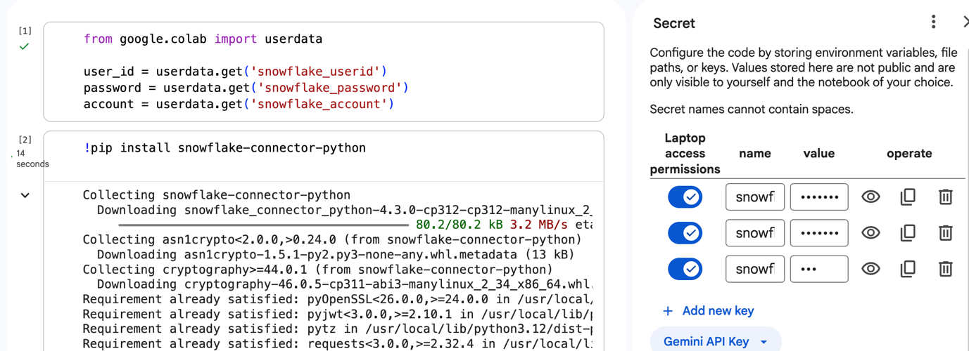
- (+2) Read the last 60 days of the weather info via the API (refer to the code snippetLinks to an external site.)
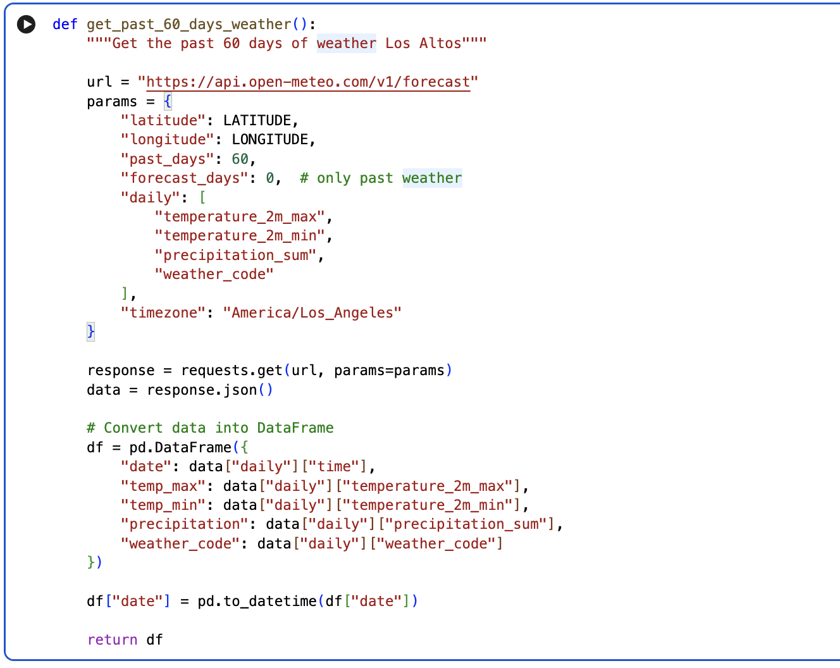
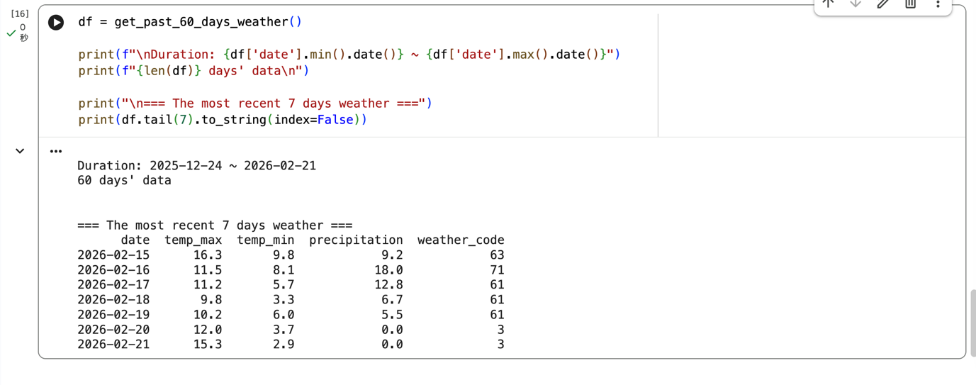
- (+1) Create a table under “raw” schema if it doesn’t exist to capture the info from the API
- latitude, longitude, date, temp_max, temp_min, precipitation, weather_code: latitude, longitude and date should be primary keys (composite key)
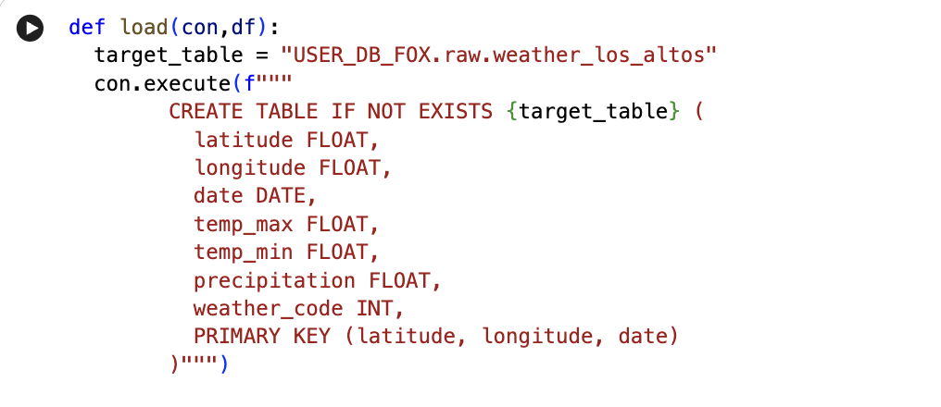
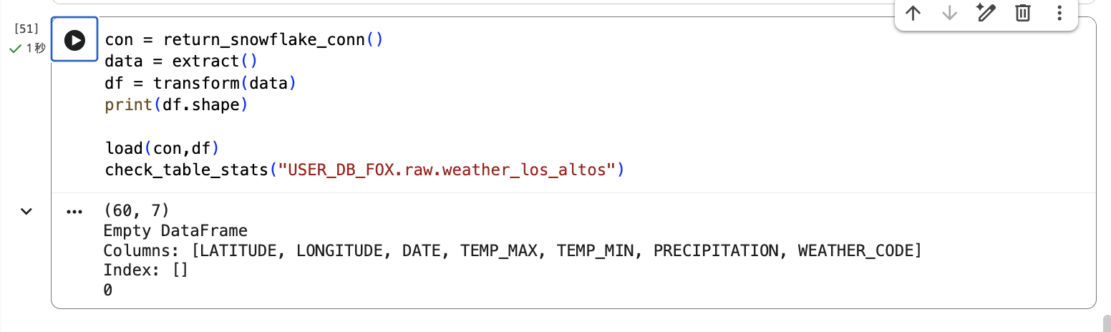
- (+1) Delete all records from the table
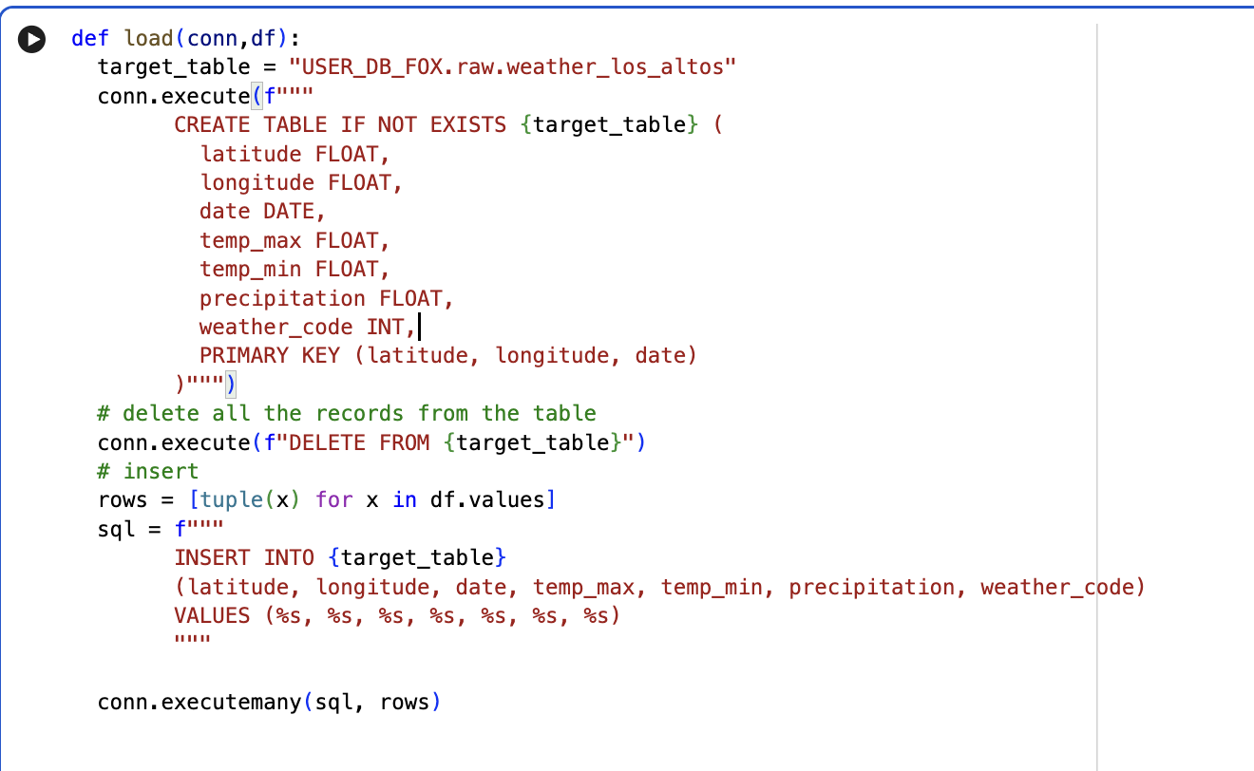
- (+1) Populate the table with the records from step 2 using INSERT SQL
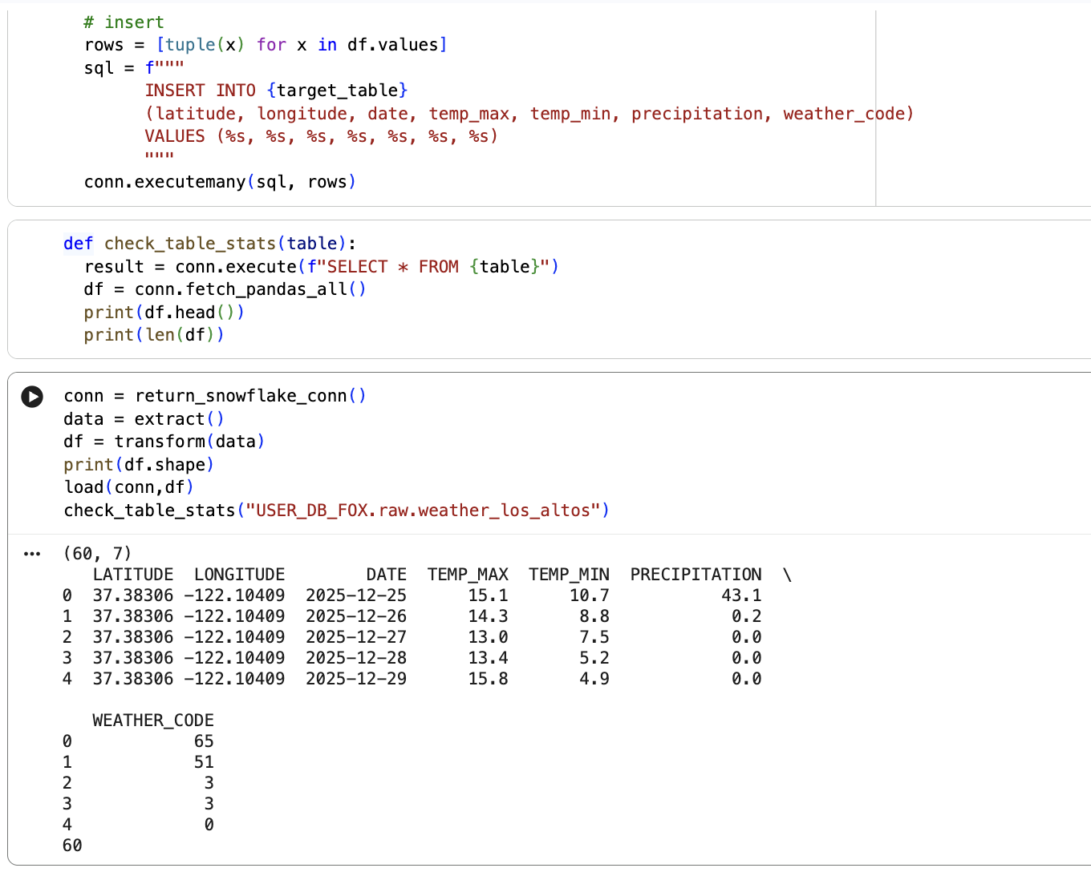
- (+4) Steps 4 and 6 need to be done together
  - Use try/except along with SQL transaction. (use the code hereLinks to an external site. as reference)
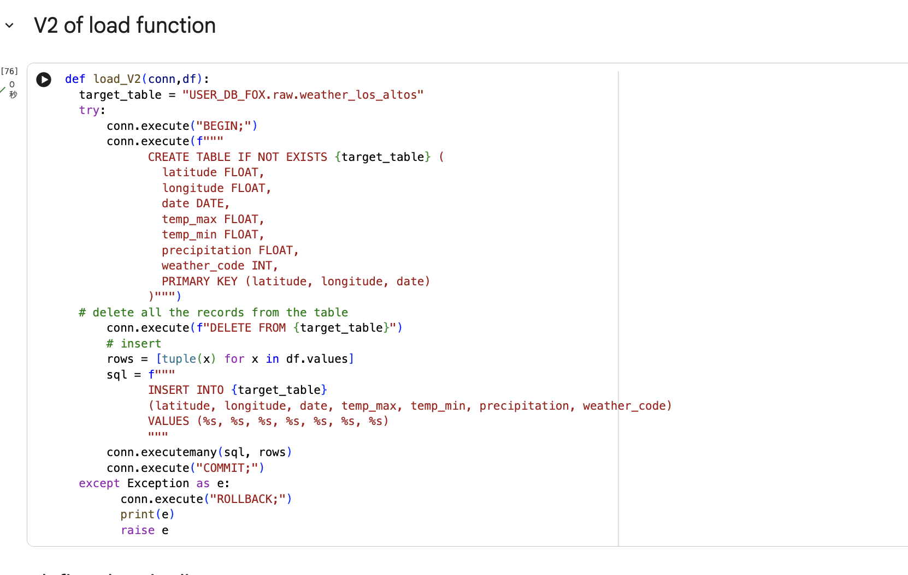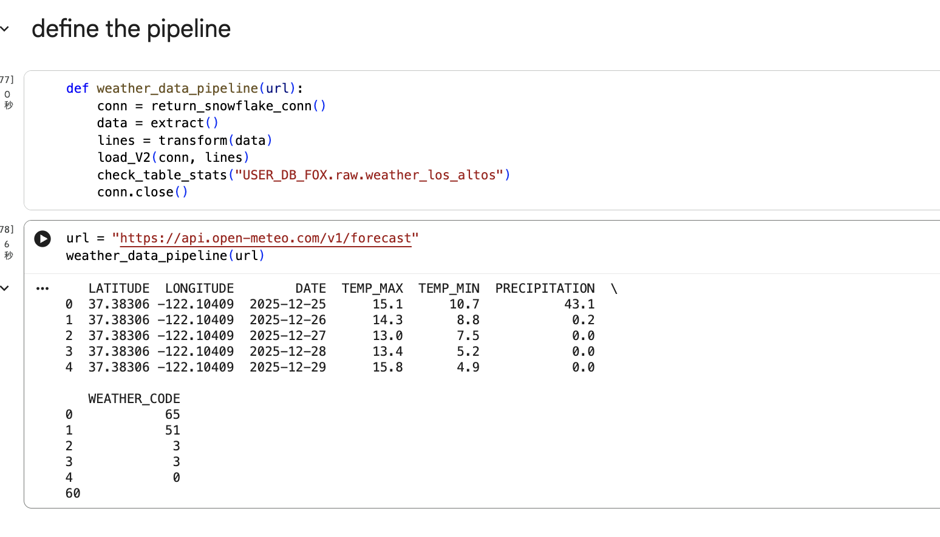
- (+1) Demonstrate your work ensures Idempotency by running your pipeline (from extract to load) twice in a row and checking the number of records (the number needs to remain the same)
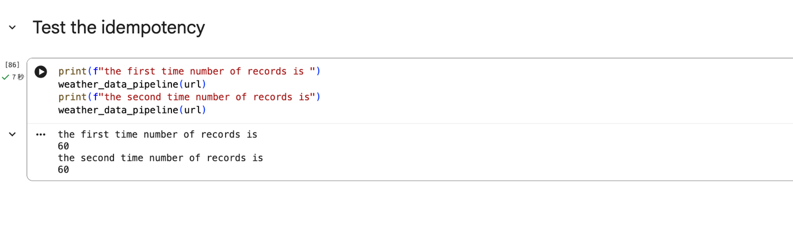
- (+2) Follow today’s demo and capture Docker Desktop screen showing Airflow

