# 问题

## 没有生成图片

ImageEntity imageEntity = new ImageEntity(byteArrayOut.toByteArray(), 300, 300);  
imageEntity.setRowspan(2);  
imageEntity.setColspan(2);

没有设置这个

anchor = new XSSFClientAnchor(10, 10, 1010, 245, (short)cell.getColumnIndex(), cell.getRow().getRowNum(), (short)(cell.getColumnIndex() + colspan - 1), cell.getRow().getRowNum() + rowspan - 1);

后四个参数，前连个表示图片左上角所在的cellNum和 rowNum，后两个参数对应的表示图片右下角所在的cellNum和 rowNum

注意：后四个参数相同不能生成图片

## 生成图片合并单元格了

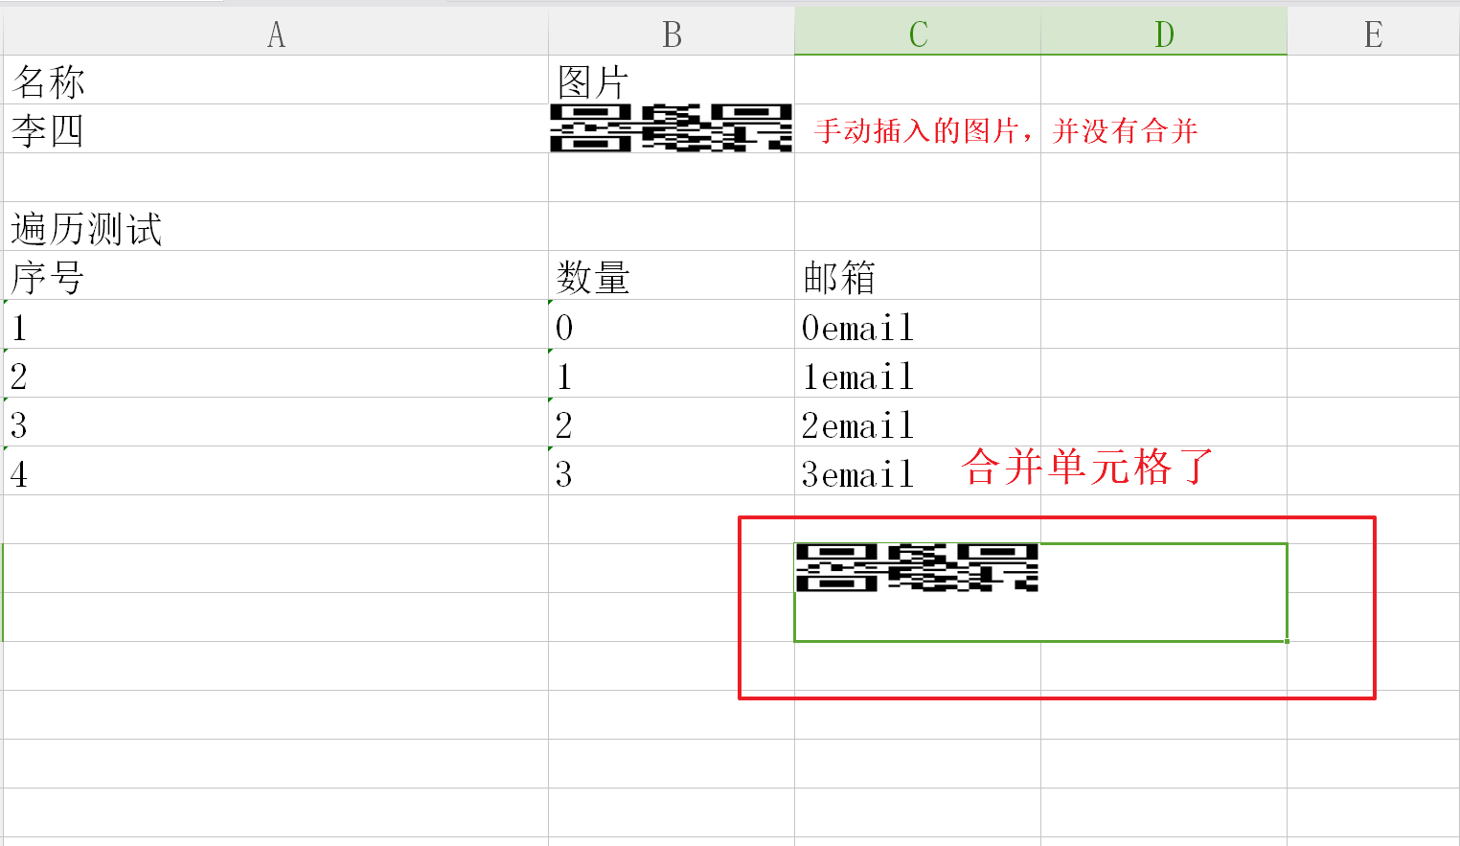

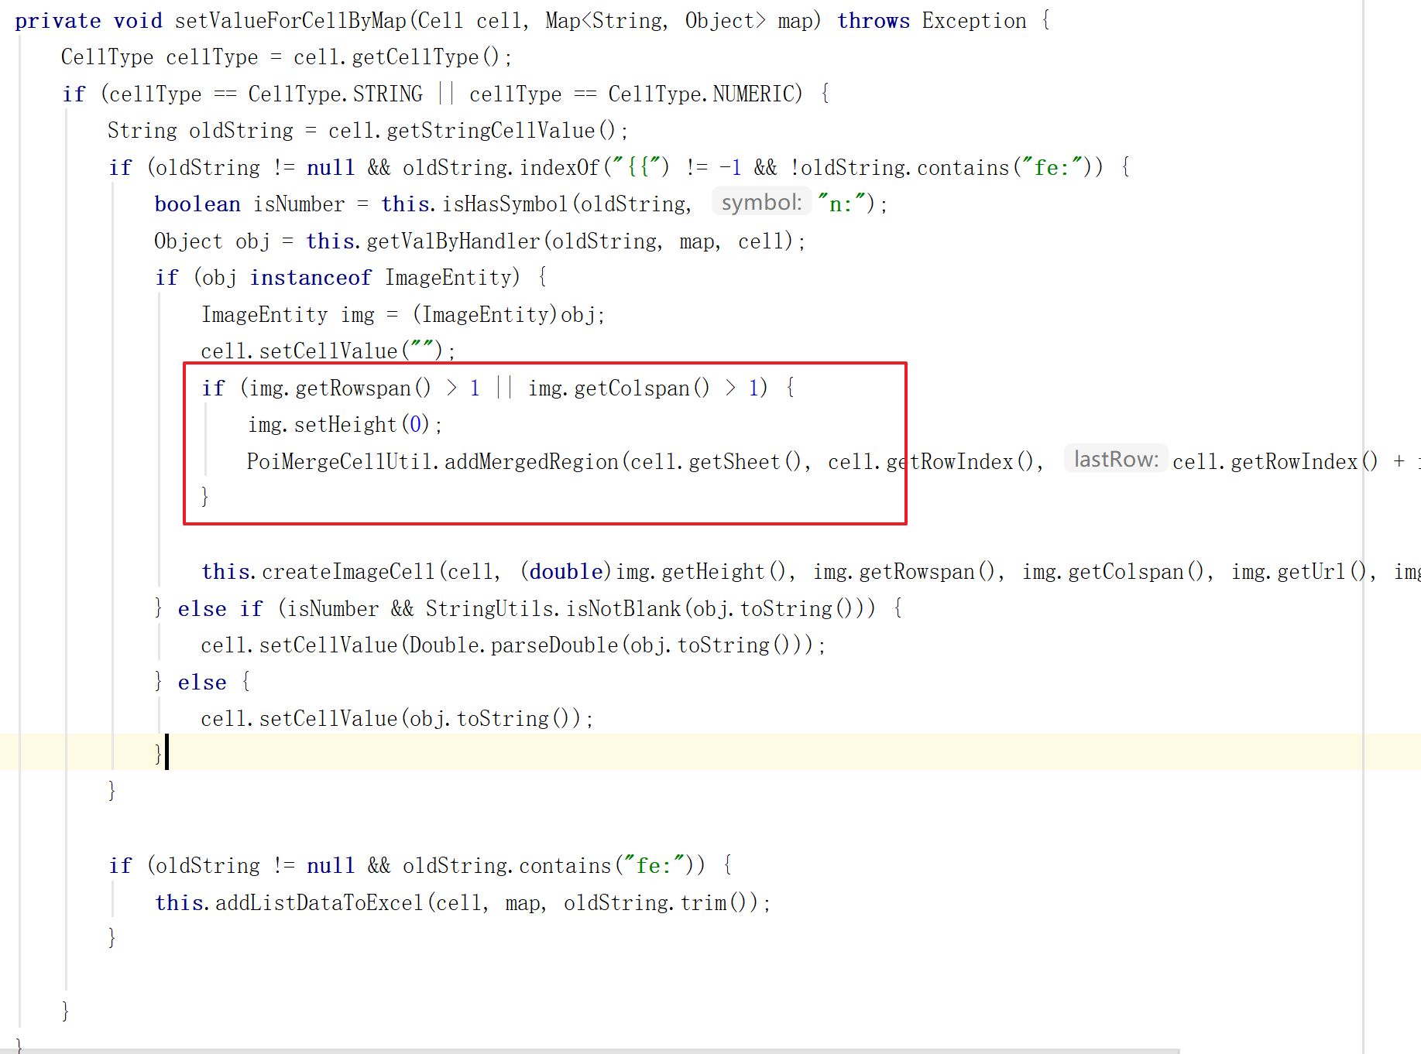

**private void** setValueForCellByMap(Cell cell, Map<String, Object> map) **throws** Exception {  
 CellType cellType = cell.getCellType();  
 **if** (cellType == CellType.STRING || cellType == CellType.NUMERIC) {  
 String oldString = cell.getStringCellValue();  
 **if** (oldString != **null** && oldString.indexOf(**"{{"**) != -1 && !oldString.contains(**"fe:"**)) {  
 **boolean** isNumber = **this**.isHasSymbol(oldString, **"n:"**);  
 Object obj = **this**.getValByHandler(oldString, map, cell);  
 **if** (obj **instanceof** ImageEntity) {  
 ImageEntity img = (ImageEntity)obj;  
 cell.setCellValue(**""**);  
 **if** (img.getRowspan() > 1 || img.getColspan() > 1) {  
 img.setHeight(0);  
 PoiMergeCellUtil.addMergedRegion(cell.getSheet(), cell.getRowIndex(), cell.getRowIndex() + img.getRowspan() - 1, cell.getColumnIndex(), cell.getColumnIndex() + img.getColspan() - 1);  
 }  
  
 **this**.createImageCell(cell, (**double**)img.getHeight(), img.getRowspan(), img.getColspan(), img.getUrl(), img.getData());  
 } **else if** (isNumber && StringUtils.isNotBlank(obj.toString())) {  
 cell.setCellValue(Double.parseDouble(obj.toString()));  
 } **else** {  
 cell.setCellValue(obj.toString());  
 }  
 }  
  
 **if** (oldString != **null** && oldString.contains(**"fe:"**)) {  
 **this**.addListDataToExcel(cell, map, oldString.trim());  
 }  
  
 }  
}