返回值为promise，option选填

(option?: Option) => Promise<TaroGeneral.CallbackResult>
样例：
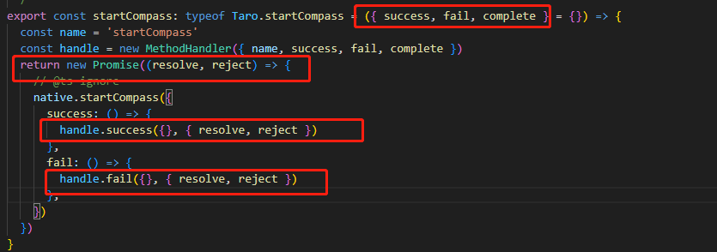

返回值promise,option必填

(option: Option) => Promise<TaroGeneral.CallbackResult>

样例
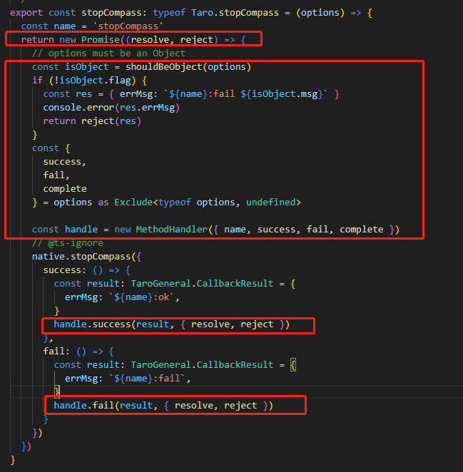

返回值为callback (callback: Callback) => void

样例：
export const onBluetoothAdapterStateChange: typeof Taro.onBluetoothAdapterStateChange = (callback) => {
const name = 'onBluetoothAdapterStateChange'

// callback must be an Function
const isFunction = shouldBeFunction(callback)
if (!isFunction.flag) {
const res = { errMsg: `${name}:fail ${isFunction.msg}` }
console.error(res.errMsg)
return Promise.reject(res)
}
// @ts-ignore
native.onBluetoothAdapterStateChange(callback)
}

返回值类型：() => Result

样例：
