1.import data
Extract the data from the hive database, convert it to CSV, and import it into SAS

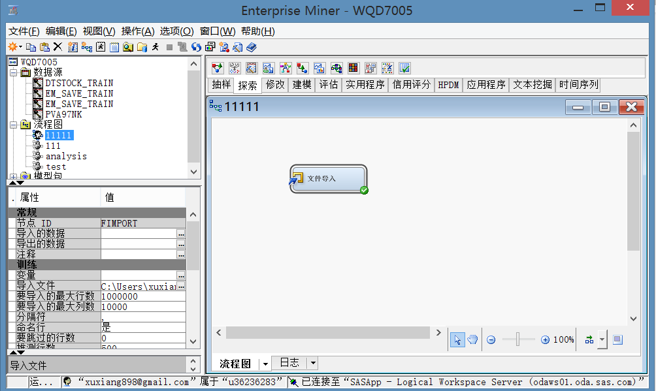

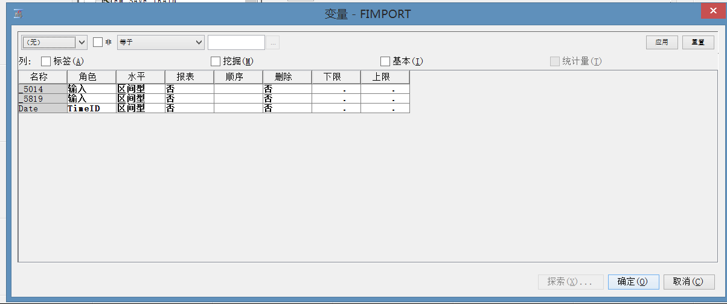

2.explore data
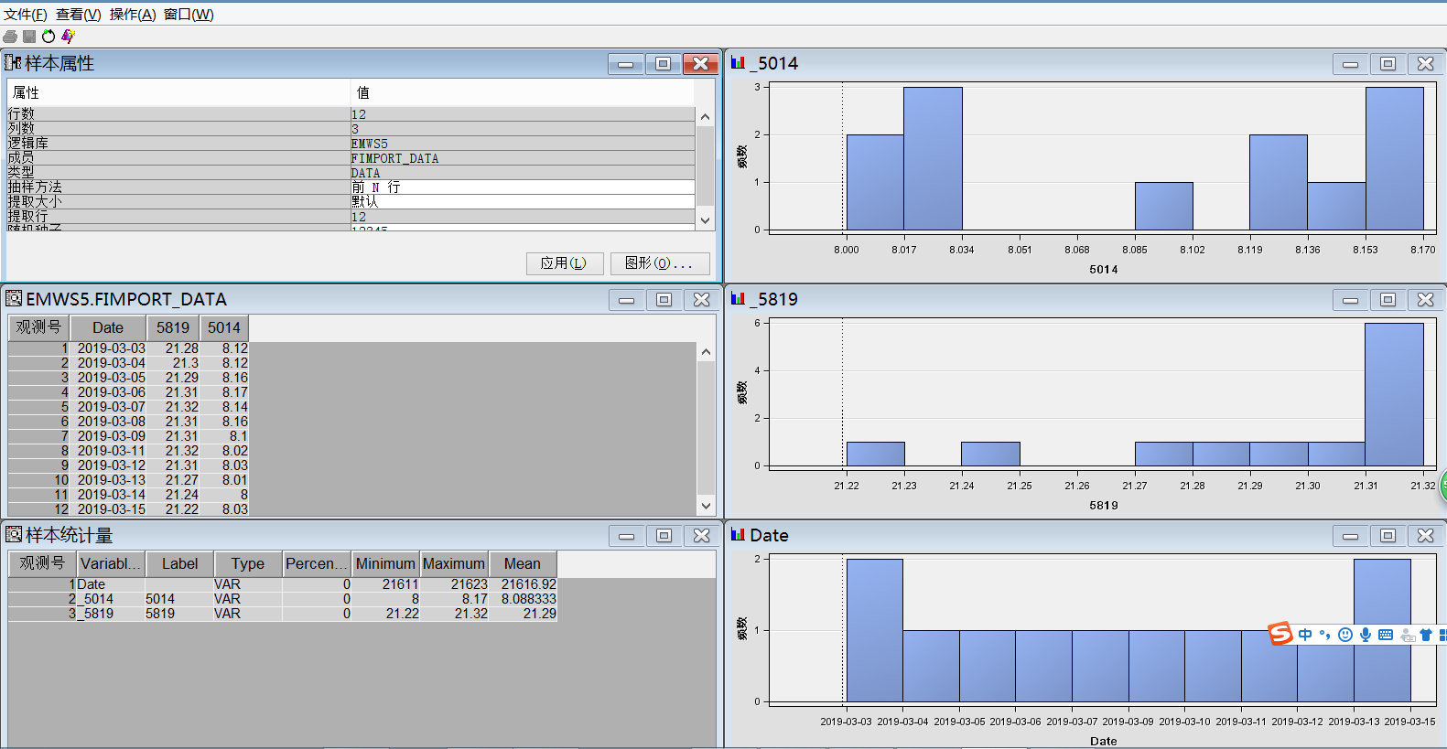

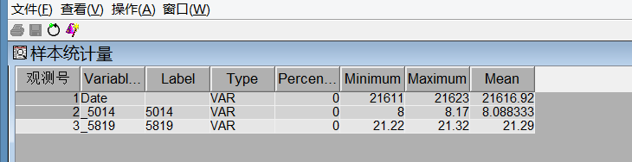

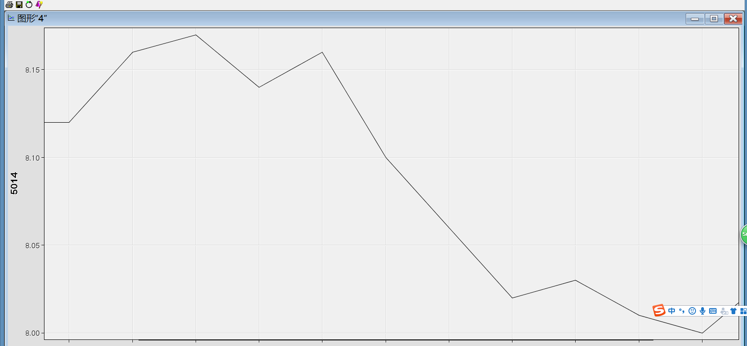

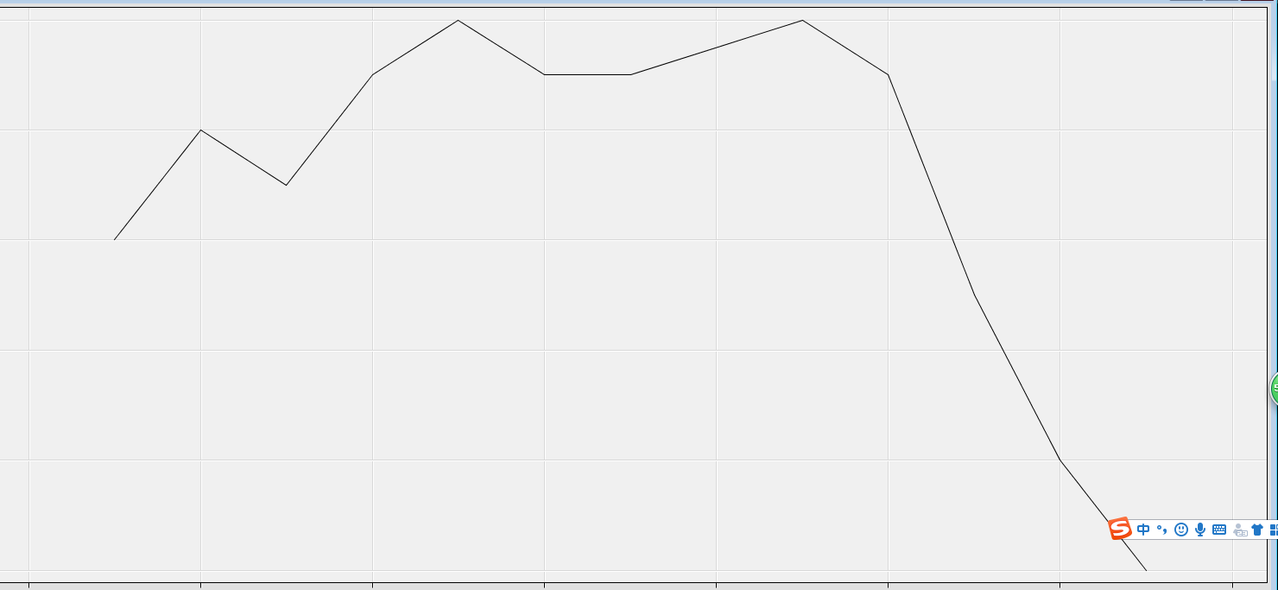
As can be seen from the chart, from March 3 to March 15, HONG LEONG BANK BHD closed at the highest price of 21.32, the lowest price was 21.22, and the average price was 21.29.
As can be seen from the chart, from March 3 to March 15, the highest price of MALAYSIA AIRPORTS HOLDINGS BHD was 8.17, the lowest price was 8, and the average price was 8.008.
As investors worried about the slowdown in global economic growth and the progress of Sino-US trade negotiations on March 12, the Asia-Pacific stock market rose on a 12-day basis, and the stock price of HONG LEONG BANK BHD fell sharply.
Because of the impact of the MALAYSIA AIRPORTS HOLDINGS BHD lawsuit and delayed KLIA expansion plan, the stock price was once severely frustrated by more than 11%. Overall, the market was overreacted, and the stock price fell to provide a low absorption opportunity.
Da Ma Airport recently pointed out that Segi Astana, which is 70% owned by WCT Holdings (WCT, 9679, Main Board Construction Group), has claimed RM70 million due to delayed commercial operations at Kuala Lumpur International Airport 2 Complex. This incident has been going on for many years and the Malaysian airport is still actively responding. At the same time as Malaysia’s claim was filed, it also issued a notice of arbitration to WCT to recover a fixed monthly fee of RM950,849 per month from the cooling system supply of chilled water from September 2013 to the present, so the share price stabilized after falling. Potential

