WQD7005 Data Mining

Xu Xiang

WQD180061

GitHub repo URL: <https://github.com/xuxiang3796/WQD7005-2019>

The codes and link to videos are in the github.

This milestone is recommendation of stocks. This can be done through clustering. The stocks are grouped into different groups with SAS Enterprise Miner clustering function. The flow chart below show how SAS do the clustering.

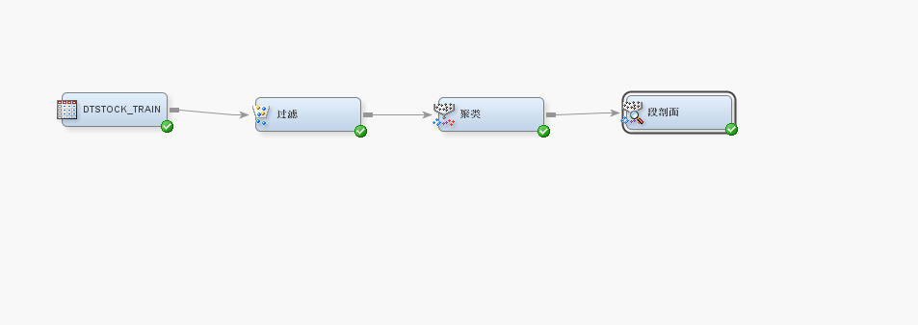

This is the result of the clustering. There are 3 clusters in total.

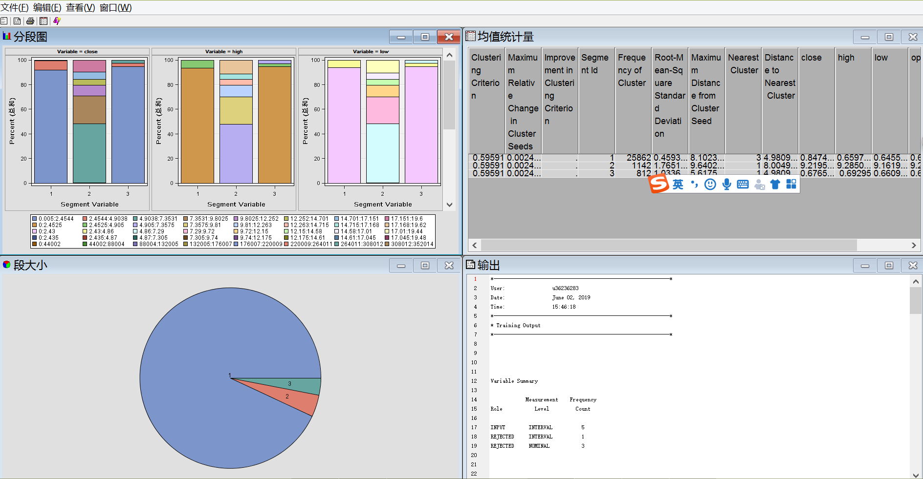

The screenshot below is the result of the clustering analysis.

