Experiment Title： Inode-based Unix-style File System
Description
Objective
- Allocate 16MB space in memory as the storage for your file system. The space is divided into blocks with block size 1KB
Assume address length is 24-bit，please design your virtual address structure.
Design what information should be contained in an i-node
The i-node should support 10 direct block addresses, and one indirect block address
- The first a few blocks can be used for storing the i-nodes, and the first i-node can be used for the root directory (/).
- Using random strings to fill the files you created. It means you just need to specify the file size (in KB) and path+name.
- Following commands should be supported in your system：
  - A welcome message with the group info (names and IDs) when the system is launched. It is also the claim of your ‘copyright’
  - Create a file：createFile fileName fileSize
i.e.：createFile /dir1/myFile 10 (in KB)
if fileSiz > max file size, print out an error message.
  - Delete a file：deleteFile filename
i.e.：deleteFile /dir1/myFile
  - Create a directory：createDir
i.e.：createDir /dir1/sub1 (should support nested-directory)
  - Delete a directory：deleteDir
i.e.: deleteDir /dir1/sub1(The current working directory is not allowed to be deleted）
  - Change current working direcotry：changeDir
i.e.: changeDir /dir2
  - List all the files and sub-directories under current working directory：dir
You also need to list at least two file attributes. (i.e. file size, time created, etc.)
  - Copy a file : cp
i.e.: cp file1 file2
  - Display the usage of storage space：sum
Display the usage of the 16MB space. You need to list how many blocks are used and how many blocks are unused.
  - Print out the file contents: cat
Print out the contents of the file on the terminal
i.e: cat /dir1/file1
  - You are NOT required to implement the function of Login!

Loading and exiting: exit the program and release all the memory occupied, but the contents of the memory should be stored on your disk for re-loading；

Requirement
- Review Unix file system design and i-node usage.
- Design and implement an i-node-based Unix-style file system.
- Implement basic functionalities specified in the following section.
- The task needs to be completed using C++ ONLY

【Environment】
Linux OS
Content
- Contributions of Group Members
- System Design
  - Memory Allocation
2.1.1 For the file system structure
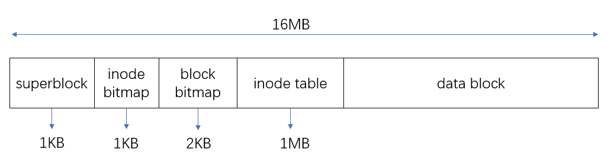
We allocate file system memory into the unit of block (1024 bytes). According to the needs of reading and writing memory, the file system can be divided into four parts: superblock, inode bitmap, block bitmap, inode table and data block. The inode is specified with a unique number(id). The superblock records the number of inodes and data blocks currently used; Inode bitmap records whether the inode is occupied; Block bitmap records whether the memory space in blocks is occupied; Inode table records the information stored in the form of inodes; Data block represents the remaining memory space.
2.1.2 For the virtual address structure
Virtual address structure contains two parts: the page and the offset into the page.
- The offset into the page
The offset into the page is use to find which bytes in the block. Since we have the block with the size of 1KB, so we should have 10 bits to represent it.
- The page
The page is use to find which block in the memory. Since the address length is 24 bits and the offset into the page occupy 10 bits, so we use 24 – 10 = 14 bits to represent the page.
  - Data Structure
According to the above file system design, we divide the 16MB memory space into blocks. Therefore, we design the contents of blocks and the information format stored in blocks as follows
2.2.1 Super block, which stores global inode and block usage information
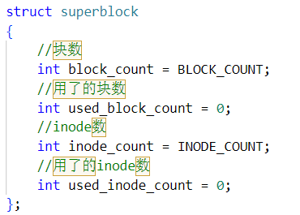
2.2.2 Inode, which is stored in the inode table with fixed size of 1MB
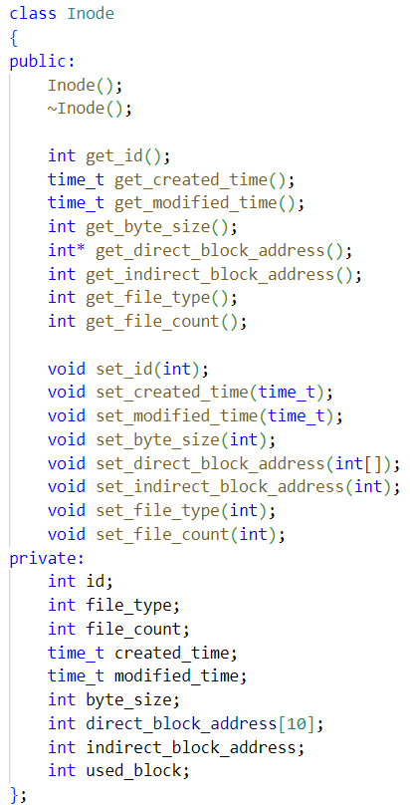
The structure diagram of inode is shown as follows. In addition to the necessary information, such as the time of inode creation and modification, the amount of space to be assigned and the type of file (file or directory), it contains a total of 10 addresses that directly point to data block and 1 indirect address. The indirect address point to a block which contains the addresses of 256 data blocks. Therefore, an inode can point to addresses of 266 data blocks, which means a file can support a space for no more than 266KB.
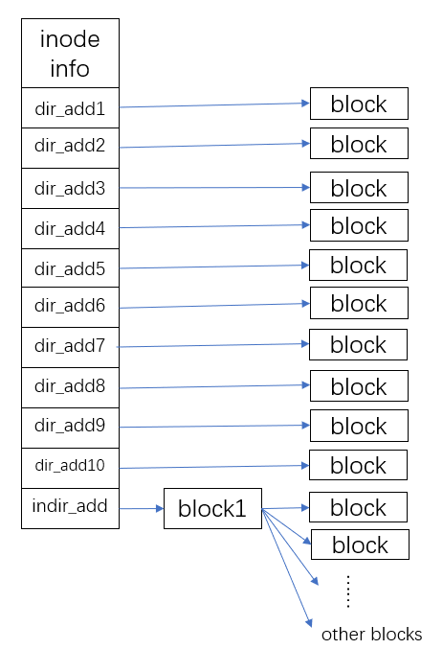
2.2.3 File, mainly including the file name and the corresponding inode ID, with a fixed size of 16B
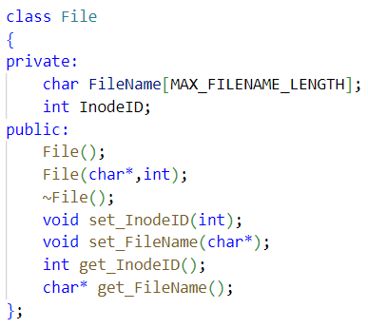
Actually, what stores under the directory is information represented as class File. When referring to a file, we may search by its file name and get the inode number. Then with the inode number, the addresses which store real data can be found and we can work with the data with our need.
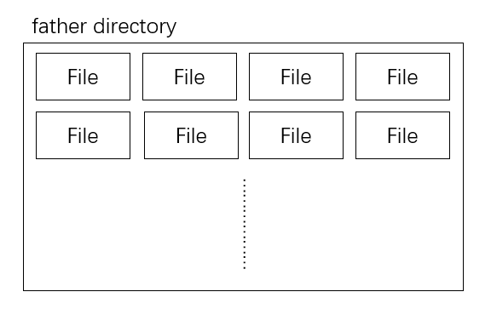
3. Function implementation
3.1 Initialize or Load File System
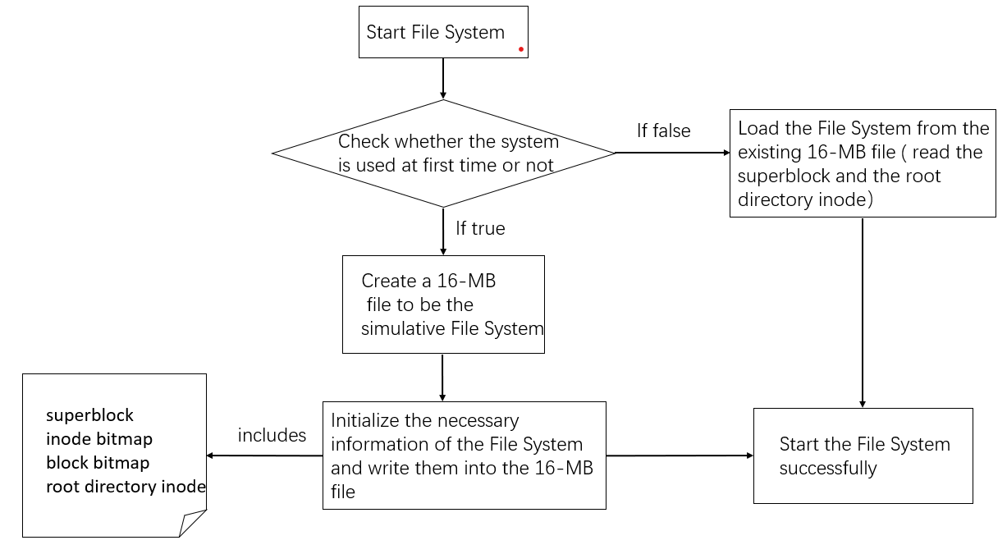
When user start the file system, the program will determine whether the file system is used at first time.
If user uses the filesystem at the first time, the program will create a 16-MB file to be the simulative filesystem. In this file, program will initialize a superblock, an inode bitmap, a block bitmap and a root directory inode and write them into the 16-MB file.
If the filesystem has been used, the program will load it from the existing 16-MB
File. That is, read the superblock and the root directory inode.
The code implementation is shown as follows:
- Initialize the file system (First time to use the file system):
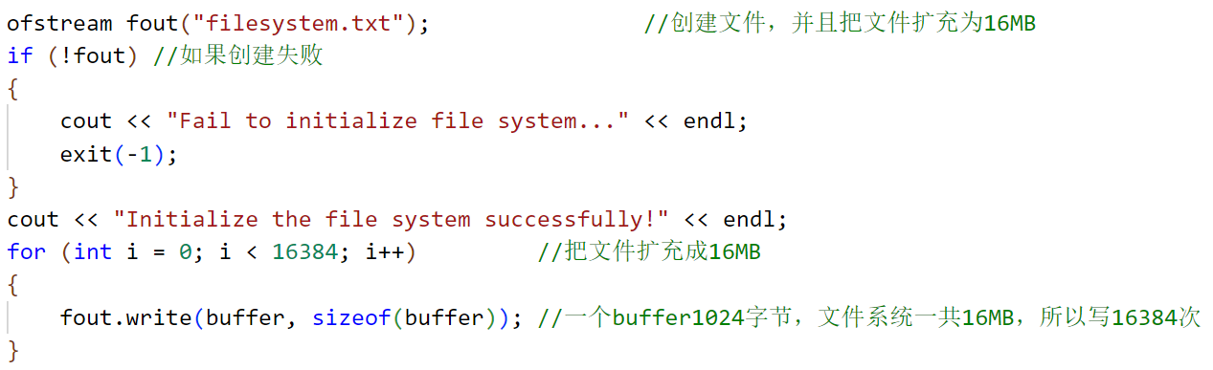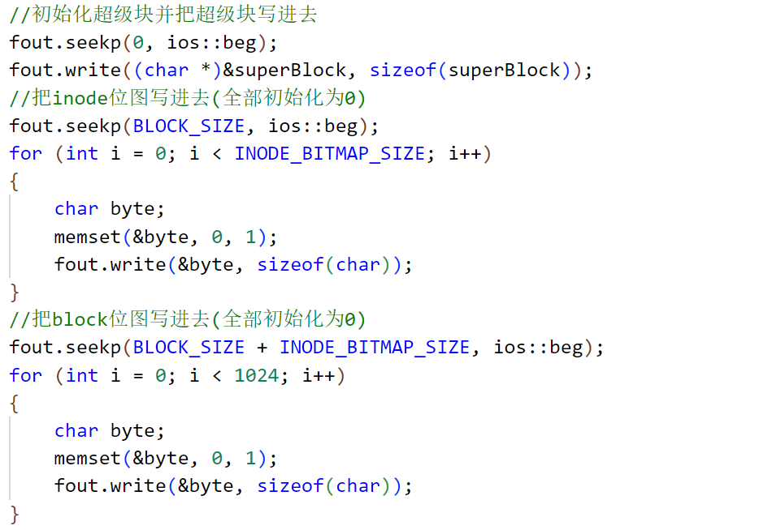
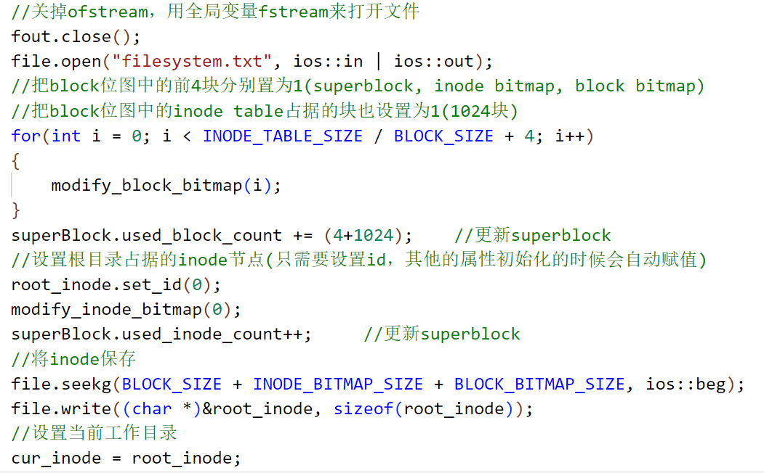
- Load the file system (file system has been used before):
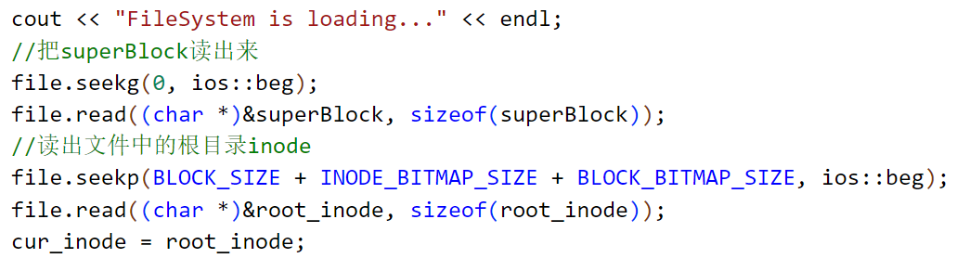
- handle the command:
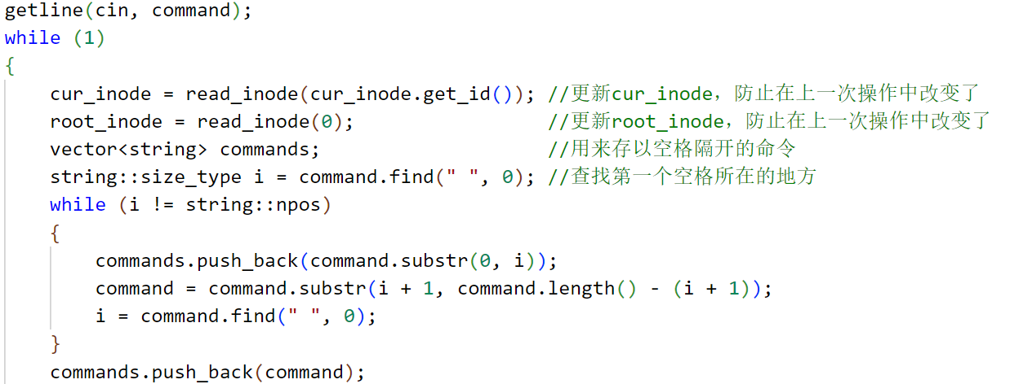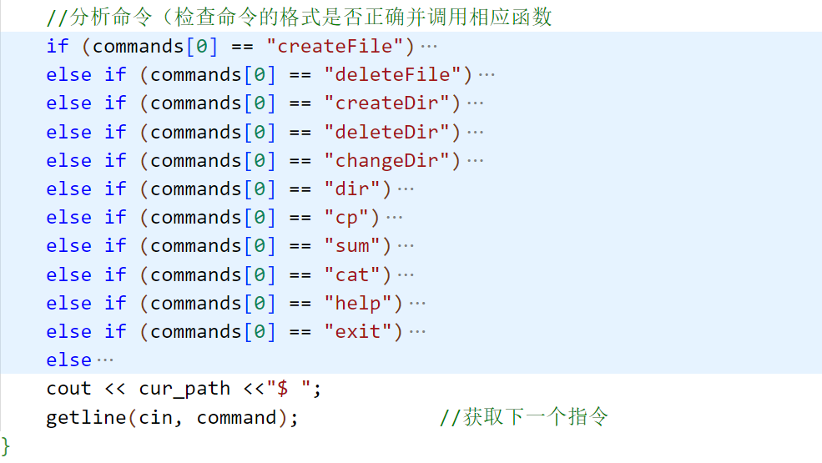
3.2 create a file
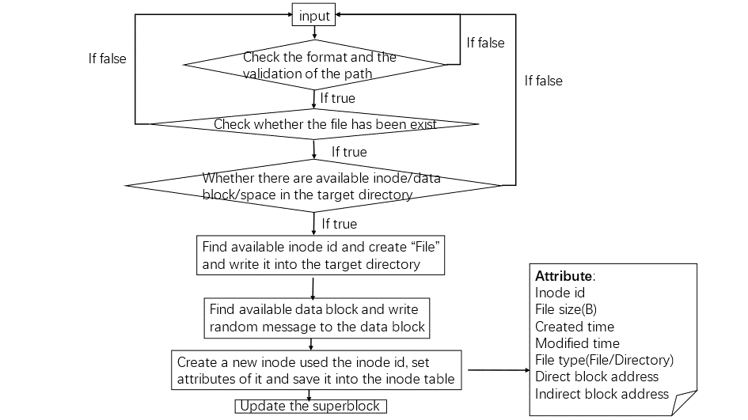
First, the program will check the format and the file size, which should be below 266KB. Then, the program will check whether the path is valid and whether the file name has been existed.
After that, the program will start to create the file. First, it will create a “File” instance, initialize the instance and save it into the target parent directory. Second, it will find the available data blocks according to the block bitmap and the file size and then write random message to blocks. Thirdly, the program will create a “Inode” instance, initialize the instance and save it into the inode table.
Finally, update the super block according to the usage of inode and data block.
The code implementation is shown as follows:
- Check the validation of path:
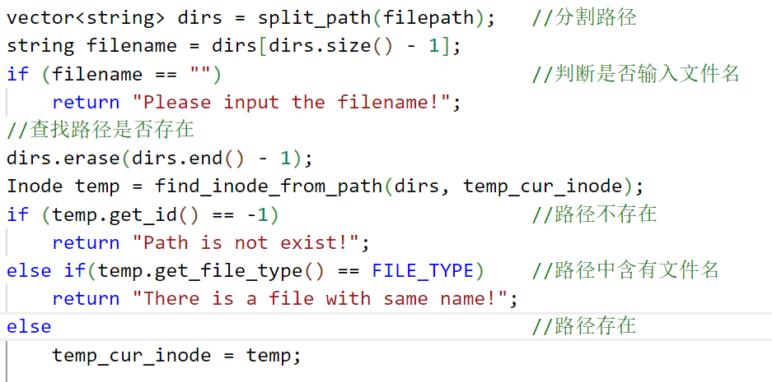
- Check whether the file has been existed:
- Create the “File” instance and add it to the directory:
- Find available data blocks and write random message into it:
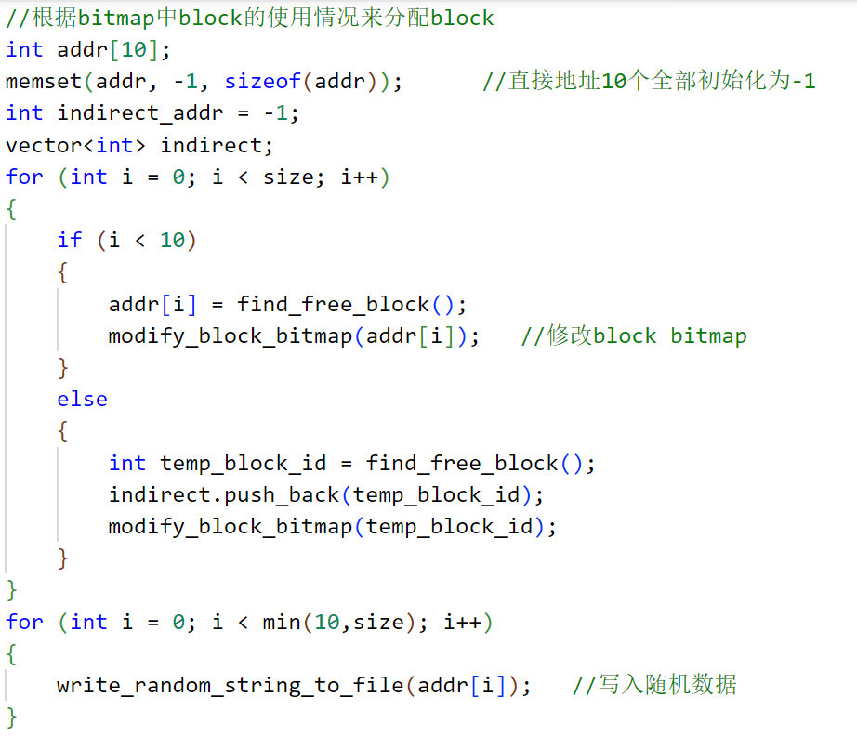
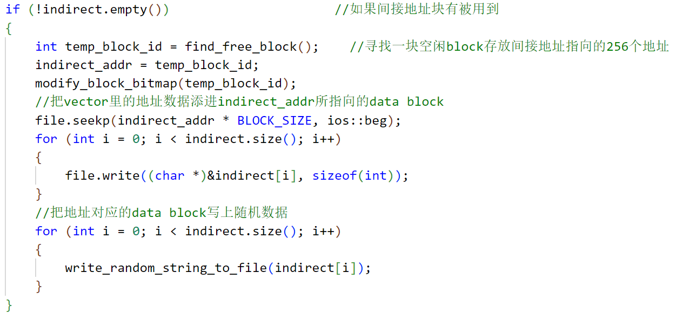
- Create the “Inode” instance and save it into the inode table:
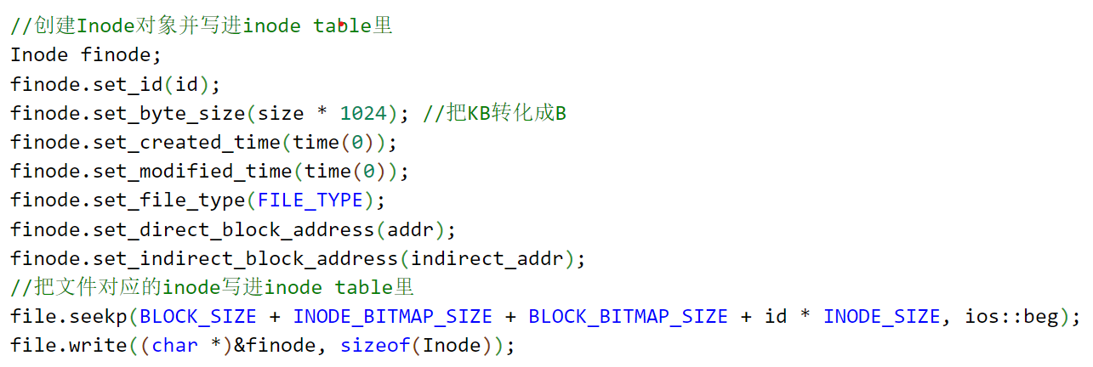
3.3 delete a file
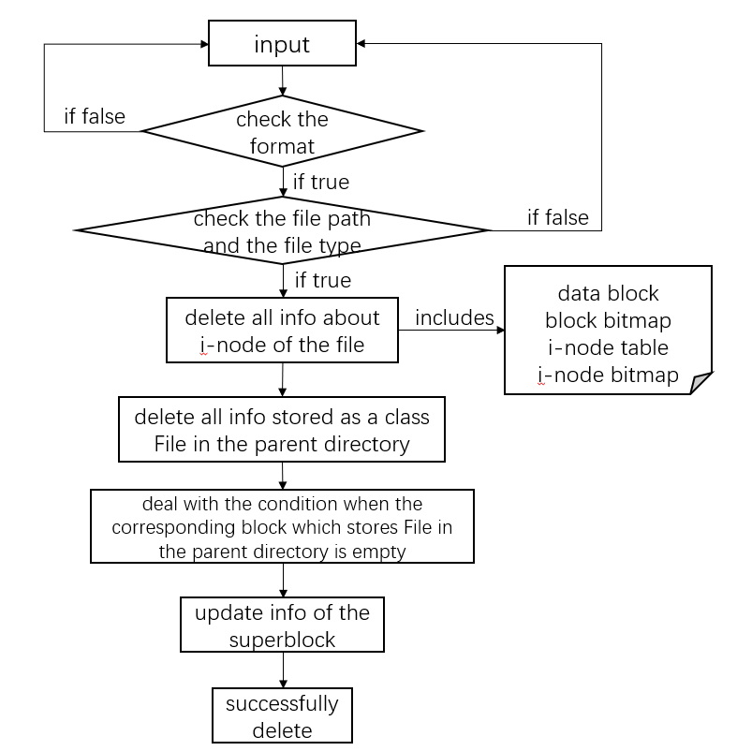

The realization of the function of deleting a directory can be divided into following steps. Firstly, judge whether the input command format is correct. Secondly, judge whether the input file path exists and whether the file type is correct. If true, trigger the mechanism of deleting the file. The contents of the file itself to be deleted include data block, block bitmap, inode table and inode bitmap. Also, it is necessary to process the storage of the folder where the information about the target file is located, that is, delete the information represented as a class File under the folder. Finally, we update the inode information corresponding to the folder and the inode information stored in the superblock.
The code implementation is shown as follows
- Determine whether the current path exists and whether the file type is correct:
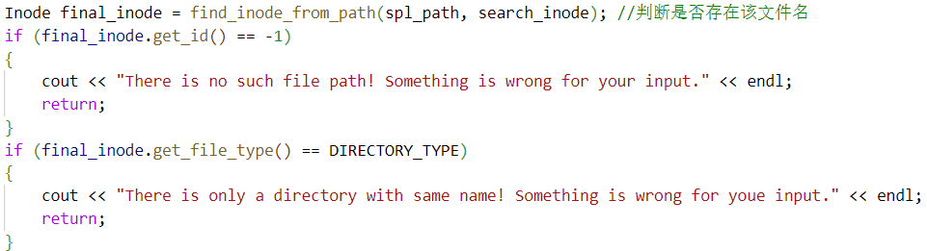
- Delete file information:
- Delete information stored as class File from the parent directory:
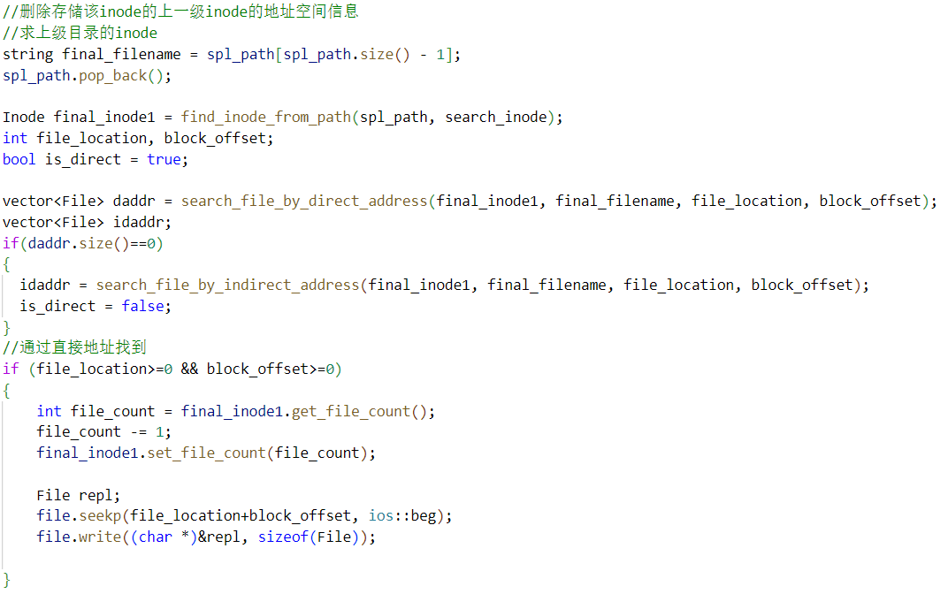
- Judge whether the data block which stored the target file information is empty after deletion:
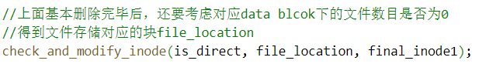
- Update superblock:
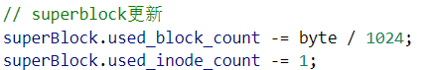
3.4 create a directory
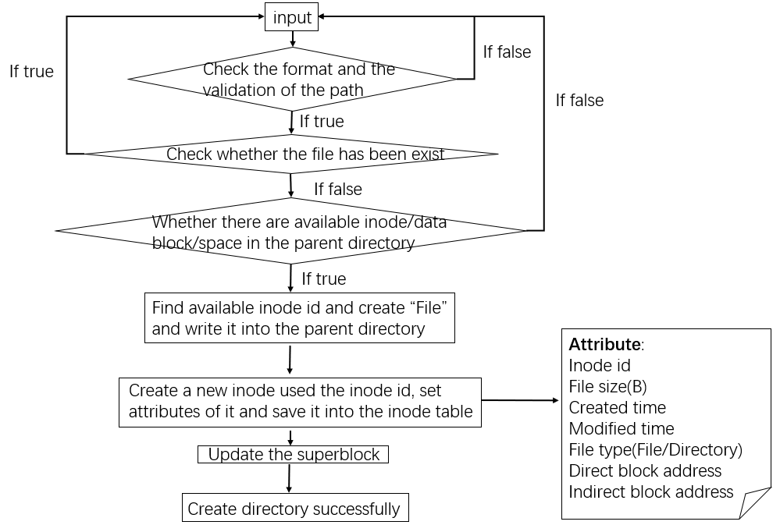
The code implementation is similar to creating a file excepting that creating directory doesn’t need write random message to data blocks.
3.5 delete a directory
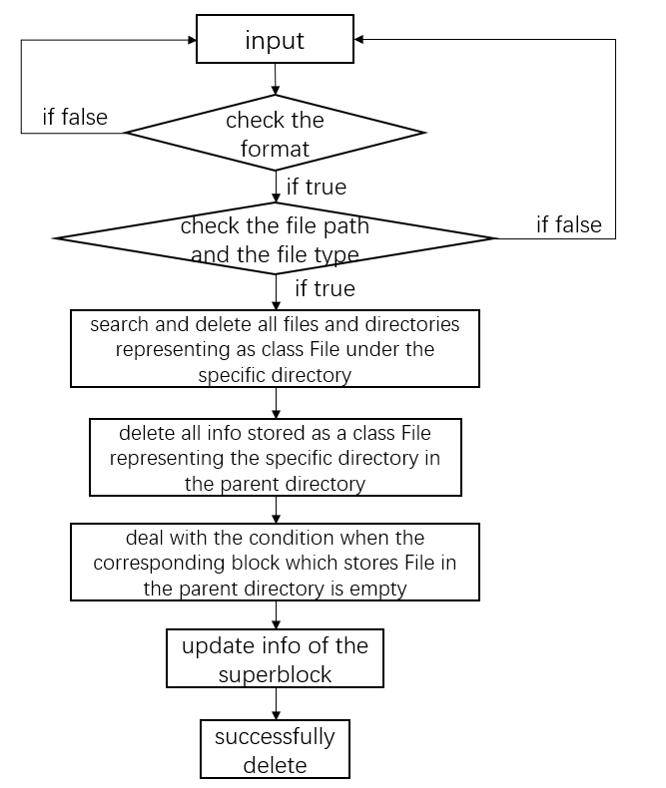
The realization of the function of deleting the target working directory can be divided into following steps.
Firstly, determine whether the input command format is correct. Secondly, determine whether the file path exists and whether the file type is correct. If the verification passes, the mechanism of deleting the directory will be triggered. All subdirectories and files under the target directory need to be locked and deleted one by one according to their category. After deleting the above information, we should also process the information of the parent directory of the current directory, that is, delete information represented as class File under the folder, and finally update the inode information corresponding to the folder and the inode information stored in superblock.
The code implementation is shown as follows:
- Determine whether the current path exists and whether the file type is correct
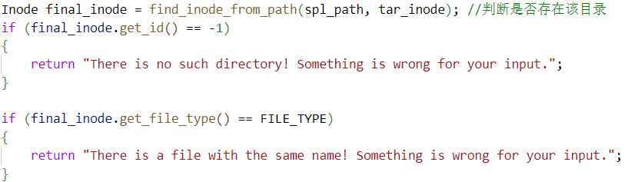
- Search all files stored in this directory
- Perform different deletion operations according to the file type
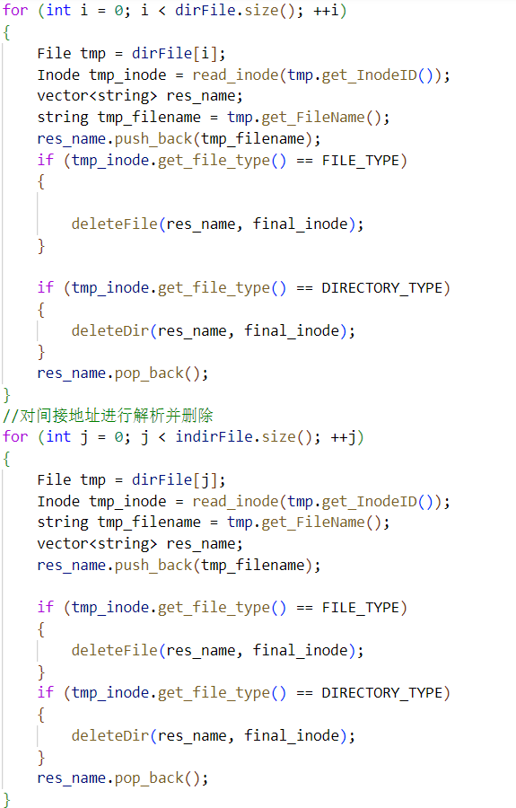
- Return the parent directory and delete the information of the target directory stored in the parent directory
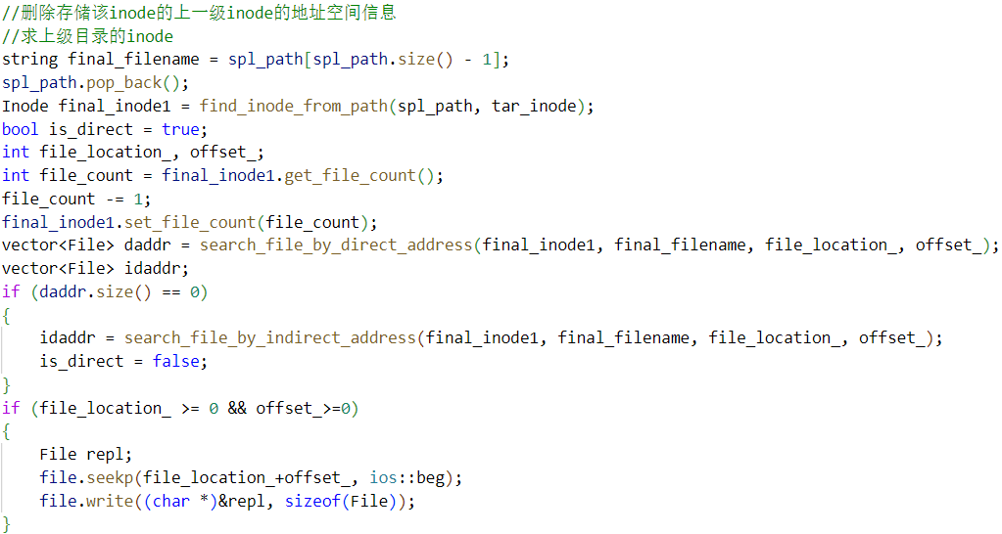
- Judge whether the data block which stored the target directory is empty after deletion and deal with the empty condition
- Update superblock
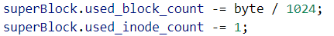
3.6 change the current working directory
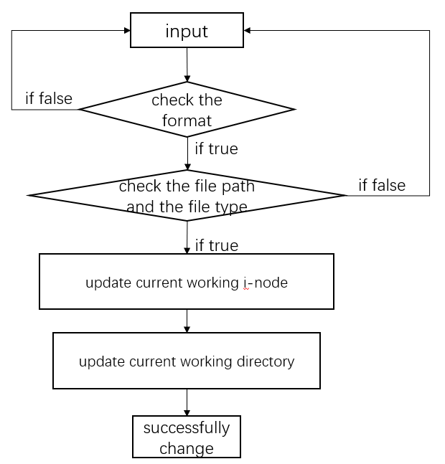

The realization of the function of changing the current working directory can be divided into following steps.
Firstly, judge whether the input format is correct. Secondly, judge whether the input file path or file name exists and whether the file type is correct. If the above verification is correct, trigger the mechanism to change the current working directory, including changing the current working inode and the current working directory. The working directory is changed and is presented in the screen.
The code implementation is shown as follows
- Determine whether the current path exists and whether the file type is correct, then assign the expected working inode
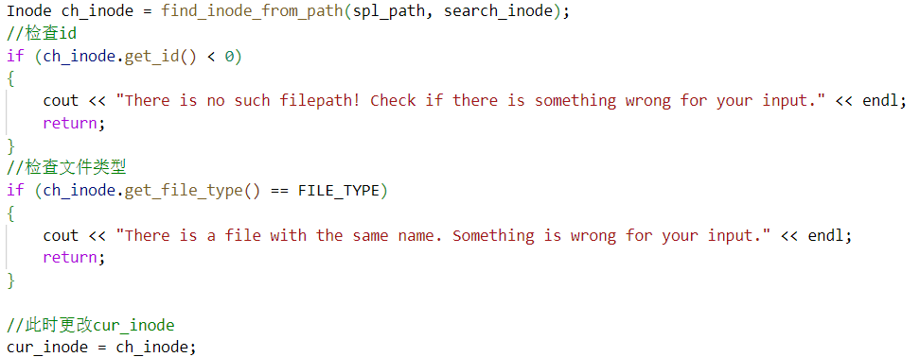
- Change the current working path and display the path on the screen
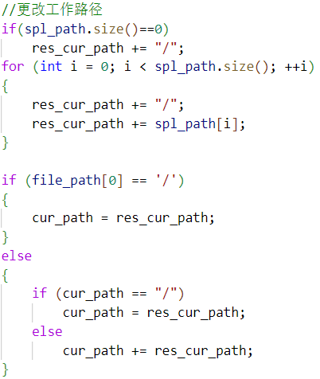
3.7 list all the file and sub-directories under current working directory
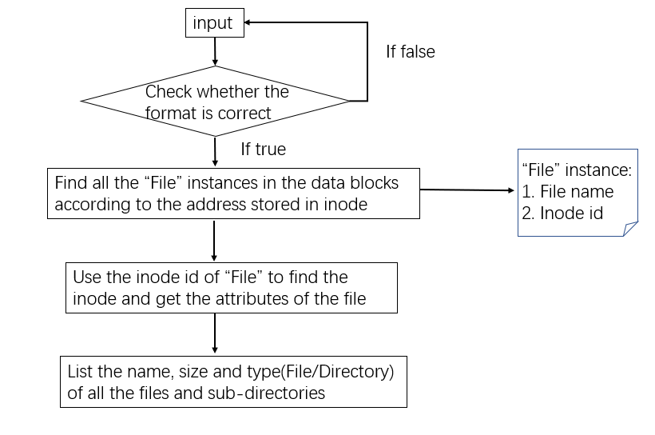
Firstly, the program will check whether the format of input is correct or not. After that, it will find all the “File” instances in the data blocks where the address stored in the current inode is point to. From the “File” instance, the program can get the name and inode id of the file or sub-directory and it can find the attributes with the inode id. Finally, the program will list the name, the size in KB and the type of all the files and sub-directories.
The code implementation is shown as follows
- Find all the “File” instance and “Inode” instance and list:
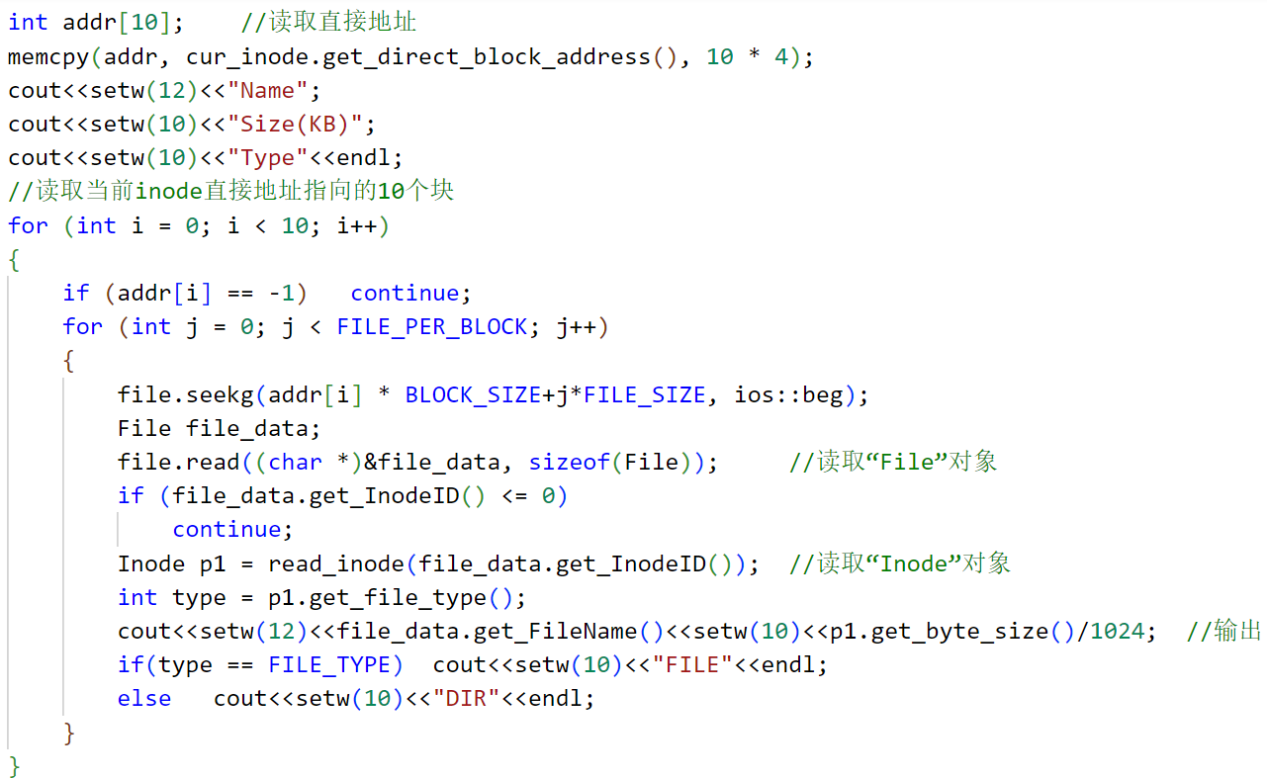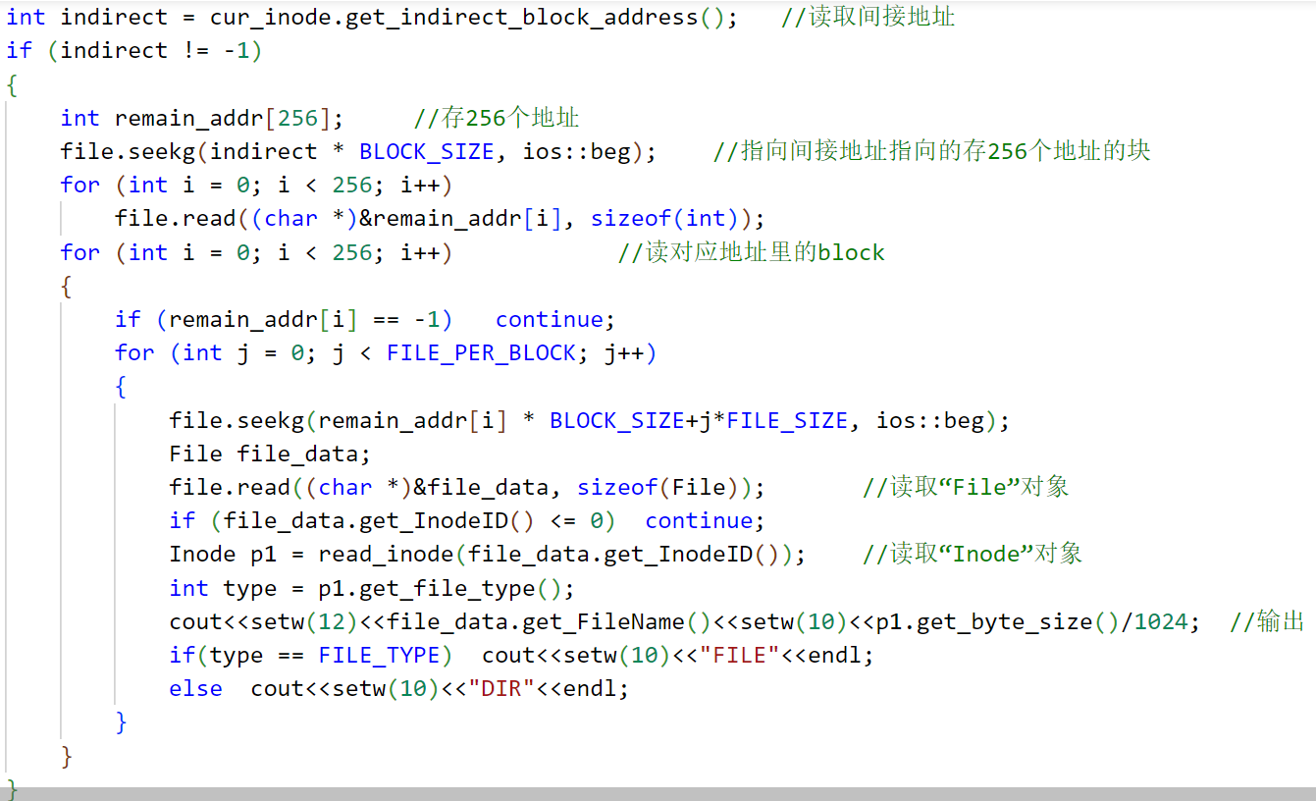
3.8 copy a file to the target path
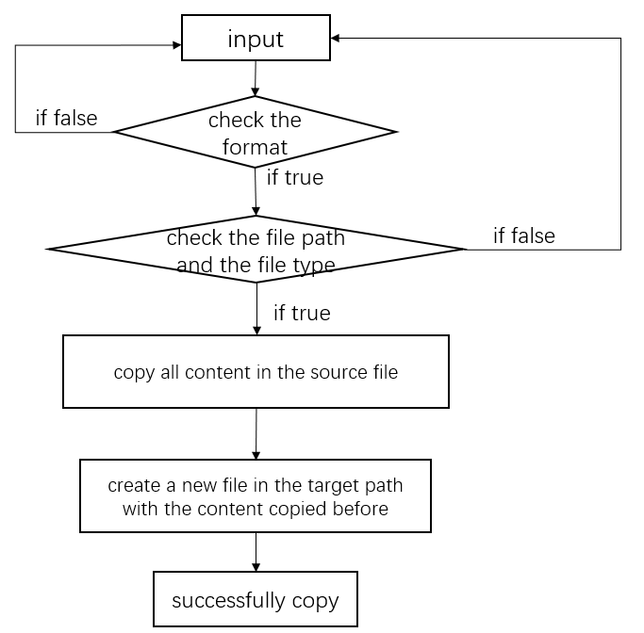

The realization of the function of copying a directory can be divided into following steps. Firstly, judge whether the input format is correct. Secondly, judge whether the input file path or file name exists and whether the file type is correct. If the above verification is correct, trigger the file copy mechanism to obtain the content stored in the source file, create a new file in the target path, and copy the previously obtained content to the file.
The code implementation is shown as follows
- Determine whether the current path exists and whether the file type is correct, the method can be also used to judge whether the target path exists
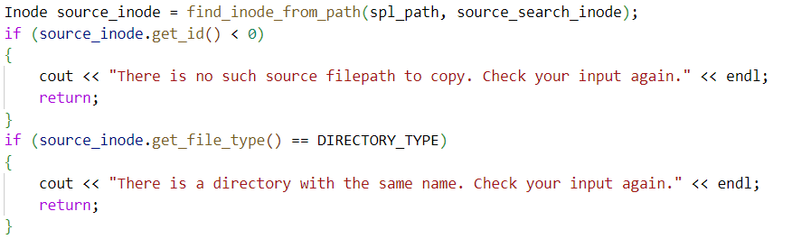
- Copy all contents in this file
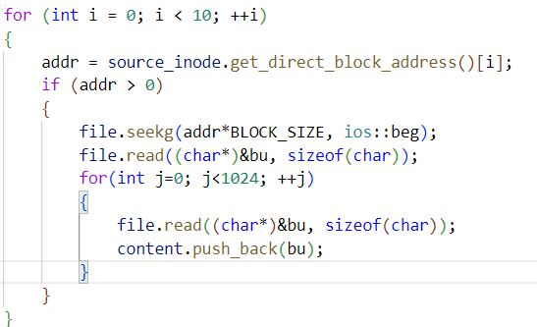
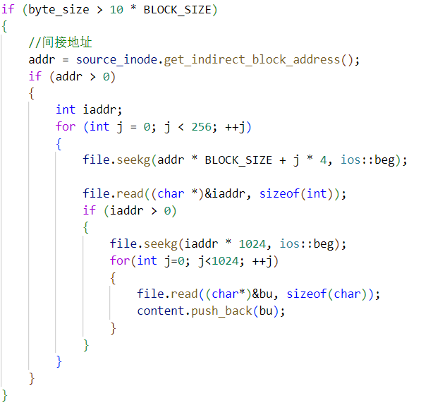
- Create a new File class under the target path
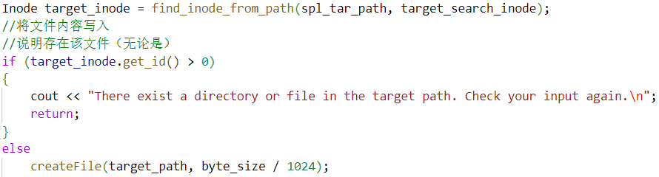
- Copy the contents of the source file to the new file
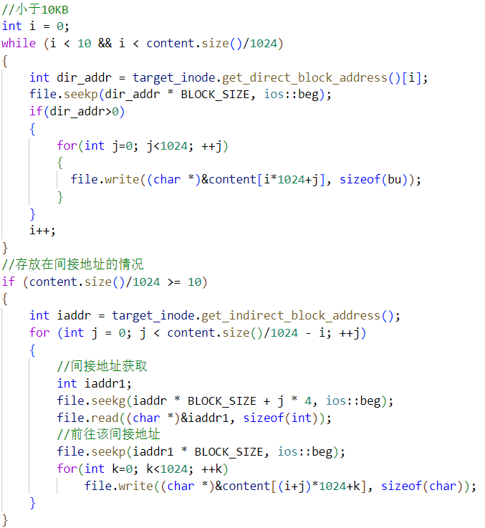
3.9 display the usage of storage space
To implement this function, the program will use the information which is stored in the superblock.
The code implementation is shown as follows
3.10 print out the file contents
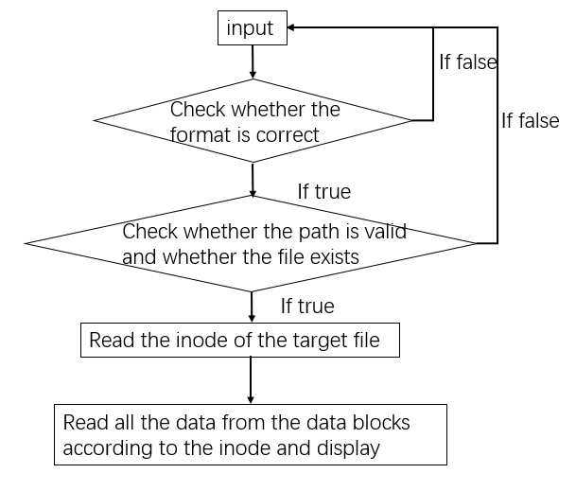
Firstly, the program will check the format and check whether the path is valid and whether the file exists. After that, the program will read the inode of the target file and read the data of the file. Finally, display the data.
The code implementation is shown as follows
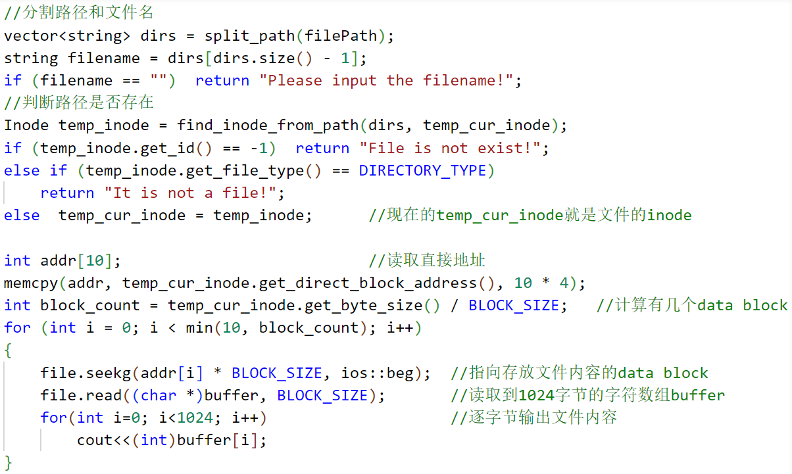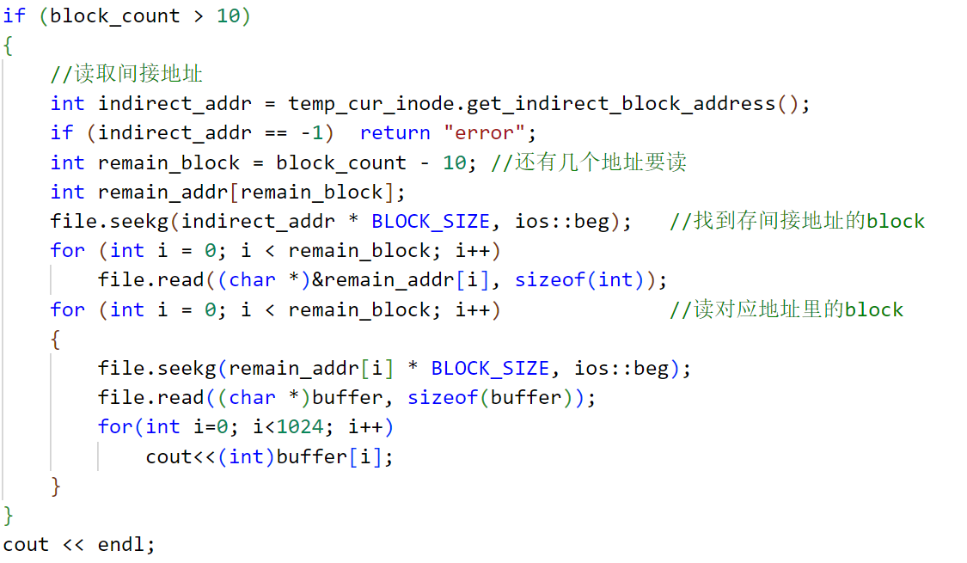
- Demonstration
4.1 welcome message and guidance
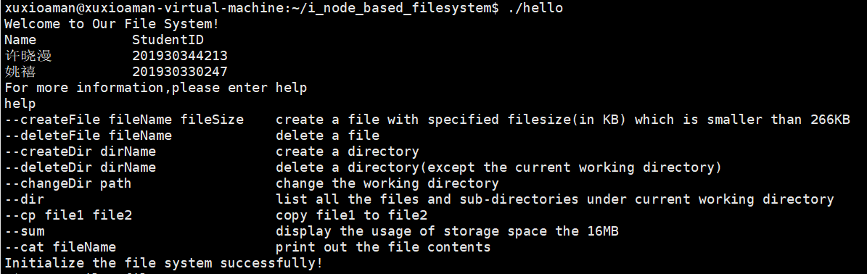
4.2 create a file
- correct case:
With absolute path:
With relative path:
- incorrect case:
the current case:
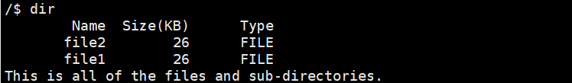
the wrong operations:
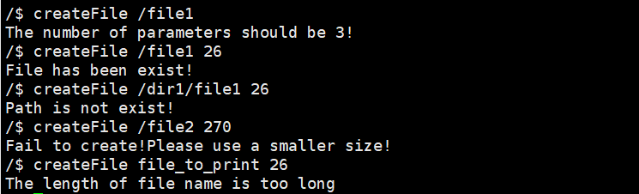
4.3 delete a file
The format of the command is “deleteFile input”, the input can be absolute file path or relative file path
- correct case:
with absolute path:
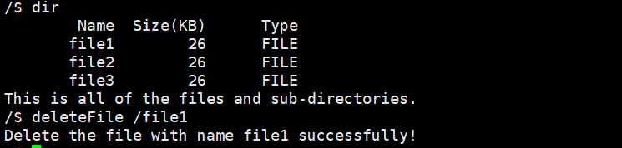
After deletion, the remaining files are
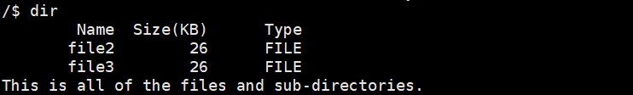
with relative path:
After deletion, the remaining files are
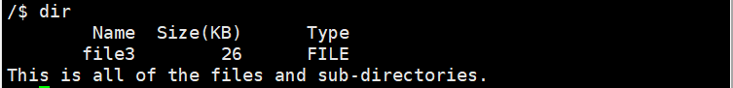
- incorrect case:
the current case:
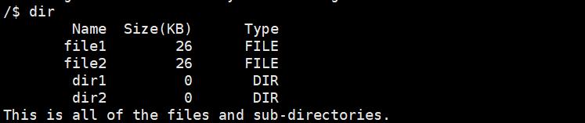
the wrong operations:
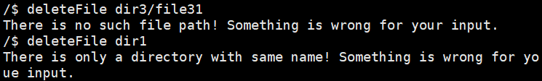
4.4 create a directory
- correct case:
with absolute path:
with relative path:
- incorrect case:
the current case:
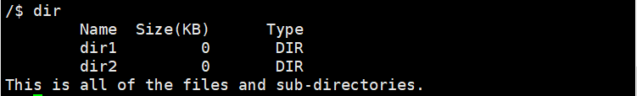
the wrong operations:
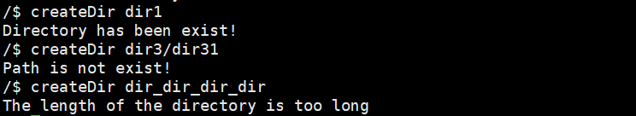
4.5 delete a directory
The format of the command is “deleteDir input”, the input can be absolute file path or relative file path
- correct case:
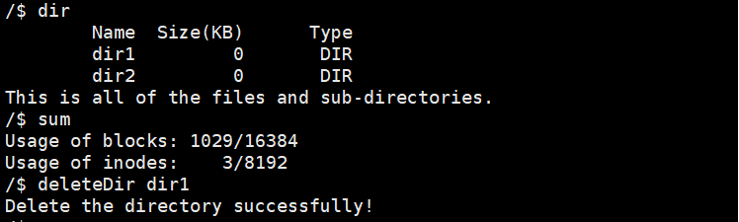
After deletion, the remaining files are
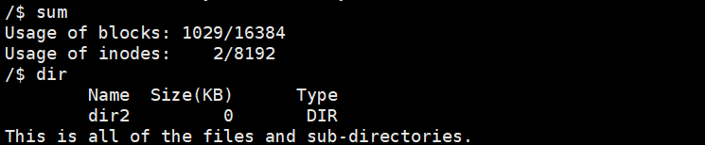
- incorrect case:
4.6 change the current working directory
The format of the command is “changeDir input”, the input can be absolute file path or relative file path
- correct case:
the current case:
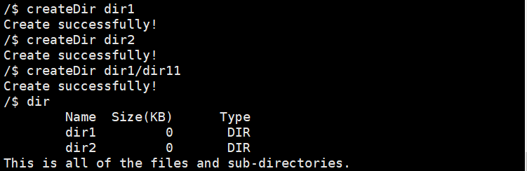
By inputting the command with relative path or absolute path, we change the current working directory like this:
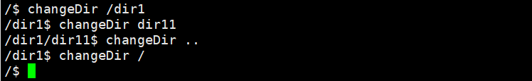
Finally, we return the root directory
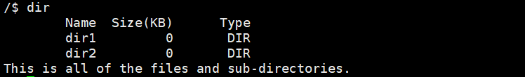
- incorrect case:
the current case:
the wrong operation:
4.7 list all the file and sub-directories under current working directory
- correct case:
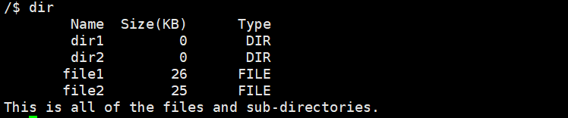
4.8 copy a file to the target path
The format of the command is “cp source_input target_input”, the input can be absolute file path or relative file path
- correct case:
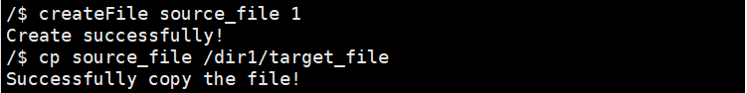
After the operation of the copy, all contents in file a is copied to the target file.
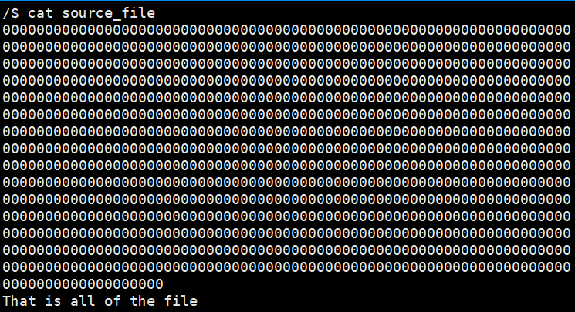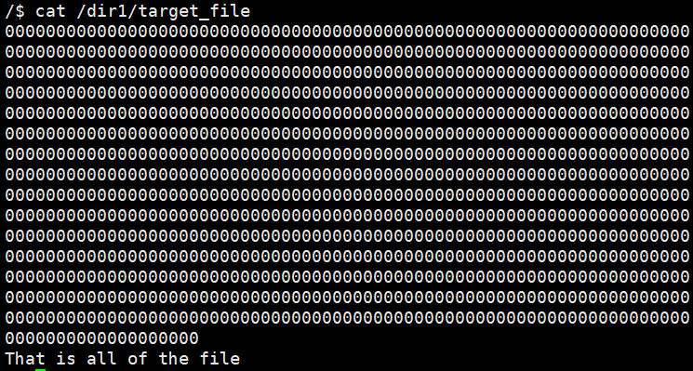
- incorrect case:
the current case:
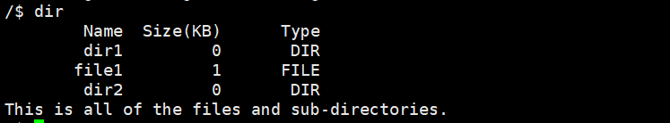
the wrong operation:
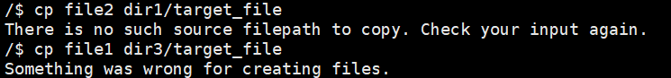
4.9 display the usage of storage space
- correct case:
4.10 print out the file content
- correct case:
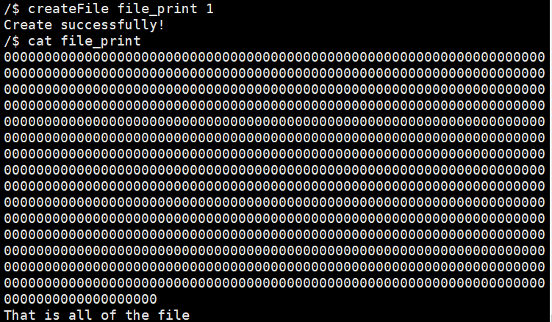
- incorrect case:
the current case:
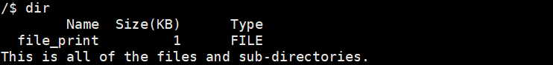
the wrong operations:
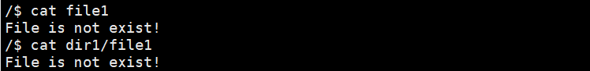
Conclusion
In the process of this experiment, we designed the framework and details, completed the basic functions of the system and tested all the functions. There are still some insufficiencies in our system, such that loss of data if closing the system without the correct command. Anyway, we learnt a lot like memory allocating, file system and so on from this experiment.
Teacher’s Comments and Score
Comment：

