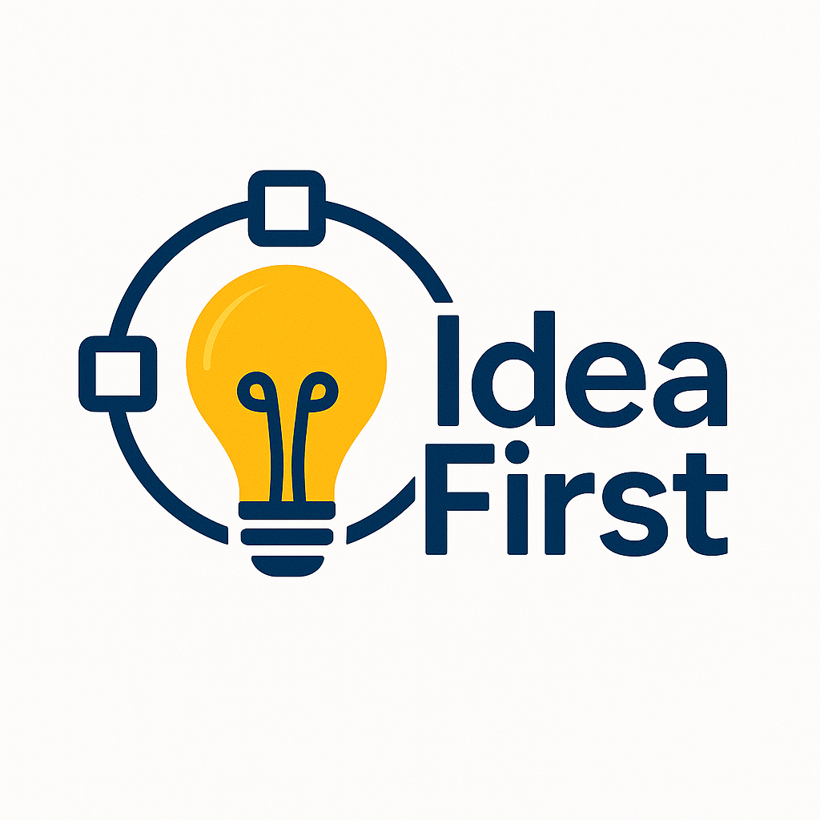

Elizabeth Wangley, Fanglei Ruan, Dong Ding, Jasmine Sun
Current Market/Current Patent Application Process
The current patent application process is characterized by a complex series of procedural steps intended to ensure thorough examination and validation of inventions. The current application process typically follows five core stages: preparation, application, examination, authorization, and maintenance. Once all objections are resolved, the patent rights will take effect, and an authorization fee and maintenance fee will be incurred.
However, this traditional method faces significant challenges, especially its long duration, often lasting for several years, which delays market entry and may erode competitive advantage. The high costs associated with legal expertise, administrative fees, and potential litigation further complicate the situation, particularly posing obstacles for smaller inventors and startups. Therefore, there is an increasing demand for more transparent and secure mechanisms, such as blockchain technology, that can provide immutable records and verifiable timestamps to alleviate these challenges and enhance trust in the patent registration process.
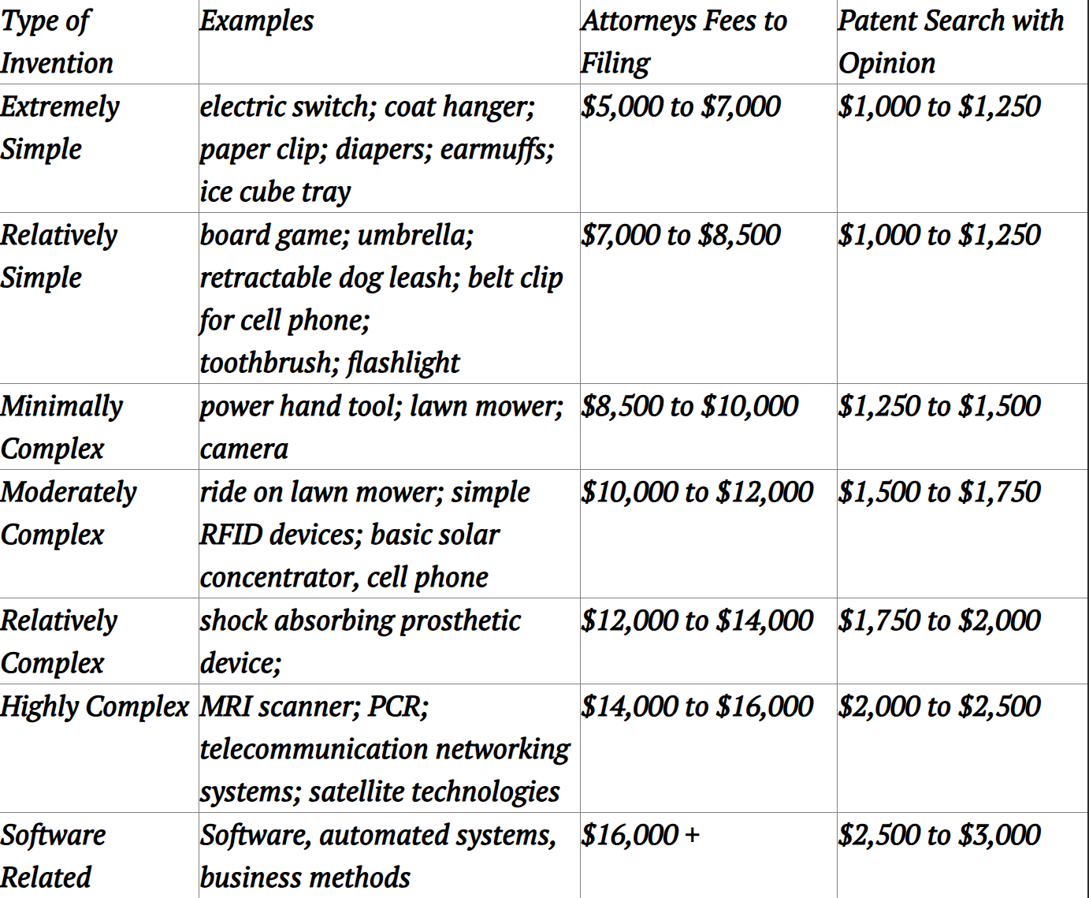

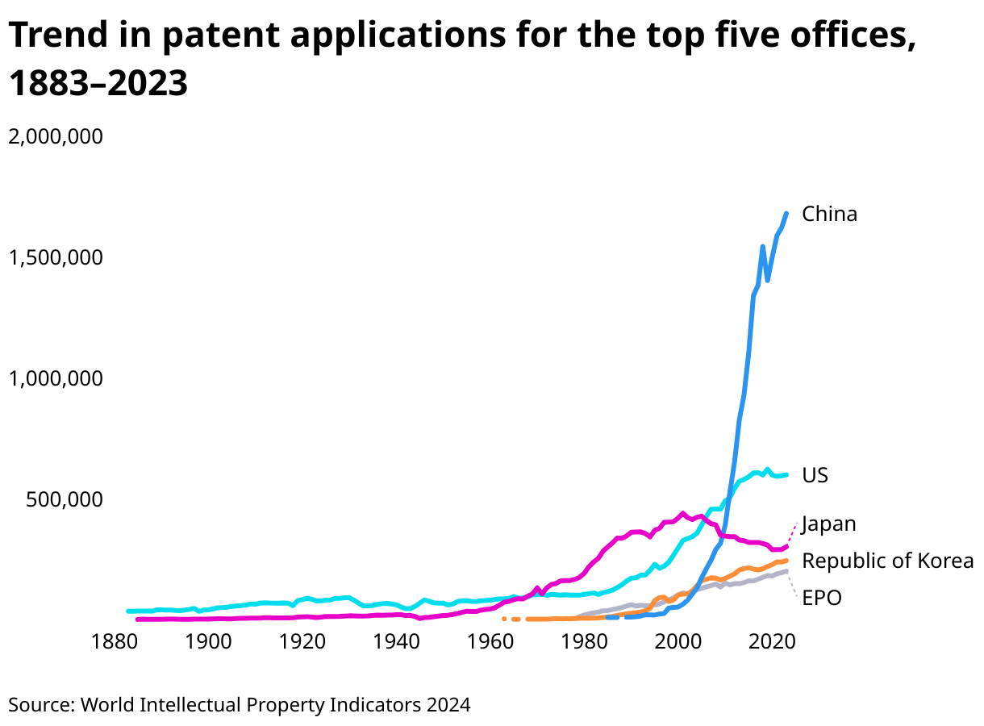

Core Operations
The core operations of IdeaFirst allow users to upload their IP materials to the platform and generate an IP hash in the form of SHA-256. On a public blockchain, the IP hash, owner wallet address, timestamp, and optional metadata are recorded. There is a basic and a premium model. Premium users have access to special features as well as lower fees when uploading IP materials.
When a user uploads their IP materials, it is compared with other IP materials on the platform for any signs of similarity immediately. That process will take around 5 minutes. This process is completed according to a queue system, meaning that they are processed in the order they are submitted. However, it is also the responsibility of the user to check if their IP is against past art outside of the platform. In the future, we plan to add a feature that checks through outside data points and compares them with user-submitted IP materials. This feature would be a part of the premium model.
During this process, we use zero-knowledge proofs to prove ownership without revealing it to others. IdeaFirst will let users know if there is a high similarity between their idea and another idea that is already filed on the platform. This triggers a warning that puts their idea on probationary status, which means it is in the chain, but there is a chance that someone else has already filed their idea. While the IP materials are being processed, it is stored on the private blockchain. Once confirmed, it will be added to a public blockchain. IP materials can be encrypted according to a user’s choice. Having a private and public hybrid blockchain ensures confidentiality and immutability.
All submissions are hashed using SHA-256 and recorded on a public blockchain. This ensures that no entity can control or alter the record of submission. All users can verify the timestamp and ownership using the hash. Additionally, in the future, we plan to integrate third-party validators. These include IP attorneys and certified IP examiners who can review content placed on probationary status. By using a third-party mechanism, users can feel more confident in the validation process.

Technology Utilized
IdeaFirst utilizes many tools. There are many layers to the platform, including the usage of blockchain, smart contracts, APIs, Oracle, coding, and security protection. There are many options for each of these layers. For blockchain, we will test using Ethereum, Polygon, and Arbitrum. For smart contracts, we will use Solidity, Chainlink functions, and API3. For the API gateway, we will use Flask and/or AWS. This will connect the frontend and backend codes. We will utilize Oracle to access live data and information outside the platform. As for the frontend, there are many options like React, Next.js, Web3.js, or Ether.js. Some testing will be required to find the best option. Lastly, having proper security measures when there is a lot of sensitive data being transferred on the platform is essential. We will have penetration testing and do smart contract auditing.

API Usage
The frontend will be built with React.js or Next.js, allowing our clients to upload their IP files to our platform. Their file will be hashed on the backend before it’s sent to the blockchain. Web3 or Ethers will send the IP information to the Solidity smart contract because a Smart contract doesn’t have the ability to pull requests from the chain. Using decentralized Oracle networks like Chainlink, once the smart contract emits an event on our filing portal, information will be pulled by the smart contract. Oracle will make an HTTP request via Flask or AWS to initiate submission to USPTO or WIPO portal, once the conditions in smart contract are met, Flash will help us to validate document format that is needed for the clients need, once validated it will sign the metadata submitted to our interface, and it will be submitted through USPTO and WIPO’s filing system. Once successfully submitted it a filing receipt and an official timestamp will be returned to both us and the client. Once rejected, it will be manually reviewed by our staff.

Dapp and Token Mechanism
As part of our long-term vision, IdeaFirst is building a decentralized application that allows users to manage their intellectual property records, access platform features, and engage in IP-related transactions directly on-chain. The DApp is designed to be the core user interface for blockchain-based interaction, ensuring seamless integration between IP management, validation, and commercialization.
To complement the DApp, we are also launching a native utility token, $IDEA, which serves as the economic backbone of the platform. The token enhances platform accessibility, rewards active participation, and facilitates secure and transparent transactions within the IdeaFirst ecosystem.
Our Core Token $IDEA will serve multiple functional roles on our platform:
- Transaction Fees where our users can pay for IP timestamping, document verification, or premium services using $IDEA
- Pushing incentives by rewarding validators, third-party IP reviewers, and active community contributors for their participation with our platform.
- Our token holders may participate in governance decisions for our future development, such as voting on our platform upgrades or feature integrations.
- $IDEA will be the primary medium for buying, selling, and licensing tokenized IP assets on our decentralized application marketplace.
Once our platform and coin are live, they will be listed on decentralized exchanges. Perhaps Uniswap, we look forward to achieving the greatest level of liquidity. This will allow peer-to-peer token transfer and staking for our clients. To maintain the currency’s volatility and fluctuation, we are pegging it to the USDT.
Our decentralized application will support a wide range of Ethereum-compatible wallets, like Metamask or Coinbase Wallet. After setting up the wallet and its address, our client will be able to view their IP submission queues and monitor their statuses, submitting new filings.
To fully comply with legal standards, our $IDEA utility token has a clearly defined function that can be used on our platform. Our smart contracts will undergo third-party security audits prior to their launch.

Coding
Pragma solidity ^0.8.0;
Contract IdeaFirst { //This is an example of how a contract is created.
Struct IdeaProof {
Address creator;
uint 256 timestamp;
string description;
}

mapping(address => IdeaProof[]) public IdeaProofs;

// This function allows a user to submit their IP materials to the platform
function submitIdea(string memory _description) public {
Ideaproofs[msg.sender].push(IdeaProof(msg.sender, block.timestamp, _description));
}

// This function returns all the ideas associated with a wallet address.
function getIdeas() public view returns (string[] memory descriptions, uint256[] memory timestamps) {
uint256 numIdeas = IdeaProofs[msg.sender].length;
descriptions = new string[](numIdeas);
timestamps = new uint256[](numIdeas);
for (uint i = 0; i < length; i++) {
descriptions[i] = IdeaProofs[msg.sender][i].description;
timestamps[i] = IdeaProofs[msg.sender][i].timestamp;
}}

// This function does a similarity check against materials on the platform
function isSimilarIdea(string memory _newDescription) public view returns (bool isSimilar, string memory flaggedIdea) {
For (uint256 i = 0; i < ideaProofs[msg.sender] length; i++) {
if (keccak256(bytes(ideaProofs[msg.sender][i].description)) == keccak256(bytes(_newDescription))) {
return (true, ideaProofs[msg.sender][i].description);
}// Conceptually, this compares the description of existing data through hash search and returns true if the description is identical. This is not what we want to happen in reality. It should compare and measure similarity, not an exact match. However, for proof of concept, the code does this.
}
return (false, “”);
}

Potential Risks and Challenges
IdeaFirst has some potential risks that may affect its effectiveness.
- Legal Recognition Risk
  - Blockchain timestamps may not yet be widely recognized as legally valid evidence of intellectual property ownership or existing technology. Without widespread legal recognition, creators still need traditional patent or copyright registration procedures.
- Fraudulent submissions
  - A significant risk involves users submitting stolen or plagiarized content, falsely claiming originality and ownership.
- Data privacy issues
  - Although the platform stores hash data, poorly implemented front-end systems or leaked metadata may expose sensitive intellectual property details and undermine user confidentiality and trust.
- Vulnerabilities in smart contracts
  - Vulnerabilities in smart contracts may pose significant risks, including data loss, damage to user funds, or system downtime. Such incidents will weaken users' trust and operational reliability.
Legal Regulatory Compliance
Our platform prioritizes strict legal and regulatory compliance, designed specifically to simplify intellectual property (IP) protection and enhance the existing patent framework. To maintain the highest standards, we closely align our operational regulations with those of the United States Patent and Trademark Office (USPTO), the World Intellectual Property Organization (WIPO), and local IP laws. Clearly disclaimers ensure users understand that registering encrypted hashes on blockchain platform does not equate to official patent or copyright registration; rather, blockchain records serve as reliable evidence supporting user claims.
We also explore optional direct integration with both the USPTO and WIPO as licensed service providers. This integration would allow our platform to handle application fees on behalf of these organizations and expedite the overall process for users. Our comprehensive terms of service reinforce user responsibility for ensuring their IP content's legality and regulatory compliance, promoting transparency and accountability.
To safeguard against fraud and unauthorized activities, we implement rigorous Know Your Customer (KYC) and Anti-Money Laundering (AML) verification procedures for all platform participants. Additionally, our smart contracts undergo external third-party audits to identify and mitigate vulnerabilities, thus securing users' digital assets effectively.
Our goal is to significantly reduce application processing times, lower costs, and increase trust and efficiency within the patent application landscape—all while fully adhering to global regulatory requirements.

Target Markets

IdeaFirst is designed to serve creators, entrepreneurs, and businesses that require accessible, verifiable intellectual property (IP) protection. In the current market, securing a patent, copyright, or trademark is often a lengthy and expensive process, leaving many individuals and early-stage startups vulnerable to idea theft. IdeaFirst bridges this gap by offering a fast and low-cost alternative to establish proof of authorship or ownership through blockchain timestamping.
The three primary customer segments we are targeting are:
- Individual Creators – This includes freelance artists, writers, designers, inventors, and students who frequently generate creative works but often lack the resources or legal knowledge to file formal IP protections. These users benefit from a simple tool to record their creations and establish evidence of origin.
- Startups and Technical Founders – Early-stage entrepreneurs and engineers who build new products or software prototypes often seek ways to document their innovation journey without disclosing their ideas prematurely. By timestamping their work on IdeaFirst, they gain proof of creation that can support future patent applications, investor due diligence, or pitch deck claims.
- Creative Businesses and Agencies – Sectors like fashion, entertainment, advertising, and software development frequently create proprietary content that is vulnerable to imitation or theft. These businesses need scalable, organized IP recordkeeping and appreciate IdeaFirst’s ease of access, team account options, and privacy features.
By targeting these segments, IdeaFirst positions itself as a platform that offers both practical utility and strategic IP protection in industries where originality is a key asset.

Blockchain Benefits
Blockchain is central to our platform’s mission because it solves several core problems in intellectual property management: trust, permanence, and verification.
Once a user uploads an idea to IdeaFirst, the file is converted into a unique cryptographic hash using SHA-256, a widely trusted hashing algorithm. This hash, along with metadata such as the submission timestamp and wallet address, is then recorded on a public blockchain (initially Polygon, for its speed and low transaction fees). This method creates a tamper-proof, publicly verifiable, and time-stamped proof of creation, without exposing the contents of the idea.
This approach provides several key benefits:
- Immutability: Records cannot be altered or deleted once written to the blockchain.
- 24/7 Global Accessibility: Proof of ownership is accessible at any time, from anywhere in the world.
- Decentralized Trust: There is no reliance on centralized notaries or legal registries.
- Privacy Protection: By storing only the hash and metadata, the actual content of the idea remains private and secure.
Uploading a document hash to a blockchain with a timestamp only shows that someone had something at a certain time. It shows proof of existence. IdeaFirst goes further by offering an ecosystem of active protection, insight, and discovery. This includes a similarity detection service, user identity and wallet linkage, metadata, external verification(future), and court-admissible records. Together, these make IdeaFirst a full IP intelligence and protection platform, not just a digital timestamp service. Compared to traditional notarization or copyright pre-registration, IdeaFirst provides a faster, cheaper, and more scalable solution for early-stage IP protection.

Revenue Stream
Our revenue model is designed to be simple at launch but scalable as user needs grow. It consists of three core components:
- One-Time Registration Fees:
Every time a user timestamps an idea on the blockchain, they pay a small transaction fee. At launch, these payments will be processed through traditional payment systems (e.g., Stripe or PayPal), ensuring that users without blockchain knowledge can still access the service. While we have considered launching a native token in the future, it will not be part of the MVP in order to prioritize accessibility and regulatory clarity.
- Premium Subscription Model:
For users who want more robust features and ongoing IP management tools, we offer a monthly or annual subscription tier.
- Marketplace Commission (Future):
In a later phase of development, we intend to launch an IP licensing and sales marketplace. Users will be able to list tokenized IP records for licensing agreements, purchases, or partnerships. IdeaFirst will charge a small commission on each transaction completed through the platform.
By blending transactional revenue with subscription services, we aim to establish both upfront and recurring income streams that align with the needs of individual and enterprise-level users.

Implementation
IdeaFirst will begin with an initial development period of 3 months to set up the technological architecture. Once developed, a demo will be available. We plan to have beta testing where all services are free for the first 6 months. For 3 of those months, we will develop the basic model, and then for the other 3 months, we will develop the premium model. Through that process, we will continuously improve our technological architecture while advertising the full release of the platform. After those 6 months, the official platform will be available to all users. IdeaFirst will continue to develop after this in areas like connecting with more external data and using third-party validators.
Sources
Quinn, Gene. “The Cost of Obtaining a Patent in the US.” IPWatchdog, 4 Apr. 2015, https://ipwatchdog.com/2015/04/04/the-cost-of-obtaining-a-patent-in-the-us/id=56485/.
Singh, Dhara. "How Much Does It Cost to Get a U.S. Patent?" Chase, 1 Nov. 2024, www.chase.com/personal/banking/education/budgeting-saving/how-much-does-it-cost-to-get-patent.
Stim, Richard, and Glen Secor. "How to Get a Patent On Your Own." Nolo, 25 Sept. 2024, www.nolo.com/legal-encyclopedia/getting-patent-yourself-29493.html.
World Intellectual Property Organization. World Intellectual Property Indicators 2024 – Patents Highlights. WIPO, 2024, https://www.wipo.int/web-publications/world-intellectual-property-indicators-2024-highlights/en/patents-highlights.html.
United States Patent and Trademark Office. Patent Process Overview. USPTO, https://www.uspto.gov/patents/basics/patent-process-overview.

