Supporting Information
Improving the Thermal Stability of GH11 Xylanase XynASP through Cord Region Engineering

Tongbiao Li¹, Ruilin Wang¹, Beibei Hua¹, Lianbin Cao¹, Qing Zhang¹, Yuanyuan Zhai¹, Shaohua Ling², Mingcheng Wang¹, Enzhong Li^{1*}

¹College of Biological and Food Engineering, Huanghuai University, Zhumadian 463000, China
²College of Life Sciences, Anhui Medical University, Hefei, Anhui 230000, China
*Corresponding author: Prof. Enzhong Li
*E-mail address: enzhongli@163.com
Mailing address: College of Biological and Food Engineering, Huanghuai University, Zhumadian 463000, China

Table S1. sequences of mutated primers
primer | Sequence (5 '- 3')
Y117W-F | TACATTCTGGAGGACTGGGGCGAGTATAATCCG
Y117W-R | CGGATTATACTCGCCCCAGTCCTCCAGAATGTA
E119A-F | CTGGAGGACTATGGCGCATATAATCCGGGCTCG
E119A-R | CGAGCCCGGATTATATGCGCCATAGTCCTCCAG
E119C-F | CTGGAGGACTATGGCTGTTATAATCCGGGCTCG
E119C-R | CGAGCCCGGATTATAACAGCCATAGTCCTCCAG
S124A-F | GAGTATAATCCGGGCGCAGCTGGCACCTACAAG
S124A-R | CTTGTAGGTGCCAGCTGCGCCCGGATTATACTC
S124M-F | GAGTATAATCCGGGCATGGCTGGCACCTACAAG
S124M-R | CTTGTAGGTGCCAGCCATGCCCGGATTATACTC
S124L-F | GAGTATAATCCGGGCCTCGCTGGCACCTACAAG
S124L-R | CTTGTAGGTGCCAGCGAGGCCCGGATTATACTC
S124W-F | GAGTATAATCCGGGCTGGGCTGGCACCTACAAG
S124W-R | CTTGTAGGTGCCAGCCCAGCCCGGATTATACTC
A125G-F | TATAATCCGGGCTCGGGCGGCACCTACAAGGGA
A125G-R | TCCCTTGTAGGTGCCGCCCGAGCCCGGATTATA
G126A-F | AATCCGGGCTCGGCTGCGACCTACAAGGGAAGC
G126A-R | GCTTCCCTTGTAGGTCGCAGCCGAGCCCGGATT
Y127T-F | CCGGGCTCGGCTGGCACCTACAAGGGAAGCGTC
Y127T-R | GACGCTTCCCTTGTAGGTGCCAGCCGAGCCCGG
E119C/S124A-F | GAGGACTATGGCTGTTATAATCCGGGCGCAGCTGGCACCTAC
E119C/S124A-R | GTAGGTGCCAGCTGCGCCCGGATTATAACAGCCATAGTCCTC
E119A/S124A-F | GAGGACTATGGCGCATATAATCCGGGCGCAGCTGGCACCTAC
E119A/S124A-R | GTAGGTGCCAGCTGCGCCCGGATTATATGCGCCATAGTCCTC
S90C-F | TCCGGCTCGTGGACCTGTACCGACAACAGCAAC
S90C-R | GTTGCTGTTGTCGGTACAGGTCCACGAGCCGGA
E119C/G118C-F | ATTCTGGAGGACTGTTGTGAGTATAATCCGGGC
E119C/G118A-R | GCCCGGATTATACTCACAACAGTCCTCCAGAAT
S94C-F | ACCAGCACCGACAACTGTAACAGCTACCTCTCC
S94C-R | GGAGAGGTAGCTGTTACAGTTGTCGGTGCTGGT
N95C-F | AGCACCGACAACAGCTGTAGCTACCTCTCCGTC
N95C-R | GACGGAGAGGTAGCTACAGCTGTTGTCGGTGCT
E119C/Y120C-F | GAGGACTATGGCTGTTGTAATCCGGGCTCGGCT
E119C/Y120C-R | AGCCGAGCCCGGATTACAACAGCCATAGTCCTC
G126C-F | AATCCGGGCTCGGCTTGCACCTACAAGGGAAGC
G126C-R | GCTTCCCTTGTAGGTGCAAGCCGAGCCCGGATT
A144C-F | TACGATATCTACACCTGTACCCGCACCAATGCT
A144C-R | AGCATTGGTGCGGGTACAGGTGTAGATATCGTA
The underline indicates the mutated bases

Table S2. Selected disulfide bridges for mutation T41W/E119C
Res1 Seq # | Res1 AA | Res2 Seq # | Res2 AA | Chi3 | Energy | Sum B-Factors
90 | SER | 118 | GLY | 82.05 | 2.7 | 1.71
94 | SER | 119 | CYS | 111.76 | 2.34 | 1.62
95 | ASN | 120 | TYR | 113.58 | 2.48 | 1.63
126 | GLY | 144 | ALA | -113.41 | 6.53 | 1.64

Figure S1. The confidence index of AlphaFold2 modeling for XynASP.(A) Plots showing the model quality for ranked_0 through ranked_4, (B) Predicted pLDDT value per position in XynASP for ranked_0 to ranked_4.

Figure S2. Structural alignment of different models. (A) Alignment of XynASP's ranked_0 to ranked_4 models. (B) Structural alignment of XynASP_SM (green) and XynASP_AF2 (cyan),

Figure S3. The evaluation of the predicted model. (A) Verify 3D plot for XynASP_AF2. (B) Verify 3D plot for XynASP_SM. (C) Ramanchandran plot for XynASP_AF2. (D) Ramanchandran plot for XynASP_SM.

Figure S4. Sequence alignment of xylanase XynASP and the relevant GH11 xylanases
Figure S5. SDS-PAGE analysis of the purified XynASP and its mutants. (A) M: Marker; Lane 1: XynASP; Lane 2: E119C; Lane 3: E119A; Lane 4: S124A; Lane 5: E119C/ S124A; Lane 6: E119A/ S124A. (B) M: Marker; Lane 1:T41W/E119C; Lane 2: T41W/E119C/S124A; Lane 3: DSM4
Figure S6. The temperature characteristics of the wild-type XynASP and its mutants in cord region. (A) Optimum temperature. (B-D) The thermostability of each enzyme was determined by monitoring the residua activities at 40-50 °C for 1 h.

Figure S7. The thermostability of the mutants containing disulfide bridges. The residual activity of wild-type XynASP and the mutants was assessed at 60 °C after incubating them at 55 °C for 30 min.
Figure S8. Impacts of pH on the wild-type XynASP and mutant DSM4. (A) The optimal pH and (B) The pH stability.
Figure S9. 3D structure of the wild-type XynASP and its mutants. (A) XynASP, (B) E119A, (C) E119C, (D) S124A, (E) E119C/S124A, (F) T41W/E119C.
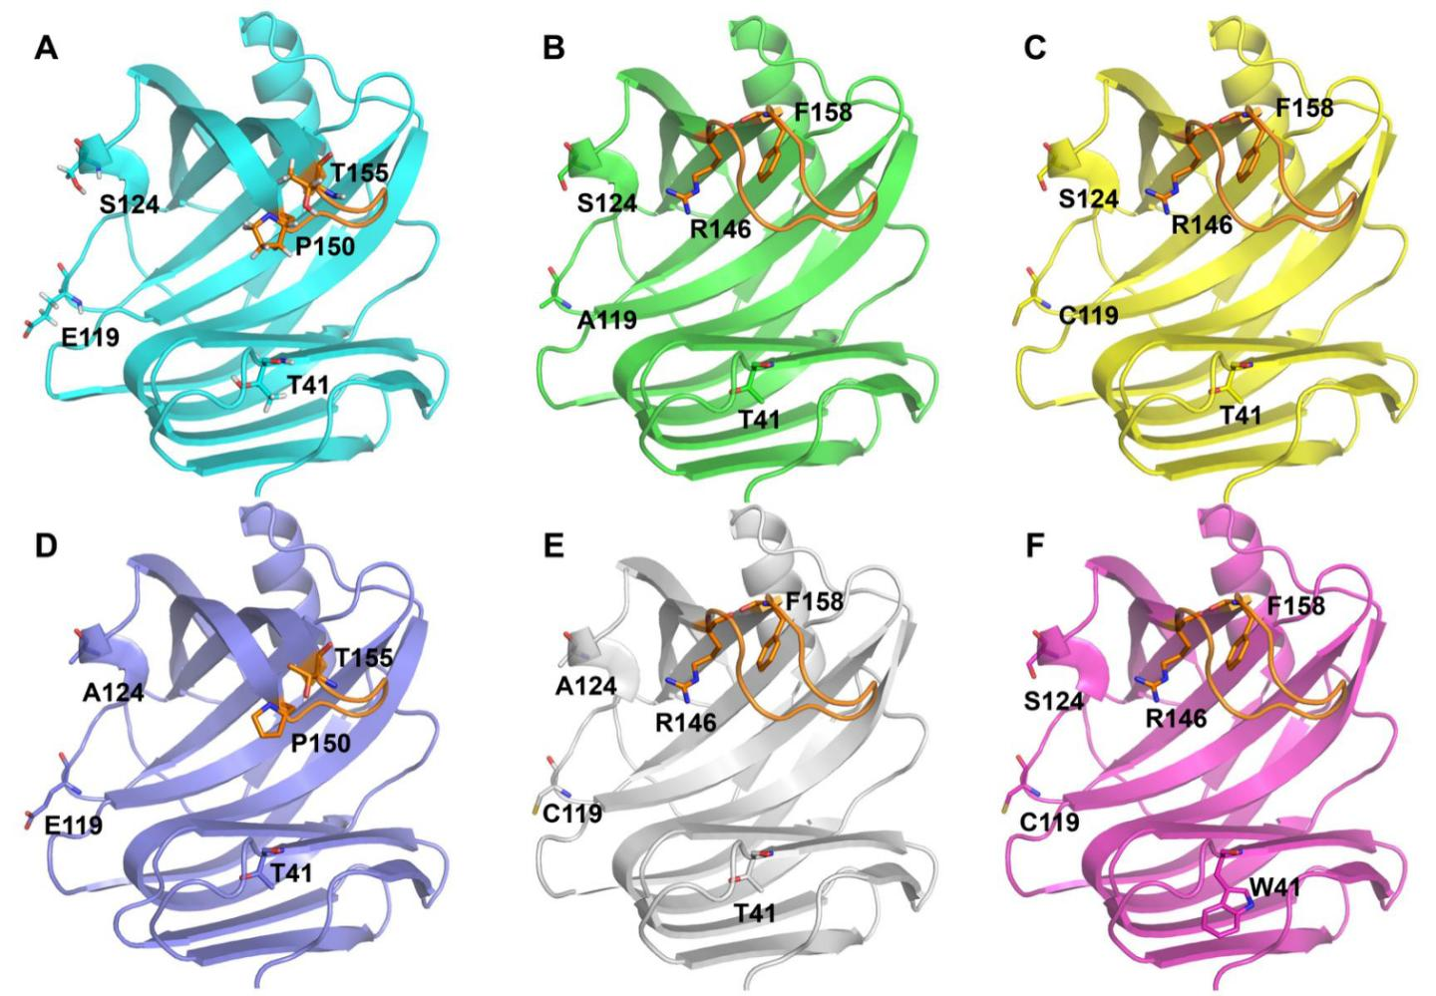
Figure S10. Comparison of the RMSF values of the wild-type XynASP and its mutants.

