Giao diện chính: button play, background, button setting, button ads

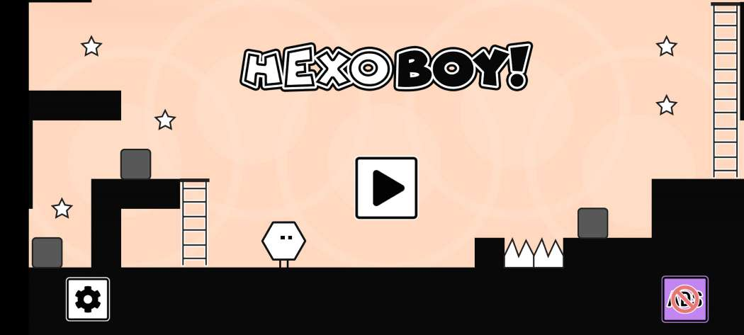

Button ADS => click to Shop(Iap, Skin, unlock map)

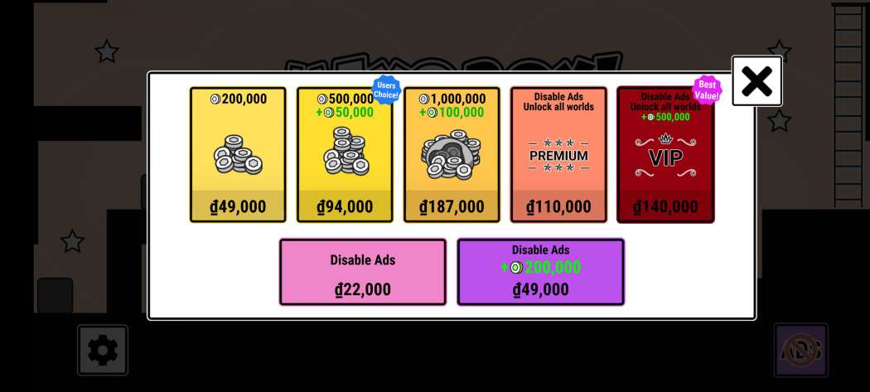

Button Setting

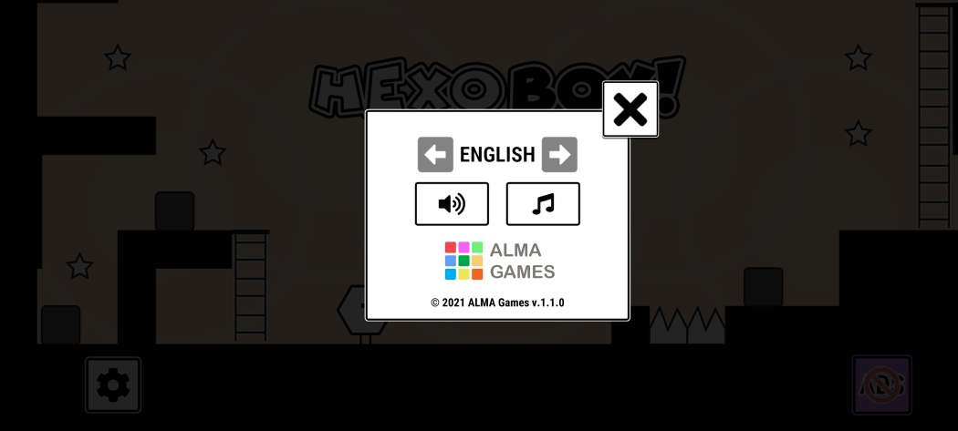

Home: Map, Shop, game slot, Skin, ADS, coin1, coin2

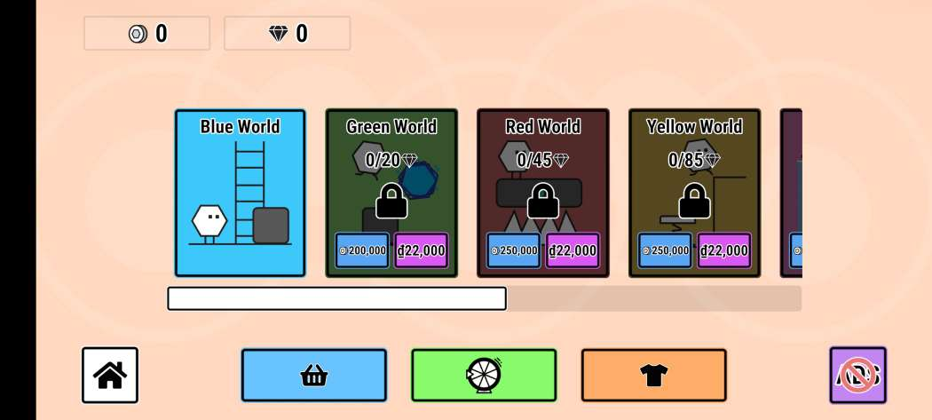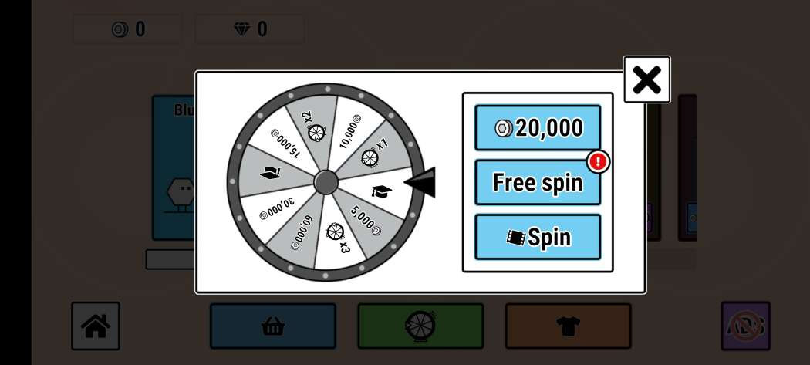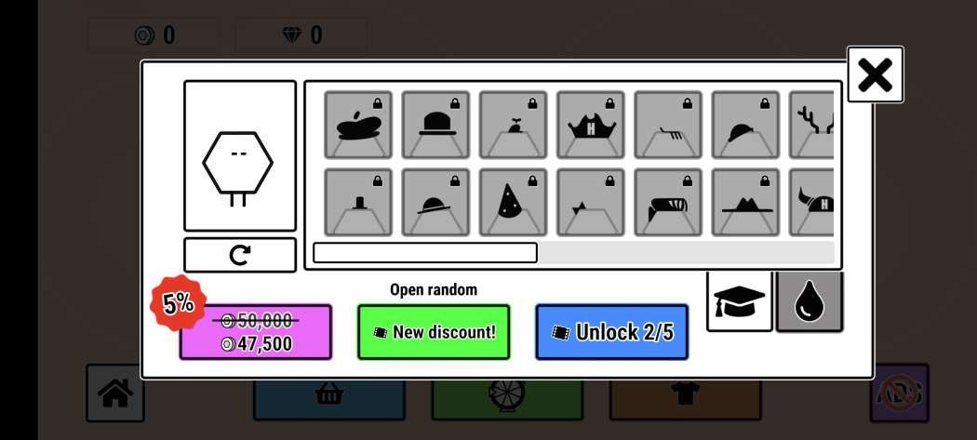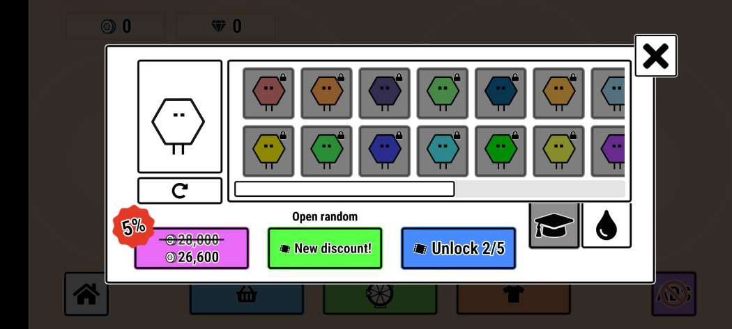

Game play: left, right, up, down, play/pause, jump…

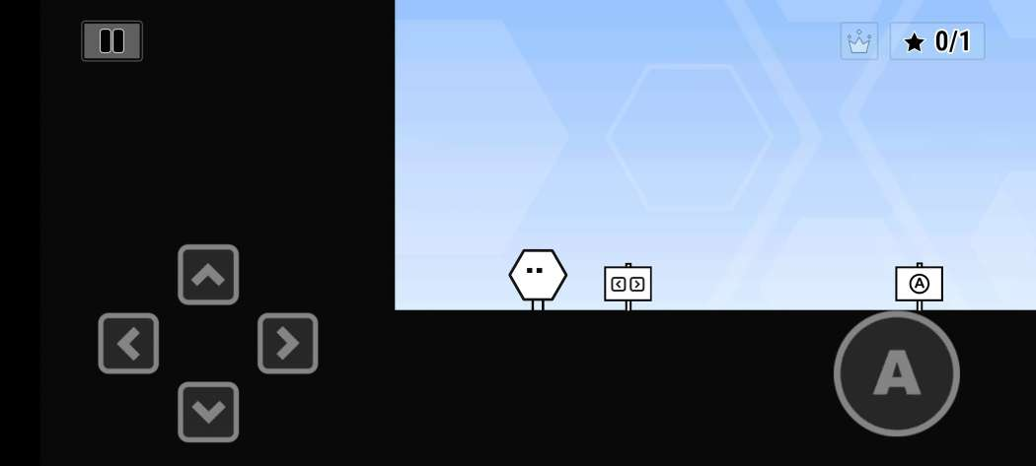

Finishmap

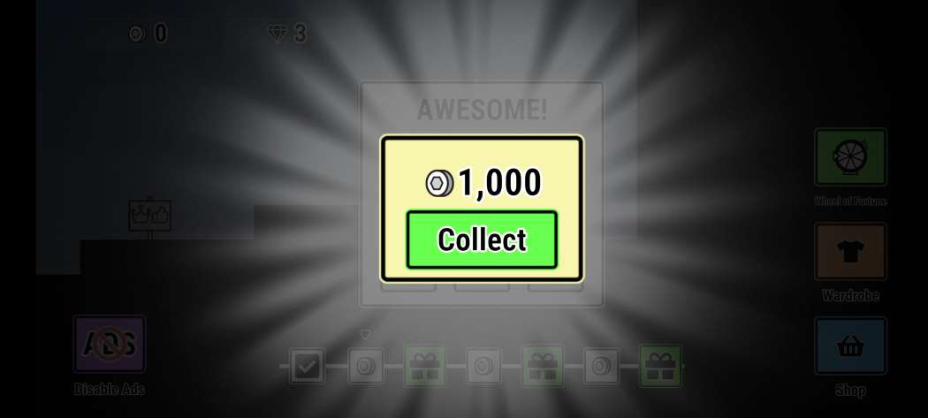

Link chơi game: <https://youtu.be/S03PU1WgAnQ>