EmguCV安装+配置
- 简介
EmguCV即C#下的OpenCV库。
- 安装
  - 去https://sourceforge.net/projects/emgucv/?source=dlp 下载2.4.9版的Emgu库。由于太大了也可以来我这拷，有200多MB。
  - 安装，一路下一步中间可以去掉对于低版本VS的支持。
- 第一个OpenCV程序
  - 新建一个WinForm项目
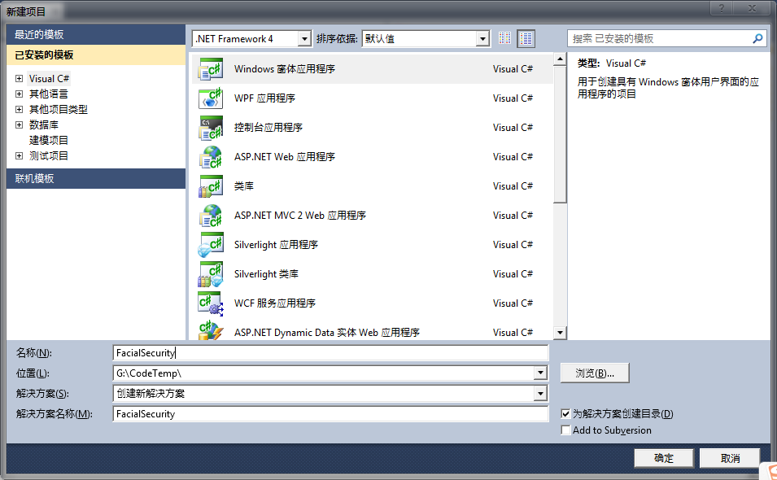
  - 添加引用
把VS2010安装目录下的Microsoft Visual Studio 10.0\Common7\Packages\Debugger\Visualizers里的Emgu开头的4个dll文件引用到项目。
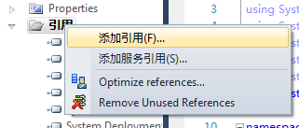
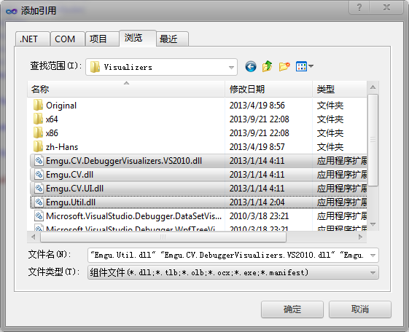
  - 写测试代码
    - 在窗体上拖一个按钮上去
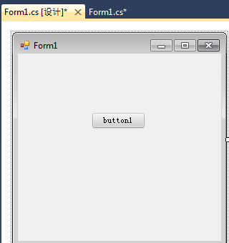
    - 双击按钮添加响应函数，将以下代码拷进去。
OpenFileDialog openFileDialog = new OpenFileDialog();
openFileDialog.Filter = "BMP文件|*.bmp|JPG文件|*.jpg|JPEG文件|*.jpeg|所有文件|*.*";
if (openFileDialog.ShowDialog() == DialogResult.OK)
{
CvInvoke.cvNamedWindow("打开图片");
IntPtr img = CvInvoke.cvLoadImage(openFileDialog.FileName, Emgu.CV.CvEnum.LOAD_IMAGE_TYPE.CV_LOAD_IMAGE_UNCHANGED);
CvInvoke.cvShowImage("打开图片", img);
CvInvoke.cvWaitKey(0);
CvInvoke.cvReleaseImage(ref img);
CvInvoke.cvDestroyWindow("打开图片");
此时Resharper应该会提示缺少using命名空间，如图
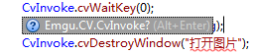这时候点一下Resharper就自动帮你把using写了，方便吧。
    - 编译。
  - 运行
编译不会有问题，运行点击按钮，会弹出一个选择图片文件的对话框，默认是bmp格式，随便打开一个，这时候应该会弹出一个运行时错误对话框，如图
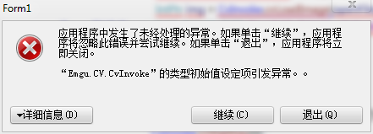
当然如果没弹出更好……
  - 解决问题
第一步：
首先尝试这个。因为我是先做了第二步没用再做第一步然后成功了的，所以我不确定是不是只需要做第一步就可以成功。
把Emgu安装目录下的这个文件夹Emgu\emgucv-windows-universal-gpu 2.4.9.1847\bin\x86里的所有dll都拷贝到项目目录下的debug的bin里面，也就是exe的所在目录。其中有一个300多m的可以不拷，其实看下面的解决办法原文就能知道其实只要拷特定的一些dll就行了，但是太麻烦了干脆全拷了（300m那个太大就不拷了）。
第二步：
如果上面的不行，再安装MSVCRT（下面原文里有链接，按住Ctrl访问），我会放在邮件的附件里，一个是32位的一个是64位的，保险起见我都装了，话说我不知道32位系统能不能装64位的囧。
这样以后再运行，应该就没问题了。
这个例子是打开一个图片并显示。
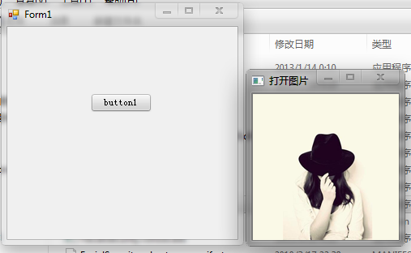
  - 解决方案原文
The type initializer for 'Emgu.CV.CvInvoke' threw an exception.（Emgu.CV.CvInvoke 的类型初始值设定项引发异常）
If you see this exception, please check the following

Have you installed MSVCRT?
- For Version 2.4+, the bundled OpenCV binary is build with Visual Studio 2010, you will needs to installed MSVCRT 10.0 SP1 x86 or MSVCRT 10.0 SP1 x64 to resolve the dependency issue.
- For Version 2.0+, the bundled OpenCV binary is build with Visual Studio 2008, you will needs to installed MSVCRT 9.0 SP1 to resolve the dependency issue.
- For Version 1.5, the bundled OpenCV pre1.1 binary is build with Visual Studio 2005, you will needs to installed MSVCRT 8.0 SP1 to resolve the dependency issue.

Have you copied the OpenCV dlls to the execution directory?
- Make sure the unmanaged DLLs are in the execution directory.
  - For Emgu CV version <= 2.1, this means the following dlls:cvXXX.dll, cvauxXXX.dll, cxcoreXXX.dll, highguiXXX.dll, opencv_ffmpegXXX.dll, mlXXX.dllcvextern.dll where XXX is the OpenCV version number.
  - For Emgu CV version 2.2, 2.3 this means the following dlls: opencv_calib3dXXX.dll, opencv_contribXXX.dll, opencv_coreXXX.dll, opencv_features2dXXX.dll, opencv_highguiXXX.dll, opencv_imgprocXXX.dll, opencv_legacyXXX.dll, opencv_mlXXX.dll, opencv_objectdetectXXX.dll, opencv_videoXXX.dll where XXX is the OpenCV version number.
  - For EMGU CV version >=2.4 cudart64_42_9.dll, cvextern.dll, npp64_42_9.dll, opencv_calib3dXXX.dll, opencv_contribXXX.dll, opencv_coreXXX.dll, opencv_features2dXXX.dll, opencv_flannXXX.dll, opencv_highguiXXX.dll, opencv_imgprocXXX.dll, opencv_legacyXXX.dll, opencv_mlXXX.dll, opencv_nonfreXXX.dll, opencv_objectdetectXXX.dll, opencv_videoXXX.dll, where XXX is the OpenCV version number.
- The best way to set up your project is:
  - Copy the unmanaged DLLs to your project folder
  - Right click on the project, click Add->Existing Item and select all unmanaged DLLs. Add them to the project.
  - For each of the included Dlls, left click on it, find the "Copy to Output Directory" option and select "Copy if newer"

- 至此，EmguCV算是配置完毕了。

