CS555/455 Summer 2012

Assignment 2
(Due on July 16, 2012. 10:00pm)

Programming: Scale Space using Laplacian of Gaussian operator; Unsharp Masking, and Sobel Operator;

Description: Unsharp masking, Sobel operator, Laplacian of Gaussian operator, and Scale Space filter can be used for edge detection and enhancement. Apply these operators to a gray scale image to generate the edge image. In this assignment, you will implement these algorithms, and get various details of edge information in a given gray scale image.

Your implementation:
- Obtain image f1 (“basel_gray.bmp) and f2 (“ant_gray.bmp), and display;
- (20%) Apply the Unsharp Masking method to enhance the edges of images(f1, f2) and obtain the enhanced image E1 and E2;
- (20%) Apply the Sobel operator to the two images (f1, f2) and generate the edge image Es1 and Es2;
- (20%) Generate LOG Mask1 7*7 (sigma = 1.4) and Mask2 11*11 (sigma=5.0).
- (20%) Apply Mask1 and Mask2 to intensity images (f1, f2), obtain two sets of edge images (E1_1, E1_2) for f1, and (E2_1, E2_2) for f2; Explain which images have more detailed edge information, and explain why.
- (Extra points 10%) Based on two different scales defined by the above Mask1 and Mask2, design an algorithm to find the zero-crossing points for fine edge detection in a scale space.
- (Extra points 10%): Apply Canny Edge detection approach to extract the edges in the image f1 and f2.

II. Hand-in

- Code package: Your program package includes all the files that can be re-compiled, executed, and demoed.
- Write-up (20%): Report the experimental results along with figures and your description of the algorithms you designed and implemented, so that the reader can understand the method you used. Note: in the report, you should include following sections:
- Author’s Name and Email.
- Purpose of the project
- Method
- Results
- Bug report (if any), which includes “PARTS THAT ARE NOT COMPLETE” indicating any uncompleted parts of the project and any BUGS in your program that you are aware but have no idea why they exist.
- Report extra work for extra credit (if any)
- References (if any): Document here any sources, books, internet resources you have benefited from.
- Submit your code and report (in a .ZIP file) through blackboard on/before the due date.

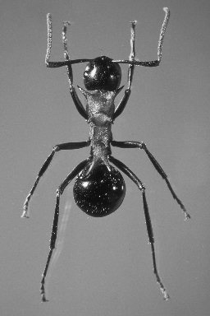

Ant Image

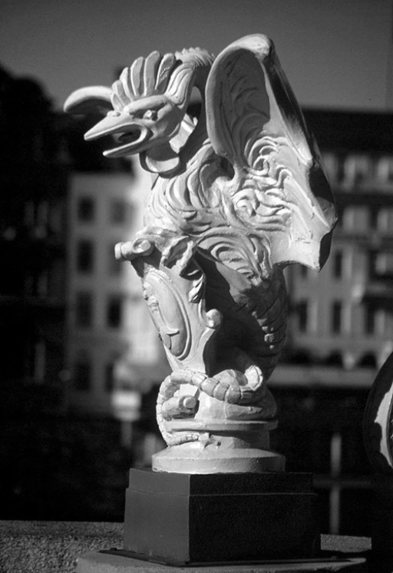
Basel Image

