CS555/455 Summer 2012
CS555 Assignment 3
(Due on August 6, 2012, 10:00pm)

Part A: DCT based image compression

Description: DCT transformation refers to the transform between image spatial domain and frequency domain. In the first part of the assignment, you are required to realize a simplified version of DCT based compression.

- (30%) Consider the following sequence of values:

  - 11 12 11 12 13 12 11
10 -10 8 -7 8 -8 7 -7

- (10%) Transform each row separately using an eight-point DCT. Plot the resulting 16 transform coefficients
- (10%) Combine all 16 numbers into a single vector and transform it using a 16-point DCT. Plot the 16 transform coefficients
- (10%) Compare the results of (a) and (b). For this particular case would you suggest a block size of 8 or 16 for greater compression? Justify your answer

(50%) 2D image compression:
- Obtain image f1 (“basel2.bmp”) and display;
- (10%) Convert image f1 from RGB to HSI, obtain intensity image I.
- (10%) Apply 8*8 DCT transform to image I, obtain frequency domain image F;
- (10%) In each 8*8 frequency block, keep DC component and remove all other frequency components from F, obtain frequency domain image D1;
- (10%) Similar to (4), in each 8*8 frequency block, keep first 9 low frequency components and remove all other high frequency components from F, obtain frequency domain image D2;
- (10%) Apply IDCT on D1 and D2, obtain image R1 and R2. Explain which image is more blurred, and why.

Basel2.bmp
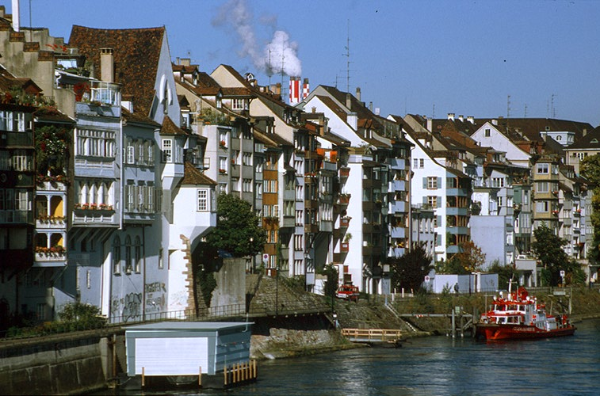

Part B: (Extra 20 points) Design your algorithm to count the number of flowers for five images in “Images.rar” using color information.

Note (Hand-in)

- Code package: Your program package includes all the files that can be re-compiled, executed, and demoed.
- Write-up (20%): Report the experimental results along with figures and your description of the algorithms you designed and implemented, so that the reader can understand the method you used. Note: in the report, you should include following sections:
- Author’s Name and Email.
- Purpose of the project
- Method
- Results
- Bug report (if any), which includes “PARTS THAT ARE NOT COMPLETE” indicating any uncompleted parts of the project and any BUGS in your program that you are aware but have no idea why they exist.
- Report extra work for extra credit (if any)
- References (if any): Document here any sources, books, internet resources you have benefited from.
- Submit your code and report (in a .ZIP file) through blackboard on/before the due date.

