## JavaScript, DOM, JSON, AJAX and JPA

General part

* Explain about the Document Object Model, and why it’s extremely relevant for modern Web-development
* Explain how JavaScript fit’s into modern Web Development
* Explain (using an example of your own choice) about JavaScript events, and Event Bubbling
* Explain (in words) the purpose of the JavaScript-arrays filter and map methods (also, provide a few examples)
* Explain the topics AJAX and how it has changed the way modern web-applications are created
* Elaborate on how JSON or XML supports communication between subsystems, even when the subsystems are implemented on diﬀerent platforms.

CA or Semester Project

For a real exam exercise, this will be a small part where you are expected to talk, in about 5 minutes, about the semester project or one of the semester CA’s (related to the topic for this question).

Practical part start (use this [index.html file](https://github.com/Cphdat3sem2017f/StartcodeExercises/blob/master/JS/index.html) as your start template)

Design a simple SPA using plain JavaScript, and fetch(for server requests). The application should allow users to create test data representing a person. Initially these data must be presented in a table, but the page must include a “Get SQL ..” button to convert the test data into a valid SQL INSERT Script, presented in the TextArea given in the start code.

**Getting started:**  Create a web-project (in whatever way you prefer) and include the index.html file given above in the project. “Run” the file in a browser to see the provided layout for the exercise. Observe script-tag, in the bottom. Create this file (app.js) and place all your JavaScript in this file.

**1)** You must use this public [REST API](https://github.com/thm/uinames/) to get data for the exercise:

Copy the link below into your browser and test. To get a feeling of how to use the API, try (as a minimum) to: remove *region*, change *gender* to *male*, remove *gender*, change *amount* to 600;

<http://uinames.com/api/?amount=25&region=denmark&gender=female>

**2)** Add the necessary code to (using fetch, the API given above, and DOM-manipulation) render a table as sketched in this figure, when the “Submit” button is pressed. 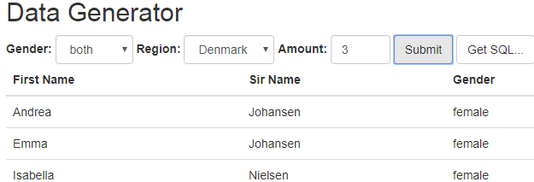

**2a)** Add a way to present errors for the users (try and request more than 500 names). Hint: Check if the response code is >= 400.

**3)** If not already done, find a way (the simplest and acceptable for this exercise, is a global variable, but feel free to come up with better alternatives) to store the data fetched above, so we can reuse it in it’s original form.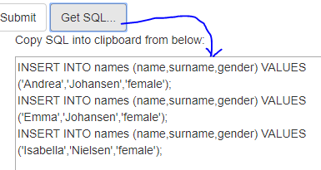

**4)** Add the necessary code to convert (when Get SQL is pressed) the data into valid MySQL syntax that will insert data, into a table with matching columns as sketched in this figure. Insert the generated SQL into the TextArea provided with the startcode.

*Hints: You can insert the SQL into the TextArea like this: document.getElementById("sql").value = sql;*

*If you have stored the data as requested in 3, and know how to use* ***map*** *and* ***join****, this should be relatively simple ;-)*

**5)** Using the generated SQL-script

This steps assumes step 1-4 is complete (if not see hints at the bottom). Now lets create a JPA-application with an Entity class, which rows are populated from the script you get from step-4.

Create a new plain Java Maven project. In this project create an Entity Class with properties matching those inserted into the script created in step4.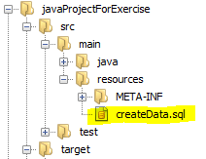

**6)**

In this project, create a file createData.sql in the exact location as sketched in this figure:

Paste the Script, generated via the feature implemented in step-4, into this script.

Add this line to your persistence.xml file (set the file to drop-and-create):

<property name="javax.persistence.sql-load-script-source" value="createData.sql"/>

Create the schema, for example by executing: Persistence.generateSchema("YOUR-PU-NAME", null);

Verify that data is inserted into the table, either by executing a select all, up against the database or, better, by creating a JPQL-Query that will fetch all data

*Hint: If you had problems with step-4, you can Create the script manually, with just a few names, and use that script for these steps. When/if this works, go back to step-4, and use this working script as template for what you have to create.*