**Object Relational Mapping and Inheritance with JPA**

General part

* *Describe how we have handled persistence in the last three semesters. The considerations should include all relevant layers. File IO, Relational Databases, the browsers local storage and cookies on the browser.*
* *Explain the JPA strategy for handling Object Relational Mapping and important classes/annotations involved*
* *Explain how Inheritance in an OO language can be mapped to tables in a relational database*
* *Explain (at least two) JPA-strategies for Inheritance Mapping*

CA or Semester Project

For a real exam exercise, this will be a small part where you are expected to talk, in about 5 minutes, about one of the semester CA’s or the semester project (related to the topic for this question).

Practical part

We need JPA mappings for this domain:

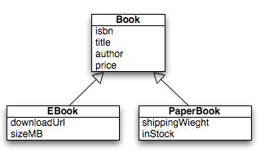

It models a naive implementation of Book-types for a Web-Book store

Create a Maven Java Application with NetBeans and design a JPA solution that implements:

* The Book Entity class (use isbn as id/primary key).
* The sub Entity Classes EBook and PaperBook. You decide which inheritance model to use, but you must argue for your choice and explain all columns in the corresponding tables.
* Make a small program that shows the four CRUD operations involving all classes.
* Makes sure to demonstrate, polymorphism in one of the examples above (fetch all Books, iterate over the collection and explain the result)

If you have time: If you would add this annotation @Column(nullable = false) on top of for example the downloadUrl field, which Inheritance Strategy would fail if you actually tried to insert a Book or a PaperBook)