QBEM技术文档目录

1. QBEM用户说明书
1.1中文用户说明书（4页）
1.2 Introduction to QBEM （英文用户使用手册）（25页）
2. QBEM设计说明书
2.1 QBEM源程序文件说明（2页）
2.2 QBEM输入语言详细说明（9页）
2.3 QBEM三维几何造型与边界元划分类库说明（11页）
3. QBEM测试说明书（4页）

QBEM中文用户说明书

本文档对三维互连寄生参数提取器QBem处理的各种电容器结构进行说明，包括示意图、输入文本。

整体分层结构（如图）
(6.5, 10.3)
(6.5, 0)
(0, 0)
x
y
z
- 大介质层为沿Z轴方向依次堆叠的长方体，它们在XOY平面上投影为矩形。
- 衬底是电压为0V的导体平面，可能出现在结构的最底部和最顶部。
- 任何一块导体块都包含于某层介质中。
- （建议Window的任一边长不应小于三个特征尺寸，以避免非常薄片的出现）

二．导体说明
- 导体为底面平行于XOY平面的多边形直棱柱，或者是底面平行于其他坐标平面的多边形直棱柱（该导体悬于某层介质内或只与下底面相贴，如下左图）。用户可以用一个多边形来描述一块导体的底面，也可以将其分成几个相对简单的多边形来描述。右下图显示的是较复杂的导体底面情况。
- 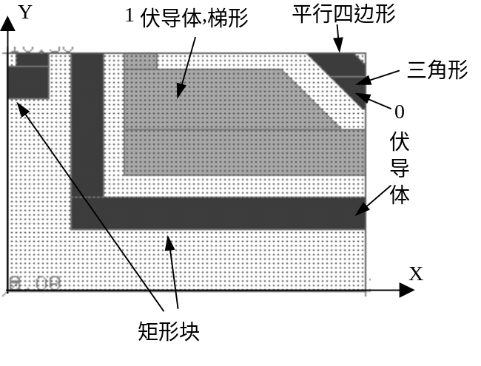沿Z方向，导体的位置可以是四种情况，如图。其中，
某种特殊导体结构可看成由若干个底面平行于其他坐标平面的直棱柱组成
- 互连线下底面贴着介质交界面。
- 通孔上底面贴介质交界面，下底悬空。
- “悬空导体”上下底都悬空，主要是在一些paper给出的例子，或用于理论分析的例子中见到。
- “特殊通孔”上下底都与介质边界相贴，主要在一些paper给出的例子见到，或者是连接非邻层的通孔。
互连线
通孔
悬空导体
特殊通孔
方向
Z
- 加1V偏压的导体称为主导体，其他导体加0V（环境导体）。规定主导体必须只有一块、或者是相互连通的几块导体。建议主导体块均在一介质层中，否则可能影响计算精度（Warning信息）。
- 错误认定：如果输入的两个导体重叠（相交区域体积大于零），做出错处理。若导体的位置、形状等方面违反上述规定，也认为输入错误。程序中实现代价较小的错误情况判断，因此错误输入造成的结果不可预期。

三．介质说明
在用QBem语言描述需计算的结构时，要求先输入介质，后输入导体。输入介质应遵循以下规则：
- 任意两介质（<medium>描述）只允许有“分离”和“包含”关系（表面可以相贴），不允许有重叠关系（相交区域体积大于零）。
- 后输入的介质只可能被包含于前面的介质之中，而不允许反过来。
- 相邻两大介质层不允许重叠和Z方向上存在间隙。

说明：
- 在<medium>描述块内使用多个<block>或者<poly>描述，可以表示比较复杂的介质形状，如conformal介质。
- 同一个<medium>描述中的多个<block>或者<poly>可以相交，并且它们的几何并运算结果为一个多面体。

下面结合输入文本，介绍三种较特殊介质的输入：小介质（气泡），Conformal介质和多平面。

例1小介质
特点：
- 往往是嵌在大介质（或conformal介质）中的气泡。
小介质
<medium>
……
</medium>
大介质层，及包含小介质的其他介质
……

<medium>
……
</medium>
<medium 小介质>
//详细的几何参数
</medium>

例2 Conformal介质
几何特点：
- 一个底面与大介质相同、高为h的介质，加上由各导体块向上和向四周扩展h得到的小介质，它们的并集就是Conformal介质。右图显示了一个含Conformal介质层的俯视图和正视图。
- 通孔导体可能穿过Conformal介质。
<medium>
……
h
通孔
</medium>
……
大介质层描述
<medium>
……
</medium>
<medium>
<block>
……
</block>
组成这个Conformal结构的各个介质块描述
……
<block>
……
</block>
diel 介电常数
</medium>
注意：如果出现多层Conformal结构，先描述外层Conformal，再描述内层Conformal。
外层con-
formal
内层con-
formal

例3多平面介质
右图显示了一层大介质中含多平面介质结构，其中三层介质介电常数分别为ε1、ε2、ε3。
ε3
ε2
ε1
z₀
z₁
z₂
z₃
<medium>
……
</medium>
……
大介质层描述
<medium>
……
</medium>
……
<medium>
<block>
……
basepoint (x, y, z₀)
……
hvector (x, y, z₁-z₀)
</block>
diel ε1
</medium>
<medium>
<block>
……
basepoint (x, y, z₁)
三个小介质描述，构成多平面结构
……
hvector (x, y, z₂-z₁)
</block>
diel ε2
</medium>
<medium>
<block>
……
basepoint (x, y, z₂)
……
hvector (x, y, z₃-z₂)
</block>
diel ε3
</medium>
说明：
- 由于多平面结构的特点，用户可以输入z₁-z₀高度、z₃-z₂高度、z₂-z₁高度三段互相分离的介质，也可以依次输入z₃-z₀高度、z₂-z₀高度、z₁-z₀高度三段嵌套介质。
- 对多平面介质的特点是导体能够穿过多个介质。因此，对此情况处理，应该先判断出多平面介质，重新生成介质层数据。然后沿多平面位置切割有关导体为多块，加入新的介质层中。

/***********************************************
Creating Document: 2002/4/26－2002/5/10，by yuwj
Modification: 2002-5-13, by yuwj
***********************************************/

Introduction to QBEM

Overview
QBEM is developed for parasitic modeling in the semiconductor industry.

QBEM can simulate the electrical analysis of three-dimensional structures, such as on-chip interconnect structures, packaging, multi-chip modules, and printed circuit boards. The following electrical areas is covered in QBEM:
• Resistance
• Capacitance

Three-Dimensional Field Solver
QBEM solve three-dimensional electrical problems both in capacitance and resistance. Different areas of parasitic simulation analysis present special design challenges. To facilitate the generation of three-dimensional structures, QBEM allows for the input of three-dimensional structures from different sources. Because the input languages of the solvers allow for parametric definition of variables, a design of a three-dimensional structure can be developed from these sources. There is one convert tool named “QBEMIN” which can generate the three-dimensional structures by GDSII file, technology file and mapping file together. QBEMIN will be introduced in chapter 1. However, this approach is problematical when the number or complexity of the input structures is above a certain limit.

Chapter 1 Usage of QBEMIN

GDS II Interface
The GDS II Stream format is the most widely used data format for layout representation. A GDS II file stores layout information as polygons, lines, or labels in up to 1,024 different layers.

(to be finished by Wang Yuan or Xiaodong)

Usage of QBEMIN
QBEMIN can generate the input file of QBEM according to the specified files. Three files are used in QBEMIN as following:
          - Techology file.
          - GDSII file interface.
          - Layer mapping file.

These file format will be described in the next sections.

Command Lines of QBEMIN
After the compilation, the executive program QBEM will be generated. QBEM can be executed with the command line as follows:

QBEMIN <GdsFile> [Option]

<GdsFile> is the GDSII file name. It should be given out.
[Option] can be the following:

- -tech Techfilename
<Techfilename> is the technology definition file name. It should follow the option <-tech>. If no technology file name specified, QBEMIN will use the default file named “TECHFILE”.

- -map Mapfilename
<Mapfilename> is the layer mapping definition file name. It should follow the option <-map>. If no mapping file name specified, QBEMIN will use the default file named “MAPFILE”.

- -h
Using “-h” option can display the help information of QBEMIN.

- -o OutFilename
QBEMIN can use the specified file name as the output file with the “-o” option. The default output file name is “qbem_format”.

Example:

- Convert the GDSII file named “gdstest.gds” to “qbem_format”. “TECHFILE” and “MAPFILE” are existed in the current directory. The following command can be used:
QBEMIN gdstest.gds
- Convert the GDSII file named “gdstest.gds” to “myqbem”. Using the “Mytech” as the technology file. Using the “Mymap” as the mapping file. The following command can be used:
QBEMIN gdstest.gds –tech Mytech –map Mymap –o myqbem

Technology File
Technology file is used to define the semiconductor process. It consists of comments and/or definitions.

- In technology file, all statements are case insensitive.
- The lines are comments if they are leaded by “//”.
- The line leaded by “+” is the continuous line.
- Definition of conductor is in the following format:
Conductor %{
Definition
}
The syntax of the definition is as the following:
Conductor Name
+ Thickness (unit = A)
+ Thickness variation ( +/- %)
+ MinWidth (unit = um) (drawWidth / SiWidth(tw/bw))
+ WidthVariation (+/-%)
+ MinSpace (unit = um) ( drawSpace / SiSpace(ts/bs))
+ SheetResistance(width1 : ohm/square, width2: ohm/square, …..)
+ TC(Temperature Coefficient) (delta/C)
+ Height (Nominal Distance Between conductor layer and substrate under FOX) (A)
+ OverEtch (um)

Definition of conductor is in the following format:
Dielectric %{
Definition
}
The syntax of the definition is as the following:
DielectricLayer Name
+ Thickness (unit = A)
+ Thickness variation ( +/- %)
+ DielectricConstant
+ Conformal(Yes/No)
+ Height(Nominal Distance Between conductor layer and substrate under FOX) (A)
+ Note (Optional)

Example of Technology File
Here is one example of technology file which define the semiconductor process as shown in Figure 1.1.

~~~~~~~~~~~~~~~~~~~~~~~~~~~~~~~~~~~~~~~~~~~~~~~~~~
//========================================//
// Example of Technology File //
//========================================//

TECHNOLOGY=TECHTEST

// Dielectric Layer Definition
Dielectric%{
Substrate
+ Thickness(A) = 0.0
+ Height(A)=0.0
+ Dielectric=3.9
}
Dielectric%{
Layer0
+ Thickness(A)=5500
+ Dielectric=4.2
+ Height(A)=5500
}

Dielectric%{
Layer1
+ Thickness(A)=4000
+ Dielectric=3.9
+ Height(A)=9500
}

Conductor%{
Metal1
+ Thickness(A)=2800
+ MinWidth(um)=0.2 (0.24/0.2)
+MinSpace(um)=0.21(0.17/0.21)
+SheetResistance(ohm/square)=0.098
+Height(A)=8300
}

Dielectric%{
Layer2
+ Thickness(A)=4900
+ Dielectric=3.71
+ Height(A)=14400
}
Conductor%{
Metal2
+ Thickness(A)=3700
+ MinWidth(um)=0.2 (0.24/0.2)
+MinSpace(um)=0.21(0.17/0.21)
+SheetResistance(ohm/square)=0.057
+TC(delta/C)=0.0038
+Height(A)=13200
}

Dielectric%{
Layer3
+ Thickness(A)=5000
+ Dielectric=8.1
+ Height(A)=19400
}
~~~~~~~~~~~~~~~~~~~~~~~~~~~~~~~~~~~~~~~~~~~~~~~~~~
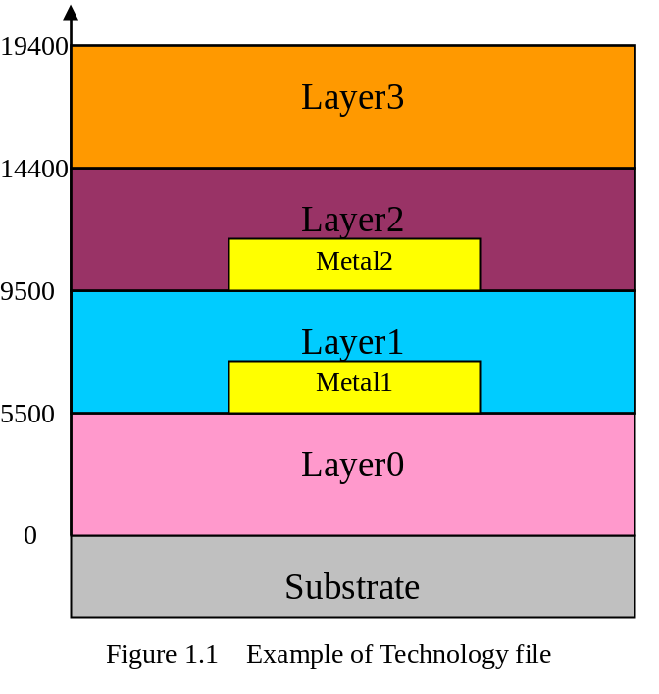

Mapping File

Chapter 2 Using QBEM

Command Line
After the compilation, the executive program QBEM will be generated. QBEM can be executed with the command line as follows:

QBEM <FILE>

<File> is the file name of the QBEM input file whose format will be defined in the next section. QBEM will give an output file named <File.out> after the computation whose format will be introduced in the post sections in this manual.

QBEM Input File Format

3D format file is used to describe 3D structures for accurate extraction. QBEM uses the 3D format file as the input file.

The syntax of the input file is explained in the next section, If no options are specified, QBEM reads <file>, makes calculations according to the input, and writes the results to the output file named <file>.out.

The input file statements consist of comments and/or commands.
- Lines beginning with /* and ending with */ are comment lines and can be ignored.
- All commands may be defined by the set description statements. The set description statements use the signs similar with HTML. It should begin with <> and end with [/].
- The following commands are available in QBEM which can be classified into 3 groups:
  - Identified commands: QBEM.
All the other commands should be included in this command.
  - Primary commands: WINDOW, MEDIUM, CONDUCTOR, PORT, TASK.
  - Basic geometry definition commands: BLOCK, POLY.
The geometry definition commands can be included in the primary commands “MEDIUM, CONDUCTOR, POR”.
  - Task definition commands: CAPACITANCE, RESISTANCE, CHARGE, CURRENT.
The task definition commands can only be included in command TASK.
- The input to QBEM is case insensitive, meaning two instructions when written with all lowercase or all uppercase letters are same.
The syntax and usage of each command are described in this section.

Identified Command

QBEM
The QBEM command is the symbol of the QBEM input format file. The file should start with <QBEM>, and end with [/QBEM].

Primary Commands

WINDOW
The WINDOW command sets the simulation cube size in three-dimension. A reflective (or, Neumann) boundary condition is applied on the six surfaces of the simulation window.

<window>
v1 <VECTOR>
v2 <VECTOR>
[/window]

Parameter | DataType | Definition
V1 | vector | Coordinates of the left bottom of the window
V2 | vector | Coordinates of the right top of the window

MEDIUM
The MEDIUM command describes one dielectric in three-dimension when compute the capacitance. It can contain one or more basic geometry description statements.

<medium>
<BASIC GEOMETRY DESCRIPTION>
[<BASIC GEOMETRY DESCRIPTION>]
…
diel <VALUE>
[/medium]

Parameter | DataType | Definition
Basic Geometry | definition | Geometry description statements, such as : BLOCK, POLY.
diel | value | Permittivity of dielectric

CONDUCTOR
The CONDUCTOR command describes one conductor in three-dimension. It can contain one or more basic geometry description statements.

<conductor>
name <NAME>
<BASIC GEOMETRY DESCRIPTION>
[<BASIC GEOMETRY DESCRIPTION>]
…
[rho <VALUE>]
[volt <VALUE>]
[/conductor]

Parameter | DataType | Definition
name | character | Name of the conductor. NAME must begin with an alphabetic character, but may include up to 100 alphanumeric characters.
Basic Geometry | definition | Geometry description statements, such as : BLOCK, POLY.
rhol | value | Resistivity of conductor. It should be defined when computing resistance.  (units: ohm·um)
volt | value | Potential of conductor. It can be specified when computing charge distribution.  (units: Volt)

PORT
The PORT command describes one port in three-dimension when compute the resistance. It can contain one or more basic geometry description statements.

<port>
name <NAME>
<BASIC GEOMETRY DESCRIPTION>
[<BASIC GEOMETRY DESCRIPTION>]
…
[volt <VALUE>]
[/port]

Parameter | DataType | Definition
name | character | Name of the conductor. NAME must begin with an alphabetic character, but may include up to 100 alphanumeric characters.
Basic Geometry | definition | Geometry description statements, such as : BLOCK, POLY.
volt | value | Potential of conductor. It can be specified when computing the current.  (units: Volt)

TASK
The TASK command defines the specific computational task to be carried on. Four different tasks can be executed including: CAPACITANCE, CHARGE, RESISTANCE and CURRENT.
<task>
<TASK DEFINITION>
[TASK DEFINITION]
…
[/task]

Parameter | DataType | Definition
Task Definition | definition | Task definition statements, such as : CAPACITANCE, RESISTANCE, CHARGE and CURRENT.

Task Definition Commands

CAPACITANCE
The CAPACITANCE command defines task to compute the self capacitance on the specific conductor and all the coupling capacitance between it and all other conductors.
<capacitance>
<CONDUCTOR NAME>
[<CONDUCTOR NAME>]
…
[ALL]
[/capacitance]

Parameter | DataType | Definition
Conductor NAME | character | The NAME of the specific conductor for capacitance computation. If the NAME is “ALL” means all the capacitances will be extracted.

RESISTANCE
The RESISTANCE command defines task to compute the resistance between the specific port and all other ports.
<resistance>
<PORT NAME>
[<PORT NAME>]
…
[ALL]
[/resistance]

Parameter | DataType | Definition
PORT NAME | character | The NAME of the specific port for resistance computation. If the NAME is “ALL” means all the resistances will be extracted.

CHARGE
The CHARGE command defines task to compute the charge on the specified conductor. The parameter “volt” of CONDUCTOR command should be defined.
<charge>
<CONDUCTOR NAME>
[<CONDUCTOR NAME>]
…
[ALL]
[/charge]

Parameter | DataType | Definition
Conductor NAME | character | The NAME of the specific conductor for charge computation. If the NAME is “ALL” means all the charges will be extracted.

CURRENT
The CURRENT command defines task to compute the current to the specified port. The parameter “volt” of PORT command should be defined.
<current>
<PORT NAME>
[<PORT NAME>]
…
[ALL]
[/current]

Parameter | DataType | Definition
Port  NAME | character | The NAME of the specific port for current computation. If the NAME is “ALL” means all the current will be extracted.

Basic Geometry Definition Commands

BLOCK
The BLOCK command defines a rectangular box. Here vector is the collection of three numbers X,Y,Z, separated by commas. These numbers are coordinates of a vector on a global coordinate system (See Figure 1).

<block>
basepoint <VECTOR>
v1 <VECTOR>
v2 <VECTOR>
hvector <VECTOR>
[/block]

Parameter | DataType | Definition
basepoint | Vector | Coordinate of the base point of the block.  (default units: microns)
V1 | Vector | Direction vector of the length axis. This vector is defined in the local coordinate system according to the base point. The magnitude of this vector is the length of the block.  (default units: microns)
V2 | vector | Direction vector of the width axis. This vector is defined in the local coordinate system according to the base point. The magnitude of this vector is the width of the block.  (default units: microns)
Hvector | Vector | Direction vector of the height axis. This vector is defined in the local coordinate system according to the base point. This vector is always perpendicular to the surface determined by V1 and V2. The magnitude of this vector is the height of the block.  (default units: microns)

Figure 1 clarifies the meanings of these parameters.

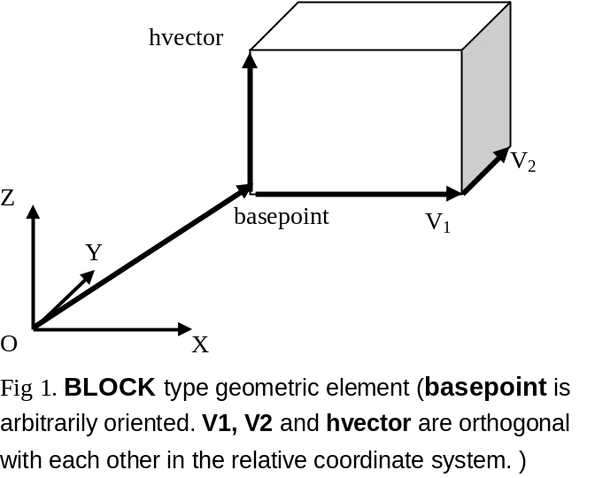

Examples:

The following commands generate a block 3 units long in the X direction, 2 units long in the Y direction and 2.5 units long in the Z direction with the base point at (1,1,2).

<block>
basepoint (1,1,2)
v1 (3,0,0)
v2 (0,2,0)
hvector (0,0,2.5)
[/block]

POLY
The POLY command defines a polyhedron with n vertices in the polygon base (bottom surface) and by extrusion of this base (See Figure 2). The <POINT> is the collection of two numbers X,Y, separated by commas.

<poly>
basepoint <VECTOR>
v1 <VECTOR>
v2 <VECTOR>
hvector <VECTOR>
<coord>
<POINT> <POINT> …
[/coord]
[/poly]

Parameter | DataType | Definition
basepoint | Vector | Coordinate of the base point of the block.  (default units: microns)
V1 | Vector | This vector is used to define the X axis of the local coordinate system according to the base point.  (default units: microns)
V2 | vector | This vector is used to define the Y axis of the local coordinate system according to the base point.  (default units: microns)
Hvector | Vector | Direction vector of the extrusion. This vector is in the local coordinate system. This vector is arbitrary oriented. The magnitude of this vector is the height of the extrusion.  (default units: microns)
Coord | point | x,y coordinates of the vertices of the polygon base expressed in the local coordinate system with origin v1 and v2. The polygon base lies in the xy-plane of this local coordinate system. A minimum of 3 coordinate points should be given.  (default units: microns)

Figure 2 clarifies the meanings of these parameters.

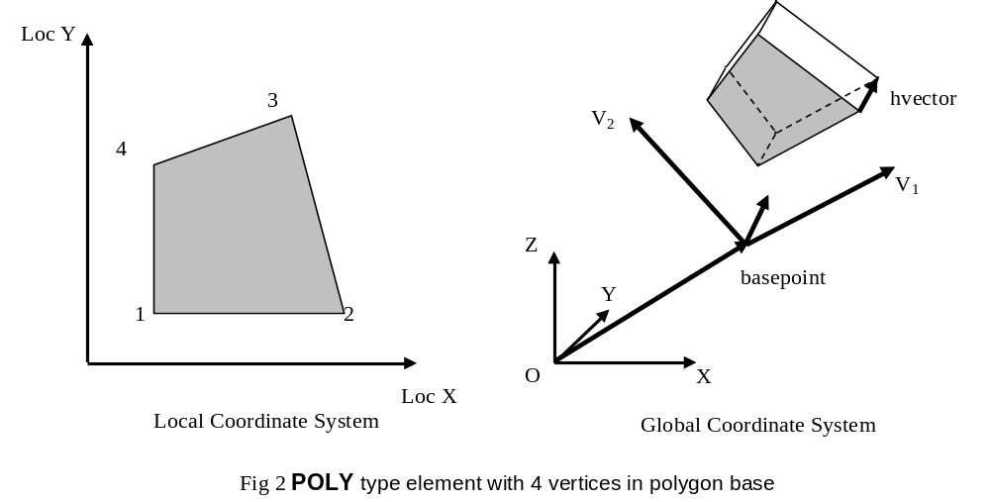

Examples:

The following commands generate a polyhedron. The polygon is defined by four vertices, with a height of 2.5. The origin of the local coordinate system is the same as the origin of the global coordinate system; the direction perpendicular to the plane of the polygon is along the global Z axis.

<poly>
basepoint (1,1,2)
v1 (1,0,0)
v2 (0,1,0)
hvector (0,0,2.5)
<coord>
(2,2) (2,4) (4,4,) (4,2)
[/coord]
[/block]

Constraints of the Input File
The structures described in the input file will have the following constraints:
- All the conductors should not be overlap with others.
- The 3D basic geometries defined in the same command set of MEDIUM can be overlap with each other.
- The geometries defined in different command sets of MEDIUM can only be inclusive or separate. The overlap of them is not allowed.

Example of the Input File
~~~~~~~~~~~~~~~~~~~~~~~~~~~~~~~~~~~~~~~~~~~~~~~~~~~~~
<qbem>
<window>
v1 (10.7500, 12.2000, -0.0100)
v2 (11.5500, 12.9250, 9.9330)
[/window]
<medium>
<block>
basepoint (10.7500, 12.2000, -0.0100)
v1 (0.8000, 0, 0)
v2 (0, 0.7250, 0)
hvector (0, 0, 0.3450)
[/block]
diel 3.9000
[/medium]
<medium>
<block>
basepoint (10.7500, 12.2000, 0.3350)
v1 (0.8000, 0, 0)
v2 (0, 0.7250, 0)
hvector (0, 0, 0.7500)
[/block]
diel 3.9000
[/medium]
<medium>
<block>
basepoint (10.7500, 12.2000, 1.0850)
v1 (0.8000, 0, 0)
v2 (0, 0.7250, 0)
hvector (0, 0, 1.5980)
[/block]
diel 3.9000
[/medium]
<medium>
<block>
basepoint (10.7500, 12.2000, 2.6830)
v1 (0.8000, 0, 0)
v2 (0, 0.7250, 0)
hvector (0, 0, 1.5000)
[/block]
diel 3.9000
[/medium]
<medium>
<block>
basepoint (10.7500, 12.2000, 4.1830)
v1 (0.8000, 0, 0)
v2 (0, 0.7250, 0)
hvector (0, 0, 5.7500)
[/block]
diel 7.5000
[/medium]
<conductor>
name groudplane
<block>
basepoint (10.7500, 12.2000, -0.0100)
v1 (0.8000, 0, 0)
v2 (0, 0.7250, 0)
hvector (0, 0, 0.0100)
[/block]
[/conductor]
<conductor>
name conductor1_61_1
<block>
basepoint (10.9500, 12.4000, 0.3350)
v1 (0.6000, 0, 0)
v2 (0, 0.1250, 0)
hvector (0, 0, 0.2500)
[/block]
<block>
basepoint (10.9500, 12.2000, 0.3350)
v1 (0.4000, 0, 0)
v2 (0, 0.2000, 0)
hvector (0, 0, 0.2500)
[/block]
<block>
basepoint (10.7500, 12.5250, 0.3350)
v1 (0.8000, 0, 0)
v2 (0, 0.2750, 0)
hvector (0, 0, 0.2500)
[/block]
<block>
basepoint (10.7500, 12.8000, 0.3350)
v1 (0.5750, 0, 0)
v2 (0, 0.1250, 0)
hvector (0, 0, 0.2500)
[/block]
[/conductor]
<task>
<capacitance>
conductor1_61_1
[/capacitance]
[/task]
[/qbem]
~~~~~~~~~~~~~~~~~~~~~~~~~~~~~~~~~~~~~~~~~~~~~~~~~~~~~

QBEM Output File

QBEM can writes the results to the output file named <file>.out when the input file <file> is computed. The output file is organized as the following formats.

Key Word | Data Type | Description
Program | Character | Show the name of the executive program.
TestCase | Character | Show the name of the test cases.
Version | Integer | Show the version information of the program
/* ……. */ |  | Comments definition.
StartTime | Character | The date time when the program is begin.
Parameter | Character | Parameter of the program.
CompResult |  | The begin flag of the result report
Capacitance | Capacitance List | Capacitance report.
Resistance | Resistance List | Resistance report.
EndTime | Char[13] Yymmddhhmmss | The date time when the program is over.
TotalMEM | Double(unit: Mbytes) | Total memory used.
TotalCPU | Double (unit: s) | Total CPU time used.

Capacitance List
The capacitance list in the output file will report the compute result in the following format:

Capacitance on <ConductorName> = <Value>

The capacitance on the conductor whose name is <ConductorName> is the value between the master conductor and the <ConductorName>. The master conductor is defined in the command set CAPACITANCE of the input file. <ConductorName> is the name of the conductor defined in the command CONDUCTOR of the input file. <Value> is the capacitance value with the unit Farad.

Example：
Capacitance on substrate = -1.2345e-17 F
Capacitance on conductor1_2_Metal1 = -1.2345e-17 F
Capacitance on conductor2_3_Metal2 = 2.4689e-17 F

Resistance List
The resistance list in the output file will report the compute result in the following format:

Resistance on <PortName> = <Value>

The resistance of the port whose name is <PortName> is the value between the master port and the one with the name <PortName>. The master port is defined in the command set RESISTANCE of the input file. <PortName> is the name of the port defined in the command PORT of the input file. <Value> is the resistance value with the unit Ohm.

Example：
Resistance on PortA = -1.2345e-14 Ohm
Resistance on PortB = -1.2345e-17 Ohm
Resistance on PortC = 2.4689e-17 Ohm

QBEM源程序文件说明

一．获得源代码
在自己的.cshrc文件中设置环境变量：setenv CVSROOT /usr2/cpe/cvsrepos。并使其得到运行。
在自己主目录或者新建的一个子目录下，输入：
$cvs checkout QmmProj
即下载库中的程序代码到QmmProj目录下。（CVS详细使用见其他文档）

二．定义形体处理类的文件（同名cxx文件为实现）：
slocat.hxx： 二三维点、向量类，包括：SLocatable2d, SLocatable3d，SVector2ddouble，SVector3ddouble。
sgeo2d1.hxx： 二维直线、线段类，包括：SLine2d, SSegment2d。
geoobj1.hxx： 三维直线、线段类，包括：SLine3d, SSegment3d。
geoobj2.hxx： 二维坐标系、平面、多边形类，包括：S2Axes，SGeomeObj2d, SPlane, SPolygon。
ssurface.hxx： 定义形体表面类SPolySurf，以及与表面边界元划分有关的类PloyEdge（边）, SweepLine（扫描线）, SweepLineLst（扫描线链表）, SMotherElement（母元）, STempMothEle, Slab（切片）, MasterPoly（主导体的多边形）。涉及的形体处理算法包括扫描线法生成母元，母元的划分，所有边界元的初始化等等。
geoobj3.hxx： 三维坐标、形体类，包括：S3Axes，SGeomeObj3d, SPolyHedron, SPddlObj3d。
pddlblock.hxx： SPddlBlock平行六面体类，具体的电学对象。
pddlplane.hxx： SPddlPlane平面构成的体类，具体的电学对象。
pddlpoly.hxx： SPddlPoly多边形棱柱类，具体的电学对象。

三．定义其他基本类的文件
dlistimp.hxx： 定义双向链表类SDblListImp, 和有关的SDblListNode类。
sbdryele.hxx： 边界元类SBdryEle。
shape.hxx： 定义一些描述形体的结构类型，用于YACC解析程序(y.tab.cxx)和pddlpoly.cxx和pddlplane.cxx使用。
sdef.hxx： 一些常量的定义，宏的定义

四．QBem主文件及主要模块文件
tpddl.cxx: 主函数main所在文件，图形界面程序尚未实现。
yf2.y, y.tab.cxx： yacc程序处理输入的PDDL文本格式，其中y.tab.cxx由yf2.y生成。
csys.cxx： QBem的计算部分的核心函数BEM()，包括方程组系数的形成以及方程组的求解。
mesh.cxx： 控制边界元自动、非均匀划分的模块，包含GapGenerate()等函数。
preprocess.cxx： 形体预处理模块。
ofm.cxx: 确定最优切割数算法。

/***********************************************
Creating Document: 2002/4/26，by yuwj
***********************************************/

QBEM输入语言详细说明

本文档介绍QBEM语言和可描述的形体范围。

可描述结构（如图）
(6.5, 10.3)
(6.5, 0)
(0, 0)
x
y
z
- 整个描述区域是一个长方体（window），其中大介质层为沿Z轴方向依次堆叠的长方体，它们在XOY平面上投影为矩形。
- 衬底是电压为0V的导体平面，可能出现在结构的最底部和最顶部。由于没有平面的语句，衬底也用导体块来描述。

二．描述语句

2.1 几点说明
- 语句大小写不敏感。
- 对于集合属性一律采用类似HTML的标记方式（< > [/ ]）。
- 支持C++注释格式（//）。

2.2 语句

2.2.1窗口定义
<window>
v1 (x1, y1, z1) // 各坐标值最小的顶点
v2 (x2, y2, z2) // 各坐标值最大的顶点
{diel value } // 目前没有意义
[/window]

2.2.2 介质定义
<medium>
形体描述语句 //可以有多个形体描述语句，后面介绍具体写法
diel value // 相对介电常数
[/medium]

2.2.3 导体定义
<conductor>
name name //导体标识，输出时显示 导体名字不能相同
形体描述语句 //可以有多个形体描述语句，后面介绍具体写法
rho value // 电阻率（单位：欧姆·米）, 算电阻时用
{volt value } // 电压，一般不用。计算charge时可以输入指定电压。
[/conductor]

2.2.4 端口定义（电阻计算）
<port>
name name //端口标识，输出时显示 端口名字不能相同
形体描述语句 //可以有多个形体描述语句，后面介绍具体写法
{volt value } // 电压，一般不用。计算current时可以输入指定电压。
[/port]

2.2.5 计算任务安排
a. 任务语句
<task>
<capacitance> //电容，为conductor的name
name, name,……
[/capacitance]

<charge> //电荷，为port的name
name, name,……
[/charge]

<resistance> //电阻，为contacnt的name
name, name,……
[/resistance]

<current> //电流，为conductor的name
name, name,……
[/current]
[/task]
b. 电容/电荷计算任务说明
1）capacitance语句指定计算电容。此时导体的volt属性无效，所指定的导体为主导体（设1V）。

<capacitance>
name1, name2, …… //指定主导体的名字，可以有多个
[/capacitance]

2）charge语句指定计算电荷。此时导体的volt属性必须为合理值（>0），否则为错误。

<charge>
name, name,…… // name为导体conductor的name，多个name表示多个导体
[/charge]

c. 电阻/电流计算任务说明
1）resistance语句指定计算电阻。根据指定的port寻找与其相连的线网和端口。此时端口的volt属性无效，所指定的端口为主端口（设1V）。

< resistance >
name1, name2, …… //指定主端口的名字，可以有多个
[/ resistance ]

2）current语句指定计算电流。此时端口的volt属性必须为合理值(>0)，否则为错误。

<current>
name,name,…… // name为端口port的name，多个name表示多个端口
[/current]

2.2.5 形体描述语句
a. 平行六面体(如图1)
<block>
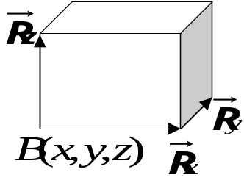
basepoint (x, y, z) //block的一个顶点
图1
v1 (x, y, z)
v2 (x, y, z)
// v1, v2为从basepoint发出的两棱向量
hvector (x, y, z) // 高向量，与v1, v2符合右手法则
{tint ( r, g, b)} //该block在显示时的颜色
[/block]
b. 直棱柱
<poly>
basepoint (x,y,z) //底面上任意一点
v1 (x, y, z) // v1, v2为底面局部坐标系的两坐标轴
v2 (x, y, z)
hvector (x,y,z) //高向量
<coord> (x, y) … [/coord] // 底面所有顶点的相对坐标，顺时针方向
{tint ( r,g,b)} //该block在显示时的颜色，十六进制数，共6位
[/poly]

2.2.7 开始与结束
<qbem> //标志描述文本的开始
[/qbem] //标志描述文本的结束，放在最后

2.3 描述规则（overlap）
1. <conductor> [/conductor]若有<poly>, 其底面必须平行与某坐标平面（通常平行与XOY平面）。
II
I
II
I
II
I
包含
分离
重叠
图2
2. 任意两介质（<medium>描述）只允许有“分离”和“包含”关系（表面可以相贴），不允许有重叠关系（相交区域体积大于零）。并且，先输入的介质可以“包含”后输入的介质，而反过来则不行。（如图2）
3. 同一个<medium>描述内的<block>或<poly>形体允许相交，它们的并集可以表示了实际的复杂介质（如conformal结构）
4. 任意两个导体以及导体内的任意两个<block>或<poly>不允许重叠或包含，可以touch。

三．说明

1．一个简单例子（如图3）

<qbem>
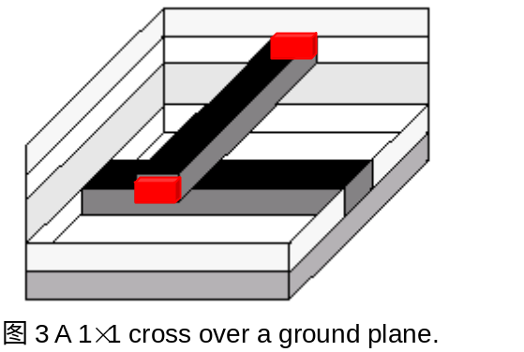<window>
v1 (0, 0, -0.01)
v2 (10, 10, 5)
[/window]
<medium>
<block>
basepoint (0, 0, -0.01)
v1 (0, 10, 0)
v2 (10, 0, 0)
hvector (0, 0, 1.01)
[/block]
diel 3.9
[/medium]
<medium>
<block>
basepoint (0, 0, 1)
v1 (0, 10, 0)
v2 (10, 0, 0)
hvector (0, 0, 1)
[/block]
diel 3.9
[/medium]
<medium>
<block>
basepoint (0, 0, 2)
v1 (0, 10, 0)
v2 (10, 0, 0)
hvector (0, 0, 1)
[/block]
diel 3.9
[/medium]
<medium>
<block>
basepoint (0, 0, 3)
v1 (0, 10, 0)
v2 (10, 0, 0)
hvector (0, 0, 1)
[/block]
diel 3.9
[/medium]
<medium>
<block>
basepoint (0, 0, 4)
v1 (0, 10, 0)
v2 (10, 0, 0)
hvector (0, 0, 1)
[/block]
diel 3.9
[/medium]
<conductor>
name groundplane
<block>
basepoint (0, 0, -0.01)
v1 (10, 0, 0)
v2 (0, 10, 0)
hvector (0, 0, 0.01)
[/block]
rho 1e-6
[/conductor]
<conductor>
name con1
<block>
basepoint (0, 4.5, 1)
v1 (10, 0, 0)
v2 (0, 1, 0)
hvector (0, 0, 1)
[/block]
rho 1e-6
[/conductor]
<conductor>
name con2
<block>
basepoint (4.5, 0, 3)
v1 (1, 0, 0)
v2 (0, 10, 0)
hvector (0, 0, 1)
[/block]
rho 1e-6
[/conductor]

<port>
name port_A
<block>
basepoint (4.5, -0.5, 3)
v1 (1, 0, 0)
v2 (0, 0.5, 0)
hvector (0, 0, 1)
[/block]
[/port]
<port>
name port_B
<block>
basepoint (4.5, 10, 3)
v1 (1, 0, 0)
v2 (0, 0.5, 0)
hvector (0, 0, 1)
[/block]
[/port]

<task>
<capacitance>
con1
[/capacitance]
<resistance>
port_A
[/resistance]
[/task]
[/qbem]

2. 关于例子的说明
此例子含有电容、电阻的所有语句。
- 如果仅仅计算电容，可以省略port定义以及与电阻计算有关的语句（红色显示）。
- 如果仅仅计算电阻，可以省略medium定义以及与电容计算有关的语句。

四．补充：一些特殊结构工艺的描述

1、关于含气泡的结构（如图4）
特点：
- 往往是嵌在大介质（或conformal介质）中的气泡。
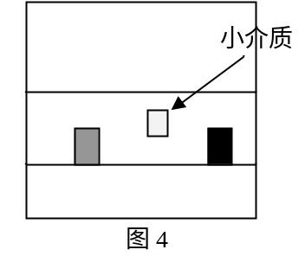
<medium>
……
[/medium]
大介质层，及包含小介质的其他介质
……

<medium>
……
[/medium]
<medium> //气泡介质
//详细的几何参数
[/medium]
……

2．关于含Conformal介质的结构
几何特点：
- 一个底面与大介质相同、高为h的介质，加上由各导体块向上和向四周扩展h得到的小介质，它们的并集就是Conformal介质。图5显示了一个含Conformal介质层的俯视图和正视图。
- 通孔导体可能穿过Conformal介质。

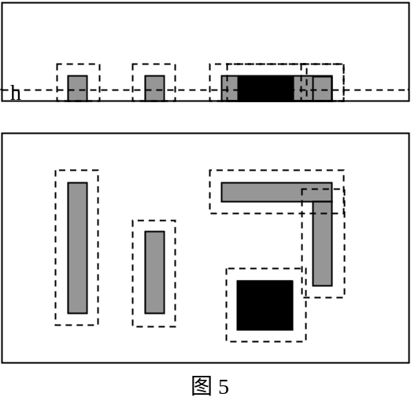
<medium>
……
[/medium]
……
大介质层描述
<medium>
……
[/medium]
<medium>
<block>
……
[/block]
组成这个Conformal结构的各个介质块描述
……
<block>
……
[/block]
diel 介电常数
[/medium]
注意：如果出现多层Conformal结构（如图6），先描述外层Conformal，再描述内层Conformal。
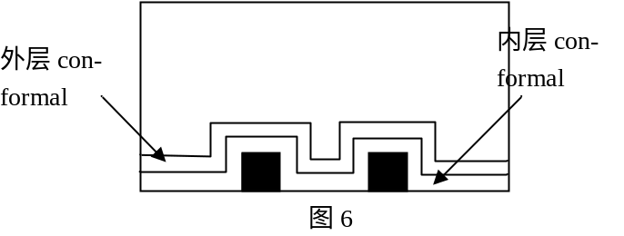

3．关于含多平面介质的结构（如图7）
下图显示了一层大介质中含多平面介质结构，其中三层介质介电常数分别为ε1、ε2、ε3。
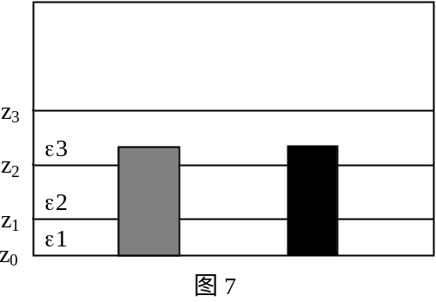

<medium>
……
[/medium]
……
大介质层描述
<medium>
……
[/medium]
……
<medium>
<block>
……
basepoint (x, y, z₀)
……
hvector (x, y, z₁-z₀)
[/block]
diel ε1
[/medium]
<medium>
<block>
……
basepoint (x, y, z₁)
三个小介质描述，构成多平面结构
……
hvector (x, y, z₂-z₁)
[/block]
diel ε2
[/medium]
<medium>
<block>
……
basepoint (x, y, z₂)
……
hvector (x, y, z₃-z₂)
[/block]
diel ε3
[/medium]
说明：
- 由于多平面结构的特点，用户可以输入z₁-z₀高度、z₃-z₂高度、z₂-z₁高度三段互相分离的介质，也可以依次输入z₃-z₀高度、z₂-z₀高度、z₁-z₀高度三段嵌套介质（推荐）。对于嵌入其中的导体将作为整体输入，不需要按层切割成小块。

/***********************************************
Creating Document: 2002/5/24，by yuwj
Modification: 2002-5-28, by yuwj，chenrm
2002-7-16, by Lu taotao. (“resistance”)
***********************************************/

QBEM三维几何造型与边界元划分类库说明

1．简介
主要基于原来B3D所使用的类库，并进行数据和方法的规范化，摒弃重复的数据。以此为手册可以可较方便地开展后续的工作。

2．主要形体类的数据和方法
下面介绍主要类的数据和方法的意义。

2.1 SVector3ddouble（slocat.hxx）

1. 成员数据
数据类别 | 名称（及相应存取方法） | 意义
保护数据 | mdX/Y/Z, mdGetX/Y/Z() | 三个分量

2. 成员方法
函数原型 | 意义
bool operator == ( const SVector3ddouble &oLeft ) | “= =”向量相等判断
SVector3ddouble operator* ( double cdScaleFac ) | 数乘，注意数放在向量右边
SVector3ddouble &operator*= ( double cdScaleFac ) | “* =”运算符
SVector3ddouble operator* ( SVector3ddouble oLeft ) | 向量叉积
SVector3ddouble &operator*= ( SVector3ddouble& oLeft ) | 向量叉积的“* =”运算符
friend SVector3ddouble operator- ( SVector3ddouble& oOriginVec ) | 向量取反，如：B= -A
double mdLength ( ) | 向量长度
double mdPointMul ( SVector3ddouble& oRight ) | 向量点积
double mdGetAngle ( SVector3ddouble& oRight ) | 两向量间夹角
bool mbOnSameLine ( SVector3ddouble oRight ) | 是否与给定向量共线
friend bool bOnSamePlane ( SVector3ddouble&, SVector3ddouble&, SVector3ddouble& ) | 给定三向量是否共平面
三维零向量常数为coZeroV3

2.2 SLocatable3d（slocat.hxx）

1. 成员数据
数据类别 | 名称（及相应存取方法） | 意义
保护数据 | mdX/Y/Z, mdGetX/Y/Z(), mvSetX/Y/Z() | 三个分量，可用方法改变其值

2. 成员方法
函数原型 | 意义
SLocatable3d ( SLocatable3d &oPoint) | 复制一个点
bool operator == ( SLocatable3d &oLeft ) | 判断点是否相等
double mdGetCoordinate(int iAxis) | 按坐标取点分量
virtual SLocatable3d operator+ ( SVector3ddouble oOffset ); | 点＝点＋向量
SLocatable3d operator+ (SLocatable3d oOffset) | 点＝点＋点
SLocatable3d operator+= ( SVector3ddouble& oOffset ) | 点＋＝向量
SVector3ddouble operator- ( SLocatable3d oBase ) | 向量＝点－点
SLocatable3d operator- ( SVector3ddouble oOffset ) | 点＝点－向量
SLocatable3d operator-= ( SVector3ddouble& oOffset ) | 点－＝向量
SLocatable3d reduce (SLocatable3d& oBase ) | 点＝点.reduce（点）
SLocatable3d operator* (double dVal) | 数乘，注意数放右边
SLocatable3d operator/ (double dVal) | 点除数
SLocatable3d operator* ( SLocatable3d); | 叉积
double pointmul(SLocatable3d oLocat1,SLocatable3d oLocat2) | 点积

2.3 S2Axes（geoobj2.hxx）

1. 成员数据
数据类别 | 名称（及相应存取方法） | 意义
保护类型 | mopX/YAxis， moGetX/YAxis() | SVector3ddouble* 类型

2. 成员方法
函数原型 | 意义
S2Axes(S2Axes &oSrc ) | 赋值
S2Axes &operator = ( S2Axes &oSrc ) | 赋值，注意应该用New申请内存
bool operator == ( S2Axes &oSrc ) | 判断相等

2.4 SGeomeObj2d（geoobj2.hxx）
继承SLocatable3d和S2Axes

1. 成员数据
数据类别 | 名称（及相应存取方法） | 意义
保护类型 | musFillColor， musGetFillColor()/mvSetFillColor() | 颜色，用于图形显示

2. 成员方法
函数原型 | 意义
int operator==(SGeomeObj2d &oRight) | 是否相等

2.5 SPlane()（geoobj2.hxx）

1. 成员数据
数据类别 | 名称（及相应存取方法） | 意义
保护数据 | mdA/B/C/D, mdGetA/B/C/D() | 平面方程Ax+By+Cz=D中的参数，且A²+B²+C²+D²=1。

2. 成员方法
函数原型 | 意义
SLocatable3d moConvert(SLocatable2d &oPoint2d) | 被CreatePlane(), CreatePoly()调用
SSegment3d *moConvert(SSegment2d *opSegment2d) | 二维线段转为三维的，目前未使用

2.6 SPolygon（geoobj2.hxx新！）
是SPlane的子类。

1. 成员数据
数据类别 | 名称（及相应存取方法） | 意义
保护数据 | mcMasterFlag, mvSetMasterFlag(),  mcGetMasterFlag() | Master导体邻近标志
 | mopVertexes, musGetVertCnt(), | 环的顶点，按逆时针顺序。SDblListImp链表中存放SLocatable3d类型指针。
 | mpOwnerPolyHedron, mvGetOwnerPolyHedron(), mvSetOwnerPolyHedron() | SPolyHedron *类型，所属的多面体
 | polyminx/y/z, polymaxx/y/z,  mdGetMax/MinCoor(), mdGetMinX/Y/Z(),  mdGetMaxX/Y/Z() | 环的几何边界，在类的初始化方法中建立。

2. 成员方法
函数原型 | 意义
void mvUpdate(SLocatable3d *opNew) 保护类型 | 比较输入点与当前的几何边界，并更新polyminx/y/z, polymaxx/y/z值
void mvInsertVert(SDblListNode *, SLocatable3d)  保护类型 | 在输入位置后插入新的顶点，不改变顶点链表原来的“当前位置”
SPolygon &operator=(SPolygon &oSrc) | 复制一个多边形
SLocatable3d *mopGetVert(ushort) | 按编号取顶点，所取顶点变为“当前位置”，第一个数据点的编号为0。
SLocatable3d *mopGetVert() | 取当前位置顶点
SLocatable3d *mopGetFirstVert() | 取第一个顶点，并将其变为“当前位置”
SLocatable3d *mopGetNextVert() | 当前位置下移一格，取此顶点
void mvInsertVert(SLocatable3d *) | 在当前位置后插入此顶点，并设其为新的当前位置
void mvInsertVert(SLocatable3d &) | 同上，只是输入类型不同。
void mvInsertVert ( ushort, SLocatable3d) | 在指定编号结点后插入新顶点，当前位置变为指定编号
SDblListNode *mopSrchVert(SLocatable3d) | 从头开始搜索点，当前位置变为该点位置。若无此点，返回NULL
void mvDeleteVert() | 取出当前结点，并释放其所含顶点，当前位置变为“后一个”
void mvDeleteVert(ushort usVertIdx) | 删除指定编号结点，当前位置变为被删除点的后一个。
int miVertOnEdgenew(SLocatable3d &oPntOnEdge); | 判断点是否在边上，-1表示不在；若在，返回边的编号（0开始）liudy
int miSrchVert(SLocatable3d &oVert ); | 查找顶点，返回编号。当前位置为找到的点的位置，若找不到返回-1。
int submiRefineRel(SLine3d &oRight, SSegment3d *&opInter) | 不清楚！liudy

2.7 SPolySurf（ssurface.hxx新！）
是SPolygon的子类。

1. 成员数据
数据类别 | 名称（及相应存取方法） | 意义
保护数据 | mcProperty, miGetProperty(), mvSetProperty() | 面的属性，包括：  INVALID（无效面）  CONDUCTOR_SURFACE  LAYER_SURFACE  MEDIUM_SURFACE  MED_MED_INTERFACE  MED_HAS_HOLE  MED_INTERFACE_HAS_HOLE  CON_CON_INTERFACE (导体/导体交界面)  CON_AT_MED_INTERFACE
保护数据 | otherMediumIdx, mvSetOtherMediumIdx(), mvGetOtherMediumIdx() | 有关的另一个介质的编号
保护数据 | mopSpolygons, musGetSpolygonCnt() | SDblListImp *类型，环的双向链表
保护数据 | mpMothEle0和mpMothEle1,  mvInsertMothEle()，插母元到上两个链表头 | SMotherElement *类型，普通母元0和靠近Master的母元1。
保护数据 | mopBdryEles, musGetEleCnt() | SDblListImp *类型，边界元的双向链表，存放SBdryEle *类型
保护数据 | muiSurfNo, mvSetSurfNo(), muiGetSurfNo() | 面的编号(下上底、侧面)
保护数据 | musMothEleCnt, musGet/mvSetMothEleCnt() | 母元数目
保护数据 | mcHidden, mvSetHidden(), mcIsHidden() | 是否隐藏，目前未用，可保留。

2. 成员方法
函数原型 | 意义
SPolygon *mopFirstPolygon() | 取第一个环，并设其为当前位置
SPolygon *mopGetNextSpolygon() | 取下一个环，并设其为当前位置
void mvInsPolygonBefore(SPolygon& polygon) | 插到第一个环之前，并设其为当前位置
void mvInsertPolygon(SPolygon& polygon) | 插到第一个环之后，并设其为当前位置
void mvRelPolygon(ushort usPolygonIdx) | 删除指定编号的环，当前位置为“下一个”
SBdryEle *mopGetFirstEle() | 取第一个边界元，并设其为当前位置
SBdryEle *mopGetNextEle() | 取下一个边界元，并设其为当前位置
void mvDelEleLst() | 删所有边界元，释放空间
mvDelPolygons()，保护类型 | 删所有环，释放空间
void mvDelMothEleLst()， 保护类型 | 删所有母元，释放空间
miSplit(SMotherElement *, SMotherElement * &, int) | 短格式的切割母元函数
miSplit(int, SMotherElement *, MasterPoly, SMotherElement **, int, int) | 短格式的切割母元函数，见readsplt.doc
mvDivideEle(float *fGaps) | 对垂直于某坐标轴的面的边界元划分
mvPolyDivideEle(float *fGaps) | 对非垂直于某坐标轴的面的边界元划分
uint muiFillGlobalEles(uint uiFillStart ) | 存边界元于全局列表，被SPolyHedron对象调用。
void mvPreProcess() | 预处理，生成母元，已被替换
void mvNewProcess() | 预处理，生成母元，替换mvPreProcess

2.8 S3Axes（geoobj3.hxx）

1. 成员数据
数据类别 | 名称（及相应存取方法） | 意义
保护类型 | mopX/Y/ZAxis, moGetX/Y/ZAxis() | SVector3ddouble* 类型，三坐标轴

2. 成员方法
函数原型 | 意义
S3Axes(S3Axes &oSrc) | 赋值
bool operator == ( S3Axes &oLeft) | 是否相等

2.9 SGeomeObj3d（geoobj3.hxx）
继承SLocatable3d和 S3Axes

1. 成员数据
数据类别 | 名称（及相应存取方法） | 意义
保护类型 | mopOwner，moGetOwner() | SPddlObj3d *类型，所属电学体

2. 成员方法
函数原型 | 意义
bool operator == ( SGeomeObj3d &oRight) | 判断相等

2.10 SPolyHedron（geoobj3.hxx新！）
SGeomeObj3d的子类。

成员数据
数据类别 | 名称（及相应存取方法） | 意义
保护数据 | mopOwner, moGetOwner()继承来的 | SPddlObj3d *类型，所属形体
保护数据 | muiBlockNum, mvSetBlockNum(), muiGetBlockNum() | 全部形体块编号，从0开始
保护数据 | mcMstNgbFlag, mvSetMstNgbFlag(), mcGetMstNgbFlag() | 1表示与Master导体邻近
保护数据 | mopSurfaces, musGetSurfCnt() | SDblListImp *类型，所包含表面的链表。

2. 成员方法
函数原型 | 意义
SPolyHedron ( SLocatable3d oBase, SVector3ddouble oAxis1, SVector3ddouble oAxis2, SVector3ddouble oAxis3, SPddlObj3d *opOwner ); | 初始化方法
SPolySurf *mopGetFirstSurf(); | 取第一个面，并设其为当前位置
SPolySurf *mopGetNextSurf() | 取下一个面，并设其为当前位置
SPolySurf* mopGetSurf(uint no) | 按编号取面，并设其为当前位置
void mvAddSurf(SPolySurf *opNewSurf) | 当前位置后插入面，并设其为当前位置
void mvDeleteSurf() | 删当前面，有点不懂！
uint muiGetEleCnt() | 统计边界元被SPddlObj3d对象调用
uint muiFillGlobalEles ( uint uiFillStart ) | 存边界元于全局列表，被SPddlObj3d对象调用
void InterSection(SPolyHedron* PolyHedron1,SPolyHedron* PolyHedron2,int mask, int SurfNo1, int SurfNo2, int SurfRelation, int VMNo=-1) | 两多面体相交
void FindSurfNo(int &x1,int &x2,int &y1,int &y2) | liudy

2.11 SPddlObj3d（geoobj3.hxx）

1. 成员数据
数据类别 | 名称（及相应存取方法） | 意义
保护数据 | musId, musGetId(), mvSetId() | 在介质或导体中的编号，0开始
保护数据 | muiLayerId, mvSetLayerId(), muiGetLayerId() | 所属介质层号，最下层为0
保护数据 | musOwner_Medno, musGetOwner_Medno(),  mvSetOwner_Medno() | 所属介质编号，Yacc后即建立
保护数据 | mucElecType, mucGetElecType() | 取值cucMedia/cucConductor
保护数据 | mdElecData, mdGetElecData(), mvSetElecData() | 导体电压/介质相对介电常数
保护数据 | mucElecFlag, mucSetElecFlag(), mucGetElecFlag() | 可取值：  LAYER 衬底  BIG_MED 大介质  INTERLINE_CON 互连线导体  VIA_CON 通孔导体  SMALL_MED 小介质  VIR_MED 虚介质
保护数据 | mfGaps[3] | x/y/z方向的边界元划分间隔
保护数据 | mopGeoObj, mopGetFirstGeoObj() | 取出其中的SPolyHedron对象指针

2. 成员方法
函数原型 | 意义
virtual mucGetShapeType() | 缺省返回PDDL_NONE，其它如下：  PddlBlock子类――PDDL_BLOCK  PddlPoly子类――PDDL_POLY  PddlPlane子类――PDDL_PLANE
uint muiGetEleCnt() | 统计边界元数目，调用SPolyHedron此方法
uint muiFillGlobalEles ( uint uiFillStart ) | 存边界元于全局列表，调用SPolyHedron此方法
virtual void mvDivide(ushort *dpDiv) | 划分边界元，由SPddlBlock等子类实现
virtual void mvDivide() | 同上
virtual void mvPreProcess() | 形体预处理，由SPddlBlock等子类实现
virtual void mvCutting(){} | 形体虚拟切割，由SPddlBlock等子类实现
void mvLabelSurface() | 给各表面编号，无效表面也编，从0开始

2.12 SPddlBlock（geoobj3.hxx）
是SPddlObj3d的子类。

1. 成员方法
函数原型 | 意义
SPddlBlock(...), 两个 | 初始化方法
virtual void mvDivide(ushort *dpDiv) | 实现SPddlObj3d的这些虚函数
virtual void mvDivide() | 实现SPddlObj3d的这些虚函数
virtual void mvPreProcess() | 实现SPddlObj3d的这些虚函数
virtual void mvCutting() | 实现SPddlObj3d的这些虚函数

2.13 SPddlPoly（pddlpoly.hxx）
是SPddlObj3d的子类。

1. 成员方法
函数原型 | 意义
SPddlPoly(...), 两个 | 初始化方法
~SPddlPoly() | 析构函数
virtual void mvDivide(ushort *dpDiv) | 实现SPddlObj3d的这些虚函数
virtual void mvDivide() | 实现SPddlObj3d的这些虚函数
virtual void mvPreProcess() | 实现SPddlObj3d的这些虚函数
virtual void mvCutting() | 实现SPddlObj3d的这些虚函数

2.14 SPddlPlane（pddlplane.hxx）
是SPddlObj3d的子类。

1. 成员方法
函数原型 | 意义
SPddlPlane(...), 一个长格式的 | 初始化方法
~SPddlPlane() | 析构函数
virtual void mvDivide(ushort *dpDiv) | 实现SPddlObj3d的这些虚函数
virtual void mvDivide() | 实现SPddlObj3d的这些虚函数
virtual void mvPreProcess() | 实现SPddlObj3d的这些虚函数
virtual void mvCutting() | 实现SPddlObj3d的这些虚函数

3 其它主要相关类
其它主要相关类的意义在这里介绍。

3.1 SDblListNode（dlistimp.hxx）
双向指针链表结点类

1. 成员数据
数据类别 | 名称（及相应存取方法） | 意义
保护数据 | mopPrev, mopSucc | SDblListNode*类型，前/后结点
保护数据 | mvpData | void *类型
保护数据 | myStatus | 状态字，cyHeadPassed/cyIsHead

2. 成员方法
函数原型 | 意义
略！ | 一般使用只使用SDblListImp即可

3.2 SDblListImp（dlistimp.hxx新！）
双向指针链表类，继承SDblListNode类。

1. 成员数据
数据类别 | 名称（及相应存取方法） | 意义
保护数据 | musCnt, ushort musGetCount() | 双向链表中数据个数
保护数据 | mopCursor， SDblListNode* mopGetCursor()  SDblListNode* mopSetCursor(SDblListNode*) | SDblListNode *类型，当前位置

2. 成员方法
函数原型 | 意义
void mvClearAll() | 删除所有数据结点，但不删除各结点所指数据
void mvResetCursor( ) | 重置当前指针到第一个数据
byte myMoveCursor ( short sCursorStep = 1 ) | 当前指针向后循环移动（跳过头结点），返回cyHeadPassed表示循环了，否则返回0
mvClrHeadPassed() | 到头标志复位
bool mbHeadPassed() | 返回是否“到头”标志
void *mvpGetData ( ); | 取当前位置数据，当前位置不变
void *mvpRetrieveData ( ) | 取出当前结点并删除，当前位置变为后一个（循环），并置“到头”标志，返回数据
void mvInsertAfter(void * ) | 插到当前位置后，并将其设为新的“当前位置”
void mvInsertBefore ( void *) | 插到当前位置前，并将其设为新的“当前位置”

3.3 SLine3d（geoobj1.hxx）
直线类，继承SLocatable3d和SVector3ddouble。

1. 成员方法
函数原型 | 意义
SLine3d(SLocatable3d& oPoint1, SLocatable3d& oPoint2) | 两点确定一条直线
SLine3d(SLocatable3d& oBase, SVector3ddouble& oVec ) | 点和向量确定一条直线
bool operator==(SLine3d &oLeft) | 判断直线是否相等
virtual int miCalcRel(SLine3d&, SLocatable3d*&) | 与另一线的关系，可能返回交点。返回值：  ciCoincide－重合  ciParallel－平行  ciIntersect－相交  ciDifferent－不在一个平面

3.4 SSegment3d（geoobj1.hxx）
线段类，继承SLine3d。

1. 成员数据
数据类别 | 名称（及相应存取方法） | 意义
保护数据 | point1, point2， mGetPoint1/2() | SLocatable3d*类型，两端点（重复的存储！）

2. 成员方法
函数原型 | 意义
virtual int miRefineRel(SLocatable3d& oRight) | 点与线段的关系，返回值：  ciSubset，ciDifferent
virtual int miCalcRel(SLine3d&, SLocatable3d*&) | 线段与直线的关系，返回值：  ciIntersect－相交，返回交点  ciDifferent－直线交，但线段不交  ciSubset－线段在直线上  0－其它情况（平行与异面）

3.5 SBdryEle（sbdryele.hxx）
边界元类。

1. 成员数据
数据类别 | 名称（及相应存取方法） | 意义
保护数据 | mucNodeCnt, mucGetNodeCnt() | uchar类型，点的数目
保护数据 | mpNode[4], mpGetNode(int i) | SLocatable3d*数组

4附录

4.1. 部分全局的类型与宏（sdef.hxx）
uchar, ushort, uint: 1,2,4 字节整数;
BOOL: FALSE, TURE, 全部小写也行;
MbFltEq, MbFltGT, MbFltLT, 浮点数的比较;
cdEpsilon（为1e-8）, cdPie
New

4.2 主要形体类的继承关系图

4.3 其它类的说明
SLocatable2d
SVector2ddouble
SLine2d 二维直线
SSegment2d 二维线段
图3.1 二维直线类继承关系图
SLocatable3d
SVector3ddouble
SLine3d 三维直线
SSegment3d 三维线段
图3.2 三维直线类继承关系图
SLocatable3d
S2Axes
SGeomeObj2d三维平面形体
SPolygon 三维平面多边形
SPlane 三维平面
图3.3 三维平面形体类继承关系图
SPolySurf 包含多边形的面
SLocatable3d
S3Axes
SGeomeObj3d 三维形体线
SPolyHedron 多面体
图3.5 三维复杂形体类继承关系图
SPddlObj3d
图3.4 三维形体类继承关系图
SPddlPoly
多边形棱柱类
SPddlBlock
平行六面体类
SPddlPlane
三维多面体类

1．基础父类：
SLocatable2d 二维点
SVector2ddouble 二维向量
SLine2d 二维直线
SSegment2d 二维线段

2．用于边界元划分的类：
PolyEdge 多边形的边
SweepLine 扫描线
SweepLineLst 扫描线链表
SMotherElement 划分母元
STempMothEle 母元链表
MasterPoly MASTER上的多边形
Slab 切片（相邻两扫描线间区域）

/***********************************************
Creating Document: 2001/9/20，by yuwj
Modifying time: 2002/4/26, by yuwj
***********************************************/
QBEM测试说明书

- 功能说明及特点
QBEM是“QMM-accelerated Boundary Element Method”的简称，为三维互连电容、电阻提取软件原型，由本课题组和美国Anchor Semiconductor合作开发。该软件的核心是采用QMM（虚拟多介质）方法对三维直接边界元计算进行加速，从而使三维电容、电阻提取具有非常高的效率。
用户通过输入三维互连导体及其周围的介质结构，便可由QBEM计算出主导体与其他各环境导体间的耦合电容值（整个电容矩阵中的一列），或主端口到其他各端口的电阻值。在QBEM中，采用虚拟切割、线性方程组组织、预条件GMRES、树状形体组织等许多创新技术，使得整体计算效率达到国际先进水平。在同等的计算精度下，QBEM比MIT开发的著名软件FastCap可快10倍。在处理复杂结构能力方面，QBEM可以处理直导线、斜导线、保形介质（conformal）、填充气隙、多平面介质，甚至更复杂的结构，具有比B3D更广泛的通用性。此外，QBEM还能直接计算电阻，这是B3D所没有的功能。
有关软件QBEM可参考下列文献：
  - Wenjian Yu, Zeyi Wang and Jiangchun Gu, “Fast capacitance extraction of actual 3-D VLSI interconnects using quasi-multiple medium accelerated BEM,” IEEE Trans. Microwave Theory Tech., 2003, 51(1): 109-120
  - 喻文健，王泽毅，侯劲松，“一种快速的三维VLSI互连电容提取方法：虚拟多介质方法”，电子学报，第29卷，第11期，pp. 1526-1529, 2001年。
  - 喻文健，VLSI三维寄生电容电阻快速直接边界元提取算法研究，清华大学博士学位论文，2003

- 输入格式

以图3所示的五层介质1×1交叉线结构为例，下面给出输入文件格式：
<qbem>
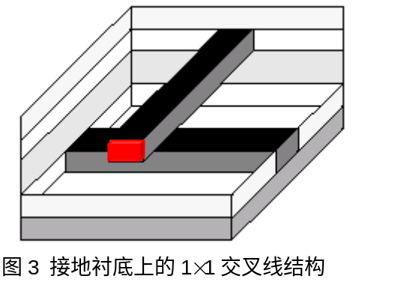<window>
v1 (0, 0, -0.01)
v2 (10, 10, 5)
[/window]
<medium>
<block>
basepoint (0, 0, -0.01)
v1 (0, 10, 0)
v2 (10, 0, 0)
hvector (0, 0, 1.01)
[/block]
diel 3.9
[/medium]
<medium>
<block>
basepoint (0, 0, 1)
v1 (0, 10, 0)
v2 (10, 0, 0)
hvector (0, 0, 1)
[/block]
diel 3.9
[/medium]
<medium>
<block>
basepoint (0, 0, 2)
v1 (0, 10, 0)
v2 (10, 0, 0)
hvector (0, 0, 1)
[/block]
diel 3.9
[/medium]
<medium>
<block>
basepoint (0, 0, 3)
v1 (0, 10, 0)
v2 (10, 0, 0)
hvector (0, 0, 1)
[/block]
diel 3.9
[/medium]
<medium>
<block>
basepoint (0, 0, 4)
v1 (0, 10, 0)
v2 (10, 0, 0)
hvector (0, 0, 1)
[/block]
diel 3.9
[/medium]
<conductor>
name groundplane
<block>
basepoint (0, 0, -0.01)
v1 (10, 0, 0)
v2 (0, 10, 0)
hvector (0, 0, 0.01)
[/block]
rho 1e-6
[/conductor]
<conductor>
name con1
<block>
basepoint (0, 4.5, 1)
v1 (10, 0, 0)
v2 (0, 1, 0)
hvector (0, 0, 1)
[/block]
rho 1e-6
[/conductor]
<conductor>
name con2
<block>
basepoint (4.5, 0, 3)
v1 (1, 0, 0)
v2 (0, 10, 0)
hvector (0, 0, 1)
[/block]
rho 1e-6
[/conductor]
<port>
name port_A
<block>
basepoint (4.5, -0.5, 3)
v1 (1, 0, 0)
v2 (0, 0.5, 0)
hvector (0, 0, 1)
[/block]
[/port]
<port>
name port_B
<block>
basepoint (4.5, 10, 3)
v1 (1, 0, 0)
v2 (0, 0.5, 0)
hvector (0, 0, 1)
[/block]
[/port]
<task>
<capacitance>
con1
[/capacitance]
<resistance>
port_A
[/resistance]
[/task]
[/qbem]

说明：此例子中定义了端口，并含有电阻计算的所关语句。

- 输出格式

/*******************************************************************
This is test output file.
*******************************************************************/
PROGRAM QBEM
TESTCASE /usr2/cpe/cases/45test1/mei1.1
VERSION 2.0
PARAMETER -v 3 5
ELEMENT 3212
VARIABLE 4560
VMCUTTING 4 5
DATAINTIME 0.23
PREPROCESSTIME 0.56
EQGENTIME 5.12
EQSOLVETIME 3.21
GMRESITER 10
COMPRESULT
Capacitance on groudplane = -1.345e-16 F
Capacitance on con2 = -3.590e-17 F
Capacitance on con1 = 1.650e-16 F
TOTALCPU 4.23
TOTALMEM 6.12

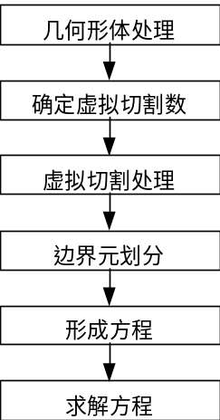
- 算法框图
图4 QBEM软件的算法流程

