- plug-n-play handshake framework - overview
The Fringe is the SV to SV interface based Plug-and-Play (PnP) protocol handshake framework. It consists of three major parts:
- Source-Destination and Signal databases (DB) and corresponding Lookup tables (LUT) structures.
- DB access methods.
- System handshake agreements.
The PnP involves one Central Server (Initiator) and one or more Residents (Targets) nodes. All nodes are connected to one another in a star topology. The “Plug” portion of the PnP establishes a communication channel between the Initiator and Targets and comprises a “TCP connection” and “Registration” phases. The PnP “Play” starts as soon as the communication channel sets up and composed of multiple data exchanges.
- Sources and Destinations and Signal Data bases configuration
The following system attributes need to be defined and communicated to all PnP participants (Table 1 Fringe `defines), prior to the start of the PnP process:
- Unique name for each PnP Source/Destinations.
- The number of signals for each PnP Source/Destinations.
- Unique current simulation identifier.
- Designated TCP host address and host port and etc.
Table 1 Fringe `defines
`define name | Default | Comments
FRNG_N_OF_SRCDSTS | 2 | Total number of Source+Destinations
FRNG_N_OF_SIGNALS | 8 | Total number of Source/destinations signals
FRNG_MAX_N_OF_BITS_PER_SIGNAL | 1024 | The max allowed signal bit width
FRNG_MAX_N_OF_PAYLOADS_PER_SIGNAL | 16 | The max allowed a number of payloads Signal DB entries (see ???)
FRNG_N_OF_BITS_PER_PAYLOAD | See Formulae 1 | The max allowed a number of pits per Signal DB payload entries (see ???)
FRNG_N_OF_PAYLOADS | See Formulae 2 | Number of signal DB payload entries per signal
MY_HOST | "localhost" | TCP host server address
MY_PORT | 3450 | TCP host port
SIM_ID | 12345678 | Unique Simulation identifier
Formulae 1 - `FRNG_MAX_N_OF_BITS_PER_SIGNAL
Formulae 2 -(`FRNG_N_OF_SIGNALS*(`FRNG_MAX_N_OF_BITS_PER_SIGNAL/`FRNG_N_OF_BITS_PER_PAYLOAD))
- The “Plug” phase.
The Fringe “Plug“ is a three-step process. The first step is a ”Fringe Initialization”. It creates DB LUTs and sets all LUT entries to the default state. The second step, called “TCP connection”, enables the TCP communication itself. The last step or “Registration” binds a particular Target to the appropriate TCP socket.
The “SrsDst DB” structure consists of the name (string __SrcDsts_name_db [<number of Source or Destinations s>]) and descriptor (fringe_SrcDsts_descriptor_t SrcDsts_db) LUTs.
The Sources and Destinations name LUT is a list of all valid Source or Destination names. The Source and Destination descriptor LUT defines as a SV structure and possess the following four properties:
Table 2 Source and Destination structure
typedef struct{
longint SrcDst_id; | // SrcDst DB entry Id
int n_signals; | // SrcDst DB entry number of signals
int socket_id; | //SrcDst DB entry destination socket id
fringe_SrcDst_status_e status; | // SrcDst DB entry status
fringe_signal_hs_e signal_status | //SrcDst DB entry aggregated signal status
} fringe_SrcDsts_descriptor_t;

The default (initial) SrsDst Db entry setting is:
Table 3 Source and Destination DB defaults
Source and Destinations DB | Default value | Comments
Initiator or Target :
__SrcDsts_name_db[i] | <name> | Set to corresponding unique PnP agent name Note: Should be only one INITIATOR in system
Target entry :
SrcDsts_db[i].SrcDst_id | -1; | -1 is Not valid id, the valid id is always > 0
SrcDsts_db[i].n_signals | Number of signals | Number of inputs and outputs
SrcDsts_db[i].status | FRNG_SRCDST_IDLE | Ref to fringe_data_e enum
SrcDsts_db[i].signal_status | FRNG_SIGNAL_IDLE | Ref. to fringe_signal_hs_e
SrcDsts_db[i].socket_id | -1 | -1 is Not valid socket, the valid socket is always >= 0
Initiator entry:
SrcDsts_db[i].status | FRNG_SRCDST_ACTIVE; | Ref to fringe_data_e enum
SrcDsts_db[i].SrcDst_id | -1 | During the PnP registration, The Initiator sends to Targets an appropriate unique identifier.

A similar setting applies also to the Signal DB LUTs. The Signal descriptor LUT defines as a following SV structure and default settings:
Table 4 Signal DB structure
typedef struct{
longint | signal_id | //unique signal identifier corresponding to the full signal name (“<SrcDst name>.<signal_name>”)
longint | SrcDst_parent_id | //corresponding SrcDst DB parent entry
longint | SrcDst_call_id | //index pointer to the SrcDst DB correspondent id
int | index_payloads | //index pointer to the corresponding signal payloads_db entry
int | number_payloads | //number payloads entries payloads_db entry
fringe_signal_type_e | signal_type | //signal type
int | signal_size | //signal size
fringe_signal_hs_e | signal_valid | //signal handshake flag
int | imestamp | //last signal event simulation time
int | event_cntr | //number of signal events
fringe_signal_debug_e | debug | //debug flag
} | fringe_signals_descriptor_t;

Table 5 Signal DB defaults
Signal DB | Default value | Comments
Initiator or Target :
__signals_db_name[i] | <name> | It sets to corresponding PnP agent signal name. (Permanent parameter)
signals_db[i].signal_id | <hash tag> | Hash tag of the “<parent SrcDst name>.<signal_name>” (Permanent parameter)
signals_db[i].SrcDst_parent_id | <hash tag> | Hash tag of the “<parent SrcDst name> (Permanent parameter)
signals_db[i].SrcDst_call_id | -1 | < SrcDst name> hash tag defines Destination or Source for fringe puts and gets (Permanent parameter)
signals_db[i].signal_type | <signal type> | Ref. to the fringe_signal_type_e enum .It defines signal type attribute for fringe puts and gets (Variable parameter)
signals_db[i].signal_size | <signal size> | The Signal size in bits > (Permanent parameter)
signals_db[i].signal_valid | FRNG_SIGNAL_IDLE | Ref. to the fringe_signal_hs_e enum .It defines signal handshake status flag signal for fringe puts and gets (Variable parameter)
signals_db[i].index_payloads | < first signal payload> | First signals_db_payloads index corresponding to signal entry (Permanent parameter)
signals_db[i].number_payloads | < number_payloads > | Number of signal payloads (Permanent parameter)
signals_db[i].timestamp | <time> | Current timestamp (Variable parameter)
signals_db[i].event_cntr | <event> | Current event counter (Variable parameter)
- The “Plug” phase flow
The “Fringe PnP” starts with setting a name and simulation identification following by DB setup, TCP socket connection and Targets registration. A full PnP flow and API functions are presented below:
Figure 1 “Plug” flow

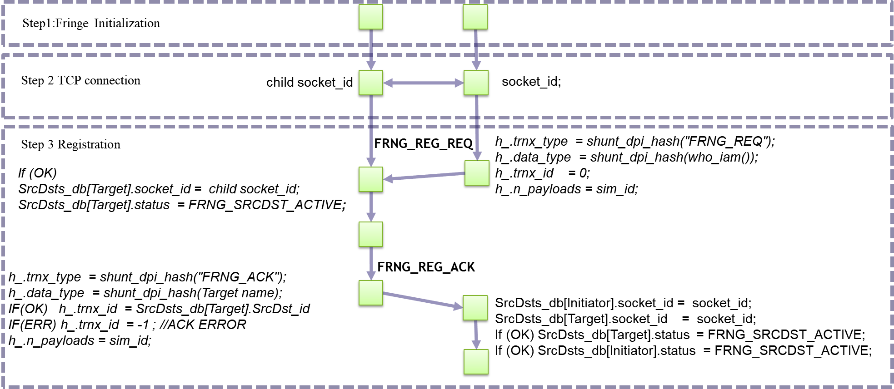

- The “Play” phase and Signal Data base.
The “Fringe Play” phase uses a client-server approach. However, there are no master-slave relations between communicators. All communications are bi-directional. The “Fringe Play” phase front-end API contains a pair of coupled functions: “fringe_api_put” and “fringe_api_get”(Figure 1).
Figure 2 The “Play” data exchange
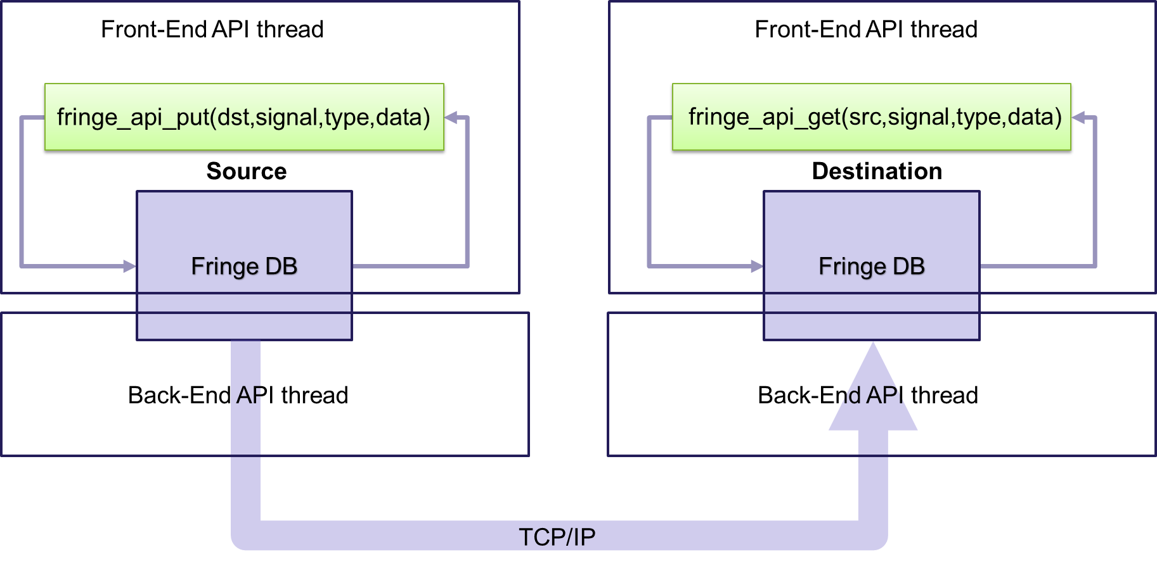

The entire data exchange process can be broken down into following steps:
- The Fringe Source/Destination endpoint spawns back-end threads immediately after performing "Plug” phase.
- The source side calls function “fringe_api_put”, sets appropriate mailbox data entries, and corresponding data-ready flags.
- When data-ready flags are valid, the Fringe back-end pool process sends out data and resets data ready mailbox semaphores (Figure 3).
Figure 3 Source put data process
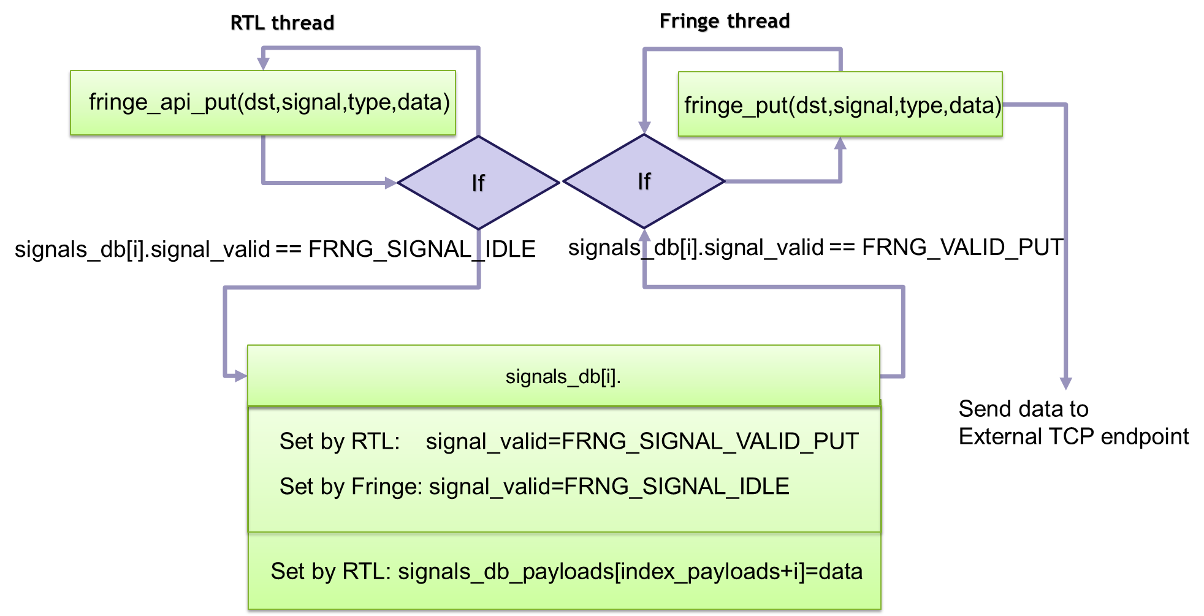

- The Destination back-end process gets data over TCP sets appropriate Source DB data entries and the data-ready flags.
- The front-end “fringe_api_get” function can be called anytime. It returns “0” if there are no new data. When data are available, the function returns “1 “and data itself. Also, “fringe_api_get” resets corresponding DB mailbox flags (Figure 4).
Figure 4 Destination get data process.
