1. Tabel Database Tokobuah

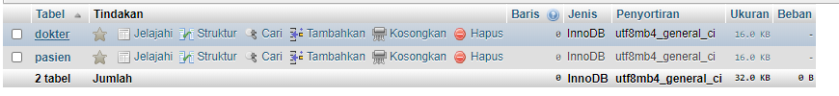

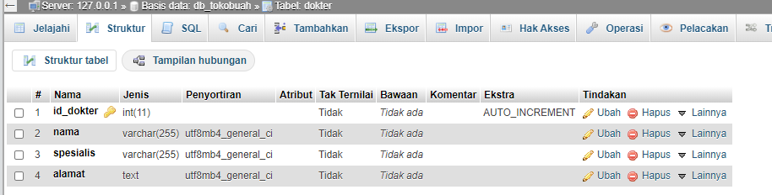

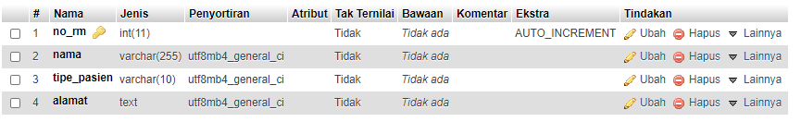

1. Rest API

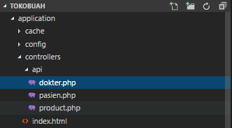

Dokter.php

<?php

require APPPATH . 'libraries/REST_Controller.php';

class dokter extends REST_Controller {

public function __construct(){

parent::__construct();

$this->load->database();

}

public function index_get($id = 0)

{

if(!empty($id = 0)){

$data = $this->db->get_where("dokter", ['id_dokter' => $id])->result();

} else {

$data = $this->db->get("dokter")->result();

}

$this->response($data, REST_Controller::HTTP_OK);

}

public function index_post()

{

$input = $this->input->post();

$this->db->insert('dokter', $input);

$this->response(['Data Dokter Berhasil Dibuat.'], REST_Controller::HTTP_OK);

}

/**

* get All Data from this method

*

* @return Response

*/

public function index_put($id)

{

$input = $this->put();

$this->db->update('dokter', $input, array('id_dokter' =>$id));

$this->response(['Berhasil mengubah Data Dokter'], REST_Controller::HTTP_OK);

}

function index_delete() {

$id = $this->delete('id_dokter');

$this->db->where('id_dokter', $id);

$delete = $this->db->delete('dokter');

if ($delete) {

$this->response(array('status' => 'Berhasil melakukan Penghapusan'), 201);

} else {

$this->response(array('status' => 'Gagal Melakukan Penghapusan', 502));

}

}

}

Pasien.php

<?php

require APPPATH . 'libraries/REST_Controller.php';

class pasien extends REST_Controller {

public function __construct(){

parent::__construct();

$this->load->database();

}

public function index_get($id = 0)

{

if(!empty($id = 0)){

$data = $this->db->get_where("pasien", ['no_rm' => $id])->result();

} else {

$data = $this->db->get("pasien")->result();

}

$this->response($data, REST_Controller::HTTP_OK);

}

public function index_post()

{

$input = $this->input->post();

$this->db->insert('pasien', $input);

$this->response(['Data Pasien Berhasil dibuat.'], REST_Controller::HTTP_OK);

}

/**

* get All Data from this method

*

* @return Response

*/

function index_put() {

$id = $this->put('no_rm');

$data = array(

'no_rm' => $this->put('no_rm'),

'nama' => $this->put('nama'),

'tipe_pasien' => $this->put('tipe_pasien'),

'alamat' => $this->put('alamat'));

$this->db->where('no_rm', $id);

$update = $this->db->update('pasien', $data);

if ($update) {

$this->response(array('status' => 'Berhasil Merubah data pasien'), 201);

} else {

$this->response(array('status' => 'Gagal', 502));

}

}

function index_delete() {

$id = $this->delete('id');

$this->db->where('id', $id);

$delete = $this->db->delete('pasien');

if ($delete) {

$this->response(array('status' => 'Berhasil menghapus data pasien'), 201);

} else {

$this->response(array('status' => 'Gagal Menghapus data pasien', 502));

}

}

}

1. Metode CRUD untuk Pasien

GET PASIEN

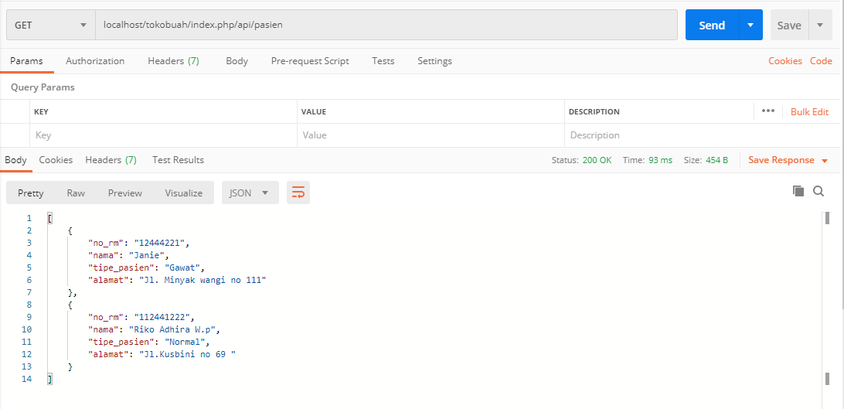

POST PASIEN

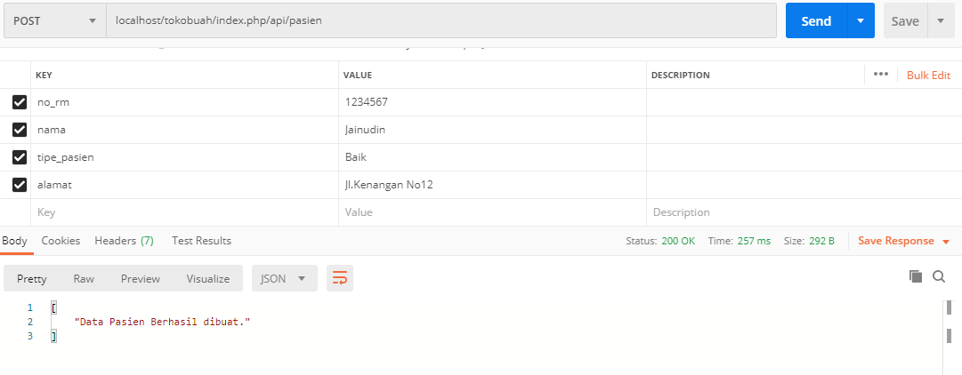

Hasil :

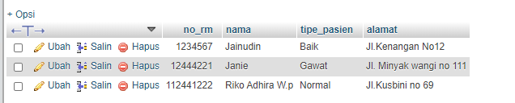

PUT PASIEN

Data Sebelum diubah

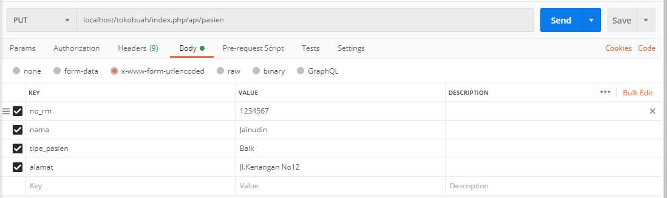

Sesudah :

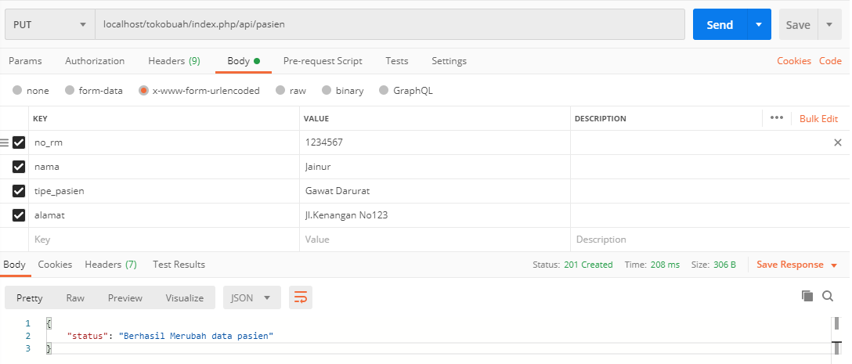

Gunakan Metode Get menampilkan Data

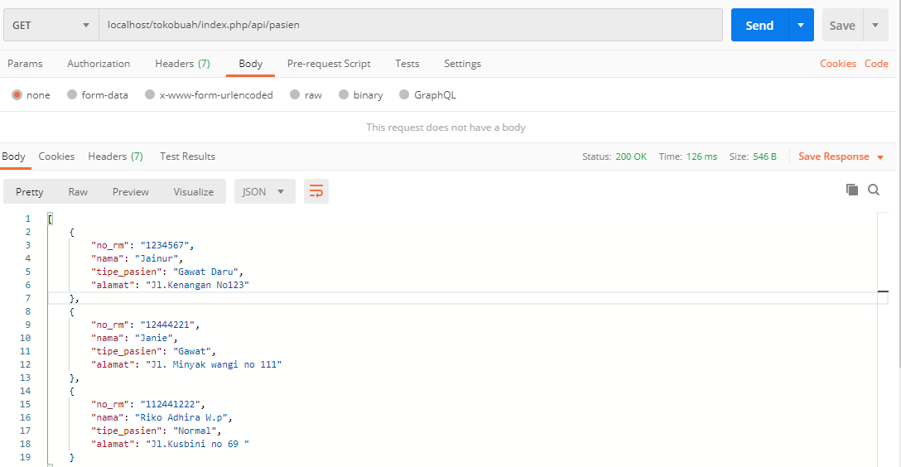

Delete Pasien :

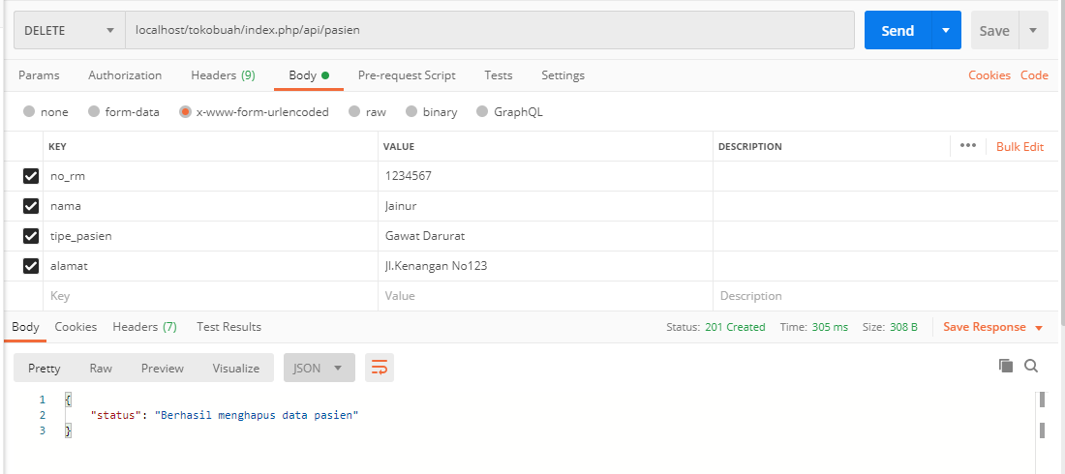

Data berhasil Dihapus

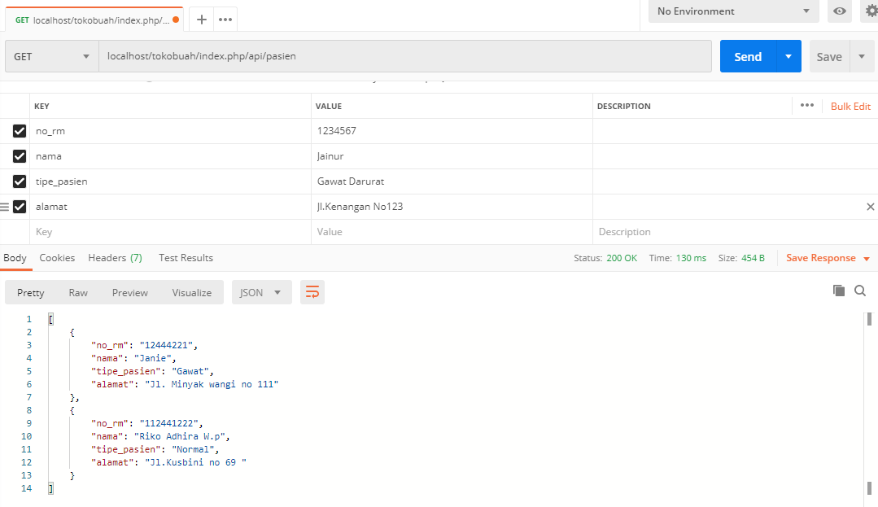

GET Dokter

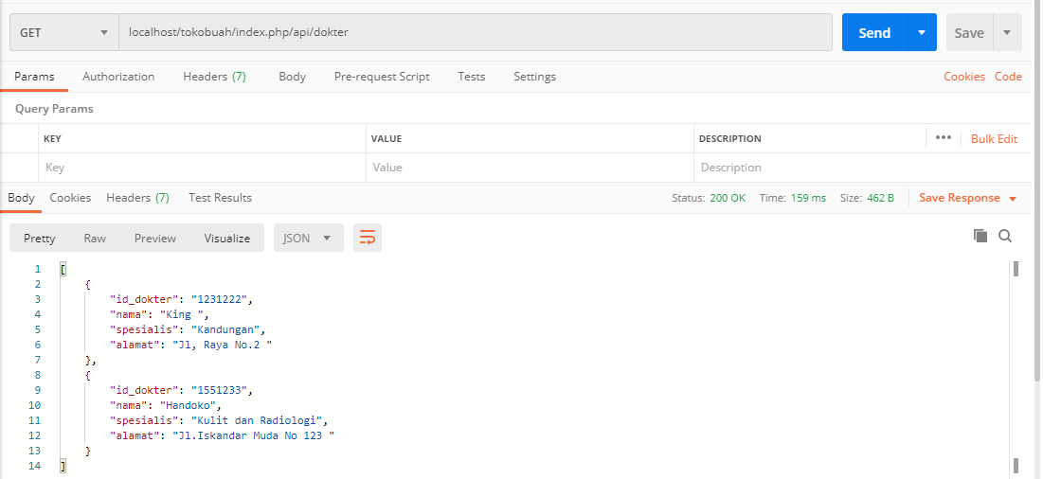

POST Dokter

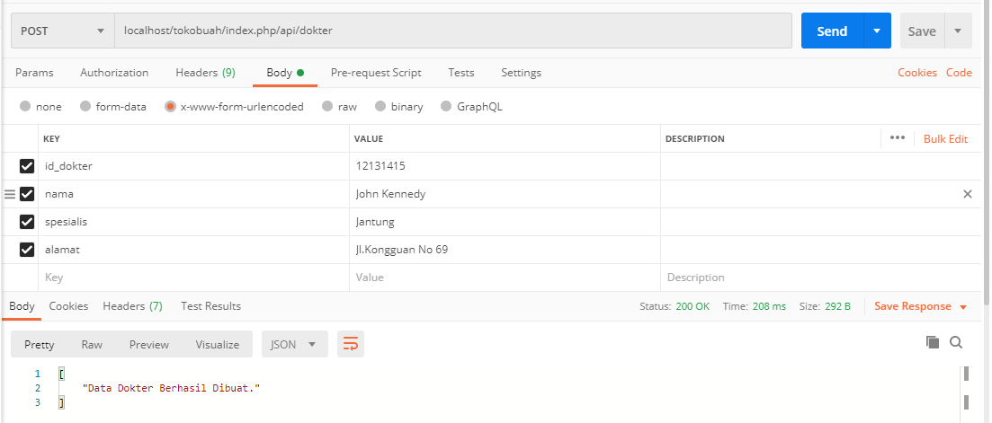

Gunakan Get untuk menampilkan Data

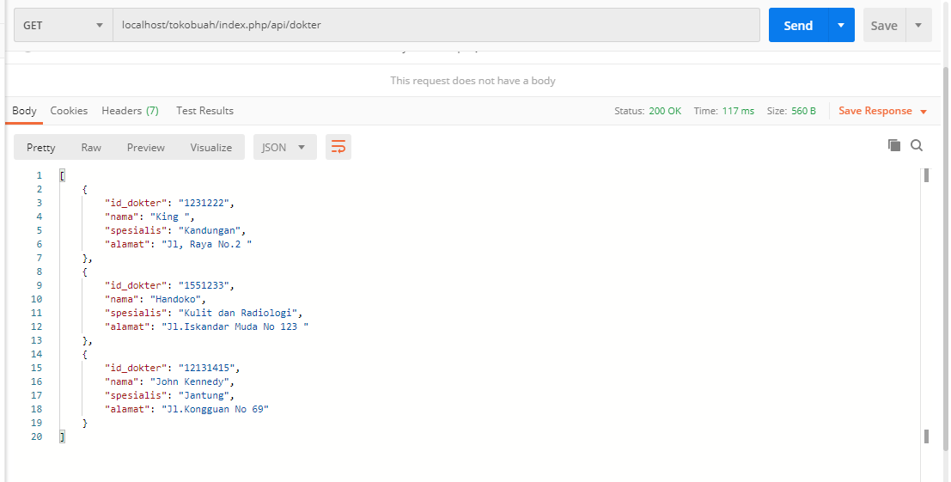

PUT Dokter

Data Sebelum Diubah



Data Sesudah dibuah

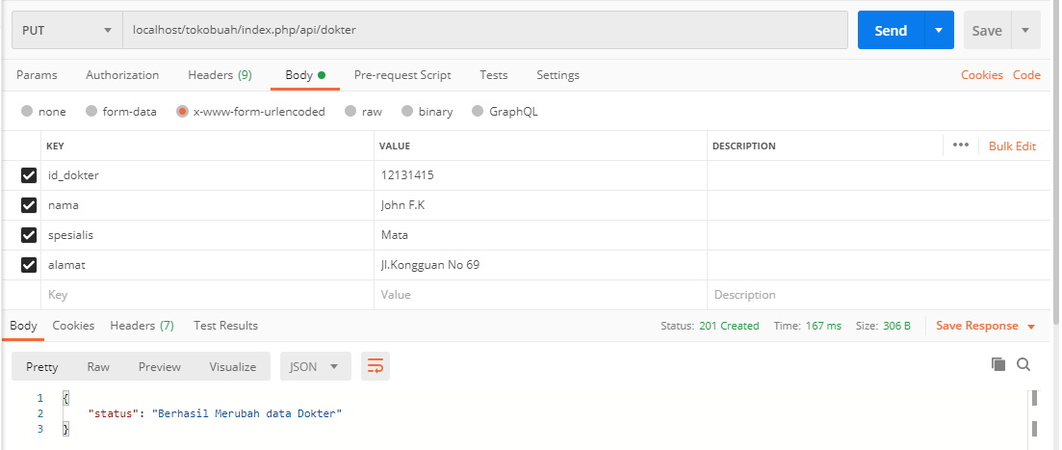

Delete Dokter :

Data yang dihapus John Kennedy

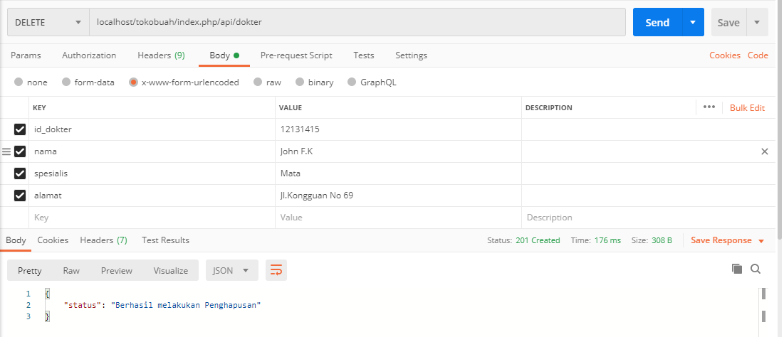

Berhasil Melakukan Penghapusan , lalu gunakan get untuk menampilkan data terbaru :

