Discovering potential key features of DNA methylation and gene expression using Decision Variable Analysis

¹School of Rail Transportation, Soochow University, Suzhou 215131, China
^{2*}Key Laboratory of Computational Biology, CAS-MPG Partner Institute for Computational Biology, 320 Yue Yang Road, Shanghai 200031, China
* To whom correspondence should be addressed. Email:

ABSTRACT
The identification of key features in DNA methylation and gene expression data has been one of the important issues for cancer detection and diagnosis. The data set contains the interesting information and also includes undesirable variations resulted from unpredictable factors. The data thus can be deemed as a combination of independent components and stochastic noise. Based on this idea, we propose a novel feature selection method called decision variable analysis (DVA) to extract the important characteristics related to the phenotype of interest from the data containing potential confounding factors. Using this method on the simulated data and real data, respectively, we find DVA performed better in identifying confounding factors comparing to other methods, including linear regression and surrogate variable analysis. Especially, our method is more efficient for the small sample data. We show improvements of DVA across four high-dimensional datasets with small samples size by the experiments. The results indicate that DVA can effectively select important features for different data sets with potential confounding factors.

1 INTRODUCTION
It is important to find variables that play a decisive role in differential expression of gene for early detection and diagnosis of human cancer. However, there are many unmodeled or unmeasured variables which may affect gene expression . These potential variables create extra sources of differential gene expression, which, unlike random fluctuations, can be observed in the expression datasets.
Primary variable (or phenotype of interest) is generally explicitly modeled in the expression studies . The primary variable is or is not correlated with any given variation of gene expression. The sources of expression variation are divided into two types. One source of variation can be explained by measured or unmeasured variables. The other is “noise” which refers to random fluctuations in gene expression. For example, in a gene expression study, caner state on a specific tissue type is deemed to be a primary variable. It is assumed that not only changes in expression related to cancer state but also the age of the individuals has a fundamental impact on the expression. Hence, some genes are observed differential expression pertaining to cancer, some corresponding to age, and some both. If age is excluded in the analysis when identifying differential expression corresponding to cancer, this may introduce additional spurious signal resulted from the effect of age on expression confounded with cancer state, or induce “regular” noise in the data. In practice, even if the age (variable) is known, it is difficult for researchers to select this factor into the model because there may be too many available related factors. Moreover, the age factor may interact with unobserved factors and complicate the effect of age on gene expression.
The sources of variation derive from technical experimental design, environmental, or genetic factors . Normalization techniques are generally used to adjust for systematic expression variation resulted from laboratory and technical sources. But there are still some unknown variations after normalization has been implemented . To model factors as statistically independent variables, independent component analysis (ICA) were introduced by some studies . Some researchers once proposed algorithm (e.g., surrogate variable analysis) to model the potential factors . However, there are not enough for accounting for all or identifying sources of expression variation, whatever unmeasured or measured factors resulted from both biological and technical sources.
We propose a new method and algorithm called decision variable analysis (DVA) to solve this problem. The basis of the framework is that the priori knowledge is closely related to the primary phenotype of interest and can be transformed into a decision variable to construct a linear regression equation. By removing the effect of the decision variable on the expression, the residual matrix is obtained, and the residual part is decomposed to statistically independent variables associated with decision variable. For the effectiveness of the framework, we design the algorithm and implement it on the simulated dataset and the real data, respectively. For comparing the results of different methods, our method shows better performance and statistical characteristics in expression analyses.

2 METHODS

2.1 Review of singular value decomposition
We have a biological data matrix A (m rows and n columns), with m representing the number of features (genes, CpGs, etc.) and n representing the number of samples. The number of features is greater than the number of samples (m>n). Matrix A can be decomposed into the column orthogonal matrix U with m rows and m columns, the diagonal matrix Σ (m rows and n columns) of the singular value of matrix A, and the transpose of the orthogonal matrix V (n rows and n columns). The singular value decomposition (SVD) of matrix A in formula can be expressed as:
 (1)
In practice, SVD does not need to use all singular values of the matrix A. In processing of biological large-scale data, a small part of the singular value of the data can represent most of the information. Therefore, the aim of SVD is to reduce the “noise” dimension of matrix A. The data with low-dimensional but representative features can clarify the relationships between gene expression and cancers. Matrix A is decomposed by singular values to obtain the decomposed matrix. We select the main singular values, that is, select the k large singular values to represent m features of data. The small singular value corresponding to noise feature is discarded. Thus, the number of features is decreased from m to k. The original matrix can be reconstructed by the following formula:
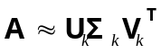 (2)
The formula (2) indicate that we can use k (k<m) features with 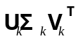 to represent the original biological data matrix A.

2.2 Notation of independent component analysis
Blind signal separation is the technique of reconstructing the source signal 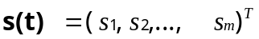from a known mixed signal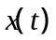. A common assumption is that the source signals are statistically independent of each other. If 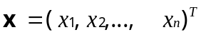denotes the n-dimensional observations, then the ICA model can be expressed as:
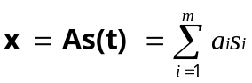 (3)
where A is the mixed matrix, is the column of A, and is the row of 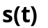.
The aim of ICA is to estimate the mixing matrix A and the source. This is solved by adaptively computing the (weight vector) and establishing a cost function which minimizes the mutual information or maximizes the non-Gaussianity of calculated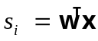. FastICA use a nonquadratic nolinear function 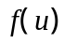 to measure non-Gaussianity. The first and second derivatives of are 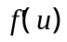 and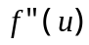, respectively. They can be the functions as follows :
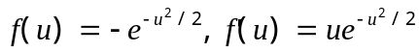, and 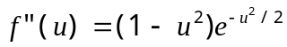 (4)
The steps for calculating the for one component of fastICA are as follows:
Step 1: Randomize the initial vector
Step 2: Let 
Step 3: Let 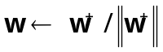
Step 4: If not converged, go back to Step 2.
where 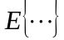 denotes averaging over all column vectors of .
The original source then can be reconstructed by multiplying the observations x with the inverse of matrix A (i.e.,). Moreover, there are other choices for the cost function and some other algorithms developed for the optimization. We use this ‘fastICA’ algorithm in our study which has many successful applications.

2.3 Decision variable analysis
The data can be affected by three factors: the first factor is associated with the phenotype of interest (POI), the second is connected with known or hidden confounding factors (CFs), and the third is random or stochastic fluctuation. The observed data can be considered as a fusion pattern by these three impact factors. For factor analysis, we resolve the data into components that are as independent as possible. For instance, if tumor samples are obtained from two related but distinct cohorts and profiled on microarrays, the array and cohort can be considered as two potential and independent factors. In more cases, CFs may influence the data in a correlated pattern. Deconvolution of CFs into statistically independent components can enhance the interpretation of the data . In view of ICA, identifying different impact factors can be deemed as ‘blind source signal separation’. To trace the sources, our method should be designed on the basis of independent non-Gaussian components corresponding to the POI and CFs. Then, we propose the following method, called decision variable analysis (DVA), as follows.
- We correlate the data with different variables (prior knowledge) to find decision variable corresponding to the smallest P-value as POI by using linear regression.
- We remove the effect of POI (y) on the data by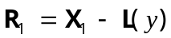, where 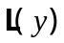means the linear part of data matrix 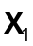 corresponding to the y.
- We obtain the number of components representing random or stochastic variation by SVD. This gives the number of components representing potential CFs as input to the ICA algorithm.
- We perform ICA on 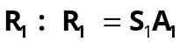, where  is the mixing matrix of , and 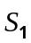 is the source matrix of .
- We correlate the data matrix with and obtain the Pearson’s r (i.e., the correlation coefficient) vector.
- We transform the distribution of Pearson’s r to normal distribution.
- We get the indexes of statistically significant correlated features with counterpart of original data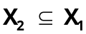.
- We perform ICA on 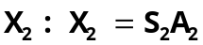, where 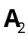 is the mixing matrix of 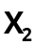, and 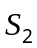 is the source matrix of .
- We obtain the vectors of as decision variables with the largest Pearson correlations between and .

2.4 Simulated dataset
The simulated data matrix consists of 2000 features and 50 samples and two confounding factors (CFs) with a phenotype of interest (POI). The POI is a binary variable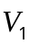. 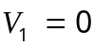 and 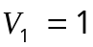 represent the samples belongs to one class and the other class. The numbers of two classes in samples are the same, that is, 25. Similarly, two CFs are also binary variables (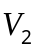 and 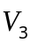). Each CF impacts on 25 randomly selected samples denoted by 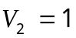 or 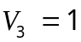.
Given a sample s, a three-tuple of variables 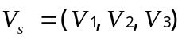is built, where 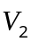andare the binary variables of two CFs. We thus obtain 8 different categories of samples. For example, 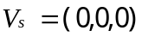 indicates that this sample belongs to one of the two phenotype classes 1 and is not influenced by the two CFs. Similarly, 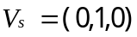 indicates that the sample belongs to one of the two phenotype classes and is affected by the first CF but not the second.
Ten percent of features (200 of 2000 features) are assumed to be true positives (TPs) which can differentiate between the two classes of POI. The two CFs are constructed as follows: each CF affects 50 features independently and 50 features are affected by both CFs. The noise is modeled by a Gaussian of mean zero and unit variance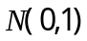. Moreover, 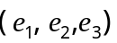 is used to represent the relative effect size of the POI and the two CFs on the data, respectively. Let 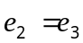 for simplicity. Since samples belongs to eight categories 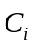 (i=1, 2,…, 8), we can construct the data values for eight categories as follows:
(1) 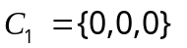: null features with no influences of CFs
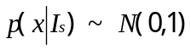 (5)
(2) 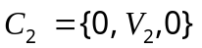: null features influenced by the first CF
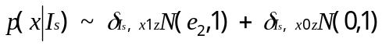 (6)
(3) 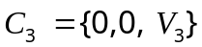: null features influenced by the second CF
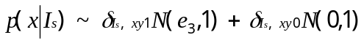 (7)
(4) 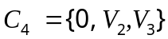: null features influenced by the two CFs
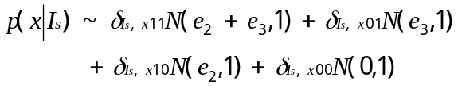 (8)
(5) 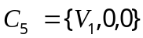: true positives with no influences of CFs
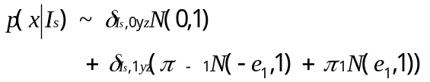 (9)
(6) 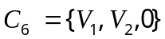: true positives influenced by the first CF
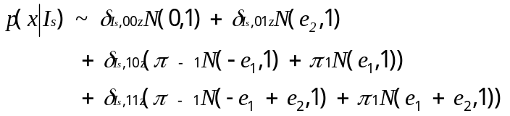 (10)
(7) 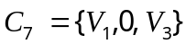: true positives influenced by the second CF
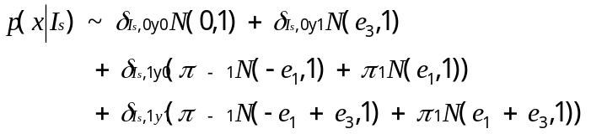 (11)
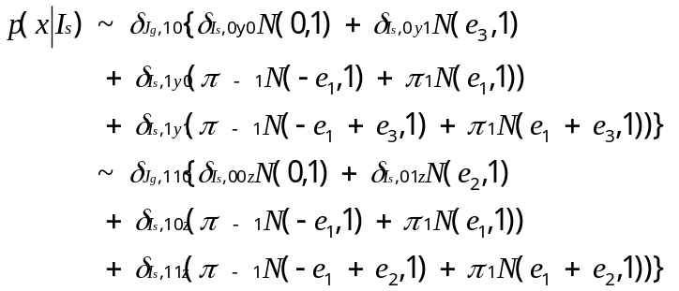 (12)
(8) 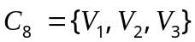: true positives influenced by all CFs
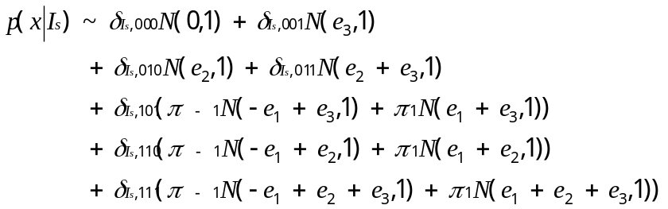(13)
where 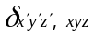 means the triple Kronecker delta: 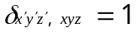 if and only if 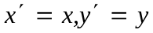, and 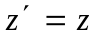, otherwise 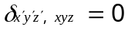 and 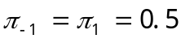.

2.5 Real biological datasets: DNA methylation
Four DNA methylation datasets are used which have been produced by Illumina’s Infinium Human Methylation 450k Beadchips. The Illumina Human Methylation 450 BeadChip tests the methylation status of CpGs at 485,577 sites across the genome . In our work, the normalized datasets are used as described in the literatures . The data is expressed as matrix X_{ij} where i denotes the CpG and j represents the sample. The methylation values of the CpGs are normalized between 0 (unmethylated locus) and 1(methylated) which follow the approximate -valued distribution . The is defined as the ratio of methylated to combined intensity values:
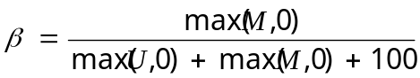 (14)
where U and M are the unmethylated and methylated intensity values of the probe and 100 is a correction term to regularize probes of low total signal intensity (i.e. probes of 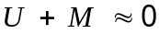 after subtracting background signal).The data matrices X_{ij} therefore can be expressed as 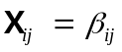, where 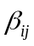 is the normalized methylation value at the i CpG locus of j sample. In these Illumina Infinium Human Methylation 450k arrays, three main CFs are set: sex, age and race variations. It is note that the variations caused by these factors have not been removed by quantile normalization procedures.
Datasets 1~4 are DNA methylation datasets from TCGA. (i) Dataset 1: the DNAm dataset is composed of 395 samples from patients with stomach adenocarcinoma and normal as controls (a total of 137 women and 258 men). (ii) Dataset 2: this DNAm dataset consists of 472 samples from patients with skin cutaneous melanoma and normal people (a total of 179 women and 293 men). (iii) Dataset 3: This dataset consists of 310 samples from a total of 141 women and 169 men (38 healthy people and 272 patients with colon adenocarcinoma). (iv) Dataset 4: This dataset consists of 102 samples from 7 healthy people and 95 patients with rectum adenocarcinoma, a total of 47 women and 55 men. We take sex, age, and race as the potential confounding factors in Datasets 1~3. Sex and age are considered as potential confounding factors in Dataset 4 because there are too many missing values in race factor.

2.6 Real biological datasets: gene expression
Datasets 5~8 are gene expression datasets from TCGA. (i) Dataset 5: this dataset consists of 16861 genes and 529 samples from 471 patients with lung adenocarcinoma and 58 healthy people (a total of 289 women and 240 men). (ii) Dataset 6: this dataset is composed of 16633 genes and 587 samples from 515 patients with kidney renal clear cell carcinoma and 72 normal, a total of 202 women and 385 men, respectively. (iii) Dataset 7: this gene expression dataset contains 16990 genes and 448 samples from a total of 158 women and 290 men (35 healthy people and 413 patients with stomach adenocarcinoma). (iv) Dataset 8: this dataset includes 16161 genes and 399 samples from 50 healthy people and 349 patients with liver hepatocellular carcinoma, a total of 136 women and 263 men. Gender, age, and race factors are taken as the potential confounding factors in Datasets 5~8.

2.7 Algorithm comparison using the same evaluation indexes
We compare the performance through applying DVA, surrogate variable analysis (SVA) and simple linear regression (SLR) with no adjustment for CFs on the same simulated and real biological datasets, respectively. We also compare different algorithms using the same statistic test method. Let 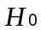 denote null features and 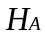 indicate the number of features following the alternative hypothesis. Let represent the number of features following the alternative hypothesis and affected by the CFs. Three algorithms DVA, SVA and SLR without adjustment for CFs are compared in their performance on detecting the number of true positives at a given false discovery rate (FDR) threshold of 0.05 , the positive predictive value 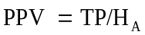, where TP is the number of true positives passing the same FDR threshold of 0.05, the false negative rate 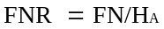where FN is the number of false negatives at the same 0.05 FDR threshold, and the sensitivity to detect true positives affected by the CFs, i.e., 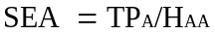, where  is the number of features affected by the CFs passing the FDR threshold of 0.05. We also evaluate the identifiability of derived surrogate or independent decision variables with CFs using the average of the best Pearson correlations (CORR) between them. Moreover, the Kolmogorov–Smirnov test (KST) is implemented to test the P-values from nulls following the uniform distribution between 0 and 1.

3 RESULTS

3.1 The results of simulated data
We generate the simulated data including 2000 features and 50 samples with a primary binary variable of POI and two CFs (also binary variables) in Section 2. It is assumed that 10% of features (i.e., 200) are distinct for POI and CFs and overlap, that is, on average ~150 of the 200 true positives are also affected by CFs. At the same FDR threshold of 0.05 and relative effect size=1,2,3,4 three algorithms (DVA, SLR, and SVA) repeat 100 runs, respectively. After running the algorithms, some important differences in all evaluation indexes among these algorithms are shown in Fig. 1A. We observe that DVA outperform SVA and SVA outperformed SLR (no adjustment for CFs) in all indexes except Kolmogorov–Smirnov test (KST). In KST, DVA and SVA show almost the same performance. The null gene P-value of DVA and SVA agree with that of a uniform distribution, whereas SLR not. It is note that DVA marked reduced the FNR, increased the PPV and SEA comparing to other algorithms. As expected, the SLR has the lowest performance because it cannot take potential confounding factors into consideration. SVA has the largest variations in detecting TP, PPV, FNR, and SEA among these methods. This suggests that the performance of SVA is not stable, although it can obtain promising results sometimes. Moreover, the decision variables which DVA found are much closer to CFs than others, which CORR is better than that obtained by SVA.
Furthermore, the relative effect sizes of the POI and CFs (i.e., 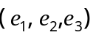in Section 2.4) are needed to be considered. Based on previous studies , we run all algorithms in which the effect sizes were set from 1 to 4. Fig. 1B shows the results of the effect size of CFs is set to be 3×the effect size of the POI. From Fig.1B, the number of TP detected is close to the true number of TP (~150). As before, DVA has the best performance among three algorithms. The performance of DVA and SVA are much better than that of SLR, even better than their performance at small effect size (Fig. 1A). The variation of performance metrics (expect KST and CORR) of DVA and SVA become smaller when comparing that of in Fig. 1A. It is noted that the variation of metrics (expect KST and CORR) of SVA has significantly decreased. This suggests that when the effects of confounders become larger, the results of SVA algorithm become more stable and vice versa. On the contrary, our DVA algorithm can remain stable and effectiveness even when confounders have small influence. Performance indexes for the case where the effect size is 2 are similar. From the experiments of adjusting the effect size, we find that as the effect size increasing (i.e., interferences stemmed from potential factors become larger), DVA and SVA capture these factors easier, and it has more necessity to consider surrogate or independent decision variables to deconvolve confounding factors.
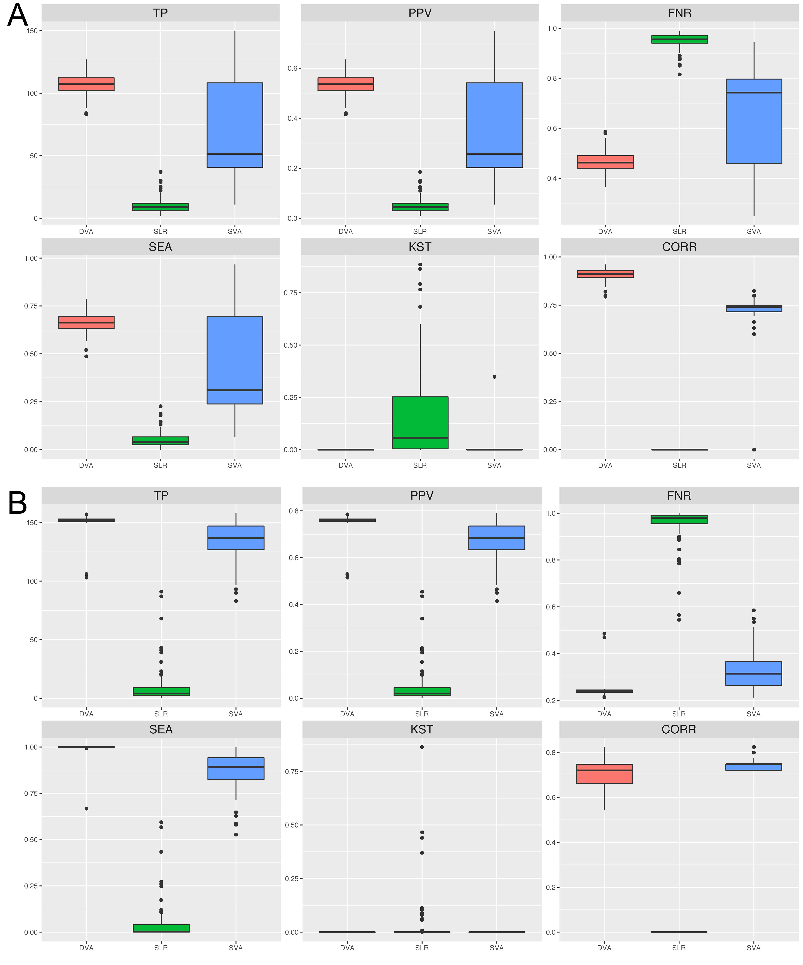
Fig. 1. Feature selection performance indexes of the different algorithms over 100 runs of simulated data. The algorithms of feature selection are decision variable analysis (DVA), surrogate variable analysis (SVA) and simple linear regression (SLR). Using the same given false discovery rate (FDR) threshold of 0.05, we compare true positives (TP) passing the FDR threshold, the positive predictive value (PPV), the false negative rate (FNR), the sensitivity to detect true positives affected by the confounding factors (CFs) (SEA), the average of the best Pearson correlations (CORR) between CFs and derived surrogate or decision variables, and the null gene P-value distribution following the uniform distribution between 0 and 1 tested by the Kolmogorov–Smirnov test (KST) (Please see Section 2 for more details). (A) Relative effect size = 1. (B) Effect size of CFs is set to be 3×the effect size of the phenotype of interest.

3.2 The results of DNA methylation datasets
After the simulation experiments, we apply the algorithms on real biological data using cancer status as the phenotype of interest. Since the role of DNA methylation in cancer has been confirmed , we also use four DNA methylation datasets which all have low signal to noise ratio (SNR) and potential CFs (Datasets 1-4 detailed in Section 2.5). The inferred surrogate variable (SV) or decision variable (DV) which best correlated with the CFs base on relationship and P-value statistics are obtained in Table 1. We find that all selected DVs correlated significantly with the sex factor. The derived DVs are more related to sex factor than other factors, whereas SVs are not. In most cases, the correlation values obtained by DVA are larger than those obtained by SVA, which means DVA models the factor better.
Through selecting the best DV/SV, we find that DVA compares favorably to SVA, especially in modeling sex factor. Given that one component of DV/SV may not capture all possible effects, the second best DV or SV correlating with the factor is also analyzed. We observe that the second best decision variable correlated more with sex factor than surrogate variable does (Figs 2 and 3). Corresponding F-statistics for DVA are also larger suggesting that the decision variables grasp more variability in gender differences (Figs 2 and 3). In the case of factors not affected by uncertainties or measurement errors, DVA (and SVA) can model the CFs fairly well (higher correlation coefficients). Under the condition of measurement variations or uncertainties, the values of DV related to CFs are much lower just as shown in relating the second best DV to CFs. From another point of view, the derived DVs may more accurately model the uncertainties than the CFs on the data. That is to say, using DVs as covariates can achieve better results than using the CFs or SVs as covariates.
The results show the better modeling performance of DVA in both simulated data and real data. Especially, for a smaller DNAm dataset (Dataset 4), we find that DVA can model effects on the data where there are 102 samples, but not so for SVA (Table 1). Sometimes, appreciable differences cannot be observed between DVA and SVA for a DNA methylation dataset (e.g. Dataset 3). This is not surprising since only a small part of the samples or features are affected by potential sources, i.e., the impacts of independent sources are not enough to cause differences between DVA and SVA. Nonetheless, the performance metrics obtained by DVA are better than those by SVA.

Table 1. The performance of DVA and SVA on DNA methylation datasets 1-4
Dataset 1 | SVA-P | SVA-R | DVA-P | DVA-R
Sex | 0.361 | 0.05 (1) | 1e-167 | 0.94 (9*)
Race | 0.018 | 0.12 (1) | 2e-10 | 0.33 (5)
Age | 1e-07 | 0.27 (2) | 1e-05 | 0.23 (7)
Dataset 2 | SVA-P | SVA-R | DVA-P | DVA-R
Sex | 0.036 | 0.10 (2) | 4e-128 | 0.85 (10)
Age | 0.005 | 0.13 (2) | 3e-08 | 0.26 (9)
Race | 0.757 | 0.01 (2) | 0.035 | 0.10 (8)
Dataset 3 | SVA-P | SVA-R | DVA-P | DVA-R
Sex | 1e-83 | 0.86 (4) | 1e-81 | 0.86 (13)
Age | 0.017 | 0.14 (3) | 0.006 | 0.16 (7)
Race | 0.254 | 0.07 (5) | 0.140 | 0.09 (8)
Dataset 4 | SVA-P | SVA-R | DVA-P | DVA-R
Sex | − | − | 3e-40 | 0.91 (2)
Age | − | − | 0.044 | 0.20 (10)
* The best surrogate variable (SV) or decision variable (DV) in inferred SVs/DVs related to the confounding factors is given in bracket.

Fig. 2. Comparison of DVA with SVA in identifying sex effect in Dataset 1. The weights (y-axis) in the two decision variables and surrogate variables the most correlated with the sex factor are plotted against genders (x-axis). The F-statistics of a linear ANOVA with sex as the independent variable are also provided for comparing the identifiability of sex effect.

Fig. 3. Comparison of DVA with SVA in identifying sex effect in Dataset 2. The weights (y-axis) in the two decision variables and surrogate variables the most correlated with the sex factor are plotted against genders (x-axis). The F-statistics of a linear ANOVA with sex as the independent variable are also provided for comparing the identifiability of sex effect.

3.3 Gene expression datasets
We further apply the DVA and SVA approaches on four gene expression datasets (Datasets 5-8, Section 2.6). These four gene expression datasets all have low signal to noise ratio (SNR), and potential CFs are sex, age, and race. The derived SV/DV which best correlated with the CFs and P-values are listed in Table 2. It indicates that the selected DVs are all significantly related to the sex factor. The derived SVs/DVs are more correlated with gender factor than other two factors. As expected, the correlation values between the DVs and the sex factor are larger than those SVs, which also suggest DVA models the factor better.
SVA method shows low correlation between SVs and sex factor in Dataset 7 from stomach adenocarcinoma. This result further suggests that the need to model the confounding factor from the data, rather than using the more error-prone confounding factor. However, SVA failed to obtain the cell cycle characteristics of all examined data sets. Observe the correlation graph between the interest phenotype and the confounding factor of the proxy variable, which is due to the presence of proxy variables that are significantly related to the level, While DVA has a substantial change. In contrast, DVA detected cell cycle-specific enrichment in the data set, again demonstrating that the ISV selection step used ICA was superior to SVD / PCA
Table 2. The performance of DVA and SVA on gene expression Datasets 5-8
Dataset 5 | SVA-P | SVA-R | DVA-P | DVA-R
Sex | 3e-50 | 0.62 (5) | 0 | 0.98 (16*)
Age | 5e-03 | 0.13 (38) | 3e-04 | 0.17 (2)
Race | 8e-05 | 0.18 (20) | 4e-02 | 0.09 (12)
Dataset 6 | SVA-P | SVA-R | DVA-P | DVA-R
Sex | 3e-44 | 0.54 (9) | 1e-224 | 0.91 (11)
Age | 2e-05 | 0.18 (9) | 8e-04 | 0.14 (11)
Race | 1e-07 | 0.22 (17) | 1e-03 | 0.13 (11)
Dataset 7 | SVA-P | SVA-R | DVA-P | DVA-R
Sex | 1e-12 | 0.35 (10) | 5e-77 | 0.77 (4)
Age | 7e-04 | 0.17 (19) | 2e-03 | 0.16 (10)
Race | 7e-06 | 0.23 (27) | 1e-02 | 0.13 (13)
Dataset 8 | SVA-P | SVA-R | DVA-P | DVA-R
Sex | 3e-28 | 0.52 (10) | 3e-105 | 0.84 (9)
Age | 4e-08 | 0.27 (15) | 1e-07 | 0.26 (4)
Race | 4e-09 | 0.29 (15) | 2e-05 | 0.21 (9)
*The best surrogate variable (SV) or decision variable (DV) in inferred SVs/DVs related to the confounding factors is given in bracket.

From another point of view, the derived DVs may more accurately model the uncertainties than the CFs on the data. That is to say, using DVs as covariates can achieve better results than using the CFs or SVs as covariates.
Nonetheless, the performance metrics obtained by DVA are better than those by SVA.

4 DISCUSSION AND CONCLUSIONS
We propose an extension of the DVA framework that uses blind source separation techniques (ICA) to model potential confounding factors and then use them as feature-selected covariates. We use simulated and real data sets, including two different data types (Illumina Infinium DNAm and mRNA expression), and the results show that DVA (ICA) improves the recognition of confounding factors for SVA using the SVD / PCA framework, And this makes the algorithm in feature selection more robust
Our results show that the robustness of DVA is derived from the combination of ICA and ISV selection steps. Although the other difference between SVA and DVA is that we use the different dimension estimation algorithm , but we have verified that the use of prcomp in the dimension estimation step only slightly improves performance. In fact, using the same arrangement-based dimensioning algorithm as SVA, modified DVA still better identifies confounding factors and is similar to ISVA, further demonstrating the superiority of ICA relative to PCA.
On the other hand, for the feature extraction of the priori knowledge decision set, we propose to introduce a priori knowledge, combine the prior knowledge with the phenotype of interest, and do linear regression with independent agent variables, Can be The presence of known or hidden confounding factors further reduced dimension, get independent decision variables. The independent decision variables obtained by the statistical calculation, and finally verify its effectiveness. The introduction of this step makes our high-latency small sample processing more reasonable and more accurate.
In conclusion, our results show that DVA is doing well in identifying confounding factors, and it provides a flexible and robust framework for downstream statistical inference. Thus, it is useful as an alternative tool for deriving a list of features that change the difference in t

References
1. Brinkman AB, Gu H, Bartels SJ, Zhang Y, Matarese F, Simmer F, et al. Sequential ChIP-bisulfite sequencing enables direct genome-scale investigation of chromatin and DNA methylation cross-talk. Genome research. 2012;22(6):1128-38.
2. Easwaran H, Johnstone SE, Van Neste L, Ohm J, Mosbruger T, Wang Q, et al. A DNA hypermethylation module for the stem/progenitor cell signature of cancer. Genome research. 2012;22(5):837-49.
3. Hon GC, Hawkins RD, Caballero OL, Lo C, Lister R, Pelizzola M, et al. Global DNA hypomethylation coupled to repressive chromatin domain formation and gene silencing in breast cancer. Genome research. 2012;22(2):246-58.
4. Laurent L, Wong E, Li G, Huynh T, Tsirigos A, Ong CT, et al. Dynamic changes in the human methylome during differentiation. Genome research. 2010;20(3):320-31.
5. Maegawa S, Hinkal G, Kim HS, Shen L, Zhang L, Zhang J, et al. Widespread and tissue specific age-related DNA methylation changes in mice. Genome research. 2010;20(3):332-40.
6. Rakyan VK, Down TA, Maslau S, Andrew T, Yang TP, Beyan H, et al. Human aging-associated DNA hypermethylation occurs preferentially at bivalent chromatin domains. Genome research. 2010;20(4):434-9.
7. Robinson MD, McCarthy DJ, Smyth GK. edgeR: a Bioconductor package for differential expression analysis of digital gene expression data. Bioinformatics. 2010;26(1):139-40.
9. Varley KE, Gertz J, Bowling KM, Parker SL, Reddy TE, Pauli-Behn F, et al. Dynamic DNA methylation across diverse human cell lines and tissues. Genome research. 2013;23(3):555-67.

References
Dedeurwaerder, S., et al. (2011) Evaluation of the Infinium Methylation 450K technology. Epigenomics, 3, 771-784.
Du, P., et al. (2010) Comparison of Beta-value and M-value methods for quantifying methylation levels by microarray analysis. BMC Bioinformatics, 11.
Hyvarinen, A. (1999) Fast and robust fixed-point algorithms for independent component analysis. IEEE Trans. Neural Networks, 10, 626-634.
Hyvarinen, A. and Oja, E. (2000) Independent component analysis: algorithms and applications. Neural Networks, 13, 411-430.
Leek, J.T. and Storey, J.D. (2007) Capturing heterogeneity in gene expression studies by surrogate variable analysis. PLoS Genet., 3, 1724-1735.
Leek, J.T. and Storey, J.D. (2008) A general framework for multiple testing dependence. Proc. Natl. Acad. Sci. U. S. A., 105, 18718-18723.
Maksimovic, J., Gordon, L. and Oshlack, A. (2012) SWAN: Subset-quantile Within Array Normalization for Illumina Infinium HumanMethylation450 BeadChips. Genome Biology, 13.
Qiu, X., Klebanov, L. and Yakovlev, A. (2005) Correlation between gene expression levels and limitations of the empirical Bayes methodology for finding differentially expressed genes. Statistical Applications in Genetics and Molecular Biology, 4.
Storey, J.D. and Tibshirani, R. (2003) Statistical significance for genomewide studies. Proc. Natl. Acad. Sci. U. S. A., 100, 9440-9445.
Storey, J.D., et al. (2005) Significance analysis of time course microarray experiments. Proc. Natl. Acad. Sci. U. S. A., 102, 12837-12842.
Teschendorff, A.E., et al. (2010) Age-dependent DNA methylation of genes that are suppressed in stem cells is a hallmark of cancer. Genome Res., 20, 440-446.
Teschendorff, A.E., Zhuang, J. and Widschwendter, M. (2011) Independent surrogate variable analysis to deconvolve confounding factors in large-scale microarray profiling studies. Bioinformatics, 27, 1496-1505.

