This is the Network Programming Assignment #2 project of ECEN 602, FALL 2016.

Team 8: Xiaopei Xu， Yanxiang Yang

In this test we use tftp_hpa in ubuntu as TFTP client.

TEST:

Firstly compile the code(call make) and get a file(TFTP):

1. Make sure the test files TFTP, test_file_1, test_file_2 and test_file_3 are in same folder. When call TFTP client to get a file, also make sure the client are called in different folder (or you must take care of the remote file name and local file name );
2. In Terminal 1, open the TFTP server ‘’./TFTP 127.0.0.1 1024” (Or other IP/port);
3. In Terminal 2, input ‘tftp 127.0.0.1 1024’; and type in ‘ trace’ to turn on packet trace; then type in ‘get test_file’; as there is no file named as “test_file”, the server will send error and client will get error with error code 1;

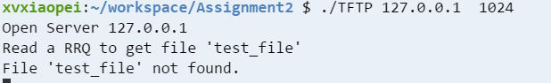

Terminal 1 (step 2-3)

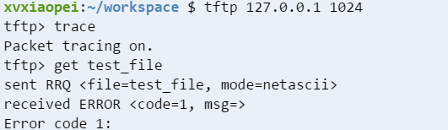

Terminal 2 (step 2-3)

1. In Terminal 2, input ‘get test_file_1’ , client will get the file from server.(Only 1 packet)

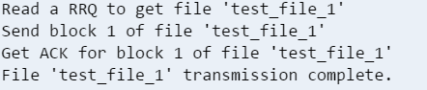

Terminal 1 (step 4)

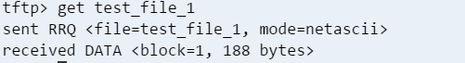

Terminal 2 (step 4)

1. In Terminal 2, input ‘get test_file_2’ , client will get the file from server.(20 packets)

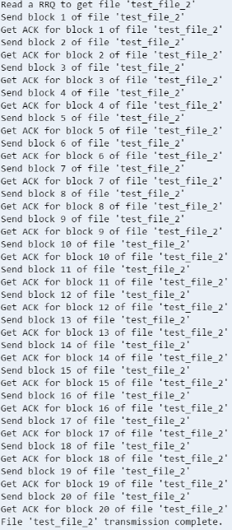 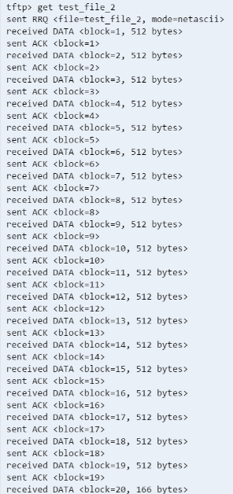

Terminal 1 (step 5) Terminal 1 (step 5)

1. For larger file, we also test with the test_file_3.
2. Use command diff to check if the remote file and local file are same.

