This is the Network Programming Assignment #3 project of ECEN 602, FALL 2016.

Team 8: Xiaopei Xu， Yanxiang Yang

In this test we will use the client to get some documents through proxy server.

TEST:

Firstly compile the code(call make) and get a file(client and proxy), then call

./proxy <ip to bind> <port to bind>

to put the server online in a terminal, I use

./proxy 172.17.0.114 1024

while other address and port is allowed.

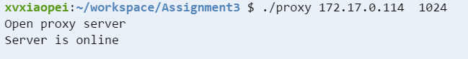

1. Test simple GET: In another terminal, input:

./client 172.17.0.114 1024 [www.google.com](http://www.google.com)

Then the server will print some logging message, include request and cache status:

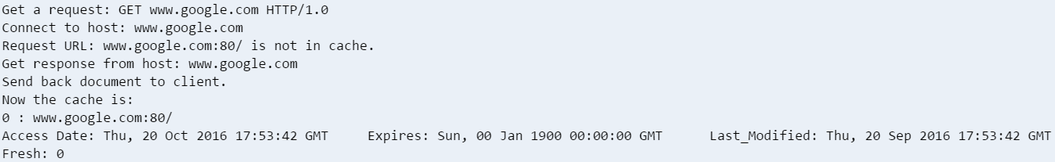

In cache it also show the dates of this document.

In client terminal, it will show

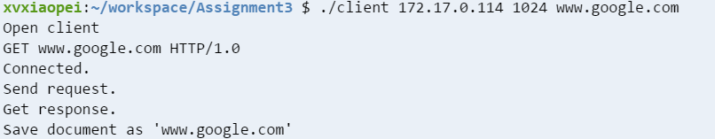

And the file “www.google.com” has been created(it is in the uploaded folder “test”)

1. In put ./client 172.17.0.114 1024 [www.tamu.edu,](http://www.tamu.edu,) then the server and client will act as previous step, and put the document of “www.tamu.edu” in the head of the cache:

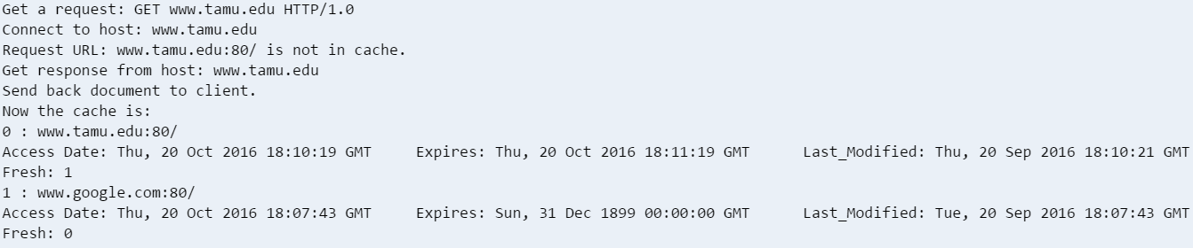

1. Input “./client 172.17.0.114 1024 [www.google.com](http://www.google.com)” again, then the server will show that the document is in cache but expired, and then go for check that if the document is still fresh by sending conditional get. The result is that the document is not fresh, so the older one in the cache will be deleted and a fresh one will be added into cache:

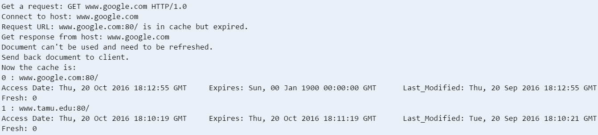

1. Input “./client 172.17.0.114 1024 disease.herokuapp.com”, server log will be like

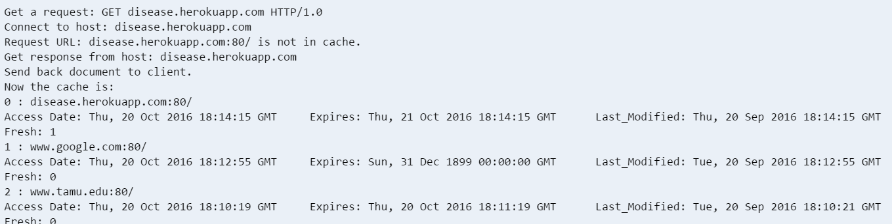

Then input “./client 172.17.0.114 1024 disease.herokuapp.com” again, this time server will find that the document is in cache and valid, so it will only return the fresh document in cache.