**Homework 1**

Xiaoning Wan

xw2501

**1.**

For example, vector $\vec{a}\left(1,0,0\right)$, $\vec{b}\left(-1,0,0\right)$ and $\vec{c}\left(0,0,1\right)$

$$\vec{a}×\left(\vec{b}×\vec{c}\right)=\left(1,0,0\right)×\left(\left(-1,0,0\right)×\left(0,0,1\right)\right)=\left(1,0,0\right)×\left(0,1,0\right)=(0,0,1)$$

$$(\vec{a}×\vec{b})×\vec{c}=\left(\left(1,0,0\right)×\left(-1,0,0\right)\right)×\left(0,0,1\right)=\left(0,0,0\right)×\left(0,0,1\right)=(0,0,0)$$

For these three vectors, $\vec{a}×\left(\vec{b}×\vec{c}\right)≠(\vec{a}×\vec{b})×\vec{c}$

**2.**

**a.**

let vector $\vec{a}$ be a vector starting from origin point ${\tilde{p}}_{1}$ ending at point ${\tilde{p}}_{2}$

vector $\vec{b}$ be a vector starting from origin point ${\tilde{p}}_{1}$ ending at point ${\tilde{p}}_{3}$

the area of triangle can be described as $S=\frac{1}{2}\left| \vec{a}×\vec{b}\right|$.

Suppose the follwing example,

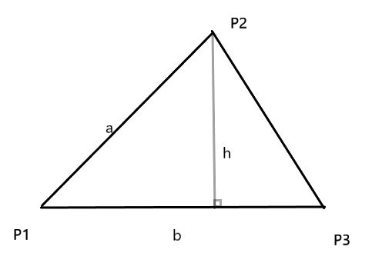

The area of triangle is $S=\frac{1}{2}bh$, where $b$ is the length of base and $h$ is the height.

According to the definiation of cross product, $\vec{a}×\vec{b}=\left\|\vec{a}\right\|\left\|\vec{b}\right\|sin⁡(θ)\vec{n}$. And if we take $\vec{b}$ as the base then, the length of height will be exactly $\left\|\vec{a}\right\|sin⁡(θ)$, thus the area of triangle is $S=\frac{1}{2}\left| \vec{a}×\vec{b}\right|$.

**b.**

the volume of tetrahedron can be described as $V=\frac{1}{6}\left|\vec{a}∙(\vec{b}×\vec{c})\right|$

as the volume of tetrahedron is $V=\frac{1}{3}Sh$, where $S$ is the area of base and $h$ is the height.

In this case, $S=\frac{1}{2}\left|\vec{b}×\vec{c}\right|$. And the height, is the dot product of vector $\vec{a}$ and norm of the base (plane formed by $\vec{b}$ and $\vec{c}$).

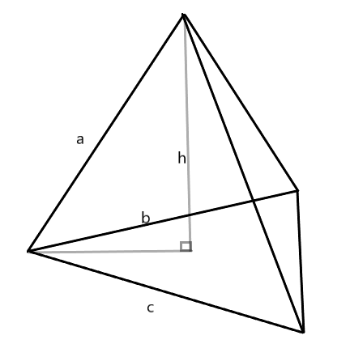

Here, $\vec{b}×\vec{c}=\left\|\vec{b}\right\|\left\|\vec{c}\right\|\sin\left(θ\right)\vec{n}=2S\vec{n}$, where $S$ is the area of base and $\vec{n}$ is a unit vector along the height direction. The dot product $\vec{a}∙\vec{n}$ is the projection of $\vec{a}$ on $\vec{n}$ which is the same as the length of height. Thus the volume is $V=\frac{1}{6}\left|\vec{a}∙(\vec{b}×\vec{c})\right|$.

**3.**

The surface normal is defined as $\vec{n}∙\vec{v}=0$, where $\vec{n}$ is the surface normal and $\vec{v}$ is the surface vertex vector.

Now, suppose in any point of the origin shape, we have $\vec{n}∙\vec{v}={(\vec{n})}^{T}\vec{v}=0$.

In the transformed shape, we have $\vec{n'}∙\vec{v'}= {(\vec{n^{'}})}^{T}\vec{v'}=0$.

As the transformation matrix is $M$, then $\vec{v'}=M\vec{v}$.

Thus, ${(\vec{n^{'}})}^{T}M\vec{v}=0$. And as $M^{-1}M=I$, we have ${(\vec{n})}^{T}M^{-1}M\vec{v}=0$.

$${(\vec{n^{'}})}^{T}={(\vec{n})}^{T}M^{-1}$$

$$\vec{n'}={({\vec{n}}^{T}M^{-1})}^{T}={{(M}^{-1})}^{T} \vec{n}=M^{-T}\vec{n}=M_{n}\vec{n}$$

**4.**

**i.**

Define the transformed shape as $\left[\begin{matrix}x' \\ y'\end{matrix}\right]$, we have

$$\left[\begin{matrix}x' \\ y'\end{matrix}\right]=T\left[\begin{matrix}x \\ y\end{matrix}\right]+U$$

Then,

$$\left[\begin{matrix}x \\ y\end{matrix}\right]=T^{-1}\left(\left[\begin{matrix}x^{'} \\ y^{'}\end{matrix}\right]-U\right)$$

Rewrite $\left[\begin{matrix}x \\ y\end{matrix}\right]$ as the straight line is defined,

$$\left[A B\right]T^{-1}\left(\left[\begin{matrix}x^{'} \\ y^{'}\end{matrix}\right]-U\right)=C$$

$$\left[A B\right]T^{-1}\left[\begin{matrix}x^{'} \\ y^{'}\end{matrix}\right]=C+\left[A B\right]T^{-1}U$$

Define

$$\left[A' B'\right]=\left[A B\right]T^{-1}$$

$$C^{'}=C+\left[A B\right]T^{-1}U$$

We can rewrite the transformed shape as

$$\left[A' B'\right]\left[\begin{matrix}x^{'} \\ y^{'}\end{matrix}\right]=C'$$

Thus, the transformed shape is also a straight line.

**ii.**

For two parallel lines $Ax+By=C_{1}$ and $Ax+By=C_{2}$ $(C_{1}≠C_{2})$,

As proved in (i), the transformed line for them are

$$\left[A B\right]T^{-1}\left[\begin{matrix}x^{'} \\ y^{'}\end{matrix}\right]=C_{1}+\left[A B\right]T^{-1}U$$

$$\left[A B\right]T^{-1}\left[\begin{matrix}x^{'} \\ y^{'}\end{matrix}\right]=C_{2}+\left[A B\right]T^{-1}U$$

Define

$$\left[A' B'\right]=\left[A B\right]T^{-1}$$

$$C_{1}^{'}=C_{1}+\left[A B\right]T^{-1}U$$

$$C_{2}^{'}=C_{2}+\left[A B\right]T^{-1}U$$

The two lines can be rewrite as

$$\left[A' B'\right]\left[\begin{matrix}x^{'} \\ y^{'}\end{matrix}\right]=C_{1}'$$

$$\left[A' B'\right]\left[\begin{matrix}x^{'} \\ y^{'}\end{matrix}\right]=C_{2}'$$

As $C_{1}≠C_{2}$, $C_{1}'≠C_{2}'$, thus the two transformed lines are also parallel.

**iii.**

Suppose a point $\vec{x}=(x_{0},y_{0})$ lies on a straight line, and $\vec{r}$ is a unit vector along the direction of the straight line (either direction is alright).

Now we have two other points, one point ${\vec{x}}_{1}$ lies on this line and its distance to point $\vec{x}$ is $l_{1}$, another point ${\vec{x}}_{2}$ lies on the same line and its distance to $\vec{x}$ is $l_{2}$. We can write these two points as

$${\vec{x}}_{1}=\vec{x}+l_{1}\vec{r}$$

$${\vec{x}}_{2}=\vec{x}+l_{2}\vec{r}$$

Now that apply the transformation

$${\vec{x}}^{'}=T\vec{x}+U$$

$${\vec{x}}_{1}^{'}=T{\vec{x}}_{1}+U$$

$${\vec{x}}_{2}^{'}=T{\vec{x}}_{2}+U$$

Now the distance between ${\vec{x}}^{'}$ and ${{\vec{x}}_{1}}^{'}$ becomes $\left\|{\vec{x}}^{'}-{{\vec{x}}_{1}}^{'}\right\|=l_{1}\left\|T\vec{r}\right\|$

And the distance between ${\vec{x}}^{'}$ and ${{\vec{x}}_{2}}^{'}$ becomes $\left\|{\vec{x}}^{'}-{{\vec{x}}_{2}}^{'}\right\|=l_{2}\left\|T\vec{r}\right\|$.

As

$$\frac{\left\|\vec{x}-{\vec{x}}_{1}\right\|}{\left\|\vec{x}-{\vec{x}}_{2}\right\|}=\frac{l_{1}}{l_{2}}=\frac{\left\|{\vec{x}}^{'}-{{\vec{x}}_{1}}^{'}\right\|}{\left\|{\vec{x}}^{'}-{{\vec{x}}_{2}}^{'}\right\|}$$

The ratios of length along a same line remains the same.

**5.**

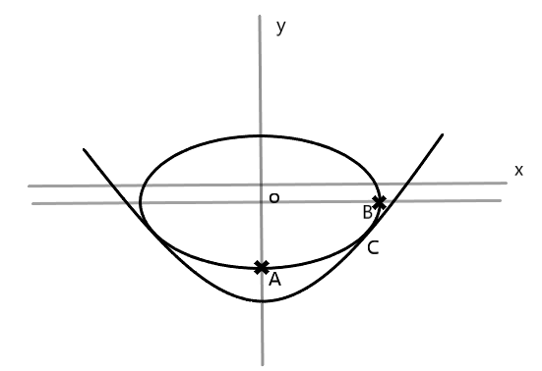

As the graph shows, both the object and supporter are symmetric, thus we just need to analyze half of the shape. Here, I’ll use the right part for analysis.

When the object is stablized, there should be only one intersection on the right part. At the intersection point C, the gradient of both curves are the same. And according to the ellipse shape, the intersection point must occur between point A and point B.

Formula of right-bottom part of ellipse:

$$y=h-b\sqrt{1-\frac{x^{2}}{a^{2}}}$$

Gradient of right-bottom part of ellipse:

$$y^{'}=-b\frac{1}{2\sqrt{1-\frac{x^{2}}{a^{2}}}}\left(-\frac{1}{a^{2}}\right)\left(2x\right)=\frac{bx}{a^{2}\sqrt{1-\frac{x^{2}}{a^{2}}}}$$

Gradient of parabola:

$$y^{'}=2x$$

Thus, solving the formula

$$2x=\frac{bx}{a^{2}\sqrt{1-\frac{x^{2}}{a^{2}}}}$$

One possible solution is $x=0$, and another is

$$a^{2}\sqrt{1-\frac{x^{2}}{a^{2}}}=\frac{b}{2}$$

$$x=\sqrt{a^{2}-\frac{b^{2}}{4a^{2}}}$$

1. When ${2a}^{2}>b$, there are two possible solutions $x_{1}=\sqrt{a^{2}-\frac{b^{2}}{4a^{2}}}$ and $x_{2}=0$. In this case, the intersection point would be $x_{1}$. And the coordinate of intersection point is $(\sqrt{a^{2}-\frac{b^{2}}{4a^{2}}}, a^{2}-\frac{b^{2}}{4a^{2}}-1)$. Then, we can compute $h$ according to the ellipse function. And $h=a^{2}+\frac{b^{2}}{4a^{2}}-1$.
2. When ${2a}^{2}≤b$, there is only one solution $x=0$. In this case, coordinate of intersection point is $(0, -1)$, $h=b-1$

**6.**

Consider a homogeneous coordinate, ${\tilde{a}}_{i}$ can be expressed as $\left[\begin{matrix}\begin{matrix}x_{a1} & x_{a2} \\ y_{a1} & y_{a2} \\ 1 & 1\end{matrix} & \begin{matrix}x_{a3} & x_{a4} & x_{a5} \\ y_{a3} & y_{a4} & y_{a5} \\ 1 & 1 & 1\end{matrix}\end{matrix}\right]$ and similarly, ${\tilde{b}}_{i}$ as $\left[\begin{matrix}\begin{matrix}x_{b1} & x_{b2} \\ y_{b1} & y_{b2} \\ 1 & 1\end{matrix} & \begin{matrix}x_{b3} & x_{b4} & x_{b5} \\ y_{b3} & y_{b4} & y_{b5} \\ 1 & 1 & 1\end{matrix}\end{matrix}\right]$.

The transformation matrix $A$ is applied as ${\tilde{b}}_{i}=A{\tilde{a}}_{i}$. Now that ${\tilde{a}}_{i}$ and ${\tilde{b}}_{i}$ are already given, and we need to compute $A$.

First rewrite the equation as

$${{(\tilde{b}}_{i})}^{T}={(A{\tilde{a}}_{i})}^{T}$$

$${{(\tilde{a}}_{i})}^{T}A^{T}={{(\tilde{b}}_{i})}^{T}$$

Then we can solve $A^{T}$,

$${\tilde{a}}_{i}{{(\tilde{a}}_{i})}^{T}A^{T}={{\tilde{a}}_{i}{(\tilde{b}}_{i})}^{T}$$

$${\left({\tilde{a}}_{i}{{(\tilde{a}}_{i})}^{T}\right)}^{-1}\left({\tilde{a}}_{i}{{(\tilde{a}}_{i})}^{T}\right)A^{T}={\left({\tilde{a}}_{i}{{(\tilde{a}}_{i})}^{T}\right)}^{-1}{{\tilde{a}}_{i}{(\tilde{b}}_{i})}^{T}$$

$$A^{T}={\left({\tilde{a}}_{i}{{(\tilde{a}}_{i})}^{T}\right)}^{-1}{{\tilde{a}}_{i}{(\tilde{b}}_{i})}^{T}$$

And the transformation matrix is

$$A={\left({\left({\tilde{a}}_{i}{{(\tilde{a}}_{i})}^{T}\right)}^{-1}{{\tilde{a}}_{i}{(\tilde{b}}_{i})}^{T}\right)}^{T}={\tilde{b}}_{i}{\left({\tilde{a}}_{i}\right)}^{T}{\left({\tilde{a}}_{i}{{(\tilde{a}}_{i})}^{T}\right)}^{-T}$$