COMS 4160

hw1 part 2

xw2501

A simple 3-D game

**Version 1**

**What I did?**

I made a simple game based on start code and functions completed in part I.

The game looks like this

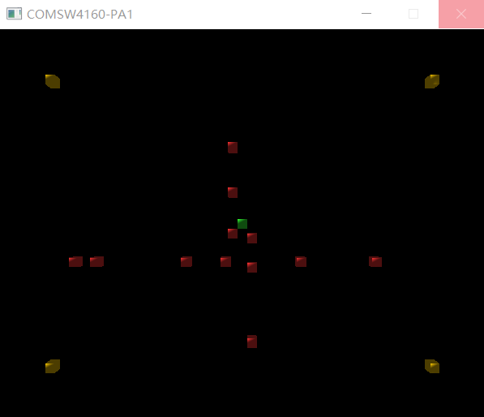

In this game, player controls the green block by ‘up’, ‘down’, ‘left’ and ‘right’ key on keyboard. The red blocks are the objects needed to be avoided. If the green block touches the red one, like illustrated on the figure above, the game is ended. And a dialogue box will show, player can choose to have another run or exit the game, as shown below.

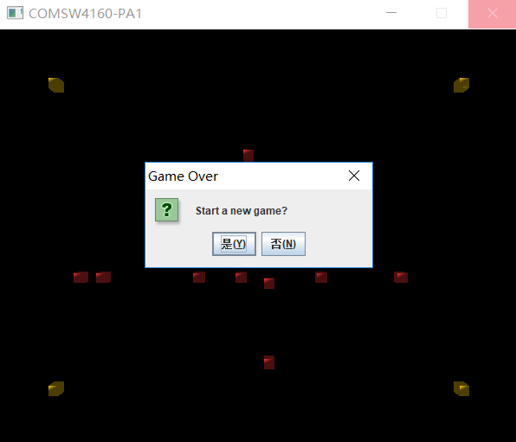

The game continues if the green block does not touch any red blocks. The yellow blocks are beacons used for showing the bounder of the game, the green block could not be moved outside this area, and red blocks will only appear in this area as well.

One thing to note here, the yellow blocks will not obstruct the green block, the player can move the green block through the yellow one.

Also, player may press ‘W’, ‘A’, ‘S’, ‘D’ to move the camera around. And press ‘Q’ and ‘E’ key to zoom in or zoom out the camera.

**How I made it?**

* Created multiple ‘gameItem’s one for each block.
* Added a new attribute ‘speed’ (Vector3f) to class ‘GameItem’.
* Added three functions to class ‘GameItem’.
* ‘getSpeed’, returns the speed of object.
* ‘setSpeed’ set the speed of object.
* ‘reset’ resets the position and speed of object, used for replacing red blocks when it goes out of bound.
* Redefined the actions when specific keys are pressed.
* Changed the initialization part of ‘DummyGame’.
* Added position and speed updating part in function ‘update’.

**Additional libraries used**

javax.swing.JoptionPane

This library is used for the dialogue.

**Things to note**

* I made an executeble jar file, you may directly open it to explore the game.
* **There is still a bug, due to the dialogue**. If the palyer is pressing a key while the game ends, forexample ‘up’ key, and if the player chooses to continue a next run, the green will go all the way up. It seems when this happens, the program keeps taking ‘up’ key as being pressed. By this time, I haven’t found a solution yet.
* I made a short video, you may want to have a look at it. When the video pauses, a dialogue is popped up, however the software I used did not capture it.

**Version 2 (Updated)**

As a matter of fact, moving a block around is kind of weird. Thus, I changed the object we are playing from a cube to a vehicle.

Now you can play with a car!

And as the object has changed, the way it moves and the way to control has also changed a little bit. Now when you press ‘up’ and ‘down’ key, you will accelerate the car or brake the car. And when you press ‘left’ or ‘right’ key, you will turn the car direction to left or right.

To realize this control method, I added another attribute ‘angle’ to class ‘gameItem’. When updating position, the program will first read the angle, then compute the speed along x-axis and y-axis based on absolute speed and this angle. And then the position can be updated by simply adding the speed to position.

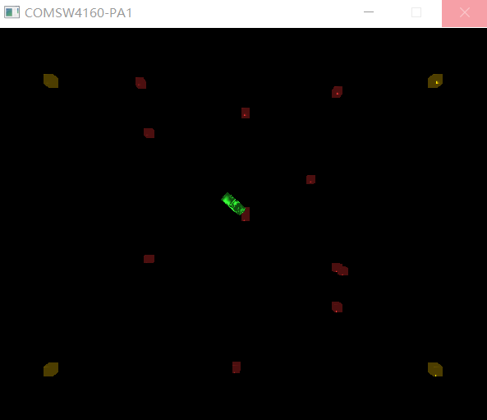

**Final version (Updated)**

Playing with a vehicle from an above view is definitly not as fun as driving it as if you are in it.

Thus, this in this update, I changed the viewpoint from above the playing area to a third person view.

And in this version, besides moving the vehicle, you can also press key ‘A’ and ‘D’ to move the camera around so that you can know on which direction there is an object coming.

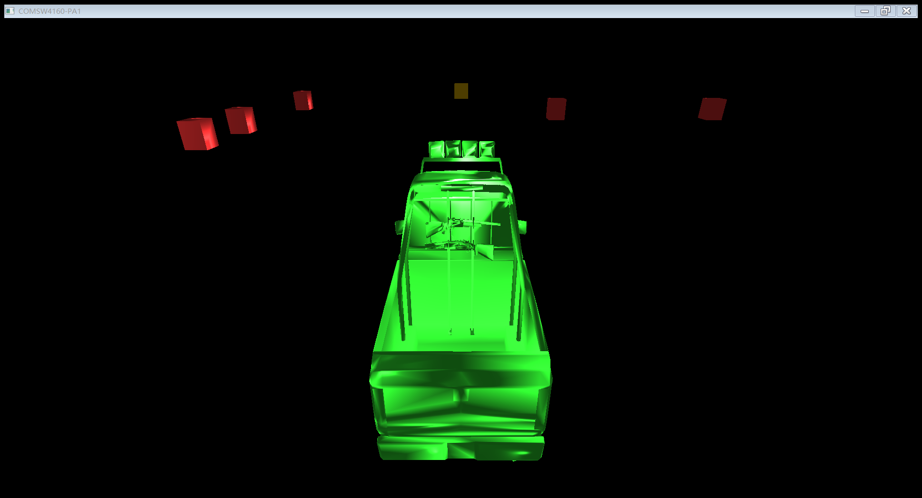

**The video and the jar file of pre-version are kept, but the I only included the code of final version in the zip file.**