For bioenergy, there are two parts in the power plant, one is to convert the biomass to methanol fuel cells and the other is to burn the biomass to produce the electricity. Although it is expensive to convert biomass to methanol, the reason why we use two methods is because we have different source of biomass such as wood that can be used for heat-led combined heat and power while corn is worth to convert to liquid biofuels to have a wider use or high efficiency. In addition, combustion will result in green house emission while methanol fuel cells have higher efficiency and low NOx emission since the working temperature is lower.



Figure Conversion of biomass to methanol

Main steps of conversion of biomass to methanol are illustrated above that contains Pre-treatment, gasifier, gas cleaning, reformer, shift reactor and methanol reactor to produce methanol.

The figure below shows the schematic of biomass power plant on how to produce the electricity.

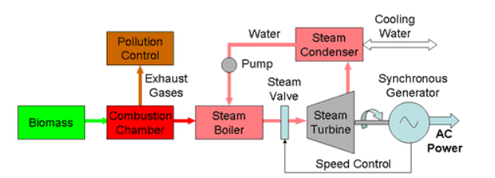

Figure Schematic of biomass power plant

Biomass are burnt in combustion chamber and the exhaust gases from the combustion will be absorbed and treated to reduce the air pollution. The water will go into steam boiler and gain heat to produce steam. Then the steam turbine is used to produce electricity.

One tone of biomass can be converted to 721 Litres of methanol. [1]

For methanol, density = 792 kg/m3, Molar mass = 32 g/mol

From the data, the amount of biomass we can get is:

|  |  |
| --- | --- |
| Source | tonnes |
| Residues from Vegetables | 517945 |
| Residues from Meat and Dairy Cattle | 9379960 |
| Residues from Poultry | 216484 |
| Residues from sheep | 843000 |
| Cereal Straw Residues | 2278000 |
| Non-Cereal straw residues | 674230 |

From model we calculate the electricity produced from direct burning and Methanol fuel cells:

Direct burning = 750 kwh/tonnes

DMFC = 854 kwh/tonnes

In our design, biomass is separated into two part: 1/3 biomass are converted to methanol and 2/3 biomass are burnt directly. The output electricity can be produced from biomass is 9,307,000,000 kwh per year which means we need a 100 MW power plant. Since it is impossible to build such a large-scale biomass power plant, in our design, two 40 MW power plants and one 20 MW power plant are built.

The total cost for the biomass plant that include capital cost and maintenance cost is:

Two 40 MW and one 20 MW power plant:

$$Capital Cost=2×\$2.5×40+\$2.5×20=\$250 million$$

Delivered biomass: $30 per MWH:

$$Delivered Cost=30×9.307=\$279.21 million$$

Production cost:

$$Production Cost=\$0.057/kwh$$

With bio energy, green house emission will reduce but some other problem such as formaldehyde may occur. Since the biomass is mainly delivered from waste and residuals that will have benefit on beautify environment and reduce the garbage pollution.

[1]<https://www.nrel.gov/docs/legosti/old/5570r2.pdf>

Appendix:

% MECH 5275

% Major project biomass model

% Author: Yuxin Zhu

% SID: 460053646

clc

clear

% Choose Direct methonal fuel cell(DMFC) as the storage

% Gibbs free energy for reactions and productions

g_ch3oh = -166360;

g_o2 = 0;

g_ch2o = -110000;

g_h2o = -228590;

g_reac = g_ch3oh + g_o2;

g_prod = g_ch2o + g_h2o;

dg = g_reac - g_prod;

% Enthalpy of reactions and productions

% liquid for methonal

h_ch3oh = -0;

h_o2 = 0;

h_ch2o = -115900;

h_h2o = -241820;

h_reac = h_ch3oh + h_o2;

h_prod = h_ch2o + h_h2o;

dh = h_reac - h_prod;

% Reversible effeciency

e_rev = dg/dh;

dq = dh-dg;

% Total residues annual

R_v = 517945;

R_meat = 9379960;

R_p = 216484;

R_s = 843000;

R_cs = 227800;

R_ncs = 674230;

R_T = R_v + R_meat + R_p + R_s + R_cs + R_ncs;

% Convert to methanol

% Biomass to methanol ratio

ratio_btm = 0.721;

rho_m = 792;

Mm_m = 32;

% Volume meter cube

V_m = 1 * ratio_btm;

% mass kg

m_m = V_m * rho_m;

% kmol

M_m = m_m/Mm_m;

% Energy per tonne in Gj

Q = M_m * dg/1000000;

% Energy in kwh

Q_kwh = Q * 278;

% Electricity from direct burning in kwh

Q_burn = 0.75*1000*R_T*2/3;

Q_fuel = Q_kwh *R_T*1/3;

% Total electricity produced

Q_T = Q_burn + Q_fuel;

Q_Tday = Q_T / 365;

Q_Tkwh = Q_Tday/24;