**IST659 Lab3 Exercise**

**M004 Wanyue Xiao**

**Data Modeling III using MS Visio and MS Access**

**Problem Description**

For this lab there are 3 separate problems. In the first problem you have to create a hierarchichal database model. For the second problem you will use conceptual modeling to model a supertype to subtype relationship. Finally, in problem number three you will take an invoice form and model the full normalized database in Visio in 3NF.

1. **Hierarchical Database Model**

You need to use the hierarchical database model to illustrate the structure of a university. Please represent the model according to the following business rules.

One university **consists of one to many schools**. *(For example, a university called University A” has the following schools - business school, engineering school, life sciences, information technology school.*

One school **consists of one to many departments**. *(For example, the information technology*

*school has departments such as Information Management, Library Information Systems, and*

*Telecommunication Network Management.)*

One department can offer **zero to many courses**.

We do not consider the situation of courses overlapping between departments or schools. If you make any assumptions in addition to the information provided above, make sure to list them with your data model.

1. **Super-type and Sub-type Relationships**

You need to use the enhanced entity relationship model to illustrate the super-type sub-type relationship of accounts at XYZ bank. Please represent the model according to the following business rules.

The XYZ Bank is a major bank that provides services for different types of customers.

Customers can open an account with XYZ bank. The type of an account must be at least one of the following. Savings, Checking, and/or Credit, or a combination of them.

For example: “Checking and Saving”, “Credit, Checking and Saving”, etc.

The model should store information about the various types of accounts offered at the bank, including Checkings, Savings, and Credit accounts.

The table below shows the information about each type of account.

**Checking** – OwnerName, OwnerAddress, BranchLocation, CheckingAccountID, OverdraftAmount, MinimumBalance, CheckingInterestRate, Current Balance

**Savings -** OwnerName, OwnerAddress, OwnerLastName, BranchLocation, SavingAccountID, OverdraftAmount, MinimumBalance, SavingInterestRate

**Credit** - OwnerName, OwnerAddress, BranchLocation, CreditAccountID, CreditLineAmount, AnnualPercentageRate

1. **Data Normalization**

For problem number three you need to develop a normalized data model to 3NF starting with a sample document (see below). The sample document is a Wireless (Mobile) bill summary sheet that the XYZ Company is currently using to track the wireless usage for its customers. The XYZ Company wants to build a database to store and retrieve this information. Assume that the customer and account information will remain the same every month.

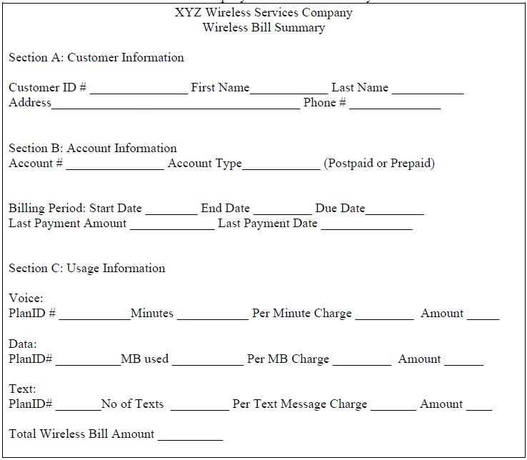

XYZ Company follows these business rules:

a. Each **account can be held by one and only one customer**.

b. Each account **will have a voice, text and data plan.**

c. Voice, Text and Data PlanID#’s are different from one another

d. Each **PlanId# (Voice, Text, Data) is associated with one or more account** numbers.

e. The **Total Wireless Bill Amount is the summation of Voice, Text and Data amounts** for the billing period. There are no adjustments from previous cycles.

**Assignment and Deliverables**

For **questions one and two, create two ERDs** according to the following instructions:

1. Create necessary tables, and give appropriate names to them.
2. Add the appropriate attributes.
3. Make sure their attributes are at atomic level and using good naming conventions (no composite attribute, no multi-value attribute).
4. Identify a primary key for each entity.
5. Establish the relationships between entities. Give the relationships appropriate verbs and recognize the associations (foreign keys).
6. Mark correct cardinality of the relationships.
7. Use identifying and non-identifying relationships appropriately.

Question 1：

Business Rules:

1. One university consists of at least one school while one school should only belong to one university.
2. One school consists of at least one department while one department should only belong to one school.
3. One university consists of at least one school while one school should only belong to one university.



Question 2:



For question (3), you will begin with

1. Identifying the **functional dependencies** (recommend excel) and then move forward with normalizing this data model to the 1NF (first normal form), 2NF (second normal form) and 3NF (third normal form).
2. Make sure you also demonstrate the intermediate steps before arriving at the 3NF i.e. show 1NF and 2NF ERDs and written explanations for the functional dependencies.
3. Your final ERD must be in the 3NF, which means, there should be no multi-valued attributes, partial dependencies or transitive dependencies in the model.

Here is the list of all items that you should turn in for problem number three:

1. 图片包含 墙壁

   描述已自动生成A list of all functional dependencies (preferably a screenshot of excel)

Business Rule:

**PRIMARY KEY**: AccountID, StartDate

**Full Dependency:**

**AccountID, StartDate** -> Total Wireless Bill Amount, Last Payment Amount, Last Payment Date, Minutes, Voice Amount, No of Text, Text Amount, MB Used, Data Amount.

**Partial Dependency:**

**AccountID** -> AccountType, CustomerID, fName, lName, address (StreetLine1, StreetLine2, City, State, Country, Zipcode), Phone Number, TextPlanID, DataPlanID, VoicePlanID, Per Text Charge, Per MB Charge, Per Voice Charge

**StartDate** -> EndDate, Due Date

**Transitive Dependency:**

**CustomerID** -> fName, lName, address (StreetLine1, StreetLine2, City, State, Country, Zipcode), Phone Number

**TextID** -> Per Text Charge

**DateID** -> Per MB Charge

**VoiceID** -> Per Voice Charge

1. The data model that conforms to 1NF

(left side)

1. Explanation of what you did to normalize the current table to 1NF

* 图片包含 屏幕截图

  描述已自动生成All the relations are in one table.
* Besides, the address had been converted to multi simple-valued attributes.
* What’s more, there are a combination of primary key which can indicate specific tuple.

1. The data model that conforms to 2NF

In this process, al the partial dependency needs to be eliminated. Hence, according to the dependency rules listed above, the entity needs to be split to three entities.



1. Explanation of what partial dependencies you have found and how you removed them.

There are two partial dependencies existed. They were Account with its relative attributes and Start Date with its relative attributes. In the Account entity, the accountID is the primary key, indicating customer information and specific plan of each data, voice, and data plan. In date entity, the primary key is Start Date, which can be used to indicate the other two attributes (endDate and dueDate). By using these primary keys, attributes like last payment amount, last payment date, total payment amount, etc. can be identified. Hence, three entities (account, data, and billing_detail whose primaries key consist of accountID and Start Date) need to be created.

1. The data model that conforms to 3NF

After solving the problem of data integrity and partial dependency, the last step is solving partial dependency problem.

1. Explanation of what transitive dependencies you have found and how you removed them

Given that each data plan can determine its charge. All the three plans (data plan, voice plan, and text plan) fits the requirements of transitive dependency. Besides, the customerID can be used to recognize the information of each customer. Hence, customerID and its relative attributes fits the requirements of transitive dependency. Therefore, all these attributes listed above should create their entities by abstracting their relative attributes from its original entity (which is the ACCOUNT entity). For example, the Voice Plan ID and its corresponding charge can be used to create an entity named VOICE.

**Submission Instruction**

Please submit your report in one Word file to BlackBoard under the appropriate Lab in the Labs section. You should copy and paste your Visio ERD directly to MS Word file.

Name your file in this format “IST659SectionNumber-Lab3-Lastname-Firstname.doc”. Please also bring a paper copy to class for the first 3 labs. It is easier to mark and comment on data models on paper. Make sure to print your names on the paper copy as well.

**Due Date**

Labs are due by the start of class of the following week. Please refer to the syllabus if there is any confusion. The reason that this is done is so that I can review the solution in class while still giving you the most time possible.

**Grading Rubric:**

This lab evaluates students’ understanding of some key concepts: entities, attributes, primary keys, cardinality of relationships, foreign key constraints. The grading is based on the assessment whether the student has grasped these key concepts.

5 points – all concepts correctly understood, all answers correct

4.5 points – confusion about a key concept, sometimes right

4 points – one key concept obviously misunderstood

3.5 points – confusion about a couple concepts, sometimes right 3 points – two key concepts obviously misunderstood

2 points or below – basically don’t understand these concepts