**IST 659 Lab 4**

**SQL I using MS SQL Server**

**Problem Description**

For this lab you are required to work in SQL Server and create the appropriate tables, columns, and constraints for the following model.

**Business Case**

Syracuse University Career Services wants to keep track of all interviews that take place. In addition to this information they would like to track the positions, candidates, companies, and interviewers. Sometimes Career Services will need to contact the companies for verification or other inquiries.

We need to build a database that would assist the Career Services in recording this

information. In this database system, each company and candidate will have their own profiles which include their names and contact information such as phone numbers and postal addresses. Candidates would need to provide information about their primary experience domain, and relevant experience.

Interviewers may or may not provide their office hour information. The schedule or office hour information should be a text describing when the interviewer’s office is open, e.g. 9am-5pm Monday – Thursday.

An interviewer can conduct one or multiple interviews of candidates. A candidate can have one or more interviews. Each interview must have an interview date and round number along with information about the Candidate and Interviewer. The database should also maintain information about the positions a company is looking to hire for. Details about the Position include position level, position name, and whether or not the position is still available.

In this lab we have already created the ERD model for the career services database (see below).

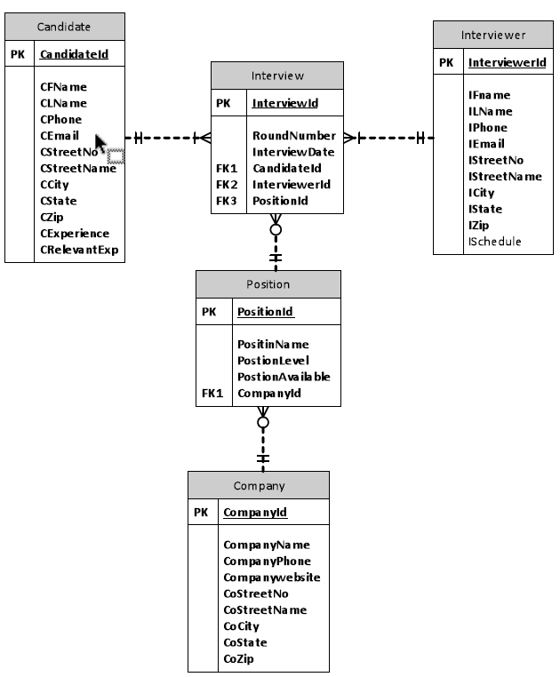

**Lab 4 Instructions**

Imagine you are hired by career services to design a new database to support this business. Now it’s time to move to the next step, database physical design and implementation. As the first step please use SQL DDL and DML to provide the following deliverables that satisfy the requirements.

1. Create the tables:

Create the five tables following the ERD above. Copy and paste the complete CREATE statements to your lab report.

Make sure you set up correct constraints for the primary keys and foreign keys, as well as the following domain constrains:

* 1. The default date set for your InterviewDate attribute in the Interview table is today’s date and show an example in your INSERT statements.
  2. The PositionLevel attribute in the Position table can only accept one of these five values - “Internship”, “Entry”, “Executive”, “Managerial”, “Staff”
  3. The PositionAvailable field in the Position table only allows either “yes” or “no”

**Candidate Table:**

create table Candidates(

CandidateID CHAR(10) NOT NULL,

CFName VARCHAR(30) NOT NULL,

CLName VARCHAR(30) NOT NULL,

CPhone VARCHAR(15) NOT NULL,

CEmail VARCHAR(30) NOT NULL,

CStreetNo VARCHAR(30) NOT NULL,

CStreetName VARCHAR(30) NOT NULL,

CCity VARCHAR(30) NOT NULL,

CState VARCHAR(30) NOT NULL,

CZip VARCHAR(5) NOT NULL,

CExperience VARCHAR(50) NOT NULL,

CRelevantExp VARCHAR(50) NOT NULL,

constraint Candidates_PK PRIMARY KEY (CandidateID)

)

**Companies Table:**

create table Companies(

CompanyID CHAR(10) NOT NULL,

CompanyName VARCHAR(30) NOT NULL,

CompnayPhone VARCHAR(15) NOT NULL,

Companywebsite VARCHAR(50) NOT NULL,

CoStreetNo VARCHAR(15) NOT NULL,

CoStreetName VARCHAR(30) NOT NULL,

CoCity VARCHAR(15) NOT NULL,

CoState VARCHAR(15) NOT NULL,

CoZip CHAR(5) NOT NULL,

constraint Companies_PK PRIMARY KEY (CompanyID)

)

**Interviewers Table:**

create table Interviewers(

InterviewerID CHAR(10) NOT NULL,

IFName VARCHAR(30) NOT NULL,

ILName VARCHAR(30) NOT NULL,

IPhone VARCHAR(15) NOT NULL,

IEmail VARCHAR(30) NOT NULL,

IStreetNo VARCHAR(15) NOT NULL,

IStreetName VARCHAR(30) NOT NULL,

ICity VARCHAR(15) NOT NULL,

IState VARCHAR(15) NOT NULL,

IZip CHAR(5) NOT NULL,

ISchedule VARCHAR(30),

constraint Interviewers_PK PRIMARY KEY (InterviewerID)

)

**Interviews Table:**

create table Interviews(

InterviewID CHAR(10) NOT NULL,

RoundNumber NUMERIC(1,0) NOT NULL,

InterviewDate DATETIME default getdate(),

CandidateID CHAR(10) NOT NULL,

InterviewerID CHAR(10) NOT NULL,

PositionID CHAR(10) NOT NULL,

constraint Interviews_PK PRIMARY KEY (InterviewID),

constraint Interviews_Candidate_CompanyID_FK FOREIGN KEY (CandidateID) REFERENCES Candidates(CandidateID),

constraint Interviews_Interviewer_CompanyID_FK FOREIGN KEY (InterviewerID) REFERENCES Interviewers(InterviewerID),

constraint Interviews_Position_CompanyID_FK FOREIGN KEY (PositionID) REFERENCES Positions(PositionID)

)

**Positions Table:**

create table Positions(

PositionID CHAR(10) NOT NULL,

PositionName VARCHAR(30) NOT NULL,

PositionLevel VARCHAR(30) NOT NULL CHECK (PositionLevel IN ('Internship', 'Entry', 'Executive', 'Managerial', 'Staff')),

PositionAvailable VARCHAR(3) NOT NULL CHECK (PositionAvailable IN ('Yes', 'No', 'YES', 'NO', 'yes', 'no')),

CompanyID CHAR(10) NOT NULL,

constraint Positions_PK PRIMARY KEY (PositionID),

constraint Positions_CompanyID_FK FOREIGN KEY (CompanyID) REFERENCES Companies(CompanyID)

)

1. **Insert data:**

Insert the following data into the tables (shown in the screenshots in the next section). Copy and paste all insert statements into the lab report. For the InterviewDate field in the Interview table please allow the default date to be passed in.

**Insert Candidates Data:**

insert into Candidates values ( '1', 'Nathan', 'Kerr', '315-555-5555', 'nathan@syr.edu', '112', 'Lafayette Rd', 'Syracuse', 'New York', '13205', 'Database, Business Analysis', 'Database'),

( '2', 'Sebatian', 'Chapman', '315-555-6666', 'sebatian@syr.edu', '17', 'James St', 'Syracuse', 'New York', '13210', 'Consultant, Business Analysis', 'Consultant'),

( '3', 'Heather', 'Cameron', '315-555-7777','heather@syr.edu', '410', 'Comatock Ave', 'Syracuse', 'New York', '13210', 'Developer, Business Analysis', 'Developer'),

( '4', 'Olivia', 'Walace', '315-555-8888', 'olivia@syr.edu', '4248', 'Nottingham Rd', 'Syracuse', 'New York', '13244', 'Database, Business Analysis', 'Database'),

( '5', 'Lily', 'Tumer', '315-555-9999', 'lily@syr.edu','3', 'Ostrom Ave', 'Syracuse', 'New York', '13225', 'Database, Business Analysis, Developer, Analyst', 'Database');

select * from Candidates;

**Insert Companies Data:**

insert into Companies values ( '1', 'Emst & Young', '315-129-5677', 'www.ey.com', '234', 'Lafayette Rd', 'New York', 'New York', '13205'),

( '2', 'Deloitte', '315-356-5887', 'www.deloitte.com', '456', 'Summer Ave', 'New York', 'New York', '13100'),

( '3', 'PWC', '315-894-4787', 'www.pwc.com', '791', 'Maryland Ave', 'New York', 'New York', '13801'),

( '4', 'KPMG', '315-129-5677', 'www.kpmg.com', '437', 'Lanchaster Ave', 'New York', 'New York', '12147'),

( '5', 'Cognizant', '315-479-5182', 'www.cognizant.com', '825', 'Acjeman Street', 'New York', 'New York', '10071');

select * from Companies;

**Insert Interviewers Data:**

insert into Interviewers values ( '1', 'Dorothy', 'Paige', '315-555-0126', 'dorothy.paige@syr.edu', '137', 'Summer Ave', 'Syracuse', 'New York', '13210', '9am-5pm Monday-Friday'),

( '3', 'Charles', 'Duncan', '315-444-5555', 'charles.duncan@syr.edu', '345', 'Lancaster Ave', 'Syracuse', 'New York', '13210', '8am-6pm Monday-Saturday'),

( '5', 'Ray', 'Myatorio', '315-129-5677', 'raymyatorio@syr.edu', '234', 'Latayette Rd', 'Syracuse', 'New York', '13205', '9:30am-5:30pm Monday-Friday');

insert into Interviewers (InterviewerID, IFName, ILName, IPhone, IEmail, IStreetNo, IStreetName, ICity, IState, IZip) values ( '2', 'Amy', 'May', '315-5555', 'amy.may@syr.edu', '777', 'Ackeman Ave', 'Syracuse', 'New York', '13210');

insert into Interviewers (InterviewerID, IFName, ILName, IPhone, IEmail, IStreetNo, IStreetName, ICity, IState, IZip) values ( '4', 'Vctor', 'Miller', '315-333-5565', 'vctor.miller@syr.edu', '7116', 'Lafayette Ave', 'Syracuse', 'New York', '13205');

select * from Interviewers;

**Insert Interviews Data:**

INSERT INTO Interviews (InterviewID, RoundNumber, CandidateID, InterviewerID, PositionID) VALUES ('1', 2, '1', '1', '1');

INSERT INTO Interviews (InterviewID, RoundNumber, CandidateID, InterviewerID, PositionID) VALUES ('2', 1, '2', '2', '2');

INSERT INTO Interviews (InterviewID, RoundNumber, CandidateID, InterviewerID, PositionID) VALUES ('3', 3, '3', '3', '1');

INSERT INTO Interviews (InterviewID, RoundNumber, CandidateID, InterviewerID, PositionID) VALUES ('4', 2, '1', '2', '1');

INSERT INTO Interviews (InterviewID, RoundNumber, CandidateID, InterviewerID, PositionID) VALUES ('5', 5, '5', '5', '5');

select * from Interviews;

**Insert Positions Data:**

INSERT INTO Positions VALUES ('1', 'Technology Analyst', 'Internship', 'yes', '1'),

('2', 'Business Analyst', 'Entry', 'yes', '1'),

('3', 'Database Analyst', 'Executive', 'yes', '2'),

('4', 'Risk Manager', 'Executive', 'no', '3'),

('5', 'Advisory Consultant', 'Staff', 'yes', '4'),

('6', 'Project Manager', 'Managerial', 'no', '5');

select * from Positions;

1. Select data:

Select all content from each table to prove the success of creating tables and inserting data. Include the screenshots of the select results in the lab report. The select results should be exactly like the following:

**Companies Data Example:**

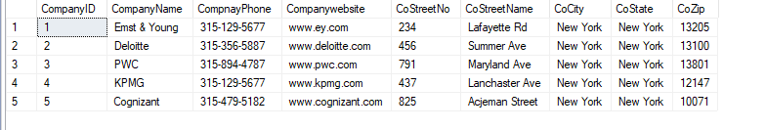

**Interviews Data Example:**

**Candidates Data Example:**

**Interviewers Data Example:**

**Positions Data Example:**

**Submission Instruction**

Please submit your report in one Word file to BlackBoard under the appropriate Lab in the Labs section.

Name your file in this format “IST659SectionNumber-Lab4-Lastname-Firstname.doc”.

**Due Date**

Labs are due by the start of class of the following week. Please refer to the syllabus if there is any confusion. The reason that this is done is so that I can review the solution in class while still giving you the most time possible.

**Grading Rubric:**

This lab evaluates students’ understanding of some key concepts: entities, attributes, primary keys, cardinality of relationships, foreign key constraints. The grading is based on the assessment whether the student has grasped these key concepts.

5 points – all concepts correctly understood, all answers correct

4.5 points – confusion about a key concept, sometimes right

4 points – one key concept obviously misunderstood

3.5 points – confusion about a couple concepts, sometimes right 3 points – two key concepts obviously misunderstood

2 points or below – basically don’t understand these concepts