# IST769 Homework Submission Template

## Basic Information

Your Name: Wanyue Xiao

SUID: 720633297

Your Email: xwanyue@syr.edu

Date Due: April 16, 2020

Homework #: HW10

## Instructions

For each answer, please include your answer as text, and any screenshot(s) which demonstrate your answer was executed. Most importantly, make sure to include evidence your answer is correct. This will most likely be a screenshot. If you had issues, problems, or had to make assumptions include them in your answer.

## Your Answers:

1. Write KSQL to create a stream named **weblogs** from the JSON keys in the **weblogs** Kafka topic. Make sure to set the TIMESTAMP property to the timestamp from the stream.

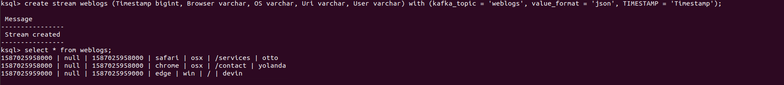

1. Write a KSQL statement create a persistent stream/table called **homepage** which only displays visitors to the root of the website (/). It should display all columns from the **weblogs** stream.  
   A screenshot of a cell phone

   Description automatically generated
2. Write a KSQL statement to count operating systems users (os) in 60 second windows. After 60 seconds, the counter should reset, and counts should begin again.

1. Write a KSQL persistent stream/table called **user_activity** which will display a count of user activity on the website within 1-minute sessions.

1. Write a KSQL statement to display users who have more than 1 pages of activity in a 1-minute session.

## Student Reflection:

To achieve the highest grade on the assignment you must be as descriptive and personal as possible with your reflection. Ask yourself the following questions.

1. What new information have I learned from completing this assignment?  
   **kafka, ksql**
2. What were my challenges / roadblocks I encountered on the way to completing it?  
   **the fourth question is unclear. What is the 1-minute session supports to mean? Using session and set the time as 1 minute? Besides, hates docker, it is too easy to generate errors.**
3. To be better prepared to attempt this assignment I should _______ ?

**Review before class.**

1. If I could make this assignment better, I would _____?

**Try to focus!!!**

1. Rate your comfort level with completing this assignment:

**1**  
1 ==> I can do this on my own and explain how to do it.

2 ==> I can do this on my own without any help.

3 ==> I can do this with help or guidance from others. If you choose this level, please list those who helped you.

4 ==> I don't understand this at all yet and need extra help. If you choose this, please try to articulate that which you do not understand.