# IST769 Homework Submission Template

## Basic Information

Your Name: Wanyue Xiao   
Your SUID: 720633297  
Your Email: xwanyue@syr.edu  
Date Due: 1/23/2019   
Homework #: hw01

## Instructions

For each answer, please include your answer as text, and any screenshot(s) which demonstrate your answer was executed. Most importantly, make sure to include evidence your answer is correct. This will most likely be a screenshot. If you had issues, problems, or had to make assumptions include them in your answer.

## Your Answers:

1. For bringing up redis environment, the commend should be “docker-compose up -d”. The commend for bringing up mssql environment is exactly the same.



However, the only difference is the directory which will execute this commend.

For example, if the student wants to bring up the redis environment, the student should change the directory to redis’s. Otherwise the student needs to use commend “docker run -d -p 8888:8888 - -name redis_test redis” to bring up the image. In this case, the differences are the assigned port, the name that make up by the student to represent the image, and the name of image that student wants to bring up (screenshots is inside question 4).

1. The docker-compose.yml document stores configuration information. Once can use both the terminal and visual studious to create a docker-compose file which configure everything the student needs to operate the container.
2. The difference between stopping an environment and bring it down is that the one can restart the container and keep the changes made inside for using stop command. However, for down command, it will remove all the changes, data, and container the student has made.

For Stopping:

For Shutting Down:

1. If one brings up the container at the first time, the container should be successfully run. Then if execute the command again, the system will report “… is up-to-date”. If one use “run” command to bring up the container, the system will throw out an error as “... the container name XXX is already in use by container YYY …”.

1. The difficult part of this lab is the missing data once one shut down the container. In order to solve the problem, one can use command “…. -v filename:/home/data/” to specify a file and a document to store the data which generated during the session. Besides, one can also manipulate or create a docker-compose.yml file to store the command which is being used to bring up the container.

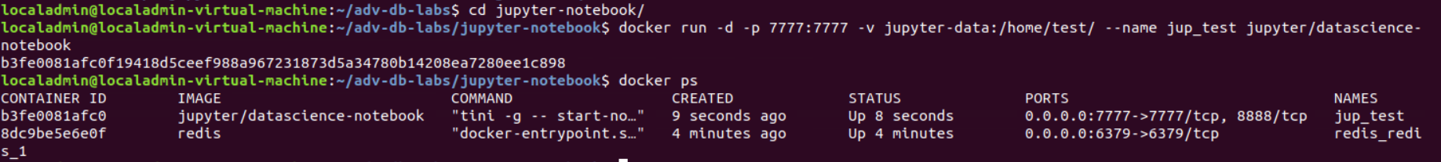

For picture below, one can find the jupyter-data in the volume file.

## Student Reflection:

To achieve the highest grade on the assignment you must be as descriptive and personal as possible with your reflection. Ask yourself the following questions.

1. What new information have I learned from completing this assignment?  
   The commands of running, stopping, shutting down the container. Pulling the image. Store the data that generated during the session into a folder or file.
2. What were my challenges / roadblocks I encountered on the way to completing it?  
   the understanding of the relationship between image and container. The purpose of some common documents, such as docker-compact file.
3. To be better prepared to attempt this assignment I should _______ ?

Do the pre-reading list. Hope professor can post more videos online.

1. If I could make this assignment better, I would _____?  
   Review the video and online codes.
2. Rate your comfort level with completing this assignment: level 3, the person who helped me is lizheng liang.  
   1 ==> I can do this on my own and explain how to do it.

2 ==> I can do this on my own without any help.

3 ==> I can do this with help or guidance from others. If you choose this level, please list those who helped you.

4 ==> I don't understand this at all yet and need extra help. If you choose this, please try to articulate that which you do not understand.