 | Barcode Sample
 | This sample uses Barcode4J Version 2.0
 | http://barcode4j.sourceforge.net/
 | Code 128 |  | 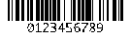
 | Codabar |  | 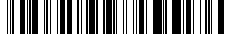
 | DataMatrix |  | 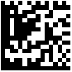
 | EAN-128 |  | 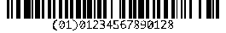
 | Code39 |  | 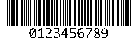
 | USPS Intelligent Mail |  | 
 | Royal Mail Customer |  | 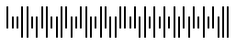
 | Interleaved 2 of 5 |  | 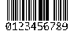
 | UPC-A |  | 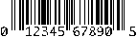
 | UPC-E |  | 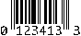
 | EAN-13 |  | 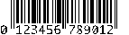
 | EAN-8 |  | 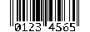
 | POSTNET |  | 
 | PDF417 |  | 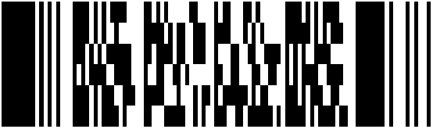
 | QRCode |  | 

