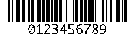
Barcode Sample
This sample uses Barcode4J Version 2.0
http://barcode4j.sourceforge.net/
Code 128
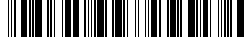
Codabar
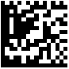
DataMatrix
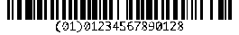
EAN-128
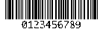
Code39

USPS Intelligent Mail
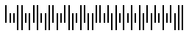
Royal Mail Customer
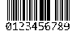
Interleaved 2 of 5
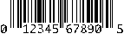
UPC-A
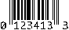
UPC-E
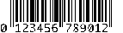
EAN-13
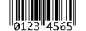
EAN-8

POSTNET
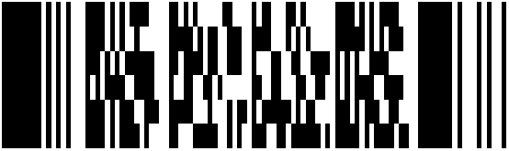
PDF417

QRCode

