This is a test document. Here we have bold text, italic text, underlined text, and some strike-through text. We also have a ^{superscript} and a _{subscript}. And now we have some colored text. Then, we have a numbered list:
- Number 1
- Number 2
  - Sub Topic (a)
  - Sub Topic (b)
- Number 3
If we have a numbered list, we should also have a bullet list:
- Bullet 1
- Bullet 2
  - Sub Topic 1
  - Sub Topic 2
- Bullet 3
Oops! I think we missed a table, here goes one:
Head 1 | Head 2 | Head 3 | Head 4
1.1
 | 2.2
 |  | 3.3
 |  |  | 4.4

Ok, now it’s time to have a link.
Then what about image links?

Finally, let’s have some special characters: € £ ¥ © ® ™ ± ≠ ≤ ≥ ÷ × ∞ µ α β π Ω ∑ ☺
It’s time for a chart:
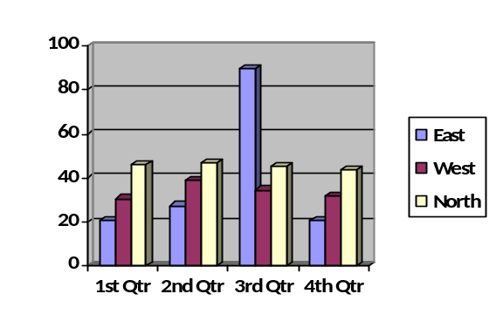
How about some word-art?
WordArt
A shape:

I think it’s enough for the moment, we can add more stuff later maybe ☺

